PickleVerse Software Design Description
  - Report 4 · Current architecture data design and proposed completion work
Working draft for team and reviewer discussion. Source snapshot c32f2a4c0a54 on 23 October 2026. No game/backend execution or code edits were performed. PKV is a working abbreviation; official code, names and approvals remain unconfirmed.

1 Design boundary and architecture
The current design combines a Unity rendering/gameplay client, an ASP.NET Core data-authority backend, PostgreSQL, Redis, Photon Fusion Shared, SMTP and S3. The backend is authoritative for commands and durable account/economy state. Real-time simulation still belongs to a peer StateAuthority. “Server” method naming inside a peer NetworkBehaviour does not establish a dedicated trusted server.
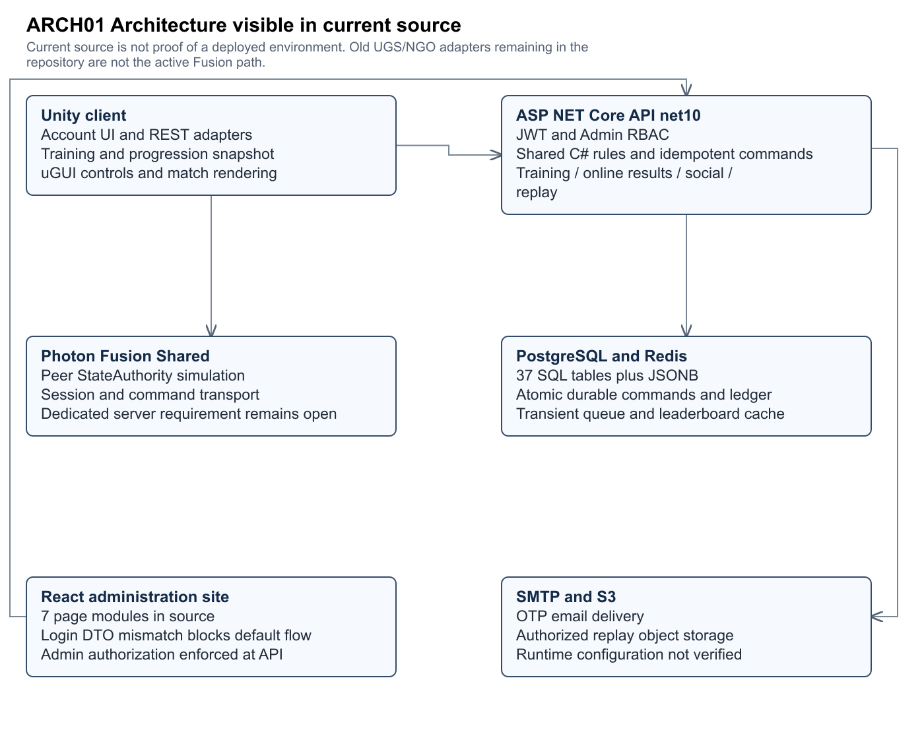
Figure ARCH01 · Editable source and full size SVG/PNG are in Diagrams/Current_c32f2a4.
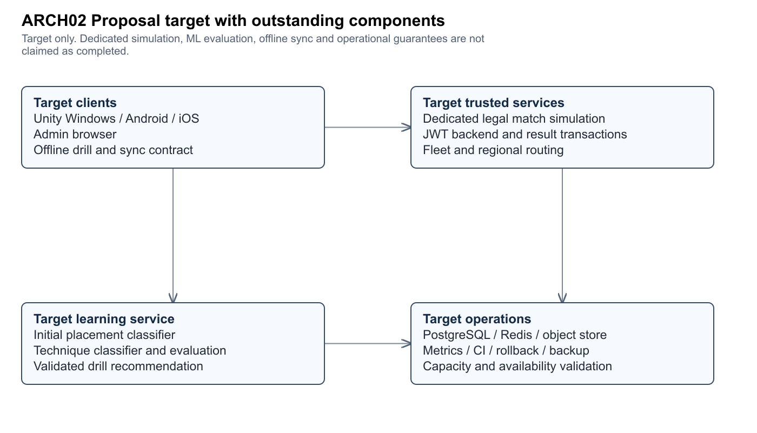
Figure ARCH02 · Editable source and full size SVG/PNG are in Diagrams/Current_c32f2a4.
Component | Version or source contract | Responsibility and limit
Unity client | 6000.6.2f1; URP 17.6.0; Input System 1.20.0; uGUI 2.6.0 | Windows/mobile rendering, controls, local simulation and REST adapters; runtime performance not measured.
Real-time network | Photon Fusion Shared in PhotonSession.cs | Shared peer authority and session transport; exact installed Fusion package version requires package/vendor manifest confirmation.
Backend | net10.0; ASP.NET Core; EF models plus raw SQL | JWT, validated commands, catalog, training, results, social and replay.
Backend libraries | StackExchange.Redis 3.4.5; MailKit 4.17.0; AWSSDK.S3 4.0.104.5 | Source package references, not proof of deployed service configuration.
Data | PostgreSQL source DDL; Redis runtime service | 37 source tables; 27 EF classes plus raw-SQL additions. Deployed engine/version/migration state must be recorded.
Admin browser | React 18; Vite 5; TypeScript 5; Tailwind 3; React Query 5 | Users/CMS/matches/moderation/analytics source exists; default auth DTO mismatch blocks integration.

2 Components and trust boundaries

Account and API transport
AccountRuntime creates the API client before scene load. UnityWebRequest supplies JSON and Bearer headers with timeout/cancellation. AccountService rotates refresh tokens on 401, keeps tokens in memory and invalidates stale account-generation responses. Password recovery is not established by the observed registration/login UI.

Catalog and progression
GameCatalogService reads configured lesson/mission/cosmetic data and rule settings. ProgressionRuntime is an in-memory view of server state. GameProgress stores aggregate JSONB and revision; existing LocalPlayerStore classes are not evidence that the active runtime is offline-capable.

Command transaction
OnlineGameService locks account/profile state, validates command ID and payload fingerprint, applies shared C# rules, persists profile/wallet/objective/ledger state, inserts command identity and commits. Identical retries return current state; conflicting reuse fails. PostgreSQL transactions, not UI state, protect exactly-once awards.

Training validation
The server creates attempt IDs, checks ownership/catalog/prerequisites, validates monotonic finite measurements and plausible elapsed time, and determines completion/review reward. It does not observe every rendered contact; measurement honesty remains a security boundary.

Ranked queue and rooms
Redis maintains search/reservation and ready policy; canonical roster and match data persist in PostgreSQL. Search mode/region/protocol/membership must agree. Configured ranked-bot fallback is a product-policy decision to disclose, not a human matchmaking guarantee.

Online results
GameMatches stores canonical session/roster/phase. GameMatchPlayers stores acceptance, report fingerprints and heartbeat. All required humans must accept; result reports must agree and satisfy score/roster rules. Finalization updates every participant transactionally. A forged-but-agreed result still needs the dedicated authority solution or an approved security tradeoff.

Social ranking and replay
Online social APIs provide real paged accounts/relationships and Elo standings. LeaderboardCache derives versioned sorted sets from PostgreSQL. Replay services authorize participants and validate bounded gzip chunks; metadata and S3 keys/hashes live in SQL. Friend-to-room invitations are distinct from friendship requests and code-based joining.

Admin and analytics
AdminController enforces the Admin JWT role. The React auth payload/response contract, enum/SQL status mismatch, configured-catalog publication and metric definitions remain open. UI pages cannot be used as evidence that these flows pass end-to-end.

3 Design decisions and alternatives
ID | Decision | Alternatives | Choice and rationale | Owner | Trace
D1 | Common account UUID and REST snapshot | Keep isolated local/UGS identity or integrate backend UUID | Use account UUID to scope all state and reject stale-session responses; source implemented. | M1 | F01/F04 ARCH01
D2 | Durable command ledger | Client rewards or idempotent server transaction | Use PostgreSQL transaction plus payload fingerprint and ledger; shared pure C# rules avoid divergent reward logic. | M4 | F03/F10 DATA01
D3 | Real-time authority | Dedicated headless authority or Photon Shared peer | Source uses Shared; proposal dedicated authority remains unresolved. Seek explicit approval or implement trusted simulation. | M3 | F09 SR01 ARCH02
D4 | Runtime content configuration | Hard-coded drills or configured catalog | Use coded validated config and version hash; admin publish path still needs completion. | M1 | F03/F16 SR06
D5 | Relational plus JSONB state | Fully normalized replacement or hybrid schema | Document actual 37-table hybrid design; keep JSON structures explicit and Redis ephemeral. Do not deploy the separate 71-table candidate implicitly. | M4 | F04/F10 ERD00

Owner slots and technology deviations are proposals for team confirmation, not inferred personal contributions or reviewer approval.

4 Relational and logical data design
The authoritative schema for this audit is src/Database.sql at the stated HEAD. Every table and column is represented in ERD01–ERD11 and Data_Dictionary_current.csv. Each diagram includes complete attributes for its primary tables and reference stubs for other pages. Dashed references are cross-page SQL relations, not new tables. The Mermaid source carries parent/child optionality; the relationship register below lists declared FK columns. Unique/composite constraints must be read with the original DDL.
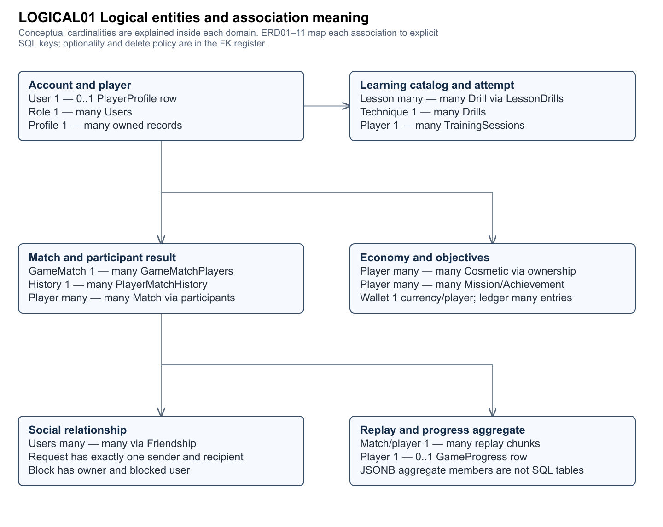
Figure LOGICAL01 · Editable source and full size SVG/PNG are in Diagrams/Current_c32f2a4.
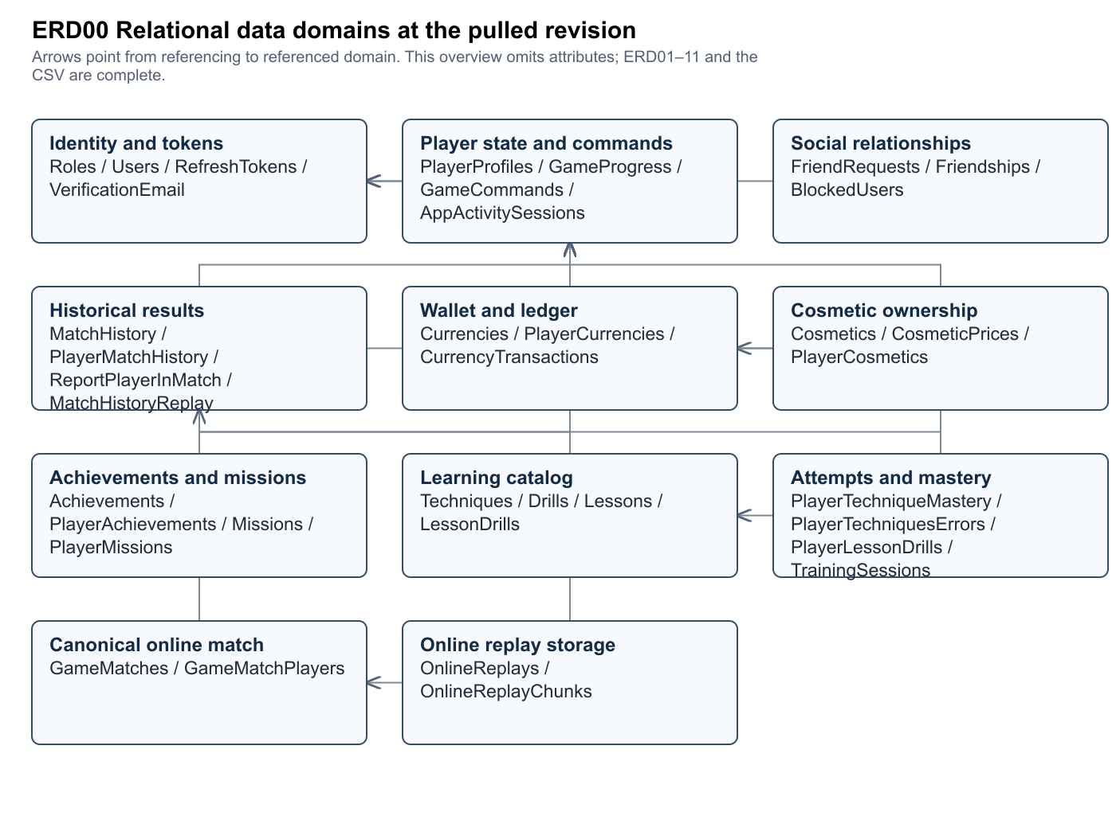
Figure ERD00 · Editable source and full size SVG/PNG are in Diagrams/Current_c32f2a4.

Current schema domain 1
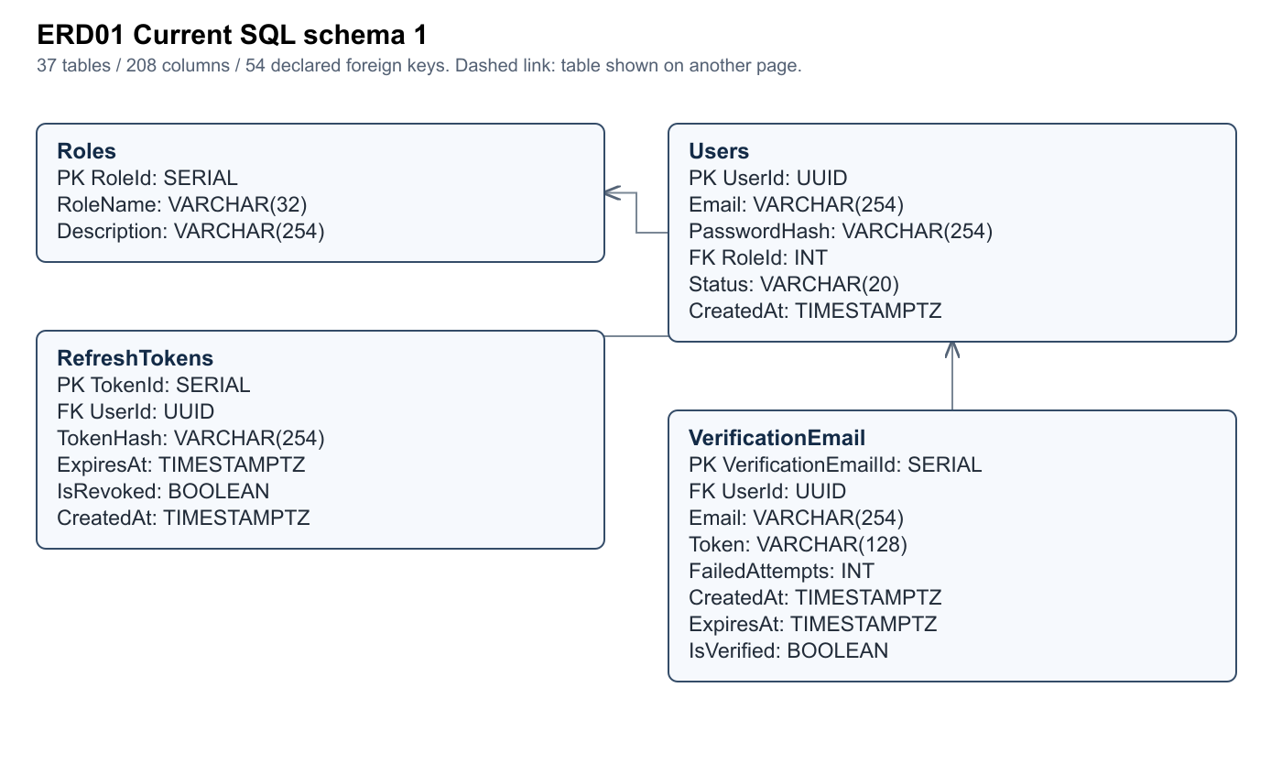
Figure ERD01 · Editable source and full size SVG/PNG are in Diagrams/Current_c32f2a4.

Current schema domain 2
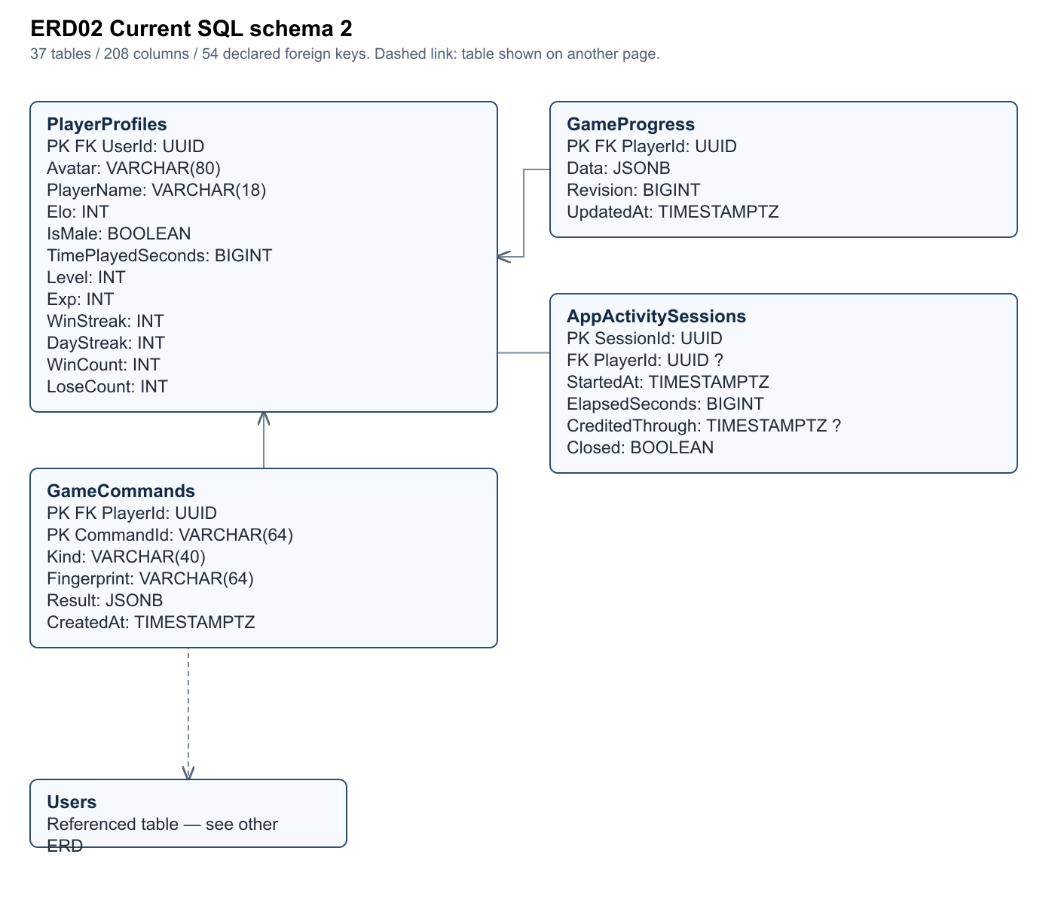
Figure ERD02 · Editable source and full size SVG/PNG are in Diagrams/Current_c32f2a4.

Current schema domain 3
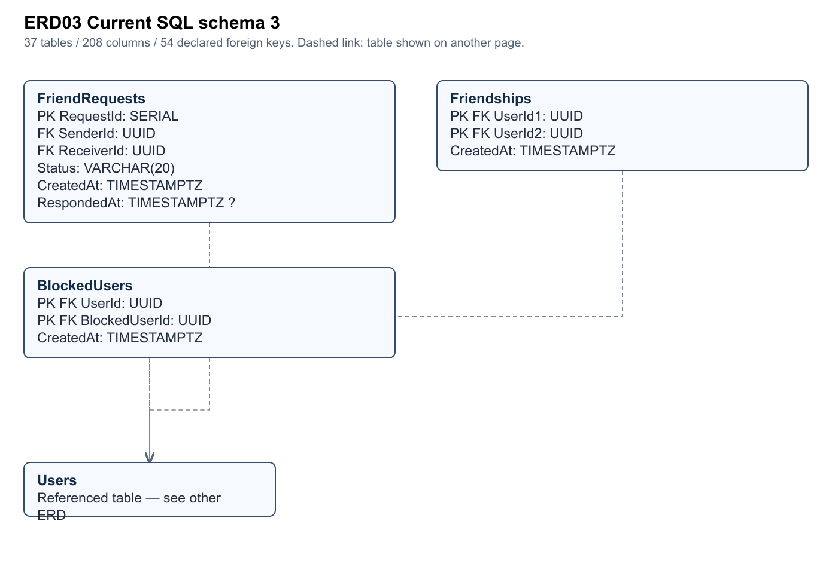
Figure ERD03 · Editable source and full size SVG/PNG are in Diagrams/Current_c32f2a4.

Current schema domain 4
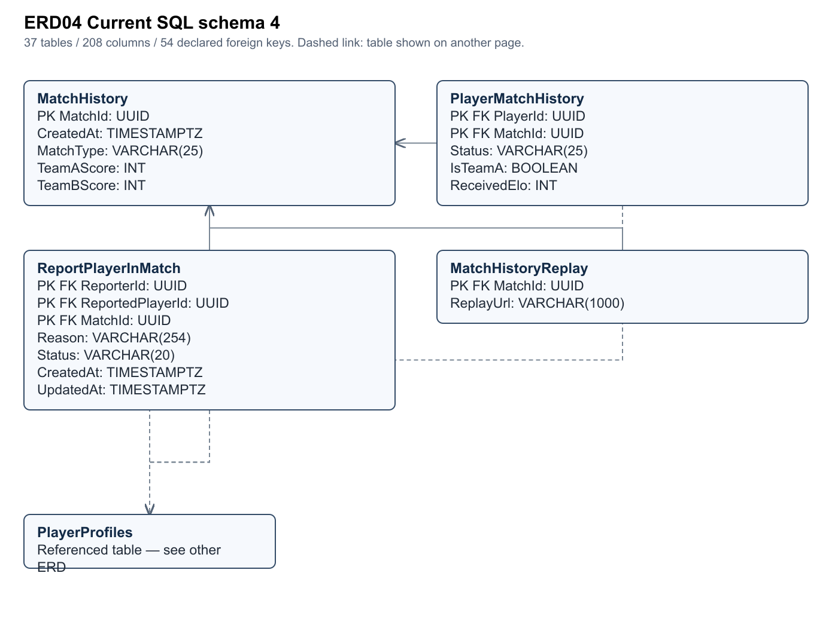
Figure ERD04 · Editable source and full size SVG/PNG are in Diagrams/Current_c32f2a4.

Current schema domain 5
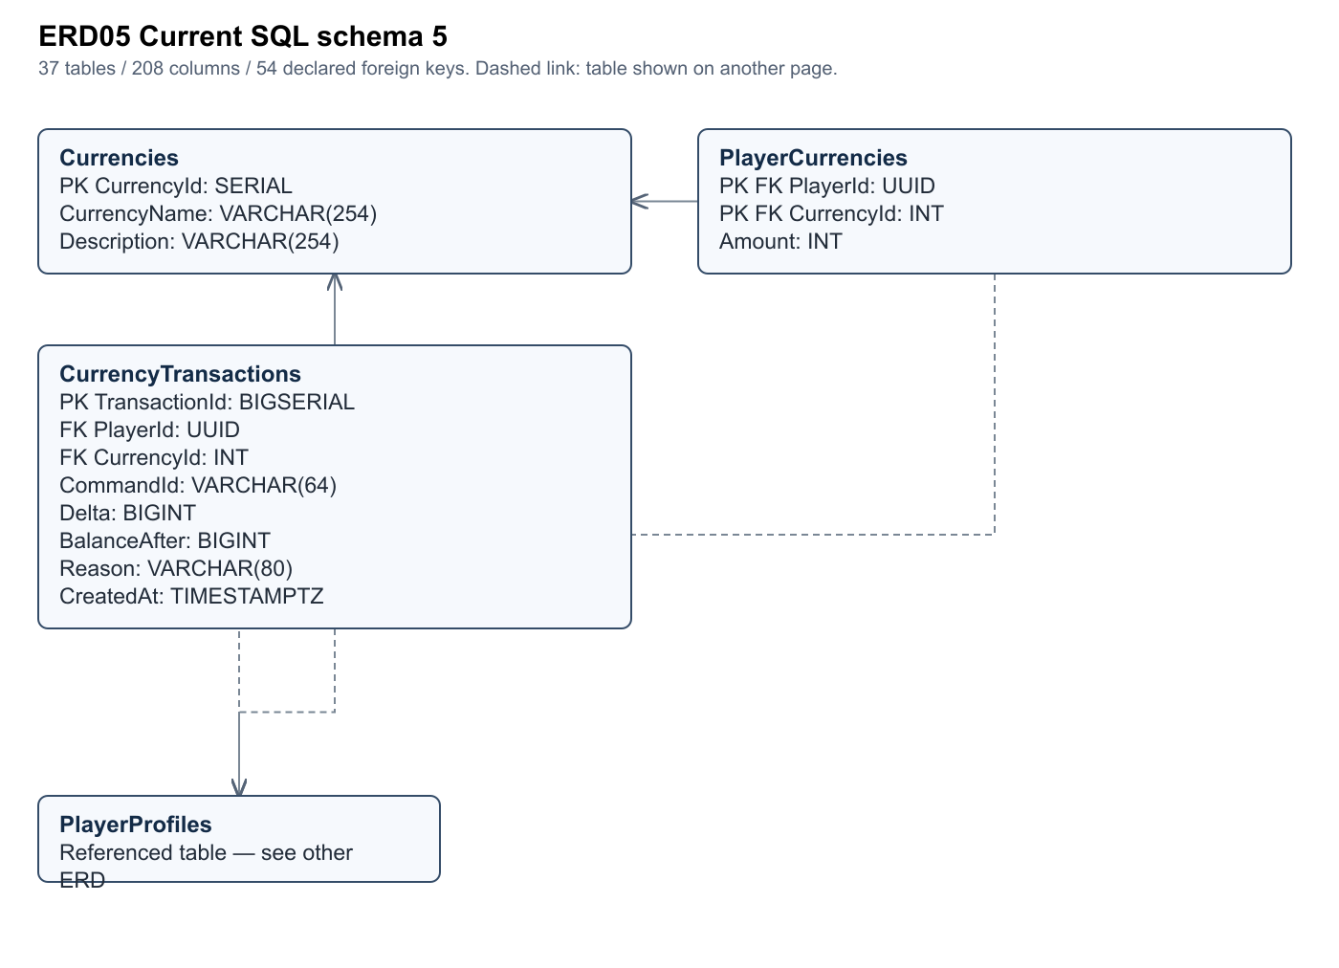
Figure ERD05 · Editable source and full size SVG/PNG are in Diagrams/Current_c32f2a4.

Current schema domain 6
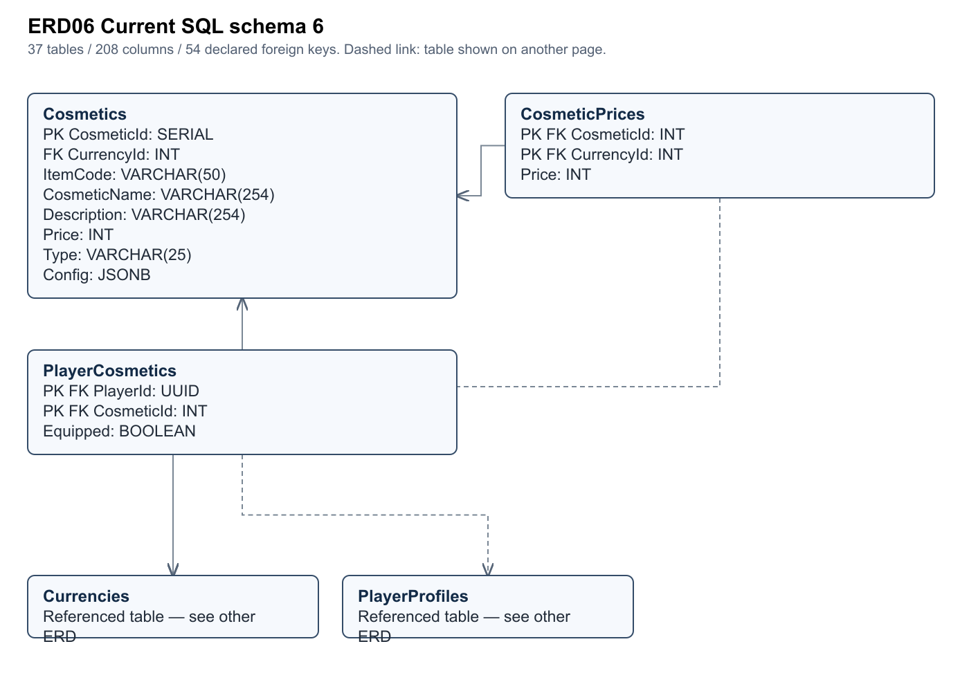
Figure ERD06 · Editable source and full size SVG/PNG are in Diagrams/Current_c32f2a4.

Current schema domain 7
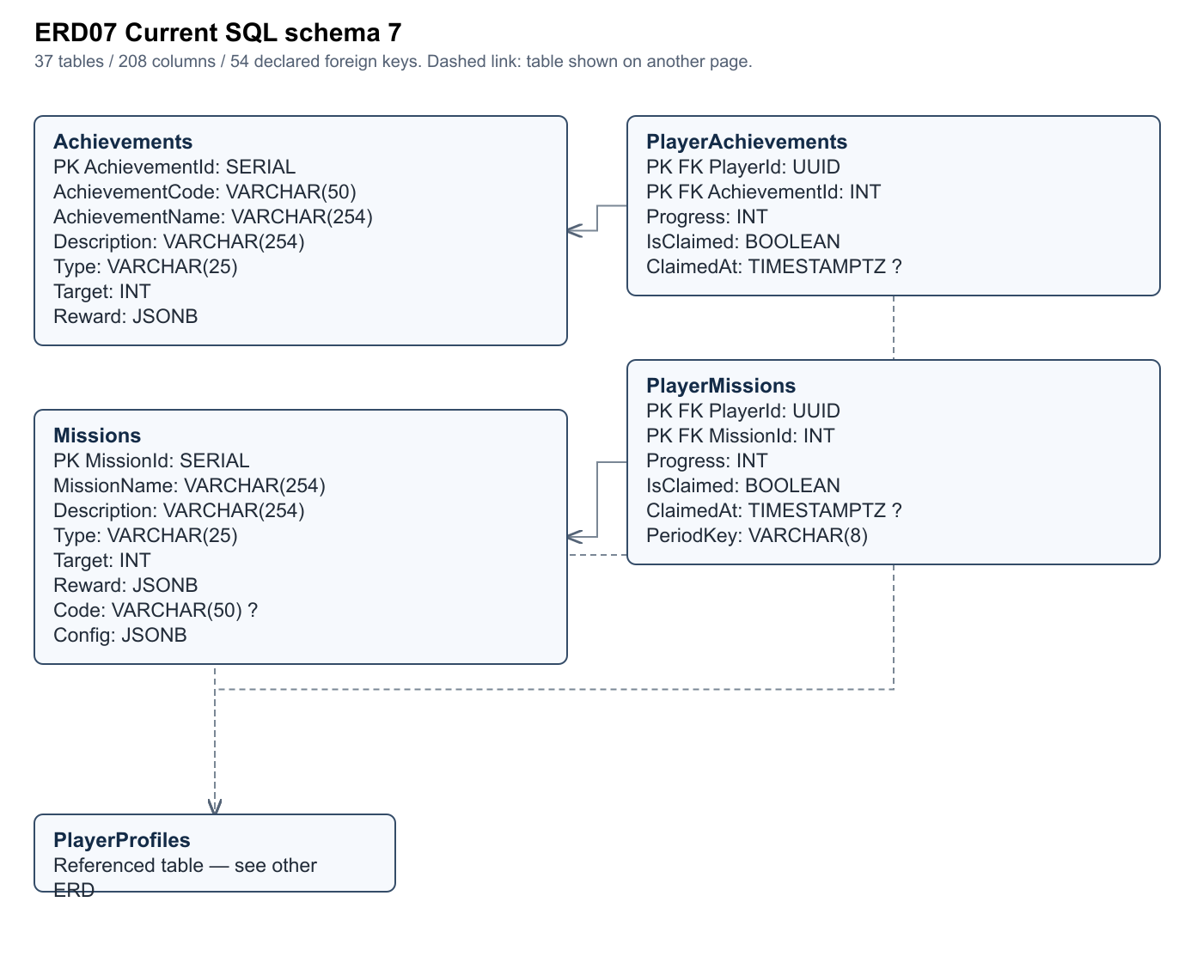
Figure ERD07 · Editable source and full size SVG/PNG are in Diagrams/Current_c32f2a4.

Current schema domain 8
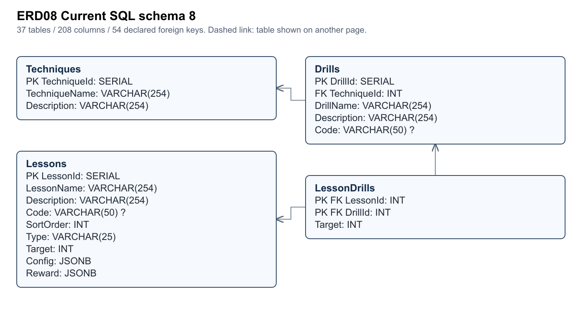
Figure ERD08 · Editable source and full size SVG/PNG are in Diagrams/Current_c32f2a4.

Current schema domain 9
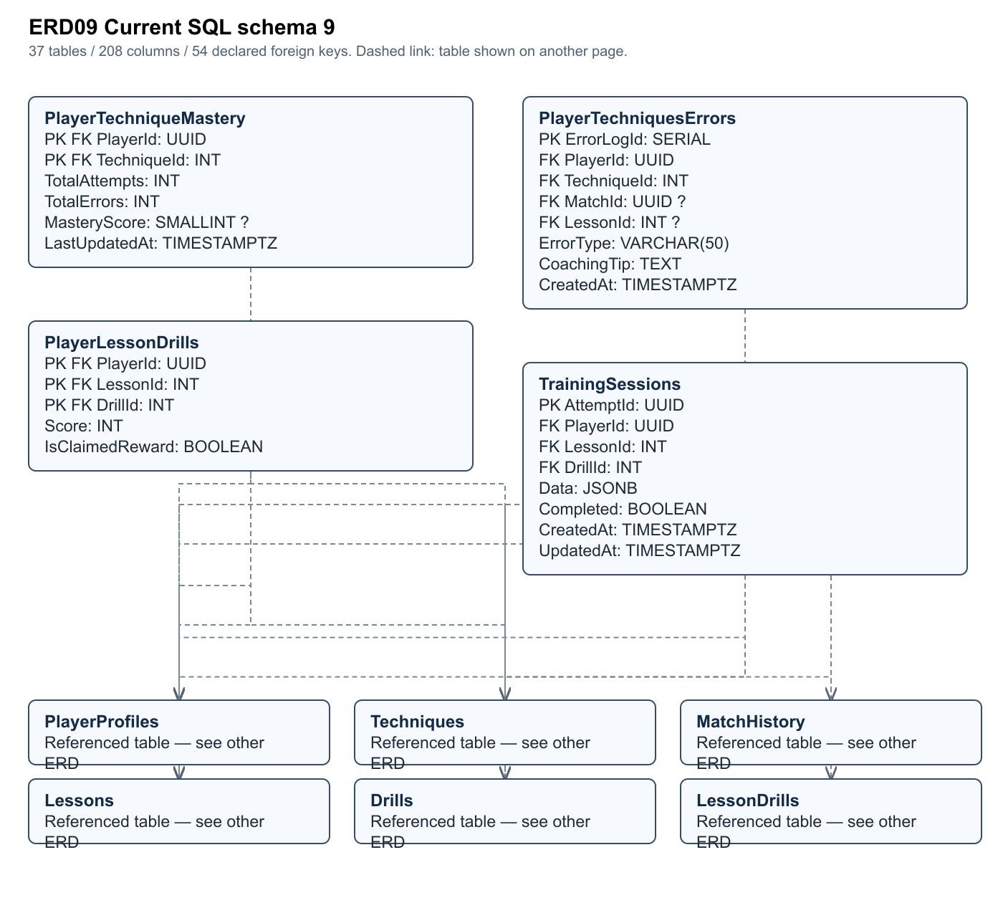
Figure ERD09 · Editable source and full size SVG/PNG are in Diagrams/Current_c32f2a4.

Current schema domain 10
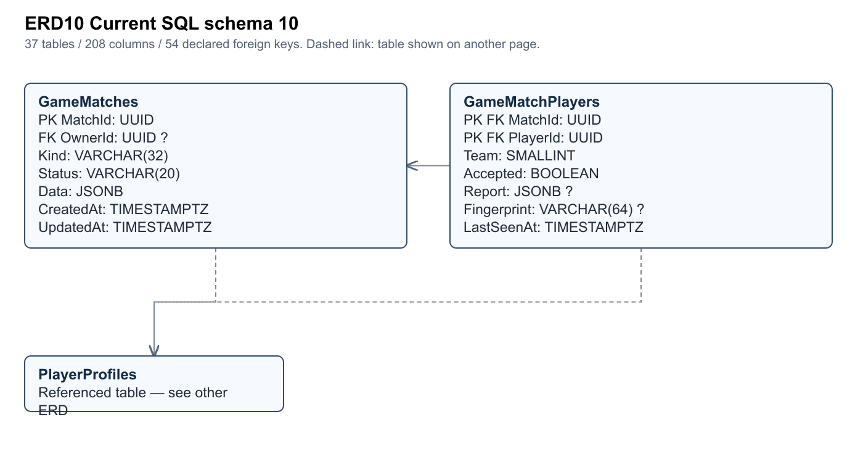
Figure ERD10 · Editable source and full size SVG/PNG are in Diagrams/Current_c32f2a4.

Current schema domain 11
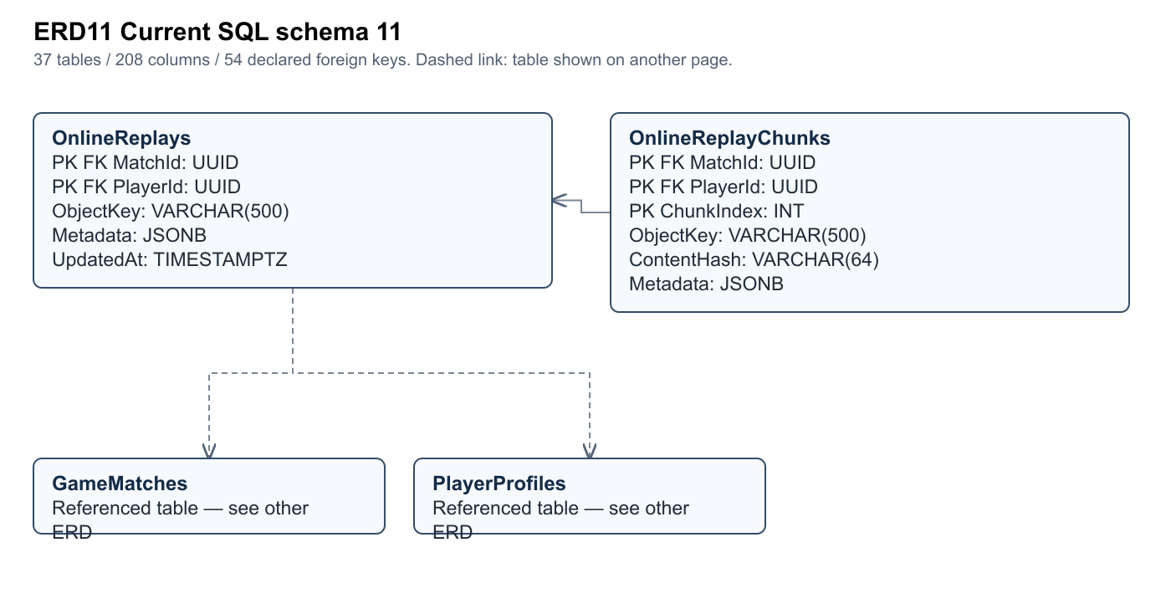
Figure ERD11 · Editable source and full size SVG/PNG are in Diagrams/Current_c32f2a4.

Foreign key relationship register
Referencing columns | Referenced columns | Parent per child | Delete
Users.RoleId | Roles.RoleId | 1 | NO ACTION
RefreshTokens.UserId | Users.UserId | 1 | CASCADE
VerificationEmail.UserId | Users.UserId | 1 | CASCADE
PlayerProfiles.UserId | Users.UserId | 1 | CASCADE
FriendRequests.SenderId | Users.UserId | 1 | CASCADE
FriendRequests.ReceiverId | Users.UserId | 1 | CASCADE
Friendships.UserId1 | Users.UserId | 1 | CASCADE
Friendships.UserId2 | Users.UserId | 1 | CASCADE
BlockedUsers.UserId | Users.UserId | 1 | CASCADE
BlockedUsers.BlockedUserId | Users.UserId | 1 | CASCADE
PlayerMatchHistory.PlayerId | PlayerProfiles.UserId | 1 | NO ACTION
PlayerMatchHistory.MatchId | MatchHistory.MatchId | 1 | CASCADE
ReportPlayerInMatch.ReporterId | PlayerProfiles.UserId | 1 | CASCADE
ReportPlayerInMatch.ReportedPlayerId | PlayerProfiles.UserId | 1 | CASCADE
ReportPlayerInMatch.MatchId | MatchHistory.MatchId | 1 | CASCADE
MatchHistoryReplay.MatchId | MatchHistory.MatchId | 1 | CASCADE
PlayerCurrencies.PlayerId | PlayerProfiles.UserId | 1 | CASCADE
PlayerCurrencies.CurrencyId | Currencies.CurrencyId | 1 | NO ACTION
Cosmetics.CurrencyId | Currencies.CurrencyId | 1 | NO ACTION
PlayerCosmetics.PlayerId | PlayerProfiles.UserId | 1 | CASCADE
PlayerCosmetics.CosmeticId | Cosmetics.CosmeticId | 1 | NO ACTION
PlayerAchievements.PlayerId | PlayerProfiles.UserId | 1 | CASCADE
PlayerAchievements.AchievementId | Achievements.AchievementId | 1 | NO ACTION
PlayerMissions.PlayerId | PlayerProfiles.UserId | 1 | CASCADE
PlayerMissions.MissionId | Missions.MissionId | 1 | NO ACTION
Drills.TechniqueId | Techniques.TechniqueId | 1 | CASCADE
LessonDrills.LessonId | Lessons.LessonId | 1 | CASCADE
LessonDrills.DrillId | Drills.DrillId | 1 | CASCADE
PlayerTechniqueMastery.PlayerId | PlayerProfiles.UserId | 1 | CASCADE
PlayerTechniqueMastery.TechniqueId | Techniques.TechniqueId | 1 | CASCADE
PlayerTechniquesErrors.PlayerId | PlayerProfiles.UserId | 1 | CASCADE
PlayerTechniquesErrors.TechniqueId | Techniques.TechniqueId | 1 | CASCADE
PlayerTechniquesErrors.MatchId | MatchHistory.MatchId | 0..1 | SET NULL
PlayerTechniquesErrors.LessonId | Lessons.LessonId | 0..1 | SET NULL
PlayerLessonDrills.PlayerId | PlayerProfiles.UserId | 1 | CASCADE
PlayerLessonDrills.LessonId | Lessons.LessonId | 1 | CASCADE
PlayerLessonDrills.DrillId | Drills.DrillId | 1 | CASCADE
CosmeticPrices.CosmeticId | Cosmetics.CosmeticId | 1 | CASCADE
CosmeticPrices.CurrencyId | Currencies.CurrencyId | 1 | NO ACTION
GameProgress.PlayerId | PlayerProfiles.UserId | 1 | CASCADE
GameCommands.PlayerId | PlayerProfiles.UserId | 1 | CASCADE
TrainingSessions.PlayerId | PlayerProfiles.UserId | 1 | CASCADE
TrainingSessions.LessonId | Lessons.LessonId | 1 | NO ACTION
TrainingSessions.DrillId | Drills.DrillId | 1 | NO ACTION
TrainingSessions.LessonId,DrillId | LessonDrills.LessonId,DrillId | 1 | NO ACTION
AppActivitySessions.PlayerId | PlayerProfiles.UserId | 0..1 | CASCADE
GameMatches.OwnerId | PlayerProfiles.UserId | 0..1 | SET NULL
GameMatchPlayers.MatchId | GameMatches.MatchId | 1 | CASCADE
GameMatchPlayers.PlayerId | PlayerProfiles.UserId | 1 | CASCADE
CurrencyTransactions.PlayerId | PlayerProfiles.UserId | 1 | CASCADE
CurrencyTransactions.CurrencyId | Currencies.CurrencyId | 1 | NO ACTION
OnlineReplays.MatchId | GameMatches.MatchId | 1 | CASCADE
OnlineReplays.PlayerId | PlayerProfiles.UserId | 1 | CASCADE
OnlineReplayChunks.MatchId,PlayerId | OnlineReplays.MatchId,PlayerId | 1 | CASCADE

JSONB transient state and object payloads
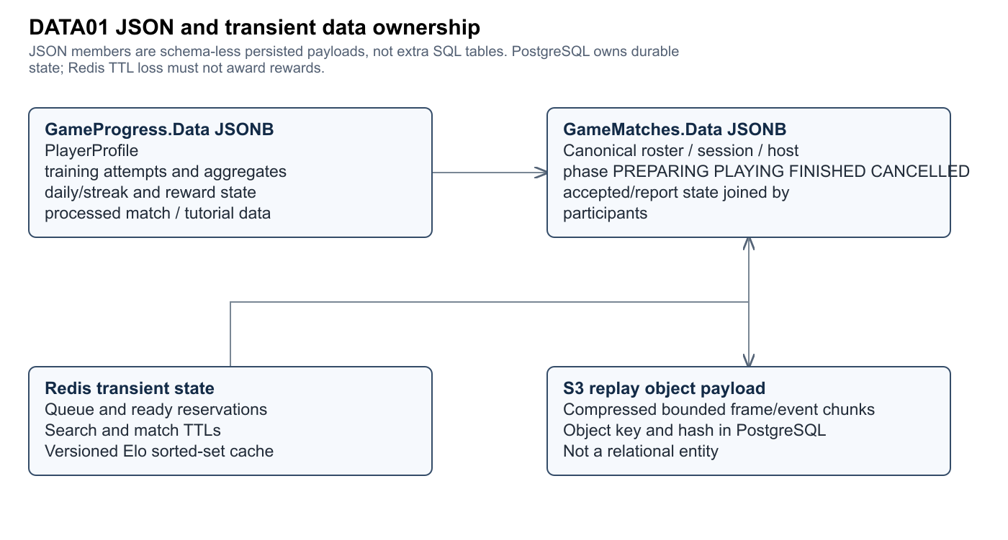
Figure DATA01 · Editable source and full size SVG/PNG are in Diagrams/Current_c32f2a4.
GameProgress.Data, GameMatches.Data and catalog Config columns carry embedded aggregate/configuration documents. They do not create implicit relational foreign keys. Attempt counters, errors and reward state are represented in shared serializable models; revisions/command IDs provide concurrency/idempotency boundaries. Redis queue TTLs and leaderboard epochs are operational data. S3 bytes are external objects referenced by SQL keys/hashes.
The 71-table src/NOREADDATABSE.sql is an alternative candidate, retained in Data_Dictionary_candidate.csv and historical diagram sources for comparison. It is not merged with the current ERD and is not labelled deployed. EF has 27 model classes; the ten new raw-SQL tables are expected in the documented hybrid design.

5 Main entity lifecycles and guard transitions
The models below include accepted and rejected transitions for testing. Except the explicit LocalMatch enum, labels may be derived business-state abstractions, not literal database values. Target publication/appeal states are deliberately labelled incomplete. For online matches, data.phase PREPARING/PLAYING differs from the broader SQL Status STARTED; they must not be conflated. Terminal states exit through explicit new entities/replay/retry only as declared.

SM01 Account lifecycle
Derived lifecycle/guard model; do not equate labels with a database enum. Trace F01 / WF01. Evidence: My project/Assets/Scripts/Services/AccountService.cs:44
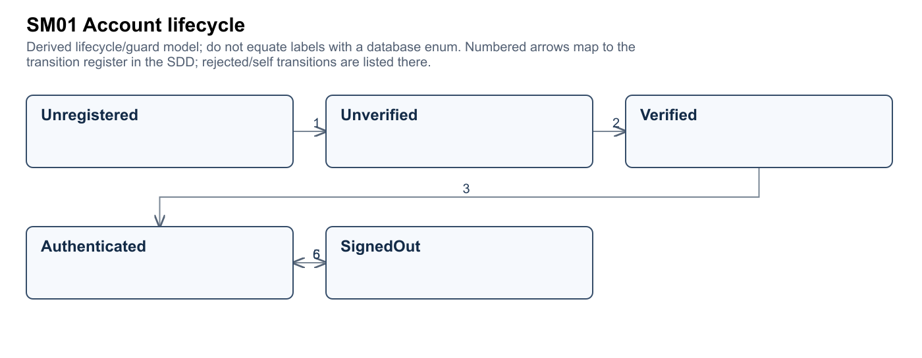
Figure SM01 · Editable source and full size SVG/PNG are in Diagrams/Current_c32f2a4.
# | From | Trigger and guard action | To | Test
1 | Unregistered | valid registration | Unverified | TC-SM01-01
2 | Unverified | valid unexpired OTP | Verified | TC-SM01-02
3 | Verified | valid login | Authenticated | TC-SM01-03
4 | Authenticated | rotate valid refresh token | Authenticated | TC-SM01-04
5 | Authenticated | logout/revoke | SignedOut | TC-SM01-05
6 | SignedOut | valid login | Authenticated | TC-SM01-06
7 | Unverified | reject wrong or expired OTP | Unverified | TC-SM01-07

SM02 Local match phase
Derived lifecycle/guard model; do not equate labels with a database enum. Trace F06 / WF02. Evidence: My project/Assets/Scripts/LocalMatch/BotMatch.cs:11
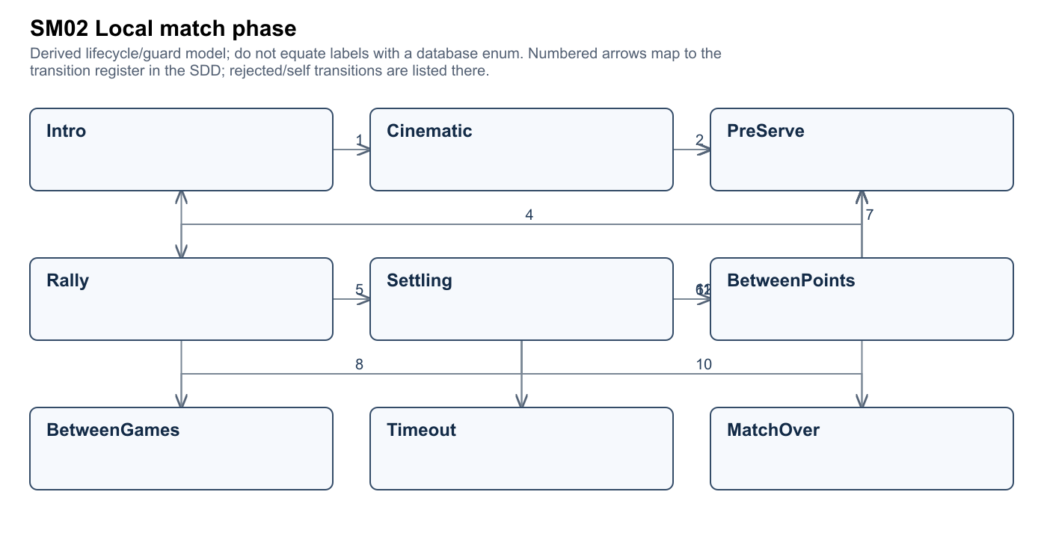
Figure SM02 · Editable source and full size SVG/PNG are in Diagrams/Current_c32f2a4.
# | From | Trigger and guard action | To | Test
1 | Intro | opening starts | Cinematic | TC-SM02-01
2 | Cinematic | opening completes | PreServe | TC-SM02-02
3 | Intro | opening skipped/unavailable | PreServe | TC-SM02-03
4 | PreServe | legal serve | Rally | TC-SM02-04
5 | Rally | fault or point | Settling | TC-SM02-05
6 | Settling | point settled | BetweenPoints | TC-SM02-06
7 | BetweenPoints | next point | PreServe | TC-SM02-07
8 | Settling | game completed | BetweenGames | TC-SM02-08
9 | BetweenGames | next game | PreServe | TC-SM02-09
10 | Settling | match completed | MatchOver | TC-SM02-10
11 | PreServe | legal timeout | Timeout | TC-SM02-11
12 | Timeout | resume | PreServe | TC-SM02-12
13 | MatchOver | explicit replay/start new match only | Intro | TC-SM02-13
14 | PreServe | reject illegal serve | PreServe | TC-SM02-14

SM03 Training attempt
Derived lifecycle/guard model; do not equate labels with a database enum. Trace F03 / WF01. Evidence: src/Backend/Services/Game/OnlineGameService.Training.cs:1
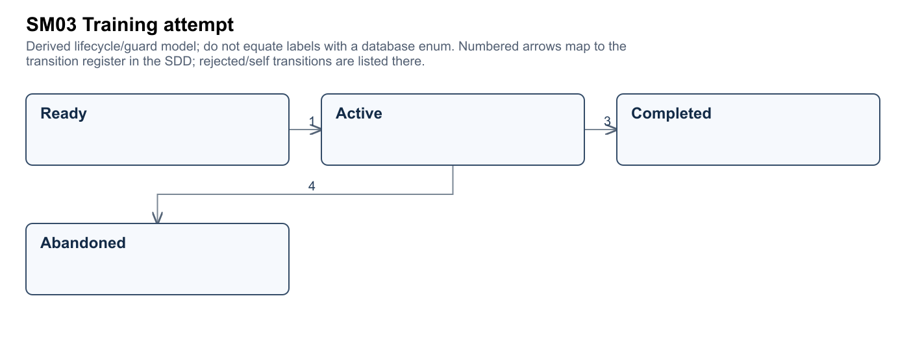
Figure SM03 · Editable source and full size SVG/PNG are in Diagrams/Current_c32f2a4.
# | From | Trigger and guard action | To | Test
1 | Ready | server attempt start | Active | TC-SM03-01
2 | Active | valid checkpoint | Active | TC-SM03-02
3 | Active | full valid trials submitted | Completed | TC-SM03-03
4 | Active | leave/replaced attempt | Abandoned | TC-SM03-04
5 | Active | reject foreign/non-monotonic trial | Active | TC-SM03-05
6 | Completed | idempotent completion/review has no first reward | Completed | TC-SM03-06

SM04 Tutorial progress
Derived lifecycle/guard model; do not equate labels with a database enum. Trace F02 / WF01. Evidence: My project/Assets/Scripts/LocalMatch/TutorialDirector.cs:11
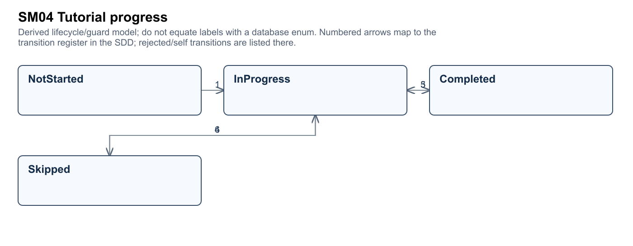
Figure SM04 · Editable source and full size SVG/PNG are in Diagrams/Current_c32f2a4.
# | From | Trigger and guard action | To | Test
1 | NotStarted | open tutorial | InProgress | TC-SM04-01
2 | InProgress | step satisfied/replay step | InProgress | TC-SM04-02
3 | InProgress | all steps completed | Completed | TC-SM04-03
4 | InProgress | confirm skip | Skipped | TC-SM04-04
5 | Completed | explicit replay | InProgress | TC-SM04-05
6 | Skipped | explicit replay | InProgress | TC-SM04-06

SM05 Skill queue and acceptance
Derived lifecycle/guard model; do not equate labels with a database enum. Trace F07 / WF03. Evidence: src/Backend/Services/Game/OnlineGameService.OnlineMatches.cs:182
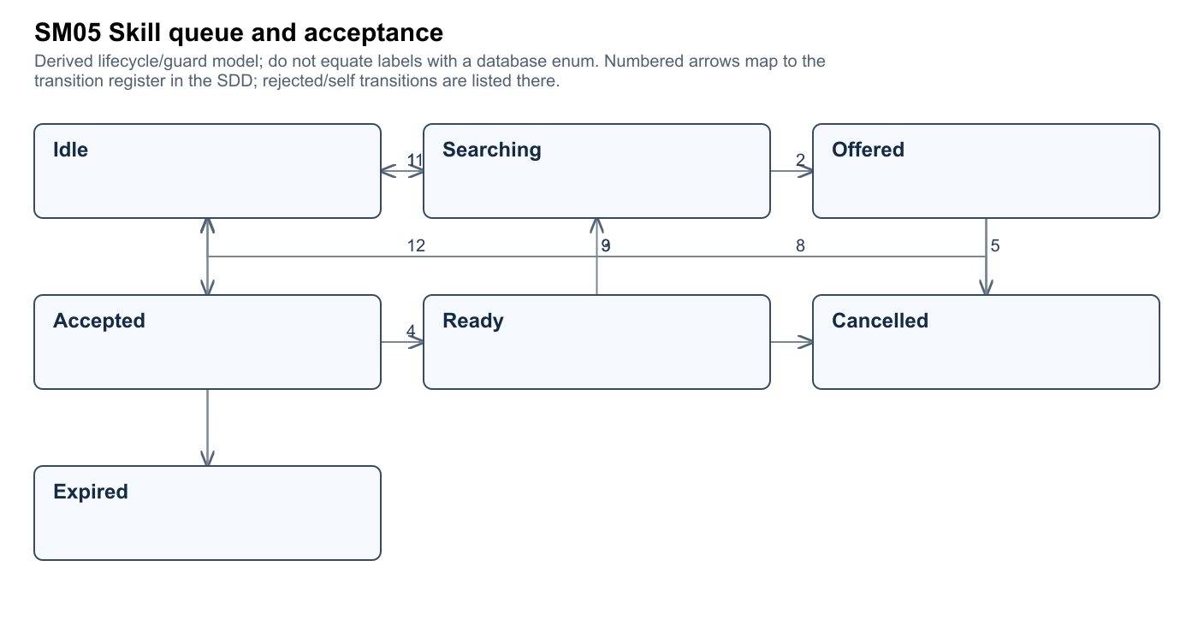
Figure SM05 · Editable source and full size SVG/PNG are in Diagrams/Current_c32f2a4.
# | From | Trigger and guard action | To | Test
1 | Idle | eligible search | Searching | TC-SM05-01
2 | Searching | server assigns offer | Offered | TC-SM05-02
3 | Offered | local accepts before deadline | Accepted | TC-SM05-03
4 | Accepted | all humans accept | Ready | TC-SM05-04
5 | Offered | local/peer declines | Cancelled | TC-SM05-05
6 | Accepted | peer declines | Cancelled | TC-SM05-06
7 | Offered | deadline expires | Expired | TC-SM05-07
8 | Cancelled | consenting peer policy requeue | Searching | TC-SM05-08
9 | Cancelled | decliner leaves queue | Idle | TC-SM05-09
10 | Expired | cleanup | Idle | TC-SM05-10
11 | Searching | cancel search | Idle | TC-SM05-11
12 | Ready | session handed off | Idle | TC-SM05-12
13 | Offered | reject foreign/stale acceptance | Offered | TC-SM05-13

SM06 Private room
Derived lifecycle/guard model; do not equate labels with a database enum. Trace F08 / WF04. Evidence: My project/Assets/Scripts/Multiplayer/PhotonSession.cs:116
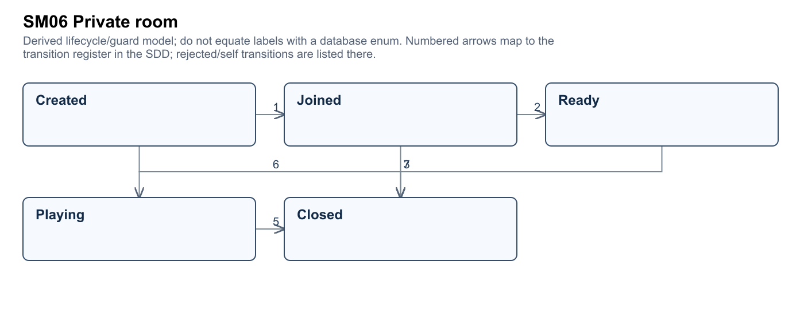
Figure SM06 · Editable source and full size SVG/PNG are in Diagrams/Current_c32f2a4.
# | From | Trigger and guard action | To | Test
1 | Created | eligible guest joins code | Joined | TC-SM06-01
2 | Joined | valid teams all ready | Ready | TC-SM06-02
3 | Ready | authorized start | Playing | TC-SM06-03
4 | Joined | reject non-host/unbalanced start | Joined | TC-SM06-04
5 | Playing | session ends | Closed | TC-SM06-05
6 | Created | host closes | Closed | TC-SM06-06
7 | Joined | room disposed | Closed | TC-SM06-07

SM07 Online canonical match
Derived lifecycle/guard model; do not equate labels with a database enum. Trace F10 / WF03. Evidence: src/Backend/Services/Game/OnlineGameService.OnlineMatches.cs:182
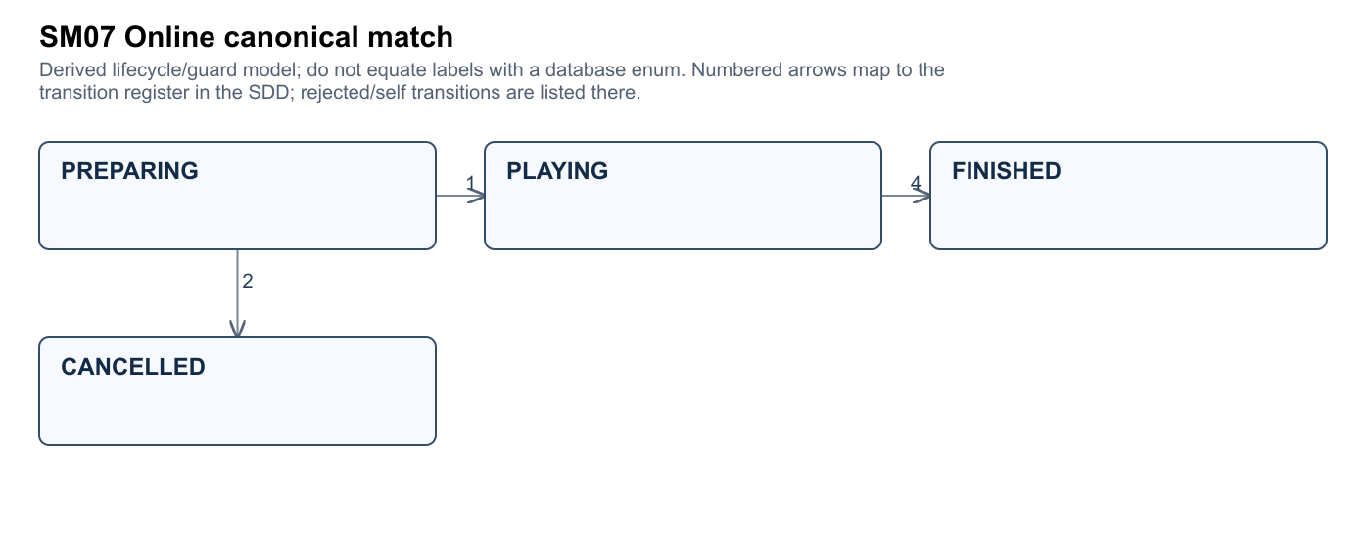
Figure SM07 · Editable source and full size SVG/PNG are in Diagrams/Current_c32f2a4.
# | From | Trigger and guard action | To | Test
1 | PREPARING | all required humans accepted and start validated | PLAYING | TC-SM07-01
2 | PREPARING | decline/timeout | CANCELLED | TC-SM07-02
3 | PLAYING | heartbeat or partial report | PLAYING | TC-SM07-03
4 | PLAYING | all matching reports or policy forfeit | FINISHED | TC-SM07-04
5 | PLAYING | reject conflicting/foreign result | PLAYING | TC-SM07-05
6 | FINISHED | duplicate same report returns state | FINISHED | TC-SM07-06
7 | CANCELLED | reject late start | CANCELLED | TC-SM07-07

SM08 Reward and command ledger
Derived lifecycle/guard model; do not equate labels with a database enum. Trace F13 / WF05. Evidence: src/Backend/Services/Game/OnlineGameService.cs:90
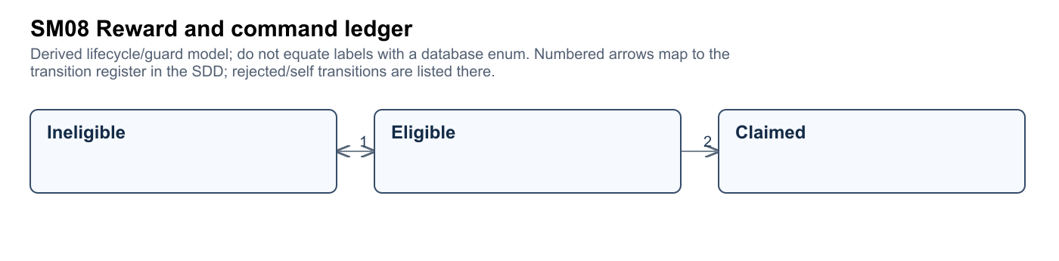
Figure SM08 · Editable source and full size SVG/PNG are in Diagrams/Current_c32f2a4.
# | From | Trigger and guard action | To | Test
1 | Ineligible | objective reaches threshold | Eligible | TC-SM08-01
2 | Eligible | valid unique claim commits | Claimed | TC-SM08-02
3 | Claimed | same request payload idempotent | Claimed | TC-SM08-03
4 | Claimed | reject conflicting replay | Claimed | TC-SM08-04
5 | Claimed | new applicable period only | Ineligible | TC-SM08-05

SM09 Friendship
Derived lifecycle/guard model; do not equate labels with a database enum. Trace F12 / WF04. Evidence: src/Backend/Services/Game/OnlineSocialService.cs:27
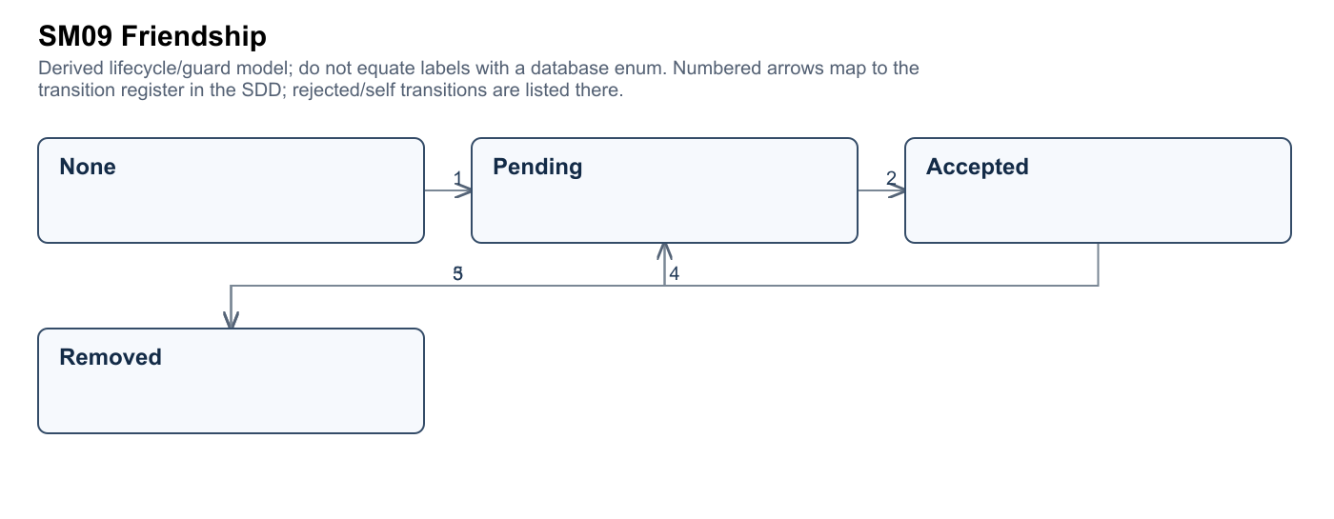
Figure SM09 · Editable source and full size SVG/PNG are in Diagrams/Current_c32f2a4.
# | From | Trigger and guard action | To | Test
1 | None | valid request | Pending | TC-SM09-01
2 | Pending | recipient accepts | Accepted | TC-SM09-02
3 | Pending | decline/cancel | Removed | TC-SM09-03
4 | Accepted | participant removes | Removed | TC-SM09-04
5 | Removed | new valid request | Pending | TC-SM09-05
6 | Pending | reject third-party acceptance | Pending | TC-SM09-06

SM10 Replay upload
Derived lifecycle/guard model; do not equate labels with a database enum. Trace F11 / WF05. Evidence: src/Backend/Services/Game/OnlineReplayService.cs:14
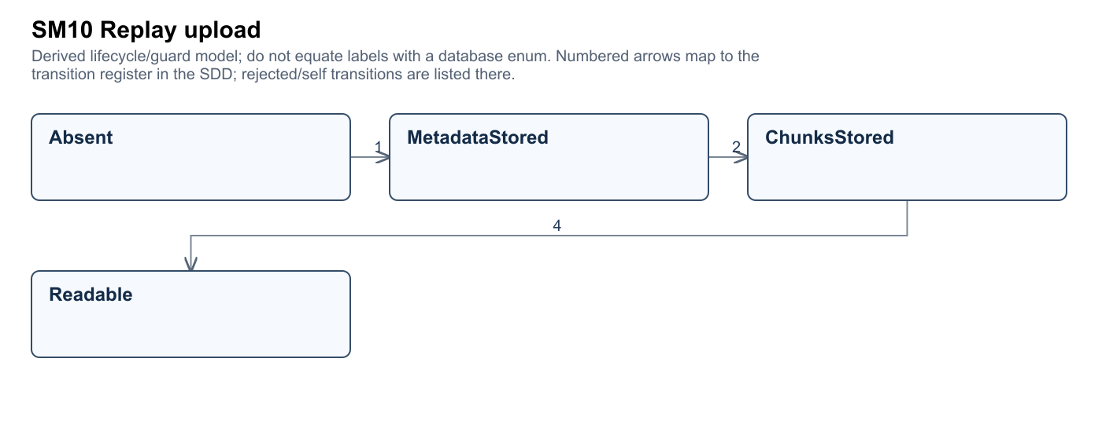
Figure SM10 · Editable source and full size SVG/PNG are in Diagrams/Current_c32f2a4.
# | From | Trigger and guard action | To | Test
1 | Absent | authorized bounded metadata | MetadataStored | TC-SM10-01
2 | MetadataStored | valid chunk upload | ChunksStored | TC-SM10-02
3 | ChunksStored | same chunk hash idempotent | ChunksStored | TC-SM10-03
4 | ChunksStored | required data available | Readable | TC-SM10-04
5 | MetadataStored | reject foreign or oversized chunk | MetadataStored | TC-SM10-05

SM11 Administrative sanction
Target lifecycle, incomplete implementation; declared SQL states retained where applicable. Trace F15 / WF06. Evidence: src/Backend/Services/Implementations/AdminService.cs:82
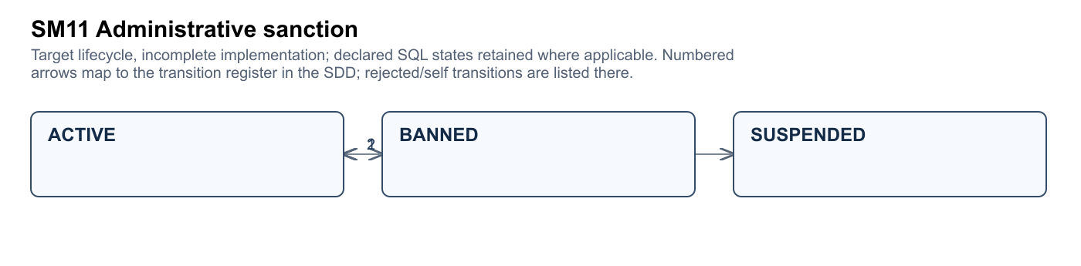
Figure SM11 · Editable source and full size SVG/PNG are in Diagrams/Current_c32f2a4.
# | From | Trigger and guard action | To | Test
1 | ACTIVE | authorized ban with SQL-valid value | BANNED | TC-SM11-01
2 | BANNED | authorized restore with SQL-valid value | ACTIVE | TC-SM11-02
3 | ACTIVE | authorized suspension target | SUSPENDED | TC-SM11-03
4 | SUSPENDED | authorized restore target | ACTIVE | TC-SM11-04
5 | ACTIVE | reject non-admin mutation | ACTIVE | TC-SM11-05

SM12 Lesson publication target
Target lifecycle, incomplete implementation; declared SQL states retained where applicable. Trace F16 / WF06. Evidence: src/Backend/Services/Implementations/AdminService.cs:159
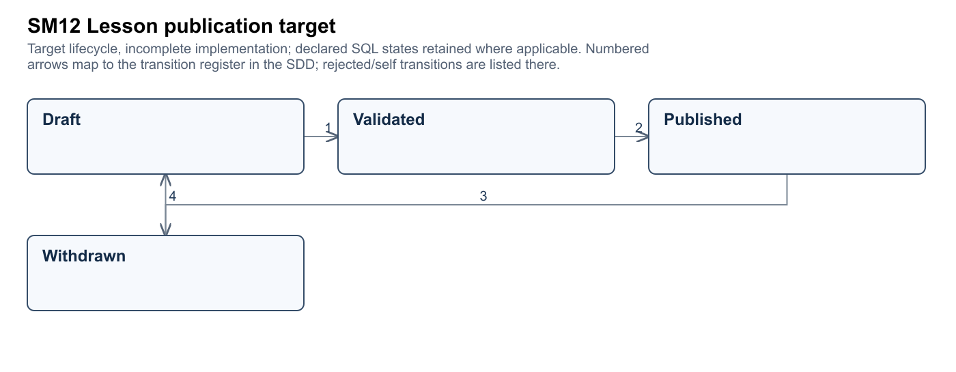
Figure SM12 · Editable source and full size SVG/PNG are in Diagrams/Current_c32f2a4.
# | From | Trigger and guard action | To | Test
1 | Draft | validate code/config and lesson/drill links | Validated | TC-SM12-01
2 | Validated | authorized publication updates catalog version | Published | TC-SM12-02
3 | Published | unpublish target | Withdrawn | TC-SM12-03
4 | Withdrawn | edit target | Draft | TC-SM12-04
5 | Draft | reject incomplete content | Draft | TC-SM12-05

SM13 Moderation and appeal target
Target lifecycle, incomplete implementation; declared SQL states retained where applicable. Trace F17 / WF06. Evidence: src/Backend/API/Controllers/AdminController.cs:10
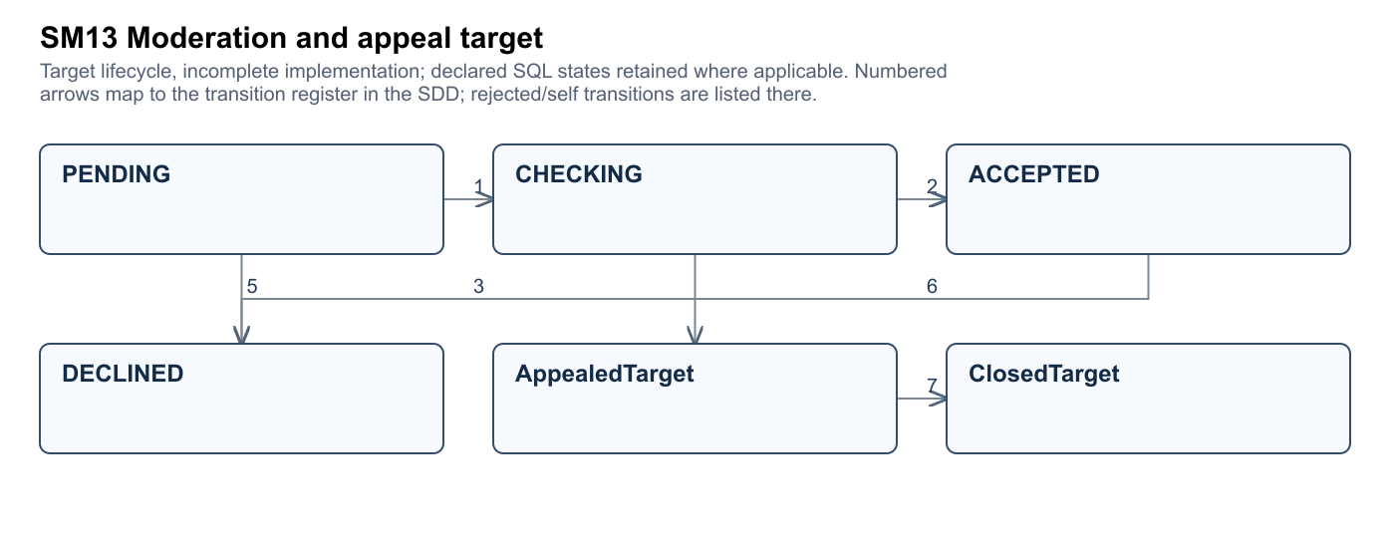
Figure SM13 · Editable source and full size SVG/PNG are in Diagrams/Current_c32f2a4.
# | From | Trigger and guard action | To | Test
1 | PENDING | authorized review begins | CHECKING | TC-SM13-01
2 | CHECKING | valid accepted decision | ACCEPTED | TC-SM13-02
3 | CHECKING | valid declined decision | DECLINED | TC-SM13-03
4 | PENDING | direct valid decision allowed by current setter | ACCEPTED | TC-SM13-04
5 | PENDING | direct valid decision allowed by current setter | DECLINED | TC-SM13-05
6 | ACCEPTED | eligible appeal target | AppealedTarget | TC-SM13-06
7 | AppealedTarget | appeal resolved target | ClosedTarget | TC-SM13-07
8 | PENDING | reject unauthorized decision | PENDING | TC-SM13-08

SM14 Training controller phase
Actual controller enum; transitions are selected main control paths. Trace F03 / WF01. Evidence: My project/Assets/Scripts/LocalMatch/TrainingDirector.cs:14
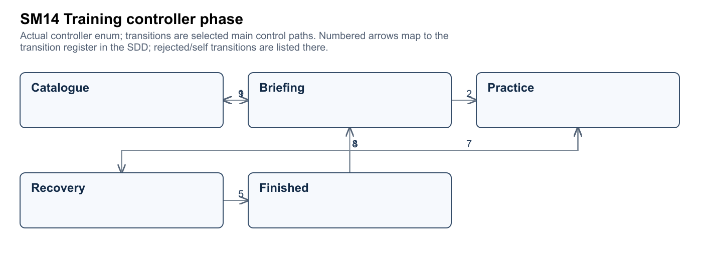
Figure SM14 · Editable source and full size SVG/PNG are in Diagrams/Current_c32f2a4.
# | From | Trigger and guard action | To | Test
1 | Catalogue | select unlocked lesson | Briefing | TC-SM14-01
2 | Briefing | server attempt start succeeds | Practice | TC-SM14-02
3 | Practice | trial success or error | Recovery | TC-SM14-03
4 | Recovery | prepare next trial | Practice | TC-SM14-04
5 | Recovery | all trials complete and submit result | Finished | TC-SM14-05
6 | Practice | return to catalog and save | Catalogue | TC-SM14-06
7 | Finished | retry lesson | Practice | TC-SM14-07
8 | Finished | select next lesson | Briefing | TC-SM14-08
9 | Briefing | return to catalog | Catalogue | TC-SM14-09
10 | Briefing | start request fails; remain and show error | Briefing | TC-SM14-10

SM15 Multiplayer client flow
Actual FlowState enum; ready acceptance is a separate canonical match state. Trace F09 / WF03. Evidence: My project/Assets/Scripts/Entites/Multiplayer/RoomModels.cs:7
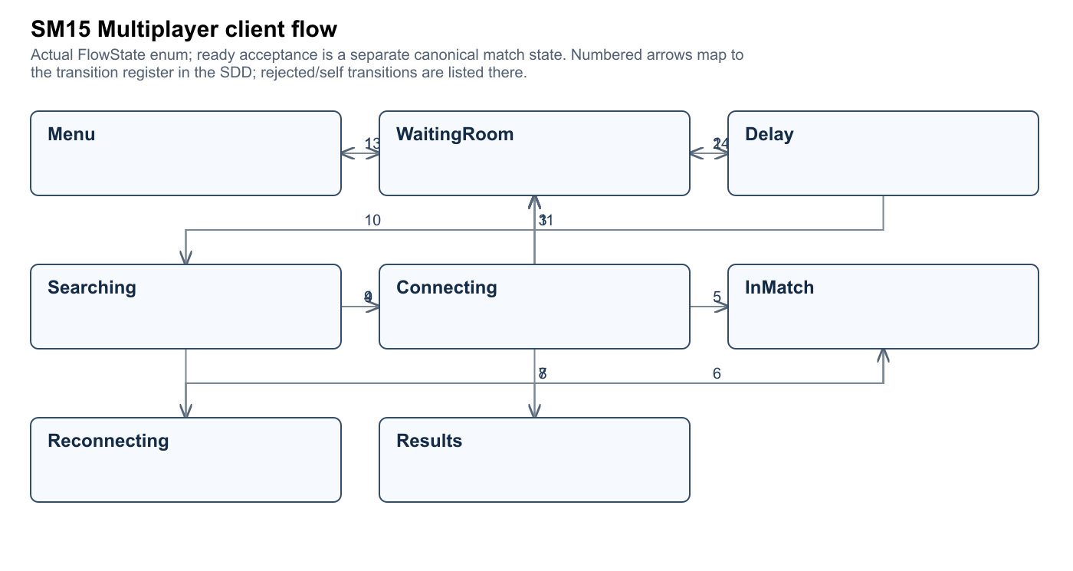
Figure SM15 · Editable source and full size SVG/PNG are in Diagrams/Current_c32f2a4.
# | From | Trigger and guard action | To | Test
1 | Menu | open/join valid room | WaitingRoom | TC-SM15-01
2 | WaitingRoom | begin eligible search | Delay | TC-SM15-02
3 | Delay | queue begins | Searching | TC-SM15-03
4 | Searching | assigned match ready offer | Connecting | TC-SM15-04
5 | Connecting | court and required peers ready | InMatch | TC-SM15-05
6 | InMatch | match result shown | Results | TC-SM15-06
7 | InMatch | connection interrupted | Reconnecting | TC-SM15-07
8 | Reconnecting | rejoin succeeds | InMatch | TC-SM15-08
9 | Reconnecting | grace fails | WaitingRoom | TC-SM15-09
10 | Searching | cancel search | WaitingRoom | TC-SM15-10
11 | Connecting | ready offer cancelled | WaitingRoom | TC-SM15-11
12 | Results | return to room | WaitingRoom | TC-SM15-12
13 | WaitingRoom | return or sign out | Menu | TC-SM15-13
14 | Delay | search setup fails | WaitingRoom | TC-SM15-14

6 Main workflow activity design

WF01 Register learn and complete a first drill
Actors: Player, SMTP delivery service. Proposed owner: M1. Features: F01, F02, F03.
Account registered → verified → tutorial completed → training attempt completed.
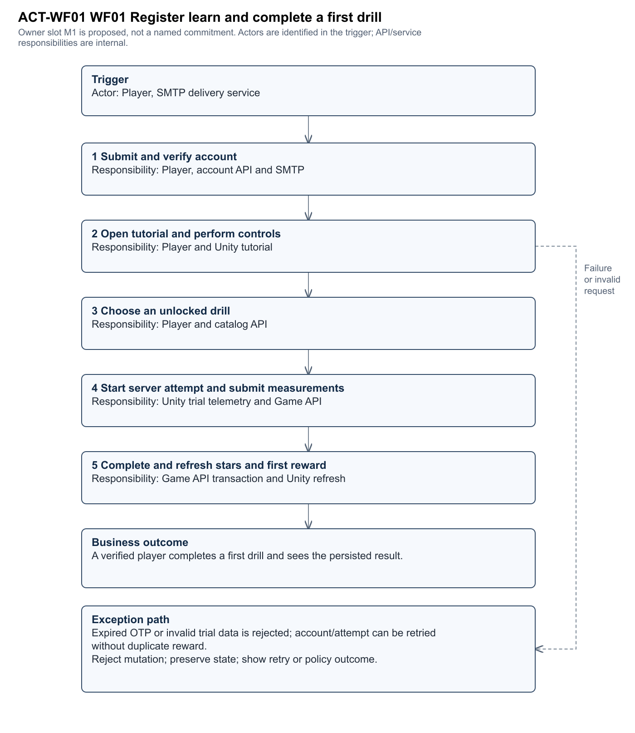
Figure ACT-WF01 · Editable source and full size SVG/PNG are in Diagrams/Current_c32f2a4.
Exception Expired OTP or invalid trial data is rejected; account/attempt can be retried without duplicate reward.
Demo WF01-MAIN and WF01-EXCEPTION. End-to-end case TC-WF01. Required outcome: A verified player completes a first drill and sees the persisted result.

WF02 Practice against an adaptive bot
Actors: Player. Proposed owner: M2. Features: F05, F06, F10, F11.
Match Intro → PreServe → Rally → MatchOver → result persisted.
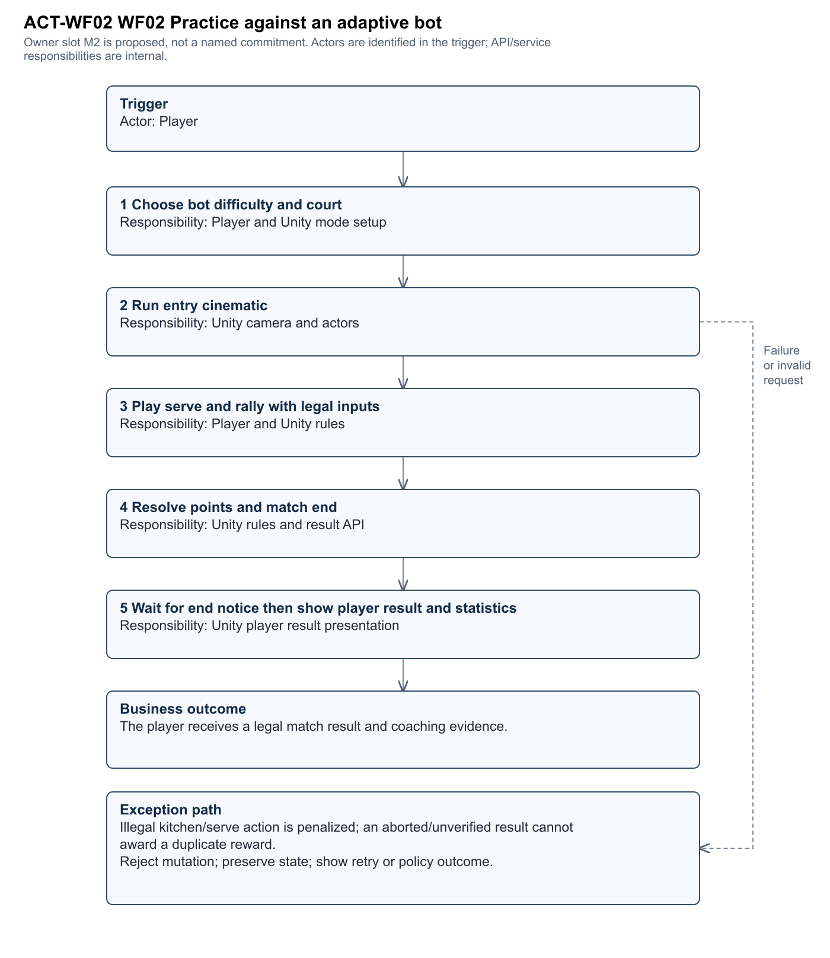
Figure ACT-WF02 · Editable source and full size SVG/PNG are in Diagrams/Current_c32f2a4.
Exception Illegal kitchen/serve action is penalized; an aborted/unverified result cannot award a duplicate reward.
Demo WF02-MAIN and WF02-EXCEPTION. End-to-end case TC-WF02. Required outcome: The player receives a legal match result and coaching evidence.

WF03 Find accept and finish an online match
Actors: Online player A, Online player B, Photon service. Proposed owner: M3. Features: F06, F07, F09, F10.
Queue searching → offer → all accepted → playing → reported → finished.
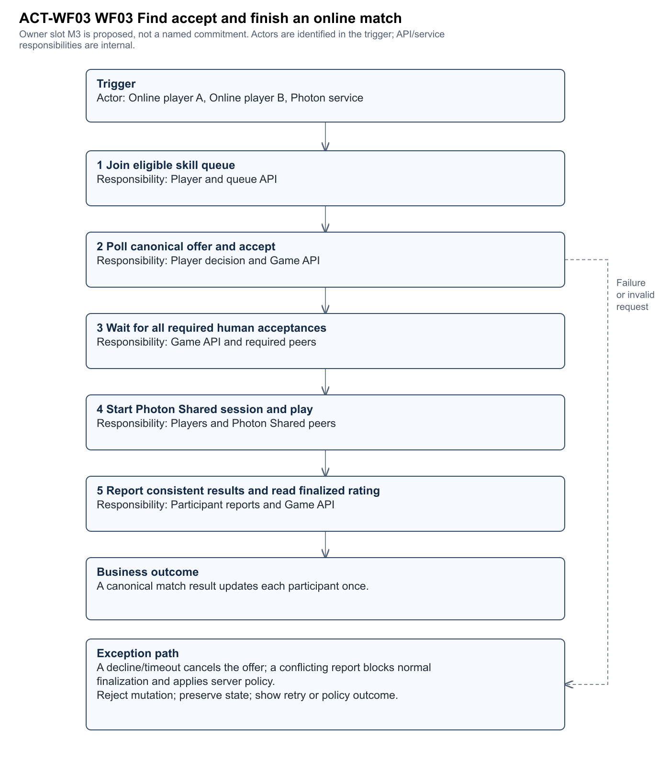
Figure ACT-WF03 · Editable source and full size SVG/PNG are in Diagrams/Current_c32f2a4.
Exception A decline/timeout cancels the offer; a conflicting report blocks normal finalization and applies server policy.
Demo WF03-MAIN and WF03-EXCEPTION. End-to-end case TC-WF03. Required outcome: A canonical match result updates each participant once.

WF04 Create a private team match
Actors: Room host, Invited player. Proposed owner: M3. Features: F08, F09, F10, F12.
Room created → joined → teams ready → playing → finished.
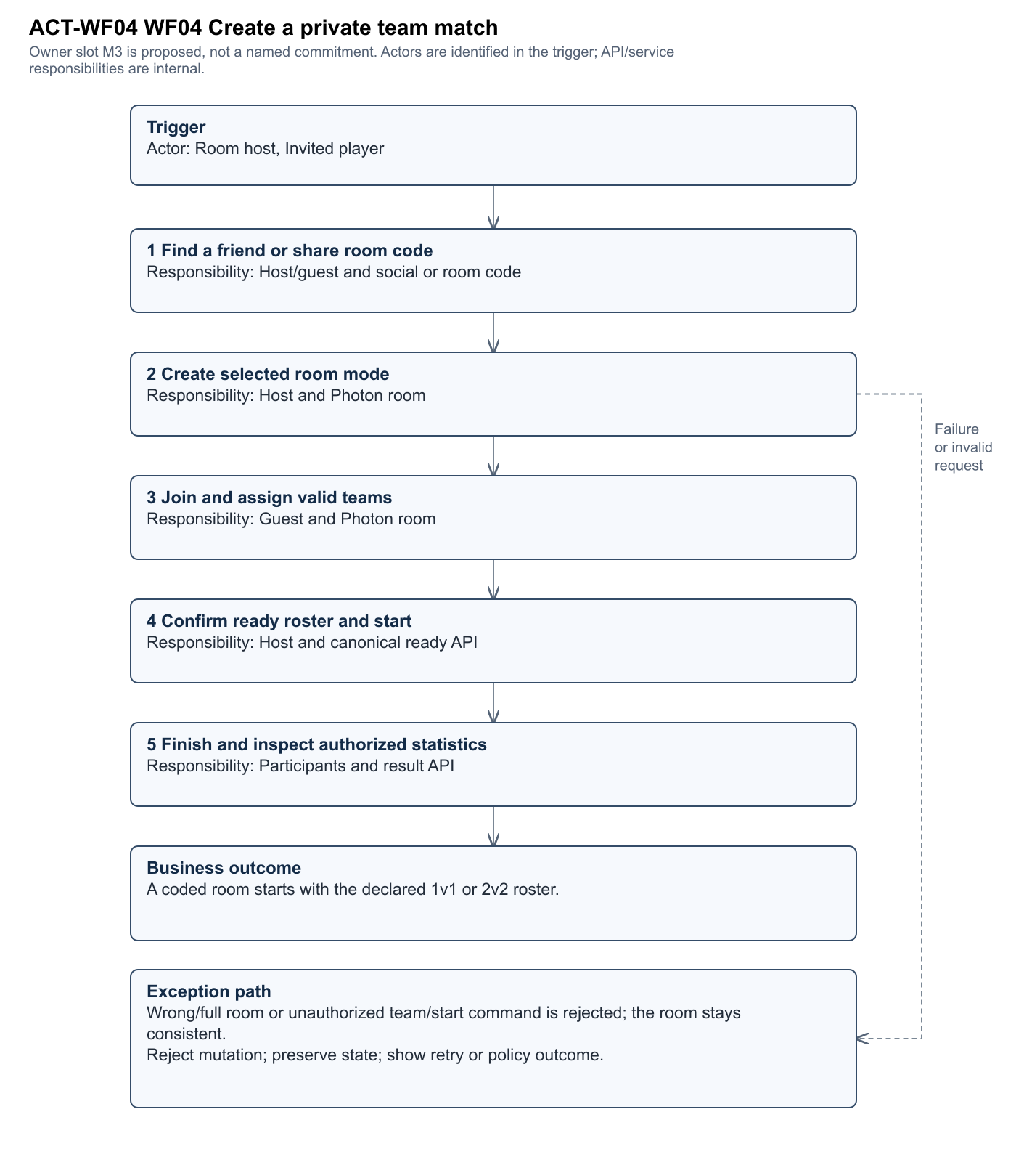
Figure ACT-WF04 · Editable source and full size SVG/PNG are in Diagrams/Current_c32f2a4.
Exception Wrong/full room or unauthorized team/start command is rejected; the room stays consistent.
Demo WF04-MAIN and WF04-EXCEPTION. End-to-end case TC-WF04. Required outcome: A coded room starts with the declared 1v1 or 2v2 roster.

WF05 Review progress and claim rewards
Actors: Player. Proposed owner: M1. Features: F03, F04, F11, F13, F14.
Attempt completed → progress refreshed → reward eligible → claimed.
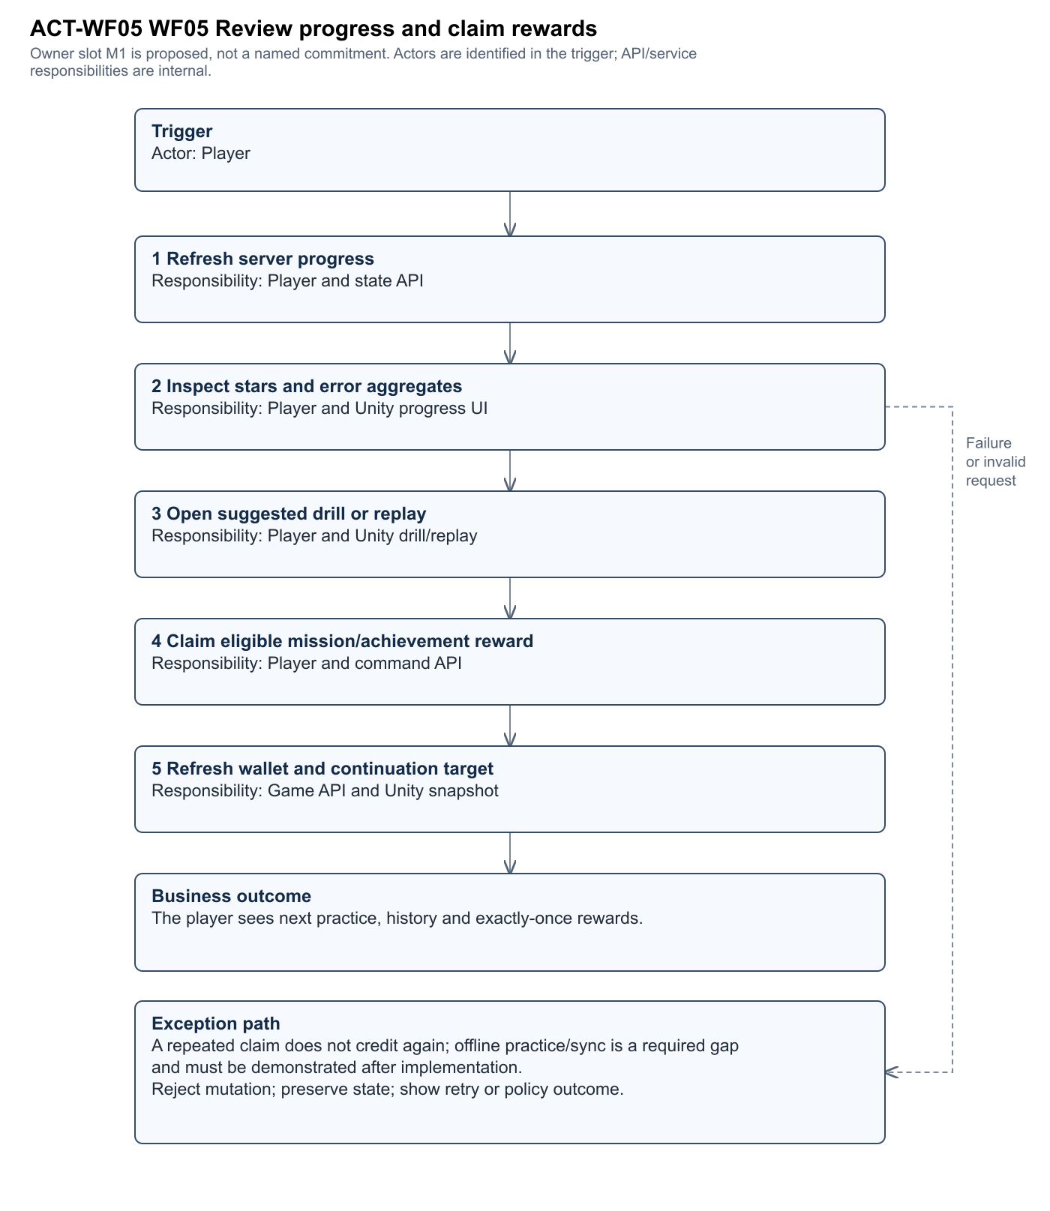
Figure ACT-WF05 · Editable source and full size SVG/PNG are in Diagrams/Current_c32f2a4.
Exception A repeated claim does not credit again; offline practice/sync is a required gap and must be demonstrated after implementation.
Demo WF05-MAIN and WF05-EXCEPTION. End-to-end case TC-WF05. Required outcome: The player sees next practice, history and exactly-once rewards.

WF06 Administer users content and operations
Actors: Administrator, Reporting player. Proposed owner: M4. Features: F15, F16, F17, F18.
User active → sanctioned/restored; lesson draft → published; report pending → resolved.
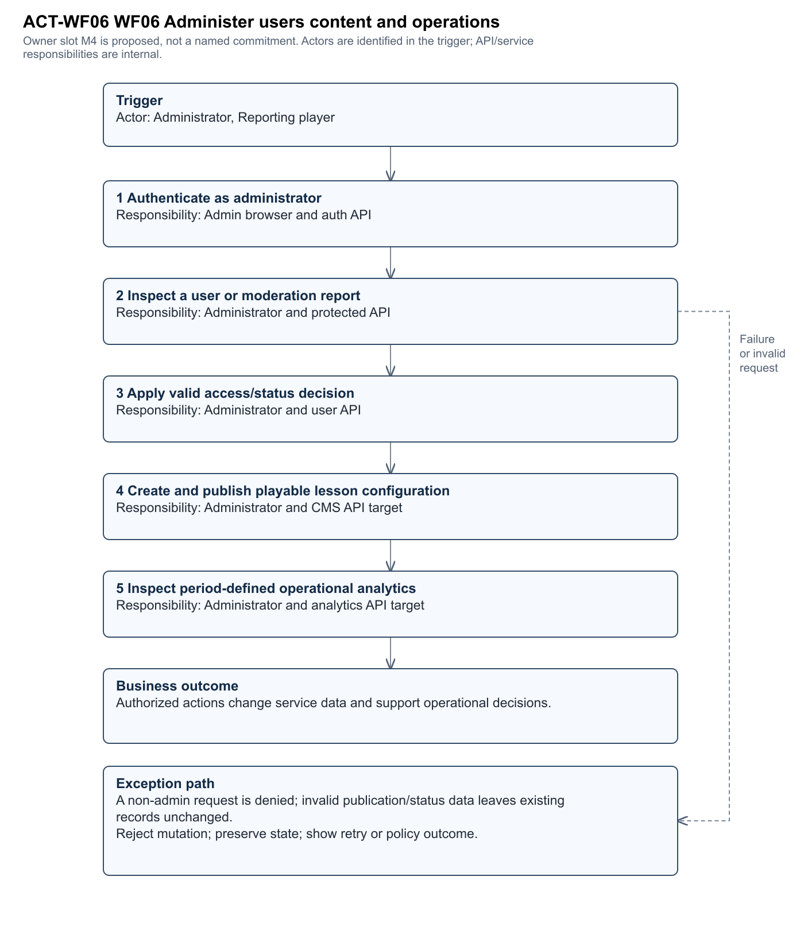
Figure ACT-WF06 · Editable source and full size SVG/PNG are in Diagrams/Current_c32f2a4.
Exception A non-admin request is denied; invalid publication/status data leaves existing records unchanged.
Demo WF06-MAIN and WF06-EXCEPTION. End-to-end case TC-WF06. Required outcome: Authorized actions change service data and support operational decisions.

7 API and shared data contracts
API_Endpoint_Inventory.csv is the complete 81-declaration route register. Action/class authorization must be evaluated together; an empty parsed class-level field does not imply an anonymous endpoint. Legacy finish and submit-drill handlers returning 410 are inventory entries, not functioning alternatives to Game commands.
Route family | Current contract
Auth and Profiles | Registration/OTP/login/refresh/logout and own profile. Unity DTO uses Email/Password and reads AccessToken/Profile. Admin browser must be aligned to this contract.
Game catalog/state/claim/purchase/equip/tutorial | JWT account scope; request IDs and server snapshot revisions; catalog rules and authoritative balances.
Game training/start/checkpoint/complete | Server attempt identity, catalog code, monotonic validated measurements and completion award policy.
Game ranked and match/online | Search identity, protocol/region/party, canonical roster, acceptance/deadline, heartbeat, report fingerprint and finalization.
Game social and replays | Paged real accounts/rankings/relationships; participant-authorized metadata/chunk operations.
Admin | Role-scoped users, content, match/moderation and analytics operations; several integration/definition gaps remain.

8 Deployment environments and operations
Source includes a backend Dockerfile and root docker-compose.yml, but no current deployed staging/prod inventory or verified CI workflow is supplied. The following is a proposed operational design, not a claim that it has been deployed.
Environment | Proposed control | Verification required
Development | Local isolated DB/Redis/object-store settings; developer-specific accounts; no committed secrets | Document actual ports, engine versions and API base URLs.
Staging | Versioned API/web/client builds; seeded repeatable Review 2 data; separate Photon/cloud configuration | Run all main/exception workflows and persist run logs tied to commit and schema version.
Production | Approved secrets, TLS, network restrictions, backups, health probes and metrics | Prove Admin RBAC, AES-256 deployment requirement, restore procedure and monthly availability.
Release and rollback | PR review and protected main; immutable version tags; reversible schema plan and previous images | Back up before migration, smoke-test candidate, monitor and restore prior image/config on failure; test DB compatibility separately.

Proposed CI: static checks and builds → pure rule/unit tests → isolated PostgreSQL/Redis API integration tests → generated coverage/contract evidence → staging smoke workflows. Do not claim ≥50% automated-in-CI until at least the agreed unique case count has actually run and logs are linked. The IntegrationChecks console source is a candidate harness, not a recorded passing run.

9 Security errors and observability
Use memory tokens on Unity, hashed passwords and rotating refresh tokens, constrained OTP attempts, server-derived owner IDs, transactional idempotency and bounded replay decoding. Verify TLS, secret injection and production defaults. No key, password or connection-string value is reproduced in this pack. Bind Photon identity to authenticated backend identity if stronger peer authentication is required; AuthenticationValues(playerId) alone is not proof of a custom JWT verification service.
Define correlation IDs for commands/matches, redact credentials and personal data in logs, measure queue wait/acceptance/abandonment, result conflicts, training rejection reasons, API latency and DB/Redis health. Derive active users from dated activity sessions, not a total-user count. Define retention cohorts and denominators before presenting charts.

10 AI tooling and documentation limits
Codex, GPT-6 family, assisted read-only repository analysis, requirement tracing, diagram generation and document preparation. The exact UI model identifier was not exposed and requires team confirmation. No source code was authored or changed in this task. Human review must validate sporting semantics, member ownership, scope decisions and test evidence. In-game ML models and their quality are separate from AI assistance used to write documentation.

11 Open design findings
SR01 High Photon Fusion Shared gives a peer state authority. This is not the proposed trusted dedicated simulation and leaves host/peer trust risk. Evidence: My project/Assets/Scripts/Multiplayer/PhotonSession.cs:116
SR02 High The active progression runtime requires server state. Offline drill execution and exactly-once later synchronization are not demonstrated. Evidence: My project/Assets/Scripts/Progression/ProgressionRuntime.cs:8
SR03 High Initial-placement ML, telemetry technique classifier, labelled evaluation and validated recommendations are not evidenced. Rule-based feedback does not establish those commitments. Evidence: My project/Assets/Scripts/LocalMatch/BotMatch.cs:11
SR04 High The React login sends emailOrUsername/passwordHash and reads role/token, while the API requires Email/Password and returns AccessToken/Profile. The default contracts are incompatible. Evidence: src/Frontend/src/context/AuthContext.tsx:41
SR05 High Admin mutations serialize enum status as Banned/Active while the SQL constraint uses ACTIVE/BANNED/SUSPENDED; these values can fail the database constraint. Evidence: src/Backend/Services/Implementations/AdminService.cs:82
SR06 High Admin lesson creation omits catalog Code/Config, while the game catalog selects coded configured lessons. CRUD does not yet demonstrate publishing a playable drill. Evidence: src/Backend/Services/Implementations/AdminService.cs:159
SR07 High Complete live-match oversight, appeals and operational analytics are not evidenced. ActiveUsersToday currently counts all users rather than dated activity. Evidence: src/Backend/Services/Implementations/AdminService.cs:353
SR08 High Current-revision physical-device, network/load, security, availability, offline and ML acceptance results are unavailable. Test source is not execution evidence. Evidence: src/Database.sql
SR09 High The local review-2 tag and CI execution evidence are absent; the required official tagged self-review and automated-in-CI target cannot be verified. Evidence: src/Database.sql
SR10 Medium The approved registration revision, official project code and decisions accepting stack/authority deviations are unconfirmed. No scope reduction has been assumed. Evidence: src/Database.sql
SR11 Medium Server-owned transactions and matching human reports improve result integrity, but peers still supply simulation outcomes and training measurements. Agreement does not independently prove legal physics. Evidence: src/Backend/Services/Game/OnlineGameService.OnlineMatches.cs:182
SR12 Medium Real friendship APIs and room-code play exist and cover the proposal room-code requirement. Account-targeted invitations are an unverified desired UX extension; confirm whether they should become a separate commitment. Evidence: src/Backend/Services/Game/OnlineSocialService.cs:27
SR13 Medium Fallback authentication configuration, deployed TLS/AES-256 controls, production rollback and iOS build acceptance require deployment evidence; configuration values are intentionally redacted. Evidence: My project/Assets/Scripts/Services/Api/UnityApiTransport.cs:17

