Tad Cordle and Nolan Lum
Gill
Computer Science IV Senior Project
20 April 24, 2012
Game Theory and Artificial Intelligence
There are often times when a problem cannot be solved through simple examination, or when an optimal strategy cannot be determined simply by observing present cases. Some problems are far too complicated to be solved by analyzing present conditions and acting on immediate gain, for the action you take may generate an astounding number of consequences. If there are too many consequences, they cannot each be individually studied or it would take far too long. Problems like these call for the efficient, systematic nature of game theory. Game theory is a method of studying efficient, effective decision making. There are many branches of game theory that can be applied to a wide range of problem types.
For our senior project, we have created a simple strategy game with artificial intelligence that utilizes game theory in order to analyze the state of the game and make an effective decision. Our objectives for this project were to create an A.I. that, by using game theory techniques, would be able to beat the average human at the game. As an added bonus, we also added in dynamic compilation of C# code files, which allows for users to create their own artificial intelligence for the game (coupled with the option to face one kind of A.I. against itself or another kind of A.I., this allows users to code their own cpu opponents and face them off against each other).
The game we have created to demonstrate our A.I. is a simple combinatorial game. One player controls red pieces while the other player controls the green pieces. To make a move, the player must select a piece. They can spawn a new piece by right click on an empt adjacent space to the selected piece, or they can move the selected piece by right clicking on an empty space that is two spaces away in a straight line. If the player makes a move to a space that is adjacent to one of the opponent’s pieces, the opponent’s piece will transform into the player’s piece. The game will end when there are no more available moves or when the game board is completely filled, and the winner of the game is the player with the most pieces.
The major algorithm that our A.I. uses to make its decision is the Minimax algorithm. The Minimax algorithm allows for the A.I. to choose a move that maximizes its score while simultaneously minimizing its opponent’s score.
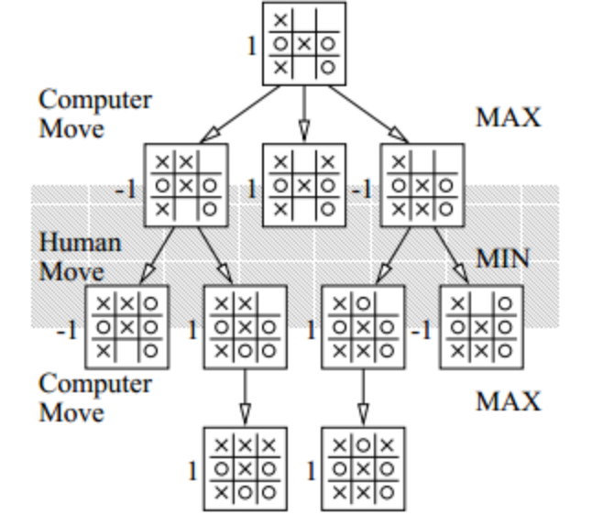
For example, in tic-tac-toe, the goal of the player is to make three shapes in a row. The above diagram is a tree that represents all of the possible moves stemming from a certain state. In the case of this game, a good player move (such as a win or tie) returns a value of 1 while a bad move or good opponent move will return a value of -1. The value of a move is evaluated by searching the bottom depth of the game tree and taking the value of that game board’s state. Depending on whose turn it is on that move, the move is assigned a value of 1 or -1. In the case of the game shown in the diagram above, the bottom row of the tree represents the board state after possible computer moves. Since those moves evaluate to a win for the computer, a value of 1 is stored. The next level of moves, the player moves, is evaluated after all of the computer’s moves are calculated, except the minimum value (the player’s best move) is stored because it is assumed that the player will choose the best move every time. This algorithm continues upwards in the game tree until the best move is determined.
Since our game does not have a specific win state like tic-tac-toe, the evaluation function calculates the number of pieces captured or lost in each move. In other words, instead of a value of 1 being a win and -1 being a loss as in tic-tac-toe, the value of each move is the number of pieces converted. If an end game board state is found and it is a win for the A.I., a value of int.MaxValue is assigned to the move that leads to that board state, and if a loss is found, int.MinValue is assigned. The A.I. will try to avoid low move values while choosing high move values when it traverses the game tree.
As stated earlier, this is a combinatorial game. In other words, the number of possible moves for each board state will increase very rapidly. For each piece, there are 16 spaces that need to be checked for whether or not the space provides for a valid move. With just 10 pieces on the board, that’s 160 spaces than need to be checked, and that number will grow even larger considering the game board being 10x10 spaces. Under these circumstances, it is impossible to check for every possible final outcome for every possible move, as the results would be virtually limitless. Therefore, the depth of the game tree is limited, but even with this limit other optimizations must be made so that the A.I. does not run too slowly.

