Smart Technology - CA1 Report
Richard Collins (D00230925) and Tadas Gliadkovskis (D00229061)

Introduction
This is a report on our CA1 for Smart Technology in which we have to load in images, pre-process the images, explore the data, create a predictive model and finally test the model. This project was done through peer programming.

Data Pre-processing
To load in the data for X_train, X_test and X_val, we had to loop through each image in the directory and use OpenCV’s cv2.imread() to read all the images into an array. Since we were working on different machines, our paths to the directories were different. To solve this issue, we added an env file with our different paths respectively and added this file to the .gitignore.

We found that reading in the train images was slightly different to the others as there were subfolders within the train folder. The “wnids.txt”, contained the names for each one of these subfolders, so if we could read the text file and add each id into an array, we could then use the same function to loop through and read the images in each folder. X_train.shape gives the output: (200, 500, 64, 64, 3)

Later we realise this was wrong as we needed the output to be: (100000, 64, 64, 3), so we made the changes required.

Once we have read in all the images, we have to preprocess the images themselves. This is done by grayscaling the images with the function cv2.cvtColor(image, cv2.COLOR_BGR2GRAY). This is done to reduce the amount of data that the computer will have to sieve through. Next we add a gaussian blur to reduce the “noise” in the image using cv2.GaussianBlur(image, (5, 5), 0). Finally, we implement an equalising histogram and normalisation with cv2.equalizeHist(image) and divide the image by 255 (image/255).

To get the bounded box, we first need to extract them from the word files. This is done by looping through each train folder again and saving the top left coords into an array e.g. [['44', '0'], ['11', '2'], ['9', '0'], ['3', '5']] and do the same for the bottom right coords e.g. [['60', '5'], ['24', '15'], ['18', '2'], ['57', '54']]. This was done for each class, giving us a dictionary of {id: [top left coord], [bottom right coord]} With these coords now available, we draw the bounded box on each respective image. While trying to draw the bounding box, we ran into an issue where the image would be returned completely black. To fix, this we needed to denormalise the image by multiplying by 255 (image*255) and making the image an uint8 type.

When testing to see if the bounding boxes were drawn right, we discovered that the images were being read in as ‘n02124075_0.JPEG’, ‘n02124075_1.JPEG’, ‘n02124075_10.JPEG’, ‘n02124075_100.JPEG’. This is a common problem that people face when trying to read in numbered files. We found that using a natsort would sort the files in the order we want as we read in the files e.g. ‘n02124075_0.JPEG’, ‘n02124075_1.JPEG’, ‘n02124075_2.JPEG’.

Data Exploration
With the pre-processing done on all the images, we can finally move on and explore the data. X_train.shape gives the output: (100000, 64, 64, 1), which breaks down to 100,000 images per class, 64 height pixel, 64 width pixel, 1 means RGB which used to be 3 before we grayscaled the image. We then reshaped X_train to: (100000, 64, 64).

The training data contains 100,000 images of 200 classes with 500 images in each class. These images have already been resized to 64px x 64px. Each class has 500 training images, 50 validation images, and 50 test images. The training data set is split into 200 folders, which contain 500 images for a specific label. The validation set contains 10,000 images with text files giving the labels and bounding boxes for the classes in each image. The test data contains 10,000 images and we are using our model to predict the label for each image.

Building the Model
We built our starting model using a LeNet model including X_train, y_train and an activation function of ReLU. This is the model we used for these tests

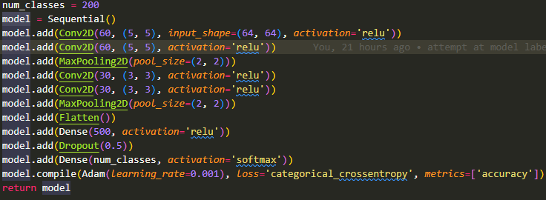

First time we ran our model with 5 epochs and purposefully underfit it
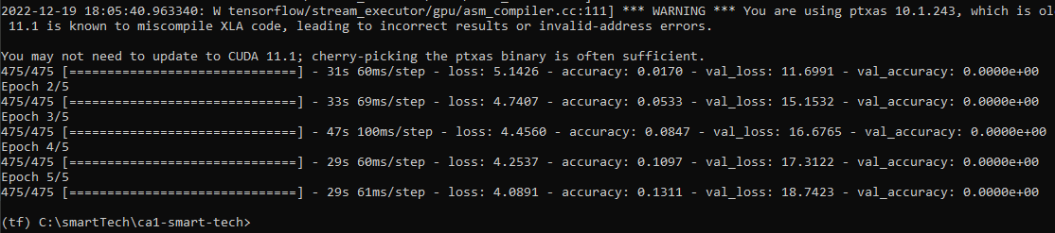

Next we ran the model with 20 epochs which returned accuracy of 40%

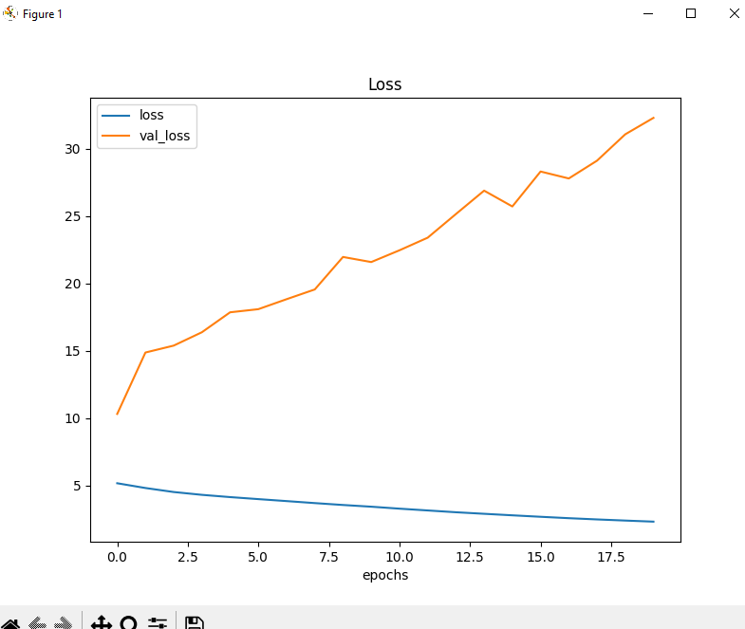

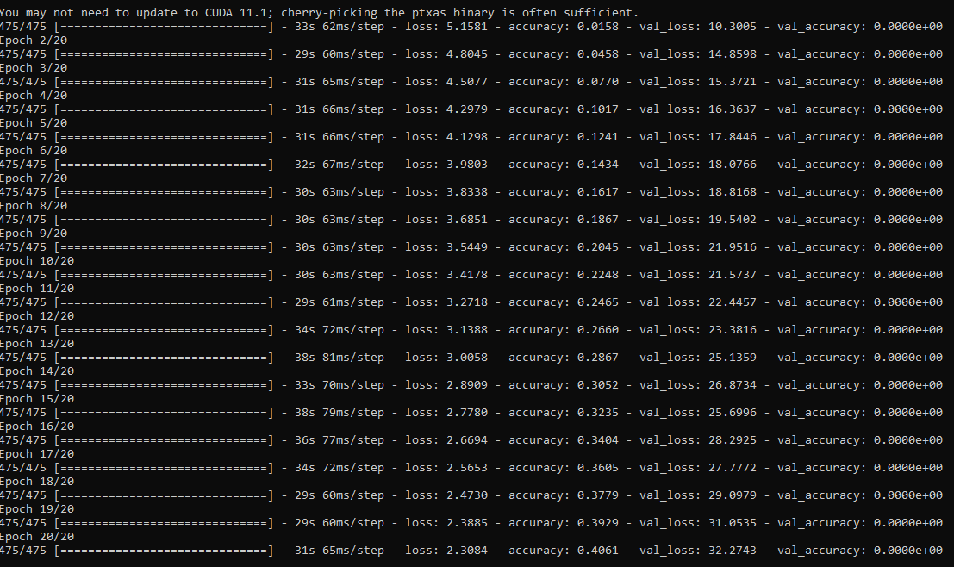

After running our model with 50 epochs and 475 steps per epoch we achieved an accuracy of 65% with a loss of 1.14 and a val_loss of 53% during this run at the beginning of the epoch the accuracy would be high and then go down very harshly towards the end where the difference per epoch became minimal to the point of +0.045. Reducing the steps to 200 gave us an accuracy of 40%.

Before we had 2 convolutional layers before the pooling layer after reducing to just one layer before the pooling layer our results were loss: 1.7075 - accuracy: 0.5165 - val_loss: 46.2827

Learning rate of 0.002 gave us an outcome of -
loss: 2.5433 - accuracy: 0.3444 - val_loss: 38.1423

We put back the learning rate to 0.001 and upped the validation split to 0.2 this gave us an outcome of - loss: 1.1646 - accuracy: 0.6473 - val_loss: 49.9923

We reduced the filters from the convolutional layers to 30 filters for the first layer and 15 filters for the second layer. This gave us - loss: 2.0649 - accuracy: 0.4365 - val_loss: 40.4606.
Then applying the activation function of ELU our results increased to - loss: 1.2240 - accuracy: 0.6548 - val_loss: 18.5187. With ELU and 2 convolutional layers after 30 epochs we got a result of - loss: 0.7229 - accuracy: 0.7913 - val_loss: 17.5443 it seems that most of our models after 30 epochs hit the peak gains and afterwards each epoch starts increasing the accuracy by 0.03 - 0.05. The peak accuracy we reached was 85% and the model that achieved this was saved into a file.

Testing the Model

Glossary
Noise - Noise in an image is the presence of artifacts that do not originate from the original scene content. (Image Engineering GmbH & Co. KG, n.d.)

References
Image Engineering GmbH & Co. KG (n.d.) Home, Image Engineering. Image Engineering GmbH & Co. KG. Available at: https://www.image-engineering.de/library/image-quality/factors/1080-noise (Accessed: December 17, 2022).

