**1. Matrix multiplication**

#include<stdio.h>

#include<stdlib.h>

int main()

{

int a[10][10],b[10][10],mul[10][10],r,c,i,j,k;

system("cls");

printf("enter the number of rows::");

scanf("%d",&r);

printf("enter the number of columns::");

scanf("%d",&c);

printf("enter the first matrix element::\n");

for(i=0;i<r;i++)

{

for(j=0;j<c;j++)

{

scanf("%d",&a[i][j]);

}

}

printf("enter the second matrix element::\n");

for(i=0;i<r;i++)

{

for(j=0;j<c;j++)

{

scanf("%d",&b[i][j]);

}

}

printf("multiplication of the matrix=\n");

for(i=0;i<r;i++)

{

for(j=0;j<c;j++)

{

mul[i][j]=0;

for(k=0;k<c;k++)

{

mul[i][j]=mul[i][j]+(a[i][k]*b[k][j]);

}

}

}

printf("Result is::\n");

for(i=0;i<r;i++)

{

for(j=0;j<c;j++)

{

printf("%d\t",mul[i][j]);

}

printf("\n");

}

return 0;

}

**output**

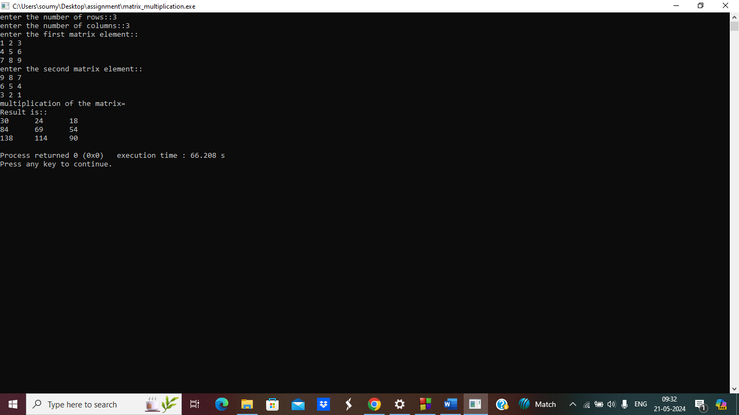

**2.print star pattern**

#include<stdio.h>

void main()

{

int i,j,n;

printf("Enter no::");

scanf("%d",&n);

for(i=1;i<=n;i++)

{

for(j=1;j<=i;j++)

{

printf(" * ");

}

printf("\n");

} }

**output**

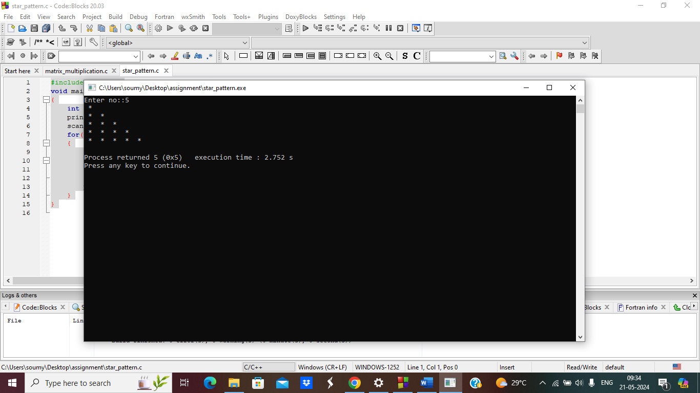

**3. Factorial of a number.**

#include<stdio.h>

void main()

{

int i,n,fact=1;

printf("enter a number to find factorial::");

scanf("%d",&n);

for(i=n;i>=1;i--)

{

fact=fact*i;

if(i== n)

printf("%d",i);

else

printf("*%d",i);

}

printf("\n factorial of %d is =%d\n",n,fact);

}

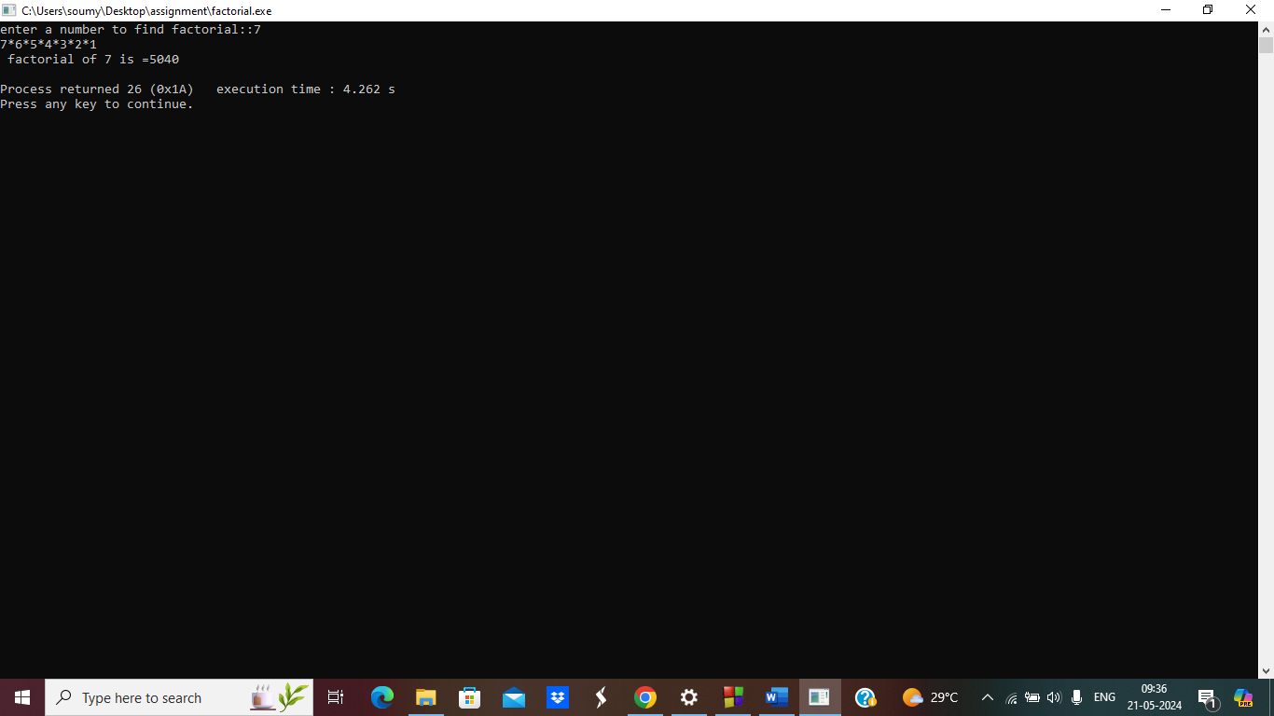

**4. Fibonacci series**

#include<stdio.h>

int main()

{

int a=0,b=1,i,n,fib;

printf("Enter the numbers of elements ::");

scanf("%d",&n);

printf("%d %d ",a,b);

for(i=2;i<n;i++)

{

fib=a+b;

printf("%d ",fib);

a=b;

b=fib;

}

return 0;

}

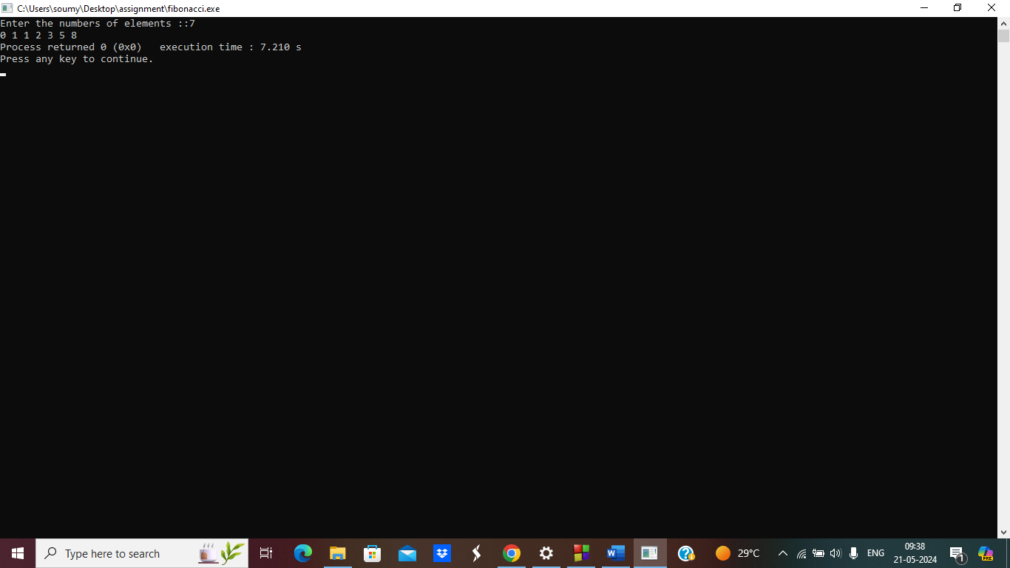

**5.while loop use (enter user and domain name)**

#include <stdio.h>

#include <string.h>

int main() {

char name[50];

char domain[50];

char choice;

printf("Do you want to continue? (y/n): ");

scanf("%c", &choice);

while (choice == 'y' || choice == 'Y')

{

printf("Enter your name: ");

scanf("%s",name);

printf("Enter your domain: ");

scanf("%s",domain);

printf("Do you want to continue? (y/n): ");

scanf(" %c", &choice);

}

printf("\n ok done");

return 0;

}

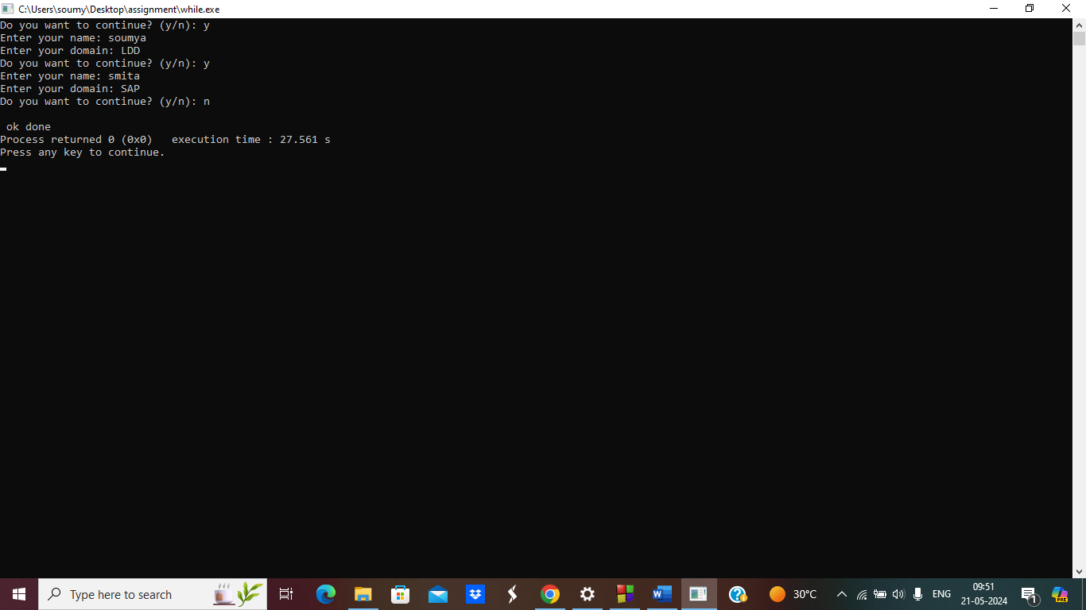

**6.Do-while loop use (enter user and domain name)**

#include <stdio.h>

#include <string.h>

int main() {

char name[50];

char domain[50];

char choice;

do {

printf("Enter name: ");

scanf("%s",name);

printf("Enter domain: ");

scanf("%s",domain);

printf("Do you want to continue? (y/n): ");

scanf(" %c", &choice);

} while (choice == 'y' || choice == 'Y');

printf("\n ok done");

return 0;

}

