**1.Binary search**

#include<stdio.h>

int binary_search(int arr[],int left,int right,int x)

{

while(left<=right)

{

int mid=left+(right-left)/2;

if(arr[mid]==x)

{

return mid;

}

else if(arr[mid]<x)

{

left=mid+1;

}

else

right = mid - 1;

}

return -1;

}

int main()

{

int n,element;

printf("enter no of array elements: ");

scanf("%d",&n);

int arr[n];

printf("enter array elements::\n");

for(int i=0;i<n;i++)

{

scanf("%d",&arr[i]);

}

printf("enter element u want to search:: ");

scanf("%d",&element);

int result=binary_search(arr,0,n-1,element);

if (result == -1)

printf("Not found");

else

printf("element %d is present at index: %d\n",element,result);

return 0;

}

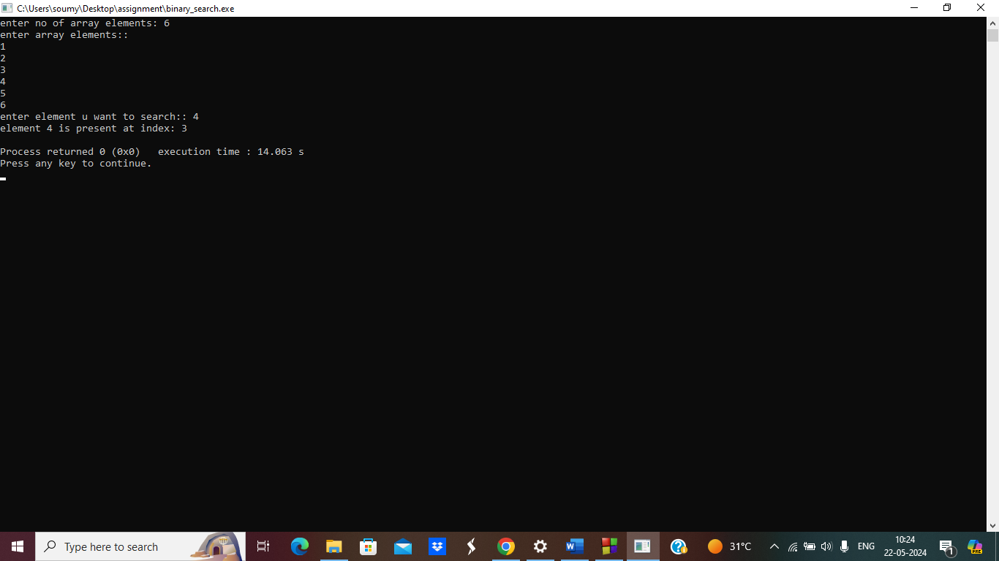

**2.count empty block of array**

#include<stdio.h>

#include<string.h>

main()

{

int n,pos;

printf("enter no of array elements: ");

scanf("%d",&n);

int a[n];

printf("enter array elements:: ");

for(int i=0;i<n;i++)

{

scanf("%d",&a[i]);

}

printf("array elements are::\n");

for(int i=0;i<n;i++)

{

printf("a[%d] is = %d\n",i,a[i]);

}

delete:

printf("enter the element position you want to delete ::");

scanf("%d",&pos);

a[pos]=0;

for(int i=0;i<n;i++)

{

printf("a[%d] is = %d\n",i,a[i]);

}

int c=0;

for(int i=0;i<n;i++)

{

if(a[i]==0)

c++;

}

printf("total empty spaces are::%d\n",c);

int choice;

printf("do you want to delete more elements(1(yes)/0(no):: ");

scanf("%d",&choice);

if(choice== 1)

{

goto delete;

}

else

return 0;

}

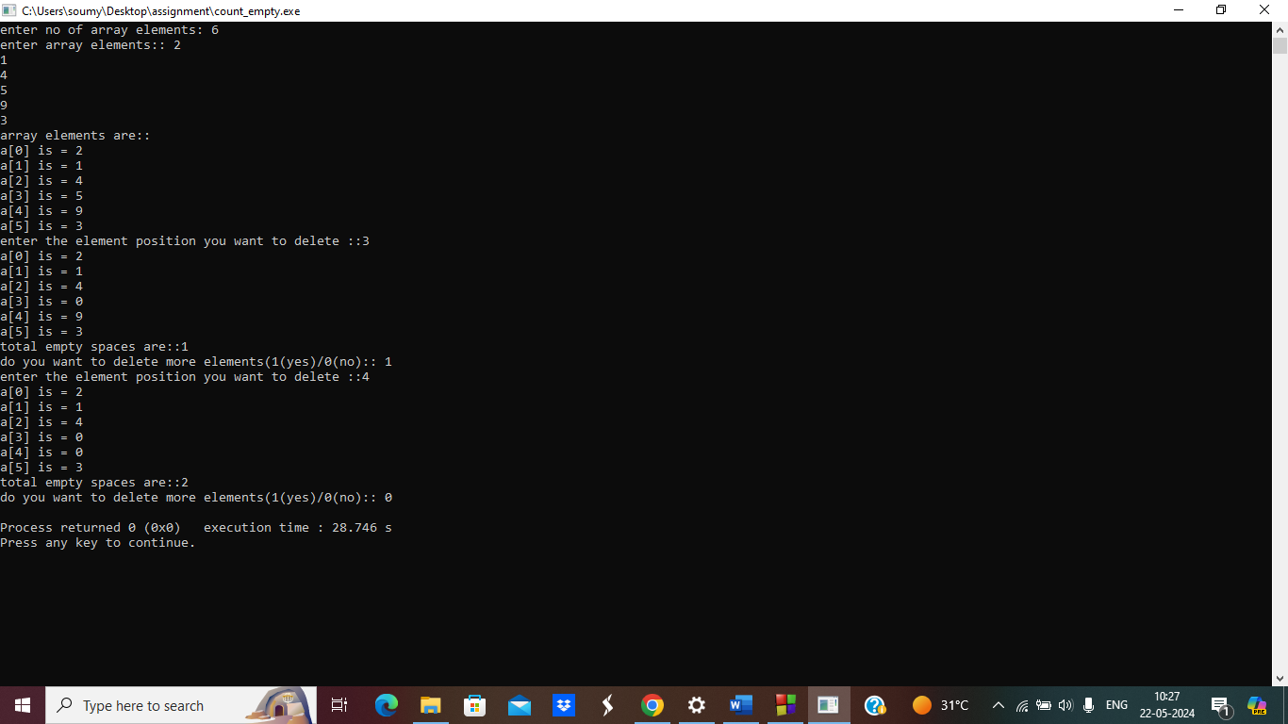

**3.File handling concept**

#include <stdio.h>

#include <conio.h>

#include <stdlib.h>

void main ()

{

int n;

FILE *fptr;

//fptr = fopen ("textfile.txt", "w");//overwrite the content

//fptr = fopen ("textfile.txt", "a");//append the data

fptr = fopen ("textfile.txt", "a+");//both read and append

// fptr = fopen ("textfile.txt", "r");//only on reading mode and sets pointer pointing to 1st char

if (fptr == NULL)

{

printf ("Error!!!!!");

exit(0);

}

printf ("Enter number::");

scanf ("%d", &n);

fprintf (fptr, "%d", n);

fclose (fptr);

}

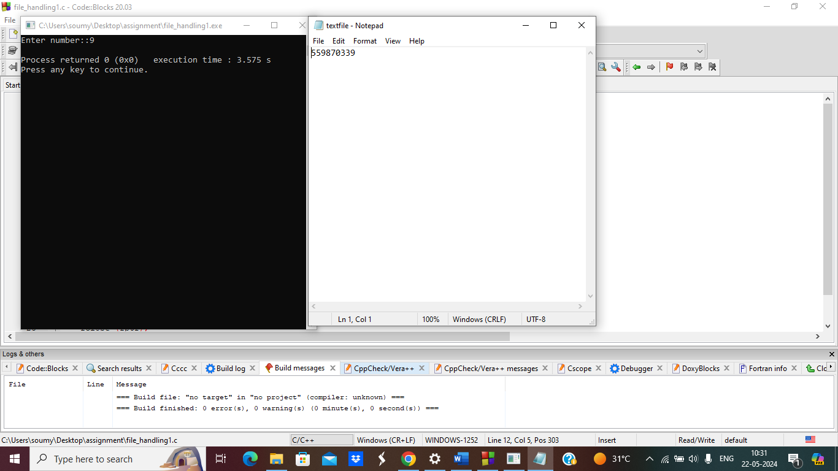

**4.fetch data**

#include<stdio.h>

void main()

{

FILE *fp;

char emp[100];

fp=fopen("employees.txt","r");

while(fscanf(fp," %[^\n]",emp)!=EOF)

{

printf("%s\n",emp);

}

//fclose(fp);

}

