**1.swap**

#include <stdio.h>

main()

{

int a,b;

a=5, b=20;

swap (a,b);

printf ("\n Swap Fun: (call by value) \n a = %d , b = %d ", a,b);

swap1 (&a, &b);

printf ("\n Swap1 Fun: (call by Ref) \n a = %d , b = %d ", a,b);

}

void swap (int x, int y)

{

int tmp;

tmp = x;

x=y;

y=tmp;

}

void swap1 (int *x1, int *y1)

{

int tmp1;

tmp1 = *x1;

*x1=*y1;

*y1=tmp1;

}

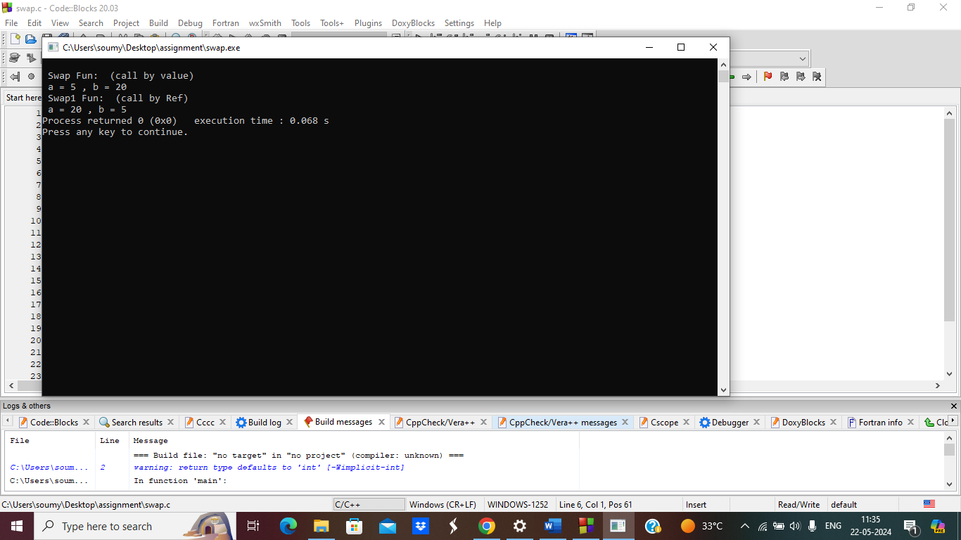

**2.average using pointer**

#include <stdio.h>

float avg (int arr[], int size);

main ()

{

int x[100], k, n;

printf("\n Enter the array size :\n");

scanf ("%d",&n);

printf("\n Enter the array elements :\n");

for (k=0;k<n;k++)

{

scanf("%d", &x[k]);

}

printf("\n Average is : %f", avg (x,n));

}

float avg (int arr[], int size)

{

int *p,i,sum=0;

p=arr;

for (i=0;i<size;i++)

{

sum = sum + *(p+i);

}

return (float) sum/size;

}

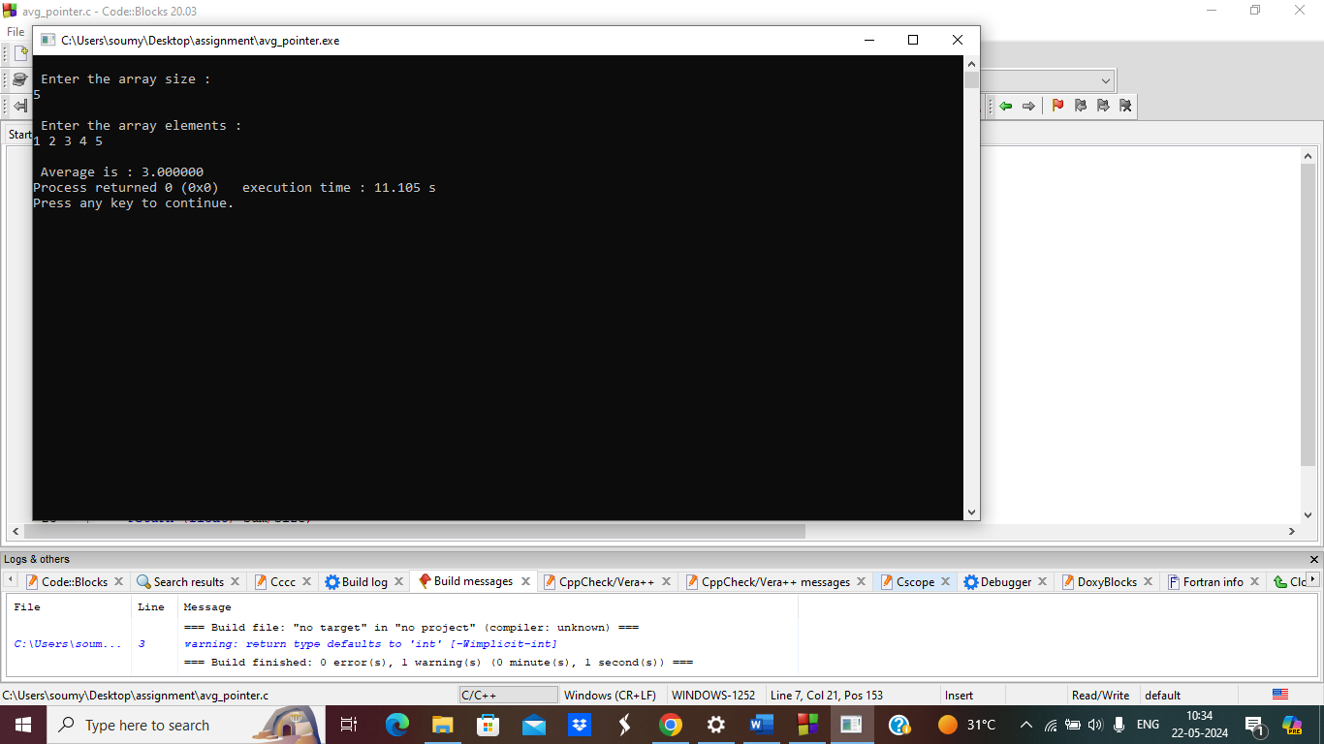

**3.print day of a month**

#include <stdio.h>

int dayOfWeek(int d, int m, int y) {

static int t[] = {0, 3, 2, 5, 0, 3, 5, 1, 4, 6, 2, 4};

y -= m < 3;

return (y + y/4 - y/100 + y/400 + t[m-1] + d) % 7;

}

void printCalendar(int month, int year) {

int daysInMonth, i, currentDay;

int days[] = {31, 28, 31, 30, 31, 30, 31, 31, 30, 31, 30, 31};

if ((year % 4 == 0 && year % 100 != 0) || (year % 400 == 0))

days[1] = 29;

printf(" **** Calendar - %d/%d ****\n", month, year);

printf(" Sun Mon Tue Wed Thu Fri Sat\n");

currentDay = dayOfWeek(1, month, year);

for (i = 0; i < currentDay; i++)

printf(" ");

for (i = 1; i <= days[month-1]; i++) {

printf("%5d", i);

if (++currentDay > 6) {

currentDay = 0;

printf("\n");

}

}

if (currentDay != 0)

printf("\n");

}

int main() {

int month, year;

printf("Enter month and year (MM YYYY): ");

scanf("%d %d", &month, &year)

printCalendar(month, year);

return 0;

}

