**1.**

#include <stdio.h>

#include <conio.h>

#include <string.h>

struct emp

{

char name[30];

int age;

float salary;

}p1;

main()

{

strcpy (p1.name, "soumya mishra");

p1.age = 27;

p1.salary = 10000;

printf("Name:: %s\n", p1.name);

printf("age:: %d\n", p1.age);

printf("Salary:: %.2f ", p1.salary);

}

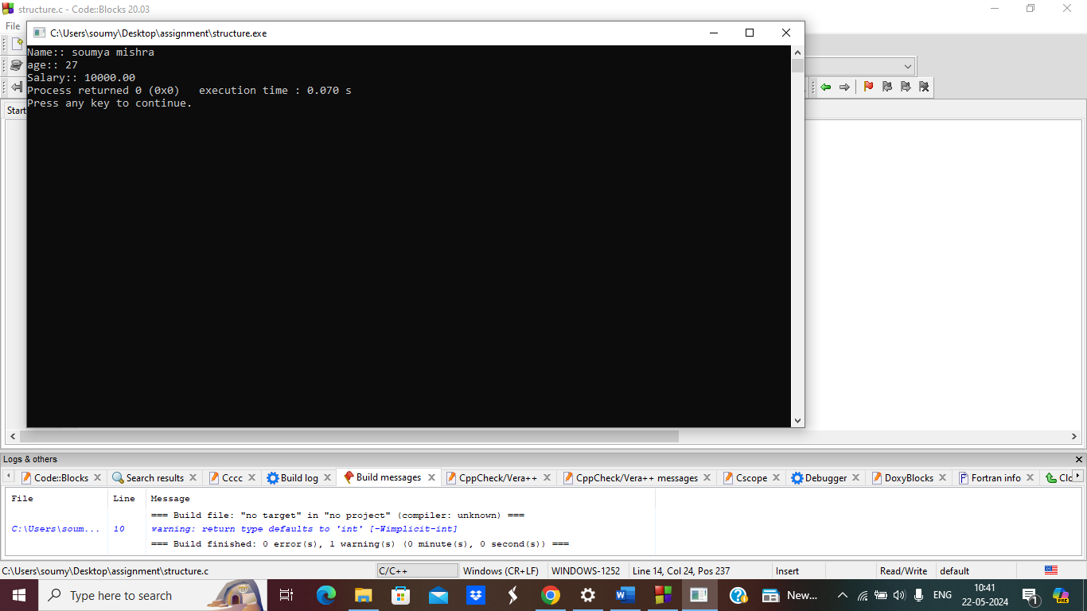

**2.Linked list**

// Linked list implementation in C

#include <stdio.h>

#include <stdlib.h>

// Creating a node

struct node {

int value;

struct node *next;

};

// print the linked list value

void printLinkedlist(struct node *p) {

while (p != NULL) {

printf("%d ", p->value);

p = p->next;

}

}

int main() {

// Initialize nodes

struct node *head;

struct node *one = NULL;

struct node *two = NULL;

struct node *three = NULL;

// Allocate memory

one = malloc(sizeof(struct node));

two = malloc(sizeof(struct node));

three = malloc(sizeof(struct node));

// Assign value values

one->value = 1;

two->value = 2;

three->value = 3;

// Connect nodes

one->next = two;

two->next = three;

three->next = NULL;

// printing node-value

head = one;

printLinkedlist(head);

}

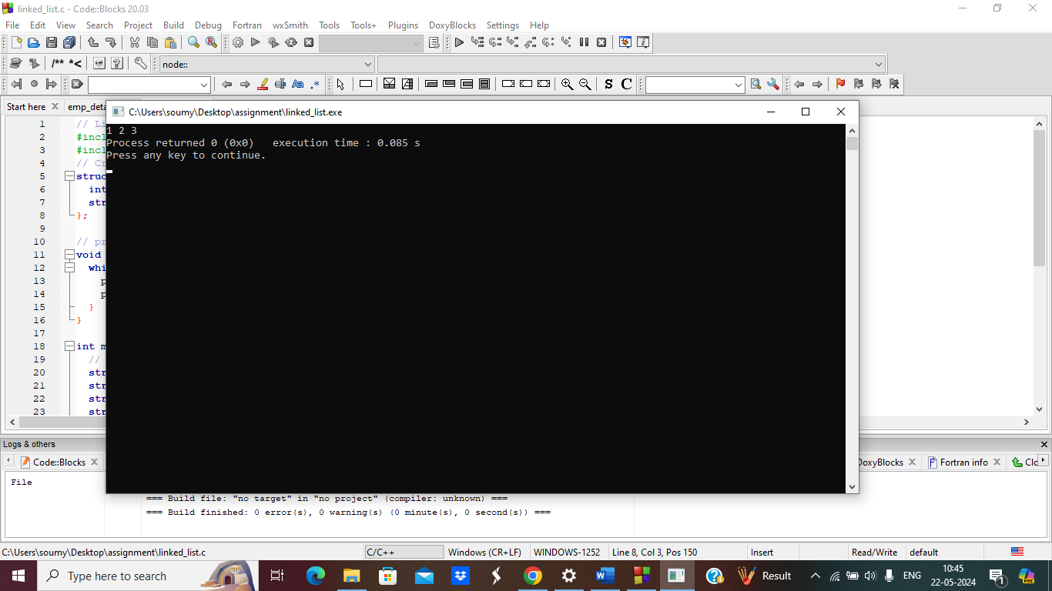

**3.Linked list traverse (name age)**

#include <stdio.h>

#include <stdlib.h>

#include <string.h>

struct Node {

char name[20];

int age;

struct Node *next;

};

struct Node *head;

void insert(char name[], int age) {

struct Node *h = head;

struct Node *nn = (struct Node*)malloc(sizeof(struct Node));

nn->age = age;

strcpy(nn->name, name);

nn->next = NULL;

if (h == NULL) {

head = nn;

return;

}

while (h->next != NULL) {

h = h->next;

}

h->next = nn;

}

void display() {

printf("Checking..\n");

struct Node* h = head;

while (h != NULL) {

printf("\nName: %s and Age: %d\n", h->name, h->age);

h = h->next;

}

int main() {

printf("Enter the number of nodes you want to create:\n");

int n;

scanf("%d", &n);

for (int i = 1; i <= n; i++) {

int age;

char name[20];

printf("Enter age for node %d\n: ", i);

scanf("%d", &age);

printf("Enter name for node %d\n: ", i);

scanf("%s", name);

insert(name, age);

}

printf("\nDisplaying the nodes:\n");

display()

return 0;

}

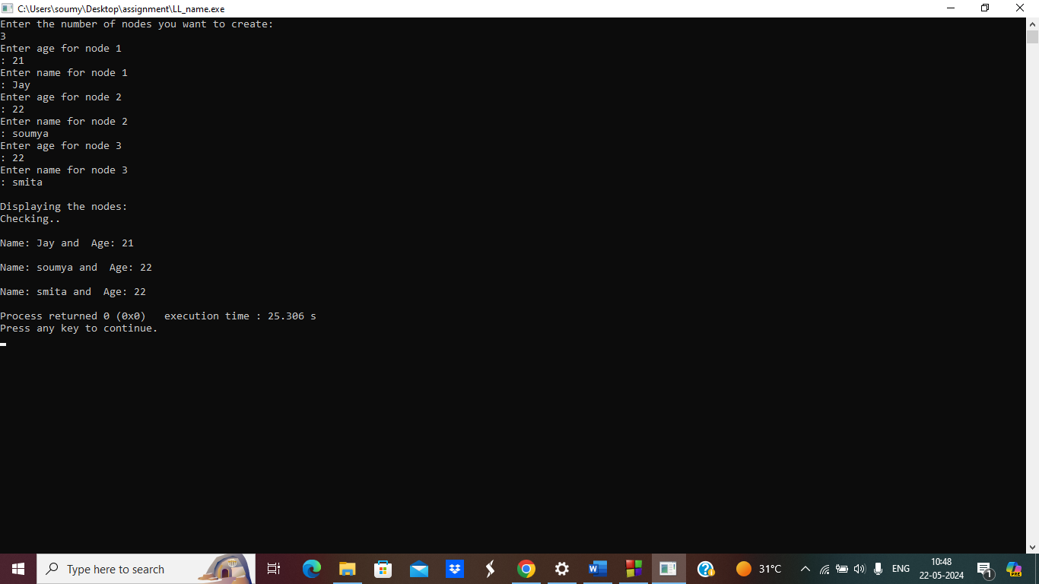

**4.Doubly linked list**

#include <stdio.h>

#include <stdlib.h>

struct Node {

int data;

struct Node *left;

struct Node *right;

};

struct Node *head;

void create(int data){

struct Node * nn=(struct Node *)malloc(sizeof(struct Node));

struct Node *h=head;

nn->data=data;

nn->left=NULL;

nn->right=NULL;

if(h==NULL){

head=nn;

return ;

}

while(h->right!=NULL){

h=h->right;

}

h->right=nn;

nn->left=h;

}

void display(){

struct Node *h=head;

while(h!=NULL){

printf("Left Address is :: %u || Value ::%d || Right Address is ::%u || Current Address :: %u\n",h->left,h->data,h->right,h);

h=h->right;

}

}

int main(){

create(10);

create(23);

create(30);

create(40);

printf("Printing the data...\n");

display();

}

