**1.Binary search tree**

#include <stdio.h>

#include <stdlib.h>

struct node {

int data;

struct node *right_child;

struct node *left_child;

};

struct node* new_node(int x){

struct node *temp;

temp = malloc(sizeof(struct node));

temp->data = x;

temp->left_child = NULL;

temp->right_child = NULL;

return temp;

}

struct node* search(struct node * root, int x){

if (root == NULL || root->data == x)

return root;

else if (x > root->data)

return search(root->right_child, x);

else

return search(root->left_child, x);

}

struct node* insert(struct node * root, int x){

if (root == NULL)

return new_node(x);

else if (x > root->data)

root->right_child = insert(root->right_child, x);

else

root -> left_child = insert(root->left_child, x);

return root;

}

struct node* find_minimum(struct node * root) {

if (root == NULL)

return NULL;

else if (root->left_child != NULL)

return find_minimum(root->left_child);

return root;

}

void inorder(struct node *root){

if (root != NULL)

{

inorder(root->left_child);

printf(" %d ", root->data);

inorder(root->right_child);

}

}

int main() {

struct node *root;

root = new_node(20);

insert(root, 5);

insert(root, 1);

insert(root, 15);

insert(root, 9);

insert(root, 7);

insert(root, 12);

insert(root, 30);

insert(root, 25);

insert(root, 40);

insert(root, 45);

insert(root, 42);

inorder(root);

printf("\n");

return 0;

}

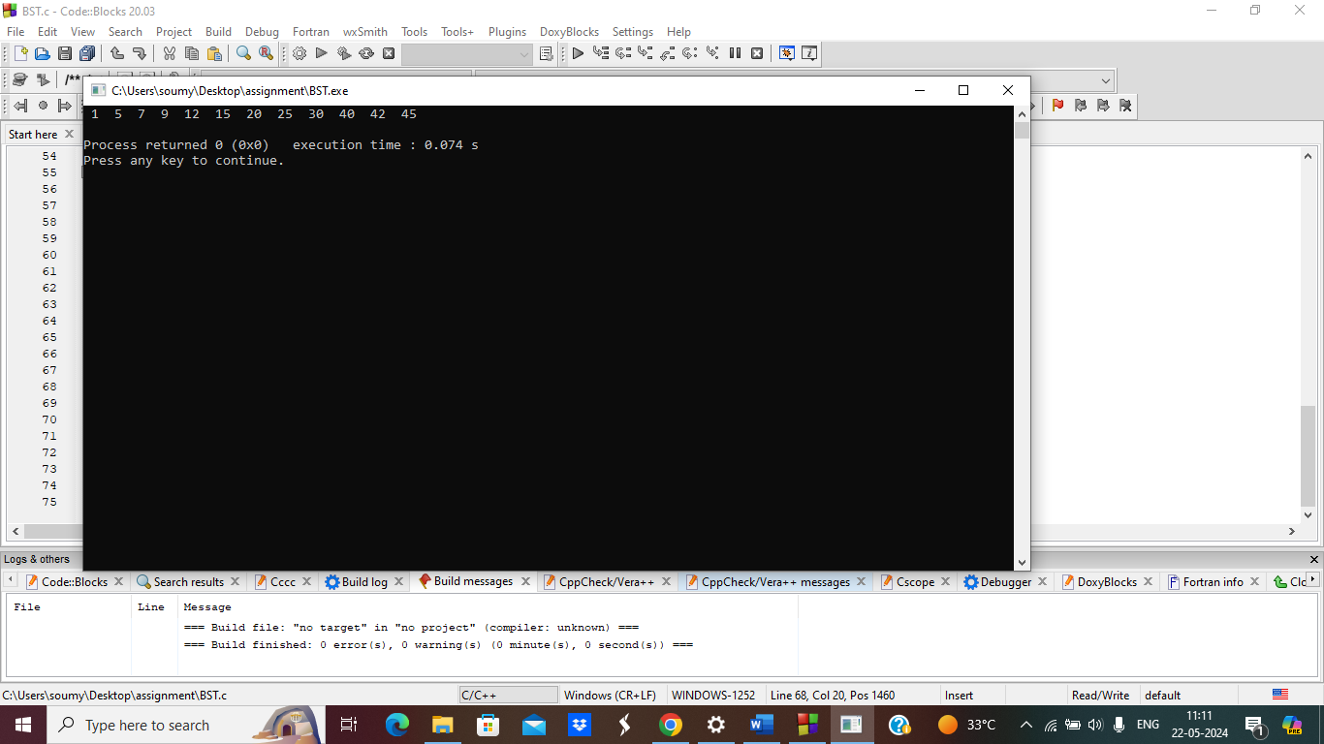

**2.Binary tree(in order, pre order, post order)**

#include <stdio.h>

#include <limits.h>

struct Node {

int data;

struct Node* left;

struct Node* right;

};

struct Node* newNode(int key) {

struct Node* node = (struct Node*)malloc(sizeof(struct Node));

node->data = key;

node->left = node->right = NULL;

return node;

}

void inOrderTraversal(struct Node* root) {

if (root != NULL) {

inOrderTraversal(root->left);

printf("%d ", root->data);

inOrderTraversal(root->right);

}

}

void preOrderTraversal(struct Node* root) {

if (root != NULL) {

printf("%d ", root->data);

preOrderTraversal(root->left);

preOrderTraversal(root->right);

}

}

void postOrderTraversal(struct Node* root) {

if (root != NULL) {

postOrderTraversal(root->left);

postOrderTraversal(root->right);

printf("%d ", root->data);

}

}

int main() {

// Constructing a sample binary tree

struct Node* root = newNode(1);

root->left = newNode(2);

root->right = newNode(3);

root->left->left = newNode(4);

root->left->right = newNode(5);

printf("In-order Traversal: ");

inOrderTraversal(root);

printf("\n");

printf("Pre-order Traversal: ");

preOrderTraversal(root);

printf("\n");

printf("Post-order Traversal: ");

postOrderTraversal(root);

printf("\n");

return 0;

}

