

**HIT 301**

**INDUSTRIAL INTERNSHIP REPORT AT**

**OK ZIMBABWE**



**29 JULY 2024 – 30 JUNE 2025**

Submitted By

**Tanatswa Mugabe H220269E**

In partial fulfillment of the requirements of the

**Bachelor of Technology Honors Degree in Computer Science**

**of the**

**SCHOOL OF INFORMATION SCIENCES AND TECHNOLOGY**

JUNE 2026

Industrial Supervisor: EDITH HLABATI Academic Supervisors: MR. MPOFU

**HARARE INSTITUTE OF TECHNOLOGY HIT 301 INDUSTRIAL INTERNSHIP REPORT DECLARATION**

I, TANATSWA MUGABE**,** hereby declare that this is a true internship report of work done at **OK ZIMBABWE** submitted in partial fulfilment of the requirement for the degree of **BTECH HONORS DEGREE IN COMPUTER SCIENCE** at **HARARE INSTITUTE OF**

**TECHNOLOGY** and it has not formed the basis for the award of any other degree.

STUDENT’S SIGNATURE: ……………………… DATE: …………………………………..

NAME OF COMPANY: OK ZIMBABWE

ADDRESS: 07 RAMON ROAD, GRANITESIDE, HARARE PHONE: +263773844300

EMAIL: EHLABATI@OKZIM.CO.ZW

INDUSTRIAL SUPERVISOR: EDITH HLABATI

PHONE: +263773844300

EMAIL: [EHLABATI@OKZIM.CO.ZW](mailto:EHLABATI@OKZIM.CO.ZW)

INDUSTRIAL SUPERVISOR’S SIGNATURE: …………………….. DATE: …………..……

RECEIVED BY **COMPUTER SCIENCE DEPARTMENT**

INTERNSHIP COORDINATOR / CHAIRPERSON: …………………………………………..... DATE: ………………..……

DATE STAMP

# APPROVAL

This Industrial Internship Report, undertaken at OK Zimbabwe, has been compiled by Tanatswa Mugabe, student number H220269E, and is hereby submitted to the Department of Information Technology at the Harare Institute of Technology. The report has been prepared with the endorsement of both the academic and industrial supervisors, and it reflects the practical training and professional experience gained by the student during the period 29 July 2024 to 9 May 2025.

Signed by Industrial Supervisors:

|  |  |  |
| --- | --- | --- |
| Edith Hlabati |  | on |

Signed by Academic Supervisors:

|  |  |  |
| --- | --- | --- |
| Mr. Mpofu |  | on |
|  |  |  |

# DEDICATION

I dedicate this report to my family and mentors, whose unwavering support, encouragement, and guidance have been the foundation of my academic and professional journey. Their belief in my potential has continually inspired me to strive for excellence.

# ACKNOWLEDGEMENT

Reaching this point has been a journey shaped by the support, guidance, and encouragement of many remarkable individuals. Above all, I am grateful to God, whose strength and grace have carried me through every challenge and milestone.

I extend my heartfelt appreciation to OK Zimbabwe for affording me the opportunity to undertake my industrial attachment within their dynamic and professional environment. The experience has been instrumental in expanding both my technical competencies and professional perspective.

My sincere gratitude also goes to my academic supervisors and the Department of Information Technology at the Harare Institute of Technology, whose mentorship and support enabled me to bridge the gap between theory and practical application.

Lastly, I am truly thankful to my family and friends for their unwavering love, patience, and motivation throughout this journey.

# EXECUTIVE SUMMARY

As part of the Bachelor of Technology Honours Degree in Computer Science, the Harare Institute of Technology requires third-year students to undertake an eight-month industrial attachment. This program is designed to provide students with real-world exposure by placing them in reputable organizations where they can apply theoretical knowledge to practical scenarios.

This report captures the authors internship experience at OK Zimbabwe, outlining the objectives, key responsibilities undertaken, and the outcomes achieved. It begins with a summary of the internship goals, followed by an overview of the host organization and its IT department, where I was based.

The report includes a strategic analysis of OK Zimbabwe’s ERP through a SWOT framework, offering insights into the company’s internal dynamics and market position. Detailed accounts are provided of my involvement in systems support, ERP modifications, software testing, and planning for technology initiatives such as the currently ongoing ShopEasy Wallet project.

Challenges faced during the internship are discussed, along with recommended solutions. Finally, the report highlights the skills acquired throughout the attachment, emphasizing their relevance to both my academic development and professional trajectory in the field of computer science.

# GLOSSARY

**ERP (Enterprise Resource Planning):** A type of software used by organizations to manage and integrate the core aspects of their business operations such as finance, supply chain, and human resources.

**UAT (User Acceptance Testing):** A process where end-users test software changes or new systems to verify that they meet business requirements before full deployment.

**Fresh service:** A cloud-based IT service management tool used for tracking, managing, and resolving support tickets within an organization.

**Change Request:** A formal proposal for an alteration to be made to a system or product. At OK Zimbabwe, these often relate to ERP enhancements or bug fixes.

**ShopEasy Wallet:** A digital wallet system being developed for OK Zimbabwe to enable cashless transactions like airtime purchases, ZESA payments, and wallet transfers.

**ZSS (Zimbabwe Shared Services):** The technology partner responsible for developing ShopEasy Wallet and other related systems.

**Stakeholders:** Individuals or groups with a vested interest in a project, including department heads, IT staff, finance teams, and third-party vendors.

**IT Governance:** A framework that ensures IT investments support business goals, often through structured roles, responsibilities, and processes.

**Systems Support:** Activities that involve troubleshooting, maintaining, and improving IT systems to ensure operational continuity for end-users.

**SWOT Analysis:** A strategic planning technique used to identify Strengths, Weaknesses, Opportunities, and Threats related to a project or organization.

**Digital Transformation:** The adoption of digital technologies to enhance business operations, improve efficiency, and deliver better customer value.

**PO (Purchase Order):** A commercial document issued by a buyer to a vendor, indicating the types, quantities, and agreed prices for products or services.

**TO (Transfer Order):** A document used in inventory management to move stock from one location to another within an organization

Contents

APPROVAL ii

DEDICATION iii

ACKNOWLEDGEMENT iv

EXECUTIVE SUMMARY v

GLOSSARY vi

CHAPTER 1: INTRODUCTION 1

CHAPTER 2: BACKGROUND OF HOST ORGANIZATION 3

2.1 Business Profile 3

Mission 3

Vision 3

Values 3

2.2 Organizational Structure 3

2.3 New Knowledge Acquired and Experience Gained 5

2.4 Challenges 7

2.5 Corporate Culture 8

2.6 Streamlined Focus: IT Department 8

2.7 Technologies Used by the IT Department at OK Zimbabwe 9

CHAPTER 3: BUSINESS OPERATIONS 10

3.1 Nature of Service System 10

3.2 SWOT Analysis of Microsoft Dynamics 365 (D365) 12

3.3 Marketing Strategy 14

3.4 Competitive Strategy 15

CHAPTER 4: RESPONSIBILITIES AS A STUDENT INTERN 16

4.1 Introduction 16

4.2 Duties & Responsibilities 17

4.2.1 IT Technical Support 17

4.2.2 Systems Support via Fresh service 17

4.2.3 Documentation and Requirements Gathering 18

4.2.4 Administrative Support (Scheduling & Coordination) 19

4.2.5 User Access Management and Role Assignments 19

4.2.6 Batch Monitoring 19

4.2.7 User Training and Support 20

4.2.8 Software Testing with Stakeholders 20

4.2.9 Report Building and Dashboard Customization 21

4.2.10 Project Management 21

4.3 Accomplishments/Milestones 22

4.4 Problems Encountered 23

4.5 How Experience Impacts Career 26

CHAPTER 5: RECOMMENDATIONS & CONCLUSION 29

5.1 Areas Exposed To & Skills Obtained 29

5.2 Recommendations to Operational Problems 30

5.3 Observations Based on Analytical Basis 31

5.4 Implementation Based on Tested Prototyping, Simulation, & Modeling 32

5.5 Required Textbook & Learning Tools 32

5.6 Conclusion of the Experience 33

REFERENCES 34

APPENDICES 35

Appendix A: 35

Appendix B 35

Appendix C 36

Appendix D 36

# CHAPTER 1: INTRODUCTION

During the internship at OK Zimbabwe Limited, the writer gained hands-on experience and insight into various sectors of digital transformation and enterprise IT. Some of the main areas of the focus were software testing and support of the systems, where the writer assisted in maintaining the firm's internal systems, specifically its ERP solutions. This experience entailed software testing, bug-fixing, and system stabilization. Work within the ERP system exposed the writer to hands-on engagement in incremental improvements, for example, data flow enhancement and system integration, which enhanced skills related to systems optimization and analysis. ERP improvements within the internship exposed the writer to the significance of efficient ERP systems in the automation of operations like supply chain, sales, and finance systems.  
  
The internship also offered experience in project planning and stakeholder management, where the author was involved in defining the scope of projects, estimating timelines, and working with various teams to utilize resources appropriately. Through attending project meetings and following senior project managers around, the author learned about the intricate, multi-disciplined nature of information technology projects and the importance of communication between technical teams and business leaders. Training and user support was another significant part of the internship, and specifically the deployment of a newly created stock take mobile application. The author helped to prepare training materials, deliver training sessions, and gather user input to fine-tune the application, highlighting the importance of training and change management to the success of software deployments.

Apart from these technical roles, the internship included experience with digital wallet and mobile solutions, in particular through work with the ShopEasy Wallet. This is a payment system accessed through the mobile, where customers are enabled to purchase goods outside OK Zimbabwe stores, e.g., utilities and airtime payments. The writer actively participated in testing the platform, specifically looking at the integrity of payment transactions and possible system faults. This engagement provided insight into e-commerce and mobile finance and connected to the overall digital transformation of the company.

During the internship, the writer worked under a systematic training program, which was intended to balance technical and non-technical exposures. Orientation and system overview was covered during the initial weeks, where the writer was exposed to the IT infrastructure of the company and its ERP systems along with network architectures. An introduction to basic system troubleshooting techniques and hands-on practice with ERP modules was provided during this period. Software testing fundamentals were covered in the next part of the internship, where the writer received training in testing methodology and tools like manual and automated testing, along with actively being involved in the testing phases of different systems.

The following weeks were focused on the deployment of the stock take mobile application, with the author gaining experience in the development of training materials, training delivery, and user feedback gathering. Simultaneously, the author was involved in database management, coordinating very closely with the database team to maintain data integrity and proper reporting. Training schedules then changed to hands-on work with digital wallet integration and user support, where the author tested the ShopEasy Wallet, with particular focus on smooth transactions and resolution of any problems encountered. Exposure to both project management and working with stakeholders persisted, offering the author the experience of watching the entire process of the project from planning to implementation, including reporting and presenting updates.

The last weeks of the internship were concentrated on advanced levels of systems integration, where the writer assisted in integrating different software applications within OK Zimbabwe's information technology environment. The writer concluded the internship by writing the final report, outlining the contributions made during the placement, the skills developed, and recommendations for possible improvements. This internship offered extensive insight into both the technical and strategic elements in enterprise IT and was an extremely valuable learning step within the writer's professional and academic development.

# CHAPTER 2: BACKGROUND OF HOST ORGANIZATION

## 2.1 Business Profile

OK Zimbabwe is one of Zimbabwe's largest retail and wholesale entities, has strong footings in the retail industry within Zimbabwe. OK Zimbabwe has grown to be at the forefront of the retail business, selling groceries, housewares, electronics, and apparel, among many others, after its inception in 1942. OK Zimbabwe has a network of retail stores under its portfolio, ranging from OK Stores to Bon Marché and Food Lovers. With an emphasis on customer service, affordability, and quality, OK Zimbabwe remains at the forefront in offering its customers diversified shopping experiences both in-store and from its expanding digital channels.

The firm has broadened its reach in the past years to include contemporary payment solutions and integrated digital services, like the ShopEasy Wallet, a card-based payment system for its customers. The organization's commitment to digital transformation is designed to automate processes, improve customer experiences, and ease internal processes.

### Mission

* To make happiness tangible by planting smiles on our employees, customers, suppliers, shareholders and the communities we operate in

### Vision

* We aim to build a PURPOSEFUL, MODERN and AGILE business that puts people’s happiness first.

### Values

* We exist to delight customers
* We work as happy proactive curious owners
* Our rigour and discipline underpin our success
* Team performance matters
* We are community developers

## 2.2 Organizational Structure

OK Zimbabwe's organizational design is functional and hierarchical, where there are well-defined lines of authority in different departments such as finance, human resources, operations, information technology, marketing, and supply chain. There is a Chief Executive Officer (CEO), at the helm of the executive management team. There are various functional managers below the CEO, responsible for some of the main departments, such as:

* **IT Department**: Responsible for the maintenance of internal systems, software development, and support for retail operations.
* **Operations**: Manages store operations, logistics, and customer service.
* **Finance**: Handles accounting, budgeting, and financial reporting.
* **Human Resources**: Focuses on employee relations, recruitment, and training.
* **Marketing**: Responsible for advertising, promotions, and market research.

Given the significant focus on digital transformation, the **IT Department** has become increasingly central to the company’s strategy. It is responsible for maintaining the ERP system, supporting hardware and software, and implementing new technologies to enhance operational efficiency.

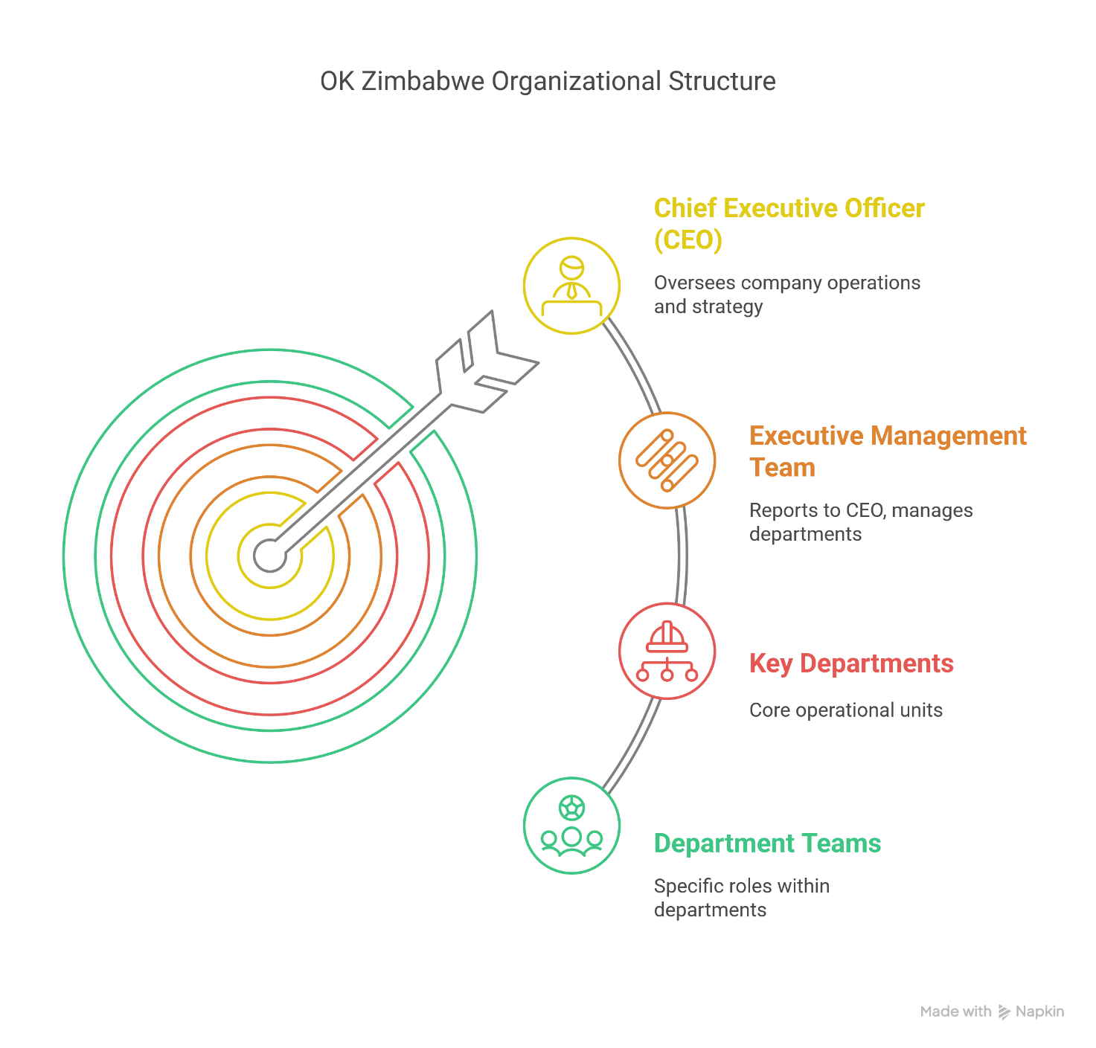

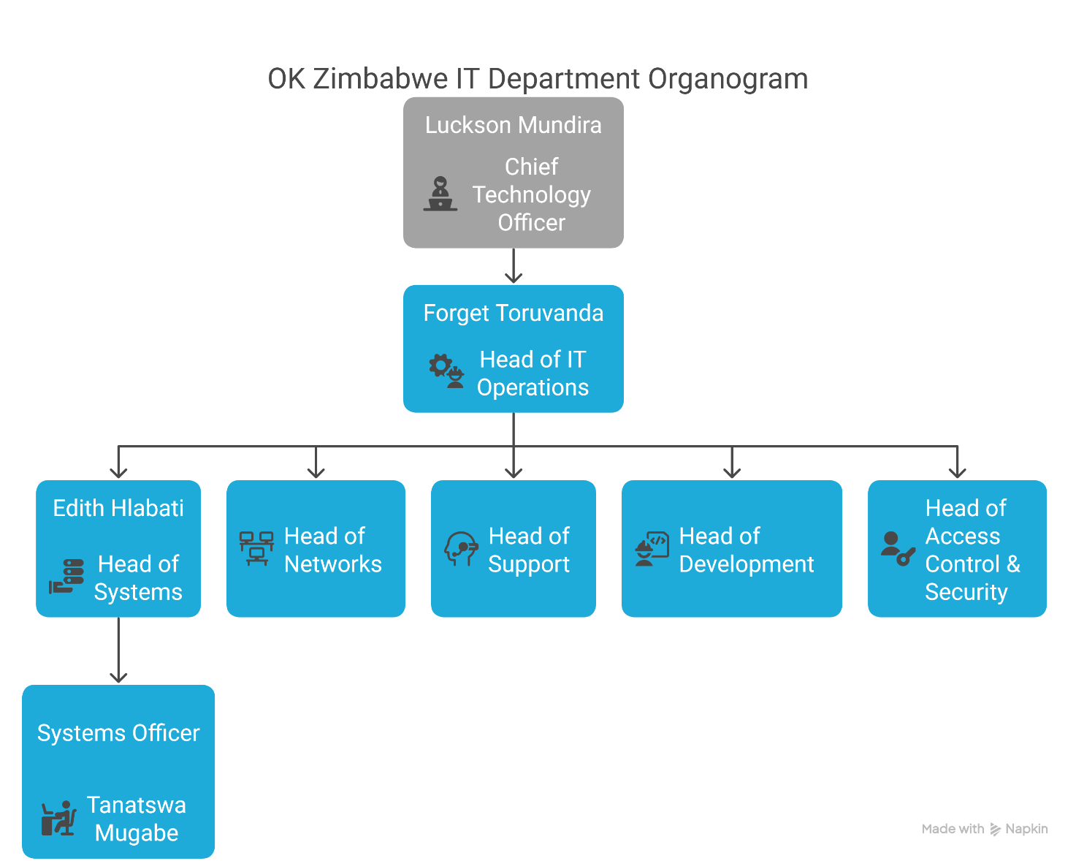

## 2.3 New Knowledge Acquired and Experience Gained

Throughout my internship at OK Zimbabwe, the writer developed a wide range of key skills and competencies that enhanced my professional growth and equipped me with practical knowledge relevant to my academic and career aspirations.

* **Time Management and Prioritization:**

One of the most valuable skills developed during the internship was time management. Balancing multiple tasks across different projects required the writer to prioritize effectively and meet deadlines consistently. For instance, while managing support tickets on Fresh service, the writer learned to assess the urgency of each request, ensuring that critical issues were addressed promptly while maintaining progress on long-term projects like the ShopEasy Wallet or the batch report automation. This experience improved the writer’s ability to handle pressure and allocate time efficiently to various tasks without compromising quality.

* **Effective Meeting and Communication Skills:**

Throughout the internship, the writer had to communicate effectively with both technical and non-technical stakeholders. Whether it was hosting training sessions for users or coordinating with developers during UAT (User Acceptance Testing), the writer learned to articulate technical information in a manner that was understandable to non-technical audiences. The writer also honed his meeting facilitation skills, particularly when gathering requirements or reviewing system changes. This included preparing agendas, managing discussions, and ensuring that all relevant points were covered, leading to productive and actionable meetings.

* **Problem-Solving and Critical Thinking:**

The writer’s role involved troubleshooting a variety of system issues, from resolving hardware failures to addressing software glitches. He learned to apply a logical and methodical approach to identify the root causes of problems and implement solutions. For instance, when handling system faults logged on Fresh service, the writer would analyse the issue, research potential fixes, and collaborate with other teams to resolve it. This process refined his problem-solving abilities and improved critical thinking, helping him make informed decisions quickly and effectively.

* **Collaboration and Teamwork:**

The writer also developed strong collaboration skills while working alongside other departments and teams. Whether it was coordinating with the finance department on report building or collaborating with the systems manager on deployment scheduling, he learned the importance of teamwork in achieving common goals. This exposure to cross-departmental projects, like the withholding tax training and ShopEasy Wallet, helped the writer understand the significance of clear communication, shared objectives, and mutual support in driving successful outcomes.

* **Technical Proficiency and Knowledge Enhancement:**

On the technical side, the writer deepened his knowledge of various IT systems, including Dynamics 365, Fresh service, Power BI, and SQL. He gained hands-on experience with system configurations, user access controls, batch monitoring, and software testing. This exposure allowed him to better understand the technical workings of the ERP system, automation tools, and business intelligence software, all of which enhanced his overall technical proficiency.

* **Adaptability and Learning Agility:**

Lastly, the dynamic nature of the internship taught the writer how to adapt quickly to changing situations. Whether it was adjusting to new software features, handling urgent user requests, or responding to unexpected issues during system testing, he learned the importance of being flexible and proactive. This ability to adjust to new challenges helped the writer stay focused and perform effectively even in unfamiliar or high-pressure environments.

In summary, the internship allowed the writer to not only apply academic knowledge but also acquire new skills that are essential for a successful career in IT and systems management. From time management to technical proficiency and effective communication, the writer feels well-equipped to handle the challenges and demands of the ever-evolving tech industry.

## 2.4 Challenges

Despite its success, OK Zimbabwe faces several challenges, particularly related to the broader economic environment in Zimbabwe. These include:

* **Currency Fluctuations**: The volatility of the Zimbabwean dollar, inflation, and foreign exchange shortages impact product pricing and profitability.
* **Supply Chain Issues**: Importation of goods, especially in a hyperinflationary economy, poses logistical challenges, which at times leads to stock shortages or delays.
* **Technological Integration**: As the company embraces digital transformation, the integration of new technologies into existing systems remains a challenge. Ensuring smooth adoption across all departments and stakeholders is an ongoing process.

The IT department plays a crucial role in overcoming these challenges, particularly in implementing efficient digital solutions that enhance internal processes and customer-facing systems. From ERP systems to the digital wallet initiative, the focus is on automating operations and improving customer interactions in a competitive retail market.

## 2.5 Corporate Culture

OK Zimbabwe prides itself on fostering a culture of **customer-first** principles, where the customer’s needs drive decisions at all levels. Employees are encouraged to be proactive, responsive, and innovative in their approach to problem-solving. This customer-centric ethos is deeply ingrained in the company’s culture, reflecting a commitment to providing the best shopping experience possible.

Internally, the company promotes a culture of collaboration, where different departments work together towards common goals, particularly in the development of new systems and processes. There is a strong emphasis on continuous learning, with regular training and upskilling programs to ensure employees remain adaptable and equipped with the latest industry knowledge. The culture of innovation is evident in the company's ongoing digital transformation, with employees encouraged to bring new ideas and approaches to the table.

Moreover, accountability and professionalism are key values within the organization, with a strong focus on meeting performance metrics and ensuring high standards in all areas of operation.

## 2.6 Streamlined Focus: IT Department

The internship was stationed within the **IT Department**, which plays a pivotal role in ensuring the smooth operation of all technology systems across OK Zimbabwe. The IT department is responsible for the internal systems that support various business functions, including finance, inventory management, sales, and customer service.

Key areas of focus within the IT department include:

* **Systems Support**: The IT department is tasked with maintaining and troubleshooting OK Zimbabwe’s ERP systems, ensuring they remain operational and up-to-date. This includes software testing and bug fixes, as well as enhancing system features to meet the growing demands of the business.
* **Software Development and Integration**: As part of its digital transformation efforts, the IT department is responsible for developing and integrating new applications. This includes the rollout of the ShopEasy Wallet and mobile solutions like the stocktake app.
* **User Support**: Providing training and support for end-users is critical in ensuring that new systems are adopted smoothly. The department’s role includes assisting users with troubleshooting issues, addressing concerns, and ensuring continuous improvement of the deployed systems.

The IT department’s influence within OK Zimbabwe underscores the critical role technology plays in supporting business operations, from supply chain management to customer-facing digital solutions.

## 2.7 Technologies Used by the IT Department at OK Zimbabwe

* **Microsoft Outlook or Thunderbird**

▸Primary email clients for secure and efficient communication.  
▸ Used for both internal coordination and external correspondence.

* **AnyDesk & TightVNC**

▸Remote desktop tools used for branch-level technical support.  
▸Enable IT staff to resolve issues quickly without needing physical access.  
▸ Reduce response time and improve user experience.

* **Microsoft Dynamics 365 (ERP)**

▸ Integrated ERP platform for managing finance, inventory, procurement, and reporting.  
▸ Facilitates seamless data flow across departments and improves decision-making.

* **Fresh service**

▸ IT service management system for tracking support tickets and IT assets.  
▸ Helps standardize issue resolution and improve service delivery.

* **VoIP System**

▸Voice-over-IP telephony used for internal and external communication.  
▸ Cost-effective with features like call routing, voicemail, and call logs.

* **Sophos Firewall**

▸Network security solution protecting against malware, intrusions, and unauthorized access.  
▸Provides web filtering, traffic control, and real-time monitoring.  
▸ Ensures safe and secure connectivity across the corporate network.

# CHAPTER 3: BUSINESS OPERATIONS

## 3.1 Nature of Service System

* **Integrated Retail and Back-Office System**

OK Zimbabwe operates a highly integrated service architecture that unifies central back-office functions with retail operations across its national branch network. This system ensures real-time synchronization between stores and head office, providing consistent visibility over stock, sales, and financial transactions.

* **Core Platform – Microsoft Dynamics 365 (D365)**

The heart of the company’s service infrastructure is Microsoft Dynamics 365 (D365), which facilitates core retail and supply chain operations. The platform handles stock takes, purchase orders (POs), transfer orders (TOs), warehouse movements, and financial postings. It ensures data consistency across departments and allows for streamlined inventory and financial management.

* **Multi-Environment Testing Strategy**

OK Zimbabwe employs three dedicated D365 testing environments — **Preprod**, **PreprodUTAN**, and **OnPrem** — before pushing updates to the live **Production** environment. This multi-layered structure allows the IT team to safely test new features, validate enhancements, and perform quality assurance without disrupting business continuity.

* **Front-End Operations – LS Central POS**

Retail sales transactions are processed through **LS Central**, a point-of-sale system that integrates directly with D365. This integration enables real-time updates of stock, pricing, promotions, and sales data, ensuring that every transaction made at the till is reflected accurately in the back-office system.

* **Customizations and Development Support**

OK Zimbabwe partners with **Braintree**, a South African IT firm, and **Kenny Muchiri**, an independent D365 consultant, to customize and extend its ERP capabilities. This collaboration allows the business to align its systems with local regulatory requirements and internal workflows through tailored solutions.

* **Semi-Manual Processes at Branch Level**

Despite the high level of automation, some functions still involve manual intervention — particularly around **consignment stock**, **ad hoc inventory adjustments**, and **offline processes during network downtime**. These are closely monitored and gradually being digitized through system upgrades and workflow automation.

* **Ongoing Investment in Automation**

As part of its broader digital strategy, OK Zimbabwe continues to invest in automating time-consuming processes and reducing manual dependencies. These upgrades include introducing features like automated alerts, advanced stocktake applications, and improved reporting dashboards — all aimed at boosting operational agility and data-driven decision-making.

* **Benefits of the Current Setup**

The integrated nature of OK Zimbabwe’s service systems ensures faster turnaround on transactions, reduced data duplication, enhanced reporting accuracy, and better oversight across the retail chain. It also creates a strong foundation for future digital transformation initiatives such as mobile wallets, omnichannel retailing, and AI-driven analytics.

**In-Branch Operations Hierarchy**

1. **Branch Manager**
   * Overall, in charge of the branch’s performance, staffing, and operations.
   * Oversees compliance, sales targets, and customer service standards.
2. **Branch Accountant**
   * Manages branch-level financial records and reconciliations.
   * Ensures accurate cash handling, expense monitoring, and financial reporting.
3. **Document Controller & Receiving Manager**
   * Handles goods receiving, stock documentation, and delivery reconciliations.
   * Ensures accurate capturing of supplier documents and GRNs into the system.
4. **Buyers**
   * Responsible for ordering stock and managing inventory levels.
   * Track fast/slow movers and adjust purchasing accordingly.
5. **Till Controller**
   * Supervises till operations and cashiers.
   * Handles float management, till variances, and cashier performance.
6. **Till Operators (Cashiers)**
   * Frontline staff handling customer transactions at the point of sale.
   * Provide customer service and process payments accurately.

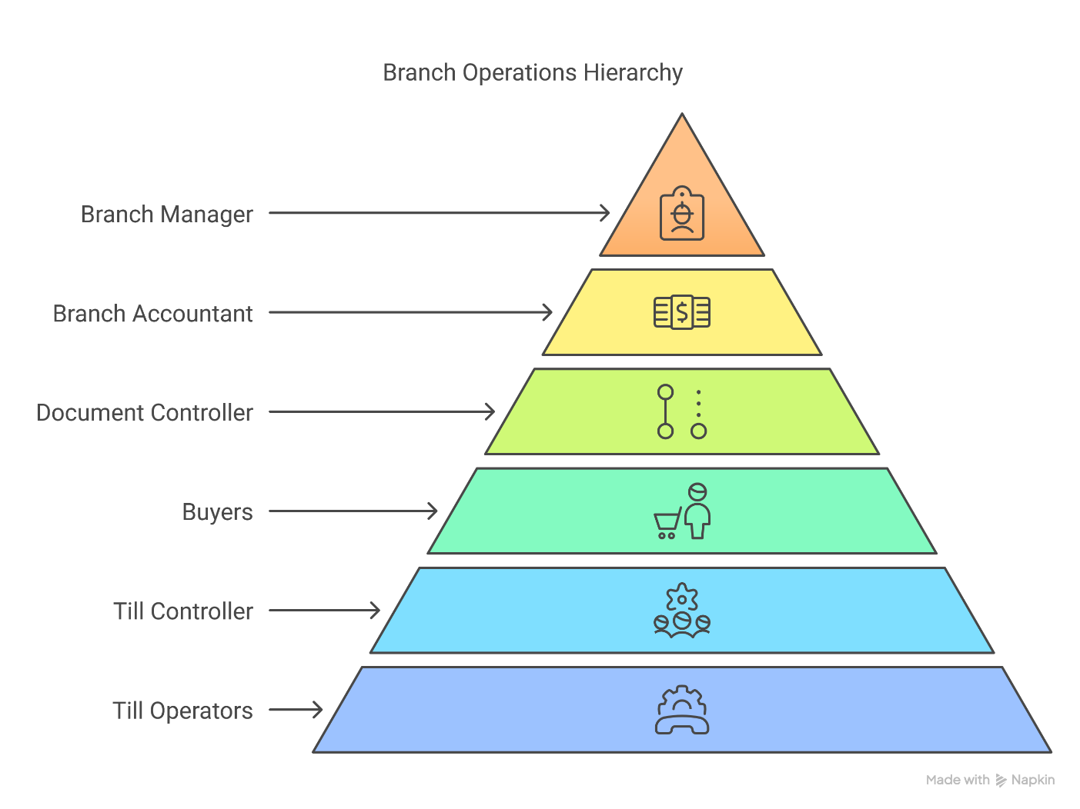

## 3.2 SWOT Analysis of Microsoft Dynamics 365 (D365)

**Strengths**

* **Integration with other Microsoft tools:** Seamlessly integrates with other Microsoft solutions like Office 365, Power BI, and Azure, offering a unified ecosystem that enhances productivity.
* **Scalability and Flexibility:** D365 can be scaled according to the needs of the business, supporting both small and large-scale operations with customizable modules.
* **Real-time data access:** Provides real-time insights and analytics across all areas of the business, allowing for informed decision-making and improved responsiveness.
* **Cloud-based and Mobile Access:** Being cloud-based, D365 offers remote access and flexibility, enabling users to work from anywhere, ensuring operational continuity.
* **Regular Updates & Support:** Microsoft offers continuous improvements and updates, keeping the software secure and up-to-date with industry standards.

**Weaknesses**

* **Complexity and Learning Curve:** The software can be complex to implement and may require significant training for users to fully leverage its capabilities, especially in areas like customization and reporting.
* **High Implementation Costs:** The initial setup and customization can be expensive, particularly for small businesses or organizations with limited budgets.
* **Dependence on Customization:** While highly customizable, D365 often requires third-party consultants (like **Braintree** and **Kenny Muchiri**) for specialized configurations, which may increase costs and time.
* **Resource Intensive:** Running D365 in-house or on-premises may require substantial hardware resources, which could lead to additional infrastructure investment.

**Opportunities**

* **Business Intelligence & Analytics:** With integrated Power BI, D365 offers advanced analytics and business intelligence tools that can be further leveraged to improve decision-making and identify new business opportunities.
* **Cross-Industry Capabilities:** D365 is adaptable across various industries (retail, finance, manufacturing, etc.), allowing for diverse use cases that can be expanded upon.
* **AI and Automation Features:** The introduction of artificial intelligence (AI) and machine learning features can optimize operations like inventory management, sales forecasting, and customer service.
* **Continuous Upgrades:** Ongoing updates from Microsoft could introduce new features that enhance functionality, improve user experience, or better align with business needs.

**Threats**

* **Competition from Other ERPs:** Strong competition from other ERP vendors like **SAP, Oracle, and Infor** could pose a challenge, especially in terms of pricing and specific industry offerings.
* **Security Risks:** As with any cloud-based solution, there are potential security risks such as data breaches or unauthorized access, despite Microsoft's strong security measures.
* **Customization Overload:** Over-customization can lead to system complexity, performance issues, or issues with updates and compatibility, especially when third-party consultants are involved.
* **Market Shifts and Changing Needs:** As business requirements evolve, D365 may need constant customization to adapt, which may increase costs and lead to slower response times if the system isn't agile enough.

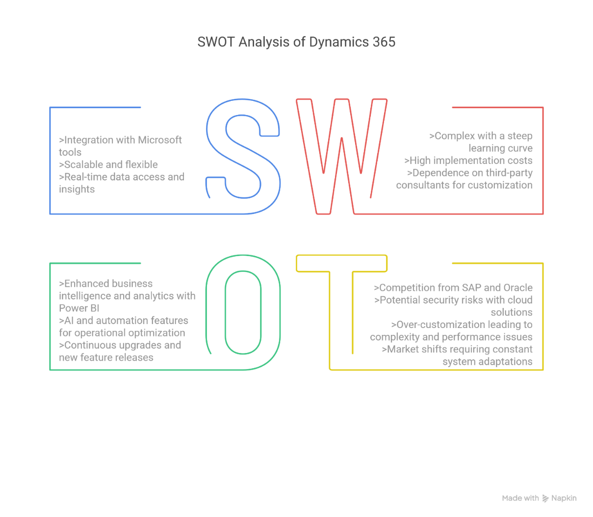

## ****3.3 Marketing Strategy****

* **In-Store Promotions:** Regular in-store promotions are held to attract and retain customers, including discounts, bundle offers, and loyalty rewards.
* **TV/Radio Advertising:** OK Zimbabwe leverages traditional media channels like TV and radio to increase brand visibility and communicate new product offerings or special promotions.
* **Customer Engagement:** A strong focus on customer service and personalized shopping experiences, enhancing loyalty and increasing foot traffic to stores.
* **Digital Presence:** OK is increasing its online presence, integrating digital channels like social media for marketing and customer interaction, and promoting e-commerce solutions where possible.

## ****3.4 Competitive Strategy****

* **Pricing:** OK Zimbabwe competes by offering competitive pricing across a wide range of products, making it a price leader for certain items.
* **Product Variety:** A wide selection of groceries and consumer goods, catering to different customer needs and preferences.
* **Superior Customer Service:** OK is committed to maintaining excellent customer service, which helps in building strong relationships and customer retention.
* **Store Network Expansion:** A larger store footprint compared to competitors, giving OK an edge in terms of accessibility for customers across the country.

# CHAPTER 4: RESPONSIBILITIES AS A STUDENT INTERN

## 4.1 Introduction

OK Zimbabwe is one of the biggest names in the country’s retail and enterprise space, and during my internship there, the writer got the chance to experience how a large organization runs its IT systems up close. This chapter looks back at the writer’s time at the company, the tasks he worked on, the lessons learned, and the projects he was part of.

From day one, OK Zimbabwe created a solid learning environment for the writer. He was able to take what he had learned in class and apply it in real business situations. The writer got involved in things like tech support, system testing, and helping roll out software updates. The way the company is structured, with a strong focus on teamwork, learning, and improving systems gave the writer the perfect space to build his practical skills in Computer Science.

This chapter covers the main duties the writer was given, like helping with User Acceptance Testing (UAT), supporting hardware, training users, and working on updates to enterprise systems. It also highlights some of the biggest wins during the internship, for example, coordinating the ShopEasy Wallet project, testing financial systems in D365, and solving support tickets using Fresh service.

You’ll also read about the new skills the writer picked up, not just technical ones, but also time management, people management, communication, and problem-solving. The writer talks about some of the challenges he faced too, and how he managed to keep learning and delivering even when things got tough.

Finally, the writer shares how this internship helped him grow as a future IT professional. It boosted his confidence, showed him where he is strong, helped him improve in areas he was weaker in, and gave him a clearer vision of the kind of career he wanted to build in information systems and enterprise tech.

## 4.2 Duties & Responsibilities

### 4.2.1 IT Technical Support

During the internship at OK Zimbabwe, the writer played an active role in providing IT support across different departments. His daily tasks included fixing hardware and software issues, setting up new computers and printers, and installing operating systems. The writer was also involved in configuring Point of Sale (POS) systems, making sure they were ready for use by the retail teams.

On the hardware side, the writer carried out repairs such as replacing hard drives, upgrading RAM, and swapping out screens. For software-related tasks, he handled installations, set up email accounts, and assigning IP addresses using IP Monitor. I also provided on-site support during stock take periods, ensuring all IT equipment was working properly so that the operations team could carry out their work without disruptions.

### 4.2.2 Systems Support via Fresh service

The writer was responsible for providing systems support using Fresh service, the company’s IT service management platform. Most of the writer’s work involved keeping an eye on support tickets that were assigned to his department, responding to faults logged by users, and making sure each issue was resolved quickly and properly. If the writer couldn’t resolve the problem remotely, he would use VoIP to call the person directly at their branch and walk them through a solution. Once everything was sorted out, I’d close the ticket in the system.

The writer also had to be careful not to let tickets go unattended for too long, as that would break our Service Level Agreements (SLAs). If a ticket stayed open for too long, the writer would have to do a Root Cause Analysis to explain why it wasn’t resolved on time. This role really sharpened the writers problem-solving and communication skills, and it gave him a solid understanding of how important quick, reliable support is in a busy organization.

Generally, faults that the writer would attend to include:

* Stock take uploading issues
* Statement posting issues
* Item journal posting issues
* User access issues
* Purchase order and transfer order issues

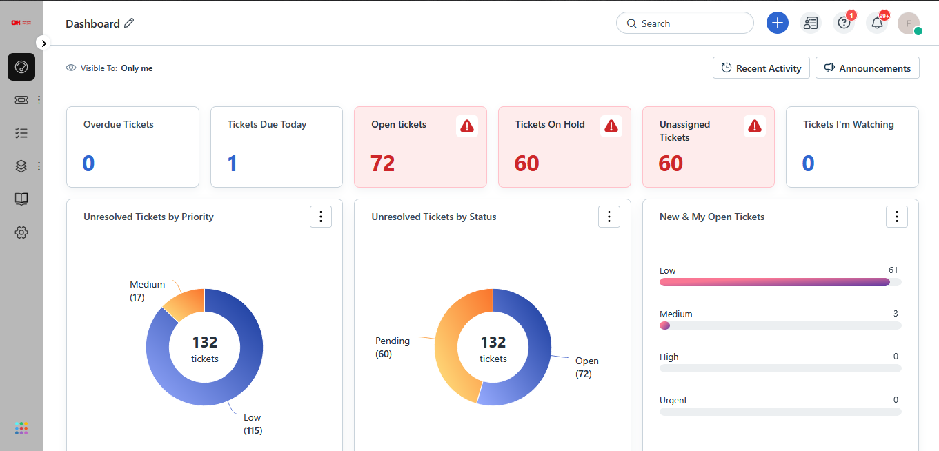

### 4.2.3 Documentation and Requirements Gathering

Other tasks also involved formalizing project handover and completion, system configurations specific to project requirements and troubleshooting. As a result of all the above endeavors, Standard Operating Procedures (SOPs), user acceptance sign offs and test cases for any new development/system upgrade were created. The documentation guaranteed the department was informed and proper upgrades were seamless, deadlines were met and that all technical matters needed were necessary and in line with the business needs. Furthermore, the writer assisted other departments in gathering the requirements for those features that needed additional enhancements on the ERP system so that the final technical output was in line with business wants/needs.

For personally allocated projects, the writer used Microsoft Project to monitor progress and requirements. This enabled me to give credible timeframes as well as status updates associated with the system changes for projects to remain within scope, schedule and budget. For project consistency, I also created SOPs to maintain uniform processes for all system-related tasks, which acted as a guide and rendered operational consistency. Overall, the tracking of projects and subsequent documentation was effective for departmental order and productivity.

### 4.2.4 Administrative Support (Scheduling & Coordination)

In addition to technical responsibilities, the writer provided administrative support such as scheduling meetings, coordinating with stakeholders, and preparing meeting minutes and action plans. These duties helped ensure project alignment and timely follow-ups, while also improving the writers organizational and communication skills.

### 4.2.5 User Access Management and Role Assignments

The writer performed user access requests and role assignments across multiple systems, including D365. If a request appeared to be valid and needed, he would generate a change request (CR). Once approved, the writer would then involve the database administrators to carry out the request and notify users of the changes once completed. This was a critical element to maintaining security and access, as the writer frequently assessed who could gain access to certain files or what approved levels of credits per role were.

In addition to managing access requests, the writer also conducted regular audits to ensure that user privileges were aligned with their roles and responsibilities. As part of my access control duties, I identified inactive user accounts, those that had not been accessed for 14 days, and disabled them. This was done through a SQL script that checked the users' last login dates, helping to prevent unauthorized access and maintaining the organization’s compliance and security standards. The writers’ efforts in access management contributed significantly to maintaining the integrity and security of the organization’s systems.

### 4.2.6 Batch Monitoring

As part of his responsibilities, the writer was tasked with batch monitoring for the D365 ERP system. This duty rotated monthly among the four people in the systems department, and the writer was on batch monitoring duty once a month. During his shift, the writer consistently checked the last document processed in the system. If there was a 30-minute gap with no document being processed, he had to immediately report this to the systems manager and the database administrator on duty. The monitoring was often supported through Fresh service, as users would log faults there if they noticed their documents were stuck in an unusually long "waiting" status. Batch monitoring also included monitoring the number of documents in ‘error’ status, a large number of documents in error could mean something is seriously wrong with the system so it’s also something the writer had to keep an eye out for. This proactive monitoring helped to ensure the smooth operation of critical financial and inventory-related processes, minimizing disruptions and maintaining data accuracy across the system.

### 4.2.7 User Training and Support

A big part of the internship involved training users on new system features and updates. Anytime there was a change, whether it was a new tool, an update to the ERP, or a completely new application it was the writer’s job to make sure people knew how to use it properly. One of the more memorable tasks was when we introduced the new stock take app. The writer was assigned to three branches and had to be there in person during their stock take operations. I actually spent a night at each branch, offering real-time support and guiding staff through the process to make sure everything ran smoothly.  
  
The writer also led training sessions for the rollout of the withholding tax feature, which was introduced to meet ZIMRA’s compliance requirements. For that one, the writer trained staff from two different branches using Microsoft Teams. These training sessions really sharpened his communication skills. The writer had to break down technical concepts in a way that made sense to everyone, regardless of their IT background, and make sure they felt confident using the new systems on their own.

### 4.2.8 Software Testing with Stakeholders

The writer worked closely with both users and developers during the testing process to guarantee that

system improvements were as expected and filled the users' requirements. The writer got the requirements in as much detail as he could from the users and sent them to the consultant for development. Once the development was done, the consultant would often talk with the writer in a follow-up meeting to clarify any further points that might have been needed. The writer then worked in the D365 test environment to test the fix.

When the writer was happy with the functionality, he would set up a UAT session with the users who had requested the change. The writer walked them through the functionality, taking the opportunity to comment on things they liked or didn't like and to ask questions. At every stage of this process, the writer took screenshots that would eventually populate the UAT document. He would also make a comment on the UAT document any time the users said they were satisfied with the results. If this was going a different route than expected, and particularly if the writer was getting a lot of comments that suggested the functionality still needed some work, he would take note of this unfriendly feedback and use it as motivation to note down the necessary changes before finalizing the UAT.

### 4.2.9 Report Building and Dashboard Customization

The writer played a key role in building reports and customizing dashboards using Power BI, with a focus on making existing reports more useful and easier to understand. The writer worked on modifying reports to better match what users actually needed, double-checking that the data was accurate, and making sure the visualizations clearly highlighted the important business insights. One project the writer was especially proud of was automating the batch report. It used to be done manually, but by using Power BI and Report Builder, the writer turned it into an automated process where all team members receive the report at 2 scheduled times without any human intervention. This saved a lot of time and made it much easier to generate accurate, up-to-date batch reports.

The writer worked closely with the IT team to make sure the reports we produced actually helped them make informed decisions. This gave the writer real-world experience in how tools like Power BI support business strategy. It also helped him sharpen his data analysis skills and gave him a clearer picture of how business intelligence fits into the bigger picture of corporate operations.

### 4.2.10 Project Management

The writer was involved in project management activities throughout the industrial attachment at OK Zimbabwe. One of the notable projects was the implementation of the ShopEasy Wallet, a digital payment solution aimed at enhancing customer convenience. The writer participated in planning sessions, assisted with requirements gathering, and supported progress tracking during the development and testing phases. This role required collaboration with internal stakeholders and the documentation of functional and non-functional system requirements.

Additionally, the writer contributed to the management of Microsoft Dynamics 365 (D365) system modifications. This involved coordinating User Acceptance Testing (UAT), compiling user feedback, and engaging with both developers and departmental heads to ensure the timely deployment of changes. Through these responsibilities, the writer gained hands-on experience with structured project workflows and cross-functional communication in a corporate IT environment.

## 4.3 Accomplishments/Milestones

During the internship at OK Zimbabwe, the writer reached several key milestones that significantly contributed to the success of various IT and system projects within the organization.

* **ShopEasy-Wallet:**  
  The writer played an integral role in the development and enhancement of the ShopEasy Wallet project, particularly focusing on system testing and user feedback. The writers work contributed to the refinement of the mobile payment system, which aimed to address currency conversion issues and improve transaction efficiency for customers and employees. The successful roll-out of key features within the ShopEasy Wallet project marked a major milestone in the organization's ongoing efforts to streamline financial processes.
* **Batch Report Automation:**

One of the writers most impactful contributions was automating the batch report process, which was previously done manually. By utilizing Power BI and Report Builder, the writer built an automated reporting system that significantly reduced the time and effort required for generating the report. This automation improved data accuracy, enhanced efficiency, and provided stakeholders with timely access to critical information.

* **Stock Take Training:**

As part of the rollout of the stock take application, the writer was tasked with training users at three branches. The writer spent a night at these branches, offering on-the-ground support during the stock take process. This hands-on training ensured that employees could effectively use the application and complete their stock takes without issues, leading to improved accuracy and efficiency during the process.

* **Withholding Tax Training:**

The writer also contributed to the training process for the new withholding tax feature implemented in compliance with ZIMRA regulations. He conducted training sessions for two branches using Microsoft Teams, ensuring that staff understood the tax process and how to properly navigate the new system. This training supported compliance and helped ensure the smooth integration of the new feature into the organization's financial operations.

* **Ocasta Setup and Branch Review System:**

The writer was involved in the setup of Ocasta, the branch review system. This included configuring the system to meet branch-specific requirements, ensuring that the review process was smooth, and testing the functionality of the tool. The user created review templates, worked with the branch teams to identify any issues, and ensured that the system functioned properly, providing the company with a reliable tool to track and manage branch performance.

* **Company Migration (Currency Transition):**

Another significant milestone was managing the company’s migration from a system with ZWL (Zimbabwe Dollar) as the base currency to a new system with USD as the base currency. This involved extensive planning, testing, and coordination with multiple teams to ensure a smooth transition. The writer supported data migration, ensured accurate currency conversion rates were applied, and provided training to staff on how the new system would function with the USD as the primary currency. This transition allowed the company to better align its financial reporting and operations with the global market.

Each of these milestones represented a significant accomplishment and helped the writer develop both technical and soft skills, while also contributing to OK Zimbabwe’s operational efficiency, compliance, and long-term strategic objectives.

## 4.4 Problems Encountered

During the internship at OK Zimbabwe, the writer encountered several challenges that tested his ability to balance competing priorities, meet organizational expectations, and manage personal development goals. These experiences were not only pivotal for his professional growth but also taught him valuable lessons in time management, work-life balance, and conflict resolution.

**Balancing Technical Support with Learning Objectives**

One of the earliest challenges faced was reconciling hands-on technical assistance with learning goals in the areas of systems development and business intelligence. As an intern, the writer was responsible for addressing user tickets in Fresh Service, resolving IT software and hardware problems, and training users. As important as these duties were to the success of the business, they were at times all-consuming, leaving little time to focus further on deeper technical topics the writer was interested in learning about, including database tuning and complex Power BI report development.  
To deal with this dilemma, the writer formulated a plan to manage time better. he made himself a daily routine where he set aside dedicated time for closing support requests, training, and learning. With the assurance of well-planned daily tasks, the writer was better able to balance the critical needs of the job with learning to obtain higher-level skills. The writer also informed the supervisor about learning goals, and it provided him with intermittent chances to work on higher-level projects, like batch report automation using Power BI, which fit better with learning objectives.

**Dealing with Evolving Project Requirements**

Another difficulty encountered was the dynamic nature of projects and the way it sometimes raised a contradiction concerning the writer’s role in the system support team and the necessity for formalized project work, such as requirements gathering and testing. For example, in working actively on system support processes like monitoring batch jobs and troubleshooting problems, the writer was at the same time working on more strategic projects, such as the deployment of the ShopEasy Wallet and the implementation of the withholding tax feature. These projects needed thorough planning, documentation, and testing, which at some times were hard to balance with my routine support work.  
To resolve this, the writer adopted a proactive mindset by prioritizing and coordinating well with colleagues. For instance, in the launch of the ShopEasy Wallet, the writer made it a must to schedule particular time allocations for training and UAT as well as attending to urgent system requests. The writer coordinated with the project teams to agree on prioritizations and set expectations by giving explicit timelines for the accomplishment of each task. This enabled the writer to satisfy both short-term operational requirements and longer-term project requirements without compromising work quality in both areas.

**Managing Work-Life Balance**

Work-life balance was another significant challenge that the writer had to navigate. The demands of an internship can often be intense, and the writer found it crucial to establish boundaries to avoid burnout. To help maintain a healthy balance, the writer took time in the evenings to go to the gym. This routine not only allowed him to clear his mind and relax but also helped him recharge and stay focused during work hours. Furthermore, the systems manager recommended that everyone in the department dedicate at least 30 minutes a day to reading or furthering their knowledge. This practice helped the writer stay intellectually engaged while managing the stress of the daily workload. By incorporating these practices, the writer was able to maintain a balanced perspective and remain productive without sacrificing my personal well-being.

**Managing Task Overload from Certain Individuals**

One of the ongoing challenges encountered was having to take on some of the minor, everyday work from some team members. This type of work tended to be time-consuming but trivial in nature, i.e., preparing for meetings or handling emails back and forth. The writer understood that, as an intern, he was there to contribute to the team, yet the extra workload hindered him from accomplishing the main duties in addition to his individual development targets. This was most difficult to manage with some strict deadlines, such as helping deploy a system or test out some sort of new feature.  
In order to deal with this, the writer took a proactive role in setting appropriate boundaries around the work. The writer would determine the priority of the jobs and, where possible, push back against ones which are not urgently needed, citing that they overlapped with his primary duties. The writer openly discussed the workload with supervision and peers, and they were accommodating and assisted to redistribute jobs where appropriate. With practice, the writer grew to feel increasingly comfortable managing expectations and prioritizing jobs.

**Navigating User Expectations vs. System Limitations**

Another common problem was dealing with user expectations, specifically when they asked for modifications to the system or enhancements which were not possible at the time due to technical constraints. For example, users tended to ask for specially tailored reports or fresh features which would call for extensive changes to the current ERP system (D365). Although the writer recognized the necessity of such improvements, he was also aware of the limitations of the system, the possible ramifications for business operations, and the amount of development time needed.

To solve this, the writer collaborated closely with both the development team and the users to control expectations. The writer would collect the user requirements and formally document them and then explain any constraints or timelines to the stakeholders. Through maintaining transparent communication and working openly with the developers, the writer set realistic expectations from the standpoint of both timelines and functionality. This not only kept users up-to-date but also allowed the writer to have the right balance of user satisfaction and system feasibility.

**Adapting to New Tools and Technologies**

Finally, the need to quickly learn and adapt to new tools and technologies sometimes presented a challenge. For example, the writer had no prior experience with Dynamics 365 or the Adobe e-signing tool before the internship, both of which he needed to use frequently. Initially, the writer struggled to get up to speed with these tools, particularly when it came to assigning people to sign the document in a specific order in Adobe e-sign tool.

To overcome these challenges, the writer took a self-driven approach by dedicating extra time after hours to study these tools. The writer also sought guidance from more experienced team members when necessary. Over time, the writer became more proficient with these tools, which not only helped him complete his daily tasks more effectively but also contributed to my overall technical growth.

In summary, the problems encountered during the internship provided the writer with valuable learning experiences. By refining his time management skills, improving communication, and adapting to new tools and technologies, the writer was able to resolve conflicts between his personal learning objectives and the demands of the organization. These experiences have better equipped the writer to handle complex work environments and competing priorities in the future.

## 4.5 How Experience Impacts Career

At the beginning of the internship at OK Zimbabwe, the writer viewed his key strengths as technical expertise in systems support, specifically in the fields of hardware troubleshooting, simple software configurations, and navigation of ERP software such as D365. The writer further felt that the database management skills gained from academic projects offered an upper hand in dealing with challenges in a real-world business setting. It became apparent to the writer within no time, however, that practical skills in troubleshooting and working with users, as well as performing under pressure, were in need of refinement. The writer’s skill at conveying technical information in simple terms was one area in which he felt needed to improve. The writer further noted that he needed to develop skills in project management, specifically within the corporate setting.

One of the primary manners in which the internship influenced the writer’s career was by enabling him to expand and reinforce his technical skills. The writer was in a position to apply theoretical knowledge from the classroom to practice through performing routine IT support functions like fixing issues with software and hardware, monitoring batch jobs, and granting access to the system. As the writer interacted regularly with users, he enhanced the skill to explain technical problems in simple language, thus developing communication skills. For instance, during the implementation of new system functionalities like the withholding tax mechanism and the ShopEasy Wallet, he undertook training and user acceptance testing, in which he learned to explain intricate information in simple and well-organized language. This learning certainly boosted the capability to better communicate with different stakeholders, both technical and nontechnical, which is one of the most important strengths in the business and IT industries.

The internship also enabled the writer to refine areas in which he was weak, specifically in the area of managing projects. With projects such as the setup of the Ocasta branch review system and the transition from a firm using ZWL as base currency to one using USD, the writer was able to experience hands-on practice in managing workflows, coordinating meetings, and managing documentation. The writer worked with project trackers, extracted requirements, and worked with teams to test and implement modifications to systems. This assisted the writer in gaining confidence in managing projects, deadlines, and documentation, all skills he was looking to acquire but with minimal experience prior to the internship.

In addition, the experience boosted time management capabilities. Initially, the writer had challenges juggling technical support work with personal development, particularly where the workload became heavy. However, during the internship period, the writer mastered the art of task prioritization, coordination with teams, and delegating where possible. For instance, as part of batch monitoring duty, the writer needed to ensure critical batch jobs ran correctly while still being prepared to troubleshoot user tickets and attend to other duties. By juggling multiple tasks and having a structured method of time management, the writer gained increased discipline and concentration, which will serve him well in the career to come.

As far as areas of growth, the writer initially wrestled with maintaining work-life balance. There were high-pressure moments during the internship where the writer was responsible for many different projects, and sometimes it seemed too much to handle. The writer coped with it, however, by creating a routine where he regularly exercised and set aside time for developing myself, like reading technical articles and research. The system managers’ advice to spend 30 minutes every day reading was specifically helpful to keep myself mentally charged. This piece of advice helped me to balance well-being and professional growth, something the writer will take with him for the rest of my working life.

In the long run, the internship exposed the writer to priceless experiences, not only validating his strength but also correcting any weaknesses. The writer feels even more comfortable at the technical level, in managing projects, and in communication within the organizational setting. With the transition to professional life, all these experiences have contributed heavily to shaping me into a better-rounded, productive, and resilient professional.

# CHAPTER 5: RECOMMENDATIONS & CONCLUSION

## 5.1 Areas Exposed To & Skills Obtained

* **Systems Analysis and Problem-Solving**

The writer enhanced his ability to break down complex IT issues into manageable components, a core skill in systems analysis. Tasks such as identifying and resolving ERP-related issues, investigating system errors, and processing access requests sharpened the writer’s troubleshooting approach, aligning well with the analytical demands of a Computer Science graduate.

* **Technical Support and IT Service Management**

By managing IT service tickets through Freshservice and resolving hardware/software issues across head office and branches, the writer gained practical experience in IT support workflows. This contributed to a deep understanding of service-level agreements, incident tracking, and support documentation — key areas in enterprise IT systems.

* **Enterprise Software Proficiency (ERP/D365)**

Supporting Microsoft Dynamics 365 (D365) allowed the writer to understand how enterprise resource planning software functions at scale. Tasks included testing new features, drafting and processing change requests, and participating in UATs, which improved the writer's familiarity with integrated systems used for finance, logistics, and operations.

* **Software Testing and Quality Assurance**

The writer actively participated in software testing, particularly through UATs, for D365 enhancements and internal tools. This involved validating system behaviour, documenting bugs, and retesting fixes, strengthening the writer’s skill in quality assurance — a key area of software engineering.

* **Business Intelligence and Data Visualization**

The writer worked with Power BI to generate reports for stock, vendor transactions, and batch job monitoring. These tasks improved the ability to transform raw data into actionable insights, a valuable competency in fields like data science, analytics, and decision support systems.

* **Project Management**

The writer coordinated cross-functional projects, including system deployments like the ShopEasy Wallet and the compliance system for withholding tax. Key activities involved requirement gathering, documentation, scheduling, and overseeing UATs. These tasks built strong foundations in project lifecycle management, aligning with core principles of software project management.

* **User Training and Communication**

Through training branch users and head office teams on new applications (e.g., stocktake app, D365 modules), the writer refined the ability to communicate technical concepts to non-technical audiences. This experience strengthened soft skills like leadership, collaboration, and user engagement — all crucial in systems analysis and IT consultancy roles.

* **Networking and System Administration**

Exposure to setting up email accounts via Linux CLI, troubleshooting network printers, and resolving connectivity issues provided practical experience in system and network administration. These align with core modules in operating systems and computer networks.

* **Time Management and Prioritization**

Balancing support requests, documentation tasks, project coordination, and system testing taught the writer how to prioritize work under pressure. These time management skills are essential for high-performance roles in development and support environments.

* **Collaboration in Agile Environments**

By working with developers, finance teams, branch staff, and external consultants, the writer experienced fast-paced, collaborative workflows. These align closely with agile development methodologies emphasized in modern Computer Science practice.

## 5.2 Recommendations to Operational Problems

* **Integrate Real-Time Communication with Ticketing System**

While Freshservice is a reliable IT support platform, the writer recommends integrating it with real-time communication tools such as Microsoft Teams or Slack. This would enhance collaboration within the IT team and improve response time for critical issues, especially those requiring immediate resolution or cross-departmental coordination.

* **Enhance Training with Interactive and On-Demand Tools**

The current training approach is effective but could be further improved through the addition of live simulations and interactive webinars. The writer suggests incorporating hands-on practice sessions alongside post-training resources like video tutorials or quick reference guides. These would increase knowledge retention and enable employees to confidently apply new system features in real scenarios.

* **Automate Batch Job Monitoring and Alerts**

Monitoring batch jobs manually can result in delayed response to failures. The writer recommends implementing automated alerts (e.g., via email or instant messaging) that notify responsible staff of failures or processing delays. This proactive approach would prevent disruptions, reduce the burden of constant manual checking, and allow the team to focus on higher-value tasks.

* **Standardize Change Request Lifecycle and Tracking**

During the internship, the writer observed variations in how change requests are documented and followed up. Introducing a standardized CR lifecycle with clearly defined approval stages, automated tracking, and linked documentation would improve clarity and accountability in change management processes.

* **Digitize and Centralize Training Feedback Mechanisms**

The writer proposes establishing a centralized digital feedback platform (e.g., Microsoft Forms or SurveyMonkey) for collecting training and system rollout feedback. This would streamline feedback collection, make analysis easier, and enable the IT department to refine future rollouts based on employee experience.

* **Improve Onboarding Experience for Interns and New Staff**

The initial onboarding process for interns could be made more efficient by creating a structured onboarding checklist, access provisioning guide, and documentation of frequently used systems. This would reduce the learning curve and enable new team members to become productive more quickly.

## 5.3 Observations Based on Analytical Basis

From the organizational side, something that the writer felt stood out was a reliance on manual processes for specific operations like batch job monitoring and report generation. Although the methods have been adequate, the writer thinks that substituting some of the processes with automated ones and applying predictive models will help streamline operations even further. For instance, applying machine learning algorithms to forecast batch job failures or applying data analytics to drive appropriate inventory levels will help the organization to act pre-emptively instead of reactively.

In addition to this, the writer noted that the training procedures of the company, although efficient, have the potential to be enhanced with the incorporation of interactive learning tools and newer technologies. Learning management systems and gamification may bring about increased employee involvement and knowledge retention. With technology deployment in training and system utilization, employees will be better equipped with tools and systems, which will ultimately lead to greater overall efficiency and less downtime.

## 5.4 Implementation Based on Tested Prototyping, Simulation, & Modeling

The deployment of innovations like the batch job alert automation might be experimented with in a test environment prior to institution-wide deployment. In the same way, training system improvements could initiate with pilot projects, where interactive training modules and follow-on support are experimented with in a smaller group before being scaled up.

Simulation runs to simulate the effect of the modifications will give insight to how well they will work and where they might still require fine-tuning before they are widely applied.  
Prototyping and simulation are equally important in facilitating system enhancements and software testing. For example, the addition of new features or updates might be tried out in a sandbox environment to confirm that they will smoothly integrate with current systems without interfering with everyday operations. This would minimize the risk of unforeseen downtime during real implementation and increase the overall dependability of the Information Technology infrastructure.

## 5.5 Required Textbook & Learning Tools

During the internship, the writer found that online learning material especially from YouTube, were invaluable in supporting growth and career development. The information covered in these videos helped the writer understand the theory behind the practices he implemented, such as troubleshooting, user access control, and data visualization using Power BI.

Additionally, online learning platforms and technical resources such as Microsoft’s documentation for D365, Power BI, and Fresh Service were indispensable. These resources helped to solve complex technical problems, build reports, and gain proficiency in managing ERP systems. Access to these tools significantly enhanced my understanding of the systems the author worked with, allowing him to be more self-sufficient and efficient in his role.

## 5.6 Conclusion of the Experience

Generally, the internship at OK Zimbabwe was very rewarding and exposed the writer to valuable experiences about the operations of IT in a large corporate setup. The writer learned significantly in the areas of systems administration, software testing, user support, and projectsmanagement. Exposure to practical real-life IT challenges enabled the writer to bridge the gap between theoretical learning achieved in the classroom to the practical skills demanded in the working environment.

This internship enabled the writer to identify and build on my strengths like problem-solving and technical communication, as well as work to overcome his weakness in time management and handling projects. It has been instrumental in the writer’s career development, equipping him with the skills and assurance to pursue a career in business and information technology management. The writer eagerly anticipates utilizing the knowledge gained in the future and feels grateful to have been in a position to contribute to the success of OK Zimbabwe during the internship.

# REFERENCES

Caldwell, A. (2020). 9 Key ERP Implementation Best Practices. Oracle NetSuite [Online]. Available at: https://www.netsuite.com/portal/resource/articles/erp/erp-implementation-best-practices.shtml.

Freshworks, Inc. (2024). Managing Agents in Freshservice. Freshservice Support [Online]. Available at: https://support.freshservice.com/support/solutions/articles/204591-managing-agents-in-freshservice.

International Organization for Standardization (ISO) (2018). ISO/IEC 20000-1:2018 Information technology – Service management system requirements [Online]. Available at: https://www.iso.org/standard/70636.html

ISACA (2012). COBIT 5: A Business Framework for the Governance and Management of Enterprise IT. Rolling Meadows, IL: ISACA.

Microsoft Corporation (n.d.). Microsoft Dynamics 365 documentation [Online]. Available at: https://learn.microsoft.com/en-us/dynamics365/

Microsoft Corporation (n.d.). Power BI documentation [Online]. Available at: https://learn.microsoft.com/en-us/power-bi/

OK Zimbabwe Limited (n.d.). Annual Reports [Online]. Available at: https://okziminvestor.com/investor/annual-reports/

OK Zimbabwe Limited (2019). Governance [Online]. Available at: <https://okziminvestor.com/governance>

# APPENDICES

## Appendix A:

Snapshot of the automated Batch Report in Power BI

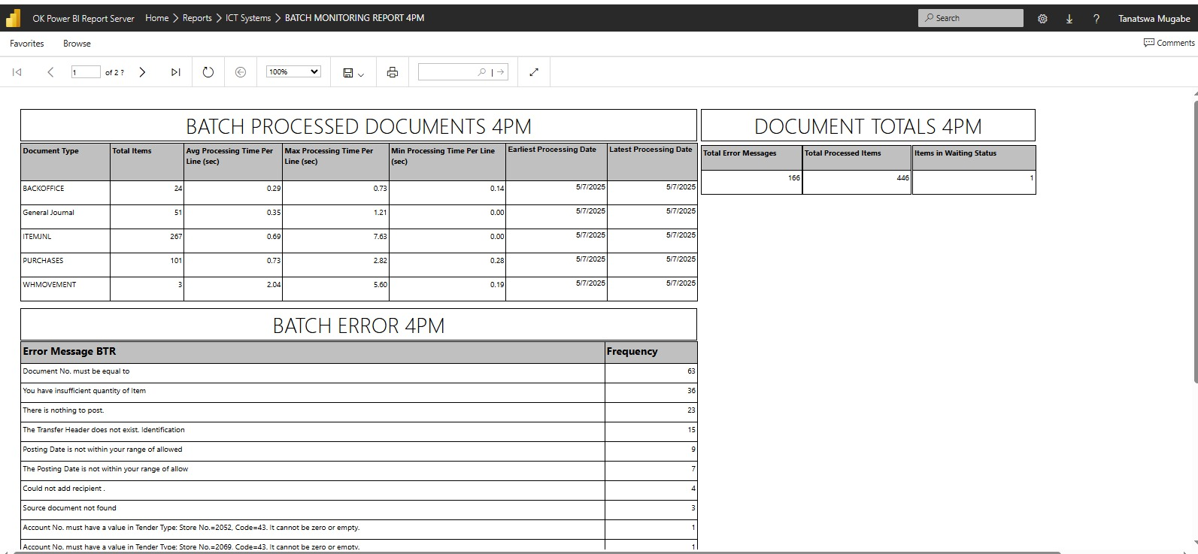

## Appendix B

Dynamics 365 Landing Screen

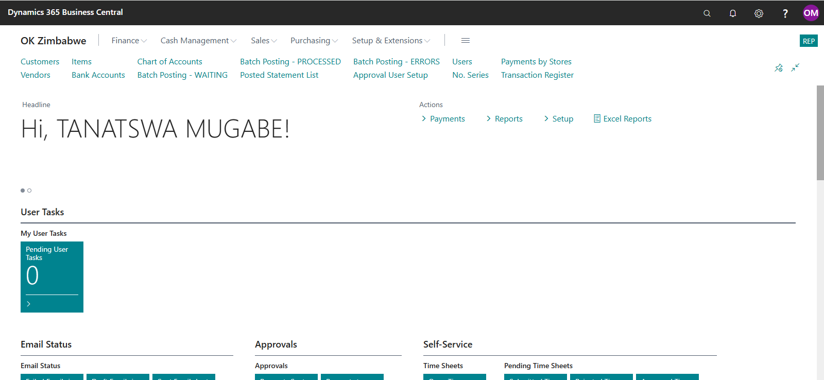

## Appendix C

OCASTA snapshot

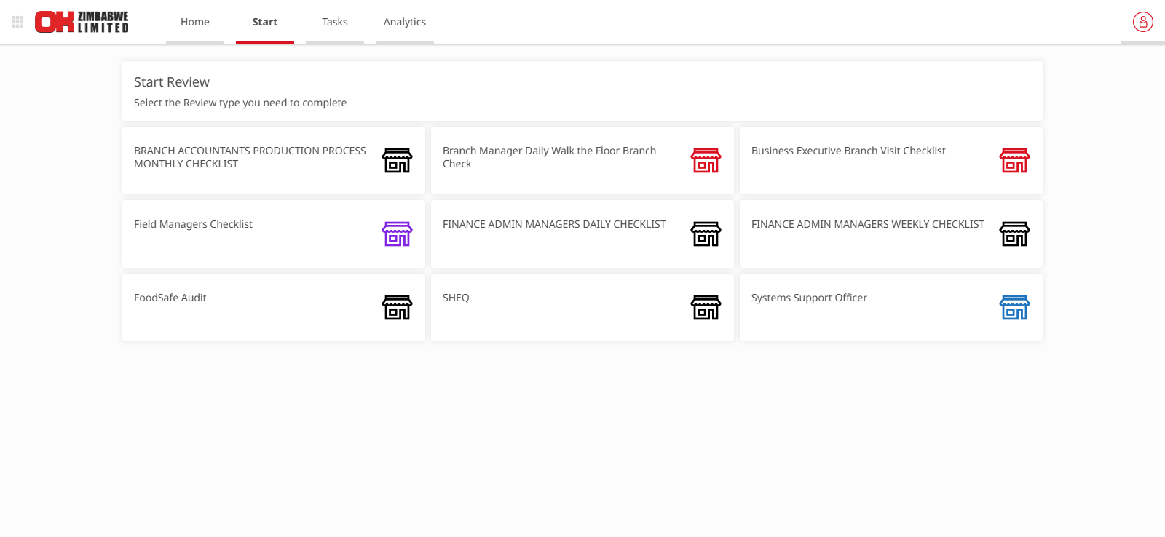

## Appendix D

Fresh Service snapshot

