 | JUNIOR COURT CLUB

JCC Activity Report
Name of Activity: | Know Your Constitution: Picture My Rights – First Career Guidance Day
Team Members: | Bridgetti Mambondiani (Director), Tatenda Gabi (Communications Officer) & Tania Chipo (Fundraising and Research Officer)
Venue: | Zengeza 1 High School
Date: | 22 May 2026
Time: | 09:00am to 14:00pm
Methodology | Facilitation, Arts, Drawing and Painting — participants traced their hands and wrote their favourite constitutional right inside, using marker pens on white cloth
Objective(s) | ❖ To increase young people's understanding of the constitution and their rights.  ❖ To integrate constitutional rights awareness into the school's first Career Guidance Day, linking rights knowledge to informed life and career choices.

Number of Participants | Target | Actual | Explanation for Target vs. Actual difference | M | F
 | Not fixed | 200+ | Event held on the school premises, drawing a much larger crowd than a standalone JCC event | N/R | N/R
N/R = not recorded on the day; gender breakdown was not captured given the scale of the school-wide turnout.
Introductions/Welcome Remarks

The Junior Court Club team was welcomed onto the school premises for the first Career Guidance Day held in partnership with Zengeza 1 High School. The Director, Bridgetti Mambondiani, and Communications Officer, Tatenda Gabi, introduced the Junior Court Club and the "Picture My Rights" activity to the assembled students as part of the day's programme, alongside the school's broader career guidance sessions.

Summary of Presentations

Following the introductions, the Picture My Rights activity was rolled out as one of the featured sessions of the Career Guidance Day. Each participant traced the outline of their own hand onto a large shared piece of white cloth and, using marker pens, wrote the constitutional right that mattered most to them inside the outline. Given the scale of the turnout, the cloth quickly filled with hundreds of hand tracings in a wide range of colours, forming a large collective mural under the banner "Picture My Rights."
The rights written by the students give a clear picture of how young people at Zengeza 1 High understand and prioritise their constitutional rights. Several broad themes emerged:
❖ Basic needs and survival: many hands were labelled with the right to food, water, shelter, health services and a birth certificate — reflecting how strongly these everyday needs feature in students' understanding of their rights.
❖ Family and belonging: a significant number of entries referenced the right to family life and care, having a family, parental guidance, and love — showing that students closely link their rights to relationships and home life.
❖ Voice and participation: several students wrote the right to be heard, freedom of speech, and the right to vote, indicating a growing awareness of civic participation and self-expression.
❖ Growth and personal development: education and freedom of thought and religion featured prominently, alongside more personal entries such as the right to have a boyfriend/girlfriend, money, and fun — suggesting students also interpret their rights in terms of personal choice and adolescent life experience.
❖ Protection and security: entries such as shelter, guidance, and "power and to be loved" pointed to an underlying desire for safety and support.
This mix of responses — spanning survival needs, family, civic voice, education, and personal autonomy — demonstrated that the drawing exercise successfully created space for students to relate constitutional rights to their own lived realities rather than reciting them abstractly. Facilitators used the shared mural to draw out discussion on how each of these rights is protected under the Constitution of Zimbabwe, closing the loop between the art activity and the day's civic education objective.

Stakeholders Present

Zengeza 1 High School (host institution and co-convener of the Career Guidance Day) and other invited organisations.

Successes

❖ Huge turnout of over 200 participants, exceeding the numbers typically reached at a standalone JCC event.
❖ Successful integration of the Picture My Rights activity into a wider school Career Guidance Day, reaching students who may not otherwise engage with a dedicated rights-awareness event.

Lessons Learnt/ Observations

❖ Hosting the activity within a school-wide event significantly boosts participation and reach.
❖ The hand-and-cloth format works well at scale, giving even very large groups of students an individual, tangible way to express which rights matter most to them.
❖ Students' choices of rights reveal a strong link in their minds between constitutional rights, family life, and personal/career aspirations — useful insight for designing future Career Guidance Day content.

Challenges and Recommendations

❖ Limited resources: the scale of the turnout stretched the markers, cloth, and materials available. There is need for more funding and bulk supplies when planning activities pegged to large school-wide events.
❖ Recommend budgeting in advance for large-turnout events (e.g. additional cloth/markers and extra facilitators) so that every participating student can be accommodated comfortably.

PICTORIAL EVIDENCE:
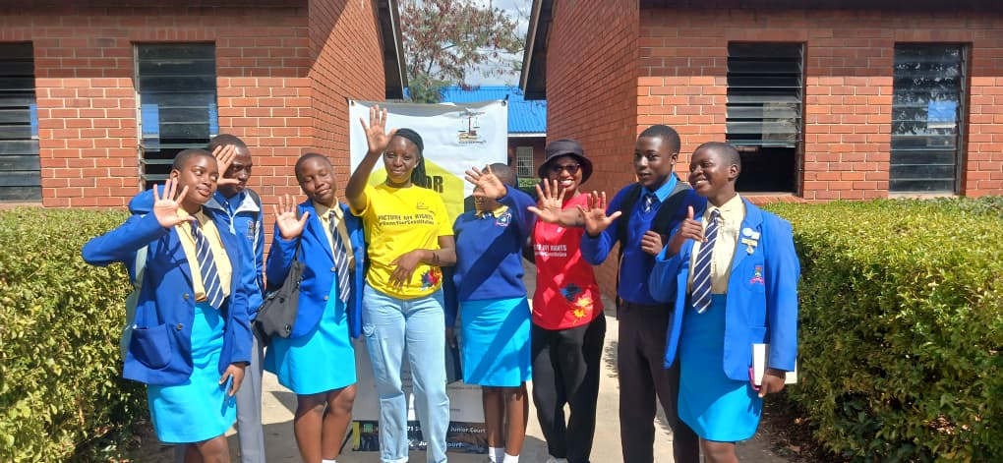 | 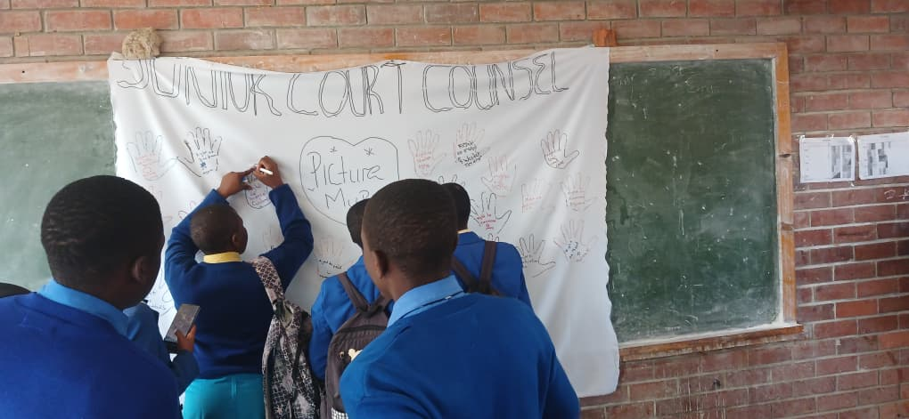
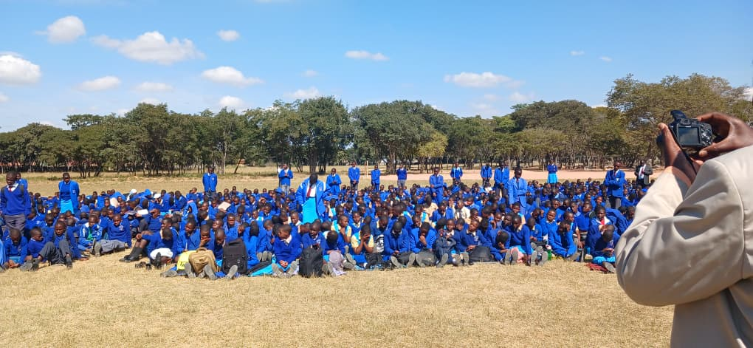 | 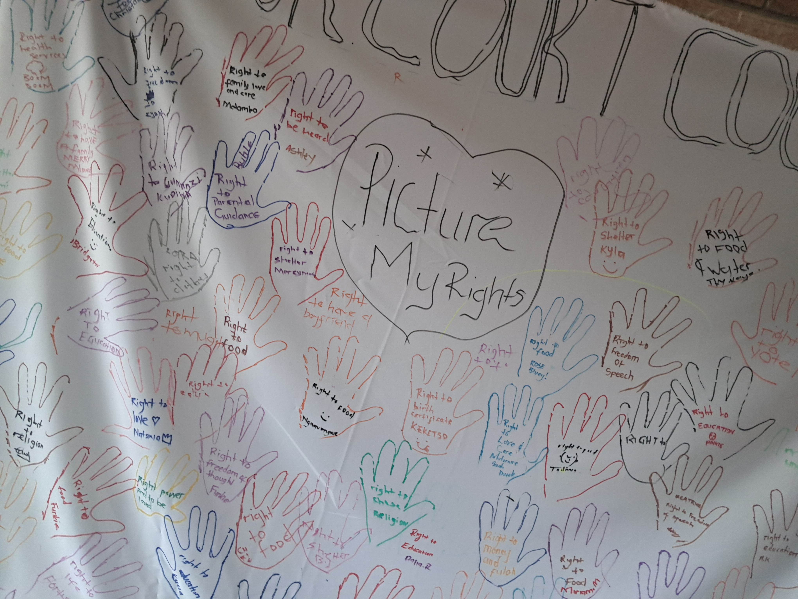
JCC team and students at Zengeza 1 High School; students adding their hand tracings to the "Picture My Rights" mural; the full student turnout at the Career Guidance Day; and the completed mural.
Compiled by | Tania Chipo
Verified by | Pending

