**Use case model**

**Actors identification**

Federation

* Message to referee
* Message to club
* Score board
* Top scorer
* Schedule
* Make game
* Advert
* Public news
* Verification code to club
* Login
* Logout
* Register
* Comment
* view profile
* Forgot password
* Update.

Referee

* Fill goals and penalty
* Login
* Logout
* Register
* view profile
* Forgot password
* Update.

Player

* Login
* Logout
* Register
* view profile
* forgot password
* Update.

Club

* assign player information
* message to player
* verification code to player
* Login
* Logout
* Register
* view profile
* forgot password
* Update.

Supporter

* comment
* Login
* Logout
* Register
* view profile
* Forgot password
* Update.

**Use case identifications**

Our system includes the following use case: -

* Message to referee
* Message to club
* Score board
* Top scorer
* Schedule
* Make game
* Advert
* Public news
* Verification code to club
* Comment
* view profile
* forgot password
* Update assign player information
* message to player
* verification code to player
* register
* Check
* Notify
* Chack membership
* Login
* Authenticate
* Error
* View message
* specific
* general
* Assign player info
* kit_num
* salary
* position
* manage game
* yellow card seen
* red card
* goal for club
* goal_player
* manage account
  + - * view profile
      * update profile
      * delete profile
* Logout

**Use case diagram**

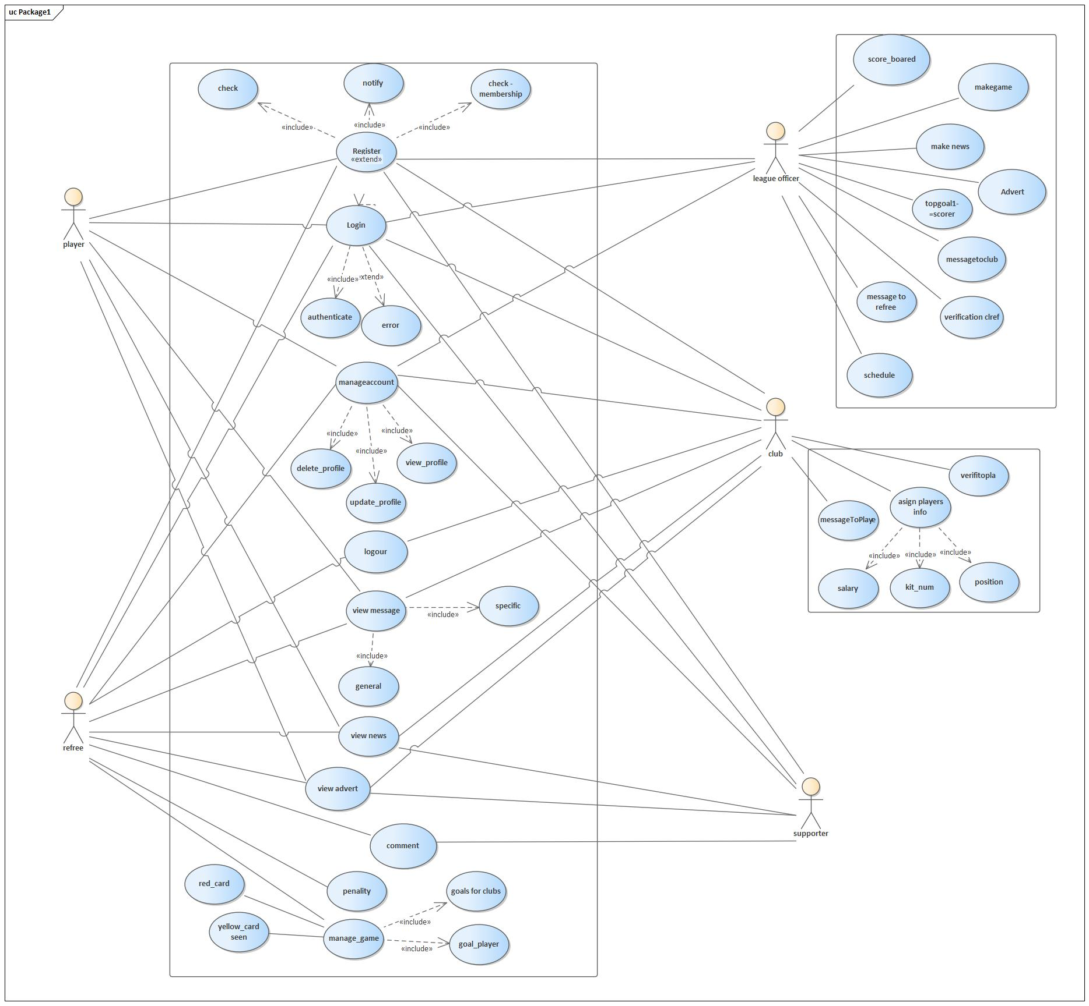

**Use case description**

|  |  |
| --- | --- |
| Use case name | Register |
| Use case ID | 01 |
| Use case description | To check/notify/ check membership of users in the database |
| Actor | All user |
| Pre-condition | Users must have smart device, Internet connection and They have to navigate to leagues URL |
| Post-condition | All users successfully notify/ check /check membership. |
| Main flow | 1. User open the system 2. User clicks register as ___ button depending on belonging of his group 3. Registration for will be displayed 4. User fills required and optional fields 5. Click Register button 6. The user will be redirected to login page |
| Exceptional flow | * When the user clicks a group where he is not belonging to the system, the system asks verification code generated by officer and the system display “you are not registered” * When the user enters wrong data to the system, the system displays “ please input correct data” |
| 0Include | Check, notify ,check membership |
| Business rule | - |
| Frequency of use | Depends on the users of the system |

|  |  |
| --- | --- |
| Use case name | Login |
| Use case ID | 02 |
| Use case description | To authentication |
| Actor | All user |
| Pre-condition | Users must have smart phone, username and password and internet connection is available. |
| Post-condition | Login to actor page / leave from page |
| Main flow | 1. User open the system 2. The user enters username and password 3. Click login button 4. The system redirects to homepage (display his appropriate page) |
| Exceptional flow | When the user fills invalid username and password the system displays incorrect message and notifies the user to enter the correct data |
| Include | Error , authenticate |
| Business rule | - |
| Frequency of use | Ounce on every user |

|  |  |
| --- | --- |
| Use case name | Score board |
| Use case ID | 03 |
| Use case description | Show the result of the club |
| Actor | All user(public) |
| Pre-condition | User must have smart device, and they have to navigate to the leagues URL and Admin should release the result |
| Post-condition | See the result on the scoreboard |
| Main flow | 1. The user opens the system- 2. Clicks score board button 3. Scoreboard page will displayed |
| Exceptional flow | - |
| Include | - |
| Business rule | - |
| Frequency of use | Depends on user |

|  |  |
| --- | --- |
| Use case name | Generate verification code |
| Use case ID | 04 |
| Use case description | To provide the verification/confirmation code |
| Actor | League officer |
| Pre-condition | League officer must have valid admin account and internet connection with smart phone |
| Post-condition | Send verification code for valid user |
| Main flow | 1. The admin opens the system and logs in to his page 2. Click verification code button 3. He/she fills (clubs, players, referees) verification codes 4. Click Save button |
| Exceptional flow | When the admin want to change the verification code after he clicks save button then he/she can click on the verification code and he/she can update |
| Include | - |
| Business rule | - |
| Frequency of use | When needed |

|  |  |
| --- | --- |
| Use case name | Send message to club |
| Use case ID | 05 |
| Use case description | Sending message to club |
| Actor | League officer |
| Pre-condition | League officer must have smart device, internet connection and he /she has to navigate to leagues URL |
| Post-condition | The system displays the message to the club what the officer choose |
| Main flow | 1. The admin opens the system and logs into his page 2. Clicks message to clubs 3. Chooses to which club field (for all or a specific club, the displays or clubs and he choose) 4. He/she fills all fields 5. He/she clicks send button |
| Exceptional flow | When the league officer enters message and he want to change he can change |
| Include | - |
| Business rule | - |
| Frequency of use | When needed |

|  |  |
| --- | --- |
| Use case name | Send message to player |
| Use case ID | 06 |
| Use case description | Sending message to player |
| Actor | Club |
| Pre-condition | Clubs must have smart device, internet connection and he /she has to navigate to leagues URL |
| Post-condition | The system displays the message to the player what the club choose |
| Main flow | 1. The clubs open the system and logs into his page 2. Clicks message to players 3. Chooses to which player field (for all, or , a specific player ,the displays or players and he choose) 4. He/she fills all fields 5. He/she clicks send button |
| Exceptional flow | When the clubs enters message and want to change he/she can change |
| Include | - |
| Business rule | - |
| Frequency of use | Depends on clubs |

|  |  |
| --- | --- |
| Use case name | Fill goals |
| Use case ID | 07 |
| Use case description | To fill the goals scored by club and player |
| Actor | Referee |
| Pre-condition | referee must have smart device, Internet connection and he/she has to navigate to leagues URL |
| Post-condition | The referee fills the number of goals to the first and the second or last club |
| Main flow | 1. The referee opens the system and log in to home page 2. Clicks Fill button 3. His/her schedule displayed 4. The referee fills number of goals to the first and the second or last club 5. The referee clicks Submit Button |
| Exceptional flow | When the referee inputs are invalid, the error message will be displayed |
| Include | - |
| Business rule | - |
| Frequency of use | Depends on the number of goal |

|  |  |
| --- | --- |
| Use case name | Removing, updating player |
| Use case ID | 08 |
| Use case description | Change player information |
| Actor | League officer |
| Pre-condition | League officer must have valid username and password, internet connection and they have to navigate to the leagues URL |
| Post-condition | 1. Displays every player belonging to the specific club with Update, remove, button 2. Displays clicks update and restricted players profile (Salary, kit Number, Goal Scored, Penalty (Red card)) |
| Main flow | 1. Club log in to home page 2. clicks VIEW button 3. the user can click Remove to remove page and asks to confirm |
| Exceptional flow | - |
| Include | - |
| Business rule | - |
| Frequency of use | Depend on user |

|  |  |
| --- | --- |
| Use case name | Advert |
| Use case ID | 09 |
| Use case description | To make promotion |
| Actor | Premier league officer |
| Pre-condition | Internet connection and must have to navigate to leagues URL  user must have valid username and password and must login |
| Post-condition | Display the promotion |
| Main flow | 1. User logs into his page 2. Click Advert Button 3. The user fills 4. The user clicks submit Button |
| Exceptional flow | When the company did not satisfied by the text the officer wrote the officer can edit by clicking Edit Button |
| Include | - |
| Business rule | - |
| Frequency of use | Depend on the number of promotion |

|  |  |
| --- | --- |
| Use case name | Comment to club |
| Use case ID | 10 |
| Use case description | To give comment for players and club |
| Actor | All user |
| Pre-condition | Internet connection and must have to navigate to leagues URL  user must have valid username and password and must login |
| Post-condition | Displays the comment from user to club |
| Main flow | 1. User logs into his page 2. Chooses Comment tab 3. The system displays choices (to which club) 4. The system displays form to fill 5. The user fills the form and click Submit |
| Exceptional flow | - |
| Include | - |
| Business rule | - |
| Frequency of use | Depends on users |

|  |  |
| --- | --- |
| Use case name | Schedule |
| Use case ID | 11 |
| Use case description | To show the plan of the league and time of play |
| Actors | League officer |
| Pre-condition | Internet connection and must have to navigate to leagues URL  user must have valid username and password and must login |
| Post-condition | Display schedule in the order of date time |
| Main flow | 1. User logs in to the page 2. Clicks schedule Button 3. The system displays form 4. User fills the Form 5. clicks Submit Button |
| Exception flow | - |
| Include | - |
| Business rule | - |
| Frequency of use | Depends on the league |

|  |  |
| --- | --- |
| Use case name |  |
| Use case ID |  |
| Use case description |  |
| Actors |  |
| Pre-condition |  |
| Post-condition |  |
| Main flow |  |
| Exception flow |  |
| Include |  |
| Business rule |  |
| Frequency of use |  |