Chapter 3: Analysis Phase
3.1 Introduction
This chapter outlines the methodology used to define the system's requirements. The information gathering methods were carried out basing on established principles in information systems research, which recommend triangulation for robust data collection (Myers & Venable, 2014). This chapter will also cover the use of structured interviews, a well-documented technique for obtaining deep qualitative data, while acknowledging the inherent risk of bias (Avison & Fitzgerald, 2003). Furthermore, it will describe the analysis of the current system's data flow, which was guided by structured systems analysis methods and utilized tools like Data Flow Diagrams (DFDs) to model information processes (Dennis, Wixom, & Tegarden, 2015). The chapter will then present the formulation of functional requirements into use cases, following best practices in software engineering for capturing interactions between actors and a system (Sommerville, 2016). Finally, it will outline the specified non-functional requirements, emphasizing that security and performance are critical quality attributes for modern web-based business systems (Bass, Clements, & Kazman, 2012).3.2 Information Gathering
3.2 Information gathering
A multi-method approach was employed to gather comprehensive and reliable data to ensure the proposed system accurately addresses the port's operational realities.
3.2.1 Structured Interviews
Conducted with key personnel, including the Port Manager, gate supervisors, customs clearance agents (ZIMRA representatives), and freight forwarders. This method was advantageous for obtaining in-depth, qualitative insights into specific pain points, workflow nuances, and stakeholder expectations. A drawback was the potential for interviewer bias, which was mitigated by using a standardized set of open-ended questions.
Advantages:
  - In-Depth Qualitative Insights: This method was instrumental in obtaining rich, detailed data about specific pain points, workflow nuances, and the underlying reasons for certain practices that cannot be captured through observation alone (Avison & Fitzgerald, 2003).
  - Stakeholder Expectations: It allowed for the direct capture of stakeholder expectations, concerns, and suggestions for the new system, fostering a sense of involvement and ownership.
  - Clarification and Probing: The interviewer could ask follow-up questions to clarify ambiguous responses and explore interesting topics that emerged during the conversation.

Drawbacks:
- Interviewer Bias: There was a potential for the interviewer's presence, tone, or line of questioning to unconsciously influence the respondents' answers.
- Social Desirability Bias: Respondents might have provided answers they believed were socially acceptable or what they thought the interviewer wanted to hear, rather than the absolute truth.
- Time-Consuming: Conducting and transcribing interviews with multiple stakeholders required a significant investment of time and resources.

3.2.2 Direct Observation
Several site visits were made to observe the gate entry process, document handling, and yard operations firsthand. This method was crucial for validating the information obtained from interviews and for identifying inefficiencies and informal practices not mentioned by staff. The main limitation was the Hawthorne Effect, where subjects may alter their behaviour when being observed.
Advantages:
  - Validation of Verbal Reports: This method was crucial for validating the information obtained from interviews. For instance, I could verify the actual time taken for gate processing versus the estimated time provided in interviews.
  - Identification of Informal Practices: It revealed inefficiencies and unofficial workarounds that staff had developed but did not mention, such as the use of personal notebooks to track shipments or informal communication channels between gate and yard staff (Dennis, Wixom, & Tegarden, 2015).
  - Contextual Understanding: It provided an irreplaceable understanding of the physical environment, including layout constraints and the movement of people, documents, and vehicles.
Drawbacks:
  - The Hawthorne Effect: The main limitation was that subjects may have altered their normal behaviour because they knew they were being observed, leading to data that did not fully reflect typical operations (Landsberger, 1958).
  - Interpretation Bias: The observer's own perceptions and experiences could influence how activities were interpreted and recorded.
  - Non-Observable Data: This method could not capture cognitive processes, decision-making rationale, or events that occur infrequently during the observation period.
- Mitigation Strategy: Observations were conducted over multiple days and at different times to allow staff to become more accustomed to our presence, thereby reducing the Hawthorne Effect over time.

3.2.3 Document Analysis
Existing physical documents, including gate passes, manual ledgers, billing invoices, and shipment dossiers, were reviewed. This provided concrete evidence of data flows, information requirements, and the sources of errors in the current system. This method was highly reliable but did not capture the dynamic, real-time challenges of the processes.
Advantages:
  - Concrete and Reliable Evidence: This method provided objective, tangible evidence of data flows, information requirements, and the specific sources of errors in the current system (e.g., illegible handwriting, missing fields in ledgers).
  - Unobtrusive Method: Since the analysis was performed on existing records, it did not interfere with or disrupt ongoing port operations.
  - Historical Insight: It offered a historical record of operations, allowing for the analysis of trends and recurring issues over time.
Drawbacks:
  - Static and Non-Interactive: The documents provided a snapshot of the system at a point in time but did not capture the dynamic, real-time challenges, negotiations, and exceptions that characterize the actual processes.
  - Incomplete Record: The analysis was limited to what was formally documented. Crucial information exchanged verbally or through informal channels was missing from the record.
  - Lack of Context: Documents often did not explain the why behind certain data entries or procedural steps, requiring inferences to be made.
The strategic combination of these three methods allowed for data triangulation, where the weaknesses of one method were compensated by the strengths of another. For example, the subjective opinions from interviews were balanced by the objective data from documents and the contextual reality check from observation, resulting in a comprehensive and validated requirements foundation for the new system.

3.3 Analysis of the Existing System
The current system at Mutare Dry Port is entirely manual and paper driven. The core of the operation relies on physical document exchanges, phone calls, and shared email inboxes. There is no centralized information repository. A freight forwarder initiates a shipment by physically submitting a set of documents. Gate staff manually log truck entries in a ledger book, and yard planning is done ad-hoc, often using whiteboards or spreadsheets that are not updated in real-time. The billing department calculates charges manually based on paper records, leading to delays and discrepancies.

3.4 Process Analysis
The current process for handling a shipment is fragmented and linear, causing significant bottlenecks. The activity diagram in Figure 3.1 illustrates the convoluted and sequential nature of the existing process.
Shipment Initiation: A freight forwarder physically delivers shipment documents to the port office and may also email copies to a general mailbox.
Customs Notification: The port staff must then manually call or email the customs office (ZIMRA) to inform them that documents are ready for review. There is no automated notification or tracking.
Gate Arrival: A truck driver arrives at the gate without a prior appointment. The driver presents physical documents to the gate staff.
Manual Verification: The gate staff searches through emails, physical files, and ledger books to verify the shipment and its customs status. This process is time-consuming.
Ad-hoc Scheduling & Slot Assignment: Upon verification, the gate staff manually assigns a parking slot based on their mental map of yard availability, leading to congestion and inefficient space utilization.
Manual Status Updates: After inspections, the status is updated on a paper sheet or a local spreadsheet, which is not visible to all stakeholders (e.g., the trucking company).
Manual Billing and Check-out: Finally, the billing office calculates charges manually, and the truck checks out after physical verification of payment.
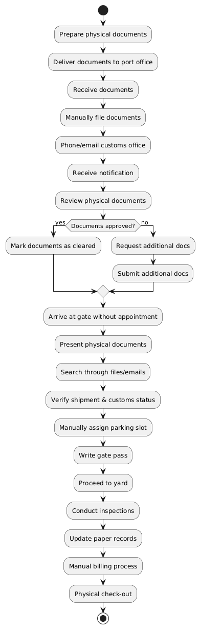
Figure 3.1: Activity Diagram of the Current Manual Process

3.5 Data Analysis
In the current system, data input is entirely manual via paper forms and ledger entries. Processing involves human calculation, physical sorting, and verbal communication. Output is in the form of physical gate passes, paper invoices, and uncoordinated email/phone updates. The context diagram in Figure 3.2 shows the external entities and their disjointed data flows with the port as a central, manual processor.
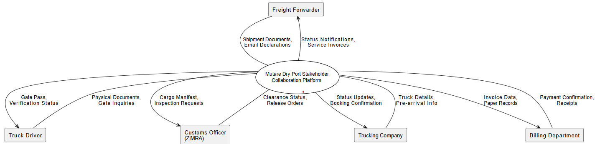

Figure 3.2: Context Diagram of the Current System

A Level 2 Data Flow Diagram (DFD) in Figure 3.3 further decomposes the central process, revealing the lack of integrated data stores and the reliance on external entities for information the port should centrally manage.
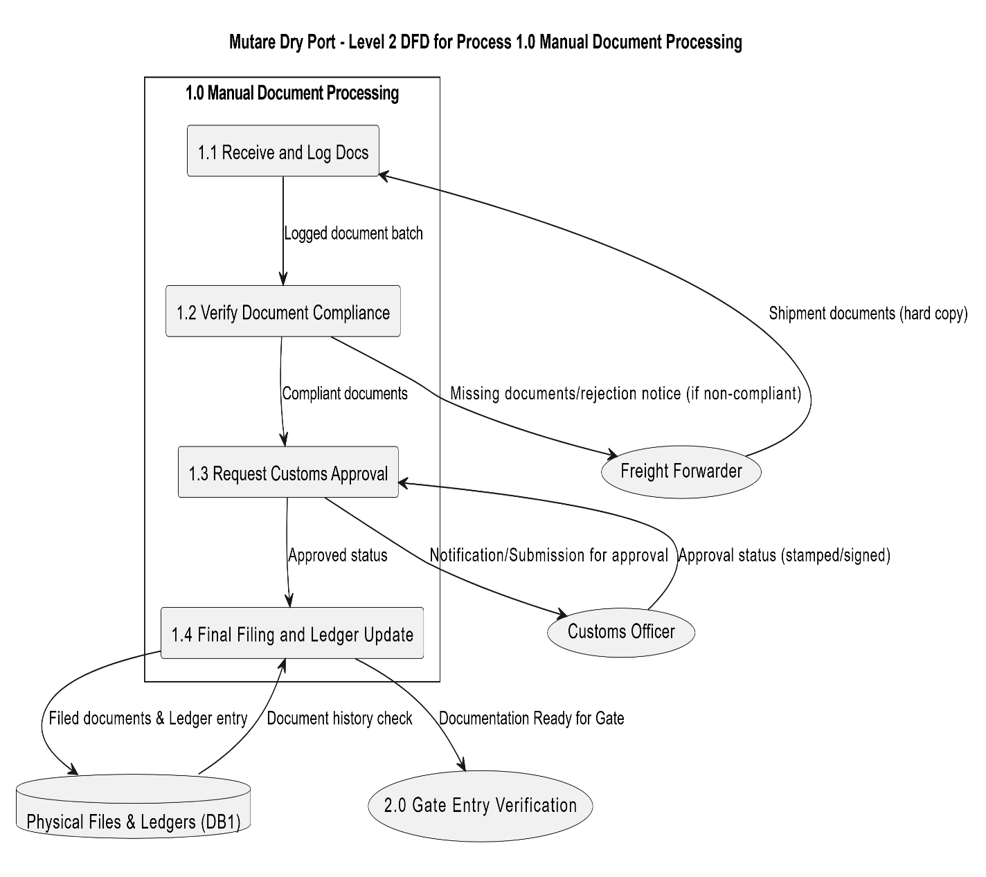

Figure 3.3: Level 0 DFD of the Current System

3.6 Weaknesses of the Current System
The analysis reveals several critical weaknesses:
- Inefficiency and Delays: Manual processes at every stage (verification, scheduling, billing) lead to long truck turnaround times.
- Lack of Real-Time Visibility: Stakeholders have no access to live information on shipment status, yard capacity, or inspection results, leading to uncertainty and poor planning.
- Security Vulnerabilities: Reliance on shared emails and physical documents poses a high risk of data loss, unauthorized access, and lack of a secure audit trail.
- Data Integrity Issues: Manual data entry is prone to errors, which propagate through billing and record-keeping, causing disputes and financial losses.
- Poor Resource Utilization: Ad-hoc gate scheduling and yard planning cause traffic congestion at the gate and suboptimal use of parking space.
- No Structured User Management: There is no concept of role-based access, forcing all communication through unsecured, general channels.
- Lack of Auditability: It is nearly impossible to track who did what and when, complicating conflict resolution and regulatory compliance.

3.7 Evaluate Alternatives
3.7.1 Outsource
Outsourcing the development and management of a platform to a third-party vendor was considered. This was rejected due to the high recurring costs, potential loss of control over critical operational data and system customization, and concerns about the vendor's understanding of the specific, localized logistics processes at a dry port.

3.7.2 Improvement
Improving the current system by digitizing existing forms (e.g., using standalone spreadsheets or a simple database) was evaluated. This was deemed insufficient because it merely automates individual tasks without addressing the core problem of fragmented data and lack of stakeholder collaboration. It would not create a unified platform or solve the real-time visibility issue.
3.7.3 Development
In-house development of a custom Stakeholder Collaboration Platform is the recommended alternative. Justification based on the feasibility analysis (Chapter 2) shows that while the initial development cost is significant, it is a one-time capital expenditure that leads to long-term operational savings. Compared to the high recurring subscription fees of an outsourced Enterprise Resource Planning (ERP) system, which may require heavy customization, a custom-built system offers superior cost-effectiveness over a 4-year period. More importantly, it allows for the creation of a system that is perfectly tailored to the unique workflows of Mutare Dry Port, ensures full data ownership, and directly addresses all the weaknesses identified in section 3.6.
3.8 Requirements Analysis
These requirements are designed to systematically eliminate the weaknesses of the current system.

3.8.1 Functional Requirements
The core functionalities of the system, as captured in the Use Case Diagram (Figure 3.4), are derived directly from the project objectives.

- The system shall allow an administrator to create and manage user accounts with specific roles (Truck Driver, Freight Forwarder, Customs Officer, Gate Staff, Billing Clerk).
- The system shall allow a Freight Forwarder to create a new shipment record in the system.
- The system shall allow a Freight Forwarder to upload and attach required documents (e.g., Bill of Lading, Commercial Invoice) to a shipment.
- The system shall automatically notify the Customs Officer via the system dashboard when new documents are uploaded for a shipment.
- The system shall allow a Truck Driver/Trucking Company to view available time slots and book a gate entry slot online.
- The system shall allow Gate Staff to assign a specific parking slot to a truck with a confirmed booking.
- The system shall allow Customs Officer/Gate Staff to update the inspection status of a container (e.g., Pending, Passed, Failed).
- The system shall automatically calculate all applicable charges based on pre-defined rules and shipment details.
- The system shall allow Gate Staff to check-in a truck upon arrival and check-out a truck upon departure using the system.
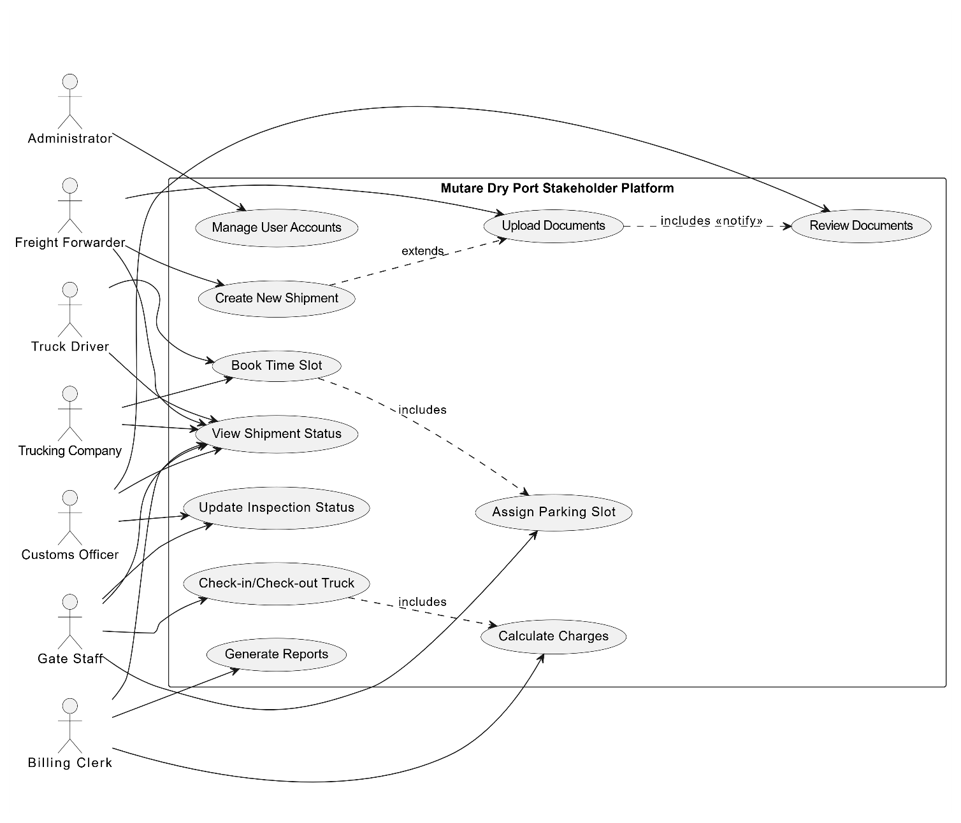Figure 3.4: Use Case Diagram of the Proposed System

3.8.2 Non-functional requirements
These define the quality attributes and constraints of the system.
- Performance: The system should support at least 50 concurrent users. Critical transactions (e.g., slot booking, check-in) must have a response time of under 3 seconds.
- Security: The system shall enforce role-based access control. All data transmissions must be encrypted (HTTPS), and passwords must be stored as hashed values. A comprehensive audit log of all user actions must be maintained.
- Availability: The system must achieve 99% uptime during core operational hours (6 AM - 8 PM).
- Usability: The user interface must be intuitive and require minimal training for users with basic computer literacy. It should be accessible in English.
- Reliability: The system must have a robust data backup and recovery mechanism to prevent data loss
3.9 Conclusion
The analysis phase has conclusively demonstrated that the existing manual system at Mutare Dry Port is the root cause of operational inefficiencies, security risks, and stakeholder dissatisfaction. The information gathered through interviews, observation, and document analysis has provided an unambiguous mandate for a digitally transformative solution. The evaluation of alternatives confirms that a custom-built Stakeholder Collaboration Platform is the most viable and cost-effective path forward. The functional and non-functional requirements specified in this chapter provide a clear and actionable foundation for the design and development of the proposed system, which will be detailed in the next chapter.

Reference List
Avison, D., & Fitzgerald, G. (2003). Information Systems Development: Methodologies, Techniques and Tools (4th ed.). McGraw-Hill Education.
Bass, L., Clements, P., & Kazman, R. (2012). Software Architecture in Practice (3rd ed.). Addison-Wesley Professional.
Dennis, A., Wixom, B. H., & Tegarden, D. (2015). Systems Analysis and Design with UML: An Object-Oriented Approach (5th ed.). John Wiley & Sons.
Myers, M. D., & Venable, J. R. (2014). A set of ethical principles for design science research in information systems. Information & Management, 51(6), 801-809.
Sommerville, I. (2016). Software Engineering (10th ed.). Pearson Education.

