**COMMUNICATION AND VISUALIZATION OF DATA**



**SIGNATURE INDIVIDUAL ESSAY**

**REPORT ON SINGAPORE GOVERNMENT EXPENDITURE**

**RAHUL REDDY TADURI**

**Introduction:**

The Singapore government’s expenditure has been visualized using the Tableau software. In this data set there are 6 columns viz, financial year, revenue type, type, category, class amount. Among these amount is an integer data type, financial year is a date data type and others are character data type. Tableau is a flexible business intelligence and data visualization solution that links to numerous data sources and provides a user-friendly drag-and-drop interface. Data scientists and analysts can benefit from its advanced analytics tools, which also enable interactive data visualizations and effectively convey thoughts.

In addition, Tableau provides sophisticated analytics tools including statistical modeling, clustering, and forecasting. It is therefore a helpful tool for data scientists and analysts who must search and examine big databases.

The data set has data from 1997 to 2021.

**Analysis:**

1. The below graph shows the government’s trend of expenditure over the years. In this i used annotations to showcase my view of graph and arranged the data in ascending order irrespective of the year. The colour complexion from light to dark represents the amount from least to highest.

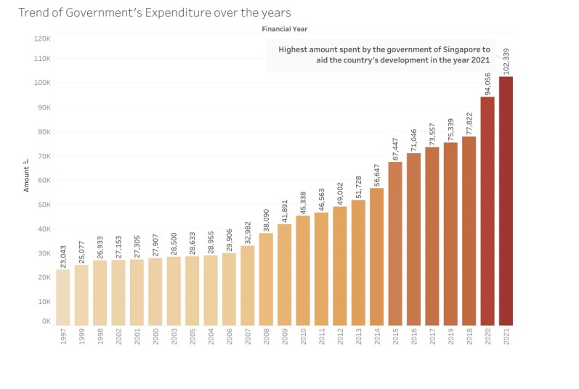

We see that the trend is in a positive and increasing direction over the years

1. The below pie chart represents the share of total percentages in the govt’s expenditure. The three colours represents the revised, estimated and actual estimates of the government. We find that the actual contributes to the major stake in the pie chart.

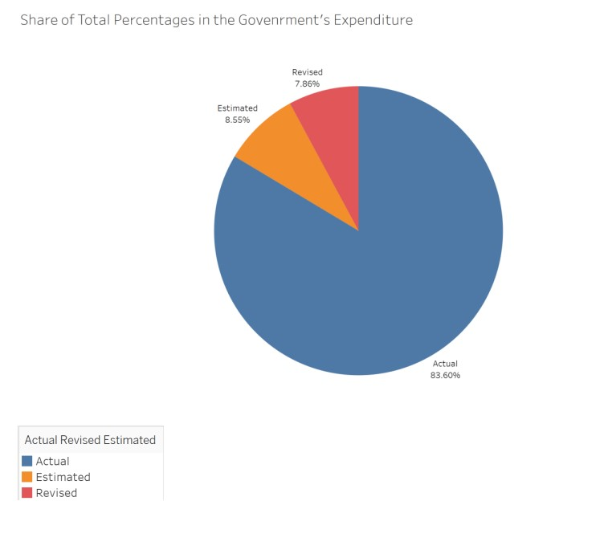

1. The below horizontal bar graph shows the distribution of the expenses amongst the categories and classes in the country. I annotated the message that I want to convey in the box. I showed different categories with different classes in different colours. I also showed the sum allocated to each class on the right of the bars.

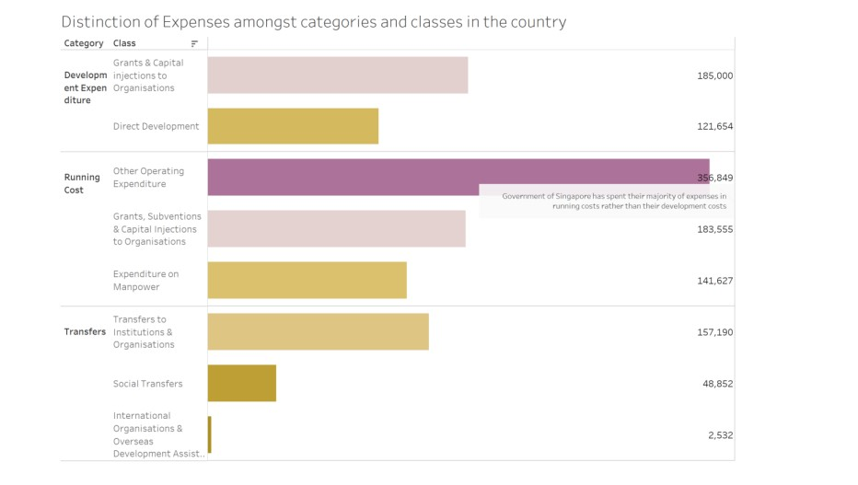

We observe that developmental class has the least allocated amount.

1. The below line graph represents the trend on expenditure on various categories in various years. We got three trend lines with categories vs amount. I had annotated the message in the box. We find the estimates are on the uptrend for all the three categories.

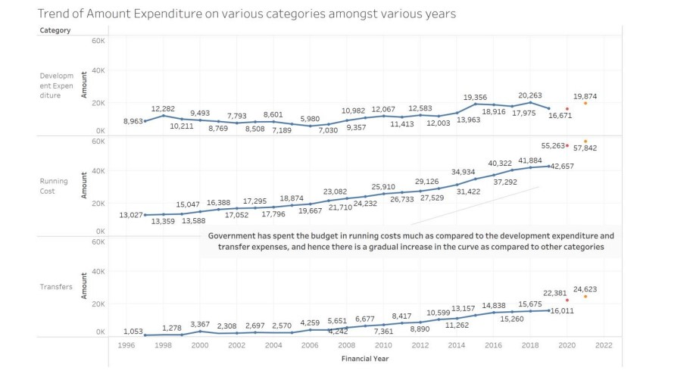

We found that the running cost is increasing at the rapid pace while development expenditure the least.

1. The below horizontal bar graph along with the trend line represent the government trend line for running costs to the total cost for all the years. It is also a dual axis graph. We see there’s dip in 2020 year which might be because of the pandemic.

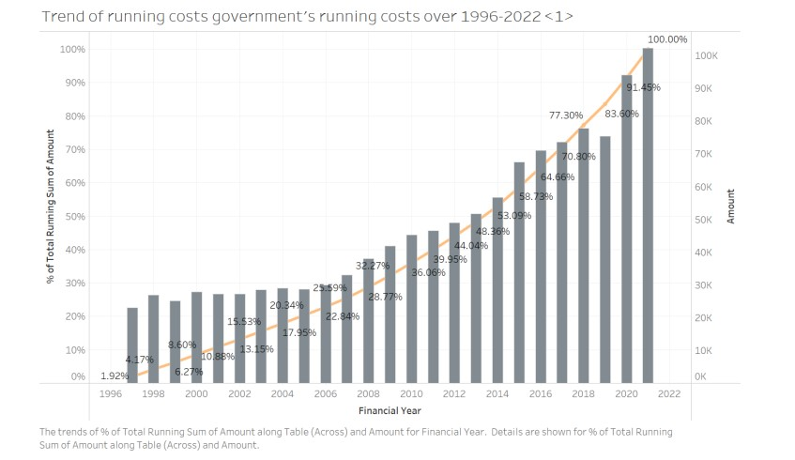

1. The below bubble graph represents, which year have the greatest and the least expenditures**.** You see that here bubbles represents the years and we found that largest bubble is for running costs over operating expenses. It could be one of the best visualizations because we can easily interpret what we see over here.

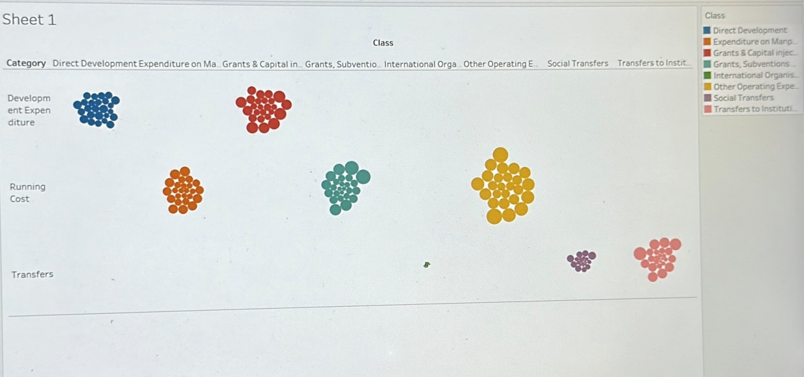

**Conclusion:**

On conclusion, tableau gives one of the best visualization comfort. Visualizations become handy, easy and faster for this interface. Tableau also have the capacity to provide interactive visuals that enable people to delve deeper and learn more about the data. This makes it a helpful tool for sharing insights with team members and presenting data to stakeholders.

**References:**

Jordan, E. (2017). *Tableau*. Dublin City Gallery, The Hugh Lane.

*Learning*. Tableau. (n.d.). Retrieved from <https://www.tableau.com/learn>

YouTube. (n.d.). *Tableau for data science and Data Visualization - Crash course tutorial*. YouTube. Retrieved from <https://www.youtube.com/watch?v=TPMlZxRRaBQ&ab_channel=freeCodeCamp.org>