5. System behaviour Model

Sequence Diagram : add food

1. Add a new customer data

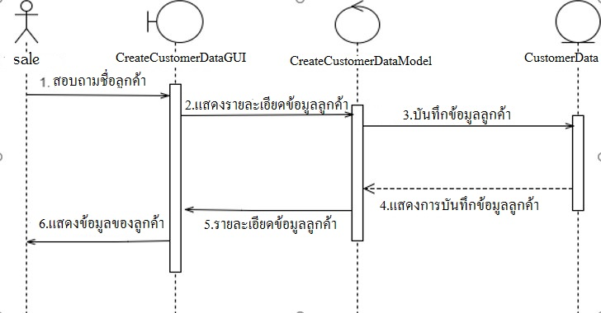

1. 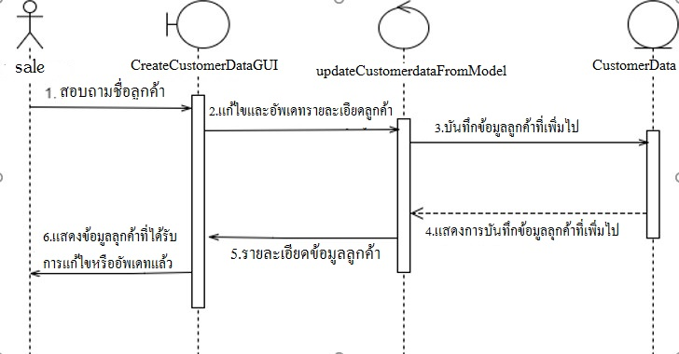Update an existing customer data.