**4. Static Structure and Data Analysis**

**4.1 Model-View-Controller (MVC) Model**

**1.** Add a new customer data.

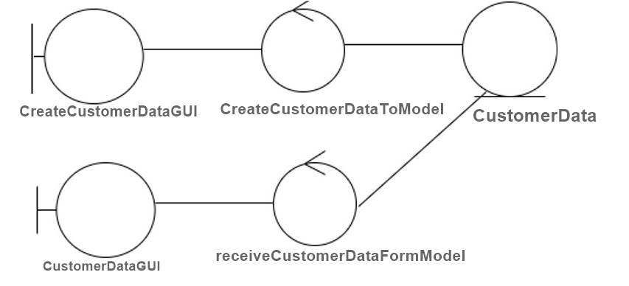

**2.**Update an existing customer data.

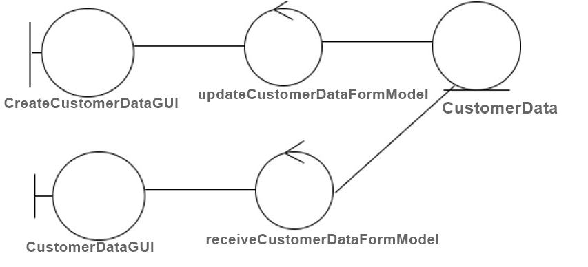

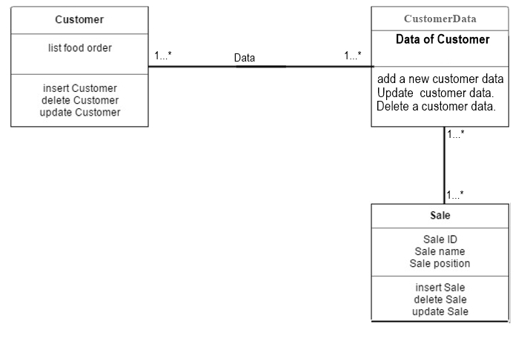**4.2 Entity Class Model**