3GPP TS 29.520 V16.0.0 (2019-06)
Technical Specification
3rd Generation Partnership Project;
Technical Specification Group Core Network and Terminals;
5G System; Network Data Analytics Services;
Stage 3
(Release 16)


The present document has been developed within the 3rd Generation Partnership Project (3GPP TM) and may be further elaborated for the purposes of 3GPP.
The present document has not been subject to any approval process by the 3GPP Organizational Partners and shall not be implemented.
This Specification is provided for future development work within 3GPP only. The Organizational Partners accept no liability for any use of this Specification.
Specifications and Reports for implementation of the 3GPP TM system should be obtained via the 3GPP Organizational Partners' Publications Offices.

Keywords

3GPP
Postal address

3GPP support office address
650 Route des Lucioles - Sophia Antipolis
Valbonne - FRANCE
Tel.: +33 4 92 94 42 00 Fax: +33 4 93 65 47 16
Internet
http://www.3gpp.org
Copyright Notification
No part may be reproduced except as authorized by written permission.
The copyright and the foregoing restriction extend to reproduction in all media.

© 2019, 3GPP Organizational Partners (ARIB, ATIS, CCSA, ETSI, TSDSI, TTA, TTC).
All rights reserved.

UMTS™ is a Trade Mark of ETSI registered for the benefit of its members
3GPP™ is a Trade Mark of ETSI registered for the benefit of its Members and of the 3GPP Organizational Partners
LTE™ is a Trade Mark of ETSI registered for the benefit of its Members and of the 3GPP Organizational Partners
GSM® and the GSM logo are registered and owned by the GSM Association
Contents
Foreword 6
1 Scope 7
2 References 7
3 Definitions and abbreviations 8
3.1 Definitions 8
3.2 Abbreviations 8
4 Services offered by the NWDAF 8
4.1 Introduction 8
4.2 Nnwdaf_EventsSubscription Service 9
4.2.1 Service Description 9
4.2.1.1 Overview 9
4.2.1.2 Service Architecture 9
4.2.1.3 Network Functions 10
4.2.1.3.1 Network Data Analytics Function (NWDAF) 10
4.2.1.3.2 NF Service Consumers 10
4.2.2 Service Operations 11
4.2.2.1 Introduction 11
4.2.2.2 Nnwdaf_EventsSubscription_Subscribe service operation 11
4.2.2.2.1 General 11
4.2.2.2.2 Subscription for event notifications 12
4.2.2.2.3 Update subscription for event notifications 13
4.2.2.3 Nnwdaf_EventsSubscription_Unsubscribe service operation 14
4.2.2.3.1 General 14
4.2.2.3.2 Unsubscribe from event notifications 14
4.2.2.4 Nnwdaf_EventsSubscription_Notify service operation 14
4.2.2.4.1 General 14
4.2.2.4.2 Notification about subscribed event 14
4.3 Nnwdaf_AnalyticsInfo Service 15
4.3.1 Service Description 15
4.3.1.1 Overview 15
4.3.1.2 Service Architecture 16
4.3.1.3 Network Functions 17
4.3.1.3.1 Network Data Analytics Function (NWDAF) 17
4.3.1.3.2 NF Service Consumers 17
4.3.2 Service Operations 18
4.3.2.1 Introduction 18
4.3.2.2 Nnwdaf_AnalyticsInfo_Request service operation 18
4.3.2.2.1 General 18
4.3.2.2.2 Request and get from NWDAF Analytics information 18
5 API Definitions 19
5.1 Nnwdaf_EventsSubscription Service API 19
5.1.1 Introduction 19
5.1.2 Usage of HTTP 19
5.1.2.1 General 19
5.1.2.2 HTTP standard headers 19
5.1.2.2.1 General 19
5.1.2.2.2 Content type 19
5.1.2.3 HTTP custom headers 19
5.1.3 Resources 20
5.1.3.1 Resource Structure 20
5.1.3.2 Resource: NWDAF Events Subscriptions 20
5.1.3.2.1 Description 20
5.1.3.2.2 Resource definition 20
5.1.3.2.3 Resource Standard Methods 21
5.1.3.2.3.1 POST 21
5.1.3.2.4 Resource Custom Operations 21
5.1.3.3 Resource: Individual NWDAF Event Subscription 21
5.1.4 Custom Operations without associated resources 23
5.1.5 Notifications 23
5.1.5.1 General 23
5.1.5.2 Event Notification 23
5.1.6 Data Model 24
5.1.6.1 General 24
5.1.6.2 Structured data types 24
5.1.6.2.1 Introduction 24
5.1.6.2.2 Type NnwdafEventsSubscription 25
5.1.6.2.3 Type EventSubscription 26
5.1.6.2.4 Type NnwdafEventsSubscriptionNotification 26
5.1.6.2.5 Type EventNotification 27
5.1.6.2.6 Type SliceLoadLevelInformation 27
5.1.6.3 Simple data types and enumerations 27
5.1.6.3.1 Introduction 27
5.1.6.3.2 Simple data types 27
5.1.6.3.3 Enumeration: NotificationMethod 28
5.1.6.3.4 Enumeration: NwdafEvent 28
5.1.7 Error handling 28
5.1.8 Feature negotiation 29
5.1.9 Security 29
5.2 Nnwdaf_AnalyticsInfo Service API 29
5.2.1 Introduction 29
5.2.2 Usage of HTTP 29
5.2.2.1 General 29
5.2.2.2 HTTP standard headers 30
5.2.2.2.1 General 30
5.2.2.2.2 Content type 30
5.2.2.3 HTTP custom headers 30
5.2.3 Resources 30
5.2.3.1 Resource Structure 30
5.2.3.2 Resource: NWDAF Analytics 30
5.2.3.2.1 Description 30
5.2.3.2.2 Resource definition 30
5.2.3.2.3 Resource Standard Methods 31
5.2.3.2.3.1 GET 31
5.2.3.2.4 Resource Custom Operations 31
5.2.4 Custom Operations without associated resources 31
5.2.5 Notifications 31
5.2.6 Data Model 31
5.2.6.1 General 31
5.2.6.2 Structured data types 32
5.2.6.2.1 Introduction 32
5.2.6.2.2 Type AnalyticsData 32
5.2.6.2.3 Type EventFilter 32
5.2.6.3 Simple data types and enumerations 33
5.2.6.3.1 Introduction 33
5.2.6.3.2 Simple data types 33
5.2.6.3.3 Enumeration: EventId 33
5.2.7 Error handling 33
5.2.8 Feature negotiation 33
5.2.9 Security 34
Annex A (normative): OpenAPI specification 35
A.1 General 35
A.2 Nnwdaf_EventsSubscription API 35
A.3 Nnwdaf_AnalyticsInfo API 40
Annex B (informative): Change history 42

Foreword
This Technical Specification has been produced by the 3rd Generation Partnership Project (3GPP).
The contents of the present document are subject to continuing work within the TSG and may change following formal TSG approval. Should the TSG modify the contents of the present document, it will be re-released by the TSG with an identifying change of release date and an increase in version number as follows:
Version x.y.z
where:
x the first digit:
1 presented to TSG for information;
2 presented to TSG for approval;
3 or greater indicates TSG approved document under change control.
y the second digit is incremented for all changes of substance, i.e. technical enhancements, corrections, updates, etc.
z the third digit is incremented when editorial only changes have been incorporated in the document.

1 Scope
The present specification provides the stage 3 definition of the Network Data Analytics Function Services of the 5G System.
The 5G System Architecture is defined in 3GPP TS 23.501 [2]. The stage 2 definition and related procedures for Network Data Analytics Function Services are specified in 3GPP TS 23.288 [17] and 3GPP TS 23.503 [4].
The 5G System stage 3 call flows are provided in 3GPP TS 29.513 [5].
The Technical Realization of the Service Based Architecture and the Principles and Guidelines for Services Definition are specified in 3GPP TS 29.500 [6] and 3GPP TS 29.501 [7].
The Network Data Analytics Function Services are provided by the Network Data Analytics Function (NWDAF). These services provide NWDAF slice congestion events notification and NWDAF specific analytics.

2 References
The following documents contain provisions which, through reference in this text, constitute provisions of the present document.
- References are either specific (identified by date of publication, edition number, version number, etc.) or non-specific.
- For a specific reference, subsequent revisions do not apply.
- For a non-specific reference, the latest version applies. In the case of a reference to a 3GPP document (including a GSM document), a non-specific reference implicitly refers to the latest version of that document in the same Release as the present document.
[1] 3GPP TR 21.905: "Vocabulary for 3GPP Specifications".
[2] 3GPP TS 23.501: "System Architecture for the 5G System; Stage 2".
[3] Void.
[4] 3GPP TS 23.503: "Policy and Charging Control Framework for the 5G System; Stage 2".
[5] 3GPP TS 29.513: "5G System; Policy and Charging Control signalling flows and QoS parameter mapping; Stage 3".
[6] 3GPP TS 29.500: "5G System; Technical Realization of Service Based Architecture; Stage 3".
[7] 3GPP TS 29.501: "5G System; Principles and Guidelines for Services Definition; Stage 3".
[8] 3GPP TS 29.571: "5G System; Common Data Types for Service Based Interfaces; Stage 3".
[9] IETF RFC 7540: "Hypertext Transfer Protocol Version 2 (HTTP/2)".
[10] IETF RFC 8259: "The JavaScript Object Notation (JSON) Data Interchange Format".
[11] OpenAPI, "OpenAPI 3.0.0 Specification", https://github.com/OAI/OpenAPI-Specification/blob/master/versions/3.0.0.md.
[12] 3GPP TS 29.510: "5G System; Network Function Repository Services; Stage 3".
[13] 3GPP TS 33.501: "Security architecture and procedures for 5G system".
[14] IETF RFC 6749: "The OAuth 2.0 Authorization Framework".
[15] IETF RFC 7807: "Problem Details for HTTP APIs".
[16] 3GPP TR 21.900: "Technical Specification Group working methods".
[17] 3GPP TS 23.288: "Architecture enhancements for 5G System (5GS) to support network data analytics services".
[18] 3GPP TS 29.554: "5G System; Background Data Transfer Policy Control Service; Stage 3"

3 Definitions and abbreviations

3.1 Definitions
For the purposes of the present document, the terms and definitions given in 3GPP TR 21.905 [1] and the following apply. A term defined in the present document takes precedence over the definition of the same term, if any, in 3GPP TR 21.905 [1].

3.2 Abbreviations
For the purposes of the present document, the abbreviations given in 3GPP TR 21.905 [1] and the following apply. An abbreviation defined in the present document takes precedence over the definition of the same abbreviation, if any, in 3GPP TR 21.905 [1].
AF Application Function
AMF Access and Mobility Management Function
API Application Programming Interface
JSON JavaScript Object Notation
HTTP Hypertext Transfer Protocol
NEF Network Exposure Function
NF Network Function
NRF Network Repository Function
NWDAF Network Data Analytics Function
NSSF Network Slice Selection Function
PCF Policy Control Function
SMF Session Management Function

4 Services offered by the NWDAF

4.1 Introduction
The Nnwdaf services are used for the NWDAF to provide specific analytics information.
The following services are specified for NWDAF:
Table 4.1-1: Services provided by NWDAF
Service Name | Description | Service Operations | Operation  Semantics | Example Consumer(s)
Nnwdaf_EventsSubscription  (NOTE) | This service enables the NF service consumers to subscribe/unsubscribe the notification for different analytics information from the NWDAF. | Subscribe | Subscribe / Notify | PCF, NSSF, AMF, SMF, NEF, AF
Nnwdaf_EventsSubscription  (NOTE) |  | Unsubscribe | Subscribe / Notify | PCF, NSSF, AMF, SMF, NEF, AF
Nnwdaf_EventsSubscription  (NOTE) |  | Notify | Subscribe / Notify | PCF, NSSF, AMF, SMF, NEF, AF
Nnwdaf_AnalyticsInfo | This service enables the NF service consumers to request and get specific analytics from NWDAF. | Request | Request / Response | PCF, NSSF, AMF, SMF, NEF, AF
NOTE: The service corresponds to the Nnwdaf_AnalyticsSubscription service as defined in 3GPP TS 23.288 [17].

4.2 Nnwdaf_EventsSubscription Service

4.2.1 Service Description

4.2.1.1 Overview
The Nnwdaf_EventsSubscription Service as defined in 3GPP TS 23.501 [2], 3GPP TS 23.288 [17] and 3GPP TS 23.503 [4], is provided by the Network Data Analytics Function (NWDAF).
This service:
- allows NF consumers to subscribe to and unsubscribe from different analytic events; and
- notifies NF consumers with a corresponding subscription about observed events.
The types of observed events include:
- Load level of network slice instance;
- Service experience for an application;
- NF load analytics information for a specific NF;
- Network load performance in an area of interest;
- Expected behaviour information for a group of UEs or a specific UE;
- Abnormal behaviour information for a group of UEs or a specific UE;
- Mobility related information for a group of UEs or a specific UE;
- Communication pattern for a specific UE;
- Congestion information of user data in a specific location.

4.2.1.2 Service Architecture
The 5G System Architecture is defined in 3GPP TS 23.501 [2]. The Network Data Analytics Exposure architecture is defined in 3GPP TS 23.288 [17]. The Policy and Charging related 5G architecture is also described in 3GPP TS 23.503 [4] and 3GPP TS 29.513 [5].
The Nnwdaf_EventsSubscription service is part of the Nnwdaf service-based interface exhibited by the Network Data Analytics Function (NWDAF).
Known consumers of the Nnwdaf_EventsSubscription service are:
- Policy Control Function (PCF)
- Network Slice Selection Function (NSSF)
- Access and Mobility Management Function (AMF)
- Session Management Function (SMF)
- Network Exposure Function (NEF)
- Application Function (AF)
The PCF accesses the Nnwdaf_EventsSubscription service at the NWDAF via the N23 Reference point. The NSSF accesses the Nnwdaf_EventsSubscription service at the NWDAF via the N34 Reference point.
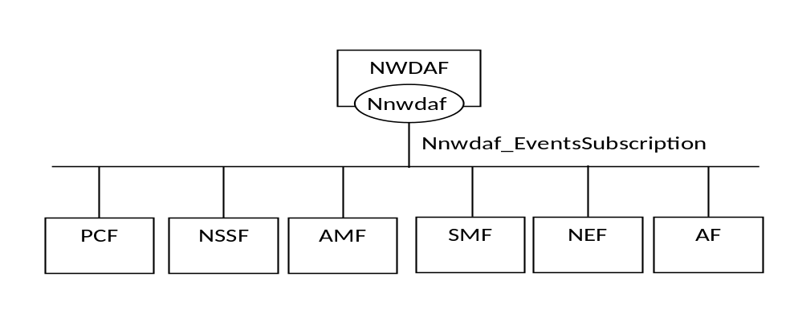
Figure 4.2.1.2-1: Reference Architecture for the Nnwdaf_EventsSubscription Service; SBI representation
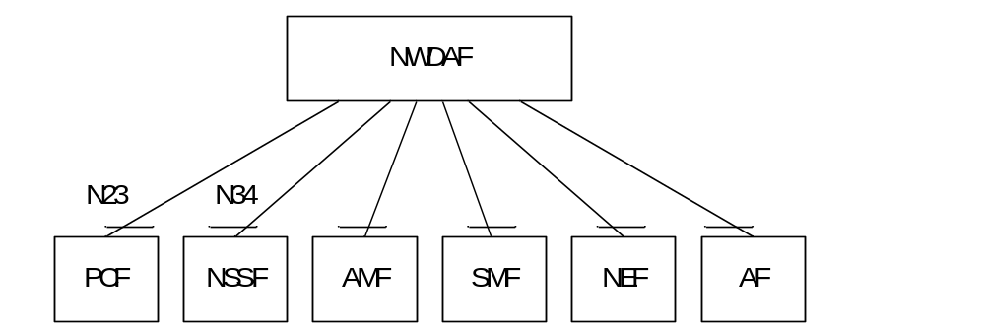
Figure 4.2.1.2-2: Reference Architecture for the Nnwdaf_EventsSubscription Service: reference point representation

4.2.1.3 Network Functions

4.2.1.3.1 Network Data Analytics Function (NWDAF)
The Network Data Analytics Function (NWDAF) provides analytics information for different analytic events to NF consumers.
The Network Data Analytics Function (NWDAF) allows NF consumers to subscribe to and unsubscribe from periodic notification and/or notification when an event isdetected.

4.2.1.3.2 NF Service Consumers
The Policy Control Function (PCF):
- Supports taking input from (NWDAF into consideration for policies on assignment of network resources and for traffic steering policies.
- Supports (un)subscription to analytics information for background data transfer from NWDAF to determine whether the negotiated transfer policy is impacted.
NOTE: How this information is used by the PCF is not standardized in this release of the specification.
The Network Slice Selection Function (NSSF):
- supports taking load level information from(NWDAF into consideration for slice selection.
The Access and Mobility Management Function (AMF):
- supports taking SMF load information from NWDAF into consideration for SMF selection.
The Session Management Function (SMF):
- supports taking UPF load information from NWDAF into consideration for UPF selection.
The Network Exposure Function (NEF):
- supports forwarding UE mobility information from NWDAF to the AF when it is untrusted;
- supports forwarding UE communication information from NWDAF to the AF when it is untrusted;
- supports forwarding user data congestion information from NWDAF to the AF when it is untrusted.
The Application Function (AF):
- supports receiving UE mobility information from NWDAF or via the NEF;
- supports receiving UE communication information from NWDAF or via the NEF;
- supports receiving user data congestion information from NWDAF or via the NEF.
Editor’s Note: The functionalities of the consumers may be updated based on further stage 2 requirement.

4.2.2 Service Operations

4.2.2.1 Introduction
Table 4.2.2.1-1: Operations of the Nnwdaf_EventsSubscription Service
Service operation name | Description | Initiated by
Nnwdaf_EventsSubscription_Subscribe | This service operation is used by an NF to subscribe or update subscription for event notifications of the analytic information.  Periodic notification and notification upon event detected can be subscribed. | NF consumer (PCF, NSSF, AMF, SMF, NEF, AF)
Nnwdaf_EventsSubscription_UnSubscribe | This service operation is used by an NF to unsubscribe from event notifications. | NF consumer (PCF, NSSF, AMF, SMF, NEF, AF)
Nnwdaf_EventsSubscription_Notify | This service operation is used by an NWDAF to notify NF consumers about subscribed events. | NWDAF

4.2.2.2 Nnwdaf_EventsSubscription_Subscribe service operation

4.2.2.2.1 General
The Nnwdaf_EventsSubscription_Subscribe service operation is used by an NF service consumer to subscribe or update subscription for event notifications. The following are the types of events for which a subscription may be made:
- Load level of network slice instance; and
- Service experience.

4.2.2.2.2 Subscription for event notifications
Figure 4.2.2.2.2-1 shows a scenario where the NF service consumer sends a request to the NWDAF to subscribe for event notification(s) (as shown in 3GPP TS 23.288 [17]).
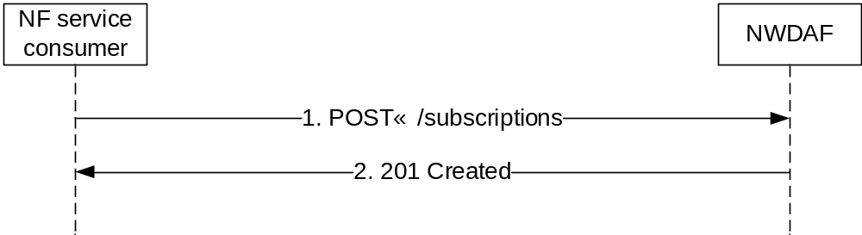
Figure 4.2.2.2.2-1: NF service consumer subscribes to notifications
The NF service consumer shall invoke the Nnwdaf_EventsSubscription_Subscribe service operation to subscribe to event notification(s). The NF service consumer shall send an HTTP POST request with "{apiRoot}/nnwdaf-eventssubscription/v1/subscriptions" as Resource URI representing the "NWDAF Events Subscriptions", as shown in figure 4.2.2.2.2-1, step 1, to create a subscription for an "Individual NWDAF Event Subscription" according to the information in message body. The NnwdafEventsSubscription data structure provided in the request body shall include:
- a description of the subscribed events as "eventSubscriptions" attribute that for each event shall include
a) an event identifier as "event" attribute;
b) if the event notification method "periodic" is selected, repetition period as "repetitionPeriod" attribute;
c) if the event is "SLICE_LOAD_LEVEL":
1) if the event notification method "upon threshold exceeded" is selected, load level threshold as "loadLevelThreshold" attribute;
2) identification of network slice(s) to which the subscription applies via:
i) identification of network slice(s) by "snssais" attribute: or
ii) any slices indication via the "anySlice" attribute;
Editor's note: It is FFS whether identification of network slice(s) is applicable for all the events (e.g. service experience).
and may include:
a) event notification method (periodic, upon threshold exceeded) as "notificationMethod" attribute;
Editor's note: It is FFS if the value "upon threshold exceeded" is applicable for all the events (e.g. service experience), and what kind of threshold will be applied.

b) if the event is "SERVICE_EXPERIENCE":
1) identification of application to which the subscription applies via identification of application(s) by "applicationIds" attribute;
Editor's note: Whether identification of application is mandatory is FFS. Whether the event subscription can be applied to all applications is FFS.
2) identification of network area to which the subscription applies via identification of network area(s) by "networkAreas" attribute;
3) identification of time window to which the subscription applies via identification of date-time(s) by "startTimeStamp" and "endTimeStamp" attribute;
4) identification of DNN to which the subscription applies via identification of application(s) by "dnns" attribute; and
Editor's note: Inclusion of Media/application bandwidth is FFS.
- an URI where to receive the requested notifications as "notificationURI" attribute; and
- list of supported features by the service consumer as "supportedFeatures" attribute.
Upon the reception of an HTTP POST request with: "{apiRoot}/nnwdaf-eventssubscription/v1/subscriptions" as Resource URI and NnwdafEventsSubscription data structure as request body, the NWDAF shall:
- create a new subscription;
- assign an event subscriptionId;
- store the subscription.
If the NWDAF created an "Individual NWDAF Event Subscription" resource, the NWDAF shall respond with "201 Created" with the message body containing a representation of the created subscription, as shown in figure 4.2.2.2.2-1, step 2. The NWDAF shall include a Location HTTP header field. The Location header field shall contain the URI of the created subscription i.e. "{apiRoot}/nnwdaf-eventssubscription/v1/subscriptions/{subscriptionId}".

4.2.2.2.3 Update subscription for event notifications
Figure 4.2.2.2.3-1 shows a scenario where the NF service consumer sends a request to the NWDAF to update the subscription for event notifications (see also 3GPP TS 23.288 [17]).
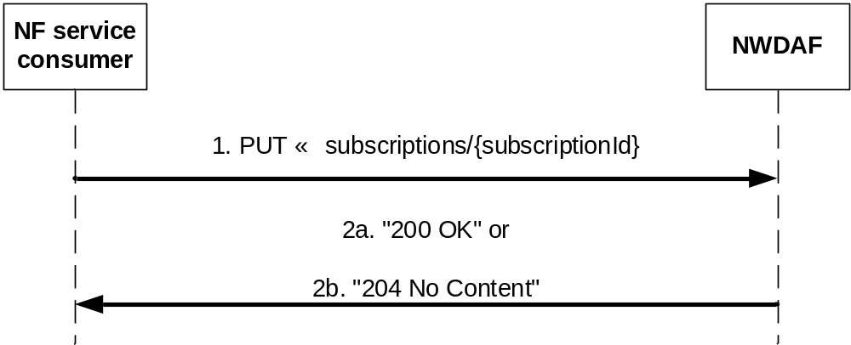
Figure 4.2.2.2.3-1: NF service consumer updates subscription to notifications
The NF service consumer shall invoke the Nnwdaf_EventsSubscription_Subscribe service operation to update subscription to event notifications. The NF service consumer shall send an HTTP PUT request with "{apiRoot}/nnwdaf-eventssubscription/v1/subscriptions/{subscriptionId}" as Resource URI representing the "NWDAF Events Subscriptions", as shown in figure 4.2.2.2.3-1, step 1, to update the subscription for an "Individual NWDAF Event Subscription" resource identified by the {subscriptionId}. The NnwdafEventsSubscription data structure provided in the request body shall include the same contents as described in subclause 4.2.2.2.2:
Upon the reception of an HTTP PUT request with: "{apiRoot}/nnwdaf-eventssubscription/v1/subscriptions/{subscriptionId}" as Resource URI and NnwdafEventsSubscription data structure as request body, the NWDAF shall:
- update the subscription of corresponding subscriptionId; and
- store the subscription.
If the NWDAF updated an "Individual NWDAF Event Subscription" resource, the NWDAF shall respond with:
a) HTTP "200 OK" status code with the message body containing a representation of the updated subscription, as shown in figure 4.2.2.2.3-1, step 2a; or
b) HTTP "204 No Content" status code, as shown in figure 4.2.2.2.3-1, step 2b.
If the Individual NWDAF Event Subscription resource does not exist, the NWDAF shall respond with "404 Not Found".

4.2.2.3 Nnwdaf_EventsSubscription_Unsubscribe service operation

4.2.2.3.1 General
The Nnwdaf_EventsSubscription_Unsubscribe service operation is used by an NF service consumer to unsubscribe from event notifications.

4.2.2.3.2 Unsubscribe from event notifications
Figure 4.2.2.3.2-1 shows a scenario where the NF service consumer sends a request to the NWDAF to unsubscribe from event notifications (see also 3GPP TS 23.288 [17]).
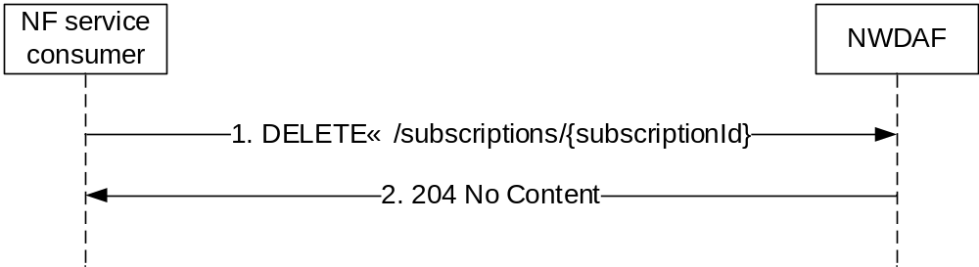
Figure 4.2.2.3.2-1: NF service consumer unsubscribes from notifications
The NF service consumer shall invoke the Nnwdaf_EventsSubscription_UnSubscribe service operation to unsubscribe to event notifications. The NF service consumer shall send an HTTP DELETE request with: "{apiRoot}/nnwdaf-eventssubscription/v1/subscriptions/{subscriptionId}" as Resource URI, where "{subscriptionId}" is the event subscriptionId of the existing subscription that is to be deleted.
Upon the reception of an HTTP DELETE request with: "{apiRoot}/nnwdaf-eventssubscription/v1/subscriptions/{subscriptionId}" as Resource URI, the NWDAF shall:
- remove the corresponding subscription.
If the HTTP request message from the NF service consumer is accepted, the NWDAF shall respond with "204 No Content".
If the Individual NWDAF Event Subscription resource does not exist, the NWDAF shall respond with "404 Not Found".

4.2.2.4 Nnwdaf_EventsSubscription_Notify service operation

4.2.2.4.1 General
The Nnwdaf_EventsSubscription_Notify service operation is used by an NWDAF to notify NF consumers about subscribed events.

4.2.2.4.2 Notification about subscribed event
Figure 4.2.2.4.2-1 shows a scenario where the NWDAF sends a request to the NF Service Consumer to notify for event notifications (see also 3GPP TS 23.288 [17]).
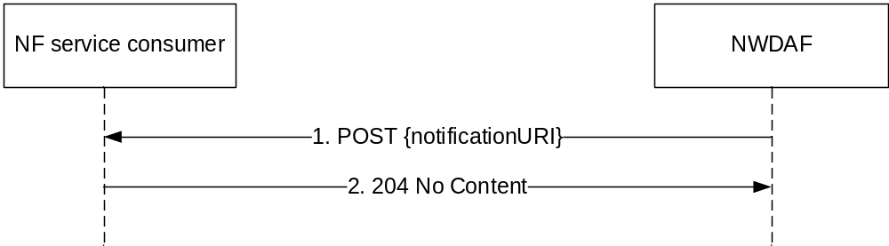
Figure 4.2.2.4.2-1: NWDAF notifies the subscribed event
The NWDAF shall invoke the Nnwdaf_EventsSubscription_Notify service operation to notify the subscribed event. The NWDAF shall sends an HTTP POST request with "{notificationURI}" received in the Nnwdaf_EventsSubscription_Subscribe service operation as Resource URI, as shown in figure 4.2.2.2.2-1, step 1. The NnwdafEventsSubscriptionNotification data structure provided in the request body that shall include:
- a description of the notified event as "eventNotifications" attribute that for each event shall include:
a) an event identifier as "event" attribute;
b) identification(s) of network slice to which the notification applies as "snssai" attribute when subscribed event is "SLICE_LOAD_LEVEL";
c) load level information as "loadLevelInformation" attribute when subscribed event is "SLICE_LOAD_LEVEL";
d) service experience information as "svcExpInfo" attribute when subscribed event is "SERVICE_EXPERIENCE"; and
Editor's note: It is FFS whether the identification(s) of network slice applies for "SERVICE_EXPERIENCE" event.
- an event subscriptionId as "subscriptionId" attribute.
Upon the reception of an HTTP POST request with: "{notificationURI}" as Resource URI and NnwdafEventsSubscriptionNotification data structure as request body, the NF Service Consumer shall:
- store the notification.
If the HTTP request message from the NWDAF is accepted, the NF Service Consumer shall respond with "204 No Content".

4.3 Nnwdaf_AnalyticsInfo Service

4.3.1 Service Description

4.3.1.1 Overview
The Nnwdaf_AnalyticsInfo Service as defined in 3GPP TS 23.501 [2], 3GPP TS 23.288 [17] and 3GPP TS 23.503 [4], is provided by the Network Data Analytics Function (NWDAF).
This service:
- allows NF consumers to request and get different type of analytic event information.
The types of observed events include:
- Load level of network slice instance;
- Service experience for an application;
- NF load analytics information for a specific NF;
- Network load performance in an area of interest;
- Expected behaviour information for a group of UEs or a specific UE;
- Abnormal behaviour information for a group of UEs or a specific UE;
- Mobility related information for a group of UEs or a specific UE;
- Communication pattern for a specific UE;
- Congestion information of user data in a specific location.

4.3.1.2 Service Architecture
The 5G System Architecture is defined in 3GPP TS 23.501 [2]. The Network Data Analytics Exposure architecture is defined in 3GPP TS 23.288 [17]. The Policy and Charging related 5G architecture is also described in 3GPP TS 23.503 [4] and 3GPP TS 29.513 [5].
The Nnwdaf_AnalyticsInfo service is part of the Nnwdaf service-based interface exhibited by the Network Data Analytics Function (NWDAF).
Known consumers of the Nnwdaf_AnalyticsInfo service are:
- Policy Control Function (PCF)
- Network Slice Selection Function (NSSF)
- Access and Mobility Management Function (AMF)
- Session Management Function (SMF)
- Network Exposure Function (NEF)
- Application Function (AF)
The PCF accesses the Nnwdaf_AnalyticsInfo service at the NWDAF via the N23 Reference point. The NSSF accesses the Nnwdaf_AnalyticsInfo service at the NWDAF via the N34 Reference point.
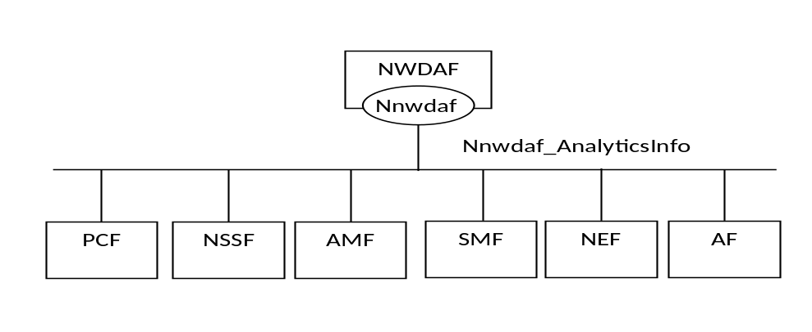
Figure 4.3.1.2-1: Reference Architecture for the Nnwdaf_AnalyticsInfo Service; SBI representation
Figure 4.3.1.2-2: Reference Architecture for the Nnwdaf_AnalyticsInfo Service: reference point representation

4.3.1.3 Network Functions

4.3.1.3.1 Network Data Analytics Function (NWDAF)
The Network Data Analytics Function (NWDAF) provides specific analytics information for different analytic events to NF consumers.

4.3.1.3.2 NF Service Consumers
The Policy Control Function (PCF):
- Supports taking input from NWDAF into consideration for policies on assignment of network resources and for traffic steering policies.
- Supports taking the analytics information for background data transfer from NWDAF into consideration to determine whether the negotiated transfer policy is impacted.
NOTE: How this information is used by the PCF is not standardized in this release of the specification.
The Network Slice Selection Function (NSSF):
- supports taking load level information fromNWDAF into consideration for slice selection.
The Access and Mobility Management Function (AMF):
- supports taking SMF load information from NWDAF into consideration for SMF selection.
The Session Management Function (SMF):
- supports taking UPF load information from NWDAF into consideration for UPF selection.
The Network Exposure Function (NEF):
- supports forwarding UE mobility information from NWDAF to the AF when it is untrusted;
- supports forwarding UE communication information from NWDAF to the AF when it is untrusted;
- supports forwarding user data congestion information from NWDAF to the AF when it is untrusted.
The Application Function (AF):
- supports receiving UE mobility information from NWDAF or via the NEF;
- supports receiving UE communication information from NWDAF or via the NEF;
- supports receiving user data congestion information from NWDAF or via the NEF.
Editor’s Note: The functionalities of the concumers maybe updated based on further stage 2 requirement.

4.3.2 Service Operations

4.3.2.1 Introduction
Table 4.3.2.1-1: Operations of the Nnwdaf_AnalyticsInfo Service
Service operation name | Description | Initiated by
Nnwdaf_AnalyticsInfo_Request | This service operation is used by an NF to request and get specific analytics from NWDAF. | NF consumer (PCF, NSSF, AMF, SMF, NEF, AF)

4.3.2.2 Nnwdaf_AnalyticsInfo_Request service operation

4.3.2.2.1 General
The Nnwdaf_AnalyticsInfo_Request service operation is used by an NF service consumer to request and get specific analytics information from the NWDAF.

4.3.2.2.2 Request and get from NWDAF Analytics information
Figure 4.3.2.2.2-1 shows a scenario where the NF service consumer (e.g. PCF) sends a request to the NWDAF to request and get from NWDAF analytics information (as shown in 3GPP TS 23.288 [17]).
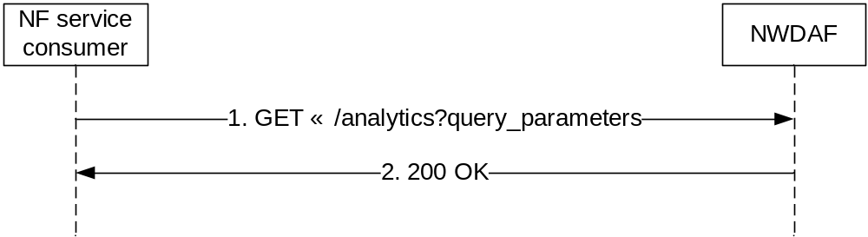
Figure 4.3.2.2.2-1: Requesting a NWDAF Analytics information
The NF service consumer (e.g. PCF) shall invoke the Nnwdaf_AnalyticsInfo_Request service operation when represent the NWDAFanalyticsinformation of particular network slice instance. The NF service consumer shall send an HTTP GET request on the resource URI "{apiRoot}/nnwdaf-analyticsinfo/v1/analytics" representing the "NWDAF Analytics" (as shown in figure 4.3.2.2.2-1, step 1), to request analytics data according to the query parameter value of the "event-id" attribute. The EventFilter data structure provided in the request body shall include:
- identification(s) of network slice when the eventId is "LOAD_LEVEL_INFORMATION" via:
1) identification of network slice(s) by "snssai" attribute; or
2) any slices indication via the "anySlice" attribute.
Upon the the reception of the HTTP GET request, the NWDAF shall:
- analyse the requested analytic data. For eventId of "LOAD_LEVEL_INFORMATION", the NWDAF shall analyse the load level information of corresponding network slice instance(s).
If the HTTP request message from the NF service consumer is accepted, the NWDAF shall respond with "200 OK" status code with the message body containing the analytics with parameters as relevant for the requesting NF service consumer. The AnalyticsData data structure in the response body shall include:
- analytics with parameters indicated in the request. For eventId of "LOAD_LEVEL_INFORMATION ", the analytics shall include the load level information of corresponding network slice instance.
If the request NWDAF Analytics data does not exist, the NWDAF shall respond with "204 No Content ".

5 API Definitions

5.1 Nnwdaf_EventsSubscription Service API

5.1.1 Introduction
The Nnwdaf_EventsSubscription Service shall use the Nnwdaf_EventsSubscription API.
The request URI used in each HTTP request from the NF service consumer towards the NWDAF shall have the structure defined in subclause 4.4.1 of 3GPP TS 29.501 [7], i.e.:
{apiRoot}/{apiName}/{apiVersion}/{apiSpecificResourceUriPart}
with the following components:
- The {apiRoot} shall be set as described in 3GPP TS 29.501 [7].
- The {apiName} shall be "nnwdaf-eventssubscription".
- The {apiVersion} shall be "v1".
- The {apiSpecificResourceUriPart} shall be set as described in subclause 5.1.3.

5.1.2 Usage of HTTP

5.1.2.1 General
HTTP/2, IETF RFC 7540 [9], shall be used as specified in clause 5 of 3GPP TS 29.500 [6].
HTTP/2 shall be transported as specified in subclause 5.3 of 3GPP TS 29.500 [6].
The OpenAPI [11] specification of HTTP messages and content bodies for the Nnwdaf_EventsSubscription is contained in Annex A.

5.1.2.2 HTTP standard headers

5.1.2.2.1 General
See subclause 5.2.2 of 3GPP TS 29.500 [6] for the usage of HTTP standard headers.

5.1.2.2.2 Content type
JSON, IETF RFC 8259 [10], shall be used as content type of the HTTP bodies specified in the present specification as specified in subclause 5.4 of 3GPP TS 29.500 [6]. The use of the JSON format shall be signalled by the content type "application/json".
"Problem Details" JSON object shall be used to indicate additional details of the error in a HTTP response body and shall be signalled by the content type "application/problem+json", as defined in IETF RFC 7807 [15].

5.1.2.3 HTTP custom headers
The Nnwdaf_EventsSubscription Service API shall support HTTP custom header fields specified in subclause 5.2.3.2 of 3GPP TS 29.500 [6].
In this release of the specification, no specific custom headers are defined for the Nnwdaf_EventsSubscription Service API.

5.1.3 Resources

5.1.3.1 Resource Structure
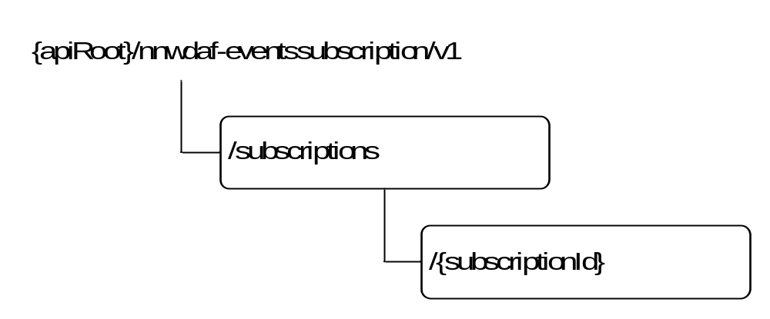
Figure 5.1.3.1-1: Resource URI structure of the Nnwdaf_EventsSubscription API
Table 5.1.3.1-1 provides an overview of the resources and applicable HTTP methods.
Table 5.1.3.1-1: Resources and methods overview
Resource name | Resource URI | HTTP method or custom operation | Description
NWDAF Events Subscriptions | {apiRoot}/  nnwdaf-eventssubscription/v1  /subscriptions | POST | Creates a new Individual NWDAF Events Subscription resource.
Individual NWDAF Event Subscription | {apiRoot}/  nnwdaf-eventssubscription/v1  /subscriptions  /{subscriptionId} | DELETE | Deletes an Individual NWDAF Events Subscription identified by subresource {subscriptionId}.
Individual NWDAF Event Subscription |  | PUT | Modifies an existing Events Subscription subresource.

5.1.3.2 Resource: NWDAF Events Subscriptions

5.1.3.2.1 Description
The NWDAF Events Subscriptions resource represents all subscriptions to the Nnwdaf_EventsSubscription Service at a given NWDAF.

5.1.3.2.2 Resource definition
Resource URI: {apiRoot}/nnwdaf-eventssubscription/v1/subscriptions
This resource shall support the resource URI variables defined in table 5.1.3.2.2-1.
Table 5.1.3.2.2-1: Resource URI variables for this resource
Name | Definition
apiRoot | See subclause 5.1.1

5.1.3.2.3 Resource Standard Methods

5.1.3.2.3.1 POST
This method shall support the URI query parameters specified in table 5.1.3.2.3.1-1.
Table 5.1.3.2.3.1-1: URI query parameters supported by the POST method on this resource
Name | Data type | P | Cardinality | Description
n/a

This method shall support the request data structures specified in table 5.1.3.2.3.1-2 and the response data structures and response codes specified in table 5.1.3.2.3.1-3.
Table 5.1.3.2.3.1-2: Data structures supported by the POST Request Body on this resource
Data type | P | Cardinality | Description
NnwdafEventsSubscription | M | 1 | Create a new Individual NWDAF Event Subscription resource.

Table 5.1.3.2.3.1-3: Data structures supported by the POST Response Body on this resource
Data type | P | Cardinality | Response  codes | Description
NnwdafEventsSubscription | M | 1 | 201 Created | The creation of an Individual NWDAF Event Subscription resource is confirmed and a representation of that resource is returned.
NOTE: The mandatory HTTP error status codes for the POST method listed in table 5.2.7.1-1 of 3GPP TS 29.500 [6] also apply.

5.1.3.2.4 Resource Custom Operations
None in this release of the specification.

5.1.3.3 Resource: Individual NWDAF Event Subscription

5.1.3.3.1 Description
The Individual NWDAF Events Subscription resource represents a single subscription to the Nnwdaf_EventsSubscription Service at a given NWDAF.
5.1.3.3.2 Resource definition
Resource URI: {apiRoot}/nnwdaf-eventssubscription/v1/subscriptions/{subscriptionId}
This resource shall support the resource URI variables defined in table 5.1.3.3.2-1.
Table 5.1.3.3.2-1: Resource URI variables for this resource
Name | Definition
apiRoot | See subclause 5.1.1
subscriptionId | String identifying a subscription to the NnwdafEventsSubscription Service

5.1.3.3.3 Resource Standard Methods

5.1.3.3.3.1 DELETE
This method shall support the URI query parameters specified in table 5.1.3.3.3.1-1.
Table 5.1.3.3.3.1-1: URI query parameters supported by the DELETE method on this resource
Name | Data type | P | Cardinality | Description
n/a

This method shall support the request data structures specified in table 5.1.3.3.3.1-2 and the response data structures and response codes specified in table 5.1.3.3.3.1-3.
Table 5.1.3.3.3.1-2: Data structures supported by the DELETE Request Body on this resource
Data type | P | Cardinality | Description
n/a

Table 5.1.3.3.3.1-3: Data structures supported by the DELETE Response Body on this resource
Data type | P | Cardinality | Response  codes | Description
n/a |  |  | 204 No Content | Successful case: The Individual NWDAF Event Subscription resource matching the subscriptionId was deleted.
ProblemDetails | M | 1 | 404 Not Found | The Individual NWDAF Event Subscription resource does not exist. (NOTE 2)
NOTE 1: The mandatory HTTP error status codes for the DELETE method listed in table 5.2.7.1-1 of 3GPP TS 29.500 [6] also apply.
NOTE 2: Failure cases are described in subclause 5.1.7.

5.1.3.3.3.2 PUT
This method shall support the URI query parameters specified in table 5.1.3.3.3.2-1.
Table 5.1.3.3.3.2-1: URI query parameters supported by the PUT method on this resource
Name | Data type | P | Cardinality | Description
n/a

This method shall support the request data structures specified in table 5.1.3.3.3.2-2 and the response data structures and response codes specified in table 5.1.3.3.3.2-3.
Table 5.1.3.3.3.2-2: Data structures supported by the PUT Request Body on this resource
Data type | P | Cardinality | Description
NnwdafEventsSubscription | M | 1 | Parameters to replace a subscription to NWDAF Event Subscription resource.

Table 5.1.3.3.3.2-3: Data structures supported by the PUT Response Body on this resource
Data type | P | Cardinality | Response codes | Description
NnwdafEventsSubscription | M | 1 | 200 OK | The Individual NWDAF Event Subscription resource was modified successfully and a representation of that resource is returned.
n/a |  |  | 204 No Content | The Individual NWDAF Event Subscription resource was modified successfully.
ProblemDetails | M | 1 | 404 Not Found | The Individual NWDAF Event Subscription resource does not exist. (NOTE 2)
NOTE 1: The mandatory HTTP error status codes for the PUT method listed in table 5.2.7.1-1 of 3GPP TS 29.500 [6] also apply.
NOTE 2: Failure cases are described in subclause 5.1.7.

5.1.3.3.4 Resource Custom Operations
None in this release of the specification.

5.1.4 Custom Operations without associated resources
None in this release of the specification.

5.1.5 Notifications

5.1.5.1 General
Notifications shall comply with subclause 6.2 of 3GPP TS 29.500 [6] and subclause 4.6.2.3 of 3GPP TS 29.501 [7].
Table 5.3.3.4.1-1: Notifications
Custom operation URI | Mapped HTTP method | Description
{notificationURI} | POST | Report one or several observed Events.

5.1.5.2 Event Notification

5.1.5.2.1 Description
The Event Notification is used by the NWDAF to report one or several observed Events to a NF service consumer that has subscribed to such Notifications via the Individual NWDAF Event Subscription Resource.

5.1.5.2.2 Operation Definition
URI: {notificationURI}
The operation shall support the URI variables defined in table 5.1.5.2.2-1, the request data structures specified in table 5.1.5.2.2-2 and the response data structure and response codes specified in table 5.1.5.2.2-3.
Table 5.1.5.2.2-1: URI variables
Name | Definition
notificationURI | String formatted as URI with the Notification Uri as assigned within the Individual NWDAF Event Subscription and described within the Nnwdaf_EventsSubscription type (see table 5.1.6.2.2-1).

Table 5.1.5.2.2-2: Data structures supported by the POST Request Body on this resource
Data type | P | Cardinality | Description
array(NnwdafEventsSubscriptionNotification) | M | 1..N | Provides Information about observed events

Table 5.1.5.2.2-3: Data structures supported by the POST Response Body on this resource
Data type | P | Cardinality | Response codes | Description
n/a |  |  | 204 No Content | The receipt of the Notification is acknowledged.
NOTE: The mandatory HTTP error status codes for the POST method listed in table 5.2.7.1-1 of 3GPP TS 29.500 [6] also apply.

5.1.6 Data Model

5.1.6.1 General
This subclause specifies the application data model supported by the API.
Table 5.1.6.1-1 specifies the data types defined for the Nnwdaf_EventsSubscription service based interface protocol.
Table 5.1.6.1-1: Nnwdaf_EventsSubscription specific Data Types
Data type | Section defined | Description | Applicability
AnySlice | 5.1.6.3.2 | Represents the any slices.
EventNotification | 5.1.6.2.5 | Describes Notifications about events that occurred.
EventSubscription | 5.1.6.2.3 | Represents the subscription to a single event.
LoadLevelInformation | 5.1.6.3.2 | Represents load level information of the network slice instance
NwdafEvent | 5.1.6.3.4 | Describes the NWDAF Events.
NnwdafEventsSubscription | 5.1.6.2.2 | Represents an Individual NWDAF Event Subscription resource.
NnwdafEventsSubscriptionNotification | 5.1.6.2.4 | Represents an Individual NWDAF Event Subscription Notification resource.
NotificationMethod | 5.1.6.3.3 | Represents the notification methods that can be subscribed.
ServiceExperienceInfo | FFS | Represents the service experience information. | ServiceExperience
SliceLoadLevelInformation | 5.1.6.2.6 | Represents the slices and the load level information.

Table 5.1.6.1-2 specifies data types re-used by the Nnwdaf_EventsSubscription service based interface protocol from other specifications, including a reference to their respective specifications and when needed, a short description of their use within the Nnwdaf service based interface.
Table 5.1.6.1-2: Nnwdaf_EventsSubscription re-used Data Types
Data type | Reference | Comments | Applicability
ApplicationId | 3GPP TS 29.571 [8] | Identifies the application identifier. | ServiceExperience
DateTime | 3GPP TS 29.571 [8] | Identifies the time. | ServiceExperience
Dnn | 3GPP TS 29.571 [8] | Identifies the DNN. | ServiceExperience
DurationSec | 3GPP TS 29.571 [8]
NetworkAreaInfo | 3GPP TS 29.554 [18] | Identifies the network area. | ServiceExperience
ProblemDetails | 3GPP TS 29.571 [8] | Used in error responses to provide more detailed information about an error.
Snssai | 3GPP TS 29.571 [8] | Identifies the S-NSSAI (Single Network Slice Selection Assistance Information).
SupportedFeatures | 3GPP TS 29.571 [8] | Used to negotiate the applicability of the optional features defined in table 5.1.8-1.
Uri | 3GPP TS 29.571 [8]

Editor's note: Whether NetworkAreaInfo defined in 3GPP TS 29.554 can cover the requirement is FFS.

5.1.6.2 Structured data types

5.1.6.2.1 Introduction
This subclause defines the structures to be used in resource representations.

5.1.6.2.2 Type NnwdafEventsSubscription
Table 5.1.6.2.2-1: Definition of type NnwdafEventsSubscription
Attribute name | Data type | P | Cardinality | Description | Applicability
eventSubscriptions | array(EventSubscription) | M | 1..N | Subscribed events
notificationURI | Uri | C | 1 | Identifies the recipient of Notifications sent by the NWDAF.  This parameter shall be supplied by the NF service consumer in the HTTP POST requests that include an object of EventSubscription type.
supportedFeatures | SupportedFeatures | C | 1 | List of Supported features used as described in subclause 5.1.8.  This parameter shall be supplied by NF service consumer in the POST request that request the creation of an NWDAF Event Subscriptions resource, and shall be supplied by the NWDAF in the reply of corresponding request.

5.1.6.2.3 Type EventSubscription
Table 5.1.6.2.3-1: Definition of type EventSubscription
Attribute name | Data type | P | Cardinality | Description | Applicability
anySlice | AnySlice | C | 0..1 | Default is "FALSE". (NOTE 1)
applicationIds | array(ApplicationId) | C | 1..N | Identification(s) of application to which the subscription applies.  The absence of applicationIds means subscription to all applications. | ServiceExperience
dnns | array(Dnn) | C | 1..N | Identification(s) of DNN to which the subscription applies.  The absence of dnns means subscription to all DNNs | ServiceExperience
event | NwdafEvent | M | 1 | Event that is subscribed.
loadLevelThreshold | integer | C | 0..1 | Shall be supplied for notification method "THRESHOLD".  Indicates that the NWDAF shall report the corresponding network slice load level to the NF service consumer where the load level of the network slice instance identified by snssai is reached.
networkAreas | array(NetworkAreaInfo) | C | 1..N | Identification(s) of network area to which the subscription applies.  The absence of networkAreas means subscription to all network areas. | ServiceExperience
notificationMethod | NotificationMethod | O | 0..1 | Indicate the notification method. (NOTE 2)
repetitionPeriod | DurationSec | C | 0..1 | Shall be supplied for notification Method "PERIODIC".
snssais | array(Snssai) | C | 1..N | Identification(s) of network slice to which the subscription applies. (NOTE 1)
startTimeStamp | DateTime | C | 0..1 | UTC time indicating the start time of the collection period of the subscription of service experience for the application.  The absence of startTimeStamp means subscription frome time being. | ServiceExperience
endTimeStamp | DateTime | C | 0..1 | UTC time indicating the end time of the collection period of the subscription of service experience for the application.  The absence of endTimeStamp means subscription to life time. | ServiceExperience
NOTE 1: When subscribed event is "SLICE_LOAD_LEVEL" and "SERVICE_EXPERIENCE", either information about slice(s) identified by snssais, or anySlice set to "TRUE" shall be included.
NOTE 2: When notificationMethod is not supplied, the default value is "THRESHOLD".

5.1.6.2.4 Type NnwdafEventsSubscriptionNotification
Table 5.1.6.2.4-1: Definition of type NnwdafEventsSubscriptionNotification
Attribute name | Data type | P | Cardinality | Description | Applicability
eventNotifications | array(EventNotification) | M | 1..N | Notifications about Individual Events
subscriptionId | string | M | 1 | String identifying a subscription to the Nnwdaf_EventsSubscription Service

5.1.6.2.5 Type EventNotification
Table 5.1.6.2.5-1: Definition of type EventNotification
Attribute name | Data type | P | Cardinality | Description | Applicability
event | NwdafEvent | M | 1 | Event that is notified.
sliceLoadLevelInfo | SliceLoadLevelInformation | C | 0..1 | The slices and the load level information.  When subscribed event is "SLICE_LOAD_LEVEL", the sliceLoadLevelInfo shall be included.
svcExpInfo | ServiceExperienceInfo | C | 0..1 | The service experience information.  When subscribed event is "SERVICE_EXPERIENCE", the serviceExperienceInfo shall be included. | ServiceExperience

Editor's note: The data type ServiceExperienceInfo is FFS.

5.1.6.2.6 Type SliceLoadLevelInformation
Table 5.1.6.2.6-1: Definition of type SliceLoadLevelInformation
Attribute name | Data type | P | Cardinality | Description | Applicability
loadLevelInformation | LoadLevelInformation | M | 1 | Load level information of the network slice instance identified by snssai.
snssais | array(Snssai) | M | 1..N | Identification(s) of network slice to which the subscription.

5.1.6.3 Simple data types and enumerations

5.1.6.3.1 Introduction
This subclause defines simple data types and enumerations that can be referenced from data structures defined in the previous subclauses.

5.1.6.3.2 Simple data types
The simple data types defined in table 5.1.6.3.2-1 shall be supported.
Table 5.1.6.3.2-1: Simple data types
Type Name | Type Definition | Description | Applicability
AnySlice | boolean | "FALSE" represents not applicable for all slices.  "TRUE" represents applicable for all slices.
LoadLevelInformation | integer | Load level information of the network slice instance.

5.1.6.3.3 Enumeration: NotificationMethod
Table 5.1.6.3.3-1: Enumeration NotificationMethod
Enumeration value | Description | Applicability
PERIODIC | The subscribe of NWDAF Event is peridodicly. The periodic of the notification is identified by repetitionPeriod defined in subclause 5.1.6.2.3.
THRESHOLD | The subscribe of NWDAF Event is upon threshold exceeded. The threshold of the notification is identified by loadLevelThreshold defined in subclause 5.1.6.2.3.

5.1.6.3.4 Enumeration: NwdafEvent
Table 5.1.6.3.4-1: Enumeration NwdafEvent
Enumeration value | Description | Applicability
SLICE_LOAD_LEVEL | Indicates that the event subscribed is load level information of Network Slice instance
SERVICE_EXPERIENCE | Indicates that the event subscribed is service experience. | ServiceExperience

5.1.7 Error handling

5.1.7.1 General
HTTP error handling shall be supported as specified in subclause 5.2.4 of 3GPP TS 29.500 [6].
For the Nnwdaf_EventsSubscription API, HTTP error responses shall be supported as specified in subclause 4.8 of 3GPP TS 29.501 [7]. Protocol errors and application errors specified in table 5.2.7.2-1 of 3GPP TS 29.500 [6] shall be supported for an HTTP method if the corresponding HTTP status codes are specified as mandatory for that HTTP method in table 5.2.7.1-1 of 3GPP TS 29.500 [6]. In addition, the requirements in the following subclauses shall apply.

5.1.7.2 Protocol Errors
In this Release of the specification, there are no additional protocol errors applicable for the Nnwdaf_EventsSubscription API.

5.1.7.3 Application Errors
The application errors defined for the Nnwdaf_EventsSubscription API are listed in table 5.1.7.3-1. The NWDAF shall include in the HTTP status code a "ProblemDetails" data structure with the "cause" attribute indicating the application error as listed in table 5.7.3-1.
Table 5.1.7.3-1: Application errors
Application Error | HTTP status code | Description
SUBSCRIPTION_NOT_FOUND | 404 Not Found | Indicates that the modification or deletion has failed because the specified Individual NWDAF Event Subscription resource does not exist. (NOTE)
NOTE: This application error is included in the responses to the GET and the DELETE requests.

5.1.8 Feature negotiation
The optional features in table 5.1.8-1 are defined for the Nnwdaf_EventsSubscription API. They shall be negotiated using the extensibility mechanism defined in subclause 6.6 of 3GPP TS 29.500 [6].
Table 5.1.8-1: Supported Features
Feature number | Feature Name | Description
1 | ServiceExperience | This feature indicates support for the event related to service experience.

5.1.9 Security
As indicated in 3GPP TS 33.501 [13] and 3GPP TS 29.500 [6], the access to the Nnwdaf_EventsSubscription API may be authorized by means of the OAuth2 protocol (see IETF RFC 6749 [14]), based on local configuration, using the "Client Credentials" authorization grant, where the NRF (see 3GPP TS 29.510 [12]) plays the role of the authorization server.
If OAuth2 is used, a n NF Service Consumer, prior to consuming services offered by the Nnwdaf_EventsSubscription API, shall obtain a "token" from the authorization server, by invoking the Access Token Request service, as described in 3GPP TS 29.510 [12], subclause 5.4.2.2.
NOTE: When multiple NRFs are deployed in a network, the NRF used as authorization server is the same NRF that the NF Service Consumer used for discovering the Nnwdaf_EventsSubscription service.
The Nnwdaf_EventsSubscription API defines a single scope "nnwdaf-eventssubscription" for the entire service, and it does not define any additional scopes at resource or operation level.

5.2 Nnwdaf_AnalyticsInfo Service API

5.2.1 Introduction
The Nnwdaf_AnalyticsInfo Service shall use the Nnwdaf_AnalyticsInfo API.
The request URI used in each HTTP request from the NF service consumer towards the NWDAF shall have the structure defined in subclause 4.4.1 of 3GPP TS 29.501 [7], i.e.:
{apiRoot}/{apiName}/{apiVersion}/{apiSpecificResourceUriPart}
with the following components:
- The {apiRoot} shall be set as described in 3GPP TS 29.501 [7].
- The {apiName} shall be "nnwdaf-analyticsinfo".
- The {apiVersion} shall be "v1".
- The {apiSpecificResourceUriPart} shall be set as described in subclause 5.2.3.

5.2.2 Usage of HTTP

5.2.2.1 General
HTTP/2, IETF RFC 7540 [9], shall be used as specified in clause 5 of 3GPP TS 29.500 [6].
HTTP/2 shall be transported as specified in subclause 5.3 of 3GPP TS 29.500 [6].
The OpenAPI [11] specification of HTTP messages and content bodies for the Nnwdaf_AnalyticsInfo is contained in Annex A.

5.2.2.2 HTTP standard headers

5.2.2.2.1 General
See subclause 5.2.2 of 3GPP TS 29.500 [6] for the usage of HTTP standard headers.

5.2.2.2.2 Content type
JSON, IETF RFC 8259 [10], shall be used as content type of the HTTP bodies specified in the present specification as specified in subclause 5.4 of 3GPP TS 29.500 [6]. The use of the JSON format shall be signalled by the content type "application/json".
"Problem Details" JSON object shall be used to indicate additional details of the error in a HTTP response body and shall be signalled by the content type "application/problem+json", as defined in IETF RFC 7807 [15].

5.2.2.3 HTTP custom headers
The Nnwdaf_AnalyticsInfo Service API shall support HTTP custom header fields specified in subclause 5.2.3.2 of 3GPP TS 29.500 [6].
In this release of the specification, no specific custom headers are defined for the Nnwdaf_AnalyticsInfo Service API.

5.2.3 Resources

5.2.3.1 Resource Structure
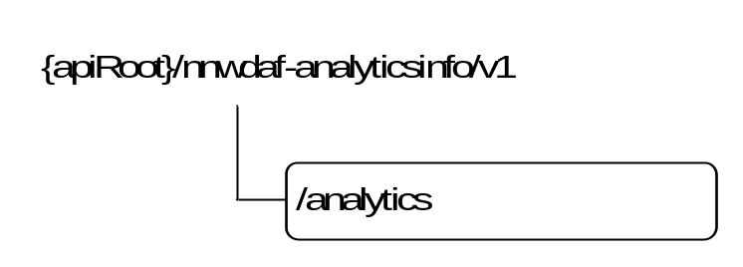
Figure 5.2.3.1-1: Resource URI structure of the Nnwdaf_AnalyticsInfo API
Table 5.2.3.1-1 provides an overview of the resources and applicable HTTP methods.
Table 5.2.3.1-1: Resources and methods overview
Resource name | Resource URI | HTTP method or custom operation | Description
NWDAF Analytics | {apiRoot}/  nnwdaf-analyticsinfo/v1  /analytics | GET | Retrieve the NWDAF analytics

5.2.3.2 Resource: NWDAF Analytics

5.2.3.2.1 Description
The NWDAF Analytics resource represents the analytics to the Nnwdaf_AnalyticsInfo Service at a given NWDAF.

5.2.3.2.2 Resource definition
Resource URI: {apiRoot}/nnwdaf-analyticsinfo/v1/analytics
This resource shall support the resource URI variables defined in table 5.2.3.2.2-1.
Table 5.2.3.2.2-1: Resource URI variables for this resource
Name | Definition
apiRoot | See subclause 5.2.1

5.2.3.2.3 Resource Standard Methods

5.2.3.2.3.1 GET
This method shall support the URI query parameters specified in table 5.2.3.2.3.1-1.
Table 5.2.3.2.3.1-1: URI query parameters supported by the GET method on this resource
Name | Data type | P | Cardinality | Description
event-id | EventId | M | 1 | Shall be included to identify the analytics.
event-filter | EventFilter | C | 0..1 | Shall be included to identify the analytics when the eventId is "Load_Level_Information".
supported-features | SupportedFeatures | O | 0..1 | To filter irrelevant responses related to unsupported features.

This method shall support the request data structures specified in table 5.2.3.2.3.1-2 and the response data structures and response codes specified in table 5.2.3.2.3.1-3.
Table 5.2.3.2.3.1-2: Data structures supported by the GET Request Body on this resource
Data type | P | Cardinality | Description
n/a

Table 5.2.3.2.3.1-3: Data structures supported by the GET Response Body on this resource
Data type | P | Cardinality | Response  codes | Description
AnalyticsData | M | 1 | 200 | Containing the analytics with parameters as relevant for the requesting NF service consumer
n/a |  |  | 204 No Content | If the request NWDAF Analytics data does not exist, the NWDAF shall respond with "204 No Content ".
NOTE: The mandatory HTTP error status codes for the GET method listed in table 5.2.7.1-1 of 3GPP TS 29.500 [6] also apply.

5.2.3.2.4 Resource Custom Operations
None in this release of the specification.

5.2.4 Custom Operations without associated resources
None in this release of the specification.

5.2.5 Notifications
None in this release of the specification.

5.2.6 Data Model

5.2.6.1 General
This subclause specifies the application data model supported by the API.
Table 5.2.6.1-1 specifies the data types defined for the Nnwdaf_AnalyticsInfo service based interface protocol.
Table 5.2.6.1-1: Nnwdaf_AnalyticsInfo specific Data Types
Data type | Section defined | Description | Applicability
EventId | 5.2.6.3.3 | Describes the type of analytics.
AnalyticsData | 5.2.6.2.2 | Describes analytics with parameters indicated in the request

Table 5.2.6.1-2 specifies data types re-used by the Nnwdaf_AnalyticsInfo service based interface protocol from other specifications, including a reference to their respective specifications and when needed, a short description of their use within the Nnwdaf service based interface.
Table 5.2.6.1-2: Nnwdaf_AnalyticsInfo re-used Data Types
Data type | Reference | Comments | Applicability
AnySlice | 5.1.6.3.2
ProblemDetails | 3GPP TS 29.571 [8] | Used in error responses to provide more detailed information about an error.
SupportedFeatures | 3GPP TS 29.571 [8] | Used to negotiate the applicability of the optional features defined in table 5.2.8-1.
Snssai | 3GPP TS 29.571 [8]
SliceLoadLevelInformation | 5.1.6.2.6

5.2.6.2 Structured data types

5.2.6.2.1 Introduction
This subclause defines the structures to be used in resource representations.

5.2.6.2.2 Type AnalyticsData
Table 5.2.6.2.2-1: Definition of type AnalyticsData
Attribute name | Data type | P | Cardinality | Description | Applicability
sliceLoadLevelInfos | array(SliceLoadLevelInformation) | M | 1..N | The slices and there load level information.
supportedFeatures | SupportedFeatures | M | 1 | List of Supported features used as described in subclause 5.1.8.  This parameter shall be supplied by NWDAF in the reply of GET request that request the analytics resource.

5.2.6.2.3 Type EventFilter
Table 5.2.6.2.3-1: Definition of type EventFilter
Attribute name | Data type | P | Cardinality | Description | Applicability
anySlice | AnySlice | C | 0..1 | Default is "FALSE". (NOTE)
snssais | array(Snssai) | C | 1..N | Identification(s) of network slice to which the subscription belongs. (NOTE)
NOTE: When event-id in the request is "LOAD_LEVEL_INFORMATION ", either information about slice(s) identified by snssais, or anySlice set to "TRUE" shall be included.

5.2.6.3 Simple data types and enumerations

5.2.6.3.1 Introduction
This subclause defines simple data types and enumerations that can be referenced from data structures defined in the previous subclauses.

5.2.6.3.2 Simple data types
The simple data types defined in table 5.2.6.3.2-1 shall be supported.
Table 5.2.6.3.2-1: Simple data types
Type Name | Type Definition | Description | Applicability
n/a

5.2.6.3.3 Enumeration: EventId
Table 5.2.6.3.3-1: Enumeration EventId
Enumeration value | Description | Applicability
LOAD_LEVEL_INFORMATION | Represent the analytics of load level information of corresponding network slice instance.

5.2.7 Error handling

5.2.7.1 General
HTTP error handling shall be supported as specified in subclause 5.2.4 of 3GPP TS 29.500 [6].
For the Nnwdaf_AnalyticsInfo API, HTTP error responses shall be supported as specified in subclause 4.8 of 3GPP TS 29.501 [7]. Protocol errors and application errors specified in table 5.2.7.2-1 of 3GPP TS 29.500 [6] shall be supported for an HTTP method if the corresponding HTTP status codes are specified as mandatory for that HTTP method in table 5.2.7.1-1 of 3GPP TS 29.500 [6]. In addition, the requirements in the following subclauses shall apply.

5.2.7.2 Protocol Errors
In this Release of the specification, there are no additional protocol errors applicable for the Nnwdaf_AnalyticsInfo API.

5.2.7.3 Application Errors
The application errors defined for the Nnwdaf_AnalyticsInfo API are listed in table 5.2.7.3-1. The NWDAF shall include in the HTTP status code a "ProblemDetails" data structure with the "cause" attribute indicating the application error as listed in table 5.2.7.3-1.
Table 5.2.7.3-1: Application errors
Application Error | HTTP status code | Description
n/a

5.2.8 Feature negotiation
The optional features in table 5.2.8-1 are defined for the Nnwdaf_AnalyticsInfo API. They shall be negotiated using the extensibility mechanism defined in subclause 6.6 of 3GPP TS 29.500 [6].
Table 5.2.8-1: Supported Features
Feature number | Feature Name | Description

5.2.9 Security
As indicated in 3GPP TS 33.501 [13] and 3GPP TS 29.500 [6], the access to the Nnwdaf_AnalyticsInfo API may be authorized by means of the OAuth2 protocol (see IETF RFC 6749 [14]), based on local configuration, using the "Client Credentials" authorization grant, where the NRF (see 3GPP TS 29.510 [12]) plays the role of the authorization server.
If OAuth2 is used, a n NF Service Consumer, prior to consuming services offered by the Nnwdaf_AnalyticsInfo API, shall obtain a "token" from the authorization server, by invoking the Access Token Request service, as described in 3GPP TS 29.510 [12], subclause 5.4.2.2.
NOTE: When multiple NRFs are deployed in a network, the NRF used as authorization server is the same NRF that the NF Service Consumer used for discovering the Nnwdaf_AnalyticsInfo service.
The Nnwdaf_AnalyticsInfo API defines a single scope "nnwdaf-analyticsinfo" for the entire service, and it does not define any additional scopes at resource or operation level.

Annex A (normative):
OpenAPI specification

A.1 General
The present Annex contains an OpenAPI [11] specification of HTTP messages and content bodies used by the Nnwdaf_EventsSubscription and the Nnwdaf_AnalyticsInfo API.
This Annex shall take precedence when being discrepant to other parts of the specification with respect to the encoding of information elements and methods within the API(s).
NOTE 1: The semantics and procedures, as well as conditions, e.g. for the applicability and allowed combinations of attributes or values, not expressed in the OpenAPI definitions but defined in other parts of the specification also apply.
Informative copies of the OpenAPI specification files contained in this 3GPP Technical Specification are available on the public 3GPP file server in the following locations (see clause 5B of the 3GPP TR 21.900 [16] for further information):
- https://www.3gpp.org/ftp/Specs/archive/OpenAPI/<Release>/, and
- https://www.3gpp.org/ftp/Specs/<Plenary>/<Release>/OpenAPI/.
NOTE 2: To fetch the OpenAPI specification file after CT#83 plenary meeting for Release 15 in the above links <Plenary> must be replaced with the date the CT Plenary occurs, in the form of year-month (yyyy-mm), e.g. for CT#83 meeting <Plenary> must be replaced with value "2019-03" and <Release> must be replaced with value "Rel-15".

A.2 Nnwdaf_EventsSubscription API
openapi: 3.0.0
info:
version: 1.1.0.alpha-1
title: Nnwdaf_EventsSubscription
description: |
Nnwdaf_EventsSubscription Service API.
© 2019, 3GPP Organizational Partners (ARIB, ATIS, CCSA, ETSI, TSDSI, TTA, TTC).
All rights reserved.
externalDocs:
description: 3GPP TS 29.520 V16.0.0; 5G System; Network Data Analytics Services.
url: 'http://www.3gpp.org/ftp/Specs/archive/29_series/29.520/'
security:
- {}
- oAuth2ClientCredentials:
- nnwdaf-eventssubscription
servers:
- url: '{apiRoot}/nnwdaf-eventssubscription/v1'
variables:
apiRoot:
default: https://example.com
description: apiRoot as defined in subclause 4.4 of 3GPP TS 29.501.
paths:
/subscriptions:
post:
requestBody:
required: true
content:
application/json:
schema:
$ref: '#/components/schemas/NnwdafEventsSubscription'
responses:
'201':
description: Create a new Individual NWDAF Event Subscription resource.
headers:
Location:
description: 'Contains the URI of the newly created resource, according to the structure: {apiRoot}/nnwdaf-eventssubscription/v1/subscriptions/{subscriptionId}'
required: true
schema:
type: string
content:
application/json:
schema:
$ref: '#/components/schemas/NnwdafEventsSubscription'
'400':
$ref: 'TS29571_CommonData.yaml#/components/responses/400'
'401':
$ref: 'TS29571_CommonData.yaml#/components/responses/401'
'403':
$ref: 'TS29571_CommonData.yaml#/components/responses/403'
'404':
$ref: 'TS29571_CommonData.yaml#/components/responses/404'
'411':
$ref: 'TS29571_CommonData.yaml#/components/responses/411'
'413':
$ref: 'TS29571_CommonData.yaml#/components/responses/413'
'415':
$ref: 'TS29571_CommonData.yaml#/components/responses/415'
'429':
$ref: 'TS29571_CommonData.yaml#/components/responses/429'
'500':
$ref: 'TS29571_CommonData.yaml#/components/responses/500'
'503':
$ref: 'TS29571_CommonData.yaml#/components/responses/503'
default:
$ref: 'TS29571_CommonData.yaml#/components/responses/default'
callbacks:
myNotification:
'{$request.body#/notificationURI}':
post:
requestBody:
required: true
content:
application/json:
schema:
type: array
items:
$ref: '#/components/schemas/NnwdafEventsSubscriptionNotification'
minItems: 1
responses:
'204':
description: The receipt of the Notification is acknowledged.
'400':
$ref: 'TS29571_CommonData.yaml#/components/responses/400'
'401':
$ref: 'TS29571_CommonData.yaml#/components/responses/401'
'403':
$ref: 'TS29571_CommonData.yaml#/components/responses/403'
'404':
$ref: 'TS29571_CommonData.yaml#/components/responses/404'
'411':
$ref: 'TS29571_CommonData.yaml#/components/responses/411'
'413':
$ref: 'TS29571_CommonData.yaml#/components/responses/413'
'415':
$ref: 'TS29571_CommonData.yaml#/components/responses/415'
'429':
$ref: 'TS29571_CommonData.yaml#/components/responses/429'
'500':
$ref: 'TS29571_CommonData.yaml#/components/responses/500'
'503':
$ref: 'TS29571_CommonData.yaml#/components/responses/503'
default:
$ref: 'TS29571_CommonData.yaml#/components/responses/default'
/subscriptions/{subscriptionId}:
delete:
parameters:
- name: subscriptionId
in: path
description: String identifying a subscription to the Nnwdaf_EventsSubscription Service
required: true
schema:
type: string
responses:
'204':
description: No Content. The Individual NWDAF Event Subscription resource matching the subscriptionId was deleted.
'400':
$ref: 'TS29571_CommonData.yaml#/components/responses/400'
'401':
$ref: 'TS29571_CommonData.yaml#/components/responses/401'
'403':
$ref: 'TS29571_CommonData.yaml#/components/responses/403'
'404':
description: The Individual NWDAF Event Subscription resource does not exist.
content:
application/problem+json:
schema:
$ref: 'TS29571_CommonData.yaml#/components/schemas/ProblemDetails'
'429':
$ref: 'TS29571_CommonData.yaml#/components/responses/429'
'500':
$ref: 'TS29571_CommonData.yaml#/components/responses/500'
'501':
$ref: 'TS29571_CommonData.yaml#/components/responses/501'
'503':
$ref: 'TS29571_CommonData.yaml#/components/responses/503'
default:
$ref: 'TS29571_CommonData.yaml#/components/responses/default'
put:
requestBody:
required: true
content:
application/json:
schema:
$ref: '#/components/schemas/NnwdafEventsSubscription'
parameters:
- name: subscriptionId
in: path
description: String identifying a subscription to the Nnwdaf_EventsSubscription Service
required: true
schema:
type: string
responses:
'200':
description: The Individual NWDAF Event Subscription resource was modified successfully and a representation of that resource is returned.
content:
application/json:
schema:
$ref: '#/components/schemas/NnwdafEventsSubscription'
'204':
description: The Individual NWDAF Event Subscription resource was modified successfully.
'400':
$ref: 'TS29571_CommonData.yaml#/components/responses/400'
'401':
$ref: 'TS29571_CommonData.yaml#/components/responses/401'
'403':
$ref: 'TS29571_CommonData.yaml#/components/responses/403'
'404':
description: The Individual NWDAF Event Subscription resource does not exist.
content:
application/problem+json:
schema:
$ref: 'TS29571_CommonData.yaml#/components/schemas/ProblemDetails'
'411':
$ref: 'TS29571_CommonData.yaml#/components/responses/411'
'413':
$ref: 'TS29571_CommonData.yaml#/components/responses/413'
'415':
$ref: 'TS29571_CommonData.yaml#/components/responses/415'
'429':
$ref: 'TS29571_CommonData.yaml#/components/responses/429'
'500':
$ref: 'TS29571_CommonData.yaml#/components/responses/500'
'501':
$ref: 'TS29571_CommonData.yaml#/components/responses/501'
'503':
$ref: 'TS29571_CommonData.yaml#/components/responses/503'
default:
$ref: 'TS29571_CommonData.yaml#/components/responses/default'
components:
securitySchemes:
oAuth2ClientCredentials:
type: oauth2
flows:
clientCredentials:
tokenUrl: '{nrfApiRoot}/oauth2/token'
scopes:
nnwdaf-eventssubscription: Access to the Nnwdaf_EventsSubscription API
schemas:
NnwdafEventsSubscription:
type: object
properties:
eventSubscriptions:
type: array
items:
$ref: '#/components/schemas/EventSubscription'
minItems: 1
description: Subscribed events
notificationURI:
$ref: 'TS29571_CommonData.yaml#/components/schemas/Uri'
supportedFeatures:
$ref: 'TS29571_CommonData.yaml#/components/schemas/SupportedFeatures'
required:
- eventSubscriptions
EventSubscription:
type: object
properties:
anySlice:
$ref: '#/components/schemas/AnySlice'
applicationIds:
type: array
items:
$ref: 'TS29571_CommonData.yaml#/components/schemas/ApplicationId'
minItems: 1
description: Identification(s) of application to which the subscription applies. When subscribed event is "SERVICE_EXPERIENCE", the absence of applicationIds means subscription to all applications.
dnns:
type: array
items:
$ref: 'TS29571_CommonData.yaml#/components/schemas/Dnn'
minItems: 1
description: Identification(s) of DNN to which the subscription applies. When subscribed event is "SERVICE_EXPERIENCE", the absence of dnns means subscription to all DNNs.
event:
$ref: '#/components/schemas/NwdafEvent'
loadLevelThreshold:
type: integer
description: Shall be supplied for notification method "THRESHOLD". Indicates that the NWDAF shall report the corresponding network slice load level to the NF service consumer where the load level of the network slice instance identified by snssai is reached.
notificationMethod:
$ref: '#/components/schemas/NotificationMethod'
networkAreas:
type: array
items:
$ref: 'TS29554_Npcf_BDTPolicyControl.yaml#/components/schemas/NetworkAreaInfo'
minItems: 1
description: Identification(s) of network area to which the subscription applies. When subscribed event is "SERVICE_EXPERIENCE", the absence of networkAreas means subscription to all network areas.
repetitionPeriod:
$ref: 'TS29571_CommonData.yaml#/components/schemas/DurationSec'
snssaia:
type: array
items:
$ref: 'TS29571_CommonData.yaml#/components/schemas/Snssai'
minItems: 1
description: Identification(s) of network slice to which the subscription applies. When subscribed event is "SLICE_LOAD_LEVEL", either information about slice(s) identified by snssai, or anySlice set to "TRUE" shall be included.
startTimeStamp:
$ref: 'TS29571_CommonData.yaml#/components/schemas/DateTime'
endTimeStamp:
$ref: 'TS29571_CommonData.yaml#/components/schemas/DateTime'
required:
- event
NnwdafEventsSubscriptionNotification:
type: object
properties:
eventNotifications:
type: array
items:
$ref: '#/components/schemas/EventNotification'
minItems: 1
description: Notifications about Individual Events
subscriptionId:
type: string
description: String identifying a subscription to the Nnwdaf_EventsSubscription Service
required:
- eventNotifications
- subscriptionId
EventNotification:
type: object
properties:
event:
$ref: '#/components/schemas/NwdafEvent'
sliceLoadLevelInfo:
$ref: '#/components/schemas/SliceLoadLevelInformation'
svcExpInfo:
$ref: '#/components/schemas/ServiceExperienceInfo'
required:
- event
#
# Editor's note: The data type ServiceExperienceInformation is FFS.
#
ServiceExperienceInfo:
type: string
SliceLoadLevelInformation:
type: object
properties:
loadLevelInformation:
$ref: '#/components/schemas/LoadLevelInformation'
snssais:
type: array
items:
$ref: 'TS29571_CommonData.yaml#/components/schemas/Snssai'
minItems: 1
description: Identification(s) of network slice to which the subscription.
required:
- loadLevelInformation
- snssais
AnySlice:
type: boolean
description: FALSE represents not applicable for all slices. TRUE represents applicable for all slices.
LoadLevelInformation:
type: integer
description: Load level information of the network slice instance.
NotificationMethod:
anyOf:
- type: string
enum:
- PERIODIC
- THRESHOLD
- type: string
description: >
This string provides forward-compatibility with future
extensions to the enumeration but is not used to encode
content defined in the present version of this API.
description: >
Possible values are
- PERIODIC: The subscribe of NWDAF Event is peridodicly. The periodic of the notification is identified by repetitionPeriod defined in subclause 5.1.6.2.3.
- THRESHOLD: The subscribe of NWDAF Event is upon threshold exceeded. The threshold of the notification is identified by loadLevelThreshold defined in subclause 5.1.6.2.3.
NwdafEvent:
anyOf:
- type: string
enum:
- SLICE_LOAD_LEVEL
- SERVICE_EXPERIENCE
- type: string
description: >
This string provides forward-compatibility with future
extensions to the enumeration but is not used to encode
content defined in the present version of this API.
description: >
Possible values are
- SLICE_LOAD_LEVEL: Indicates that the event subscribed is load level information of Network Slice instance
- SERVICE_EXPERIENCE: Indicates that the event subscribed is service experience.

A.3 Nnwdaf_AnalyticsInfo API
openapi: 3.0.0
info:
version: 1.0.2
title: Nnwdaf_AnalyticsInfo
description: |
Nnwdaf_AnalyticsInfo Service API.
© 2019, 3GPP Organizational Partners (ARIB, ATIS, CCSA, ETSI, TSDSI, TTA, TTC).
All rights reserved.
externalDocs:
description: 3GPP TS 29.520 V15.4.0; 5G System; Network Data Analytics Services.
url: 'http://www.3gpp.org/ftp/Specs/archive/29_series/29.520/'
security:
- {}
- oAuth2ClientCredentials:
- nnwdaf-analyticsinfo
servers:
- url: '{apiRoot}/nnwdaf-analyticsinfo/v1'
variables:
apiRoot:
default: https://example.com
description: apiRoot as defined in subclause 4.4 of 3GPP TS 29.501.
paths:
/analytics:
get:
parameters:
- name: event-id
in: query
description: Identify the analytics.
required: true
schema:
$ref: '#/components/schemas/EventId'
- name: event-filter
in: query
description: Identify the analytics.
required: false
content:
application/json:
schema:
$ref: '#/components/schemas/EventFilter'
- name: supported-features
in: query
description: To filter irrelevant responses related to unsupported features
schema:
$ref: 'TS29571_CommonData.yaml#/components/schemas/SupportedFeatures'
responses:
'200':
description: Containing the analytics with parameters as relevant for the requesting NF service consumer.
content:
application/json:
schema:
$ref: '#/components/schemas/AnalyticsData'
'204':
description: No Content (The request NWDAF Analytics data does not exist)
'400':
$ref: 'TS29571_CommonData.yaml#/components/responses/400'
'401':
$ref: 'TS29571_CommonData.yaml#/components/responses/401'
'403':
$ref: 'TS29571_CommonData.yaml#/components/responses/403'
'404':
description: Indicates that the NWDAF Analytics resource does not exist.
content:
application/problem+json:
schema:
$ref: 'TS29571_CommonData.yaml#/components/schemas/ProblemDetails'
'406':
$ref: 'TS29571_CommonData.yaml#/components/responses/406'
'414':
$ref: 'TS29571_CommonData.yaml#/components/responses/414'
'429':
$ref: 'TS29571_CommonData.yaml#/components/responses/429'
'500':
$ref: 'TS29571_CommonData.yaml#/components/responses/500'
'503':
$ref: 'TS29571_CommonData.yaml#/components/responses/503'
default:
$ref: 'TS29571_CommonData.yaml#/components/responses/default'
components:
securitySchemes:
oAuth2ClientCredentials:
type: oauth2
flows:
clientCredentials:
tokenUrl: '{nrfApiRoot}/oauth2/token'
scopes:
nnwdaf-analyticsinfo: Access to the Nnwdaf_AnalyticsInfo API
schemas:
AnalyticsData:
type: object
properties:
sliceLoadLevelInfos:
type: array
items:
$ref: 'TS29520_Nnwdaf_EventsSubscription.yaml#/components/schemas/SliceLoadLevelInformation'
minItems: 1
description: The slices and their load level information.
EventFilter:
type: object
properties:
anySlice:
$ref: 'TS29520_Nnwdaf_EventsSubscription.yaml#/components/schemas/AnySlice'
snssais:
type: array
items:
$ref: 'TS29571_CommonData.yaml#/components/schemas/Snssai'
minItems: 1
description: Identification(s) of network slice to which the subscription belongs.
not:
required: [anySlice, snssais]
EventId:
anyOf:
- type: string
enum:
- LOAD_LEVEL_INFORMATION
- type: string
description: >
This string provides forward-compatibility with future
extensions to the enumeration but is not used to encode
content defined in the present version of this API.
description: >
Possible values are
- LOAD_LEVEL_INFORMATION: Represent the analytics of load level information of corresponding network slice instance.

Annex B (informative):
Change history
Change history
Date | TSG # | TSG Doc. | CR | Rev | Cat | Subject/Comment | New
2017-10 |  |  |  |  |  | TS skeleton of Network Data Analytics Services. | 0.0.0
2017-11 | CT3#92 |  |  |  |  | Inclusion of documents agreed in CT3#92 C3-175356. | 0.1.0
2017-12 | CT3#93 |  |  |  |  | Inclusion of documents agreed in CT3#93 C3-176166, C3-176260, C3-176324, C3-176325, C3-176326, and C3-176327. | 0.2.0
2018-01 | CT3#94 |  |  |  |  | Inclusion of documents agreed in CT3#94 C3-180252, C3-180253, C3-180254, C3-180255, C3-180256, C3-180257, C3-180344, C3-180345, C3-180346, C3-180323 and C3-180347. | 0.3.0
2018-03 | CT3#95 |  |  |  |  | Inclusion of documents agreed in CT3#95 C3-181253, C3-181255, C3-181256, C3-181257, C3-181260, C3-181312, C3-181342 and C3-181343. | 0.4.0
2018-03 | CT3#96 |  |  |  |  | Inclusion of documents agreed in CT3#96 C3-182379 and C3-182380. | 0.5.0
2018-05 | CT3#97 |  |  |  |  | Inclusion of documents agreed in CT3#97 C3-183285, C3-183532, C3-183533, C3-183534 and C3-183535. | 0.6.0
2018-06 | CT#80 | CP-181032 |  |  |  | TS sent to plenary for approval | 1.0.0
2018-06 | CT#80 | CP-181032 |  |  |  | TS approved by plenary | 15.0.0
2018-09 | CT#81 | CP-182015 | 0001 | 3 | F | Clarification on mandatory HTTP error status codes | 15.1.0
2018-09 | CT#81 | CP-182209 | 0002 | 4 | B | OpenAPI for TS 29.520 | 15.1.0
2018-09 | CT#81 | CP-182015 | 0003 | 1 | F | Description of Structured data types | 15.1.0
2018-09 | CT#81 | CP-182015 | 0004 | 1 | F | Resource structure presentation | 15.1.0
2018-12 | CT#82 | CP-183205 | 0006 |  | F | Default value for apiRoot | 15.2.0
2018-12 | CT#82 | CP-183205 | 0007 | 2 | F | Correct Nnwdaf service | 15.2.0
2018-12 | CT#82 | CP-183205 | 0008 | 1 | F | Cardinality | 15.2.0
2018-12 | CT#82 | CP-183205 | 0009 |  | F | API version | 15.2.0
2018-12 | CT#82 | CP-183205 | 0010 |  | F | ExternalDocs OpenAPI field | 15.2.0
2018-12 | CT#82 | CP-183205 | 0011 | 1 | F | Security | 15.2.0
2018-12 | CT#82 | CP-183205 | 0012 | 1 | F | Supported content types | 15.2.0
2018-12 | CT#82 | CP-183205 | 0013 | 2 | F | HTTP Error responses | 15.2.0
2018-12 | CT#82 | CP-183205 | 0014 | 2 | F | Correct NWDAF resource | 15.2.0
2018-12 | CT#82 | CP-183205 | 0016 | 1 | F | Adding HTTP status code "204 No Content" | 15.2.0
2018-12 | CT#82 | CP-183205 | 0019 |  | F | Location header field in OpenAPI | 15.2.0
2019-03 | CT#83 | CP-190113 | 0020 |  | F | Support of NSSF as the service consumer | 15.3.0
2019-03 | CT#83 | CP-190113 | 0021 | 1 | F | Formatting of structured data types in query | 15.3.0
2019-03 | CT#83 | CP-190113 | 0022 |  | F | OpenAPI info version update | 15.3.0
2019-03 | CT#83 | CP-190213 | 0023 | 1 | F | Correction of Location header in Nnwdaf_EventsSubscription OPenAPI | 15.3.0
2019-06 | CT#84 | CP-191078 | 24 | 1 | F | Correction of Nnwdaf_EventsSubscription OpenAPI | 15.4.0
2019-06 | CT#84 | CP-191078 | 29 | 7 | F | Corrections on TS 29.520 | 15.4.0
2019-06 | CT#84 | CP-191078 | 35 | 1 | F | Precedence of OpenAPI file | 15.4.0
2019-06 | CT#84 | CP-191078 | 37 | 1 | F | Copyright Note in YAML files | 15.4.0
2019-06 | CT#84 | CP-191090 | 25 | 1 | B | Reference update and service representation | 16.0.0
2019-06 | CT#84 | CP-191090 | 27 | 3 | B | Support of more consumers | 16.0.0
2019-06 | CT#84 | CP-191090 | 28 | 1 | B | Support of more analytic events | 16.0.0
2019-06 | CT#84 | CP-191225 | 31 | 9 | B | Subscribing of service experience for the application | 16.0.0
2019-06 | CT#84 | CP-191090 | 33 | 2 | B | Delete the subscription of service experience for the application | 16.0.0
2019-06 | CT#84 | CP-191090 | 34 | 5 | B | Notification of service experience for the application | 16.0.0
2019-06 | CT#84 | CP-191090 | 39 | 2 | F | Copyright Note in YAML files | 16.0.0

