**Positive 20% flip, Negative 10% flip**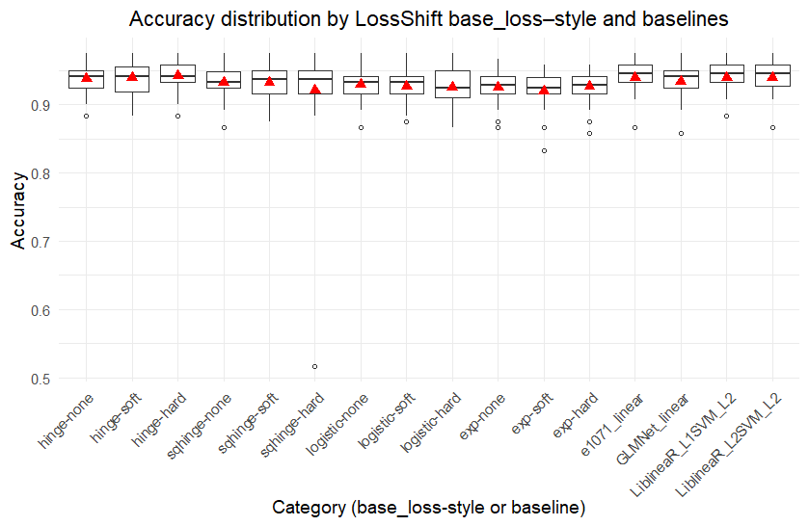

**Positive 30% flip, Negative 10% flip**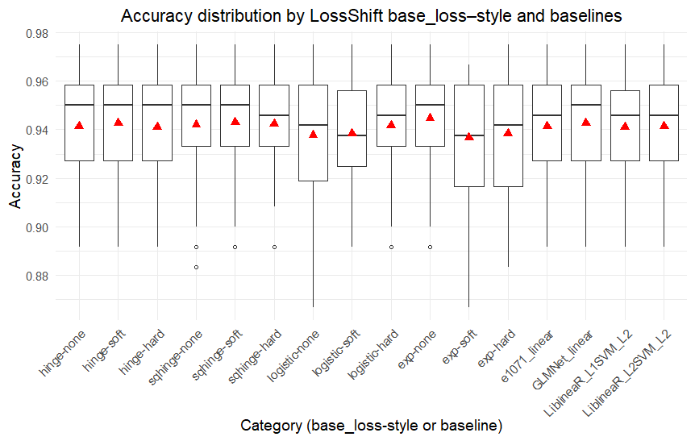

**Positive 40% flip, Negative 10% flip**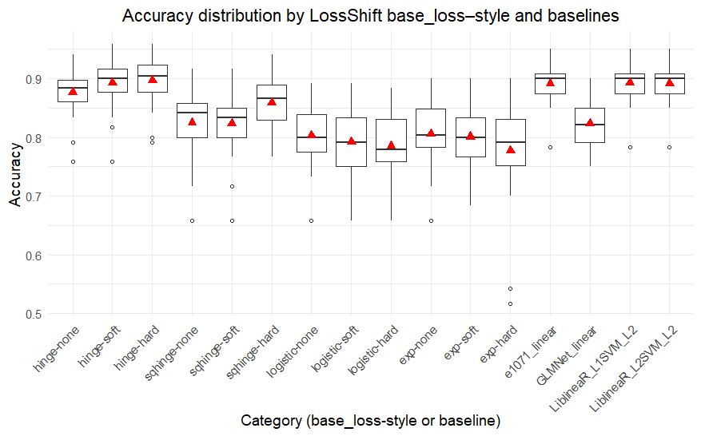

**Positive 30% flip, Negative 20% flip**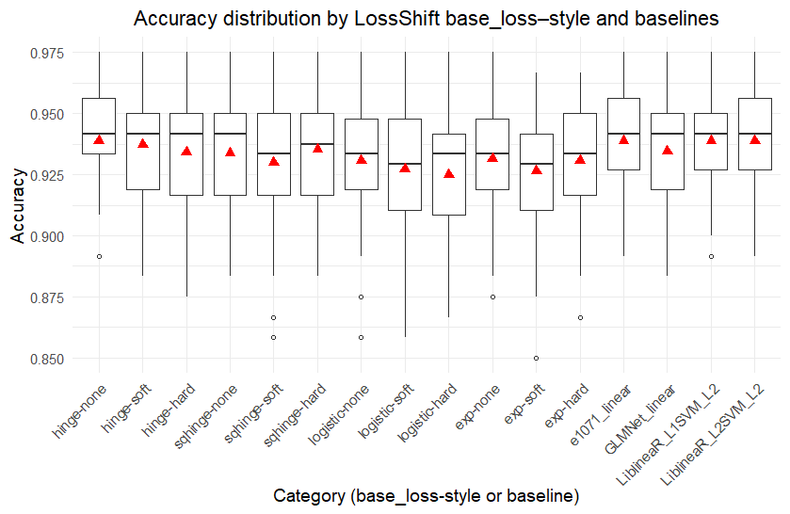

**Positive 40% flip, Negative 20% flip**