I declare that in submitting all work for this assessment I have read, understood and agree to the content and expectations of the Assessment declaration.

**Assignment 1 – My Profile (Early Feedback)**

Do Hoang Quan – S3800978

**Personal Information**

**Name:** Do Hoang Quan, but most of my friends call me Liam.

**Student Number:** S3800978

**Email:** [liamhoangdo@gmail.com](mailto:liamhoangdo@gmail.com) or [s3800978@rmit.edu.vn](mailto:s3800978@rmit.edu.vn)

**Background Information:**  
I am a Vietnamese, born and raised in Ho Chi Minh City. I’ve studied completely in the public school system, which doesn’t teach much IT, so I am very excited to be learning here at RMIT. My high school was Le Quy Don High School, which I love very much. I am fluent in Vietnamese and English.

**Fun fact:**

* I took 2 gap years.
* I have an American citizenship.

**Interest in IT**

**What is your interest in IT? When did your interest in IT start? Was there a particular event or person that sparked your interest? Outline your IT experience (if any).**

I love IT for because with it I can make life better for other people. I was the “IT guy” for my classmates, from fixing laptops, upgrading Windows to teaching my friends how to download and use software for film editing and designing. Using technology, I can empower people to work easier and make their life more convenient. My interest for tech started when I was still in kindergarten. Back then, my brother would downloads games from internet for me. From those game, I not only had fun but also learned English. It taught me that knowledge in IT open up so many doors and opportunities for my future.

**Why did you choose to come to RMIT?**

RMIT has a special combination of things that are hard to find in Vietnam: top-of-the-line infrastructure, extensive English programs, and always up-to-date lessons. In short, I would be hard-pressed to find a better place to learn. Moreover, RMIT also give me the opportunity to experience internship, which will make learning and applying for work easier. The faculty are not only skilled but also very friendly and welcoming, making me happy and motivated to come to class everyday to learn something I am passionate in.

**What do you expect to learn during your studies?**

A comprehensive understanding of modern day technology: coding and programming, AI and machine learning, a bit of crypto… Most importantly, I deeply want to learn HCI and UX, how people interact with technology, and from that knowledge, build intuitive and helpful experiences. I wish to also learn creative way to solve problems, teamwork, and many soft skills to prepare me for future work.

**Ideal Job**

**The job advertisement itself.**

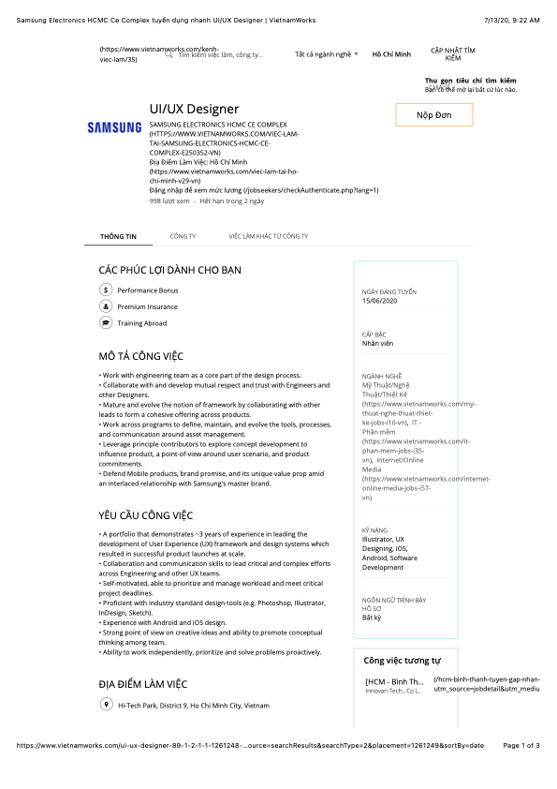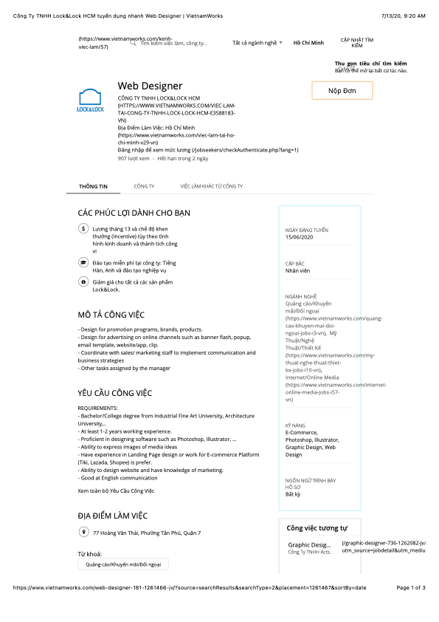

**A description (in your own words) of the position:**

Build thoughtfully designed and beautiful products (website, apps…) with the combination of intuitive User Experience and delightful User Interface. Research how users use products to make an easy-to-understand experience, and combine that with beautiful UI. The goal is to help users use the products better, increase trust in the brand, and keep users coming back.

**What makes this position appeals to you:**

* Improve my knowledge of how human perceive and interact with technology.
* It is my passion to help people by making useful and delightful products that improve their quality-of-life.
* Great salary and benefits.
* Always keeping up-to-date with new advancements and improvements in technology.

**A description of the skills, qualifications, and experience required for the position:**

* BA/BS in Human-Computer Interaction / ComSci / Psychology…
* Many years of experience in the field, with a portfolio in to prove.
* Proficiency in many tools: Sketch, Figma, Adobe Photoshop, Illustrator, XD…
* Good English is preferred.
* Teamwork and communication skills.
* Passionate and motivated in helping and understanding clients.
* Self-motivated, responsible, self-disciplined. Work well under stress and deadlines.
* Creative and good at solving problems in a cost-effective way.

**A description (in your own words) of the skills, qualifications, and experience you currently have.**

* Teamwork and communication skills.
* Good English.
* Motivated in helping others.
* Work well under stress and deadline.
* Can come up with creative and effective solutions.
* Proficient in Photoshop, Illustrator, Sketch, Figma.
* Understanding of basic UI/UX.
* In the process of getting a BS in ComSci.

**A plan describing how you will obtain the skills, qualifications, and experience required for the position, building on those you have now. This need not be greatly detailed, (and will probably change significantly over time anyway), but try to be as specific as you can.**

* Continue to learn and study to get a BS in IT.
* Learn more about UI / UX from experienced workers in the field. Participate in internships to build a good portfolio and amass an understanding of real-life work experiences.
* Participate in team-work.
* Practice more soft skills by utilizing electives.

**Personal Profile**

**Myers-Briggs:** INFP-T (The Mediator)

**Learning style test:** Visual/Tactile

**Big Five Personality Test:**

**What do the results of these tests mean for you?**

Firstly, while the personality test offer a general look into people personality, which might be useful in certain situations, but must not be taken as the only assessment into someone. On the other hand, the learning style test offers clear insight on how people learn, and such knowledge is useful in tailoring lessons and experiences so that they may be taken better.

**How do you think these results may influence your behaviour in a team?**

These insights would help me notice what I might be doing that could impede teamwork and improve on them. I want a professional and harmonious team that works well and respect each-other, so anything I can do to better my part in it is a mission worth undertaking.

**How should you take this into account when forming a team?**

I don’t think these tests can show accurately how people work together, but they might be useful for selecting a well-balanced team. An example would be that an introverted member would benefit from an extraverted member, who can help them communicate or present in front of a large group. However, it is also important that the members differences compliment, not conflict one another. Most importantly, it’s essential to have members who are diplomatic and good at resolving conflicts, open-minded and respectful of others.

**Project ideas**

**Overview**

There’s is always a time when you need an IT guy, from helping you fix your computer to teaching you how to use an app or service. This project is an “IT guy” AI that listens to the users’ input, understand their intents, and do the task that is asked of it. This AI target demographic is people who are unfamiliar with the many complexities of tech (older people) or people with cognitive or physical difficulties. However, provided the AI is “smart” enough, it can be useful for anyone.

**Motivation**

The motivation is from me being the IT guy and having to constantly fix or help people do basic tasks that would be easily done if they understood how the tech work. For example, my mom’s phone stops letting her take photos because it’s out of storage, and a subscription to iCloud would fix the problem. Another one is my parents yelled at me to come out of the showers twice to help them add a member to their messenger call. These solutions require them to understand how everything in the phone is connected and how they work, which can be difficult for many people. AI would be able to solve these problems.

**Description**

*How it works:*

The AI’s main goal is to help users accomplish tasks that require interactions with machines. The AI will listen to the user’s voice or text input (for the vocally unable or challenged), process their intention, then either interact with their machines’ OS (using accessibilities options or assistant) to fulfill that intent. For other machines (ATMs, food ordering kiosks…), the user could point their camera or smart glasses at the object, and the AI would show guide (where to click, etc.) to the users and help them fulfill that intent. On top of the visual guide, the AI will also provide an auditory guide to help the user. The AI will prioritize doing the task automatically on its own, and only deferring to helping the user do the task if it cannot be done automatically.

The AI will be able to communicate with a vast variety of platforms. It will use the accessibilities options (touch, move the mouse, clicking…) or interact with the OS’s assistant to get the task done. It must also understand many hardware and how to interact with them. This will require excellent object recognition and categorization.

For the early version, the AI could be an app on the user’s phone. For later versions, it would be best to integrate this AI directly as a feature of the OS’s assistant. The ultimate version of this AI would live on a pair of smart glasses, as it can utilize what the user sees and offer the easiest guide to finishing a task (i.e. drawing a red box on the icon the user is supposed to click).

*Concerns*

The AI will have to be extremely good at understanding intent from the input. For example, when users ask it to “make their phone run faster”, the AI isn’t going to overclock the phone and kill the battery. It’s supposed to run a diagnostic on why there are slowdowns: “peak-performance battery capability” on iPhone (Apple slow down phones with degraded battery to prevent shutdowns), or check what app might be silently using resources in the background on Android, then fix it for the users AND tell them what is the reason, what is the fix, and why did it use that fix. The AI must be transparent to increase user’s trust, perception of the AI’s intelligence, and development purposes.

Not only this, the AI has to be approachable and friendly, but not appear to sound exactly like a human. When user perceives it more like a robot, they are more willing to let go of some fault of the AI, whereas AI that sounds extremely human will anger the user more if it does something wrong (see the Uncanny Valley effect). Preferably, the AI should like a friendly robot.

The AI will have to have access to a lot of personal data from the user to best do its job. For example, if someone says: “Show me what my friends are up to”, the AI has to know who the user’s friends are, which one they care about the most, which platform the user uses, and then pull data from it. This is a very large privacy issue. One way around this is to make it run locally on the device. This might impede its long-term learning capabilities, but this issue can be overcome by clearly asking the user to submit entirely anonymous data.

Preferably, this AI will be platform and language agnostic, being able to work across a variety of machines (phones, laptops, ATM, smart car, IOTs…) and languages (i.e. and English person asking the AI how to print a business card from a Japanese card printer during a business trip). This would require a huge leap in translation capabilities. But for the early version, English alone would be sufficient.

**Tools and Technology**

The AI would be a combination of many already well-developed foundation, including smart assistant (Siri, Google, Cortana…), accessibilities options, artificial intelligence, and machine learning (to understand and process intents), language skills… The most difficult part is to first convince companies to work together in this undertaking, then writing the software capable of working with all of the underlying foundations mentioned earlier. Software to be used will include machine learning software (Tensorflow, etc.).

**Skill Required**

The skill required to create this AI is monumental, but fully within reach. Extremely throughout knowledge of machine learning is required to teach this AI everything it has to know: what the user wants, how to do it, how to work across a myriad of different OS, systems, machines, people… The AI also would greatly benefit from people with knowledge in language, psychology, UIUX, fintech… The most important hardware that is still currently lacking is a good pair of smart glasses, and this will truly make the experience seamless for the user.

**Outcome**

If the project is fruitful, it will most definitely change how we interact with tech. Humanity is known for relying on anything that can make our life more convenient (like the washing machine). It will enable a giant population who couldn’t use a phone before to use it with ease. Imagine never having to interact with any devices to get things done. “Download the highest game on the chart” would automatically get it from Steam or the Play Store or App Store, “add my brother to this call” would run from WhatsApp to Messenger,… The possibilities are truly endless.