EE412 Foundation of Big Data Analytics, Fall 2022

HW3

Name: 함태욱

Student ID: 20180716

Discussion Group (People with whom you discussed ideas used in your answers):

On-line or hardcopy documents used as part of your answers:

## Answer to Problem 1

(a) **[Codes and its Page information text file]**

I reuse the source code and the text file format of problem 1-(b) that uses pyspark

In the text file each number means {1:’A’, 2:’B’, 3:’C’, 4:’D’}

And for instance, line 1 2 means A(1) directs B(2) like graph.txt

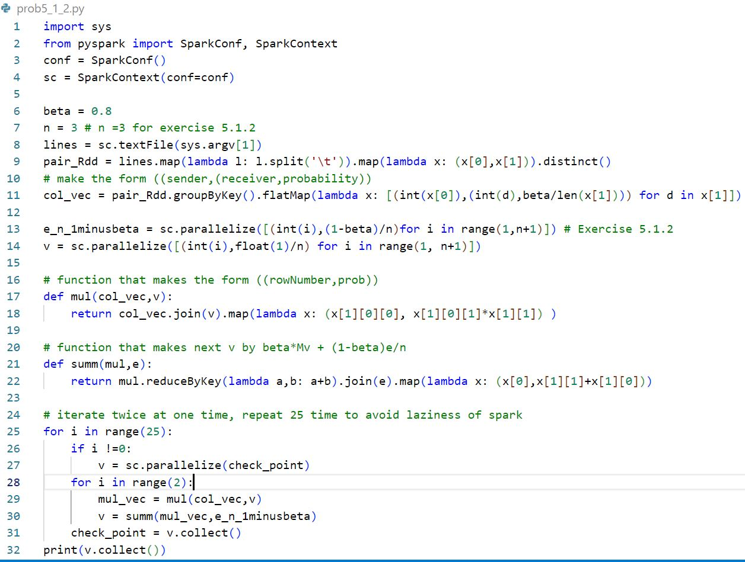In addition, in the problem 5_3_1, if the teleport set is [A,C], then the line 14 must be activated while line 13 must be not. The iteration is 50 times as same as 1-(b)

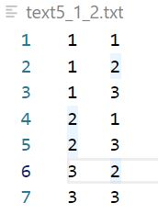

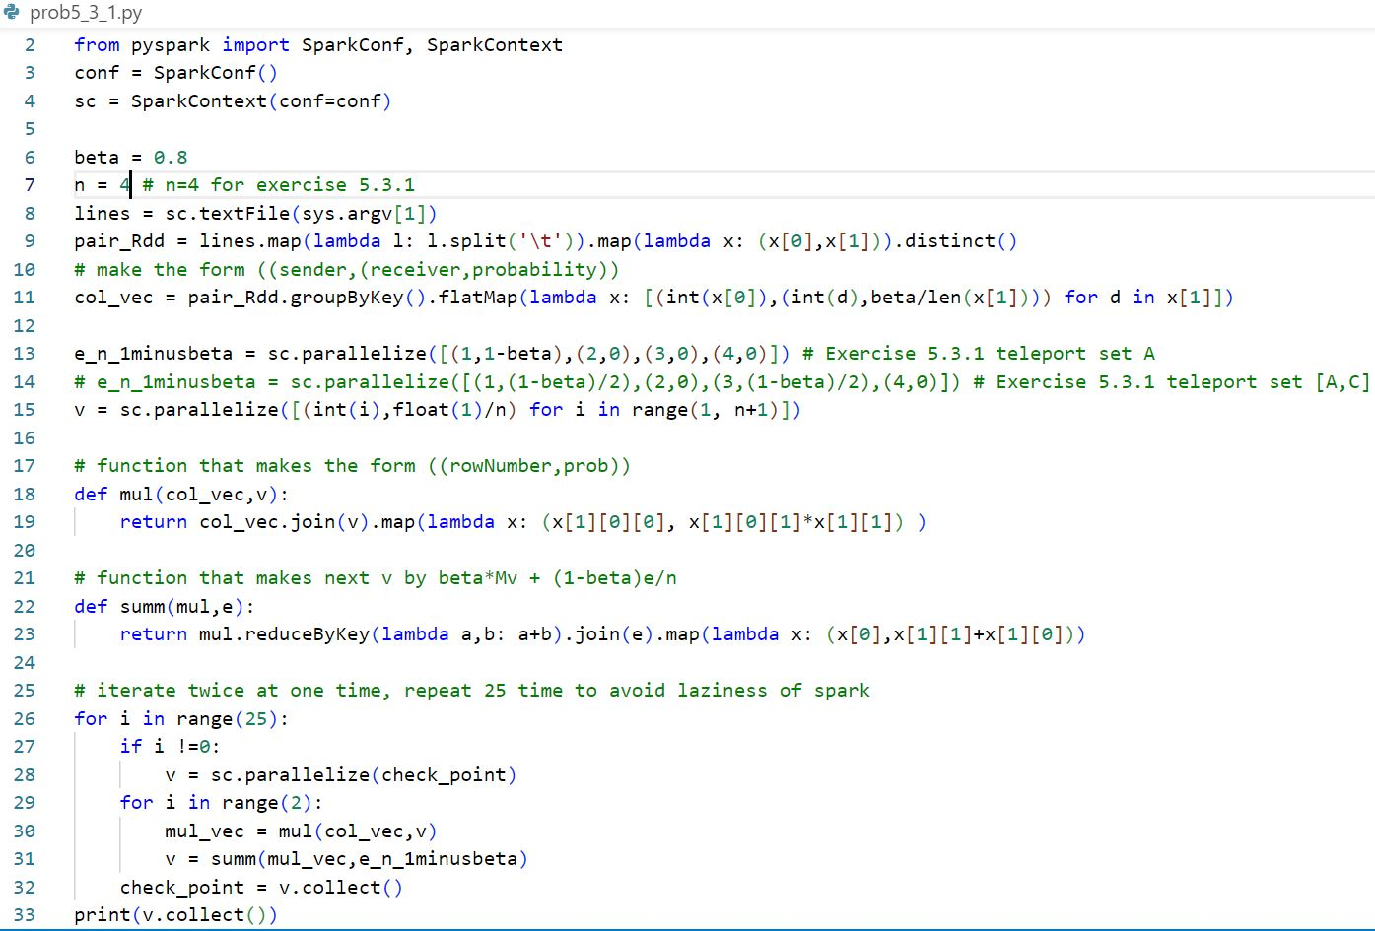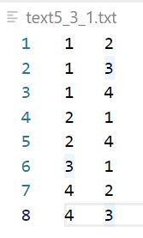

**[Answer of the problems in 1-a]**

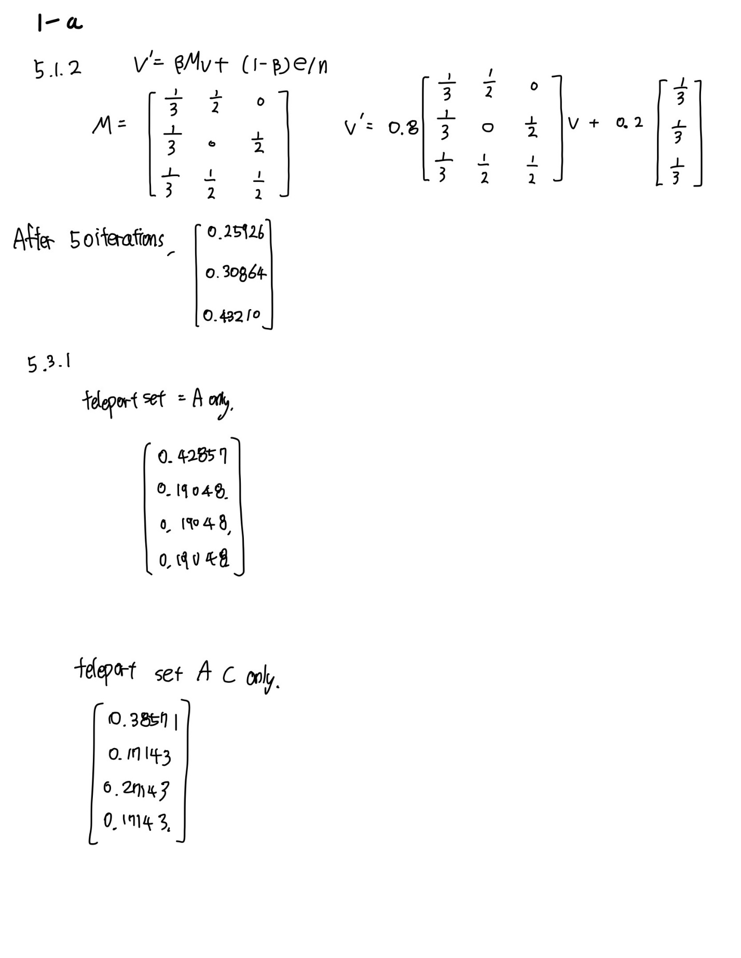

(b)

263 0.00216

537 0.00212

965 0.00206

243 0.00197

255 0.00194

285 0.00193

16 0.00191

126 0.00190

747 0.00190

736 0.00189

## Answer to Problem 2

(a)

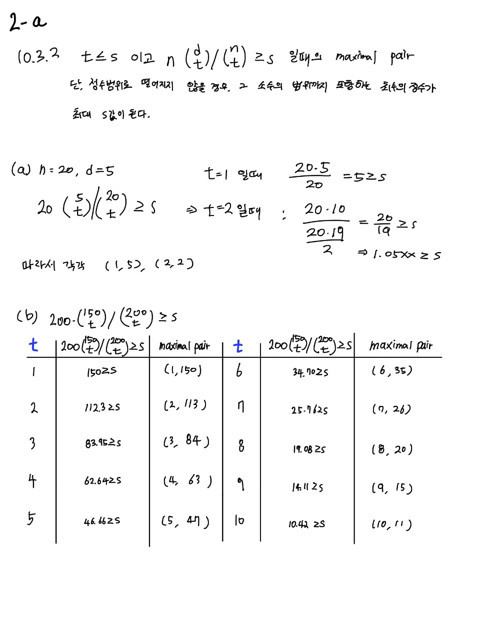

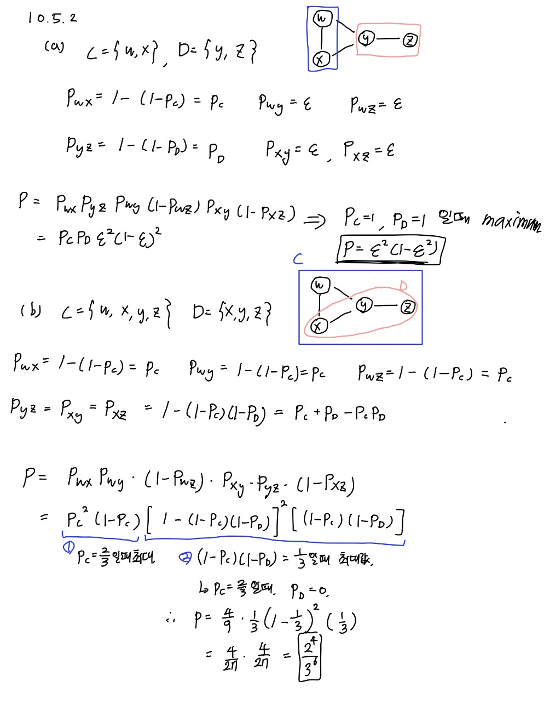

(b)

3501542

## Answer to Problem 3

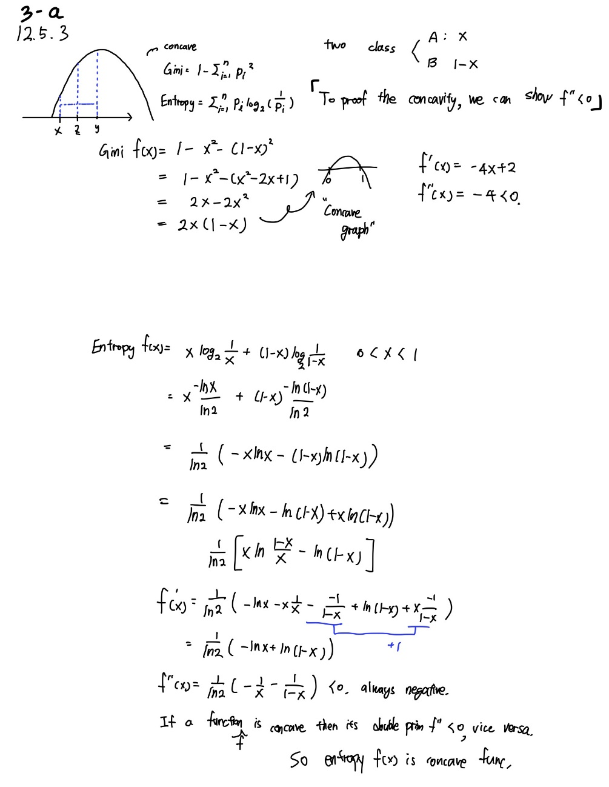

(b)

0.832833333333

0.7

0.001