EE412 Foundation of Big Data Analytics, Fall 2022

HW4

Name: TaewookHam

Student ID: 20180716

## Answer to Problem 1

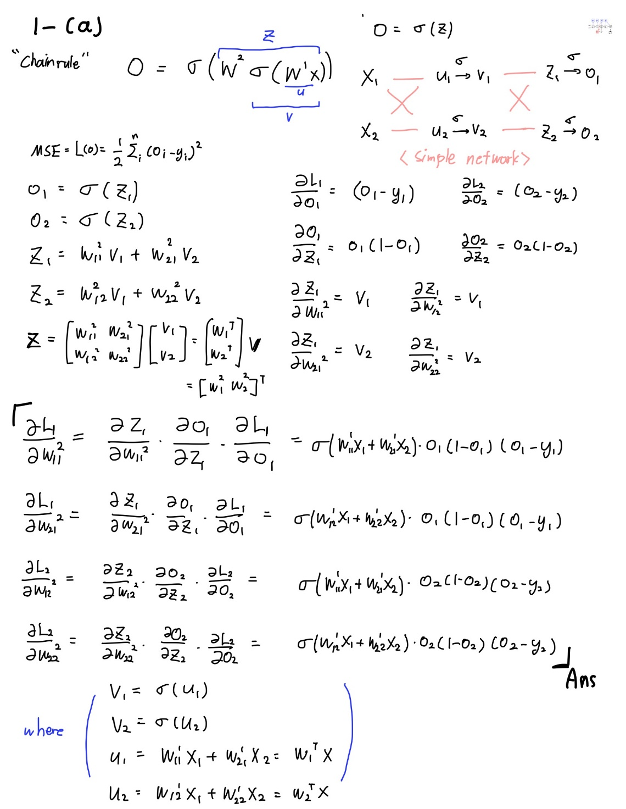

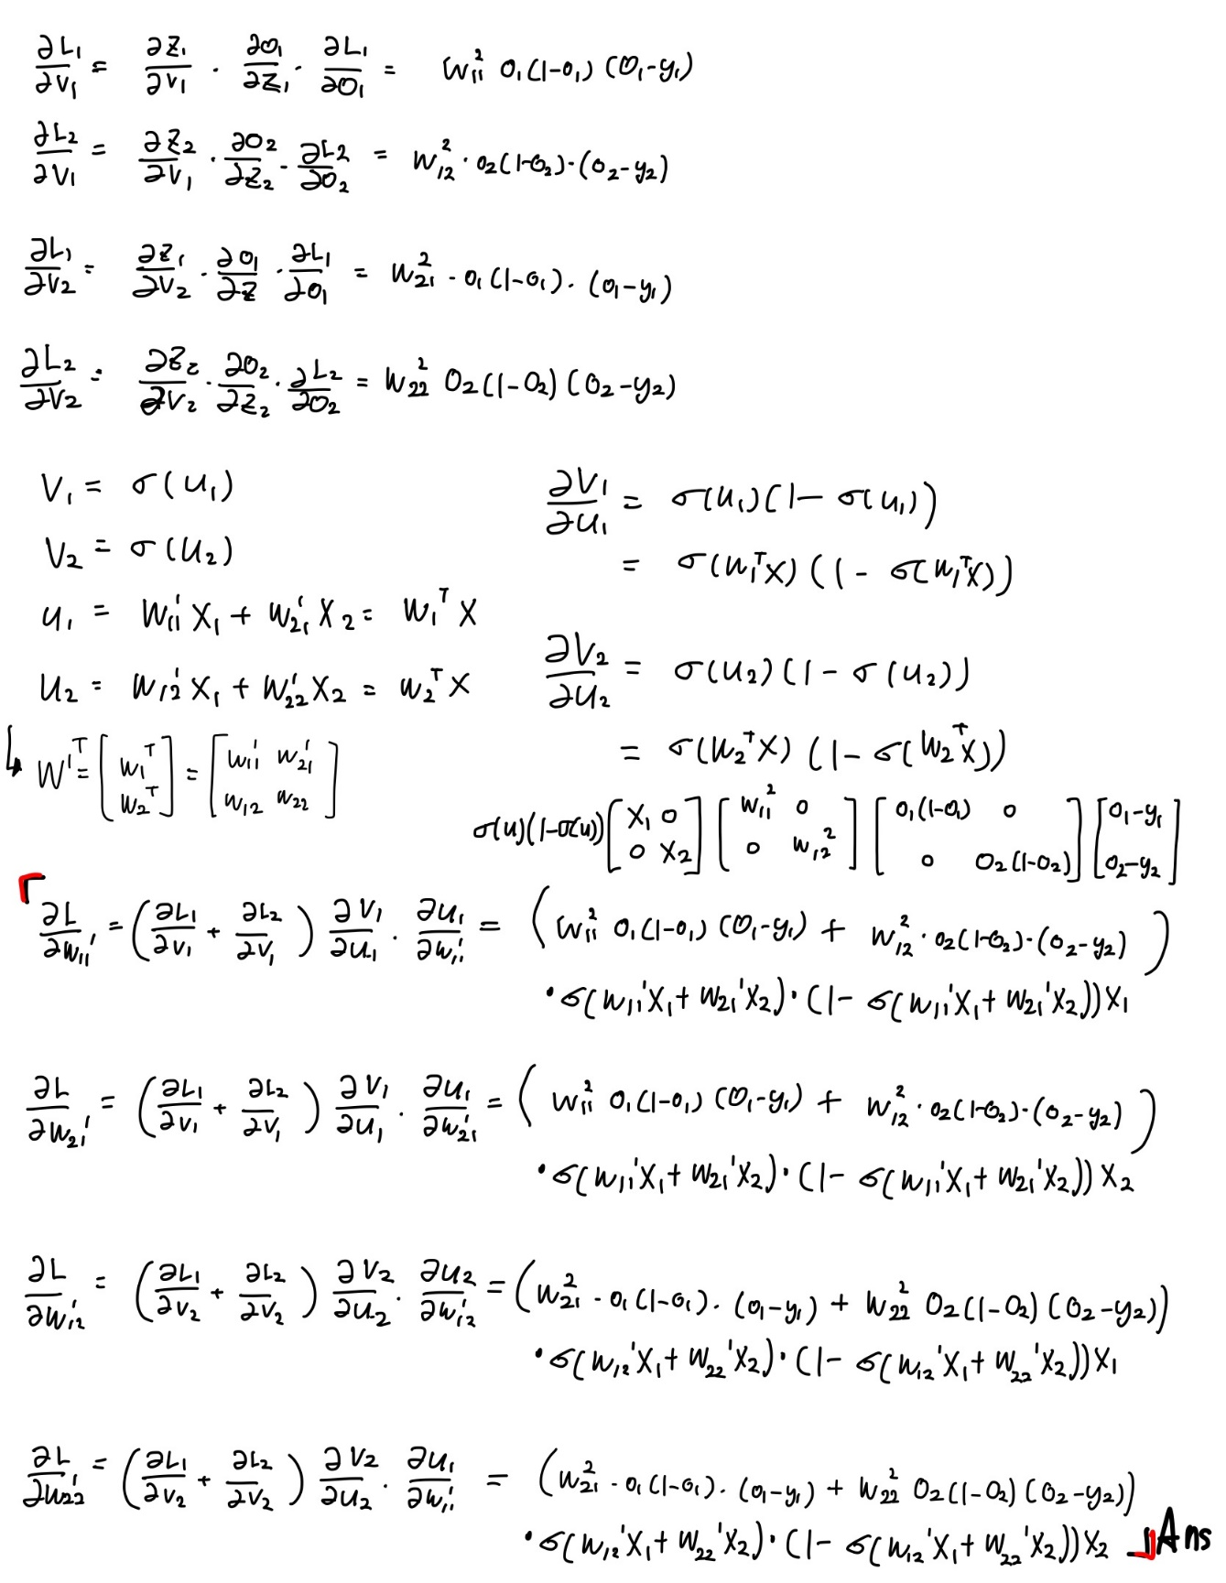

(b)

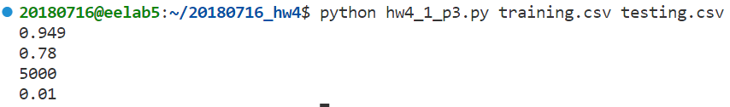

## Answer to Problem 2

(a)

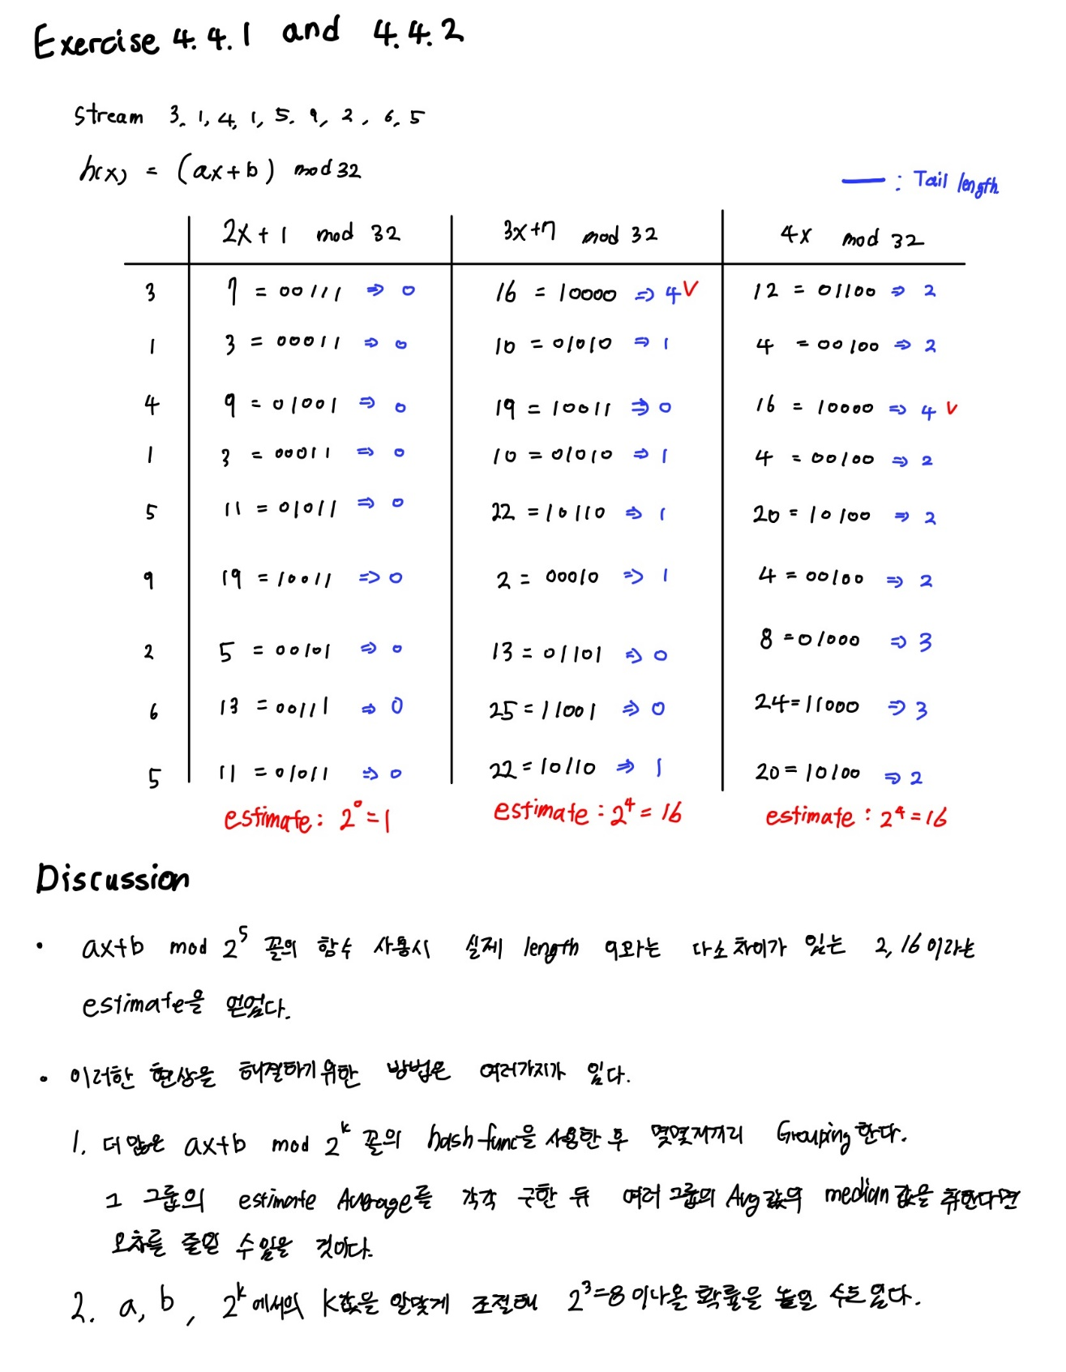

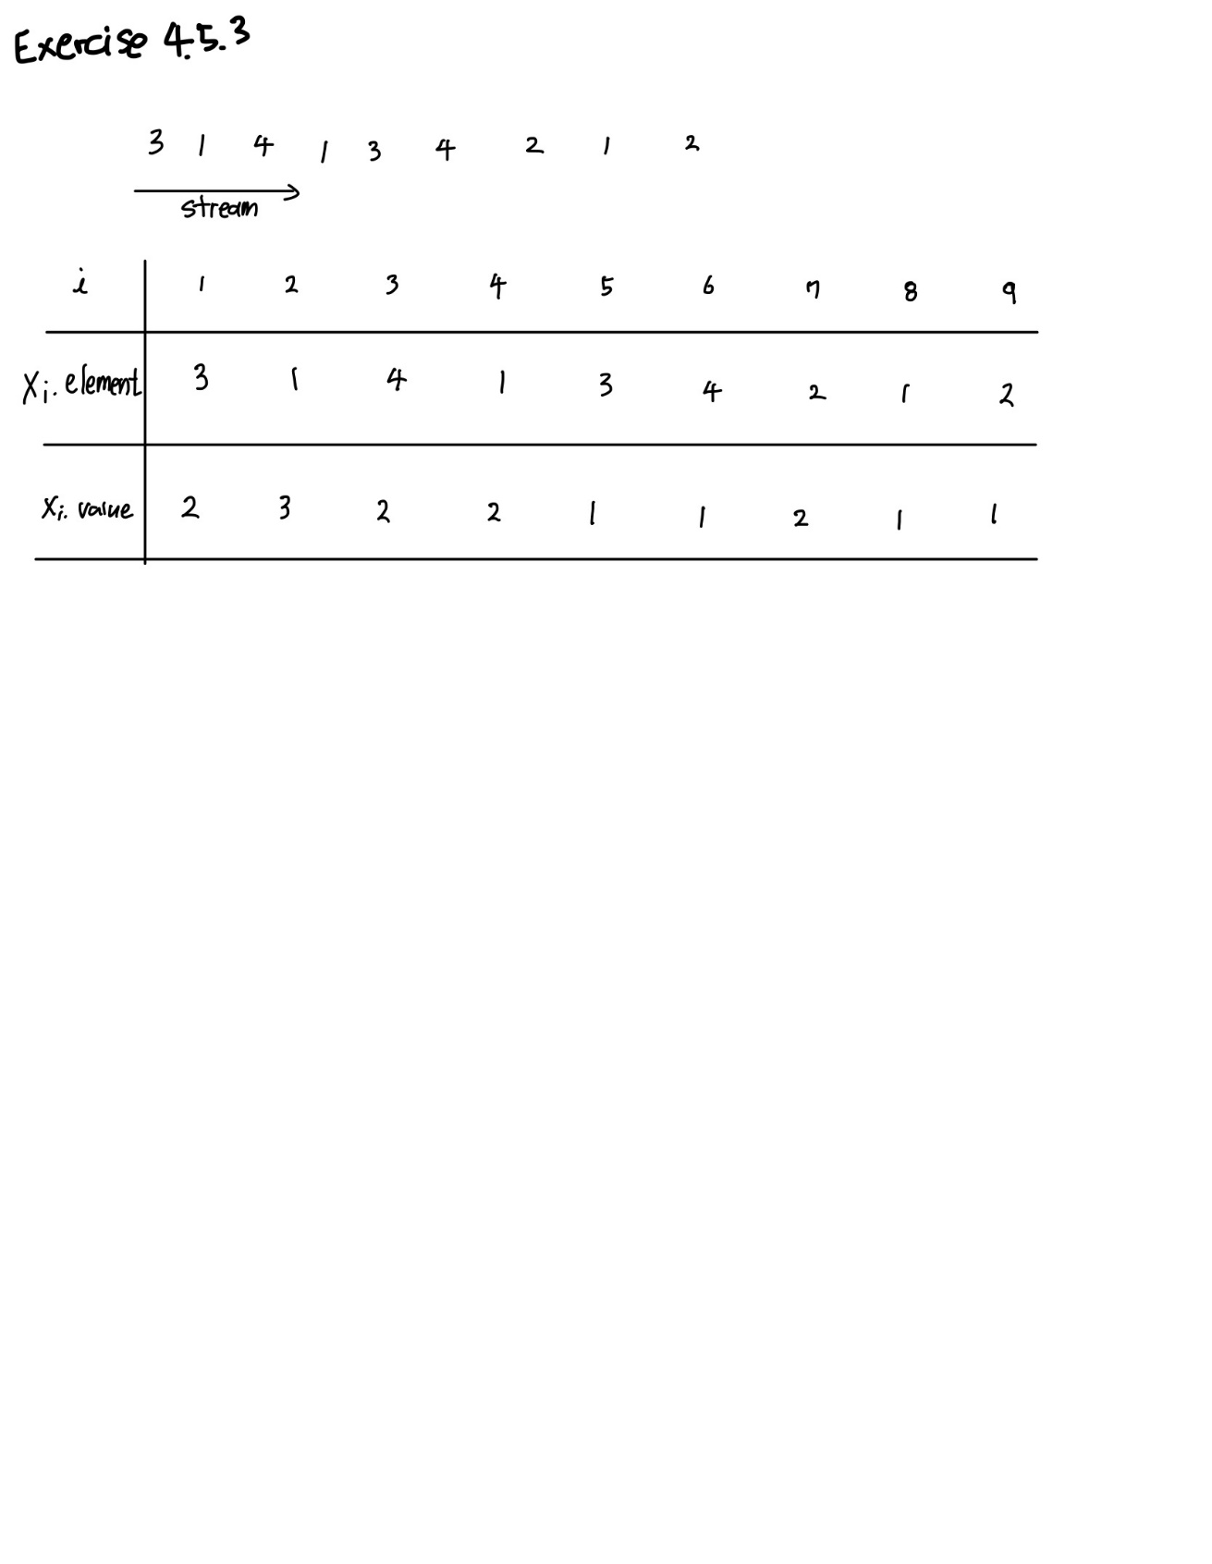

(b) when k’s are 1, 10, 100

0.5

2.0

23.0