Screen Shots
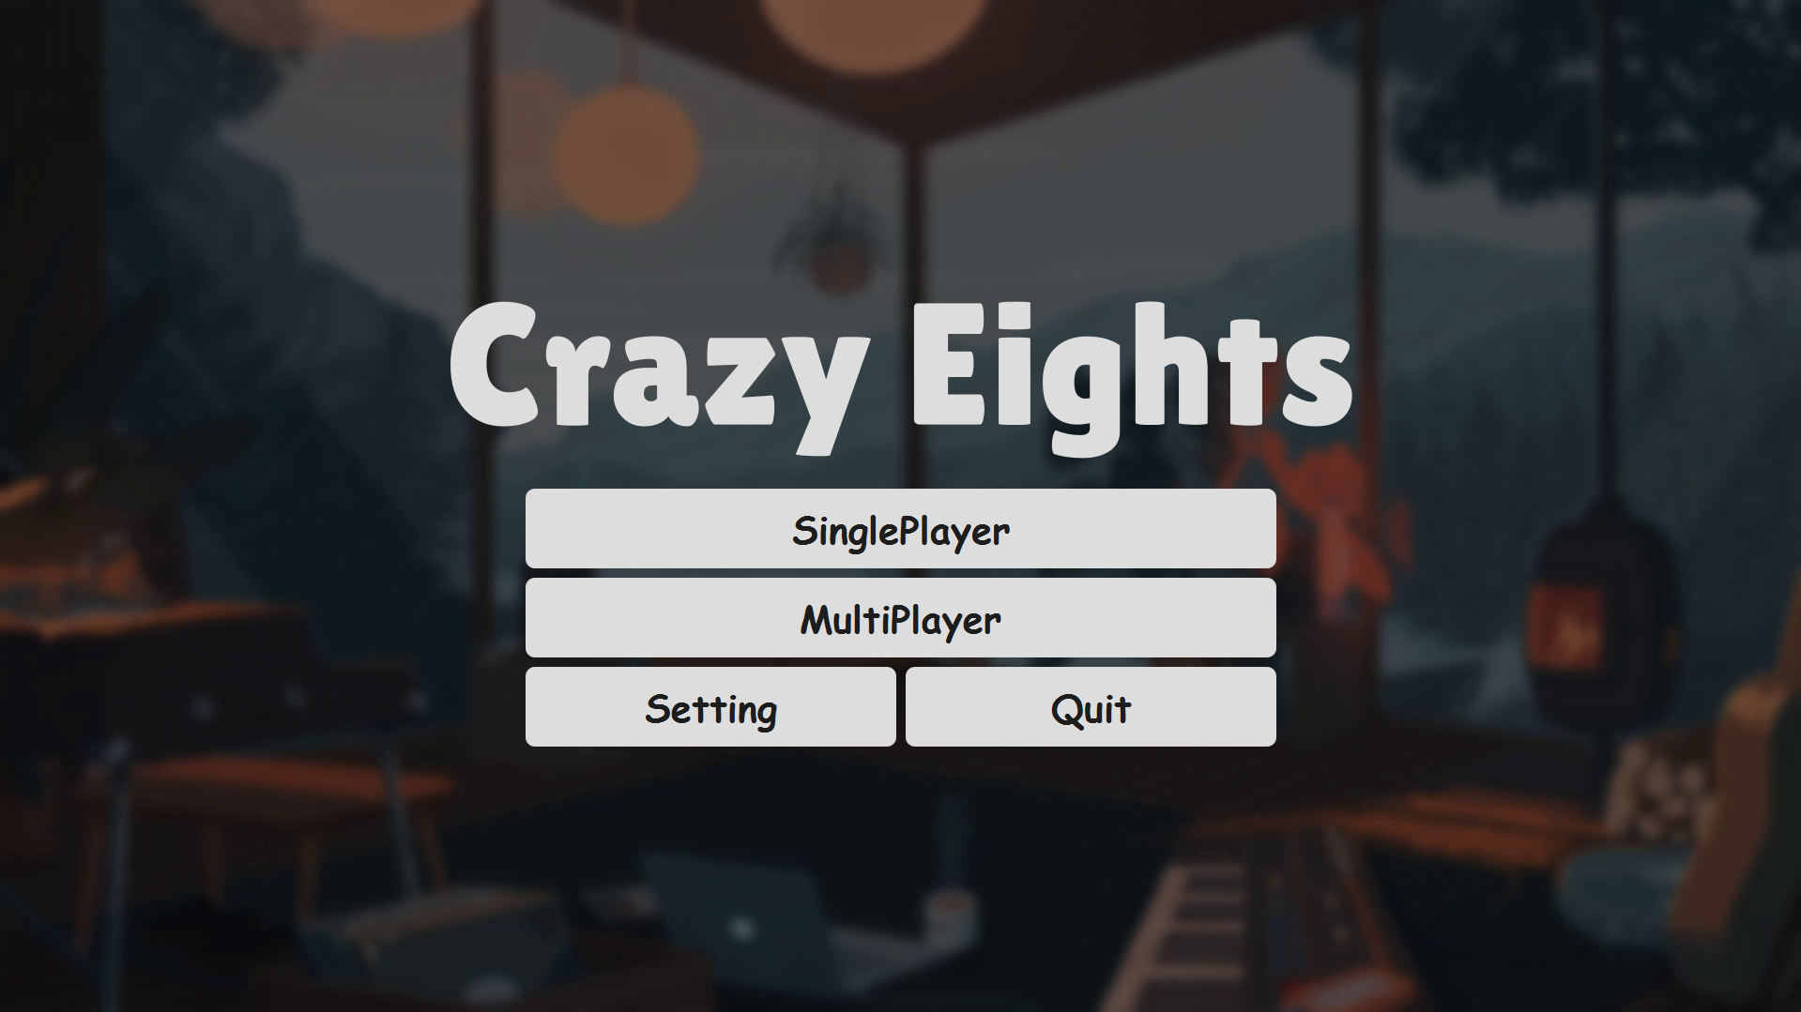
Figure 1 - Main Menu
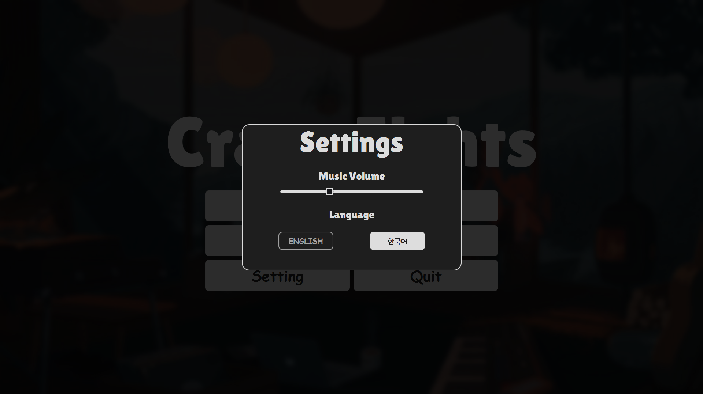
Figure 2 - Setting in Main Menu
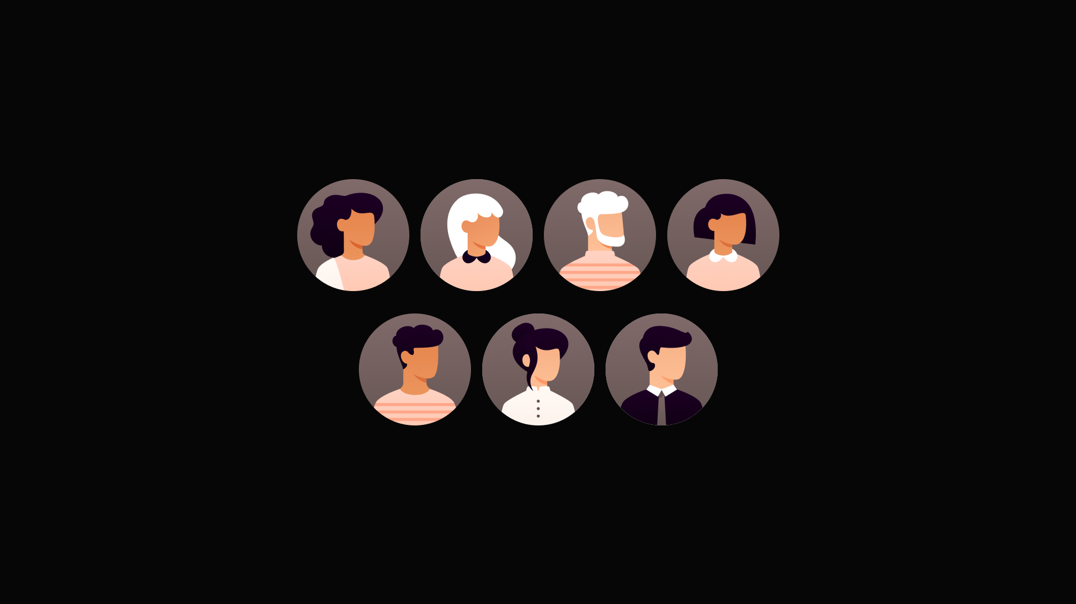
Figure 3 - Select Character Before Single Play Game
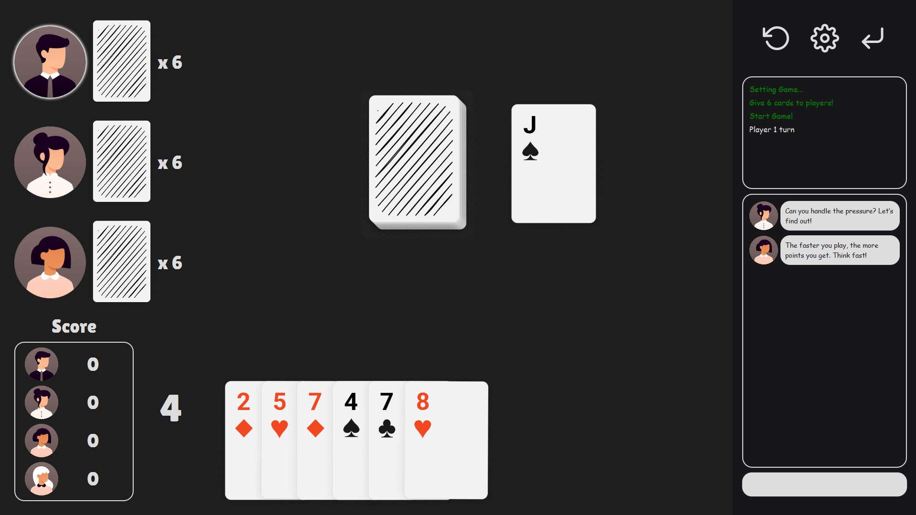
Figure 4 - In Single Play Game
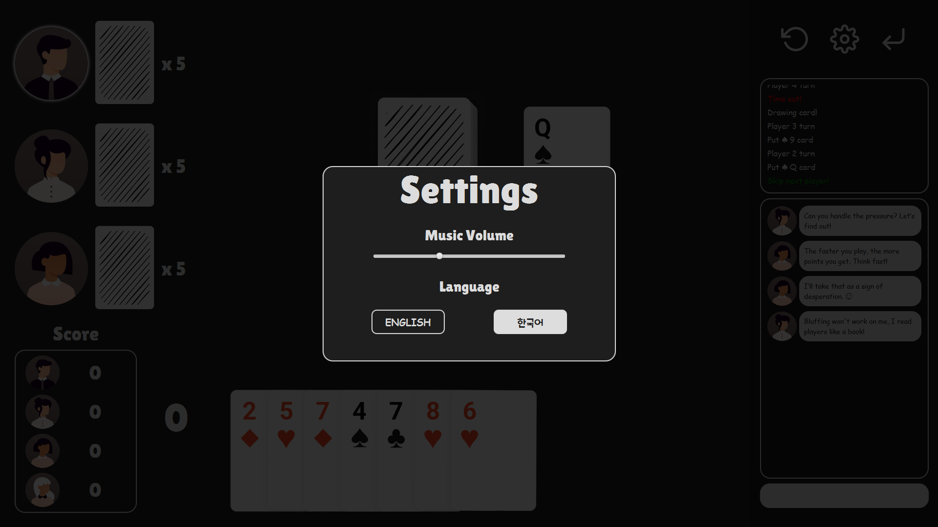
Figure 5 - Setting In Single Play Game
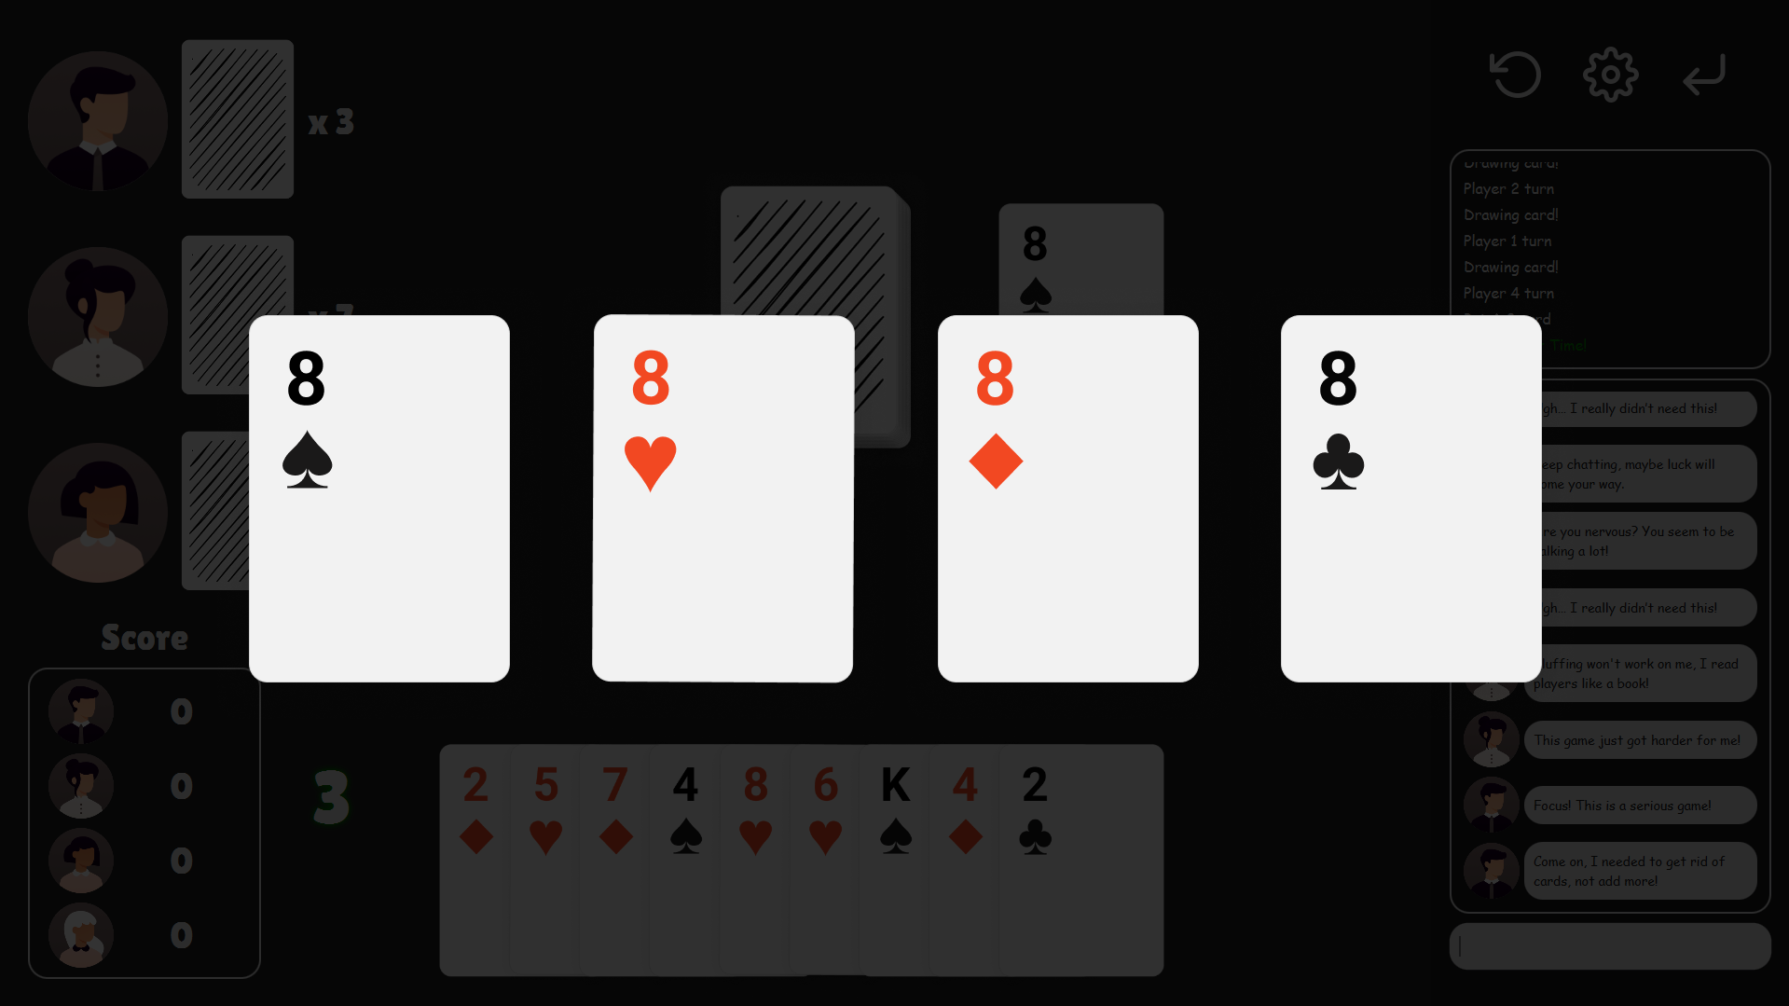
Figure 6 - Crazy Eight Time
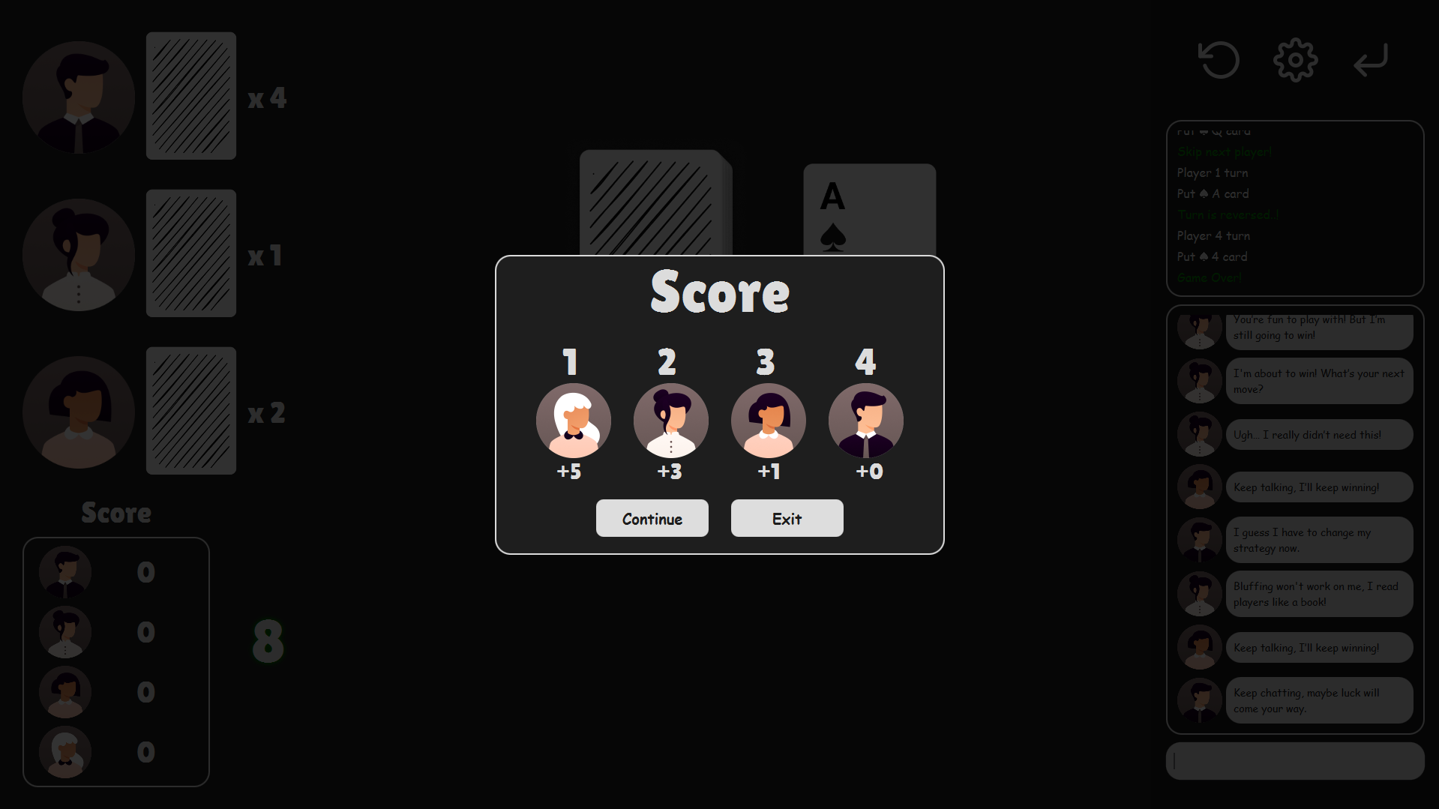
Figure 7 - End Game and Scoring

GitHub Link
https://github.com/TaeyoungYou/Crazy-Eights
Commit Logs
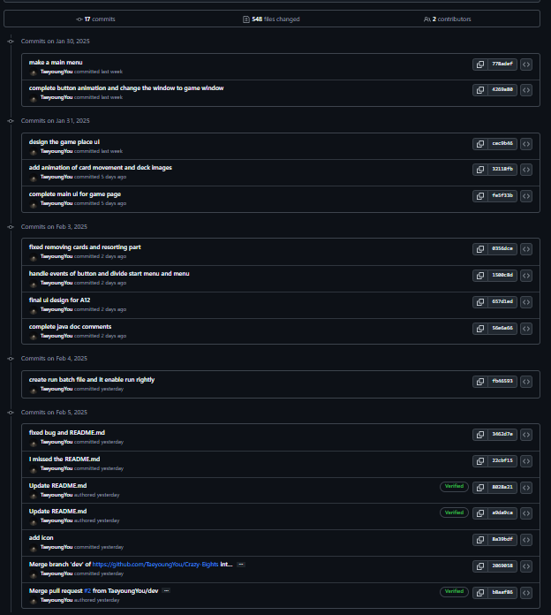

Asset Reference
Written in copyright.txt

