Screen Shots

Figure - Main Menu

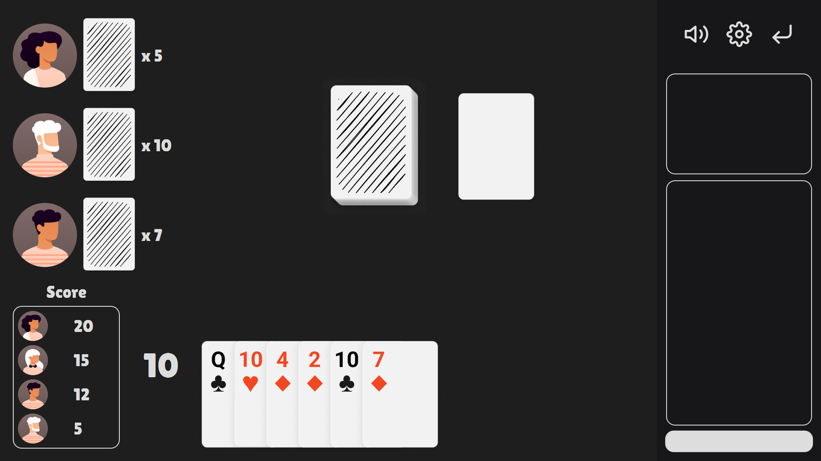

Figure - Single Player Game

GitHub Link

<https://github.com/TaeyoungYou/Crazy-Eights>

Commit Logs

Asset Reference

Written in copyright.txt