Algonquin College Logo

# SCHOOL OF ADVANCED TECHNOLOGY

### ICT - Applications & Programming

### Computer Engineering Technology – Computing Science



A11

Computer Science Challenge

Lab Professor / Lab Session:

[Singh, Ramanjeet / CST8221_300_303]

Team:

[Taeyoung You – 041079981]

CS Challenge 1: Crazy Eights Design

***The use of this template is not required, but should help guide your responses***

|  |  |
| --- | --- |
| **Part**  **1** | **Implementing the UI** |

**Note 1: Read Specification**

*This is only a suggested template. Please check instructions in the A11 specification.*

*If you do use this document, put some care into it. You won't be marked on format, but leaving unneeded or example elements will lead to confusion and risk costing you marks.*

* 1. **Intended UI.**

**UC Diagram** (example in a different context):

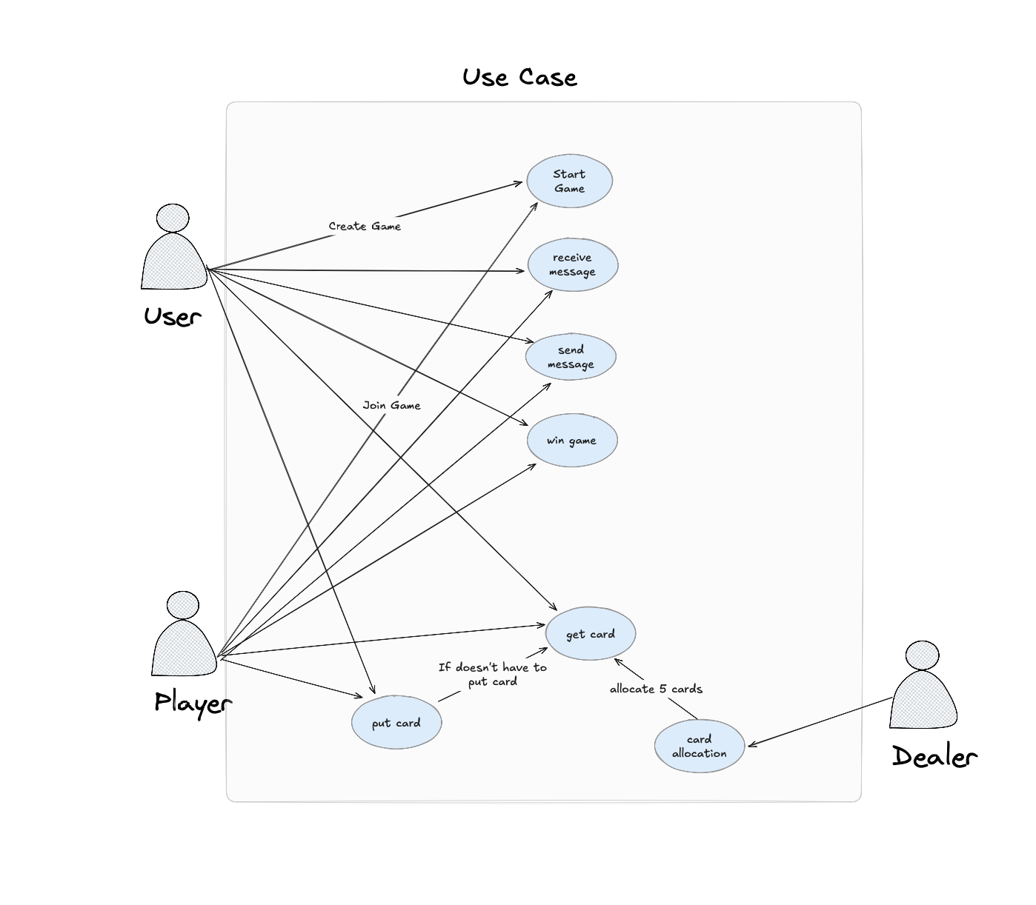

**Actors table** (example):

|  |  |
| --- | --- |
| **Actors** |  |
| Current User | This actor is the current player of the game. |
| Other User | This actor represents the other player for the game. |
| Dealer | This actor represents the card dealing in-game. Responsible for giving the players card to play |

**UC table** (example):

|  |  |
| --- | --- |
| **Use Cases** |  |
| Start Game | The players can start game. |
| Create Game | The players can create room for a game |
| Join Game | The players can join a hosted game |
| Receive Message | The players can receive message from other players |
| Send Message | The players can send message to other players |
| Win game | The players can win game |
| Put card | The players can put a card |
| Get card | The players can get a card |
| Card allocation | In-game dealer can allocate card to the users. |

* 1. **Intended UI.**

**What should your UI look like?**

Include a sketch of your UI.

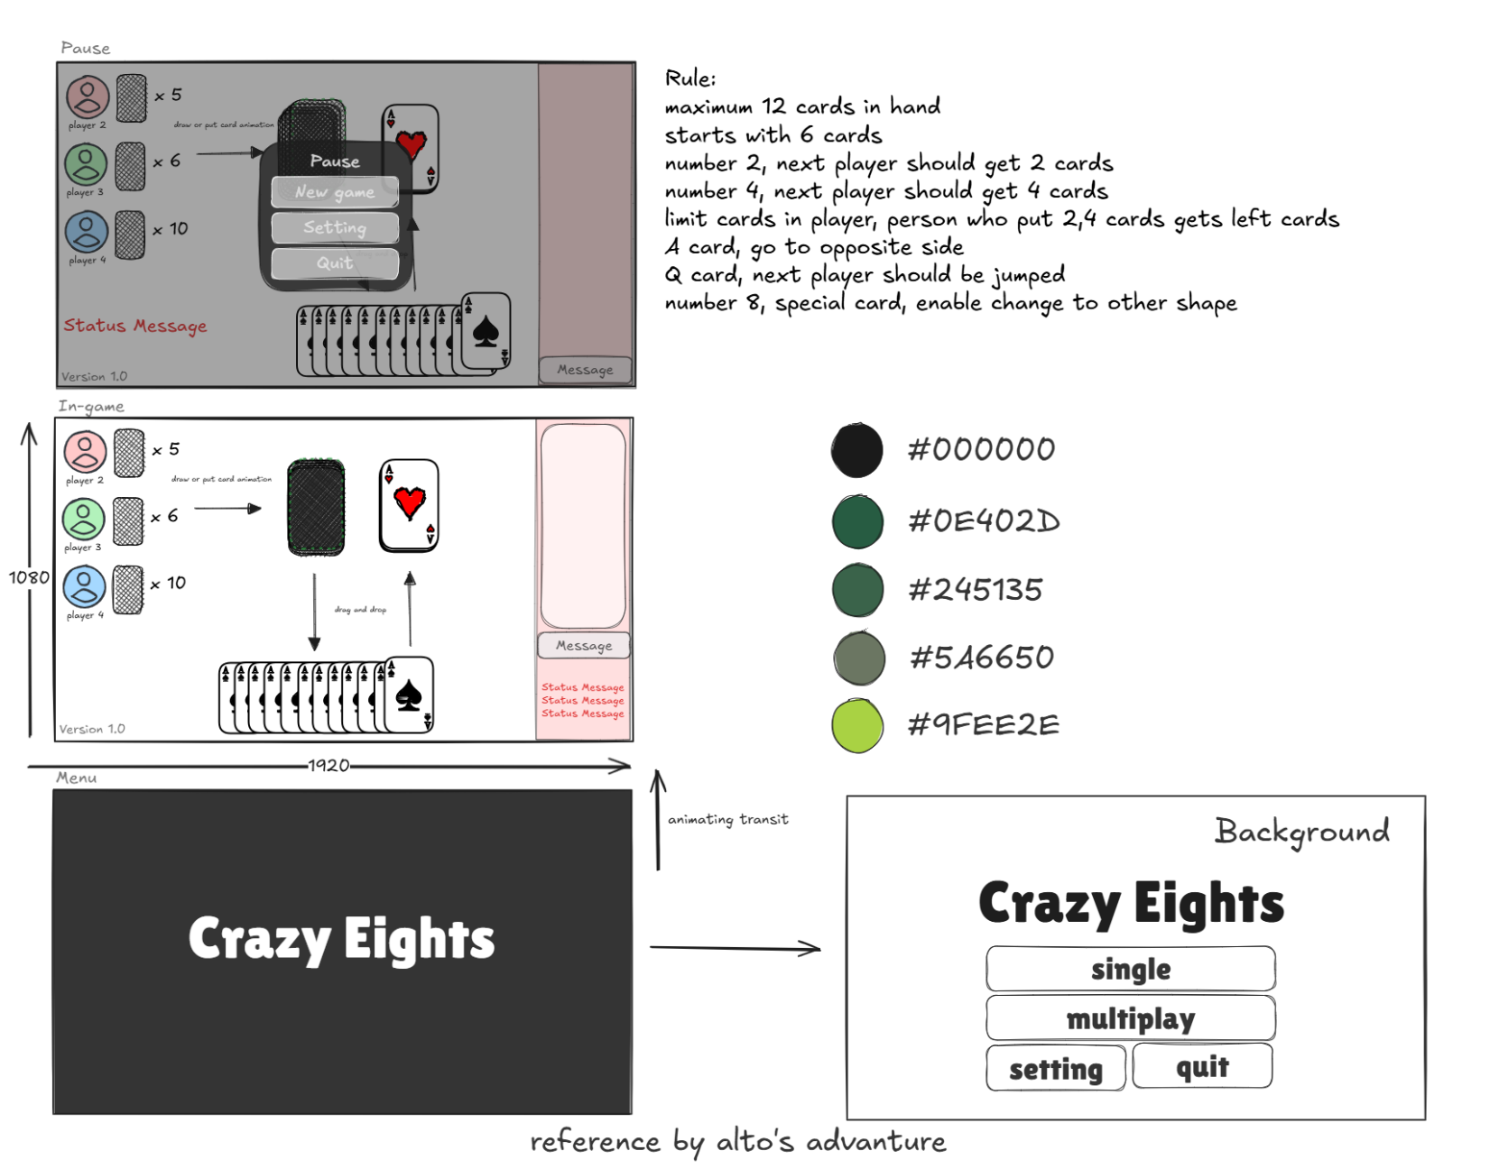

* 1. **UI Sizing and Colours**

**How is it all put together?**

A breakdown of your UI by component sizes and colours. See section 1.2 in the A11 Specification document.

**IN GAME SCREEN**

|  |  |
| --- | --- |
| Components | Size (in pixels, width by height ) |
| Card | 154px by 209px |
| Chat Box | 200px by 222px |
| Message Box | 265px by 708px |
| Chat Side Box | 268px by 65px |
| Chat | 290px by 1070px |
| Card Deck | 250px by 65px |

**OTHER SCREEN**

|  |  |
| --- | --- |
| Components | Size (in pixels, width by height ) |
| Button | 493px by 124px |
| Title | 1137px by 265px |
| Setting Button | 150px by 144px |
| Version Label | 316px by 144px |

1.4. **Visual Components**

What components are required for your UI? List each component, where it goes in the UI, and what it's meant to do. A table is helpful. (Consider annotating a diagram of your UI if that helps make things clearer.)

**IN GAME SCREEN**

|  |  |
| --- | --- |
| Components | Description |
| Buttons | Use for buttons in app. |
| Box | Use for base, cards, and custom setting icon. |
| ScrollPane | Use for chat box scroll feature |
| Vbox | Use for chat box container |
| TextArea | Use for message, title, credits, ip text, and verison |
| Music | 250px by 65px |

* 1. **Language**

This program will be usable in two languages. English is one of them. The other one is up to you. What language will you use, and why? If you haven't read chapter 1 of the Hybrid material, you really should.

* Korean
* English

**FINAL SUGGESTIONS**

*Here some ideas to think about your implementation....*

* *Try to create an application whose execution can be very intuitive (easy to be played). You want the user to not have to click through a lot of things, or struggle to work out what is going on.*
* *Remember that this game will be in fact implemented only in the next assignment. NO CODE IS REQUIRED.*
* *Make sure you remove examples and guidance text from this document. This should contain only your content, and none of mine, apart from headers and style.*

**References**

*[Include any references used here.]*

*Sketching and planning:*

*Excalidraw*

<https://excalidraw.com/>

Figma

<https://www.figma.com/>

*Use Case:*

*https://en.wikipedia.org/wiki/Use_case_diagram*

*How to play the Crazy-8 card game:*

*https://playwithrules.com/crazy-8-rules-how-to-play/*

**Github Link**

*Repository:* [*https://github.com/TaeyoungYou/Crazy-Eights*](https://github.com/TaeyoungYou/Crazy-Eights)

|  |  |
| --- | --- |
|  | * ***NOTE****: Report all references used. Uncited references are unprofessional, at the minimum.* |

Algonquin College

Winter 2025