

SCHOOL OF ADVANCED TECHNOLOGY

ICT - Applications & Programming

Computer Engineering Technology – Computing Science



A21
Model Definitions (RE/Automaton)

Lab Professor / Lab Session:
[Prof. Sara Khan / 303]

Team:
[Taeyoung You] - Id: [041079981] / [Juhyeon Oh] - Id: [041023645]

Language Name [FlowCode]

This template is suggested (not mandatory) to answer A11 Specification.

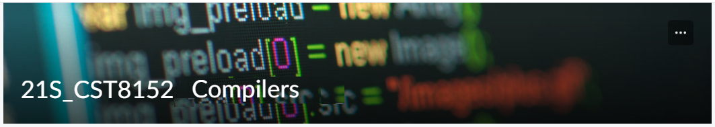

MODEL TASK FOR ASSIGNMENT 2.1 – FlowCode

- Note: This task is part of the Assignment 2 from Compilers Course. Any problem, contact your lab professor.

Task 1: Language Symbols (2.0 marks)

List examples: Define main symbols to be used:
- Comments
- Variables
- Functions
- Literals (numbers, strings)
- Keywords
- Datatypes

Answer:
- Comment: Comments are used to add explanations in the code without affecting its execution.
[Example] Single-line comment(SLC): ** comment **
Multi-line comment(MLC): ** comment1
comment 2 **
- Variable: A variable is a named storage that holds data values.
[Example] string name
Rules:
- A variable must start with a letter (a-z, A-Z) or an underscore (_).
- It can contain letters, numbers (0-9), and underscores (_).
- It cannot start with a number.

- Function: A function is a block of code that performs a specific task.
[Example]
void SampleFunc():
** code **
end;

Rules:
- Function names must start with a letter( a-z, A-Z) but highly recommend starting with Uppercase letter.
- Functions must have a return type (int, void, etc.).
- Functions may have parameters enclosed in parentheses ().

- Literal: Literals are fixed values used directly in code.
[Example] integer literal: 30
Floating literal: 3.14
String literal: ‘Hello World’
Rules:
- Numbers can be integers (30) or floating points (3.14).
- Strings must be enclosed in single quotes (‘ ’).

- Keywords: Keywords are reserved words in the programming language that have special meanings.
[Example] : if, then, elif, else, endif, repeat, check, break, continue, return, end, void, int, string, bool, double, datatype[N?], cons, declaration, begin, import, and, or, xor, not, null, CR

- Datatype: Data types specify the type of data that a variable can store.
[Example] int(integer number), double(decimal number), string(text), bool(true/false)

Task 2: RE – Regular Expression (3.0 mark)

Special Chars: List all special chars that must be used in your language:
Char: Usage:
; Function statement terminator
+ Addition operator
- Subtraction operator
* Multiplication operator, double ** used for SLC, MLC comments
/ Division operator
% Modulus(remainder) operator
^ Exponentiation (power) operator
== Equality comparison
, Separator(e.g., function arguments)
( ) Used in expressions (grouping), function calls
{ } Used in expressions (grouping)
= Assignment operator
<= Less than or equal comparison
>= Greater than or equal comparison
< Less than comparison
> Greater than comparison
!= Not equal comparison
‘ ’ Used to define string literals
“ ” Used for concatenation of variables or strings within strings
$ Used before variable names inside double quotes to indicate a variable

Lexeme Classes: Define the classes to be used in your regular expression:

Answer:
L= [a-zA-Z] ** Letter(uppercase and lowercase)
N= [0-9] ** Digital
U= _ ** Underscore
M= : ** Method delimiter
S= ‘ ** Single Literal delimiter
D= “ ** String concatenation delimiter
C= * ** Asterisk (Used for comments)
F= . ** Decimal point
O= [^LNUMSDC] ** Other
Define the RE to be used for: variables, literals and keywords:

Answer:
- Comments: CC([^C]|\*(?!\*))+CC
- Variables: [L|U][L|N|U]*
- Methods: L[L|N|U]*M
- Literals:
- Numbers: N*(integer), N+(\.N+)?(floating-number)
- Strings: S(^S)S
• Keywords: (if| then| elif| else| endif| repeat| check| break| continue| return| end| void| int| string| bool| double| datatype[N?]| cons| declaration| begin| import| and| or| xor| not| null| CR)

Task 3: TD – Transition Diagram (3.0 marks)

Activity: Starting from the previous lexeme classes and obeying the RE, it is possible to define the automata for your language:

Answer (draw / copy image of the automata):
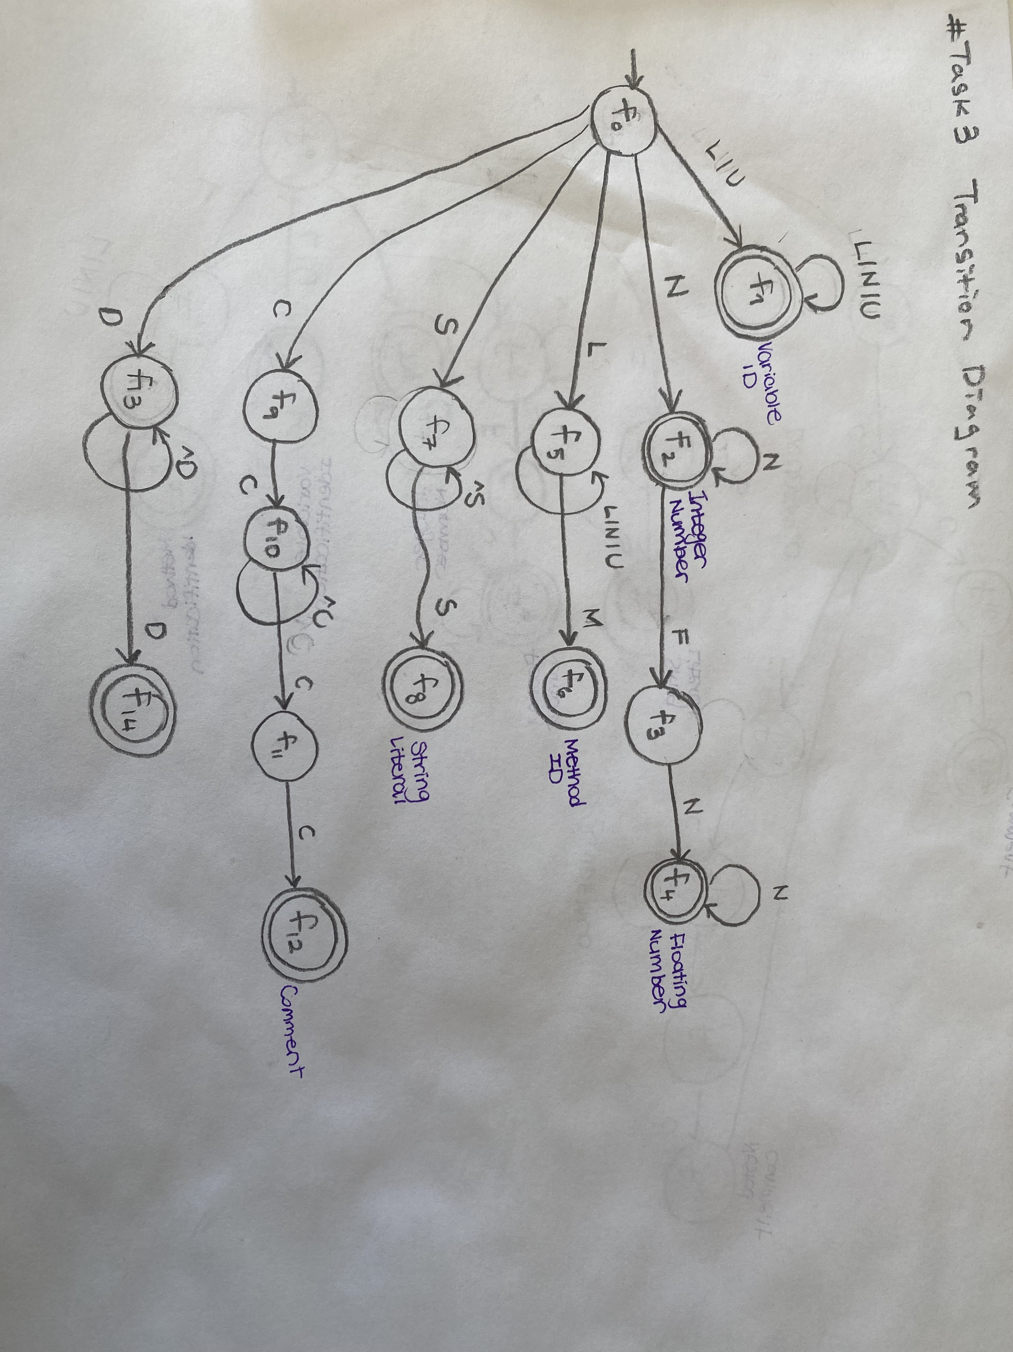

Task 4: TT – Transition Table (2.0 marks)

Activity: Now, it is possible to define the TT for these lexemes:

Answer (Transition Table):

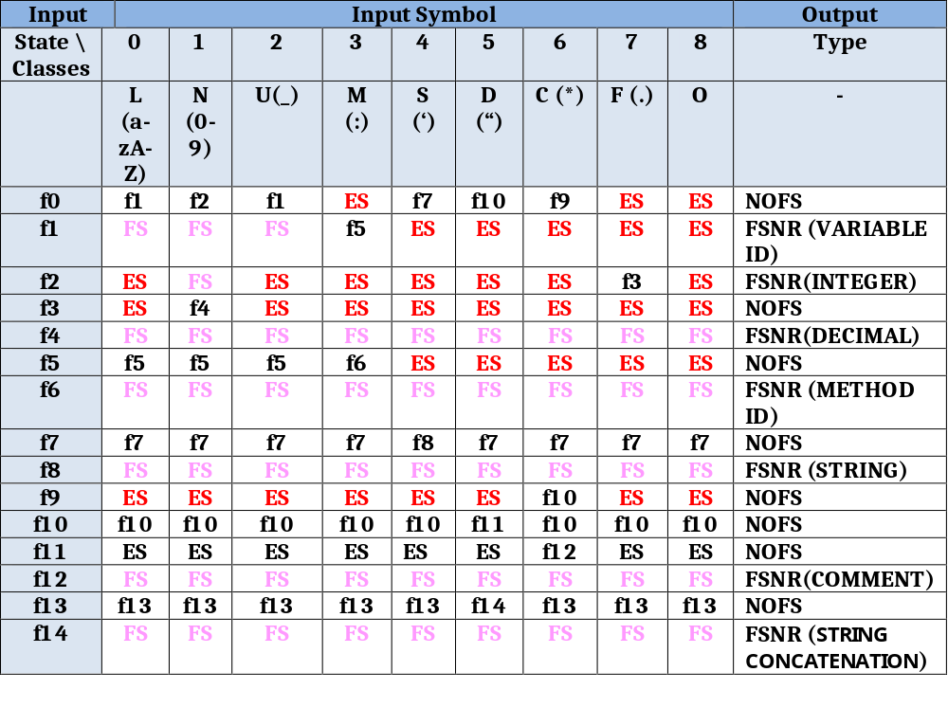

Update: Oct 1st 2024.

Adapted from resources developed by Prof. Svillen Ranev (Algonquin College, 2019)

