Bulawayo Waste Management: A Multi-Stakeholder Framework and the App to Support It
Oct 4, 2026 · @Tafadzwa Mutambisi

At a glance
Bulawayo's waste problem is a coordination problem before it is a truck problem, and no single institution can fix it alone. Nearly eight years of monthly clean-up days have raised awareness but not changed daily habits, because nothing links one clean-up to the next.
This summary draws on Karl Malotane's PhD proposal (Africa Research University, 2026), which sets out to design a shared leadership framework for the City Council, EMA, churches, residents' associations, business and informal waste pickers. It then proposes a practical tool to make that framework work day to day: a ward-level digital platform that lets every partner see the same problems, agree who acts, and track whether it was done.
Everything here is built to serve the case study, not to run alongside it. A draft framework sets out what the study expects to find; the questionnaires test and refine it; and the app is how the refined framework is put to work and kept alive after the thesis, as a living model for the city.
A working prototype of that app now exists. It can be opened on any phone at bulawayo-waste-hub.vercel.app, uses invented data only, and comes with a user manual and a ten-minute demo guide for stakeholder meetings.
The ask: that each partner tries the demo and gives feedback, takes part in the study, and helps validate and pilot the final framework.

The problem
Bulawayo, once called Zimbabwe's cleanest city, now lives with uncollected refuse, illegal dumps, blocked drains and recurring cholera and typhoid risk in high-density suburbs. The National Clean-Up Campaign, running since December 2018 on the first Friday of each month, treats waste after it piles up rather than preventing it.
Indicator | What the record shows
Population served | 665,952 (ZIMSTAT 2022 census)
Refuse compactors | 17 in April 2025, against at least 30 needed (BCC via Mayor's office)
Fleet reliability | In 2023 only 8–10 of 14 trucks ran at any time; 13 breakdowns in one month (CITE)
Landfill | Richmond (Ngozi Mine), built 1994 for a 20–25 year life; 109+ fires in 2021–2024 (CITE)
Enforcement | Illegal dumping fine of US$30, below legal landfill fees; Council debated raising it in December 2025 (Mayor's office)
Regional context | Sub-Saharan Africa collects about 36% of its municipal waste (UNEP & ISWA, 2024)
The proposal's central diagnosis is that these are symptoms of fragmented governance. The Council, EMA, private operators, residents, informal pickers and community groups mostly act separately, with overlapping mandates and no shared accountability. Three independent Bulawayo studies (Emthunzini, Cowdray Park, and dumpsite pickers) each trace failure to a breakdown between at least two actors, not to one institution alone.

What the study proposes
The study aims to design a strategic leadership framework that lets diverse stakeholders work together and build an everyday culture of responsible waste management in Bulawayo.
It has three objectives:
- Measure how far shared leadership has changed waste behaviour during the Clean-Up Campaign.
- Explain why the campaign has not built lasting responsibility among residents.
- Design a practical framework with clear roles, responsibilities and accountability for every partner.
It tests three hypotheses: joint management improves outcomes; deeper participation moves residents from event-day action to daily habit; and formally including waste pickers and private companies makes the campaign more effective.
The framework treats shared leadership as the driver. It works through collaboration mechanisms (joint planning, communication platforms, shared accountability), which in turn shape whether a lasting waste culture takes root. National law, Council capacity, equipment and finance can help or block that chain.
The method is a mixed-methods case study: 300 resident questionnaires, 45 stakeholder focus-group participants and 5 key-informant interviews, plus Council and EMA documents. Findings will be shared as a plain-language policy brief with the Council, EMA and the community groups who took part, timed where possible to the Council's budget cycle.

A draft framework for the study to test
The study needs a rough picture of the framework now, so that questionnaire and focus-group responses have somewhere to land. The draft below follows the proposal's own conceptual framework: leadership drives collaboration mechanisms, which build a lasting waste culture, all shaped by the policy and institutional environment. Each layer matches one section of the questionnaire.
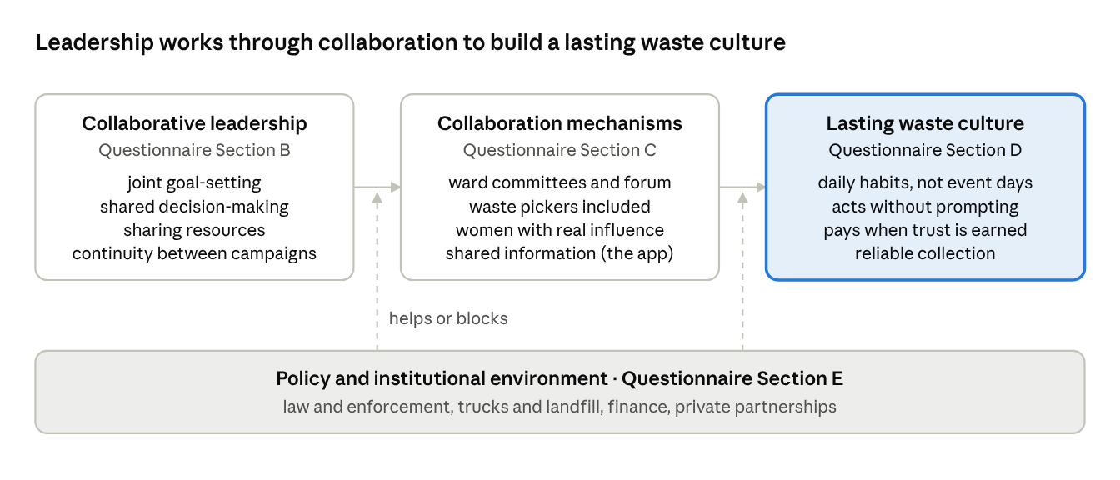
Draft framework · the study's conceptual model mapped to questionnaire Sections B–E
In practice, the draft framework has six working parts:
- City Waste Partnership Forum. BCC chairs, with EMA, churches, residents' associations, business, private operators, a waste pickers' representative and a university partner. It meets quarterly to set city targets, settle the BCC–EMA division of duties, and agree budget and sponsorship priorities.
- Ward Waste Committees. The ward councillor, residents' association, a church representative, youth, women and pickers. They meet monthly, straight after the clean-up day, so each campaign day starts a month of follow-up rather than ending the effort.
- Partnership Charter. A short signed document naming each partner's role, response times and what data they share. This is what partners "buy into".
- Inclusion rules. Pickers are registered and represented; women hold real influence, not only seats; information reaches people by phone, USSD and radio, not only smartphones.
- One shared information system. A single place where problems are reported, assigned and tracked, visible to all partners. This is the role of the app.
- Review cycle. Monthly ward reviews, quarterly forum reviews and an annual public scorecard, so the framework adjusts as it learns.
The questionnaire results will confirm, reshape or drop each part. What survives becomes the Chapter Five framework.

How the study, the framework and the app line up
Every app feature traces back to a research question and a questionnaire section, so nothing is built that the case study does not justify.
Research question | Evidence in the study | Framework part it shapes | What the app tracks afterwards
RQ1: How does collaborative leadership affect behaviour change? | Questionnaire Section B (joint goals, shared decisions, resource sharing, continuity); key-informant interviews | Forum, ward committees, charter | Meetings held, joint decisions logged, agreed actions completed on time
RQ2: Why has the clean-up campaign not built lasting responsibility? | Section D (habits outside clean-up days, willingness, paying for service, reliability, responsibility); Section E (enforcement, partnerships); focus groups | Monthly ward cycle, service reliability, enforcement roles | Reports made between clean-up days, collections on schedule, dump sites that recur, enforcement cases closed
RQ3: What framework would work for Bulawayo? | Section C (committees, picker inclusion, women's influence, accessible information); focus groups by stakeholder category | Inclusion rules, shared information system, review cycle | Registered pickers and material recovered, women on committees, report fix times, residents reached by channel
The same indicators also test the hypotheses over time: joint management and outcomes (H1), the shift from event-day to daily habits (H2), and the effect of including pickers and private firms (H3). The study gives a one-off baseline; the app keeps measuring after the thesis is submitted.

What the evidence says works
A lasting waste culture needs five conditions at once; the proposal finds that every struggling Zimbabwean suburb studied is missing at least one.
Condition | What it means in practice
Reliable service | Residents can plan around collection days
Capacity | Enough working trucks, landfill space and recovery facilities
Legitimacy | People trust the institutions coordinating the effort
Financial trust | Residents see fees turn into visible service (Glenview, Harare study)
Inclusive tools | Technology reaches informal pickers and offline residents, not only the connected
Three international cases show the principle, though none is a template:
- Kigali, Rwanda. Monthly community work (umuganda) is embedded in a formal village-level structure with named local leaders who organise and report, so it does not lapse after the day ends.
- Curitiba, Brazil. Residents where trucks cannot reach swap sorted recyclables for bus tickets or food, a model designed around local constraints.
- Surabaya, Indonesia. Ward-level composting run largely by residents, with Council and NGO support, cut landfill-bound waste.
The warnings matter as much. Partnerships with private operators can improve efficiency without involving residents, as in Ghana. Recycling facilities built without pickers duplicate their work and displace them. Digital tools can widen gaps if they assume smartphones, formal registration or constant connectivity. And monitoring data changes nothing unless partners review it together on a regular cycle.

Who does what
Each partner brings something the others cannot, and the framework only works if roles are written down and reviewed together. The roles below are a starting proposal for discussion, drawn from the study's evidence; the research itself will test and refine them.
Partner | What they uniquely bring | Proposed role | What they gain
Bulawayo City Council | Legal mandate, collection fleet, by-laws, landfill | Owns collection schedules; responds to reports within agreed times; chairs ward reviews | Fewer dumps to clear, better rates compliance, evidence for budgets
EMA | Environmental regulation and enforcement | Leads enforcement on serious and repeat dumping; agrees with BCC who handles what | Clear division of duties with BCC, data for enforcement
Churches and faith groups | Weekly gatherings, trusted voice, presence in every suburb | Carry the message between clean-up days; host drop-off points and ward meetings | Visible community service, youth engagement
Residents' associations | Ward-level organisation and an existing link to Council | Bridge residents and Council; verify that reported problems are fixed | A formal channel that turns complaints into action
Corporate sector | Funding, logistics, recyclable markets, staff volunteers | Sponsor pilots and rewards; buy recyclables; adopt a ward | Credible ESG and CSR results, cleaner trading areas
Informal waste pickers | Daily recovery work and street-level knowledge | Registered recovery partners paid for sorted material | Recognition, safer work, fairer prices
The study's own literature notes that churches and youth groups meet regularly, which gives them an advantage in sustaining participation between campaign days: exactly the gap the monthly model leaves open.

Where technology fits, and its limits
Technology can fix the information and coordination gaps; it cannot replace missing trucks or a failing landfill. Its job is to make the framework visible and accountable: who reported what, who owns it, and whether it was fixed.
Zimbabwe is ready for it. POTRAZ reported 102.6% mobile penetration and 81.8% internet usage in the second quarter of 2025 (MEA TechWatch), and WhatsApp has long carried about a third of the country's mobile data (ITWeb). A tool that works over WhatsApp and basic-phone USSD reaches far more people than a downloadable app.
Past efforts show what to keep and what to avoid:
- TauraHarare (City of Harare with its residents' association) let residents report issues over WhatsApp, SMS and Messenger. No usage results were published, a reminder that a reporting channel is only as good as the response behind it (Kubatana).
- Clean City Africa offered paid on-demand collection in Harare via a ride-hailing app, reporting 500,000 households in range and 50+ illegal dumps closed (WEF).
- Coliba (Côte d'Ivoire) used app, SMS and voice notes; collectors weigh material and pay by mobile money, households earn data credits, and pickers became salaried staff (GSMA).
AI is useful but modest. Route optimisation in Accra cut travel distance by about 11% (Awuah et al.), helpful for a stretched fleet but no substitute for 13 missing compactors. Image models can recognise dump sites, which helps sort and de-duplicate citizen reports (Padubidri et al., 2022).

The application: a ward-level waste hub
The app (working name: Bulawayo Waste Hub) is not a separate product; it is the framework's shared information system, part 5 of the draft framework. It runs the ward and forum review cycle, records who agreed to do what, and keeps measuring the same indicators the questionnaire captures. Its final design will follow the Chapter Five framework, so features below that the findings do not support will be dropped.
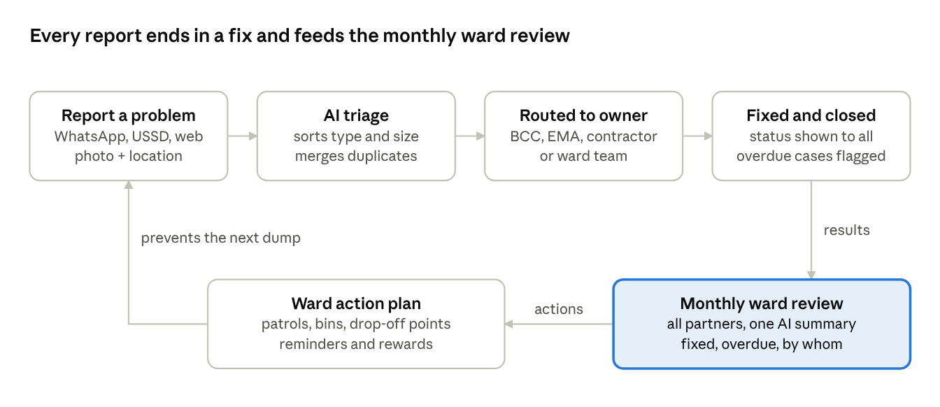
How a report moves through the hub · 4 steps and a monthly loop
The monthly review closes the loop: partners see what was fixed and what is overdue, then agree the actions that stop the next dump.

What has been built
The prototype was built in six tested stages and is live at bulawayo-waste-hub.vercel.app. Each screen carries one part of the framework and answers one part of the research.
Screen | What it does | Framework part | Research link
Start here | Ten-minute demo guide for stakeholder meetings | Stakeholder buy-in | RQ3: an acceptable framework
Ward map and Reports | Every report as a pin by status, size and owner; full case history | Shared information system | RQ1: shared information between partners
WhatsApp and USSD | Residents report by smartphone or basic phone, in English, isiNdebele and chiShona | Inclusion rules | RQ2: reporting between clean-up days
Partner queues | Each partner's cases with deadlines; fix with an after photo; residents verify or reopen | Partnership Charter | RQ1 and RQ3: roles and accountability
Pickers and recyclables | Pickers registered; recovered material logged; buyer confirms and pays | Inclusion rules | H3: including pickers and business
Review and forum | Monthly ward review pack, action tracker, city forum and indicators | Review cycle, forum, committees | H1 and H2: joint management, routine habits
Feedback | Stakeholder scores and comments, exported as a spreadsheet | Stakeholder buy-in | Validation of the framework
Settings | Charter rules, wards, partners and indicators as settings, with survey baseline slots | Partnership Charter | Fusing survey results into the app

How AI and technology serve the research
AI in this design does the routine sorting, matching and summarising, so that people can spend their time on the decisions the framework is about. It never decides who is responsible or whether a site is clean; partners and residents do.
AI function | In the demo today | In the live app | What it does for the study
Report triage | Waste type, size and hazards suggested from sample photos | A vision model reads each resident's photo | Consistent case data across wards and channels
Duplicate merging | Reports at the same spot join one case | Location and photo matching | True counts of sites, not of complaints; repeat sites become visible
Routing | The Charter's rules send each case to its owner | Same rules, agreed and changed by partners | Clear roles and accountability (RQ1, RQ3)
Local languages | Bot and USSD in English, isiNdebele and chiShona (drafts) | Reviewed wording; voice notes | Inclusion of residents without English or smartphones
Review summaries | Monthly summary drafted from the ward's figures | A language model drafts; the committee edits | Evidence for monthly review, turning clean-up days into a cycle (H2)
Indicators | App measures fix times and reporting between clean-up days; survey slots ready | Baselines from the questionnaire; repeat surveys | Links Sections B–E to live, ongoing measurement
Safeguards. The demo uses invented data only. The live app needs a POTRAZ data-controller licence and a Data Protection Officer, collects only what each step needs, keeps a human in charge of every decision, and works on basic phones so that technology does not widen the gaps the proposal warns about (Mhlanga and Shao, 2025).

From prototype to live app
The prototype is a single web page that runs in any browser, hosted free on Vercel with GitHub as backup, and costs nothing to show. The live version keeps the same screens and swaps what sits around them:
Part | Prototype now | Live app
Reporting channels | Simulated WhatsApp and USSD phones | WhatsApp Business Platform and a USSD gateway
Data | Sample data in each viewer's browser | Shared PostgreSQL database with maps (PostGIS)
AI | Tags and summaries prepared from sample data | Hosted vision and language models
Payments | Simulated mobile money | Mobile money through a licensed provider
Compliance | Not needed for invented data | POTRAZ data-controller licence and a Data Protection Officer under the Cyber and Data Protection Act regulations (SI 155 of 2024) (MISA)

Roadmap, risks and the ask
The prototype is shown now, before the survey, as a picture of how the framework could run; the survey results are then fused into it. What waits until after data collection is real use by residents in the study's sample areas, so the app does not change the behaviour the baseline measures.
- Done: prototype built. Six stages, tested and live, with a user manual and demo guide.
- Now (study Phase 2, months 10–18). Show the demo to stakeholders and collect feedback; check the questionnaire and guides against the draft framework; have native speakers review the isiNdebele and chiShona wording.
- Data collection (Phase 3, months 19–30). Survey, focus groups and interviews give the baseline. No live app in sampled wards.
- Framework finalised (Phase 4). Load survey baselines into the app; adjust roles, routing and indicators to the Chapter Five framework; partners agree and sign the Partnership Charter at a validation workshop.
- Living model (after validation). Build the live version and pilot it for six months in two wards, with a short repeat of questionnaire Sections B–D at month six to measure change.
This order lets the study offer more than a proposed model: a framework that stakeholders validated and that was tested in practice. Whether the pilot results go into the thesis or a follow-up paper is for Karl and his supervisor to decide.
Risk | Mitigation
Reports pile up with no response, and trust falls | Agreed response times in the charter; public overdue list reviewed monthly
Pickers and offline residents left out | USSD and voice notes; registration through associations and churches
Tool seen as one partner's project | Joint ownership; neutral host such as a university or civil society body
Fleet and landfill limits remain | Use data to target scarce trucks and to support budget and donor bids
Personal data misuse | POTRAZ licence, a named Data Protection Officer, minimal data collected

What we ask of each partner
- Bulawayo City Council: name a ward liaison, commit to response times, and share collection schedules.
- EMA: agree the enforcement split with BCC and act on escalated cases.
- Churches: announce and promote the pilot, host a drop-off point, and send a representative to ward reviews.
- Residents' associations: co-chair the ward review and verify that fixes happened.
- Corporate sector: fund the pilot and rewards, and commit to buying sorted recyclables.

Supporting materials
Material | What it is
Live demo | The working prototype, with invented data; backup at taffn.github.io/bulawayo-waste-hub
User manual | How to use and test each screen, how the app serves the study, and how to run a stakeholder demo; also available as a PDF
Prototype plan | Screens, data model, technology choices and build stages

Sources
- Malotane, K. (2026). A Multi-Stakeholder Framework for Collaborative Strategic Leadership in Promoting a Sustainable Waste Management Culture: Evidence from Bulawayo's National Clean-Up Campaigns. PhD proposal, Chapters 1–3, Africa Research University.
- BCC commissions 4 refuse compactors, Mayor's office, April 2025
- Council debates fines hike, Mayor's office, December 2025
- BCC blames shortage of trucks for uncollected garbage, CITE, February 2023
- How waste pickers and infrastructure upgrades could transform Ngozi Mine, CITE
- Global Waste Management Outlook 2024, UNEP & ISWA
- POTRAZ: over 100% mobile penetration, MEA TechWatch, October 2025
- More Zimbabweans engage social networks as OTT dominates, ITWeb, October 2018
- Harare goes digital in service delivery monitoring, Kubatana, October 2021
- App to clean up Zimbabwe's cities, World Economic Forum, October 2019
- Coliba: using mobile to formalise plastic recycling, GSMA, 2019
- Optimisation of solid waste collection routing using GIS, Accra, Awuah, Rockson & Andam-Akorful
- Detection of illegal dumping sites using aerial photography and deep learning, Padubidri et al., 2022
- MISA Zimbabwe on the new data regulations, November 2024

