ABSTRACT

It is a website which reduce the time and effort needed to regularly check sites for updates, creating a unique information space or "personal newspaper".Once subscribed to this website, our site is able to check for new content or updates for user-selected categories and retrieve the update. The categories are provided by the site and the user can select more than one topic from the given categories. This site can be used by the subscribed users to view the relevant news updates. The subscription is free of cost. This site is created using PHP, XML and MySQL. This site uses RSS technology.

PROBLEM DESCRIPTION

News Feeds is a website that periodically reads a set of news sources, in one of several XML-based formats, finds the new bits, and displays them in reverse-chronological order on a single page. News Feeds is the latest information management website. News Feeds is using RSS [Rich Site Summery or Really Simple Syndication] technology. RSS is a family of Web feed formats used to publish frequently updated works—such as blog entries, news headlines, audio, and video—in a standardized format. An RSS document (which is called a "feed", "web feed", or "channel") includes full or summarized text, plus metadata such as publishing dates and authorship. News Feeds is a useful website for all kind of peoples, for finding updated news for their specified and desired topics. It will bring new dimensions on news searching. It will be very useful for studios pupils as well as new readers.

SYSTEM SPECIFICATION

- Hardware Requirements
CPU : PENTIUM IV
SPEED : 2 GHz
COPROCESSOR : BUILT IN
TOTAL RAM : 128 MB
DISKETTE A : 1.44MB FLOPPY 3.5”
HARD DISK : 40 GB
KEYBOARD : 105 KEYS
MOUSE : LOGITECH MOUSE
DISPLAY : SGVA COLOR
PRINTER : HP DESK JET

2. Software Requirements

FRONT END : PHP 5
BACK END : MySQL 5
OPERATING SYSTEM : WINDOWS XP

SYSTEM STUDY
INTRODUCTION
System analysis is a process of gathering and interpreting facts, diagnosing problems and the information to recommend improvements on the system. It is a problem solving activity that requires intensive communication between the system users and system developers. System analysis or study is an important phase of any system development process. The system is studied to the minutest detail and analyzed. The system analyst plays the role of the interrogator and dwells deep into the working of the present system. The system is viewed as a whole and the input to the system are identified. The outputs from the organizations are traced to the various processes. System analysis is concerned with becoming aware of the problem, identifying the relevant and decisional variables, analyzing and synthesizing the various factors and determining an optimal or at least a satisfactory solution or program of action.
A detailed study of the process must be made by various techniques like interviews, questionnaires etc. The data collected by these sources must be scrutinized to arrive to a conclusion. The conclusion is an understanding of how the system functions. This system is called the existing system. Now the existing system is subjected to close study and problem areas are identified. The designer now functions as a problem solver and tries to sort out the difficulties that the enterprise faces. The solutions are given as proposals. The proposal is then weighed with the existing system analytically and the best one is selected. The proposal is presented to the user for an endorsement by the user. The proposal is reviewed on user request and suitable changes are made. This is loop that ends as soon as the user is satisfied with proposal.
Preliminary study is the process of gathering and interpreting facts, using the information for further studies on the system. Preliminary study is problem solving activity that requires intensive communication between the system users and system developers. It does various feasibility studies. In these studies a rough figure of the system activities can be obtained, from which the decision about the strategies to be followed for effective system study and analysis can be taken.
Here in the project News aggregator, a detailed study of existing system is carried along with all the steps in system analysis. An idea for creating a better project was carried and the next steps were followed.

FEASIBILITY STUDY

An important outcome of the preliminary investigation is the determination that the system requested is feasible. Feasibility study is carried out to select the best system that meets the performance requirements.

Feasibility study is both necessary and prudent to evaluate the feasibility of the project at the earliest possible time. It involves preliminary investigation of the project and examines whether the designed system will be useful to the organization. Months or years of effort, thousand for millions of money and untold professional embarrassment can be averted if an in-conceived system is recognized early in the definition phase.

The different types of feasibility are: Technical feasibility, Operational feasibility, Economical feasibility.

- Technical feasibility

Technical Feasibility deals with the hardware as well as software requirements. Technology is not a constraint to type system development. We have to find out whether the necessary technology, the proposed equipments have the capacity to hold the data, which is used in the project, should be checked to carryout this technical feasibility.

The technical feasibility issues usually raised during the feasibility stage of investigation includes these
- This software is running in windows 2000 Operating System, which can be easily installed.
- The hardware required is Pentium based server.
- The system can be expanded.

2) Operational feasibility

This feasibility test asks if the system will work when it is developed and installed.
Operational feasibility in this project:

- The proposed system offers greater level of user-friendliness.
- The proposed system produces best results and gives high performance. It can be implemented easily .So this project is operationally feasible.

3) Economical feasibility

Economical Feasibility deals about the economical impact faced by the organization to implement a new system. Financial benefits must equal or exceed the costs. The cost of conducting a full system, including software and hardware cost for the class of application being considered should be evaluated.

Economic Feasibility in this project:
- The cost to conduct a full system investigation is possible.
- There is no additional manpower requirement.
- There is no additional cost involved in maintaining the proposed system.

EXISTING SYSTEM

Existing system refers to the system that is being followed till now. Presently all the news aggregators provide the timely updates for all the categories such as politics,business,sports etc.Thus a user will have to spent more time in browing to obtain the updates for a desired category.This may lead to wastage of time if the page containing the required data is unknown to the user. The main disadvantage is that their will be lot of difficulties for the user to find the specified news updates for his/her choice of category.
Draw backs of existing system.
- Difficult for user to find required news updates.
- Time consuming.

PROPOSED SYSTEM

The aim of proposed system is to develop a system of improved facilities. The proposed system can overcome all the limitations of the existing system. The system reduces time wastage. The existing system has several disadvantages and many difficulties to work efficiently. The proposed system tries to eliminate or reduce these difficulties up to some extent. The proposed system will help the user to consume less time to obtain the required information. The system requires very low system resources and the system will work only in internet connection.

Advantages of Proposed System
- NEW AGGREGATOR allows the key elements of websites, such as headlines, to be transmitted in unembellished form.
- It helps to share content between websites.
- It enables information from scores of websites to be viewed simultaneously., all on one page, consequently, numerous sites can be scrutinized in seconds rather than having to be tediously downloaded independently.
- It has the ability to keep track of changes on the web.
DATA FLOW DIAGRAM

Data flow oriented techniques advocate that the major data items handled by a system must be first identified and then the processing required on these data items to produce the desired outputs should be determined. The DFD (also called as bubble chart) is a simple graphical formalism that can be used to represent a system in terms of input data to the system, various processing carried out on these data, and the output generated by the system. It was introduced by De Macro (1978), Gane and Sarson (1979).The primitive symbols used for constructing DFD’s are:
Symbols used in DFD

A circle represents a process.

A rectangle represents external entity

A square defines a source or destination of the system data.

An arrow identifies dataflow.

Double line with one end closed indicates data store

DFD for Login Module

User Login Details

News Feeds
User

Admin Login Details

News Feeds
Admin

DFD- User

Category Details
category

News Feeds
account
Registration Details

Verify
Login
Login Details

User

DFD- Admin

Administrator
admin
account
Reg: Details
Login Details
Verify
Login
category
Add categories

News Feeds

E-R DIAGRAM

Register

username
password
dob
selcat
email
Account
Admin

Add

lastname
view
Category
NewsCat

View
password
catname
userid
username
firstname
catlinkename
catid

catid
userid
Check
Registration

SOFTWARE DESCRIPTION
PHP is an open-source server-side scripting language we can create dynamic web pages with the PHP scripting language. A dynamic Web page interacts with the user, so that each user visiting the page sees customized information. PHP can also be used to create dynamic web pages that are generated from information accessed from a MySQL database. we can embed PHP commands within a standard HTML page. PHP's syntax is similar to that of C and Perl, making it easy to learn for anyone with basic programming skills. Another feature that PHP offers is connectivity to most of the common databases (including Oracle, Sybase, MySQL, ODBC and many others, although currently only MySQL is supported on the central webservers.) PHP also offers integration with various external libraries, which allow the developer to do anything from generating PDF documents to parsing XML.

Using PHP on Webserve
- Bang lines are not required and will be ignored if present. (This information is provided for historical purposes as the previous web server environment required bang lines.)
- You should use .php as the file extension. This refers to only PHP files executed directly via a URL. Include files may use other extensions, such as .inc. If you have PHP files that currently use .php4 extensions, it is strongly recommended that you move toward using .php for these instead.
- The script must have owner execute permission. For best security, we strongly recommend using permissions set to 700 (only owner has read, write, and execute privileges).

Sessions

- By default, when PHP creates a session file it stores it in /tmp. The /tmp directory is local and independent to each of the backend web servers. Hence, if a request is made to server_1, it stores the session file in its own /tmp. If a subsequent request for the same user ends up going to server_2, it won't find the original session file.
- The load balancers control how web requests are distributed across the backend web servers. These load balancers are configured to provide session persistence by tracking the IP address of the web browser and the backend web server to which a request is sent. The goal is to send all subsequent requests from a given web browser back to the same backend web server. As a result, normally the PHP session files in /tmp work as expected because the multiple requests for the same user is consistently sent to the same backend web server.
- However, the load balancers can only cache so much data and eventually older data is overwritten by new incoming requests. This can cause the loss of persistence information. PHP allows you to specify the location of the session files (i.e., other than /tmp). In the Webserve environment, it is recommended that you create a session directory in the login directory of your account and write the session information there. Doing it this way will guarantee session persistence. You should do occasional cleanup of any unused session files that aren't deleted.

Troubleshooting
When running your scripts, if you receive a 500 Internal Server Error message, please check the following:
1. Check to make sure the file permission is set to 700 (read, write, and execute for owner only).
2. Check the Directory (folder) permission. Setting it to 777 will give you a 500 - Internal Server Error.
Set it to 711.
3. When the file/directory permissions are set correctly, and you are still getting a 500 error, it is likely due to line compatibility between the program used to create/upload the file and the Linux server. To correct this, login to the account on Webserve via an SSH client that provides a command line interface and do the following:
- Move to the directory where your php file is using the 'cd' command (e.g., cd www).
- Open the file using an editor such as nano and save it by typing Ctrl + o
This simple steps may solve your problem because it converts Windows CR/LF (carriage return/line feed) to Unix LF (line feed) or Mac CR to Unix LF.
To prevent this problem, you need to change settings/preferences in the program you are using to develop php files. To set preferences in Dreamweaver, go to Edit => Preferences. Select Code Format or HTML Format (depending on the versions). Change Line Breaks to LF (Unix).

Connecting to MySQL using PHP
- The purpose of this document is to help the MySQL account holders get started with developing their Web front for their MySQL database.
- Please note that the IU/UITS WebMaster and IU/UITS WebHost groups will not be providing services related to database design, creation, and management (often referred to as the DBA, or DataBase Administrator role) or Web to database application programming services as part of the mySQL database service.
- We provide the following codes as an example of scripts connecting to MySQL DB from your Veritas/Champion account when you use PHP or Perl scripts.
- To make the code work for your account, replace port_number with your mysql account's port number, user_name with your user name, and password with the user's password.

DATABASE DESIGN

A database is an organized mechanism that has the capability of storing information through which a user can retrieve stored information in an effective and efficient manner. The data is the purpose of any database and must be protected.
The database design is a two level process. In the first step, user requirements are gathered together and a database is designed which will meet these requirements as clearly as possible. This step is called Information Level Design and it is taken independent of any individual Database Management System (DBMS).
In the second step, this Information level design is transferred into a design for the specific DBMS that will be used to implement the system in question. This step is called Physical Level Design, concerned with the characteristics of the specific DBMS that will be used. A database design runs parallel with the system design. The organization of the data in the database is aimed to achieve the following two major objectives.
- Data Integrity
- Data independence

DATABASE TABLE DESIGN

Table Name: - admin
Field Name | Data Type | Size | Key
username | Varchar | 50 | -
password | Varchar | 25 | -

Table Name: - accout
Field Name | Data Type | Size | Key
first_name | Varchar | 50 | -
last_name | Varchar | 50 | -
dob | Varchar | 15 | -
username | Varchar | 50 | -
password | Varchar | 25 | -
sel_cat | int | 3 | -
email | Varchar | 50 | -

Table Name: - category
Field Name | Data Type | Size | Key
cat_id | int | 3 | -
cat_name | Varchar | 25 | -
cat_link | Varchar | 100 | -

SAMPLE CODING
Home page
<!DOCTYPE html PUBLIC "-//W3C//DTD XHTML 1.0 Strict//EN""http://www.w3.org/TR/xhtml1/DTD/xhtml1-strict.dtd"><html xmlns="http://www.w3.org/1999/xhtml" xml:lang="en" lang="en">
<head><meta http-equiv="Content-Type" content="text/html; charset=utf-8"/>
<title>News Aggregator</title>
<link rel="stylesheet" href="style.css" type="text/css" charset="utf-8" /> <style type="text/css">
.style1 {font-family: Verdana, Arial, Helvetica, sans-serif}
.style4 {font-family: Arial, Helvetica, sans-serif; }
.style5 {font-family: Arial, Helvetica, sans-serif; font-size: 12px; }
.style6 {
font-size: 14px;
font-weight: bold;}
.style9 {font-size: 14px}
.style11 {
font-size: 14px;
color: #000000;
font-weight: bold;} </style>
</head><body >
<div id="wrapper">
<h1>...The <strong>Worldwide</strong> News...</h1>
<div id="top-nav">
<ul> <li><a href="signin.php">sign in</a> &nbsp;&nbsp;|&nbsp;&nbsp; </li>
<li><a href="signup.php">sign out</a></li>
</ul> </div>
<div id="mmagic"> </div>
<div id="header"> </div>
<div id="spacer"> </div>
<div id="body">
<div id="left">
<div id="nav">
<ul>
<li class="drk"><a href="index.php">Home</a></li>
<li><a href="aboutus.php">About Us</a></li>
<li><a href="signup.php">Registration</a></li>
<li><a href="news.php">News</a></li>
</ul>
</div>
<div id="visit">
<p align="justify">
<span class="style5"><br>
<span class="style6">News Feeds</span> reduce the time and effort needed to regularly check websites for updates, creating a unique information space or "personal newspaper." Once subscribed , News Feeds is able to check for new content at user-determined intervals and retrieve the update. The content is sometimes described as being "pulled" to the subscriber, unlike recipients of some "pushed" information, the New Feeds user can easily unsubscribe from a feed.</span></p>
</div> <div id="subs">
<div id="subs-left"><img src="images/rss_icon.jpg" alt="" width="186" height="186" /></div> <div id="subs-right">
<p class="style4"><span class="style11"><span class="style1">Subscription</span><br> <br> </span>
Subscribe to News Feeds and get latest updates of any categories provided by us. To subscribe please fill up the registration form and get your username. It is free of cost. Hurry up!!!</p> </div>
</div> <div id="right"> <div id="nav" > <ul> <li style="border-left-color:#646C79"><a href="contactus.php" style="color:#FFFFFF; font-weight:100">Contact us</a></li> <li ></li> <li style=" border-left-color:#646C79"></li>
</ul> <br><h2><br>News Categories</h2> <p align="justify" class="style5">There is a set of categories, from that categories you can select your own topics.News Feeds will search for those selected topics and get the updated news for you. For that you only need to subscribe to News Feeds to view the updates of selected categories. Some of the categories are shown below.<br> </p>
<h3><strong>News</strong></h3>
<img src="images/pic_1.jpg" width="103" height="79" alt="Pic 1" class="left" /> <p align="justify" class="style4">This category will give the updates on newspapers. To get the updtes of newpapers please select this category.</p> <p class="style1">&nbsp;</p>
<h3 align="justify"><strong>Sports</strong></h3>
<div align="justify"><img src="images/pic_2.jpg" width="103" height="79" alt="Pic 2" class="left" />
</div> <p align="justify">If you are interested in sports please select this category. You will get update all sports itrems..</p> <h3>&nbsp;</h3> </div>
</div> <div class="clear"> </div>
</div> <div id="copyright"> <p><span class="style9">&copy;</span> News Feeds. All rights reserved</p> </div> </div></body></html>

Registration page
<!DOCTYPE html PUBLIC "-//W3C//DTD XHTML 1.0 Strict//EN" "http://www.w3.org/TR/xhtml1/DTD/xhtml1-strict.dtd"><html xmlns="http://www.w3.org/1999/xhtml" xml:lang="en" lang="en">
<head><meta http-equiv="Content-Type" content="text/html; charset=utf-8"/> <title>News Aggregator</title>
<link rel="stylesheet" href="style_signup.css" type="text/css" charset="utf-8" /><script language="javascript" type="text/javascript">function valid()
{var v=true;
if(document.getElementById("first_name").value=="")
{ alert("Enter your first name");
v=false; }
else f(document.getElementById("last_name").value=="")
{ alert("Enter your last name");
v=false;
}
else if(document.getElementById("date").value=="dd")
{alert("Enter your dob date");
v=false; }
else if(document.getElementById("month").value=="mm")
{alert("Enter your dob month");
v=false; }
else if(document.getElementById("year").value=="yyyy")
{ alert("Enter your dob year");
v=false; }
else if(document.getElementById("username").value=="")
{ alert("Enter your username");
v=false; }
else if(document.getElementById("password").value=="")
{alert("Enter your password");
v=false; }
else if(document.getElementById("cpassword").value=="")
{ alert("confirm your password");
v=false; }
else if(document.getElementById("password").value != document.getElementById("cpassword").value)
{ alert("Password not matching");
v=false; }
else if(document.getElementById("email").value=="")
{ alert("Enter your email");
v=false;}
return v;}
</script><script language="javascript" type="text/javascript">
function Move(inputControl)
{ var left = document.getElementById("Left");
var right = document.getElementById("Right");
var from, to;
var bAll = false;
switch (inputControl.value)
{
case '<<':
bAll = true;
// Fall through
case '<':
from = right; to = left;
break;
case '>>':
bAll = true;
// Fall through
case '>':
from = left; to = right;
break;
default:
alert("Check your HTML!");
}
for (var i = from.length - 1; i >= 0; i--)
{
var o = from.options[i];
if (bAll || o.selected)
{
from.remove(i);
try
{
to.add(o, null); // Standard method, fails in IE (6&7 at least)
}
catch (e)
{
to.add(o); // IE only
} }
}}
</script>
</head>
<body>
<div id="wrapper">
<h1>...The <strong>Worldwide</strong> News...</h1>
<div id="top-nav">
<ul>
<li><a href="signin.php">sign in</a> &nbsp;&nbsp;|&nbsp;&nbsp; </li>
<li><a href="signup.php">sign out</a></li>
</ul>
</div>
<div id="mmagic"> </div>
<div id="header"> </div>
<div id="spacer"> </div>
<div id="body">
<div id="left">
<div id="nav">
<ul>
<li><a href="index.php">Home</a></li>
<li><a href="aboutus.php">About Us</a></li>
<li class="drk"><a href="signup.php">Registration</a></li>
<li><a href="news.php">News</a></li>
<li><a href="contactus.php">Contact us</a></li>
<li></li>
<li style=" border-left-color:#646C79; border-left-width:7px"></li>

</ul>
<div class="clear"> </div>
</div>
<div id="visit" style="height:500px; padding-left:200px" >
<h2><strong>Registration...</strong></h2>

<form name="signup" id="signup" method="post" action="" >
<table width="345" height="473" border="0" bgcolor="#B1B6BF">
<tr>
<td width="4" height="40">&nbsp;</td>
<td width="125"><strong>First Name </strong></td>
<td colspan="3"><input name="first_name" type="text" id="first_name" size="25" /></td>
<td width="6">&nbsp;</td>
</tr>
<tr>
<td>&nbsp;</td>
<td><strong>Last Name</strong></td>
<td colspan="3"><input name="last_name" type="text" id="last_name" size="25" /></td>
<td>&nbsp;</td>
</tr>
<tr>
<td>&nbsp;</td>
<td><strong>Date of Birth</strong></td>
<td width="51"><select name="date" id="date">
<option value="dd" >dd</option>
<?php
for($d=1;$d<=31;$d++)
echo "<option value=".$d.">".$d."</option>"; ?>
</select> </td>
<td width="64"><select name="month" id="month">
<option value="mm">mm</option>
<?php
for($m=1;$m<=12;$m++)
echo "<option value=".$m.">".$m."</option>"; ?>
</select></td>
<td width="69"><select name="year" id="year">
<option value="yyyy">yyyy</option>
<?php
for($y=1910;$y<=2009;$y++)
echo "<option value=".$y.">".$y."</option>"; ?>
</select></td>
<td>&nbsp;</td>
</tr>
<tr>
<td>&nbsp;</td>
<td><strong>User Name</strong></td>
<td colspan="3"><input name="username" type="text" id="username" size="25" /></td>
<td>&nbsp;</td>
</tr>
<tr>
<td>&nbsp;</td>
<td><strong>Password</strong></td>
<td colspan="3"><input name="password" type="password" id="password" size="25" /></td>
<td>&nbsp;</td>
</tr>
<tr>
<td height="29" align="center">&nbsp;</td>
<td align="left"><strong>Confirm password</strong></td>
<td colspan="3" align="left"><input name="cpassword" type="password" id="cpassword" size="25" /></td>
<td align="center">&nbsp;</td>
</tr>
<tr>
<td height="216" align="center">&nbsp;</td>
<td align="left"><strong>Select Categories</strong><br>

<select id="Left" multiple="multiple" size="10" style="width:120px">
<option>Cricket</option>
<option>Football</option>
<option>Tennis</option>
<option>Politics</option>
<option>Newspaper</option>
<option>Jobs</option>
<option>Education</option>
<option>Fashion</option>
</select> </td>
<td>
<div id="Toolbar">
<input type="button" value="&gt;" onclick="Move(this)"/>
<input type="button" value="&gt;&gt;" onclick="Move(this)"/>
<input type="button" value="&lt;&lt;" onclick="Move(this)"/>
<input type="button" value="&lt;" onclick="Move(this)"/>
</div>
</td>
<td colspan="2">
<select id="Right" multiple="multiple" size="10" style="width:120px" >
</select></td>
<td ></td>
</tr>
<tr>
<td height="36" align="center">&nbsp;</td>
<td align="left"><strong>Email</strong></td>
<td colspan="3" align="center"><input name="email" type="text" id="email" size="25" /></td>
<td align="center">&nbsp;</td>
</tr>
<tr>
<td height="36" align="center">&nbsp;</td>
<td align="center"><input type="submit" name="submit" id="submit" value="Submit" onclick="return valid();"/></td>
<td colspan="3" align="center"><input type="reset" name="button2" id="button2" value="Reset" /></td>
<td align="center">&nbsp;</td>
</tr>
</table>
</form>

<p>&nbsp;</p>
</div>
<div id="subs"></div>
</div>
<div class="clear"> </div>
</div>
<div id="copyright">
<p><span class="style9">&copy;</span> News Feeds. All rights reserved</p>
</div>
</div>

</body>
</html>
<?php
include("conn.php");
if(isset($_POST['submit']))
{
$f=$_POST['first_name'];
$l=$_POST['last_name'];
$dob=$_POST['dob'];
$username=$_POST['username'];
$password=$_POST['password'];
$email=$_POST['email'];
$query="insert into account(first_name,Last_name,dob,user_name,password,email) values('".$f."','".$l."','".$dob."','".$username."','".$password."','".$email."')";
if(mysql_query($query))
{
echo "Submitted";
}
else
{
echo "Error";
}
}
?>

News Feeds
<!DOCTYPE html PUBLIC "-//W3C//DTD XHTML 1.0 Strict//EN"
"http://www.w3.org/TR/xhtml1/DTD/xhtml1-strict.dtd">

<html xmlns="http://www.w3.org/1999/xhtml" xml:lang="en" lang="en">
<head>
<meta http-equiv="Content-Type" content="text/html; charset=utf-8"/> <title>News Aggregator</title>
<link rel="stylesheet" href="style_signup.css" type="text/css" charset="utf-8" />
</head>
<script type="text/javascript">
function validate()
{ var name=document.getElementById("txtname").value;
var email=document.getElementById("txtemail").value;

var subject=document.getElementById("txtsub").value;
var message=document.getElementById("txtmsg").value;
if(name=="")
{
alert("Enter your name");
return false;
} else if(email=="")
{alert("Enter your mail Id");
return false;
}
else if(subject=="")
{alert("Enter Subject for the mail");
return false;
}else if(message=="")
{alert("Enter your message");
return false;
}return true;
}</script>
<body>
<form id="contact" action="news.php" method="post">
<div id="wrapper">
<h1>...The <strong>Worldwide</strong> News...</h1>
<div id="top-nav">
<ul>
<li><a href="signin.php">sign in</a> &nbsp;&nbsp;|&nbsp;&nbsp; </li> <li><a href="#">sign out</a></li>
</ul>
</div>
<div id="mmagic"> </div>
<div id="header"> </div>
<div id="spacer"> </div>
<div id="body">
<div id="left" style="width:730px">
<div id="nav">
<ul> <li ><a href="index.php">Home</a></li>
<li><a href="aboutus.php">About Us</a></li>
<li><a href="signus.php">Registration</a></li>
<li class="drk"><a href="news.php">News</a></li>
<li><a href="contactus.php">Contact us</a></li>
<li></li>
<li style=" border-left-color:#646C79; border-left-width:7px"></li>
</ul>
<div class="clear"> </div>
</div>
<div id="visit" >
<h2><strong>News Feeds...<br></strong></h2>
<div id="cat" style="color: #000000;font-weight:bold;">
<a href="news.php?file=cricket">Cricket</a> | <a href="news.php?file=cricket">Politics</a> | <a href="news.php?file=cricket">Education</a> | <a href="news.php?file=cricket">Fashion</a>
</div>
<div id="dis" background-color:#FF9900"><br><br>
<?php
echo "<font size=5><b>".$_GET['file']."</b></font>";
if(isset($_GET['file']))
{
$file=$_GET['file'];
//echo $file;
include($file.".php");
} ?>
</div> </div>
<div id="subs"></div>
</div> <div class="clear"> </div>
</div> <div id="copyright">
<p><span class="style9">&copy;</span> News Feeds. All rights reserved</p> </div> </div></form></body>
</html>

OUTPUTS

Home
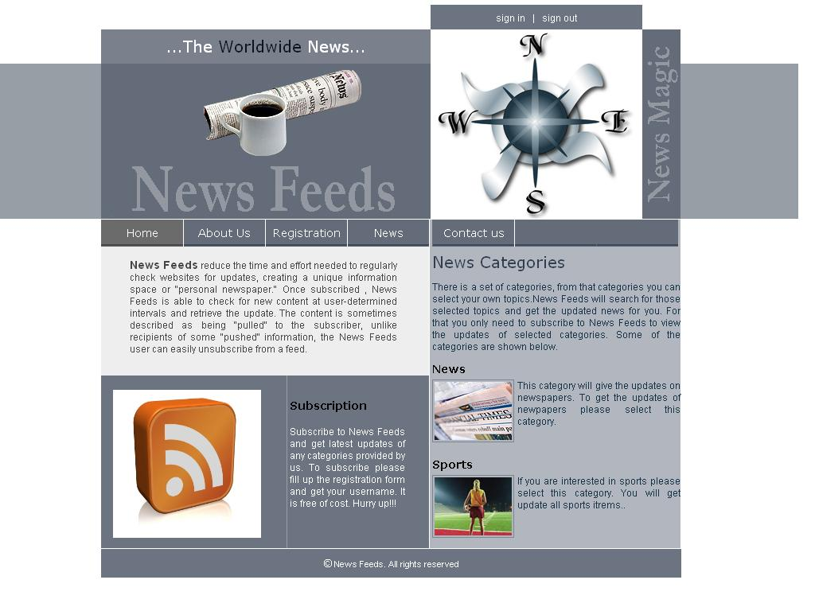

Registration

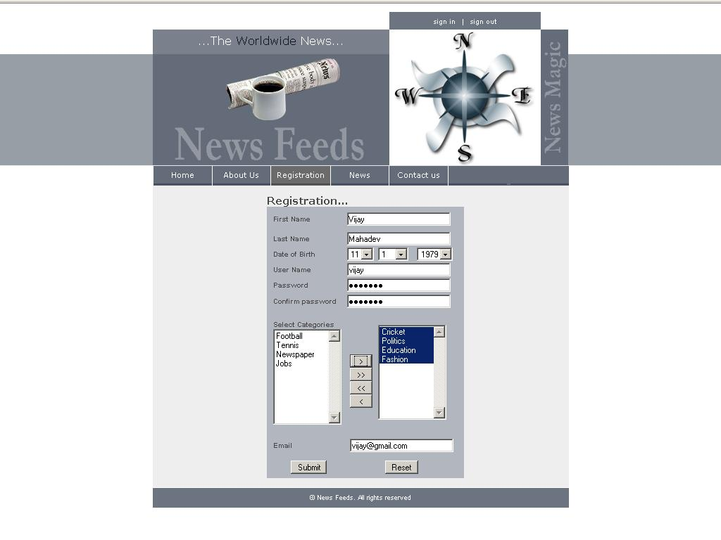

Sign in
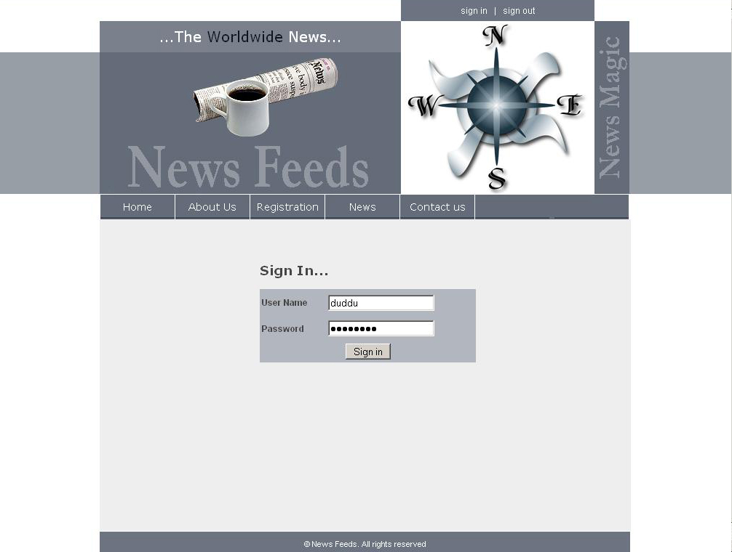

News Feeds

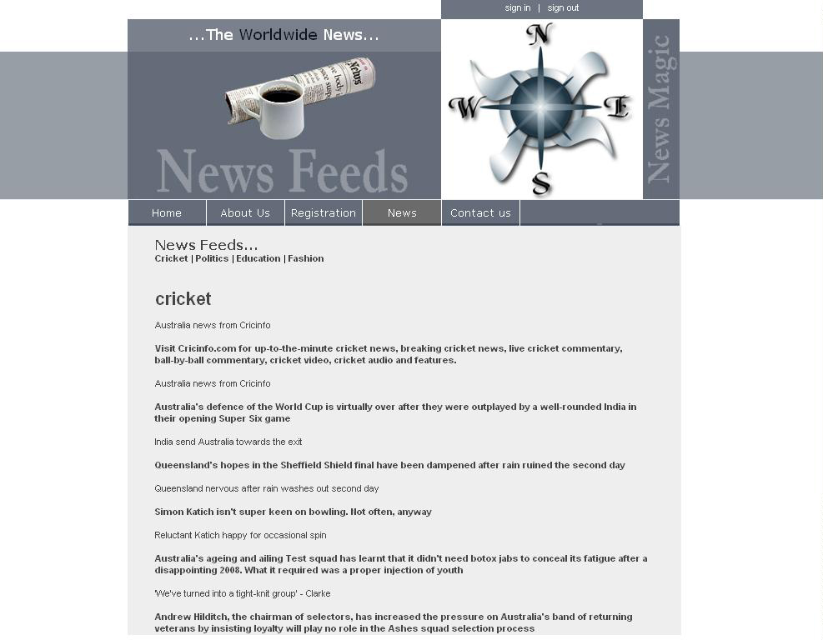

Contact
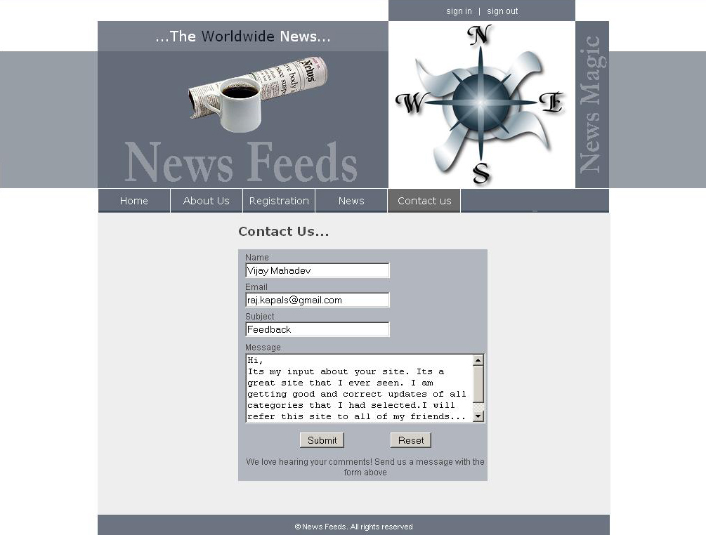

Admin Login
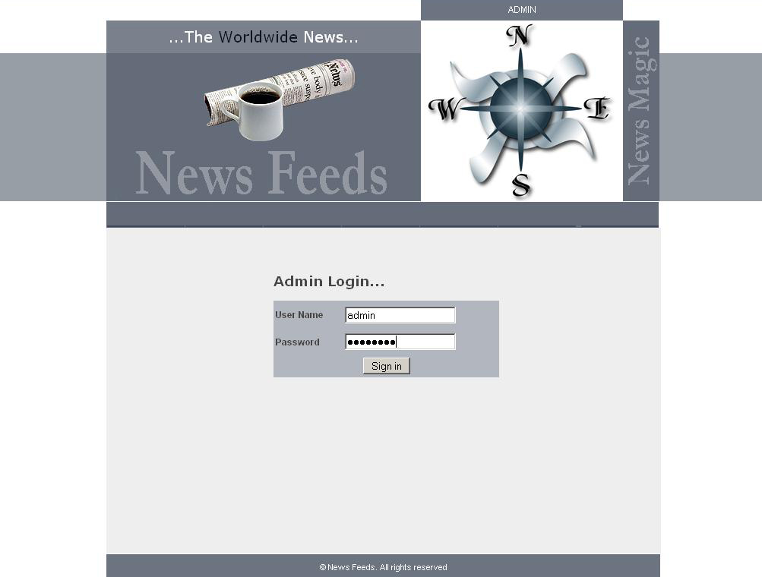

Create Category
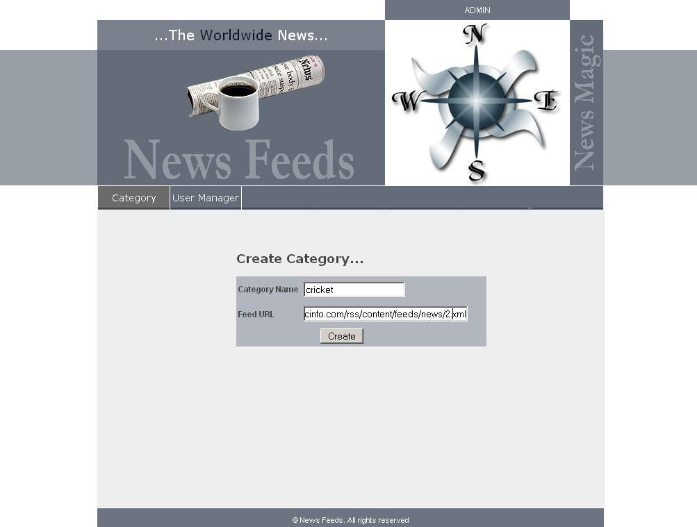

CONCLUSION

News Feeds is a useful website for all kind of peoples, for finding updated news for their specified and desired topics. It will bring new dimensions on news searching. It will be very useful for studios pupils as well as new readers. It allows the key elements of websites, such as headlines, to be transmitted in unembellished form and helps to share content between websites.
It enables information from scores of websites to be viewed simultaneously., all on one page, consequently, numerous sites can be scrutinized in seconds rather than having to be tediously downloaded independently. It has the ability to keep track of changes on the web.

BIBLIOGRAPHY

BOOKS:

- Charles Hampfed --(2000) ‘PHP’ University of Toronto
- Herhert Schildt --The Complete Reference PHP (Fifth Edition)
- Jim Farely $ William Crawford—PHP MySQL (Third edition)
Site:
- www.w3schools.com/
- www.sitepoint.com/article/

