Q1. What is Flask Framework? What are the advantages of Flask Framework?

Ans: Flask is a web framework. Flask allows you to build a web application by providing tools, libraries, and technologies. This web application will be a web page, a wiki, or a big web-based calendar application or commercial website.

Advantage of Flask:

Integrated support for unit testing

Built-in development server and fast debugger

Restful request dispatching

Unicode base

Support for cookies

Templating jinja2

Q2. Create a simple Flask application to display ‘Hello World!!’. Attach the screenshot of the output in Jupyter Notebook.

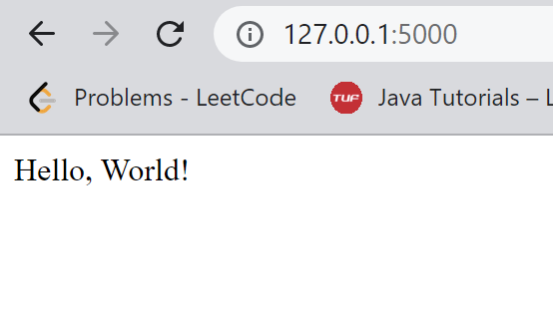

Q3. What is App routing in Flask? Why do we use app routes?

Ans: App routing means mapping the URL to a specific function that will handle the logic for the URL.

Q4. Create a “/welcome” route to display the welcome message “Welcome to ABC Corporation” and a “/”

route to show the following details:

Company Name: ABC Corporation

Location: India

Contact Detail: 999-999-9999

Attach the screenshot of the output in Jupyter Notebook.

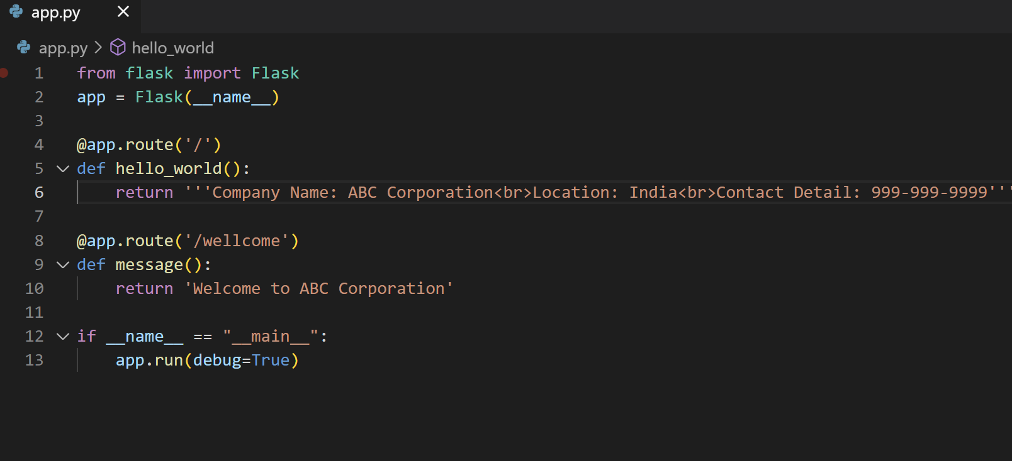

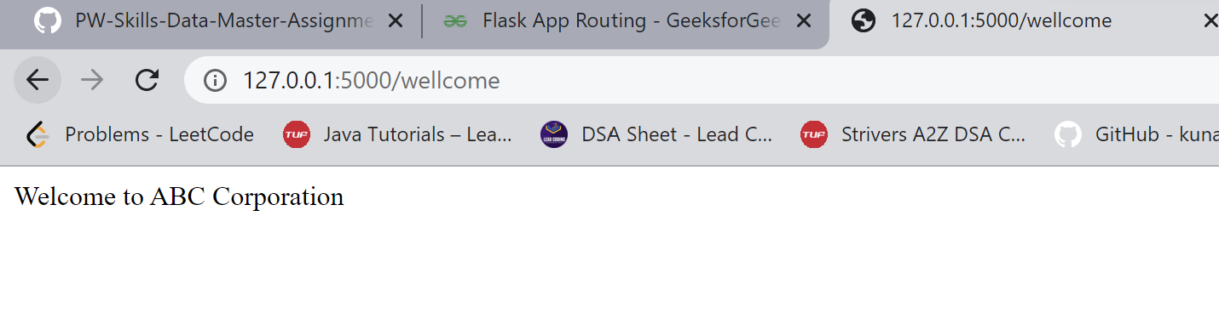

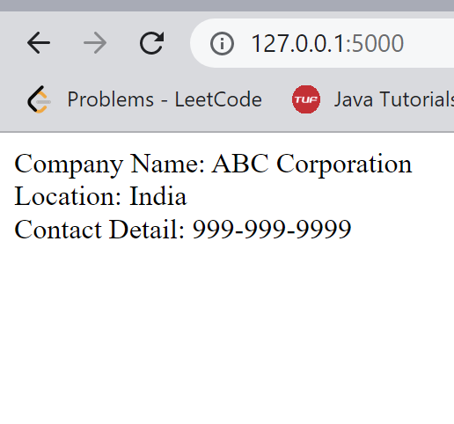

Q5. What function is used in Flask for URL Building? Write a Python code to demonstrate the working of the

url_for() function.