

American International University-Bangladesh (AIUB)  
Department of Computer Science  
Faculty of Science &Technology (FST)  
Summer 2021-2022  
Software Quality and Testing

College Banking System

Section: B

A Report submitted

By

|  |  |  |
| --- | --- | --- |
| SN | Student Name | Student ID |
| 1 | Abul Kashem Nibir | 18-38660-3 |
| 2 | Fahim Ahmed | 18-36833-1 |
| 3 | Md. Tafiquzzaman | 18-36743-1 |
| 4 | Naim Hasan Mim | 19-40604-1 |

Under the supervision of

Abhijit Bhowmik

Associate Professor

Department of Computer Science

Faculty of Science & Technology

American International University-Bangladesh

Software Test Plan

for

College Banking System

Version 1.0 approved

Prepared by

Abul Kashem Nibir

Fahim Ahmed

Md. Tafiquzzaman

Naim Hasan Mim

American International University-Bangladesh

20 August,2022

Table of Contents

1. Revision History 4

1. TEST PLAN IDENTIFIER: RS-MTP01.3 4

2. REFERENCES 4

3. INTRODUCTION 5

1. 3.1 Background to the Problem 5

2. 3.2 Solution to the Problem 5

4. REQUEIREMNT SPECIFICATION 6

1. System Features 6

2. System Quality Attributes 7

3. System Interface 8

4. Project Requirements 10

5. FEATURES NOT TO BE TESTED 11

6. TESTING APPROACH 12

1. Testing Levels 12

2. Test Tools 12

3. Meetings 14

7. TEST CASES/TEST ITEMS 14

1. Registration 14

2. Login 15

3. Withdraw Money 16

4. Reset Password 16

5. Add Money 17

6. Logout 17

8. ITEM PASS/FAIL CRITERIA 18

9. TEST DELIVERABLES 19

10. STAFFING AND TRAINING NEEDS 19

11. RESPONSIBILITIES 19

12. TESTING SCHEDULE 22

13. PLANNING RISKS AND CONTINGENCIES 22

14. APROVALS 23

# Revision History

|  |  |  |  |
| --- | --- | --- | --- |
| Revision | Date | Updated by | Update Comments |
| 0.1 | 2022.08.11 | Abul Kashem Nibir | First Draft |
| 0.2 | 2022.08.12 | Fahim Ahmed | Second Draft |
| 0.3 | 2022.08.13 | Md. Tafiquzzaman | Third Draft |
| 0.4 | 2022.08.14 | Naim Hasan Mim | Fourth Draft |
| 0.5 | 2022.08.15 | Abul Kashem Nibir | Fifth Draft |
| 0.6 | 2022.08.16 | Md. Tafiquzzaman | Sixth Draft |
| 0.7 | 2022.08.17 | Fahim Ahmed | Seventh Draft |
| 0.8 | 2022.08.18 | Naim Hasan Mim | Eighth Draft |
| 0.9 | 2022.08.19 | Fahim Ahmed | Ninth Draft |

# TEST PLAN IDENTIFIER: RS-MTP01.3

# REFERENCES

* Software Quality And Testing Course PowerPoint Slides.

LINK: https://portal.aiub.edu/Student/Section?q=l%2B8%2Fxrq04%2BWmv99xw%2F7i9Q%3D%3D#/notesTab

# INTRODUCTION

### 3.1 Background to the Problem

In the present context of College there is no bank account system for student. A student bank account management system refers to the system that allows students to make money transfer, withdraw and to deposit their money. If this system is added in College management system then student do not need to go outside of the University to deposit or withdraw their money. They can easily make their payment of the university by using this system.

## 3.2 Solution to the Problem

Our main focus on College student mobile banking system policy that will be practiced by student of that college. It is one type of banking system towards college going students to deposit or withdraw money without any charge. A banking system has Saving, current, fixed deposit, joint, and minor deposit accounts. Any student who wishes to become a new bank customer must pick from one of these options. A new student to the bank can create an individual account, a joint account, or a minor account, depending on his or her preferences. There are no limits on the quantity or amount of deposits for cash transactions over 49,999 TK. When a student with a savings bank account makes a cash deposit or cash withdrawal, the bank authority responsible for this section will update the bank database and the customer's account database by entering all transaction details (customer name, account number, phone number, deposited/withdrawal amount, and PAN number if the transaction exceeds 49,999 TK).  It also offers fund transfer services, which allow money to be transferred from one customer's account to another. Money can be transferred inside the same bank; however, transferring money to the account holder of another bank incurs no fee.

Students can get their money through ATM card, an internet website or mobile device. By using the ATM card, a customer can withdraw cash from either checking or savings account, query the balance of an account, or transfer funds from one account to another.  A transaction is initiated when a customer inserts an ATM card into the card reader. Encoded on the magnetic strip on the back of the ATM card is the card number, the start date, and the expiration date. Manually managing all of these bank data and documents is impossible. As a result, there is a need for software that can manage all of the details on both the university students' and bank officials' sides. The software's primary goal is to automate all aspects of bank operations, both for students and for bank officials. As a result, the banking management system is established to address this problem. The system allows students to create accounts, deposit/withdraw money from their accounts. This system will help to do student’s banking activities such as deposits and withdrawals without having to locate an open location and without any charge.

# REQUEIREMNT SPECIFICATION

## System Features

1. System Registration

**1.1** Student open aBank account by doing registration

**1.2** Provide Name, Email, user name, password, Date of birth,gender etc.

**1.3** select Account Type

**1.4** verifyStudentUsername, Password, Phone number, Email

**1.5** submit and create

Priority Level: High  
Precondition: verify all information

* 1. System Login
  2. The system will allow the student to enter the correct User Name and Password.

**2.2** If Its failure to provide correct User Name and Password then it can reset the Password by sending verification code through the email .

Priority Level: High  
 Precondition: User have valid user name and password

1. Add Money
   1. The system will allow the student to add or cash in money.
   2. Student can add or Transfer money from another account to this account.

Priority Level: Medium  
Precondition: Verify Login

1. Withdraw Money
   1. The system will allow the student to withdraw money by ATM Card using ATM machine.
   2. If the balance is less than 500, student not able to withdraw money

Priority Level: Medium  
Precondition: Check Balance

1. Account Setting
   1. student can change password, ATM Card’s PIN
   2. password and pin verification using Email and phone number

Priority Level: High  
 Precondition: Verify information

1. Transfer Money

## System Quality Attributes

**Performance**: Performance requirements define how well or how rapidly this system must perform specific features. Speed, throughput, capacity, timing. It also addresses how the system's performance will degrade in an overloaded situation (when more student doing transection at a time).

**Efficiency:**This attribute defined how use this system efficiently**.** It deals with the hardware resources needed to perform the different functions of this system. It includes processing capabilities, its storage capacity and the data communication capability (Local server to Central Server).

**Usability:** This can be measured in terms of ease of use. The application should be user-friendly. Usability meanshow easily and first user(student) can use this system and get services. During money transection, this attribute is important.

**Integrity:** Integrity this factor deals with the system security that is, to prevent access to unauthorized persons. This attribute is most important to provide security.

**Reliability:** Reliabilityof a system is defined how reliable to use this system. This attribute defined how much secured during money transection.

**Testability:** If the System face any error or defect then it must have the testing ability of that error or defect.

## System Interface

1. Registration Interface:

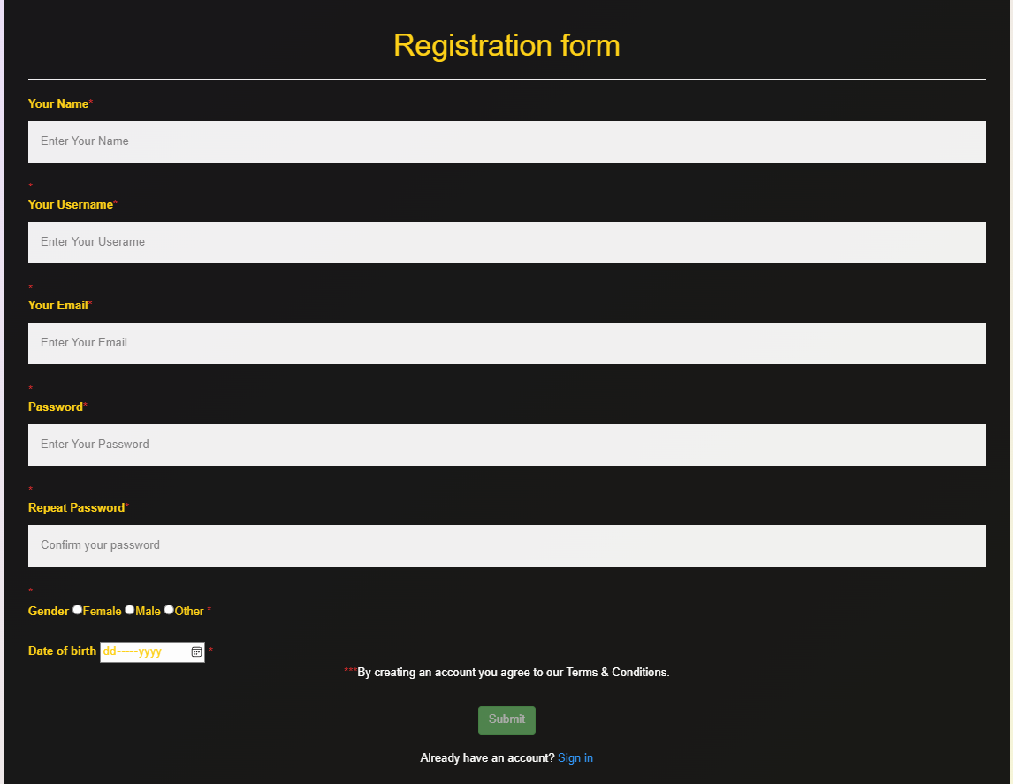

Figure:4.3.1

# Login Interface

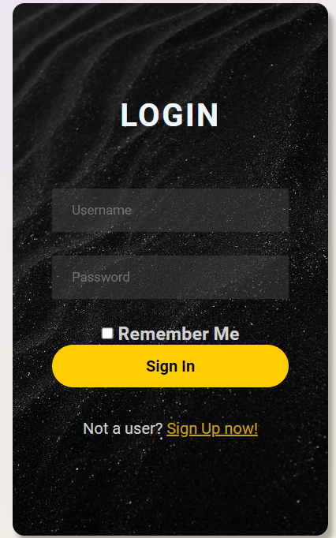

Figure:4.3.2

# 3.Settings Interface:

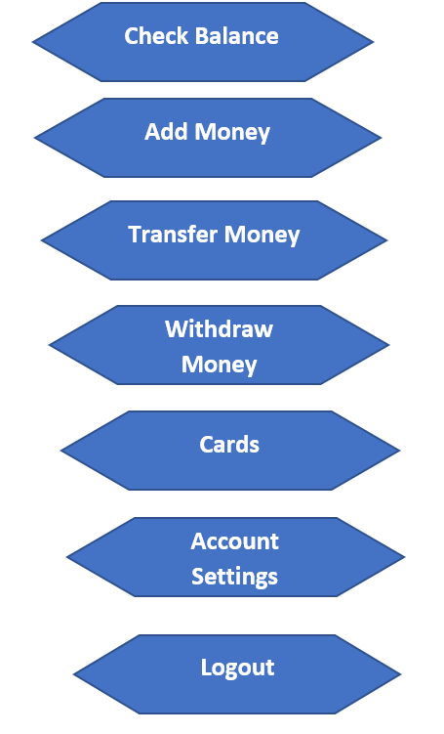

Figure:4.3.3

## Project Requirements

The Constructive Cost Model (COCOMO) is an algorithmic software cost estimation model**.** The software project type that we will be using is organic**.** It is a software project that must be developed within a strongly coupled to hardware environment**.**

· **Effort = PM (person-months needed for project (labor working hours))**

**=Coefficient<Effort Factor>*(SLOC/1000)^P**

**=2.4* (10000/1000)^1.05 [here SLOC = 10000, organic co- efficient**

**effort factor is 2.4 and P(project complexity which is 1.05)]**

**= 26.928 labor working hours**

**· Development Time, DM= 2.50*(PM)^T**

**· =2.50*(26.928)^0.38 [here T for organic is 0.38] =8.73 months**

**· Required Number of People, ST (average staffing necessary)**

**= PM/DM**

**=26.928/8.73**

**=3.08**

# FEATURES NOT TO BE TESTED

The following is the list of the features not to be tested:

* Registration or Logout of accounts
* Create, update, or delete student transection records
* Maintenance of the student records, account records, and debit card records
* Maintenance of the hardware devices of the ATM
* Network facilities

# TESTING APPROACH

## Testing Levels

* **Unit Testing:** First we will do the Unit Testing during our system development. In this testing we will tests individual software modules and see whether the individual system module has error or not. This testing methodology is done by the software developers and QA staff. This testing goal is to ensure that each unit of software code works as intended. In this step, we will follow “White Box Testing” technique.
* **Integration Testing:** After that in the second part we will do the Integration. In this testing we will make sure that all the software modules are integrated logically and tested as a group and working correctly. The goal of this level of testing is to find flaws in the way various software modules interact when they're integrated. In this step, we will follow the “Bottom-up Integration” technique.
* **System Testing:** Then we will do the system testing. Through the system testing we will test of full-featured, fully integrated system. Then we will verify if it meets all the requirement. Black-box testing falls under this condition. So, in this level, we will follow “Black Box Testing” technique.
* **Acceptance Testing:** The last phase of our testing is Acceptance Testing. We will do this Testing for checking the acceptability of our product. This test will be done to check whether any defect missed during the functional testing phase. In this level, we will follow the “Black Box Testing” technique. After that, we may run unit tests again.

## Test Tools

We are going to use Selenium Web driver Tool for automated testing. We use this tool to detect error or defect and ensure the systems high-quality, responsive, progressive or regular.

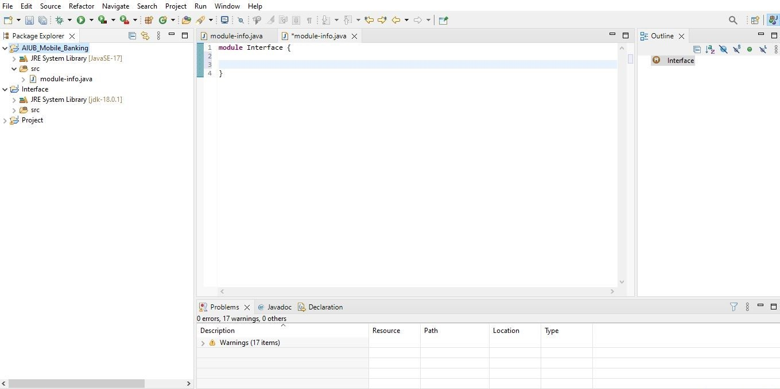

Figure: 6.2.1

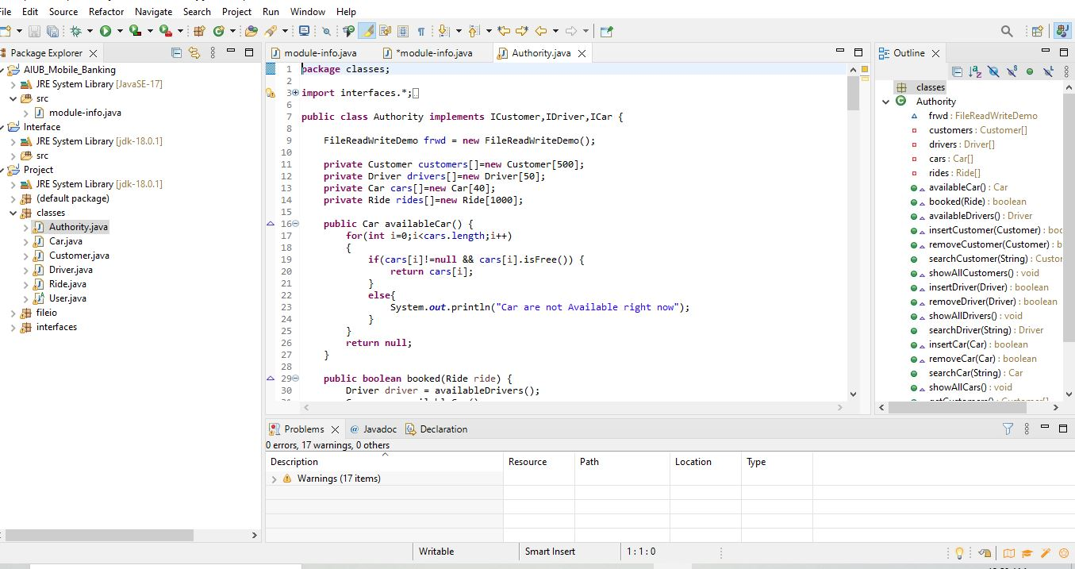

Figure: 6.2.2

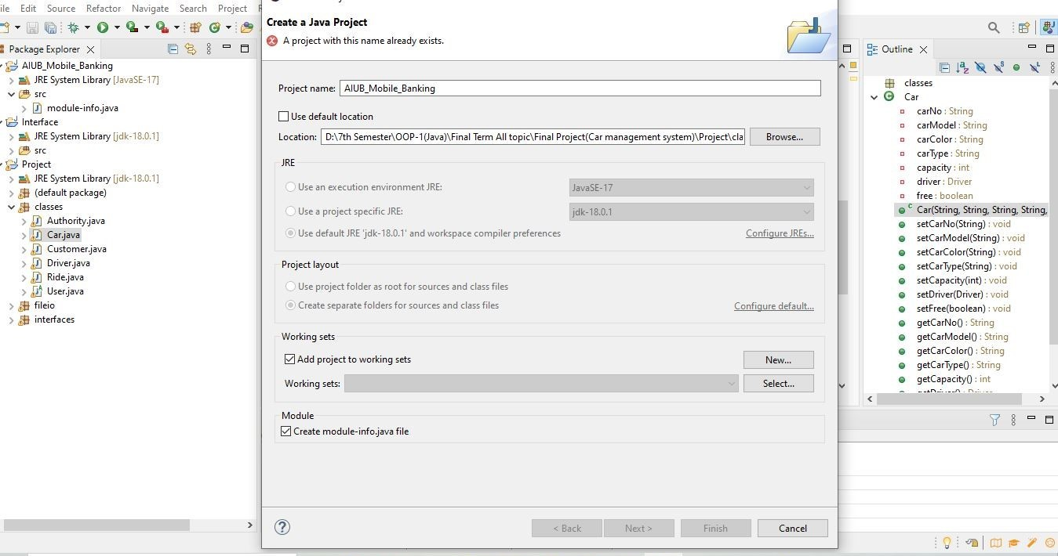

Figure: 6.2.3

## Meetings

Distributing the proper task to the right individual is one of the most important parts of becoming a successful testing team. So, in order to be a successful team, it is critical to hold regular team meetings. As a result, the test team will meet once a week to review each member's progress and determine whether or not they have completed their allocated tasks. And see if they're experiencing any issues with testing; if they are, the entire team will help him and attempt to resolve the issue as soon as possible. Once every two weeks, the testing team lead will meet with the development and project manager. If there is an emergency, an urgent meeting will be scheduled.

# TEST CASES/TEST ITEMS

## Registration

|  |  |  |  |  |  |
| --- | --- | --- | --- | --- | --- |
| Project Name: College Banking System | | | Test Designed by: Fahim Ahmed | | |
| Test Case ID: Registration_1 | | | Test Designed date:14/8/22 | | |
| Test Priority (Low, Medium, High): high | | | Test Executed by: Fahim Ahmed | | |
| Module Name: Registration | | | Test Execution date:14/8/22 | | |
| Test Title: Validate registration of an account with username, email and password,dob,gender | | |  | | |
| Description: Test the registration system | | |  | | |
| Precondition (If any): User must fill-up all the input field. | | | | | |
| Test Steps | Test Data | Expected Results | | Actual Results | Status (Pass/Fail) |
| 1. Go to the website 2. Click on register 3. Enter student name 4. Enter email 5. Enter password 6. Sign up | Student username: fahim  Email: fahimahmed6008@gmail.com  Password: 321 | Account created successfully and go to the home page | | As expected | Pass |
| Post Condition: User information added in the database section | | | | | |

**Figure 7.1**

## Login

|  |  |  |  |  |  |
| --- | --- | --- | --- | --- | --- |
| Project Name: College Banking System | | | Test Designed by: Abul Kashem Nibir | | |
| Test Case ID: Login_2 | | | Test Designed date:14/8/22 | | |
| Test Priority (Low, Medium, High): high | | | Test Executed by: Abul Kashem Nibir | | |
| Module Name: login session | | | Test Execution date:14/8/22 | | |
| Test Title: verify login with valid username and password | | |  | | |
| Description: Test login page | | |  | | |
| Precondition (If any): User must have valid username and password | | | | | |
| Test Steps | Test Data | Expected Results | | Actual Results | Status (Pass/Fail) |
| 1. Go to the homepage 2. Enter username 3. Enter password 4. Click submit | Username: nibir  Password: 321 | User should login into the application | | As expected | Pass |
| Post Condition: User is validated with database and successfully login to account. The account session details are logged in the database. | | | | | |

**Figure 7.2**

## Withdraw Money

|  |  |  |  |  |  |
| --- | --- | --- | --- | --- | --- |
| Project Name: College Banking System | | | Test Designed by: Md. Tafiquzzaman | | |
| Test Case ID: Withdraw_Money_3 | | | Test Designed date:14/8/22 | | |
| Test Priority (Low, Medium, High): high | | | Test Executed by: Md. Tafiquzzamans | | |
| Module Name: Withdraw money | | | Test Execution date:14/8/22 | | |
| Test Title: verify withdraw money with pin number, username and password | | |  | | |
| Description: Test the website withdraw money method | | |  | | |
| Precondition (If any): User’s pin number, username and password should be valid. | | | | | |
| Test Steps | Test Data | Expected Results | | Actual Results | Status (Pass/Fail) |
| 1. Go to the homepage 2. Enter username 3. Enter password 4. Click submit | Username: taufiq  Password: 321 | User should login into the application | | As expected | Pass |
| Post Condition: User has successfully withdrawn money from account | | | | | |

**Figure 7.3**

## Reset Password

|  |  |  |  |  |  |
| --- | --- | --- | --- | --- | --- |
| Project Name: College Banking System | | | Test Designed by: Naim Hasan Mim | | |
| Test Case ID: Reset password_4 | | | Test Designed date:14/4/22 | | |
| Test Priority (Low, Medium, High): Medium | | | Test Executed by: Naim Hasan Mim | | |
| Module Name: Reset password | | | Test Execution date:14/8/22 | | |
| Test Title: put old username and password to set up new password | | |  | | |
| Description: Test the website reset password page | | |  | | |
| Precondition (If any): User has valid username and password | | | | | |
| Test Steps | Test Data | Expected Results | | Actual Results | Status (Pass/Fail) |
| 1. Go to the homepage 2. Enter email 3. Enter username 4. Enter password 5. Click submit | Email:mim@gmail.com  Username: mim  Old Password: 321  New password:467 | User should change his password | | As expected | Pass |
| Post Condition: User is validated with database and successfully changed to password. | | | | | |

**Figure 7.4**

## Add Money

|  |  |  |  |  |  |
| --- | --- | --- | --- | --- | --- |
| Project Name: College Banking System | | | Test Designed by: Fahim | | |
| Test Case ID: Add_Money_5 | | | Test Designed date:14/8/22 | | |
| Test Priority (Low, Medium, High): Medium | | | Test Executed by: Fahim Ahmed | | |
| Module Name: Add money | | | Test Execution date:14/8/22 | | |
| Test Title: verify add money with pin number, username and password | | |  | | |
| Description: Test the website add money method | | |  | | |
| Precondition (If any): User’s email, username and password should be valid | | | | | |
| Test Steps | Test Data | Expected Results | | Actual Results | Status (Pass/Fail) |
| 1. Go to the homepage 2. Enter student email 3. Enter username 4. Enter password 5. Click submit | Student nid:1234  Username: fahim  Password: 467 | User can add cash his/her account | | As expected | Pass |
| Post Condition: User has successfully added cash on account | | | | | |

**Figure 7.5**

## Logout

|  |  |  |  |  |  |
| --- | --- | --- | --- | --- | --- |
| Project Name: College Banking System | | | Test Designed by: Abul Kashem Nibir | | |
| Test Case ID: Logout_6 | | | Test Designed date:14/8/22 | | |
| Test Priority (Low, Medium, High): Medium | | | Test Executed by: Abul Kashem Nibir | | |
| Module Name: log out | | | Test Execution date:14/8/22 | | |
| Test Title: verify user logout option | | |  | | |
| Description: Test the website logout option | | |  | | |
| Precondition (If any): Need to be logged in | | | | | |
| Test Steps | Test Data | Expected Results | | Actual Results | Status (Pass/Fail) |
| 1. Go to the homepage 2. Login in to the site 3. Click logout button |  | Successfully log out | | As expected | Pass |
| Post Condition: User has successfully added cash on account | | | | | |

**Figure 7.6**

# ITEM PASS/FAIL CRITERIA

Testing team will be a group of -

* Unit Test Manager
* Test Analyst
* Project Sponsor
* Developer

The team will be doing the following tasks-

* There will be error free codes and in time compilation
* The test will pass only if there is 100% passing rate.
* If any error found or passing rate remains below 100% it will be resolved in time.
* All the possible tests will be documented

Here we have implemented 6 test cases. 80% of the test cases were passed successfully when we applied the test case and 20% were fail. Because of some query related issues on the database, the test cases were failed. When the test case was applied after solving query related problem, all the test cases are successfully passed.

# TEST DELIVERABLES

* Test specification document: The summary of the scenarios that are going to be tested
* Test strategy: The high-level document defines the testing approach
* Test scenario: We have to make sure that every process flow is tested in detail
* Test data: the data or input provide to the application with intent of fetching results
* Defect reports: Bug report of a feature
* Test design: ensure formal way to design of test
* Test status report: Way the development of application
* Summary of all reports: Summary of testing, overall opinions and test pass/fail

# STAFFING AND TRAINING NEEDS

* Use certification to document expertise and encourage learning new skills.
* Encourage training in software and computing as a continuing physics activity.
* Use workbooks and wikis as evolving, interactive software documentation.
* Use online media to share training.
* marketable for non-academic jobs.

We require a large number of skilled personnel to complete our project, Skilled Workers can complete a project more efficiently and within budget. Skilled workers will complete a high-quality assignment on schedule. Five full-time testers with extensive understanding of various levels of testing and testing technologies will be required. The tester must be familiar with ATM machines and should receive training on the system.

# RESPONSIBILITIES

* The project team leader is responsible for verifying all test plans.
* The test lead is responsible for writing the test plan.
* The test managers are responsible for writing test cases.
* The entire project team will participate in the system review.
* The developer is responsible for fixing bugs; the tester is responsible for detecting bugs rather than fixing bugs.
* The administration is responsible for verifying the test results.

|  |  |  |  |
| --- | --- | --- | --- |
| Serial | Name | Role | Responsibilities |
| 1. | Abul Kashem Nibir | Test Lead | 1.Test plan guidance, monitoring control.  2. Determining the scope of testing for each release and each level or cycle of software testing.  3. Regularly updating the project manager on the status of testing efforts.  4. The efficient use of resources and the management of resources for software testing. |
| 2. | Fahim Ahmed | Senior tester | 1. Creating test cases and test plans for the product.  2. To define product testing criteria, meet with the product design team.  3.Test data collection, generating test scenario.  4. For the resources, there is a direct contact lead. |
| 3. | Md Tafiquzzaman | Associate Test Engineer | 1.Test data collection, generating test scenario.  2. For the team leader, create test data and status reports.  3. Should make a modification to the code to resolve a bug, run regression testing.  4. Carry out the testing. |
| 4. | Naim Ahmed Mim | Tester | 1.Test case documentation, test case execution, defects reporting tracking. |

|  |  |
| --- | --- |
| Tasks | Task Duration  (Days) |
| Project Proposal | 4 |
| Project Requirement | 6 |
| Project Agreement | 11 |
| Project Planning | 17 |
| System Design and Architecture | 20 |
| Coding | 38 |
| Testing | 39 |
| Implementation and Unit Testing | 3 |
| System Integration and System Testing | 3 |

# TESTING SCHEDULE

**Gantt Chart for Following Schedule:**

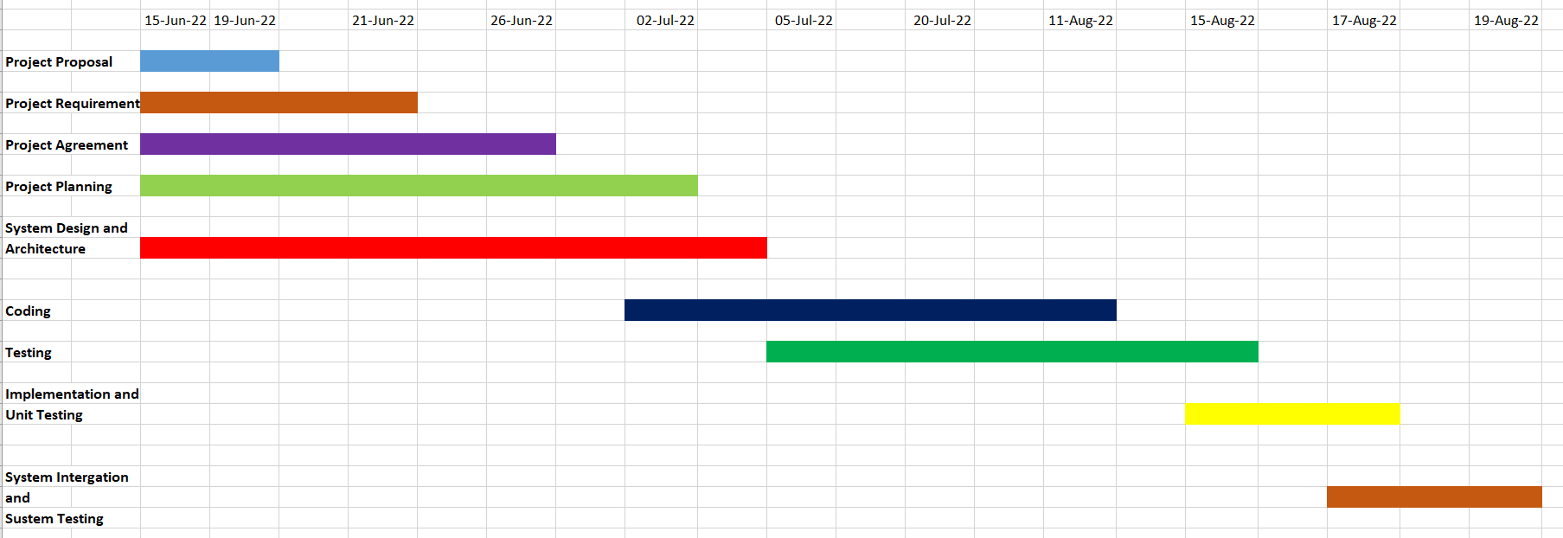

# PLANNING RISKS AND CONTINGENCIES

* Illness or Injury: Regular medical checkups are arranged for the employees.
* Software Failure: Failure of Main or Back-up Hardware: We will maintain a main and Back-up hardware system, printers and workstations should be serviced and maintained regularly.
* Internal Issue: Chain of command will be conducted strictly.

# APROVALS

|  |  |
| --- | --- |
| Project Sponsor | Abul Kashem Nibir |
| Development Management | Fahim Ahmed |
| EDI Project Manager | Md Tafiquzzaman |
| RS Test Manager | Abul Kashem Nibir |
| RS Development Team Manager | Fahim Ahmed |
| Reassigned Sales | Naim Ahmed Mim |
| Order Entry EDI Team Manager | Md Tafiquzzaman |