

American International University-Bangladesh (AIUB)  
**Department of Computer Science  
Faculty of Science &Technology (FST)  
Summer 2021-2022**

**Online shop management system**

Software Requirement Engineering

Sec: **C**

Project submitted by

|  |  |
| --- | --- |
| **Student Name** | **Student ID** |
| Fahim Ahmed | 18-36833-1 |
| Md Tafiquzzaman | 18-36743-1 |
| Durjoy Sarker | 18-38181-2 |
|  |  |

1. **PROBLEM DOMAIN**
   1. **Background to the Problem**

In Bangladesh departmental store is used by everyone but they are not using online shop. In urban areas some use online shop to conduct their business to apart form traditional style. But in the rural areas there is no such thing called online shop. They do all their business related work from calculate their money to sell product by their own hand in offline it is too much time consuming in this era. In this pandemic time when lock down impose then they have to shut their whole business. Because of that they are suffering from huge loss and consumer also suffering because they can not go out and buy their product.

* 1. **Solution to the Problem**

We are doing this mainly because of covid-19 situation as well as for digitalization of the shop store across the Bangladesh. So here we are coming with the solution of this problem .Our solution ss a web based solution through this project both owner and customer of the shop can use this and owner can sell their product through this project. Here shop keeper to sell the product and consumer buy the product by home they will be benifited through this web base project. Shopkeeper can calculate all their calculation through this web base project. Their will also be a payment method through this both party can do transaction and there is also unique transaction id every order. There are lots of feature using in this project those are user friendly. The existing software solutions are available to solve the problem like Amazon, Alibaba etc.

1. **SOLUTION DESCRIPTION**
   1. **System Features**

There will be 8 feature in our project. The features will be

1.Regreistration   
2. Log in ,Log out ,sign up  
3. Create ,update ,delete profile   
4. Home   
5. Product category   
6. Product availability   
7. Order ,Cart  
8. Transaction section.

A short description of this System feature is given below:

**1. Registration:** In this section people can give their information like first name ,last name ,phone number ,email, age ,date of birth for this selected section.

Priority Level: High  
Precondition: No condition

**2. Log in , Log out ,sign up:** In the system software shall allow users to login with their given username and password. If the username / password has been wrong for more than four times, the random verification code will be generated and send it email/phone number by the system to retry login. If the verification code of login attempt exceed its limit (4 times), the system will be block the user account login for one hour. The user can not sign in multiple(maximum 3) devices. The user can be log out and sign up in this software.

Priority Level: High  
Precondition: Valid user id and password

1. **Create ,update ,delete profile:** In this software User can create update and also delete profile.

**Priority Level:** High

**Precondition:** User Must be log in into system

1. **Home**: In this software a home page where show all the interface and also select the product and other things.

**Priority**: High

**Precondition**: User must be log in into the system

**5. Product category** :There are lot product in online shop. Those product have to decorate in a category

**Priority**: High  
 **Precondition :** User must be log in into the system

**6. Product availability:** This feature shows that the product is available or stockout and also see product price

**Priority**: High  
 **Precondition** : User must be log in into the system

**7. Order,Cart:** If a user order a product then cart session start this cart session calculate the product price.

**Priority**: High  
 **Precondition** : User must be log in into the system

**8. Transaction section:** People can pay their bill through transaction. This system create a unique transaction id. They can use mobile banking as well as any credit card.

**Priority:** High  
 **Precondition** : User must be log in into the system

**2.2 UML Diagrams(Optional)**

**Use-case diagram: :** This use case diagram there are four actor Admin, System user, Customer, Salesman.

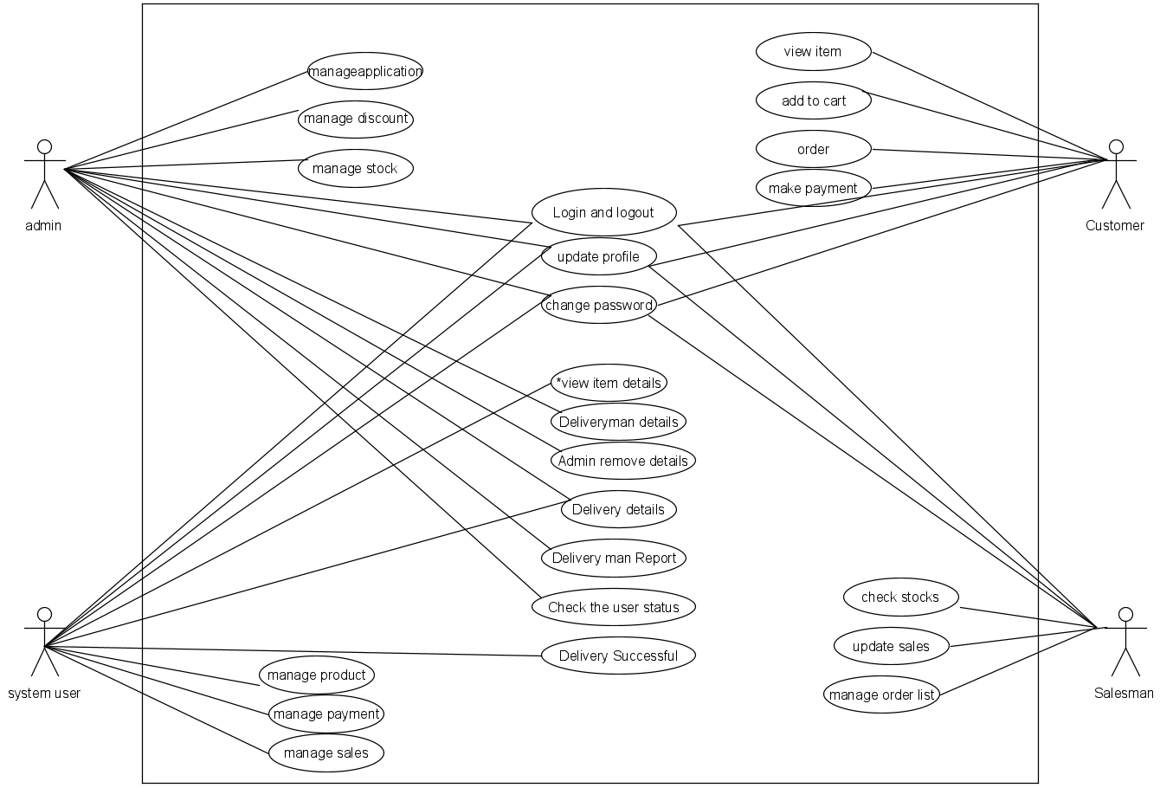

**Activity diagram:**

This is activity diagram of shop management system which shows the flow between the activity of sales, stock inventory, payments, discounts, product. The main activity involved in this UMI Activity Diagram of shop management system are as follows:

1. Sales Activity  
2.Stock Inventory Activity  
3.Payments Activity  
4.Discount Activity  
5.Product Activity

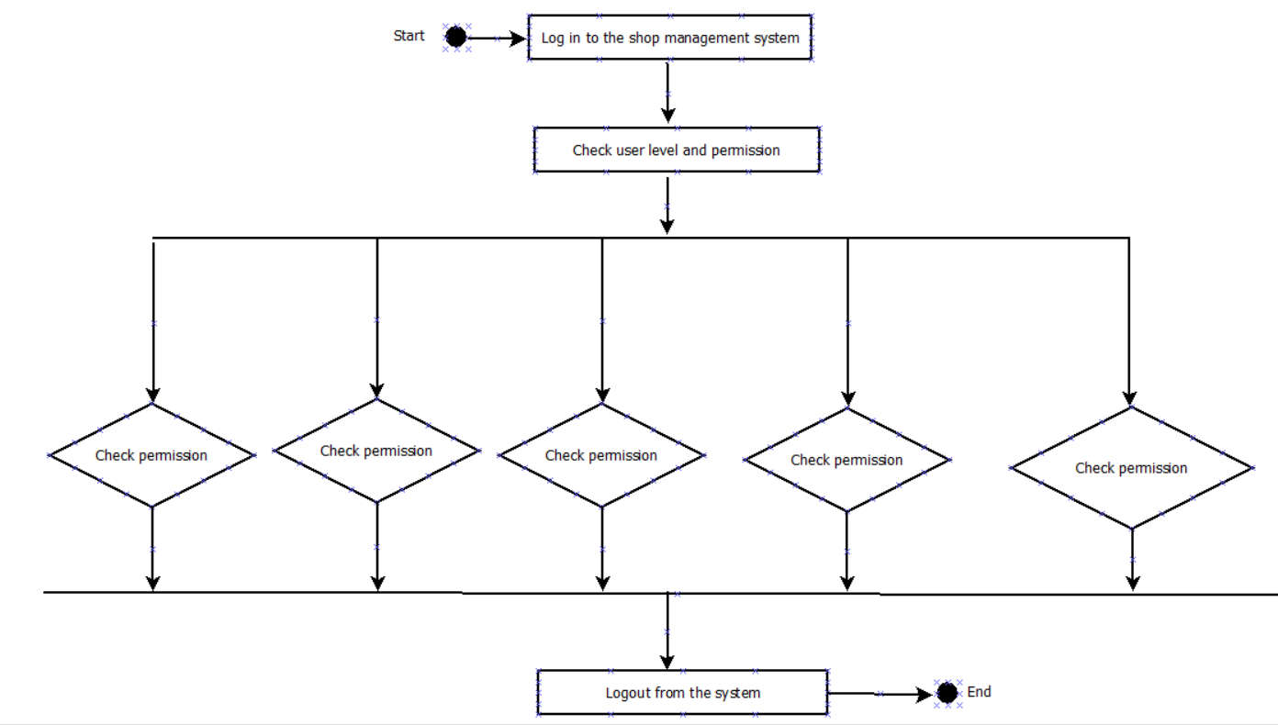  
**Feature Of the Activity UML Diagram Of shop management system**   
i. Admin user can search sales, view description of a selected sales, add sales, update sales and delete sales  
ii. It shows the activity flow of editing, adding and updating of stock inventory  
iii. User will be able to search and generate report of payments, Discounts, product  
iv. All objects such as (sales, stock inventory, product) are interlinked  
v. Its show the full description and flow of sales, Discounts, product, payments, stock inventory

**Login Activity Diagram Of shop management system:**   
  
 This is the Login Activity diagram of shop management system, which shows the flows of Login activity, where admin will be able to login using their username and password. After login user can manage all the operation on payments, sales, stock inventory, product, Discounts. All the pages such as stock inventory, product, Discounts are secure and user can access these pages after login. The diagram bellow helps demonstrate how the login page works in a shop management system. The various objects in the product, payments, sales, stock inventory and discount page-intact over the course of activity and user will not be able to access this page without verifying their identity

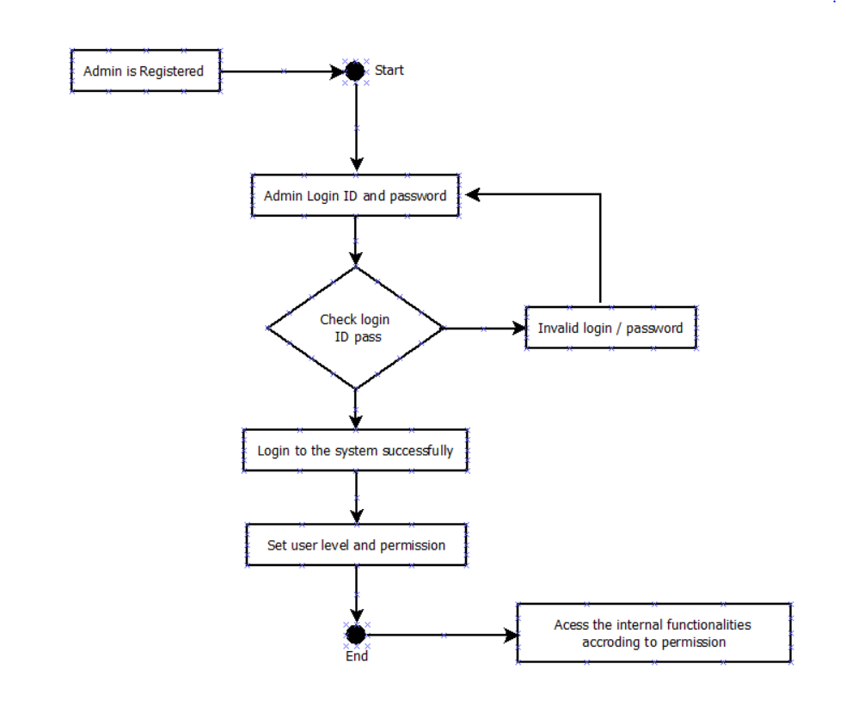

**Class diagram:** 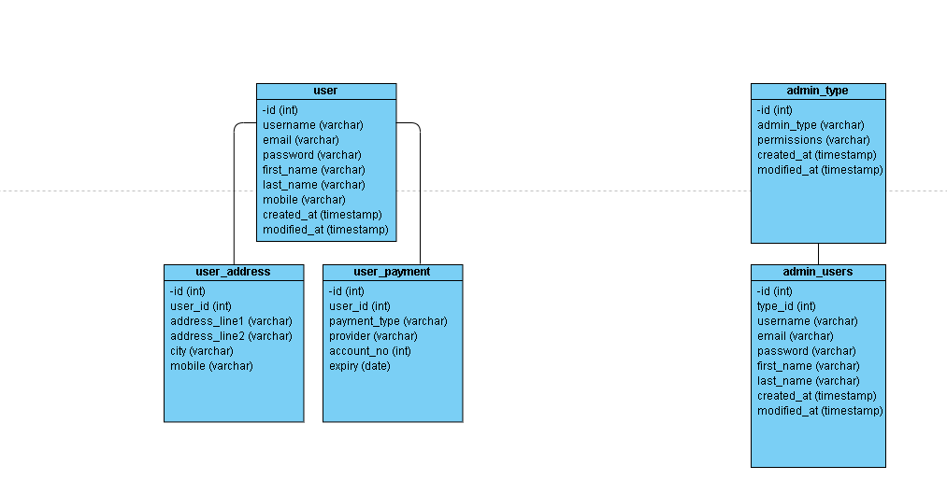

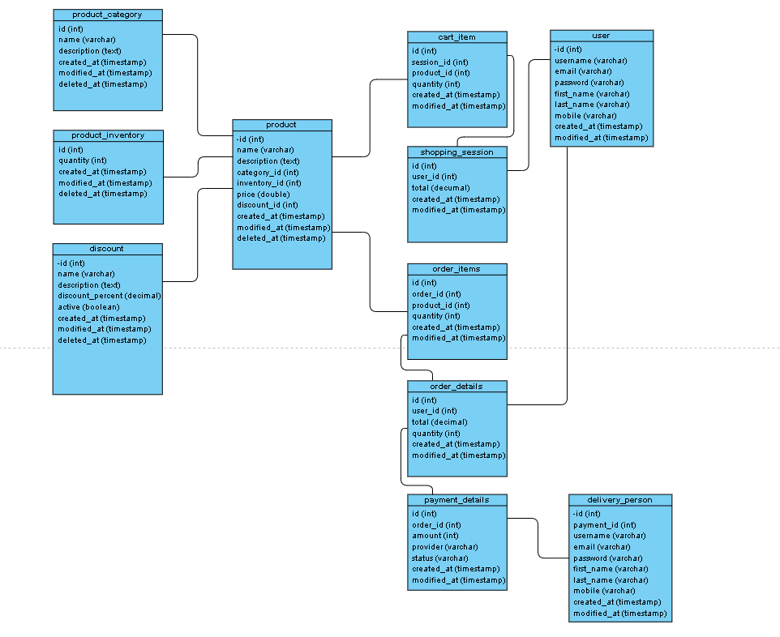

**ER diagram:** 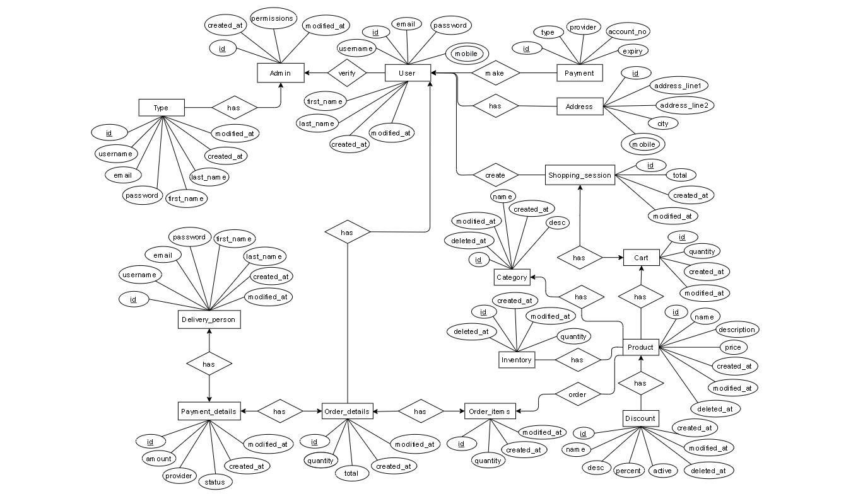

**3.Social Impact**

There will be a huge impact on society because owners can avoid loss in this pandemic time and can save their time and costing. Customer can get their required things without get out of their house. In some house the only capable person maybe busy in some work or may get ill in this case the other person of that house can order anything from their shop so it will be a great help for them. It can decrease illegal work that some worker do because it will track all the activity. If this made available in whole country then it will help create digital Bangladesh. In Bangladesh all the transaction is recorded in tali paper. Imagine a country where all transaction and inventory is being recorded in a web site and can’t be deleted until owners approve.This is a smart transaction solution in any digital country.In this society thus people will be benefitted from our project.

**4.Development Plan**

Every successful project have a proper development plan.In this projuct we are following Software Development Life Cycle(SDLC) plan.Basically the software development life cycle (SDLC) is a process used for structuring the development of any software system, from initiation through to implementation. An increase in demand for software to meet customer needs effectively but with less cost and faster delivery has put tremendous pressure on modern organizations.It is impossible to come up with a successful project without having a development plan like SDLC.

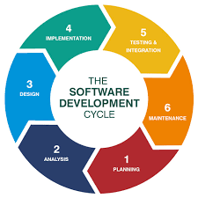

**i. Planning:** It is first section of SDLC.In this phase, all the important information is collected from the customer to develop a product as per their expectation. Any ambiguities must be resolved in this phase only.In our project there are lots of feature like log in,log out, product visiable,product availability,transaction etc we are planning

### ii. Analysis: In this section we will check and analysis that all the whether our project passed all the rule and regulation or not. We will do five checks economic, legal, operation feasibility, technical, schedule.

### iii. Design: In this design phase, the requirement of the project gathered in the SRS document is used as an input and software architecture that is used for implementing system development is derived.

### iv. Implementation: here we will use C#(coding language) to develop this project. In the backend we will use sql database. For this we will use sql server. We will use visual studio to write our code. All the components of the software are implemented in this phase.

### v. Testing and Intregration:After done our code now check the software are ready or not.There are lots of testing tools to test this software good or not.After passing all the test case the product will be considered all done.

### vi. Maintenance: Once the system is tested and intregrated, any necessary upgrades, enhancements, and changes can be made, implementing new features into the operating software. It is crucial to maintain and modernize the system regularly so it can adapt to future needs.

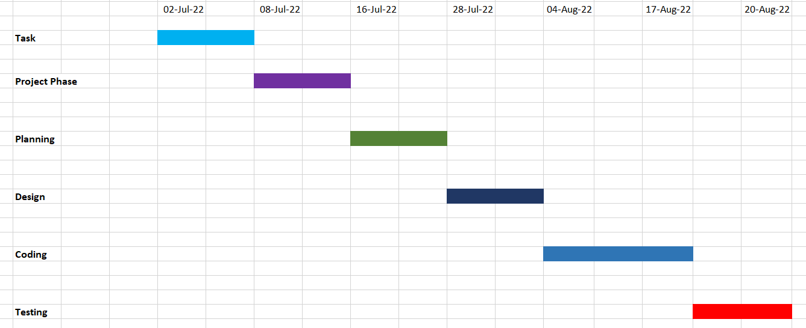

**5**.**Marketing Plan**

A marketing plan is a roadmap to present your products to different audiences in the most effective way possible. The primary objective of a marketing plan is to institutionalize your techniques and strategies. This will keep you on schedule and enables you to evaluate the success of your marketing. It is very important to develop a plan that will help us to increase the brand value and develop a corporate image for our software. The marketing team will be recruited based on their experience of the field work.

i).The first step in our marketing plan will be conduct research about our market. It will help us to make our marketing plan.

ii). Advertised our business in relevant magazines, newspapers,TV stations ,radio stations and so on.  
  
 iii). Encourage the use of word of mouth publicly from our loyal and satisfied employees.  
  
 iv).Organising and conducting business exposes , seminars and many business fairs.  
  
 v). Engaged with direct marketing approach.  
  
 vi). Making some attractive skim to attract the customers.  
  
 vii). We have to encourage our customers and employees.  
  
 viii). We have to create a official website and have to publish regularly.

**6.Cost and Profit Analysis:** This software cost and profit analysis is given bellow .

**Cost:** Monthly Investment 1,49,000

|  |  |  |  |
| --- | --- | --- | --- |
| Costs | Monthly | Annual |  |
| Development process | 10000 | 120000 |  |
| HR cost | 20000 | 240000 |  |
| Equipment | 5000 | 60000 |  |
| Utilities and transportation | 10000 | 120000 |  |
| Risk management cost | 6000 | 72000 |  |
| Marketing cost | 8000 | 96000 |  |
| Training cost | 5000 | 60000 |  |
| Software testing cost | 10000 | 120000 |  |
| Other | 5000 | 60000 |  |
| Total | 79000 | 948000 |  |

**Profit:**

|  |  |  |
| --- | --- | --- |
| Profit(Avg) | Month | Annual |
| 70000 | First to continue | 840000 |