**IMAGES:**

[](https://user-images.githubusercontent.com/94165479/143161821-bc40b931-3ef2-4d8d-a541-5a0d50a40b18.png)

[](https://user-images.githubusercontent.com/94165479/143161975-0b8ff10b-cd12-44cf-b354-6e879c1b6dad.png)

[](https://user-images.githubusercontent.com/94165479/143162045-b7d40ff9-2b88-49bf-82b2-8963003c3b6c.png)

[](https://user-images.githubusercontent.com/94165479/143162132-c2a93c48-ffcd-4583-bc57-5f868aa1cffd.png)

[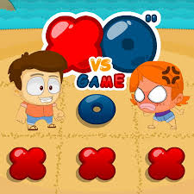](https://user-images.githubusercontent.com/94165479/143162229-84051f06-54ce-4d73-9319-eb044870be30.png)

**VIDEOS:**

<https://www.youtube.com/watch?v=USEjXNCTvcc>

https://youtu.be/5SdW0_wTX5c