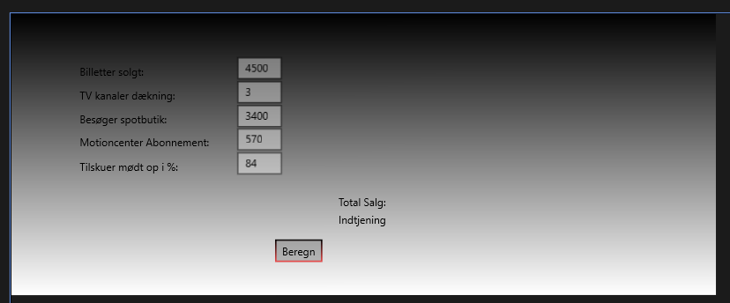

using System;

using System.Collections.Generic;

using System.Globalization;

using System.IO;

using System.Linq;

using System.Runtime.InteropServices.WindowsRuntime;

using Windows.Foundation;

using Windows.Foundation.Collections;

using Windows.UI.Xaml;

using Windows.UI.Xaml.Controls;

using Windows.UI.Xaml.Controls.Primitives;

using Windows.UI.Xaml.Data;

using Windows.UI.Xaml.Input;

using Windows.UI.Xaml.Media;

using Windows.UI.Xaml.Navigation;

// The Blank Page item template is documented at https://go.microsoft.com/fwlink/?LinkId=402352&clcid=0x409

namespace assignmentOne

{

/// <summary>

/// An empty page that can be used on its own or navigated to within a Frame.

/// </summary>

public sealed partial class MainPage : Page

{

const double SALG_FRA_BUTIK_BESOEG_PCT = 0.2;

const double BILLET_PRIS_GENNEMSNIT = 175.00;

const double SALG_DRIKKEVARE_GENNEMSNIT = 70.00;

const double SALG_SPORTS_VARE_GENNEMSNIT = 245.00;

const double ABONNEMENT_PRIS_6_MAANEDER = 999.00;

const double TV_RETTIGHEDER_PR_KANAL = 1000000.00;

const double TOTAL_OMK_I_PCT = 0.64;

public MainPage()

{

this.InitializeComponent();

}

private void Beregn_Click(object sender, RoutedEventArgs e)

{

Boolean formIsValid = true;

if (billetterSolgt.Text == "")

{

Warning1.Text = "Error in input - need value";

formIsValid = false;

}

if (TVkanaler.Text == "")

{

Warning2.Text = "Error in input - need value";

formIsValid = false;

}

if (VisitorToStore.Text == "")

{

Warning3.Text = "Error in input - need value";

formIsValid = false;

}

if (MotionscenterAbonnement.Text == "")

{

Warning4.Text = "Error in input - need value";

formIsValid = false;

}

if (Tilskuer.Text == "")

{

Warning5.Text = "Error in input - need value";

formIsValid = false;

}

if (formIsValid)

{

Warning1.Text = "";

Warning2.Text = "";

Warning3.Text = "";

Warning4.Text = "";

Warning5.Text = "";

Boolean calcOK = true;

if (Convert.ToDouble(billetterSolgt.Text) < 0)

{

Warning1.Text = "Error in input - need value above or equal to zero";

calcOK = false;

}

if (Convert.ToDouble(TVkanaler.Text) < 0)

{

Warning2.Text = "Error in input - need value above or equal to zero";

calcOK = false;

}

if (Convert.ToDouble(VisitorToStore.Text) < 0)

{

Warning3.Text = "Error in input - need value above or equal to zero";

calcOK = false;

}

if (Convert.ToDouble(MotionscenterAbonnement.Text) < 0)

{

Warning4.Text = "Error in input - need value above or equal to zero";

calcOK= false;

}

if (Convert.ToDouble(Tilskuer.Text) < 0)

{

Warning5.Text = "Error in input - need value above or equal to zero";

calcOK = false;

}

if (calcOK)

{

Warning1.Text = "";

Warning2.Text = "";

Warning3.Text = "";

Warning4.Text = "";

Warning5.Text = "";

double ticketsSold = Convert.ToDouble(billetterSolgt.Text);

double tVKanaler = Convert.ToDouble(TVkanaler.Text);

double visitorsToStore = Convert.ToDouble(VisitorToStore.Text);

double motionsCenter = Convert.ToDouble(MotionscenterAbonnement.Text);

double visitorPercentage = Convert.ToDouble(Tilskuer.Text);

double totalSale;

double revenue;

double saleFromDrinks = ticketsSold * visitorPercentage * SALG_DRIKKEVARE_GENNEMSNIT;

double saleFromTV = tVKanaler * TV_RETTIGHEDER_PR_KANAL;

double salesFromTickets = ticketsSold * BILLET_PRIS_GENNEMSNIT;

double salesFromStore = visitorsToStore * SALG_FRA_BUTIK_BESOEG_PCT * SALG_SPORTS_VARE_GENNEMSNIT;

double salesFromAbonnement = motionsCenter * ABONNEMENT_PRIS_6_MAANEDER;

totalSale = salesFromTickets + saleFromDrinks + saleFromTV + salesFromStore + salesFromAbonnement;

revenue = totalSale * TOTAL_OMK_I_PCT;

TotalSalgResult.Text = string.Format("{0:N2}", totalSale);

IndtjeningResult.Text = string.Format("{0:N2}", revenue);

}

}

}

}

}