Epic 1:
We created azure account using school email:
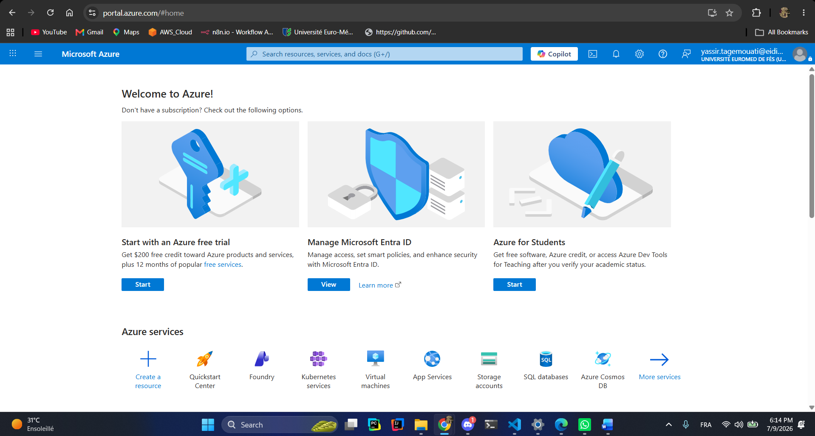
Architecture:
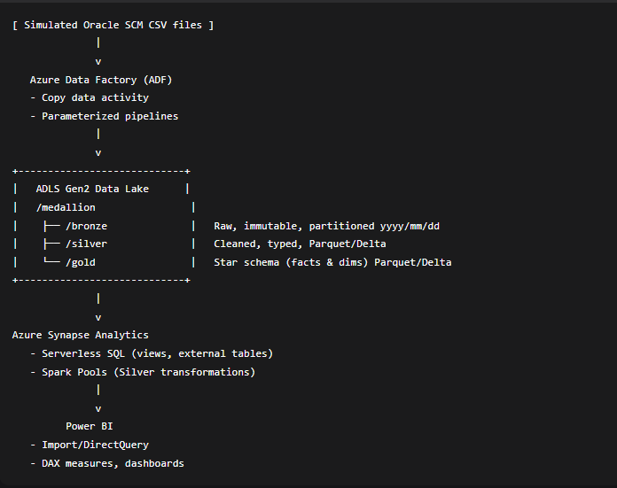
Create the Storage Account
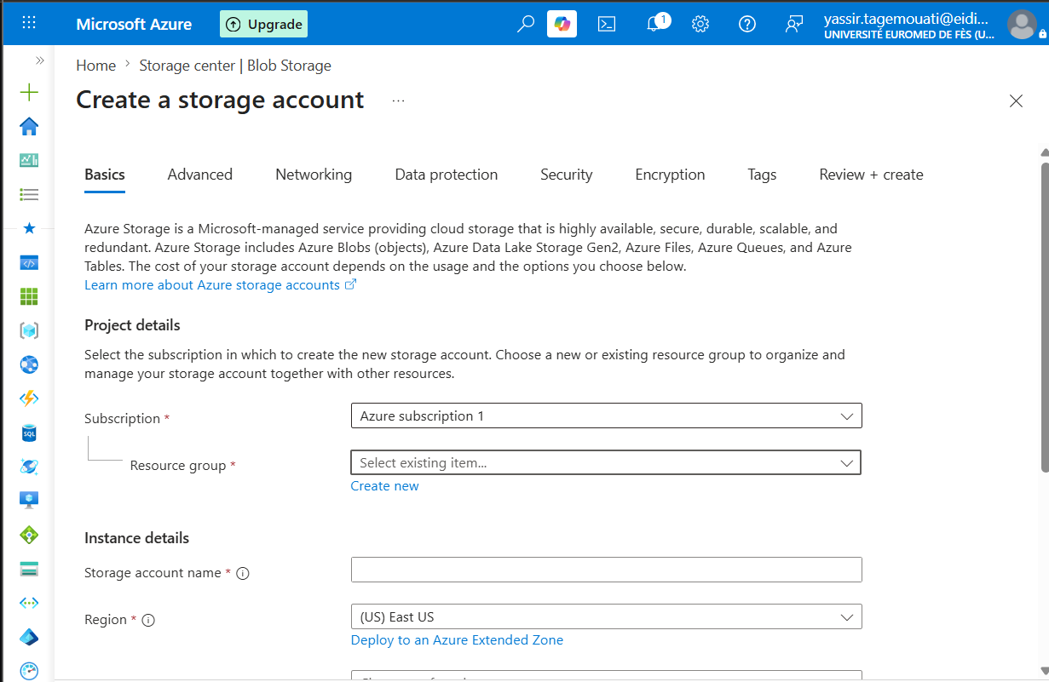
But first we need to create a resource group!!
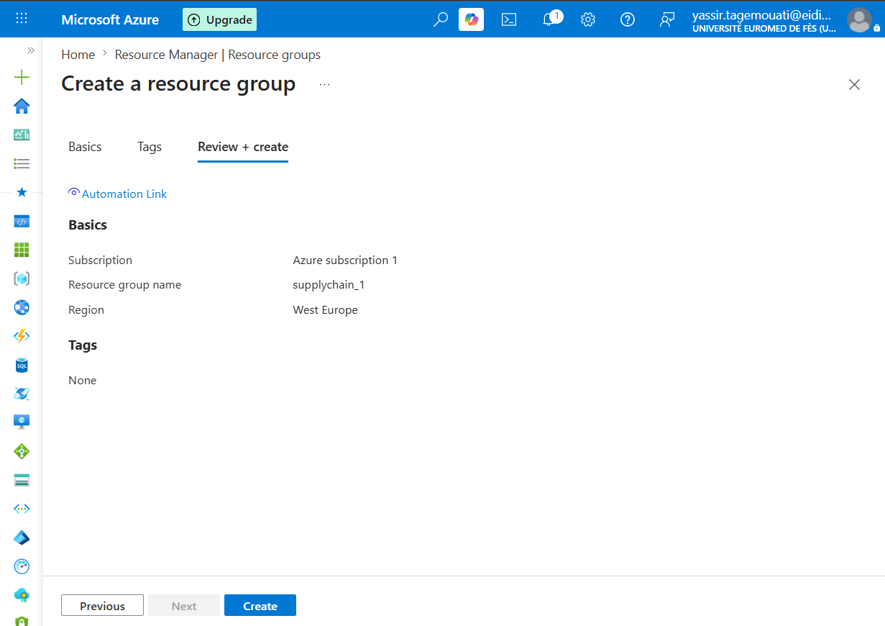
Storage account with this config:

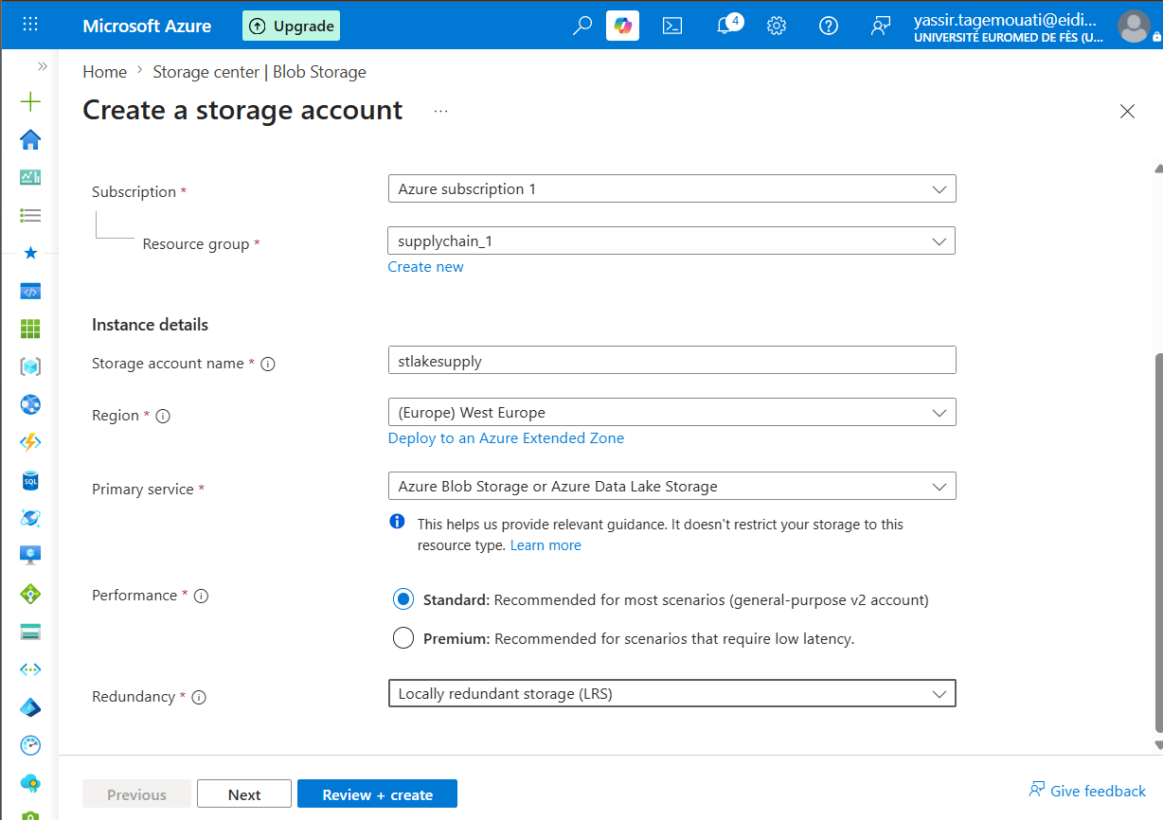

Enable hierarchical namespace
This transforms your storage account into a true ADLS Gen2 Data Lake, capable of folder structures and analytics workloads.
Access tire is set to cool because the bronze data will not be visited that much and to lower the cost.
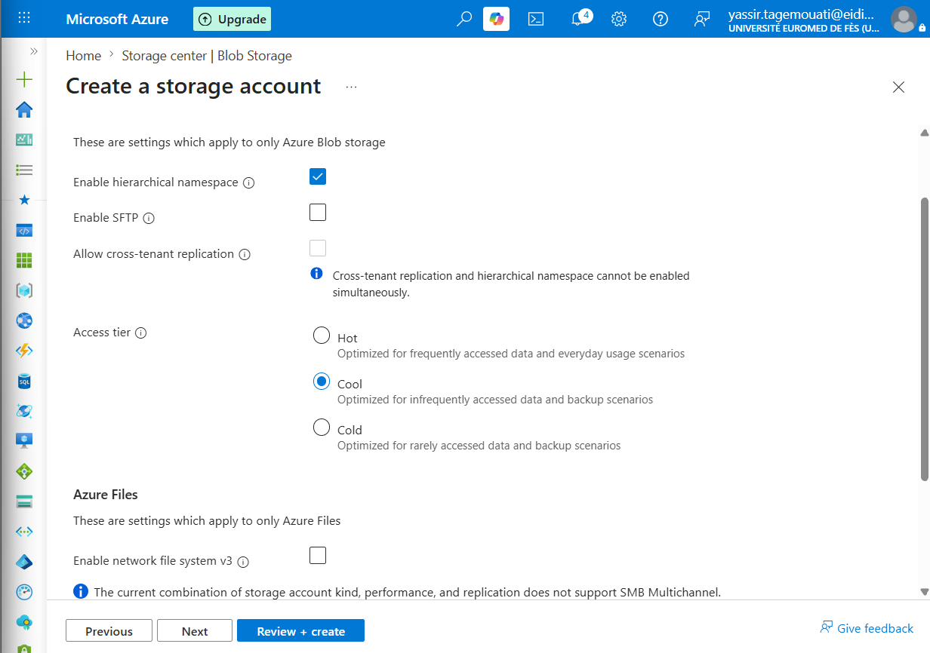
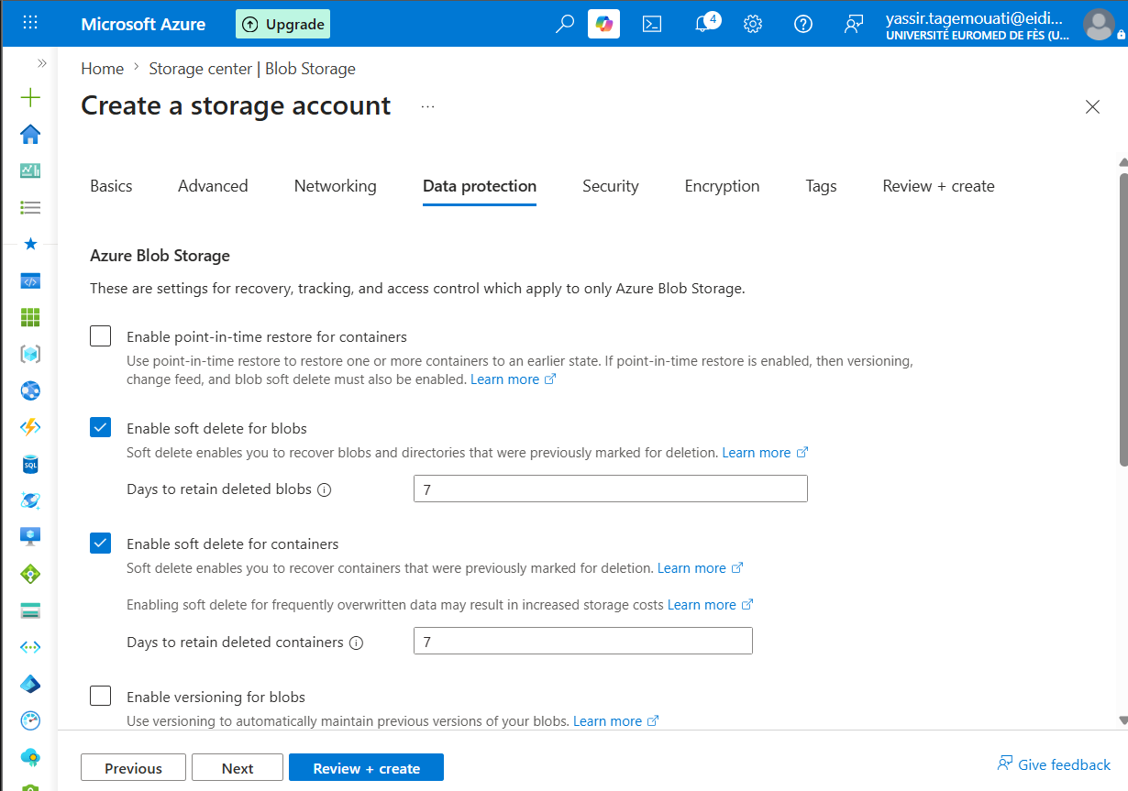
I will try to take of all those features of recovery and deletion because my data is not important for now and the budget does not allow it so they are important but out of my budget I need to keep the project at low cost so I can learn with no problem.
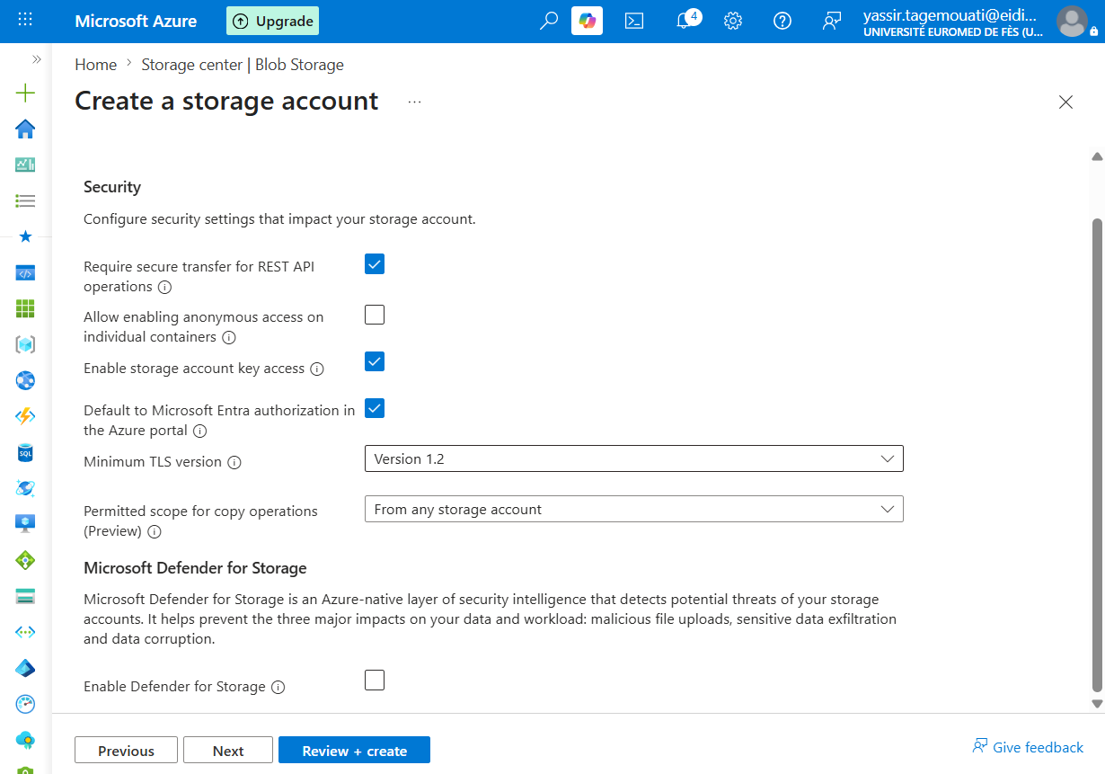
The defender for storage is good but out of budget!!
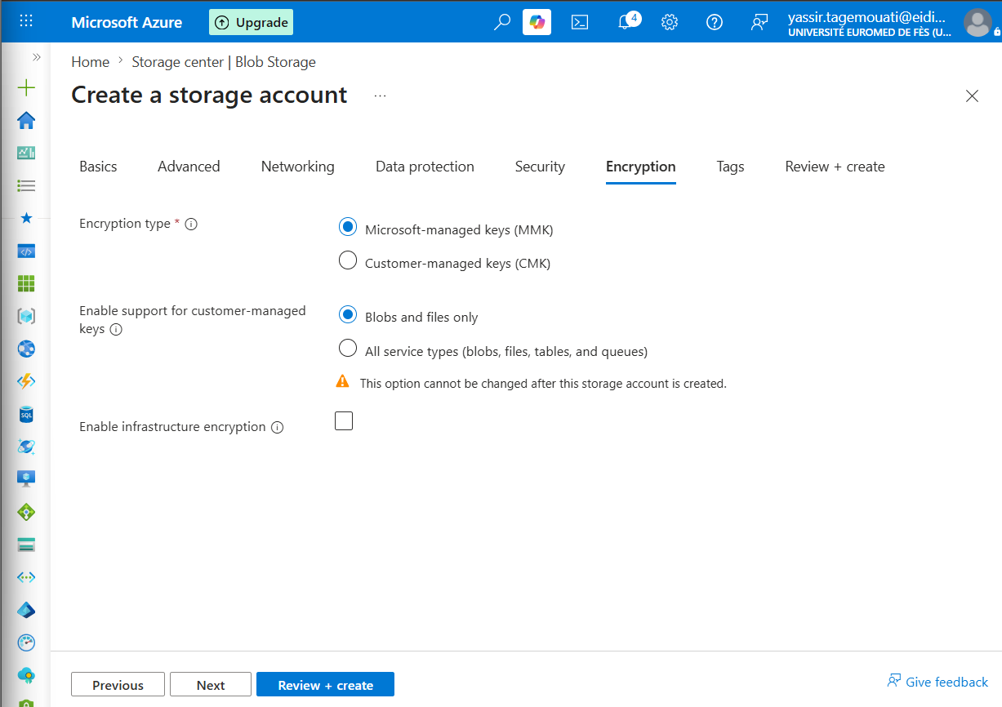
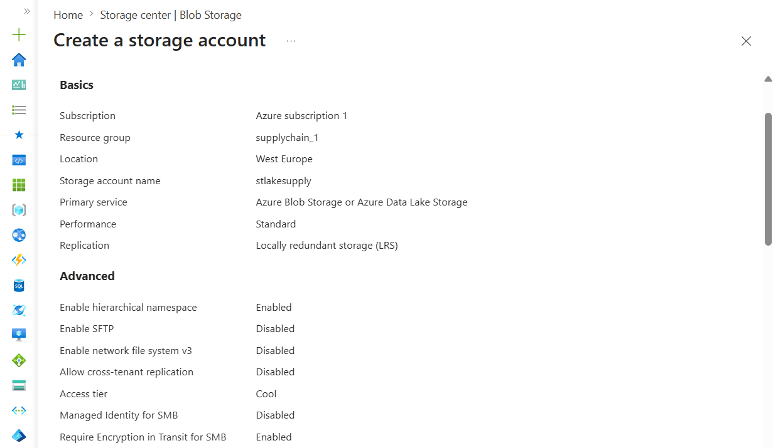
This is the final config!!
Create the Medallion Container & Folders
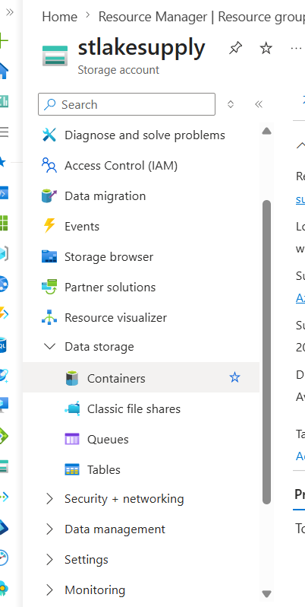
Go to data storage and containers!!
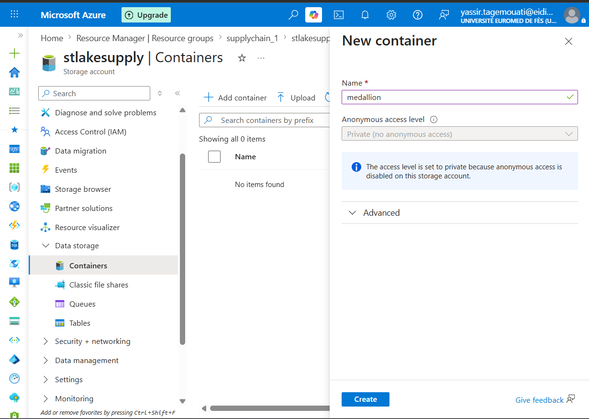
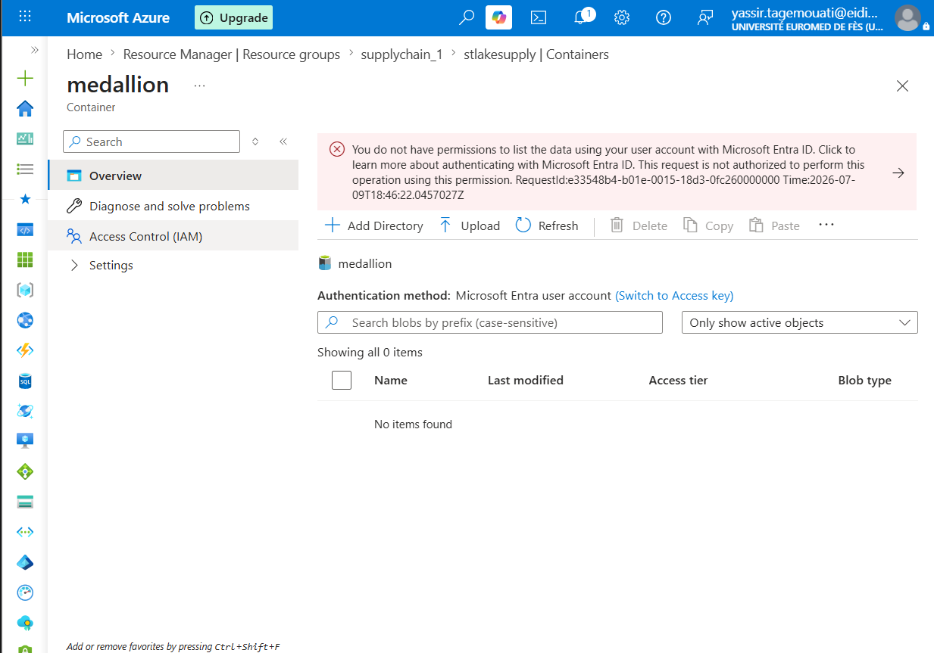this problem appears and to fix all you need is to add a role to the member Add role!!!
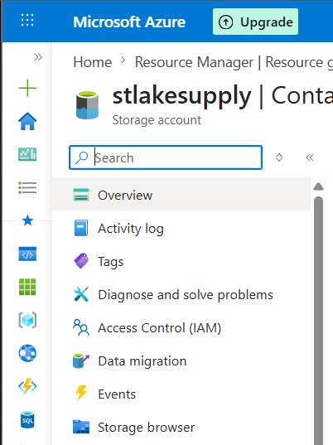
Click on the IAM
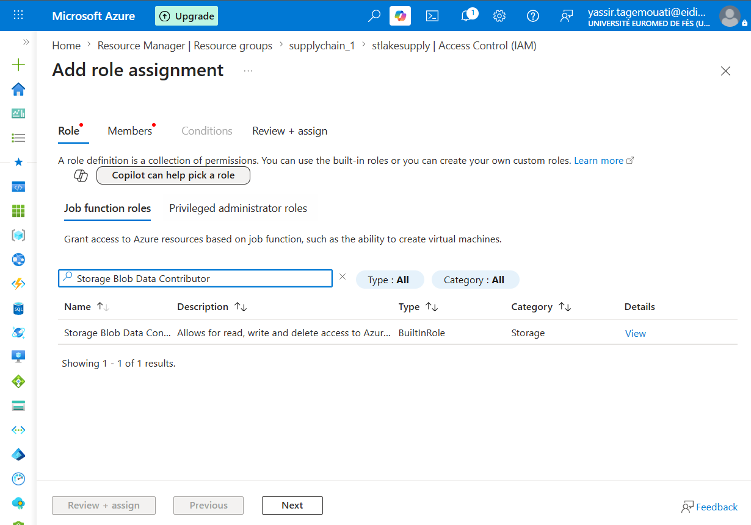
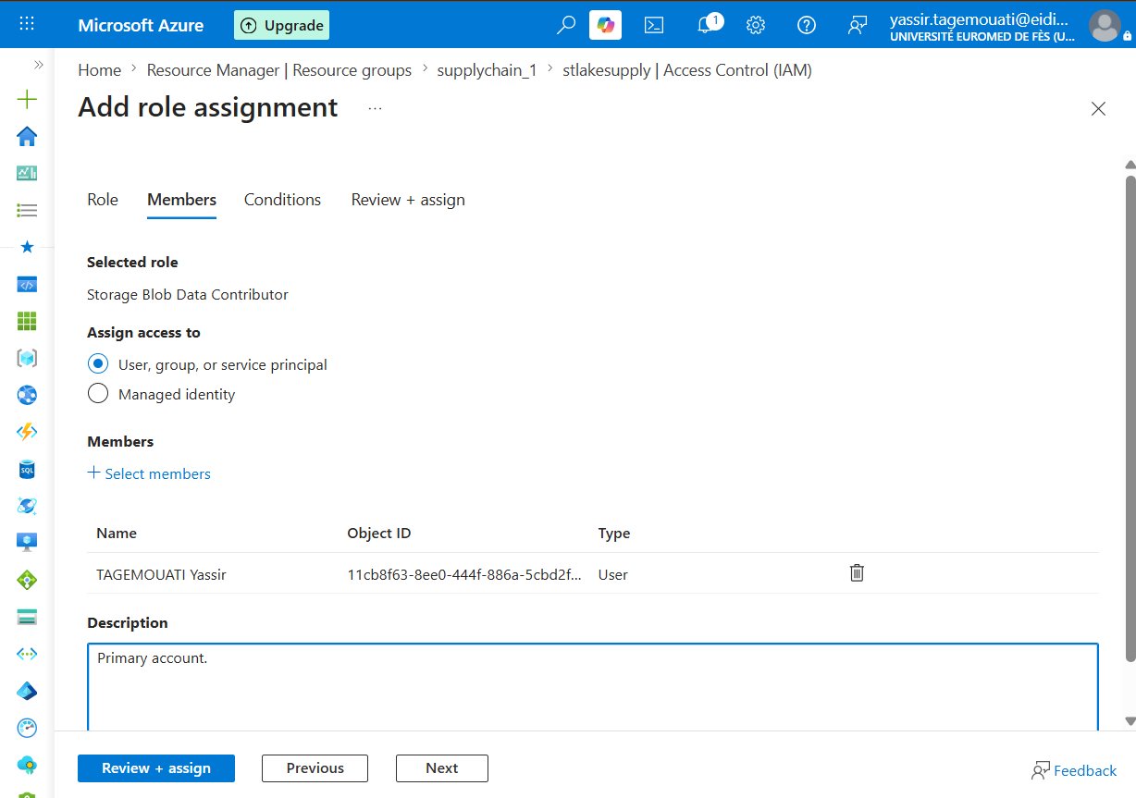
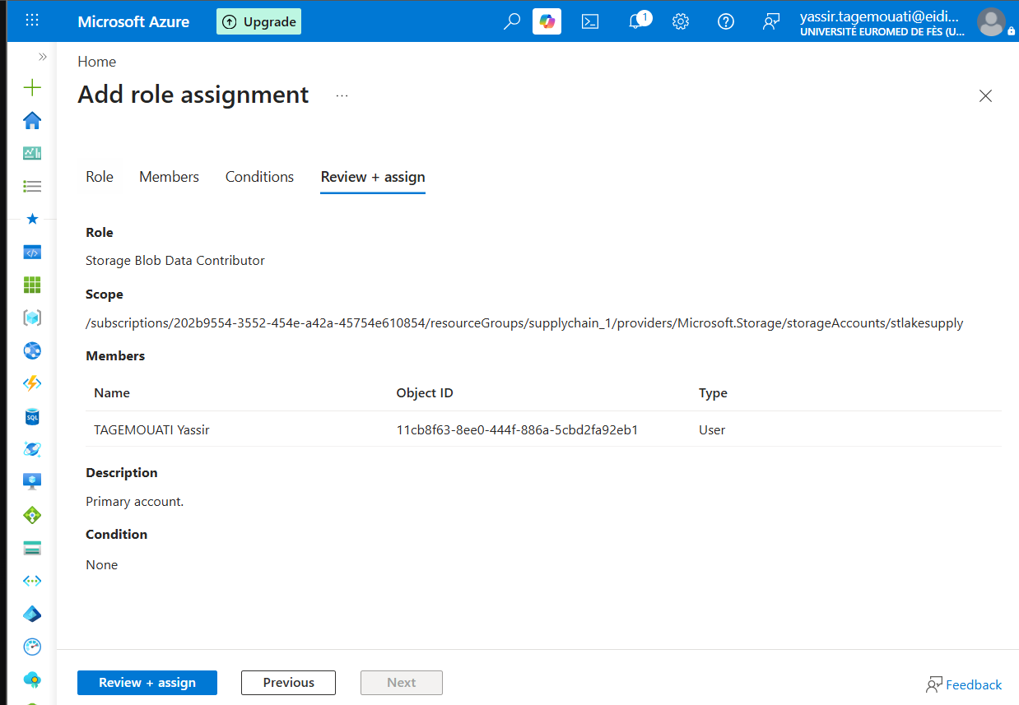
Medallion Folders
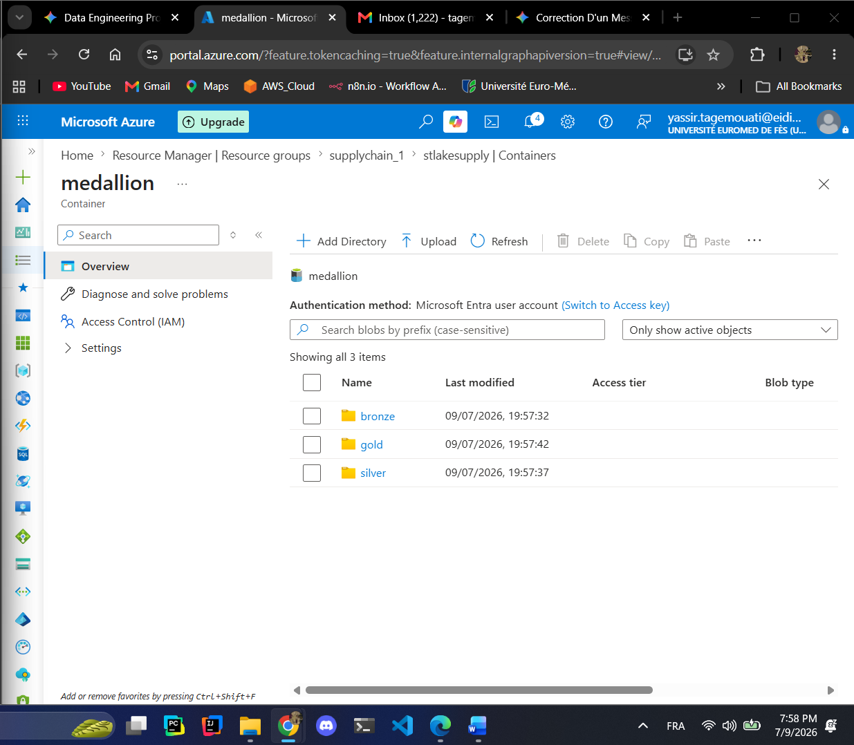
Provision Azure Data Factory (ADF)
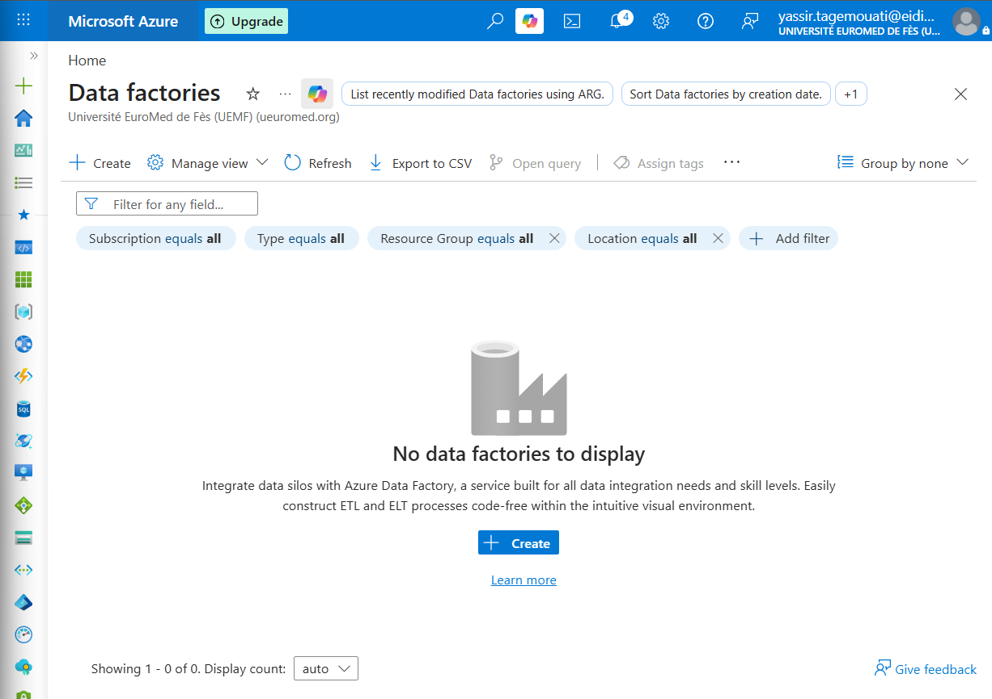
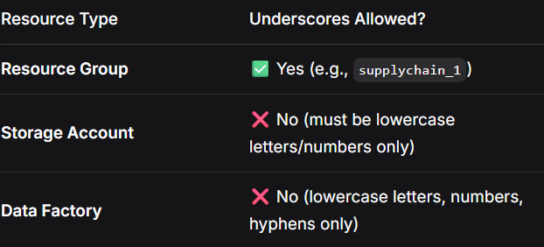
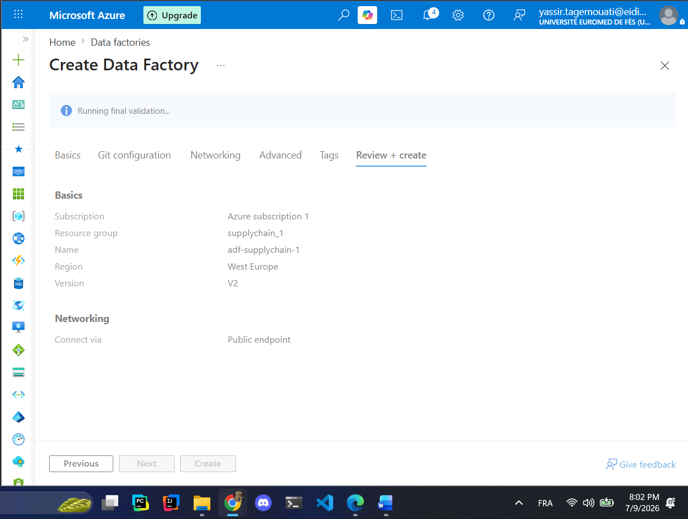
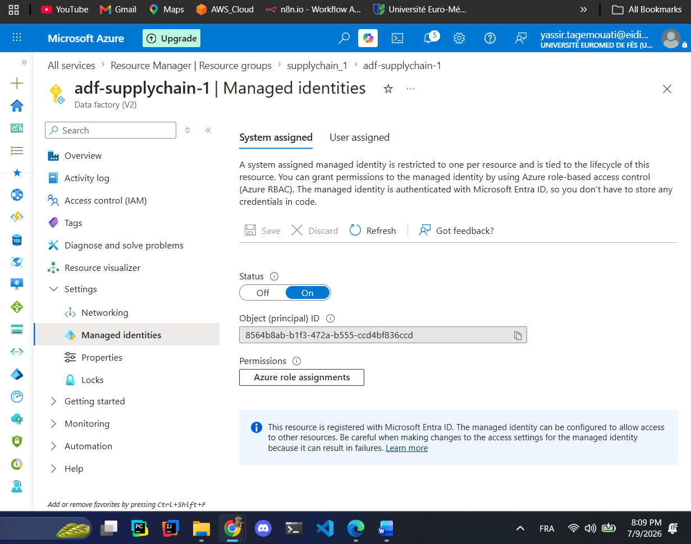
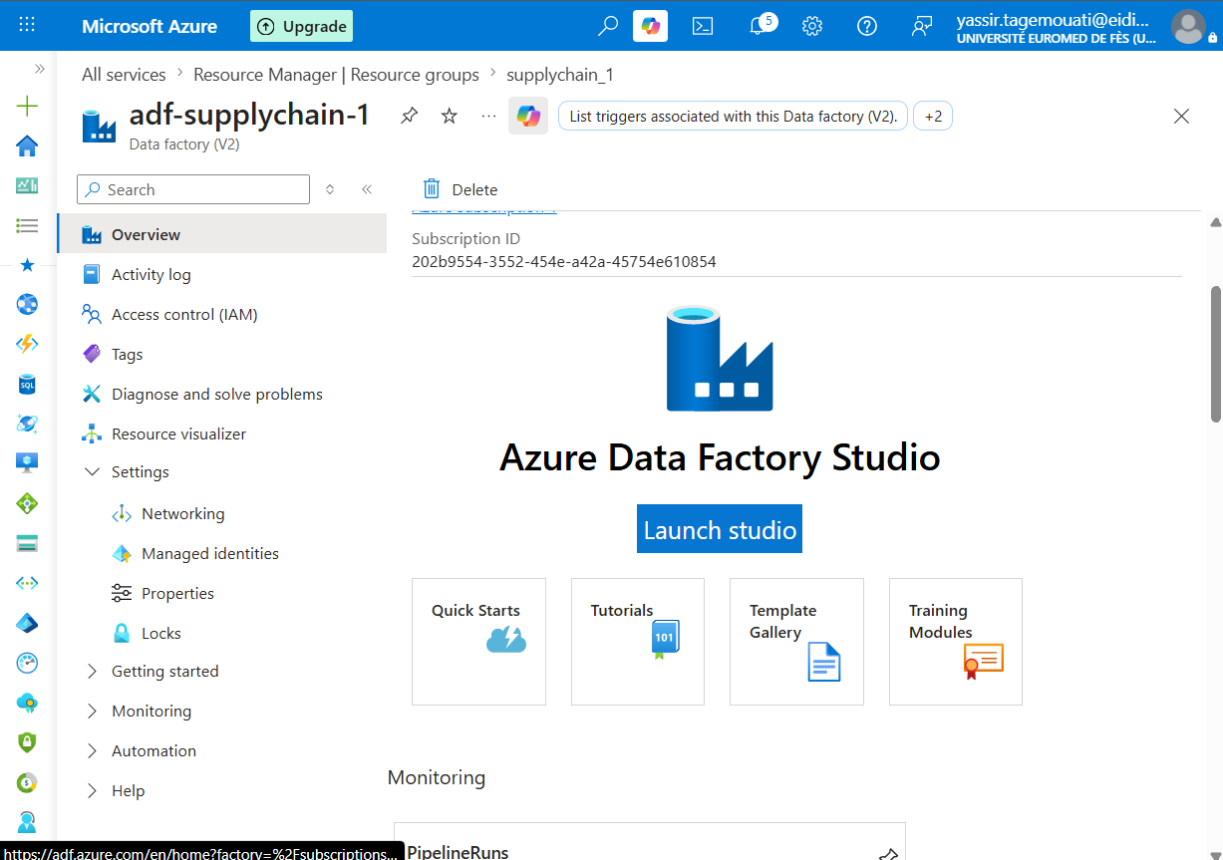
Click on launch studio so you get to the studio!!
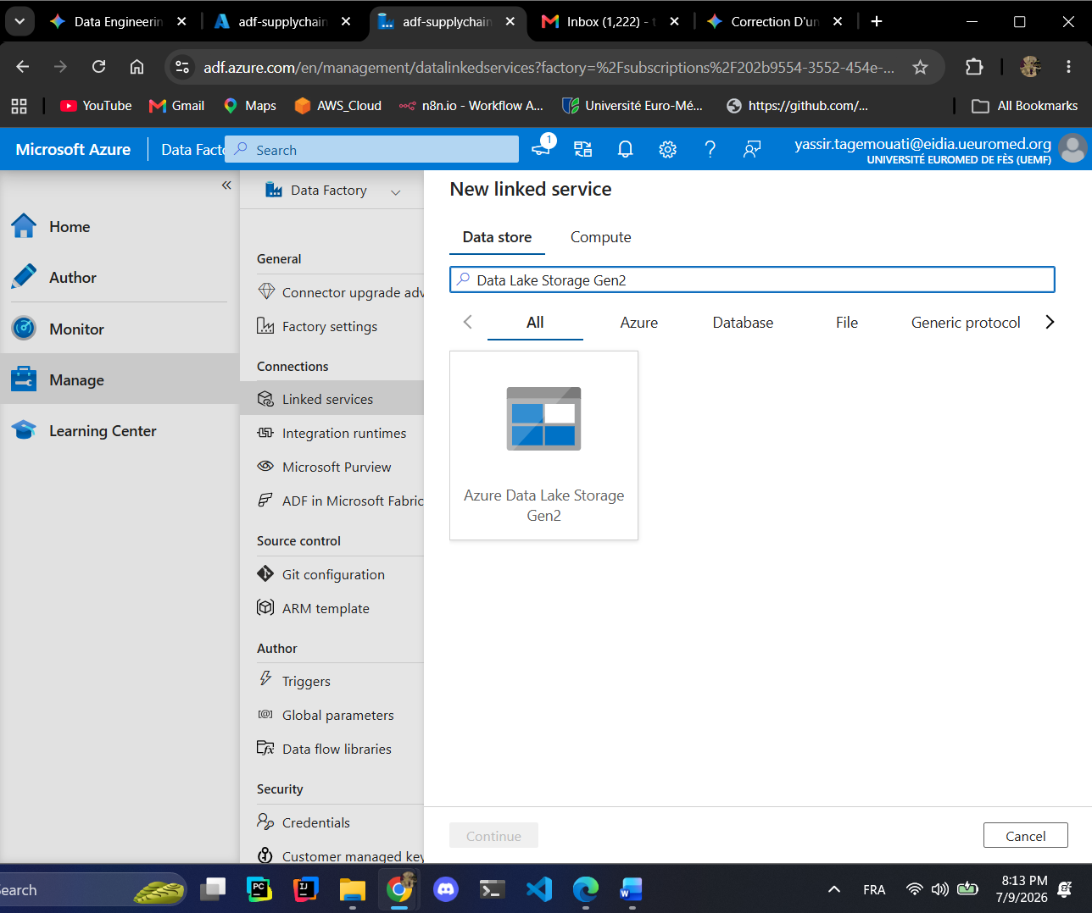
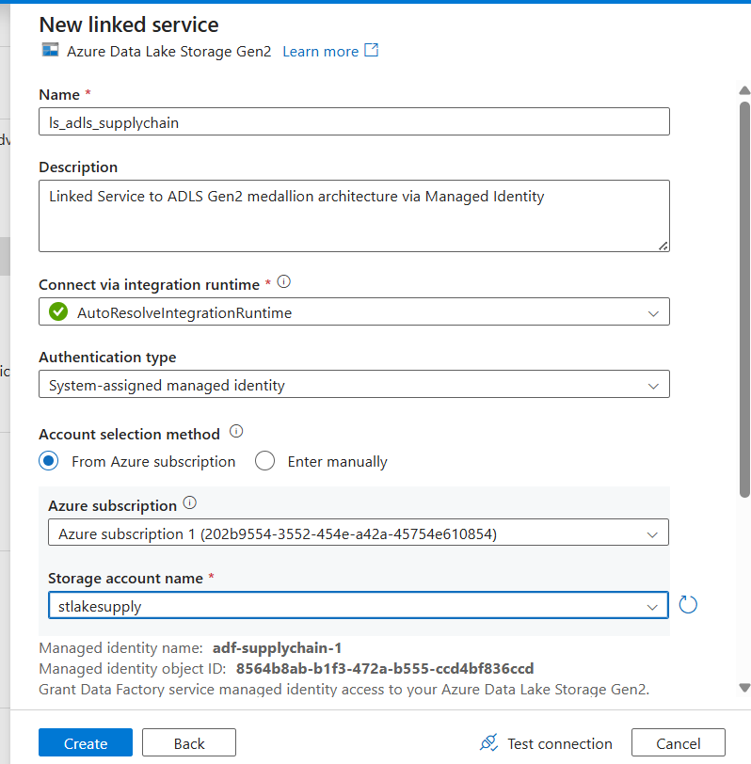
Creating key vault!!
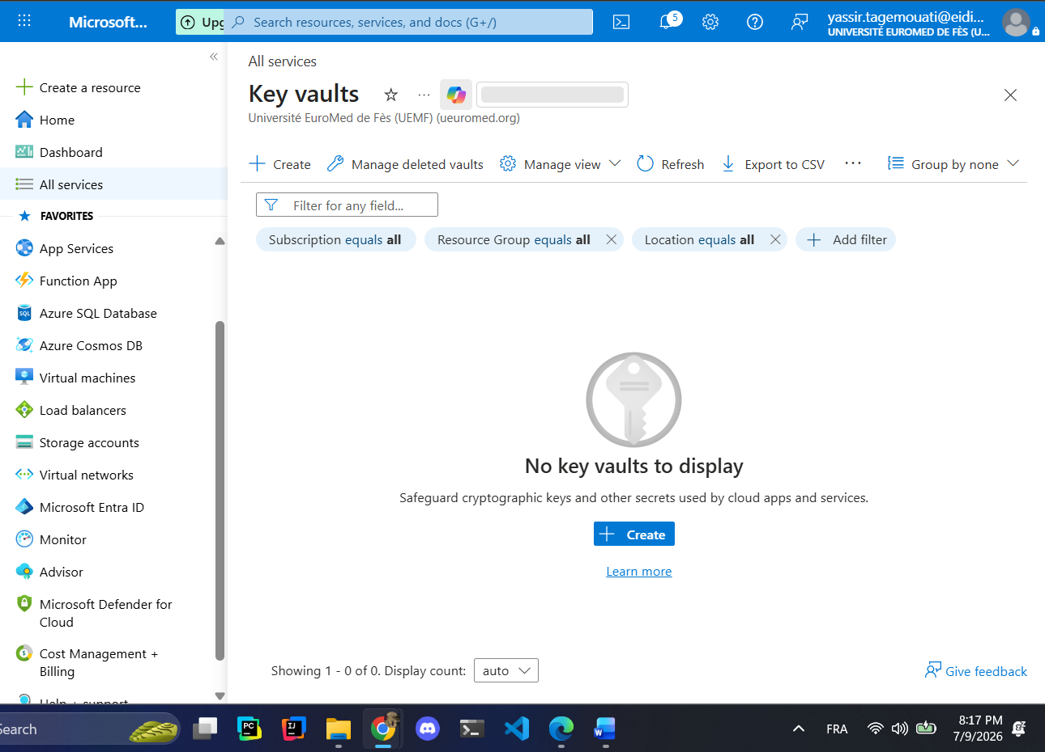
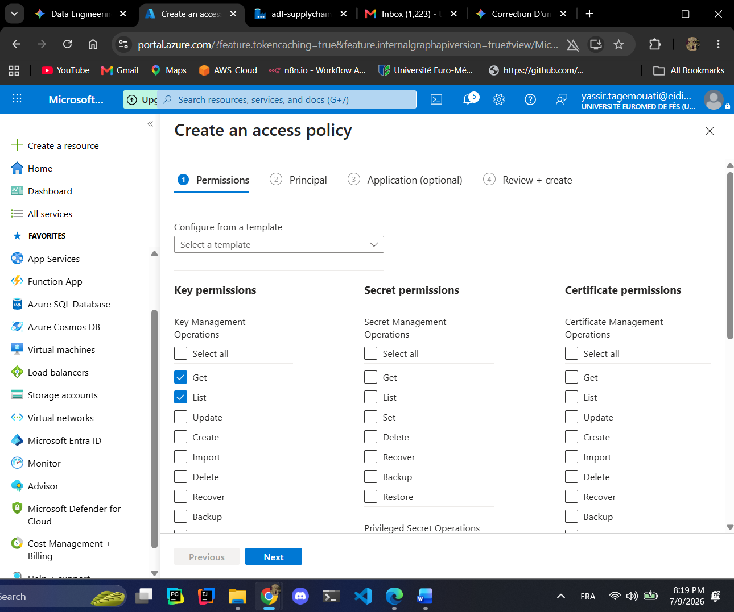
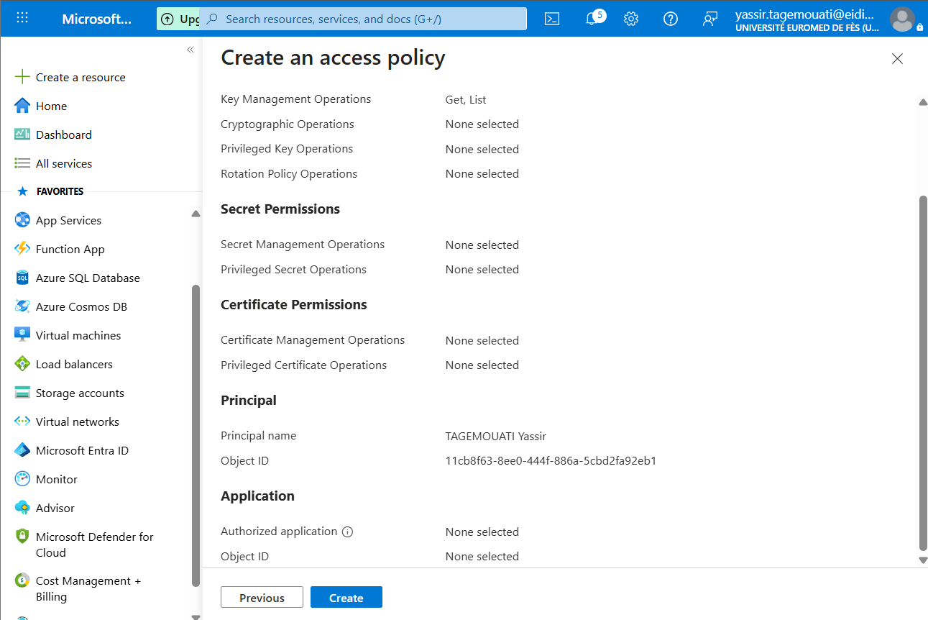
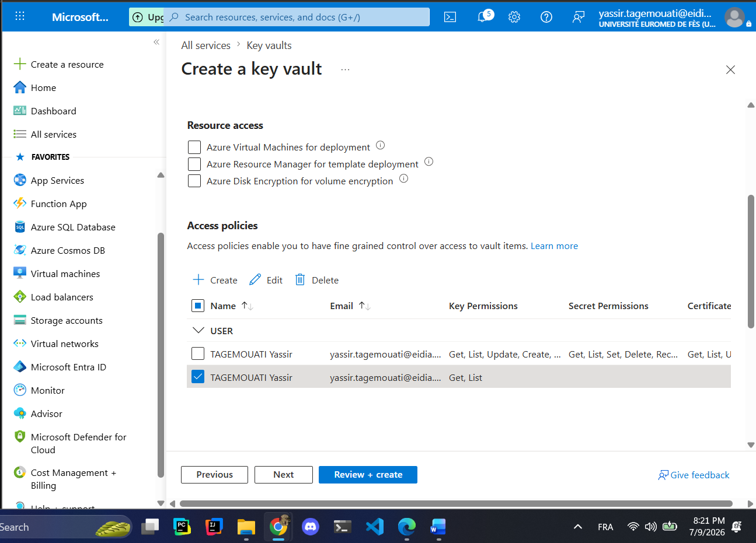
We limited the user to get and list if we want to change it we could create a new key for that!!!

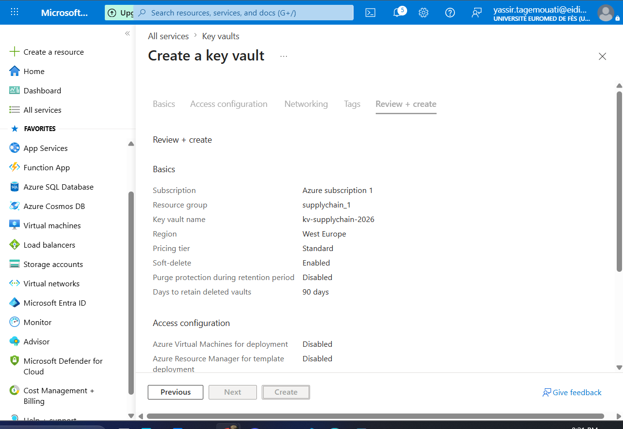
Linked service for the key

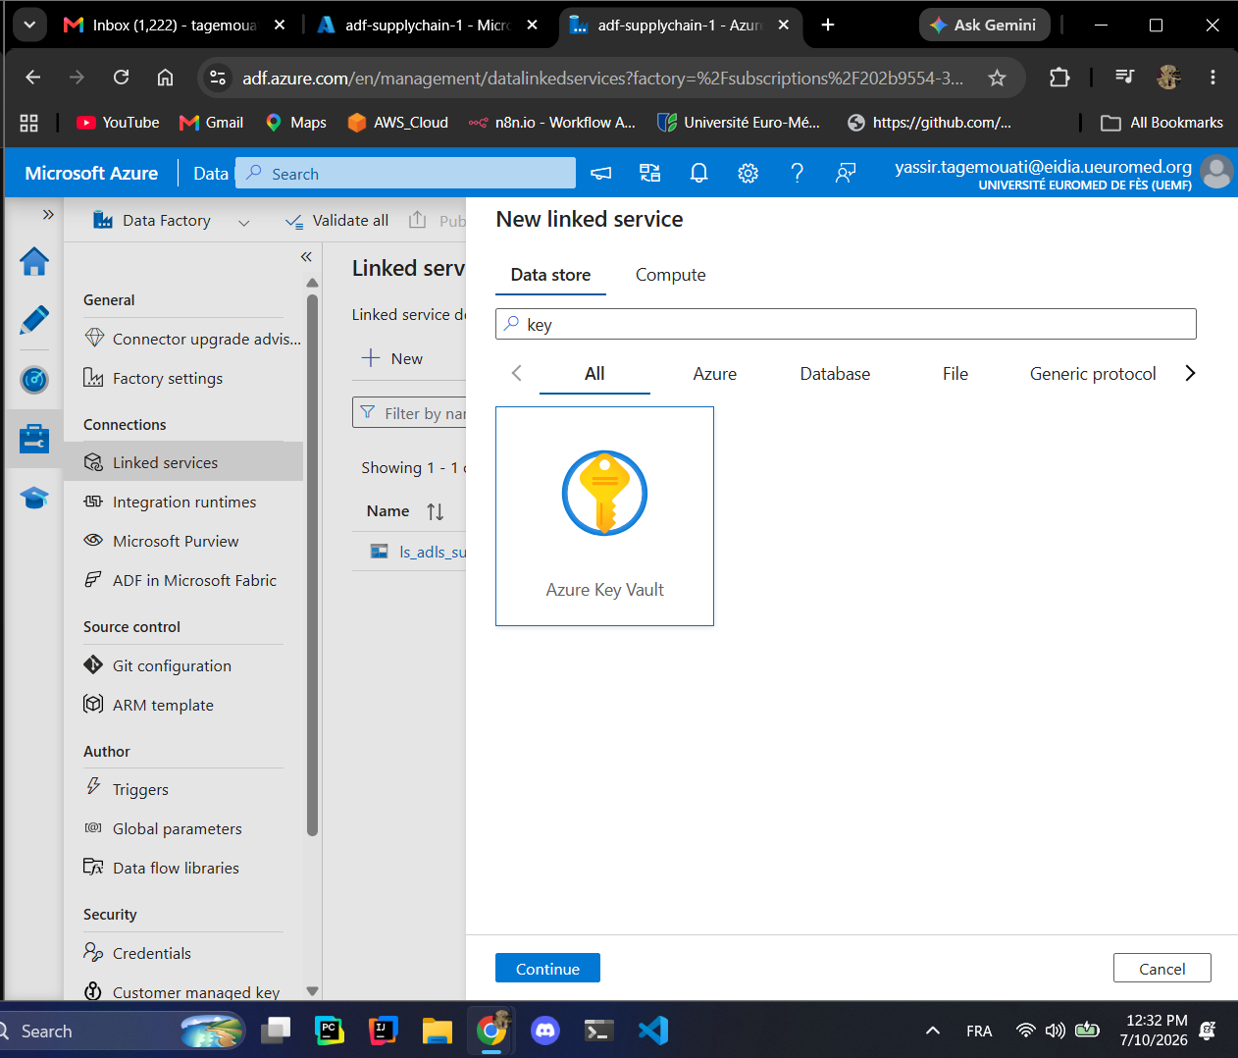
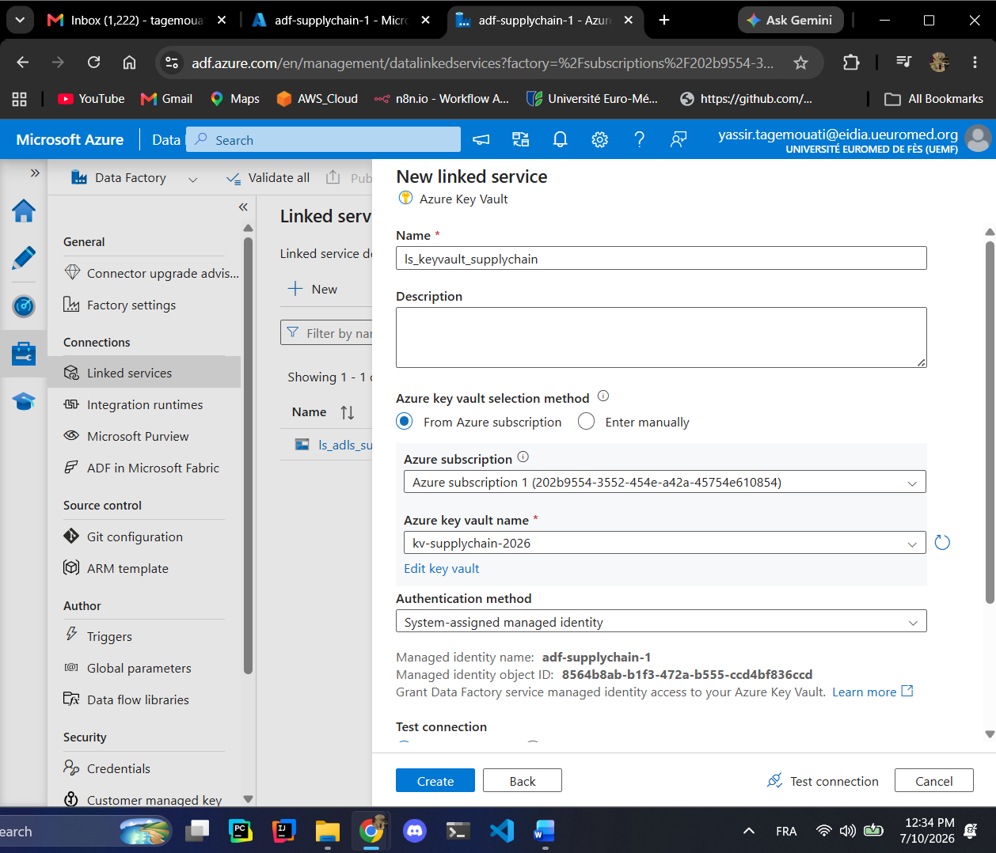
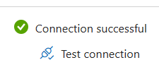
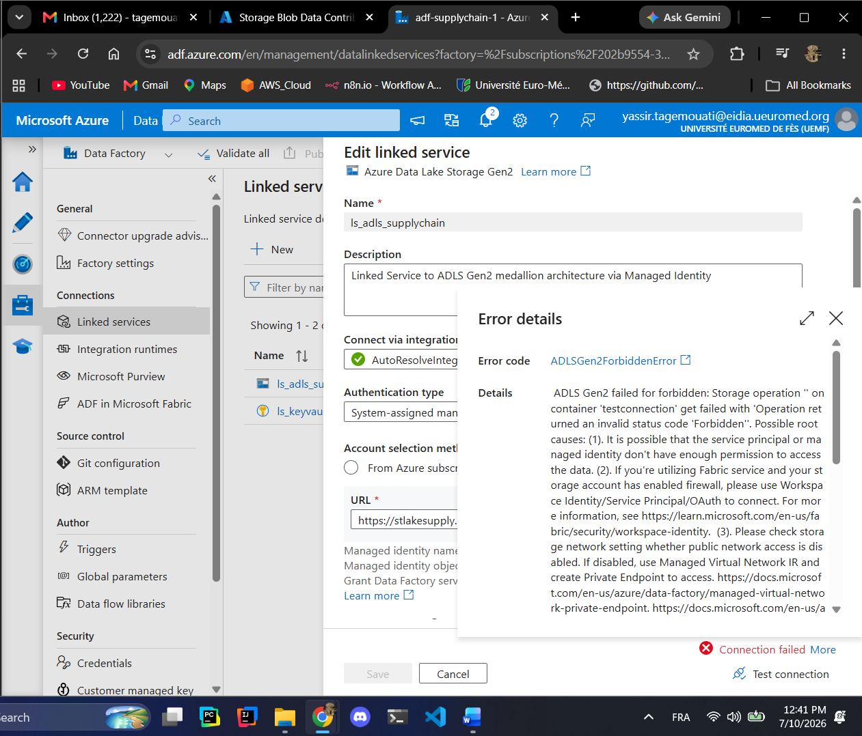
This error was made because I assigned the Storage Blob Data Contributor
To wrong instance I should assign it to the adf-supplychain-1 not my account.
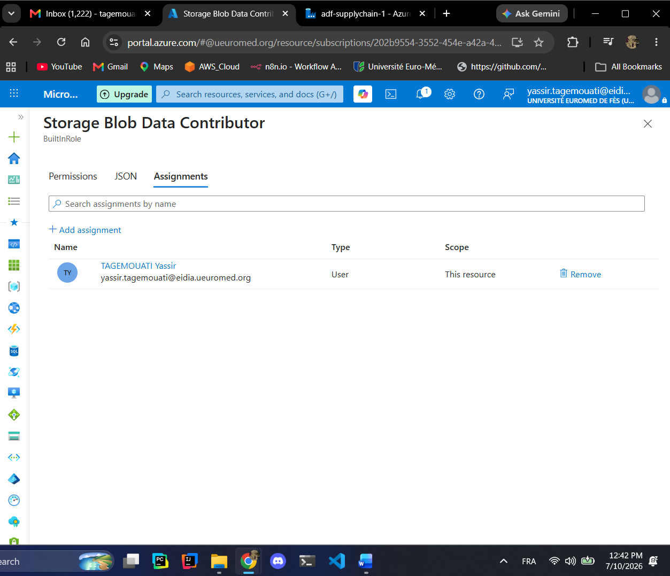
Fix
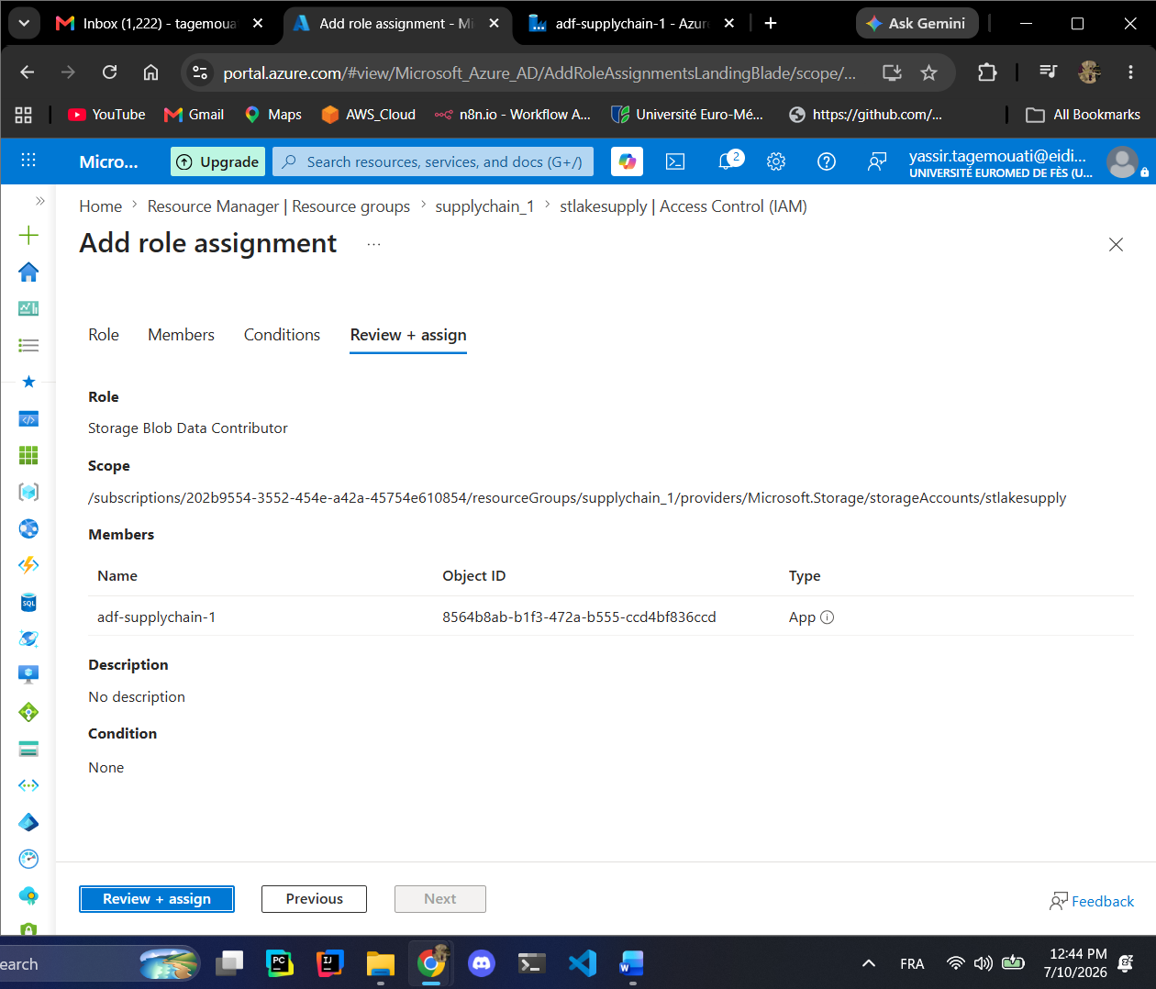
Now the connection is good!!
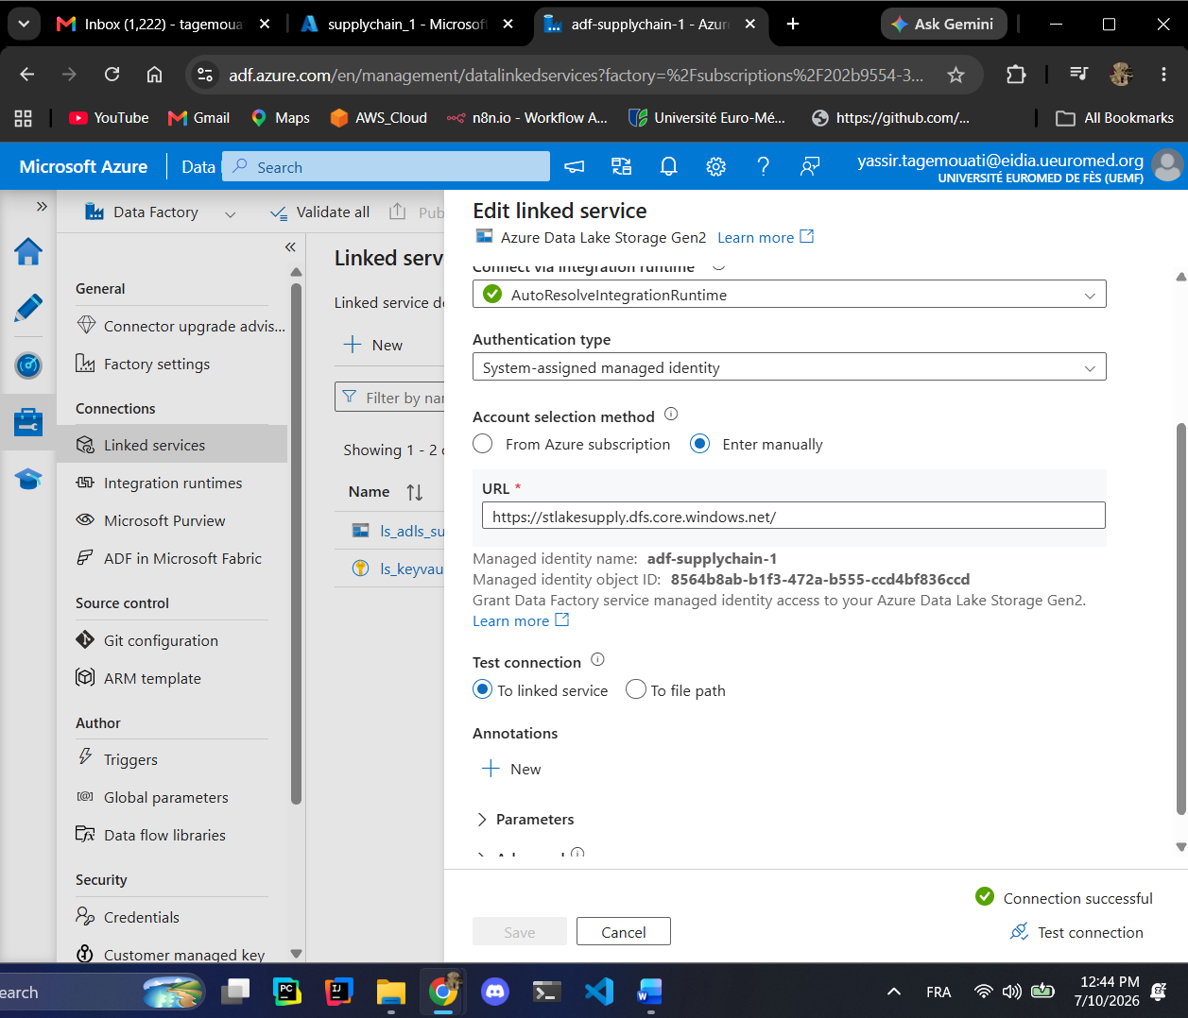
Provision Azure Synapse Analytics Workspace
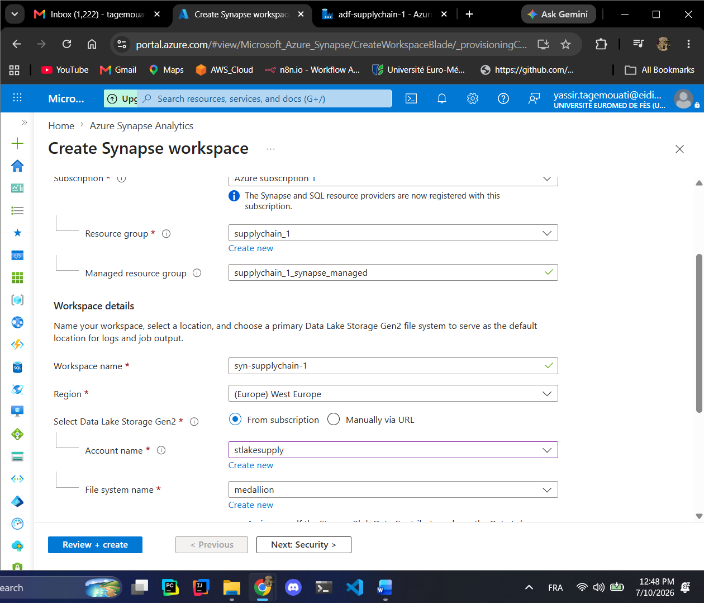
Downloaded the template for automation if needed in later!!
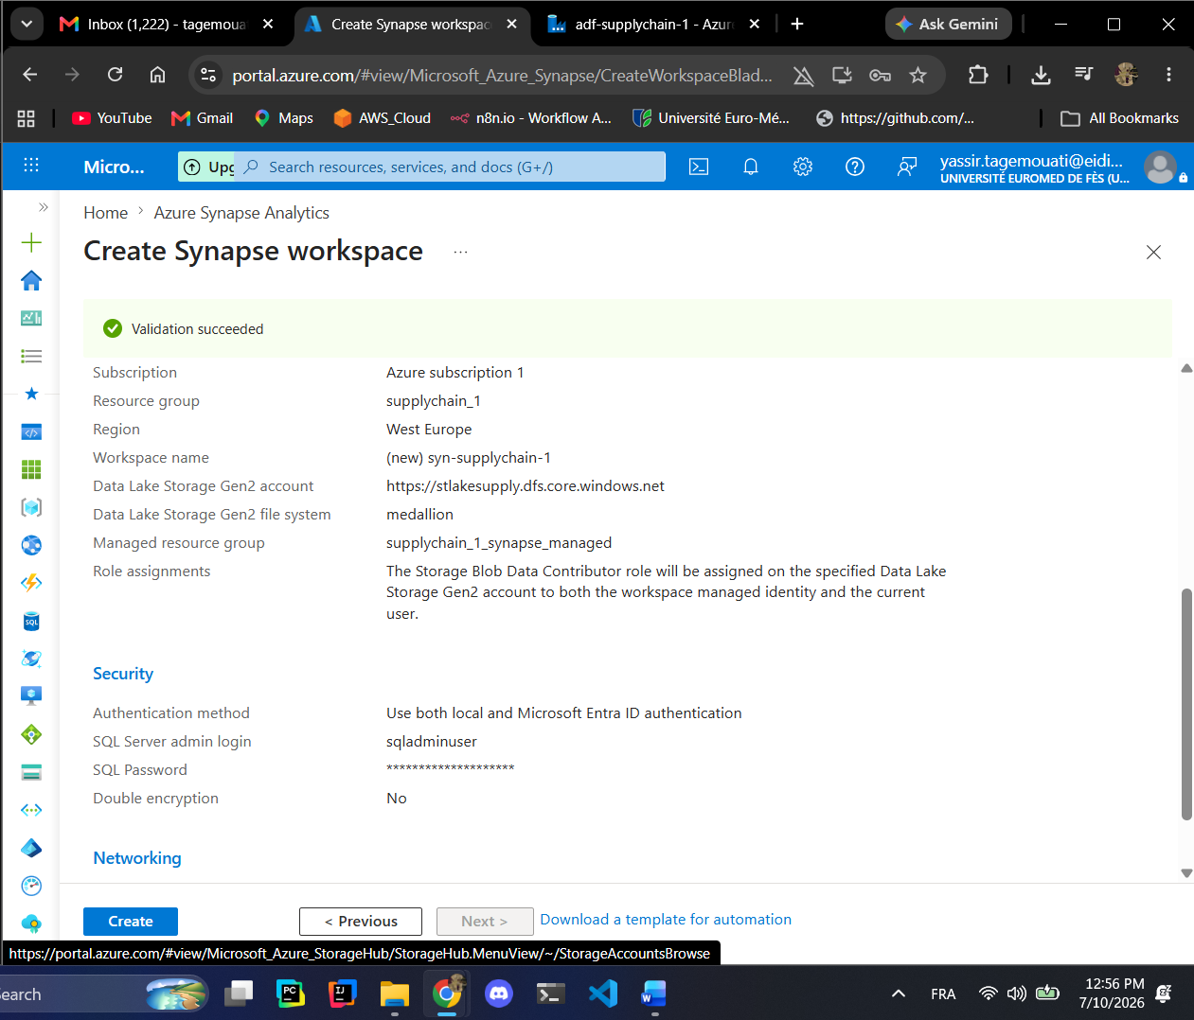
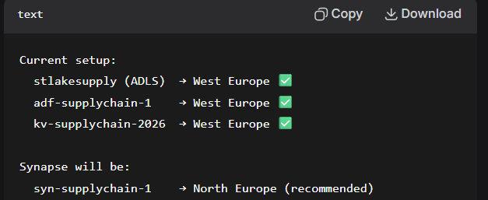
If you get this error
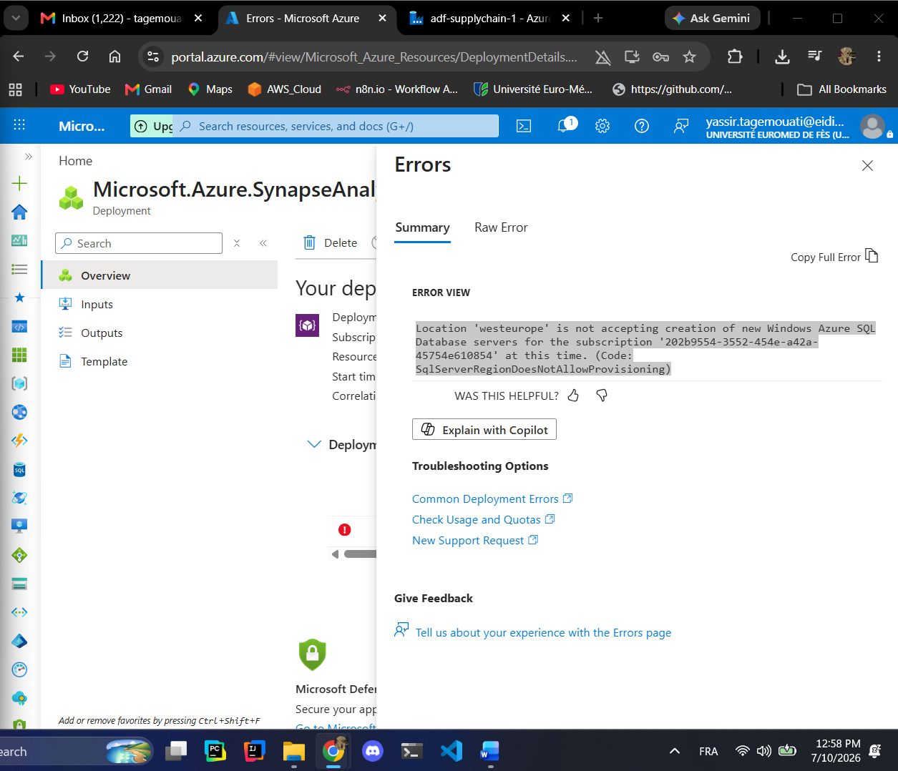
Try to change the server

Your form should now look like:
Field | Value
Subscription | Azure subscription 1
Resource group | supplychain_1
Managed resource group | supplychain_1_synapse_managed
Workspace name | syn-supplychain-1
Region | France Central
Data Lake Storage Gen2 | From subscription
Account name | stlakesupply
File system name | synapse

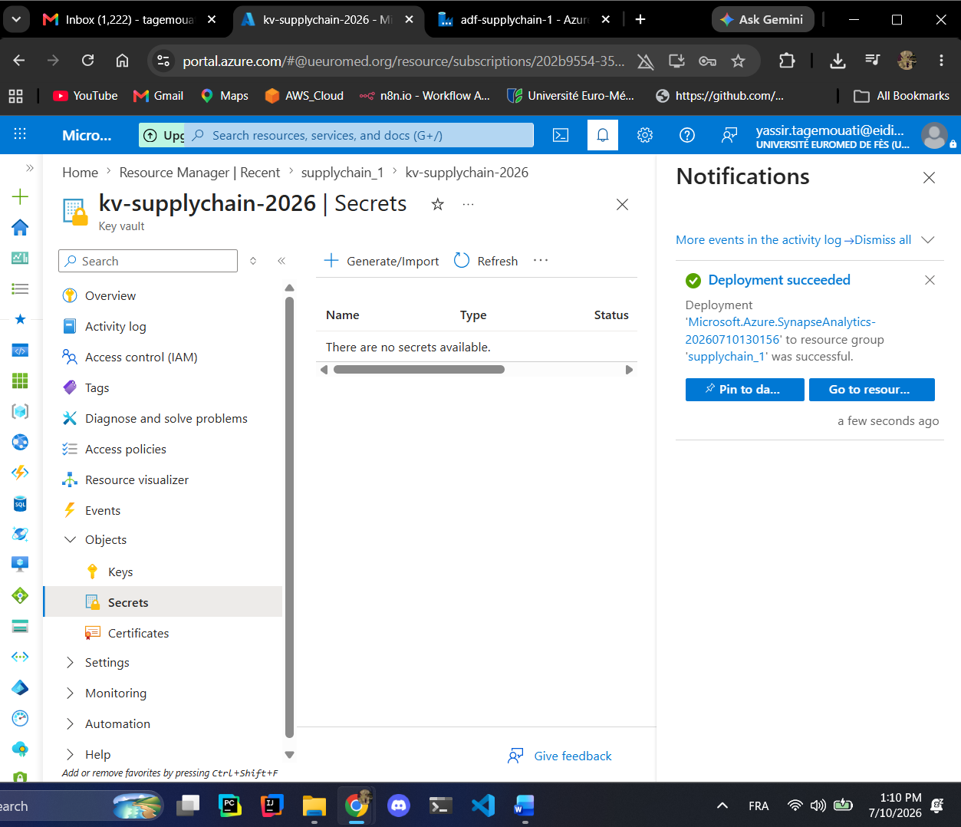
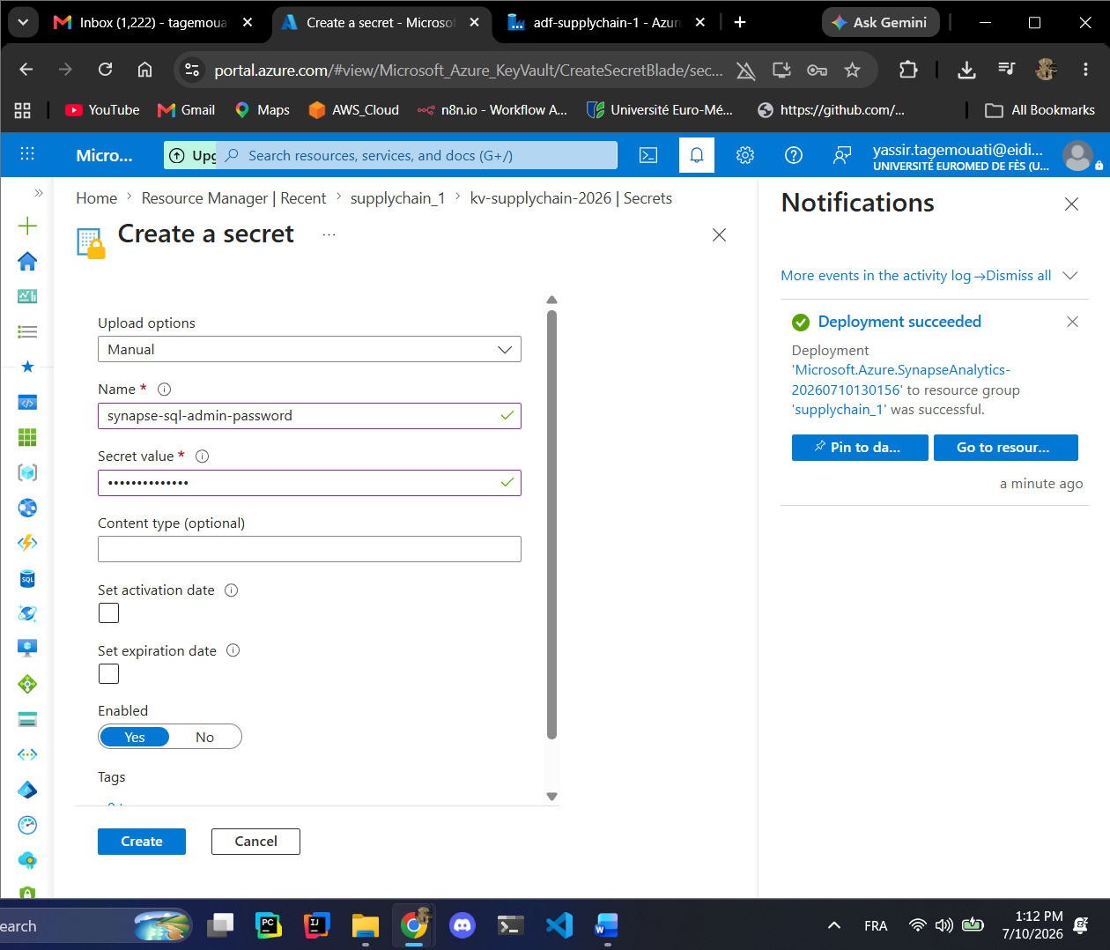
In the secret value you put the password you just created in the sql admin!!
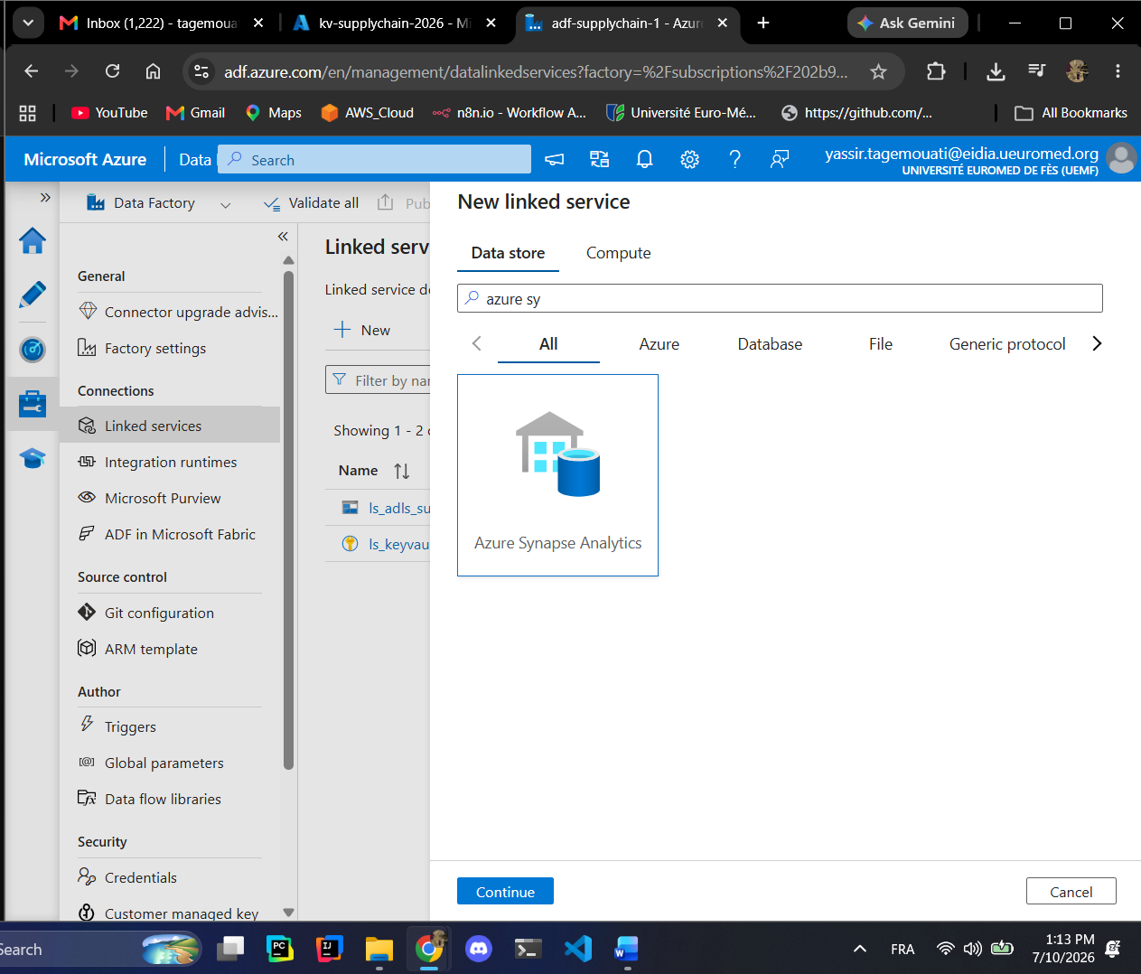
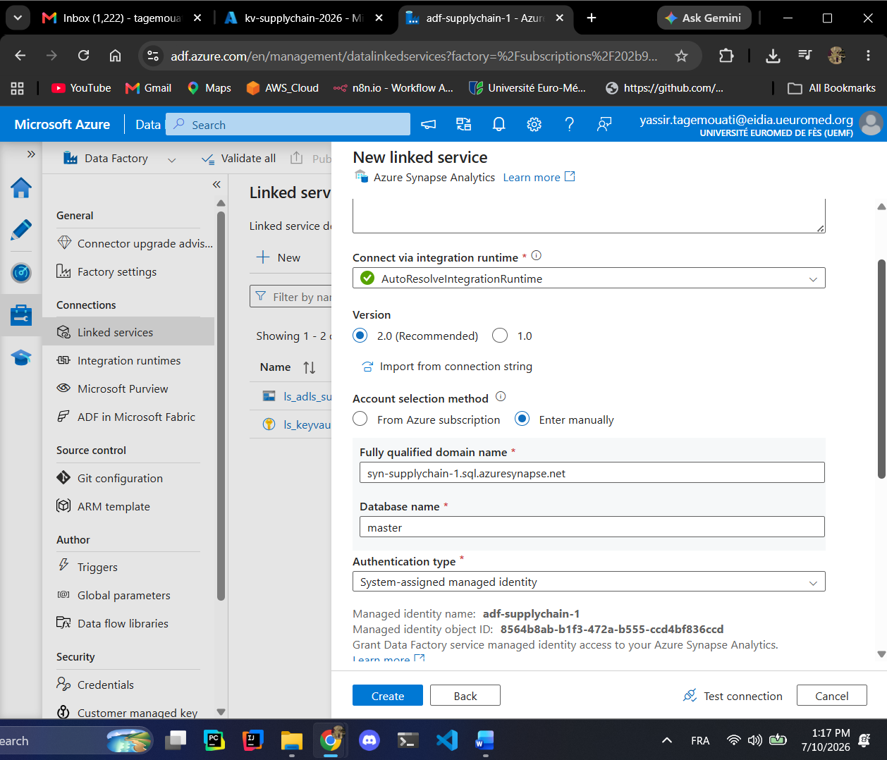
I chooses the manually so I can get the database name to modify because no database was detected!!!
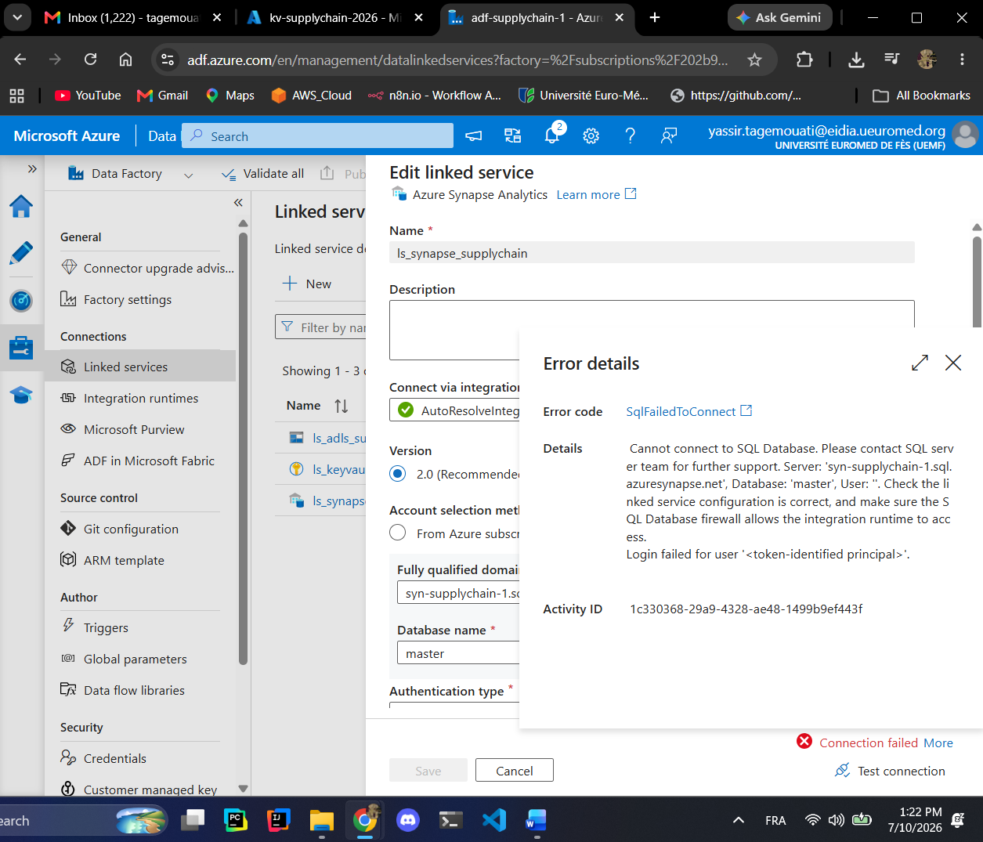
Grant Synapse Access to Storage
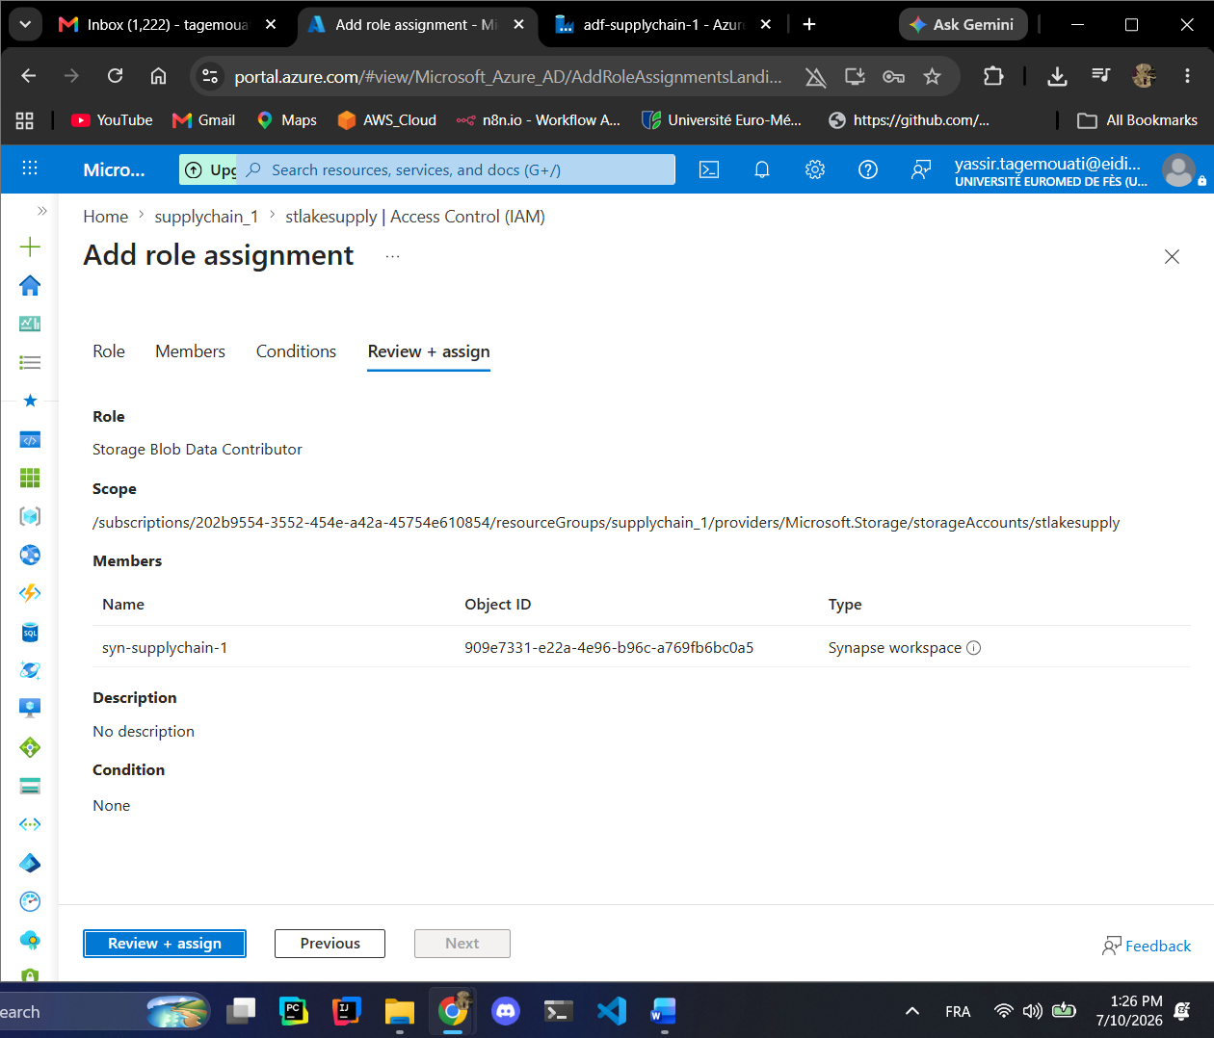
We need to add the role to synapse data factory also so we open the studio
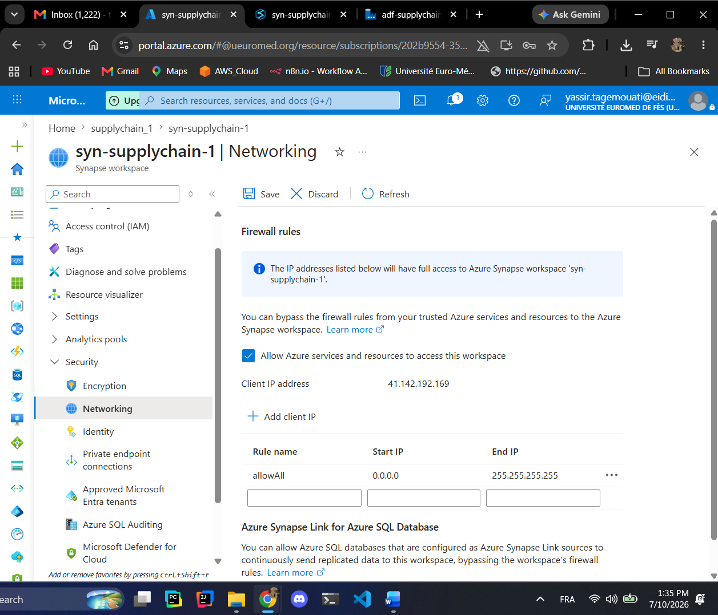
The firewall is not the fix!!!!
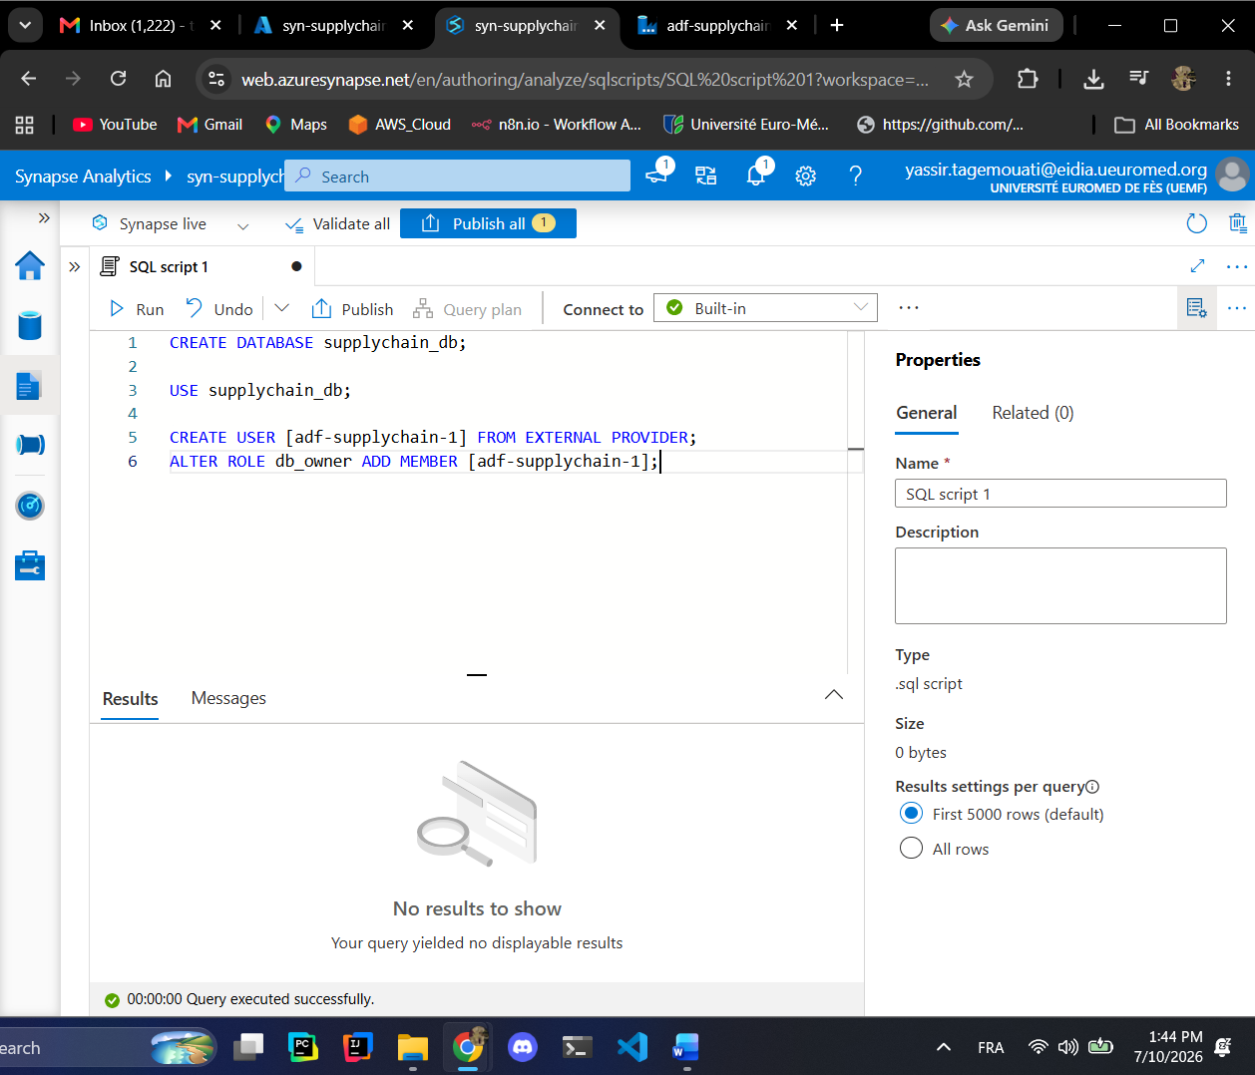
We created the database and we created the user with a db_owner!!!
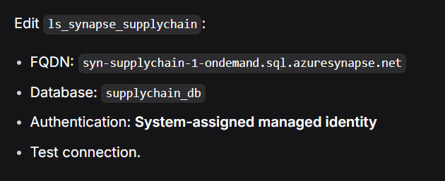
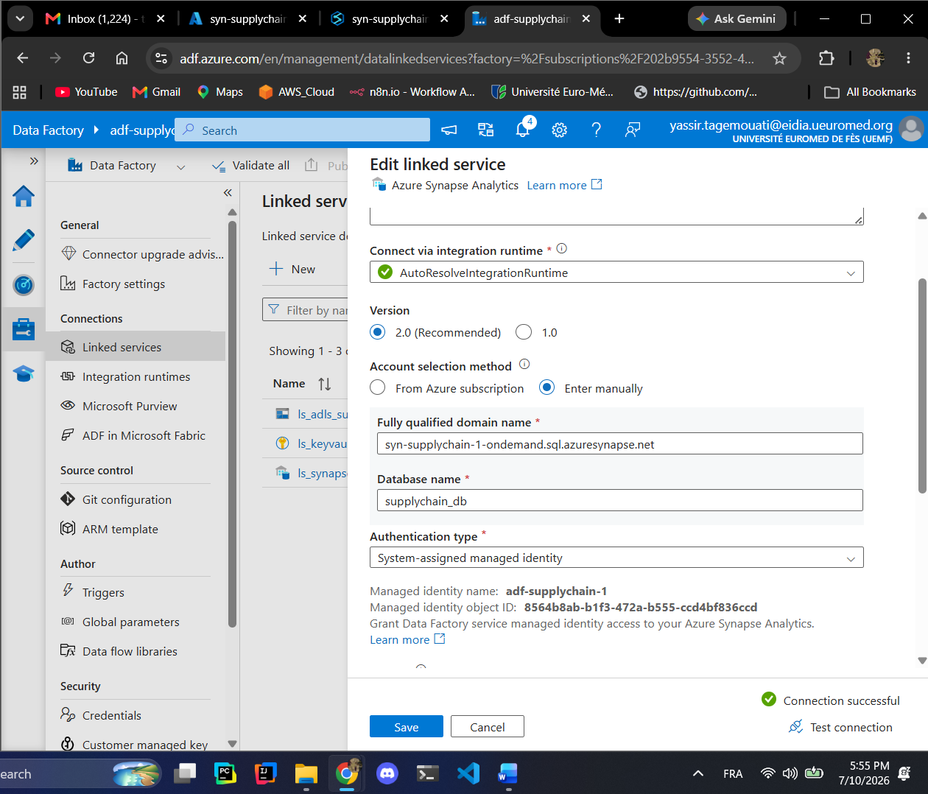
Now the connection of the linked service is working fine!!!
Create Spark Pool
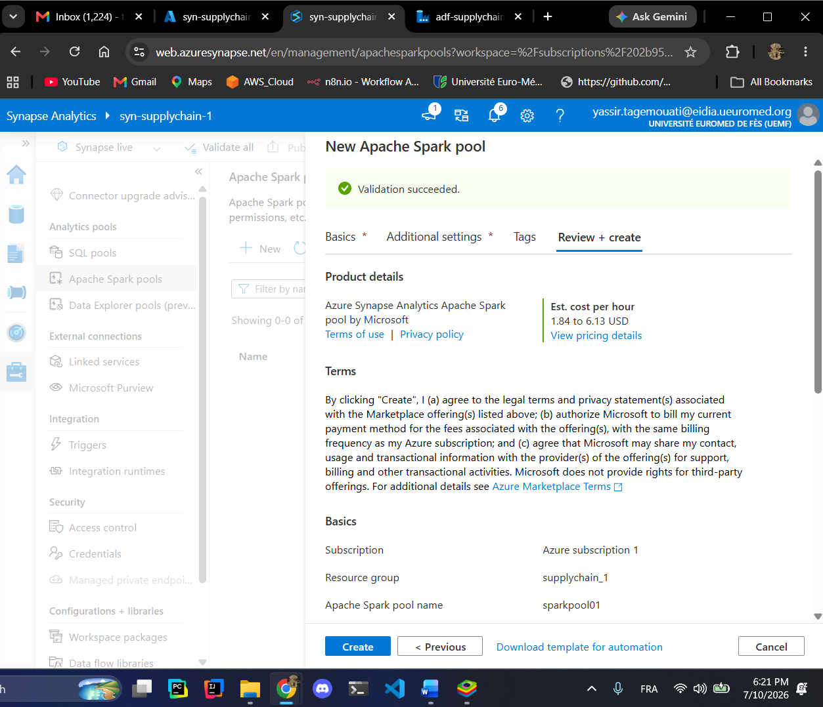
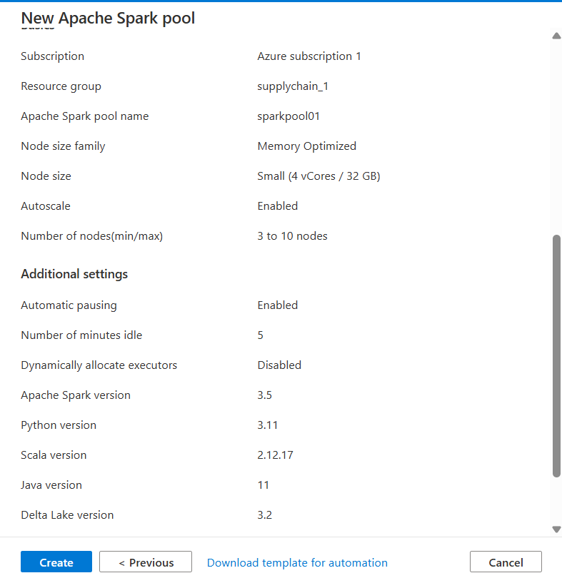
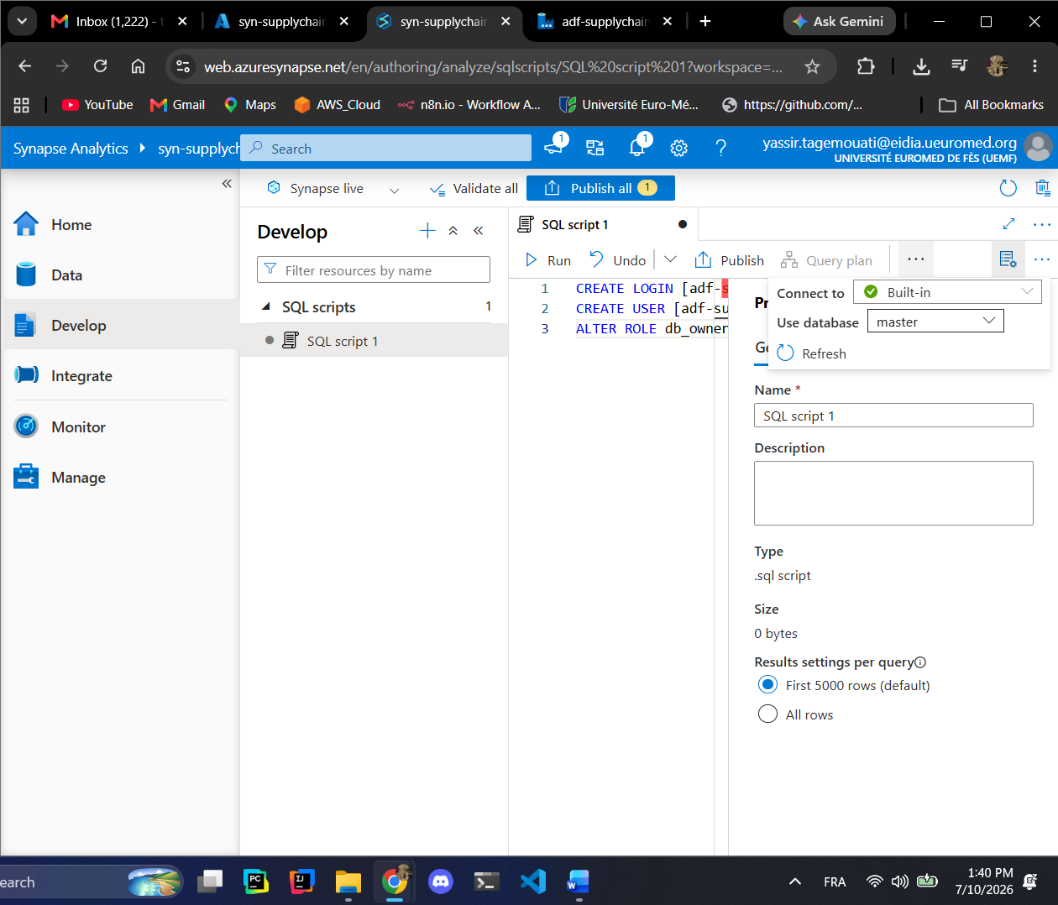
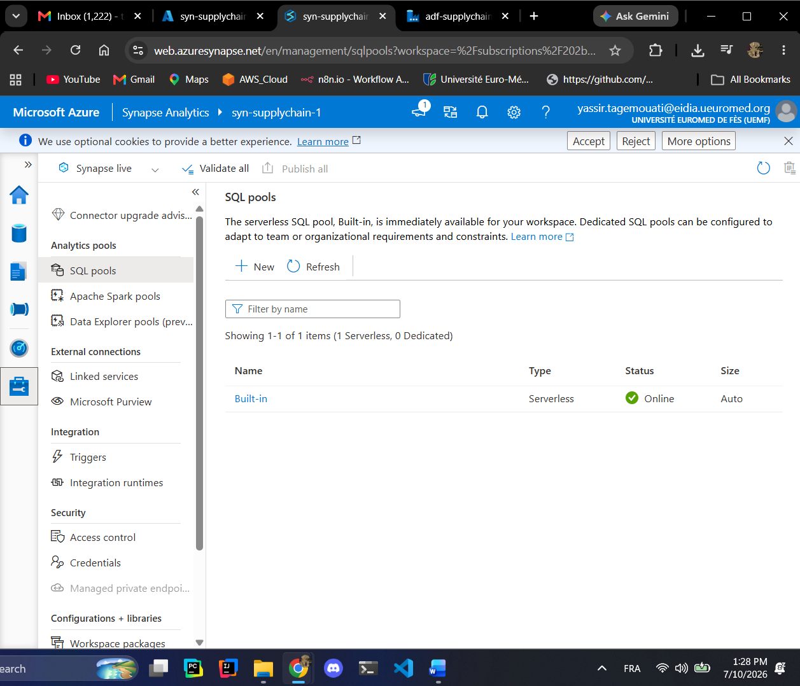
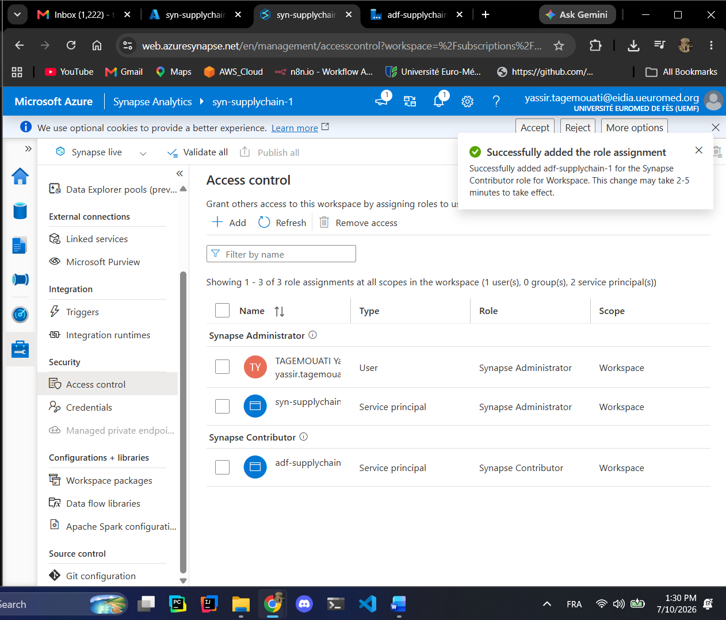
Epic 2:
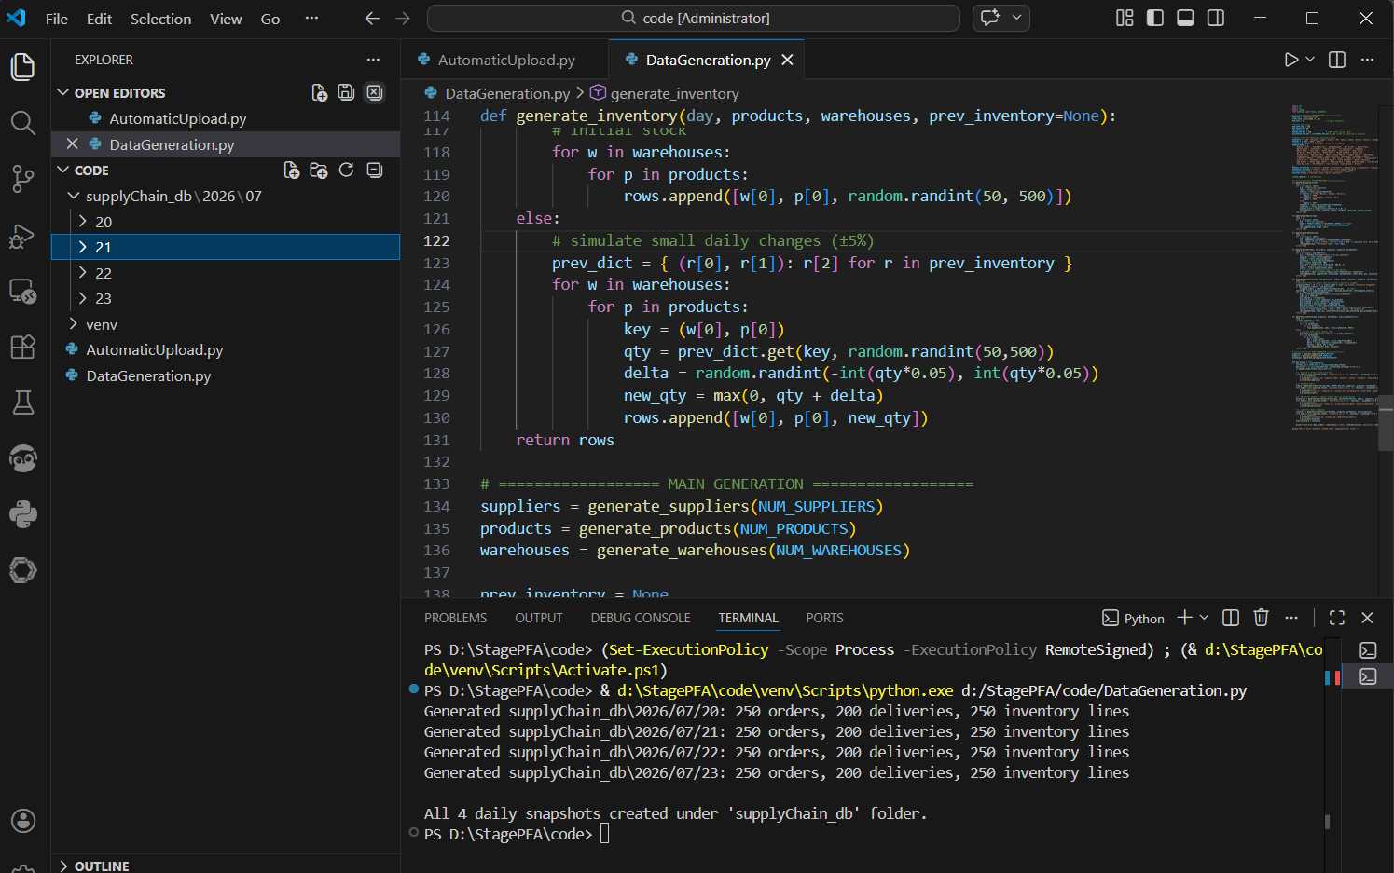
Generated the dataset.
Created a new container called source-files which is controlled by the adf already created this container will help us maintain the structure of the medallion container untouchable.
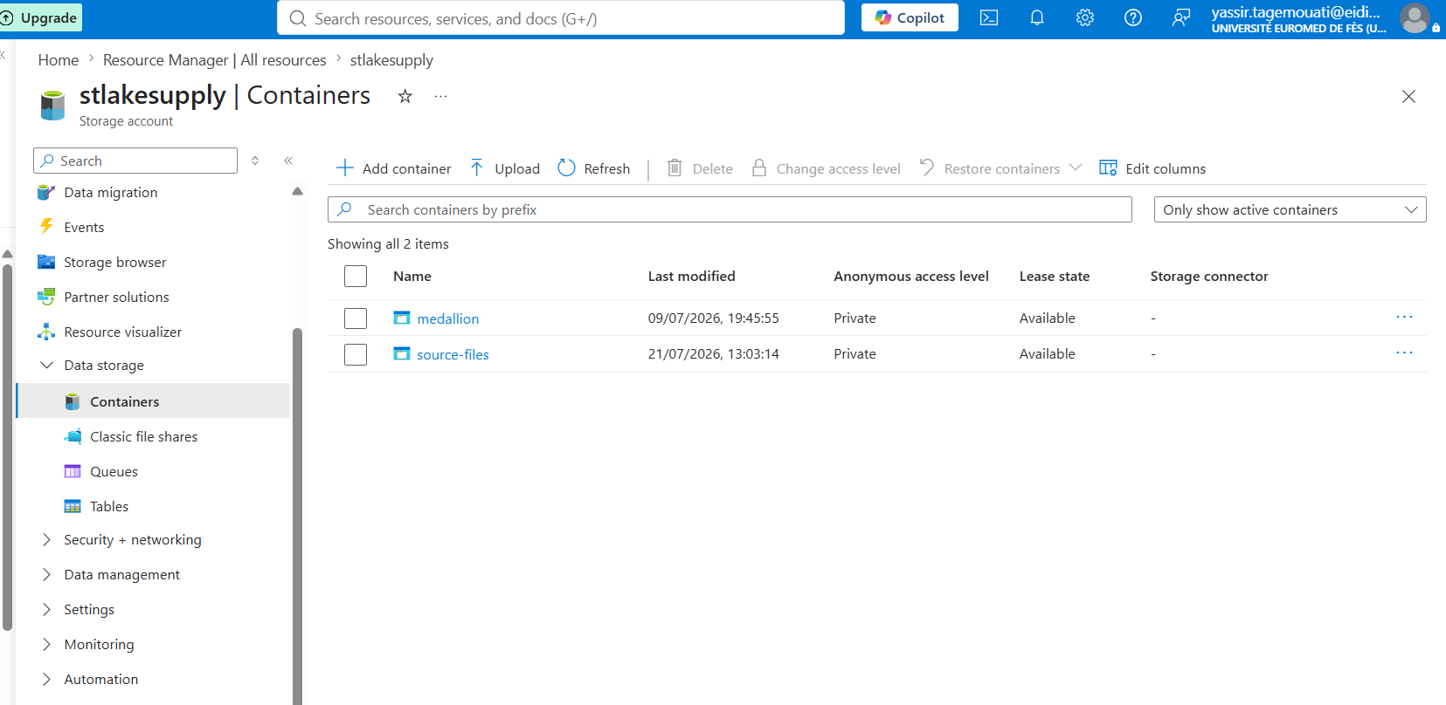
We need to create a sink dataset:
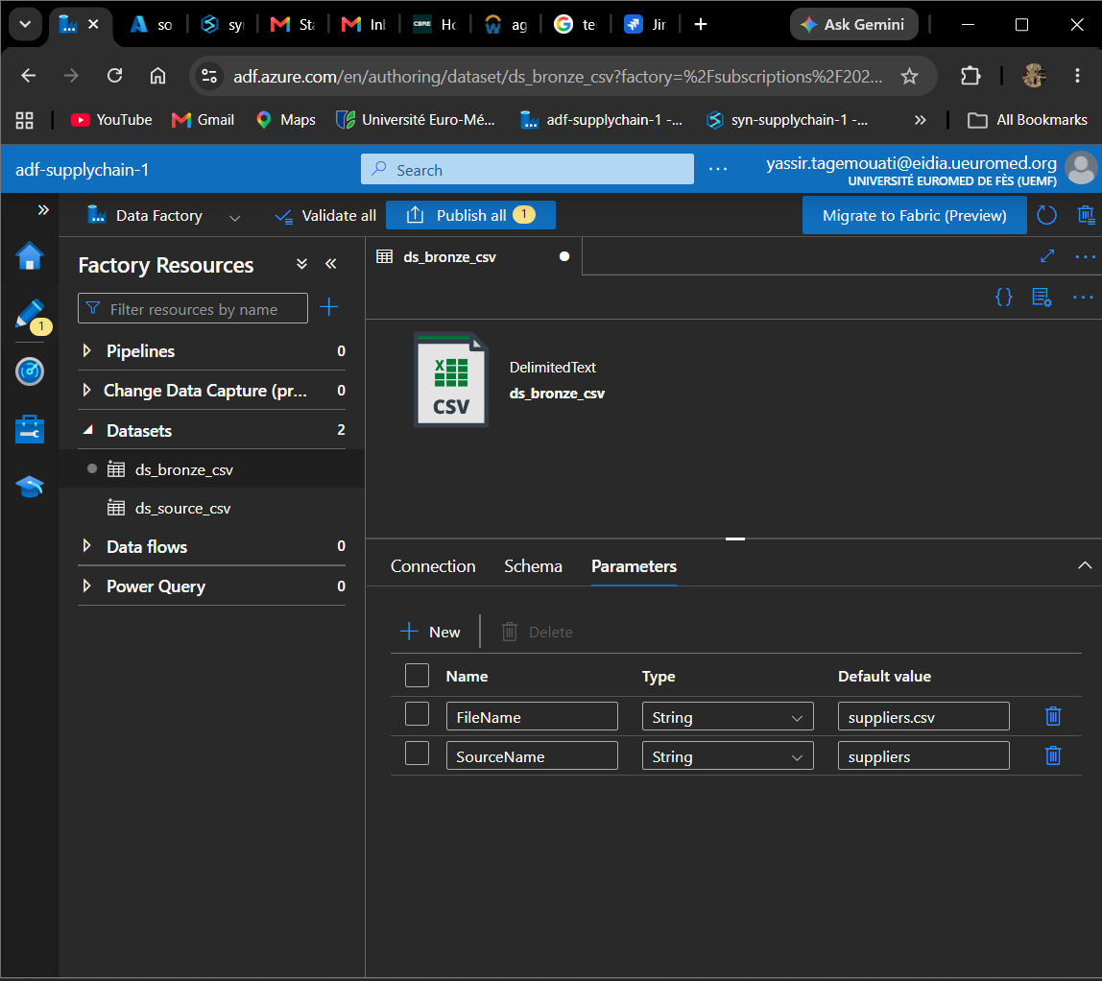
To be able to upload automatically all your stuff in azure using PY code you need to get the Azur access key first connect using your id and then you can work finally with it:
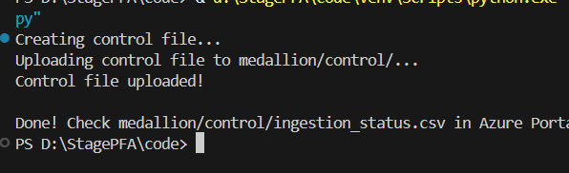
This part is very important in our application to create a small log for our ingestion if any error happens, we could be notified after that:
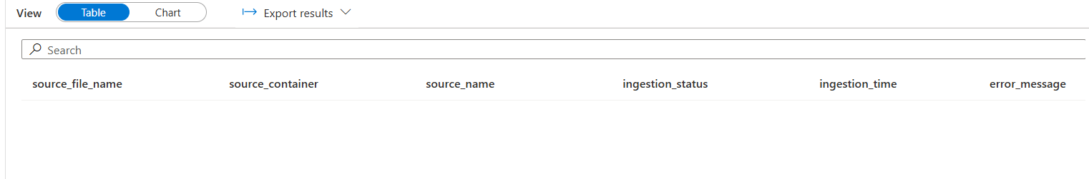
Now we create a new linked service for that:
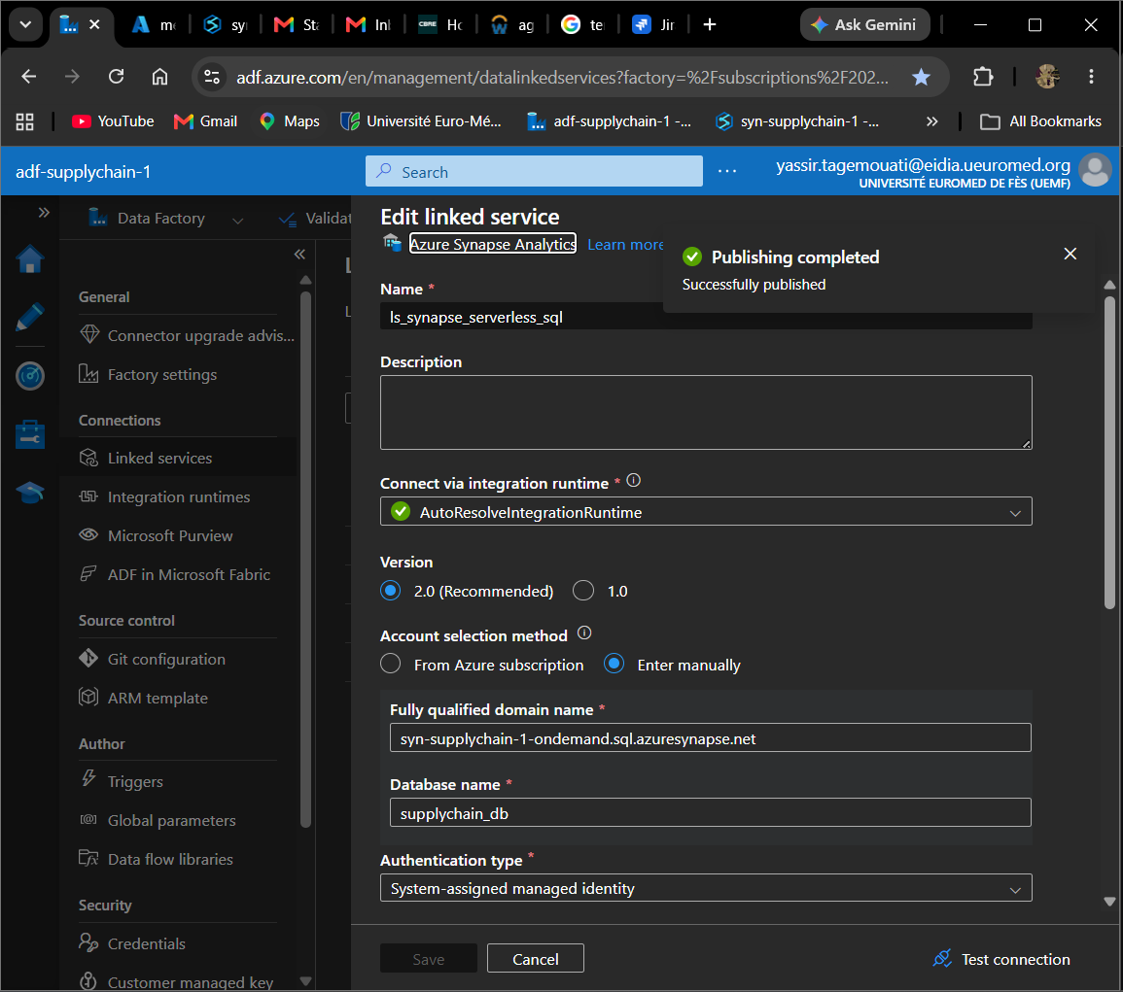
Now we create a new dataset for that:
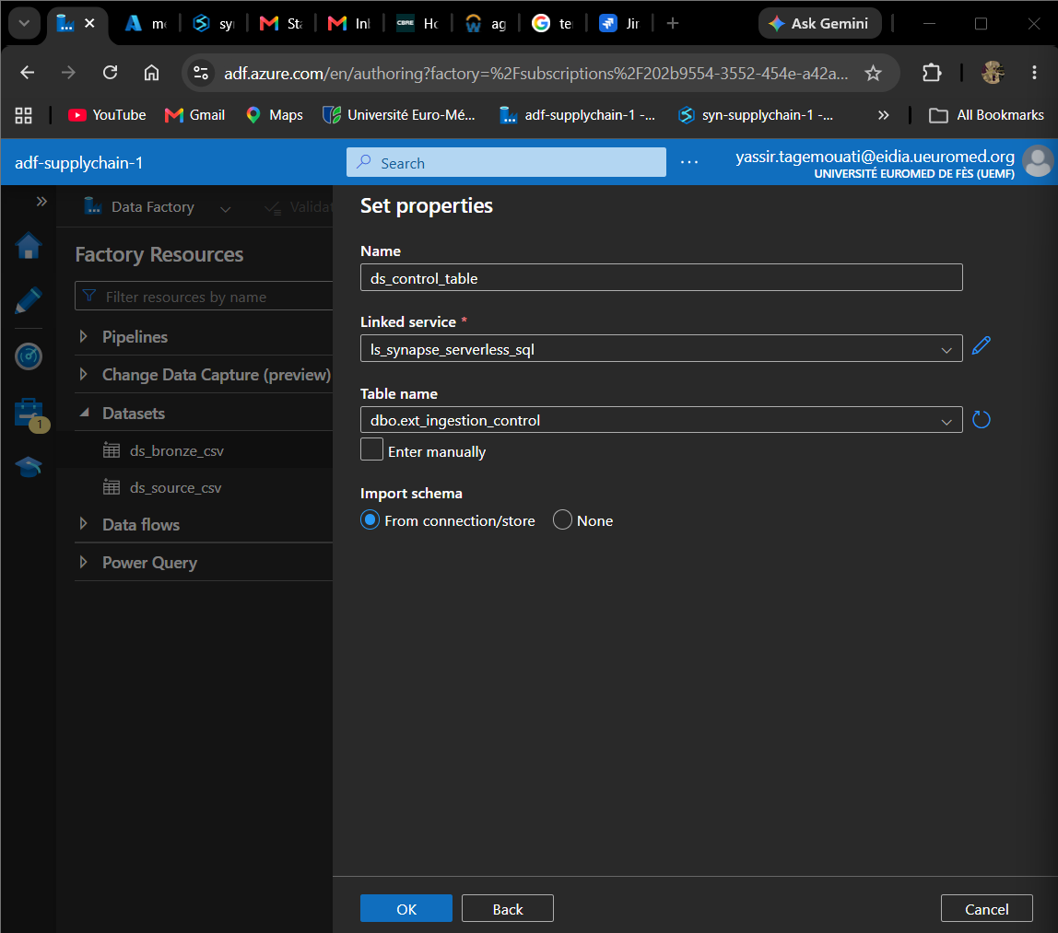
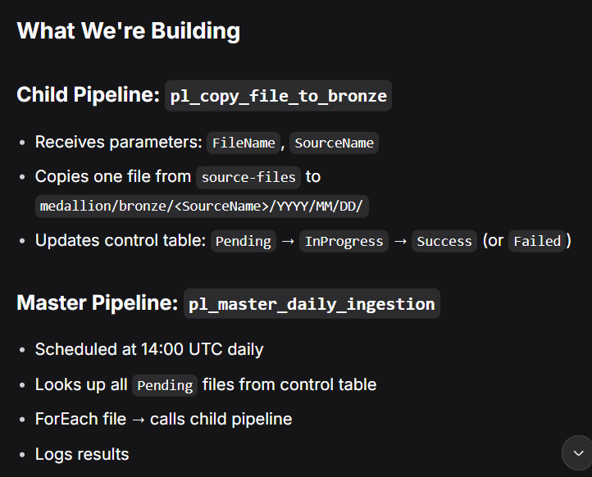
The first pipeline:
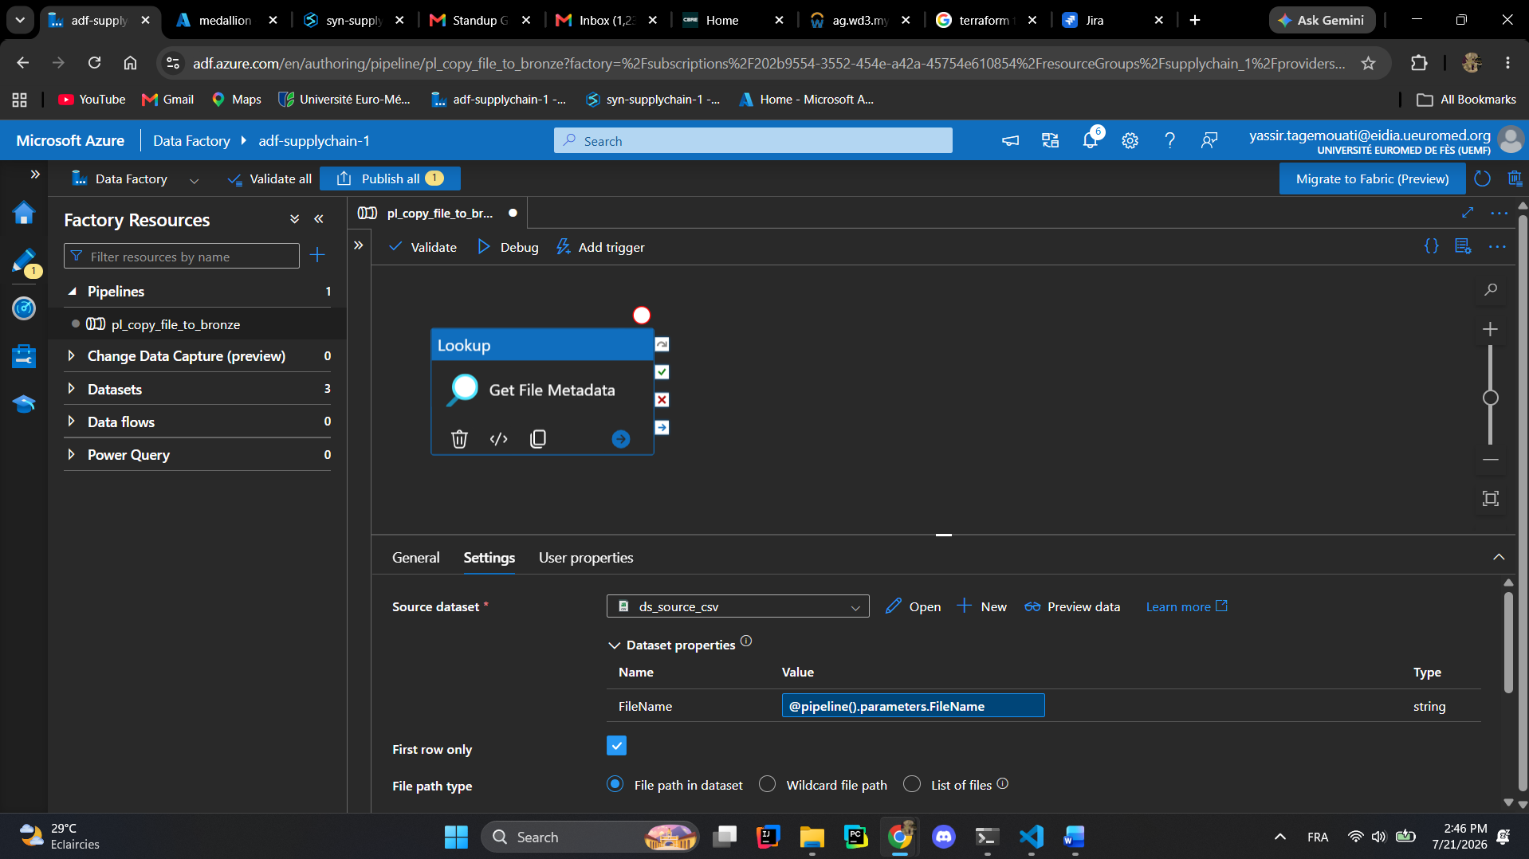
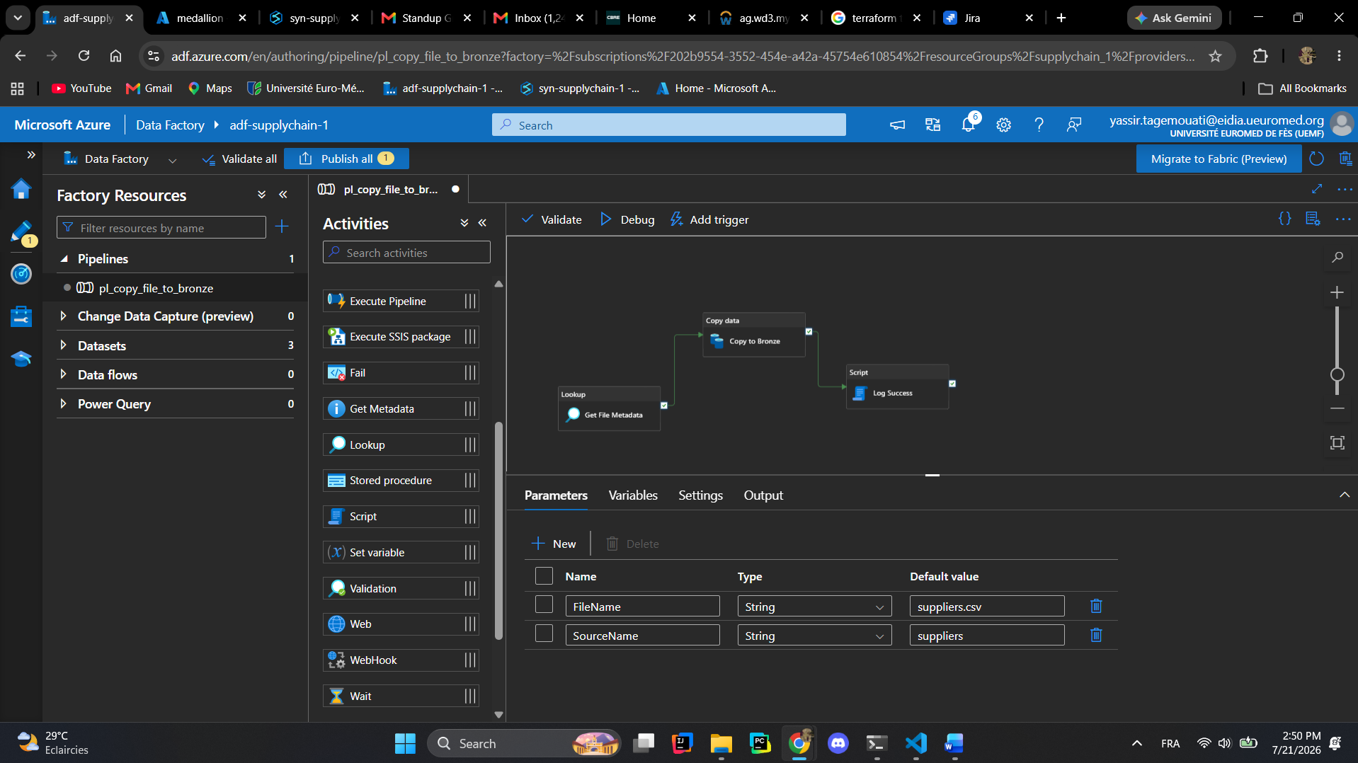
The first pipeline is fully created!!!
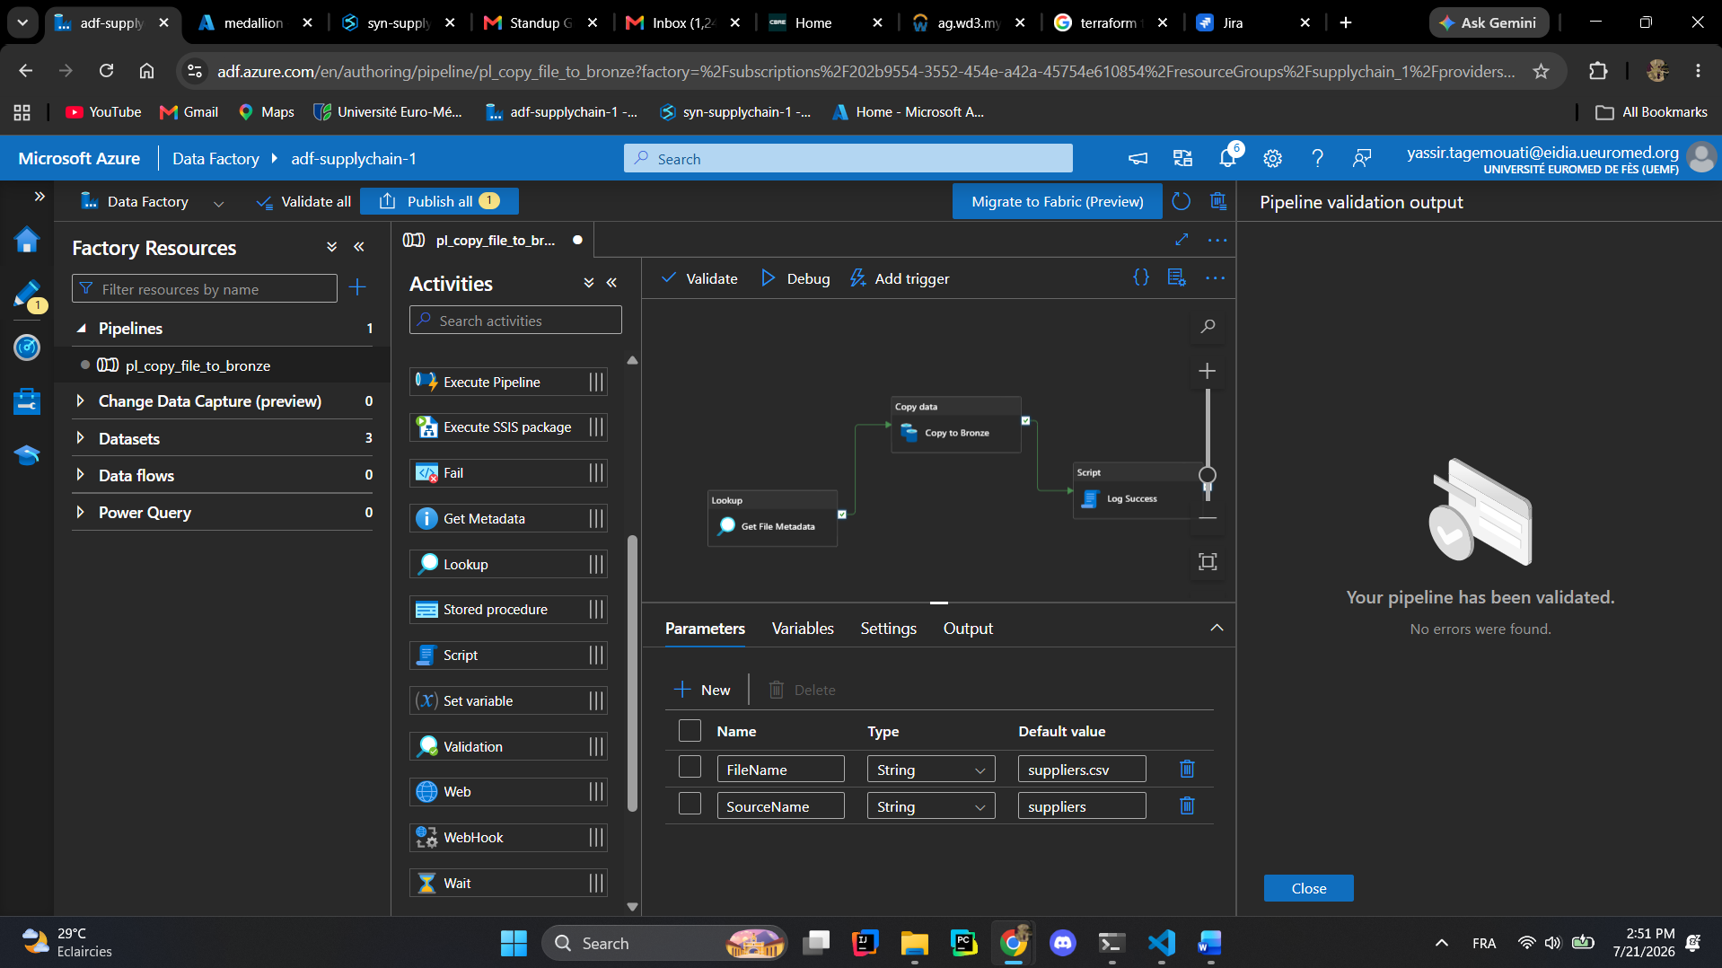
Let us move to the next pipeline:
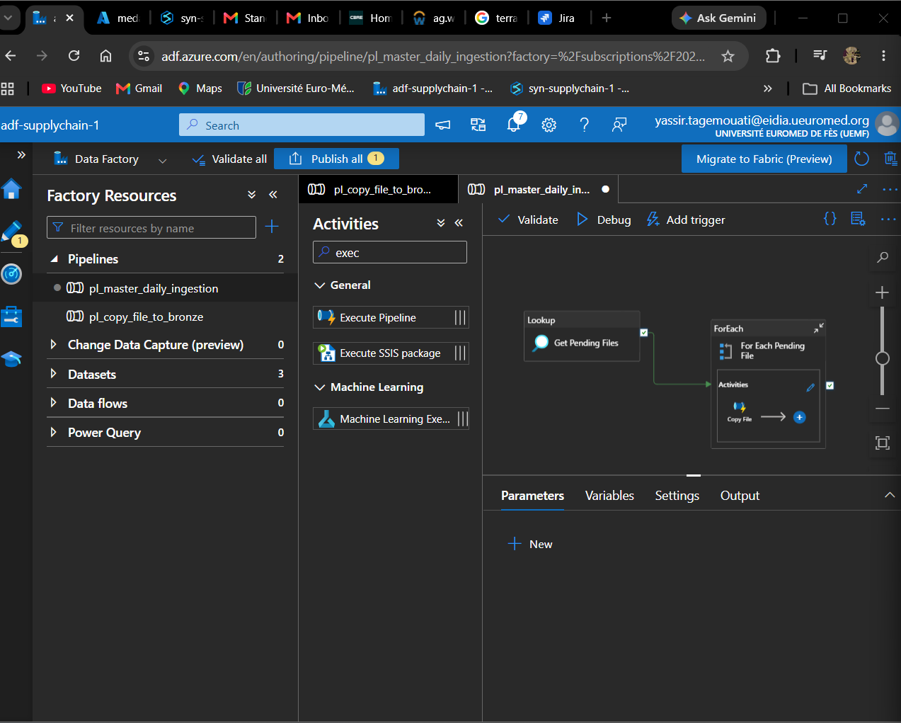
We create an execute command inside the for each for the pending data in order to launch the first pipeline we made to copy from the source sink to the original bronze sink to the real bronze folder:
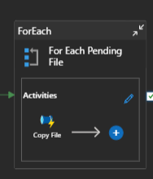
We run now a test to upload the files using the code we created earlier:
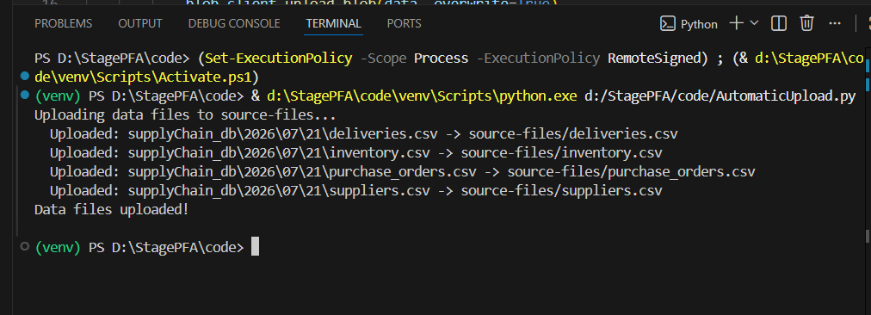
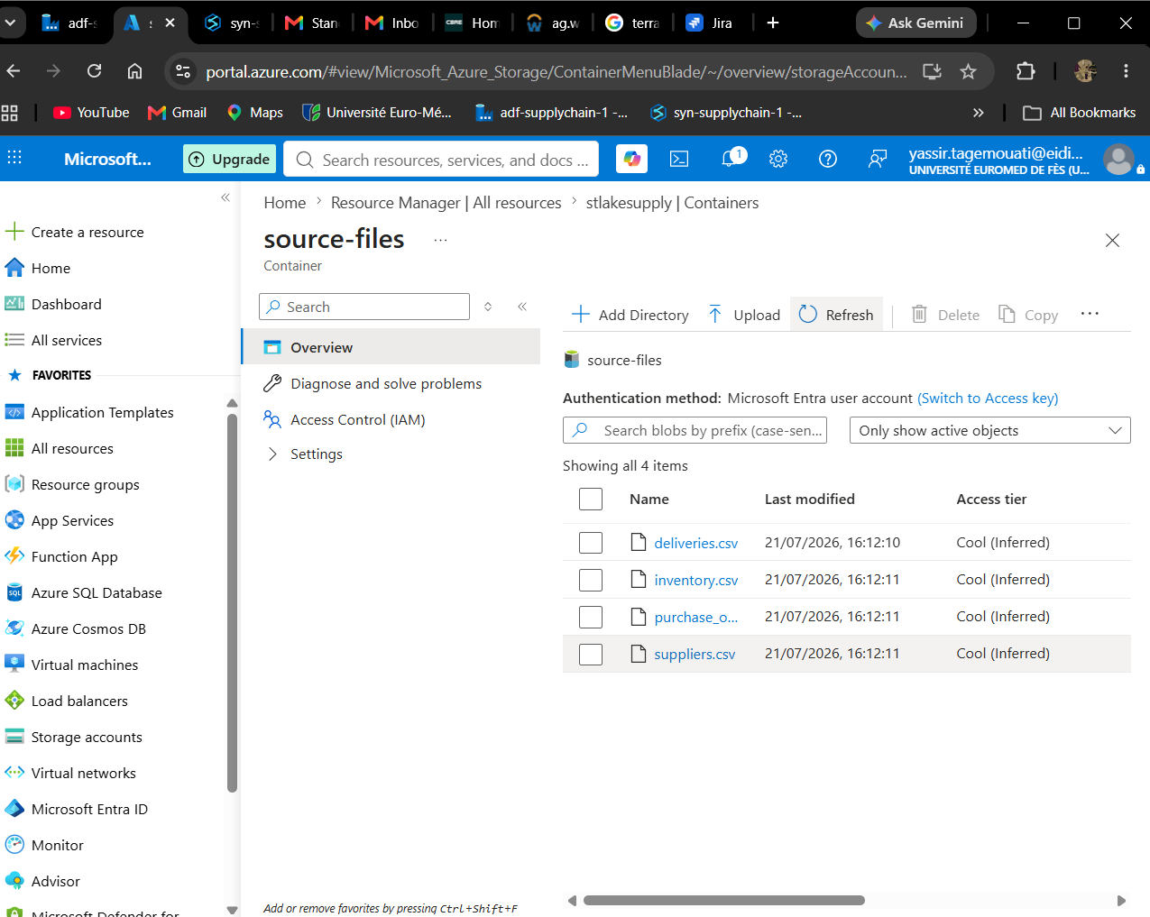
Know we test the trigger:
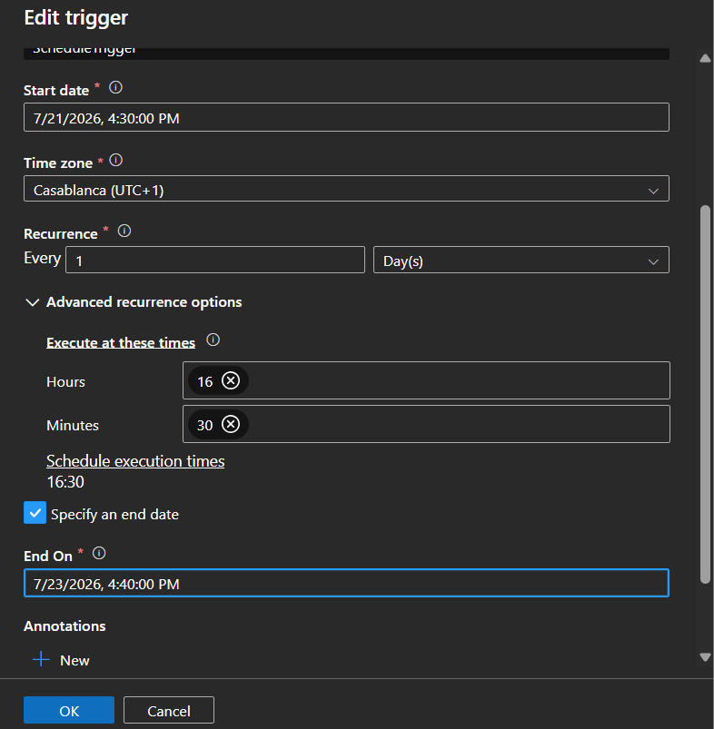
Now we wait for the trigger and pls note that I will be testing it for the coming two days to make sure that the stuff is working!!
Don’t forget to set the daily limit for SQL storage pool so the data storages you created on the adf before will work!!
If you get this error:
Query is rejected because SQL Serverless budget limit for a period is exceeded. (Period = Daily: Limit = 0 TB, Data processed = 0 TB)
Now it is good you get this :
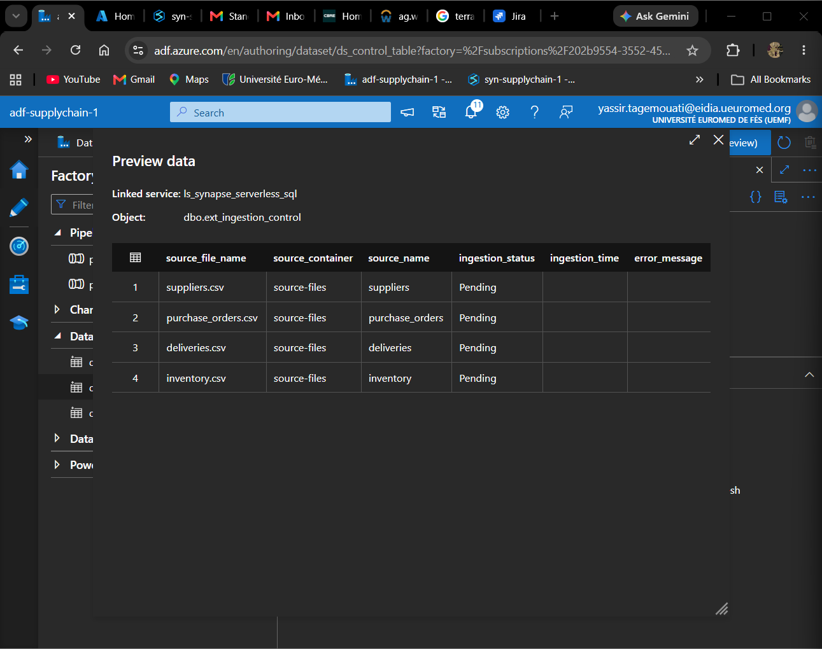
Debug the first pipeline:
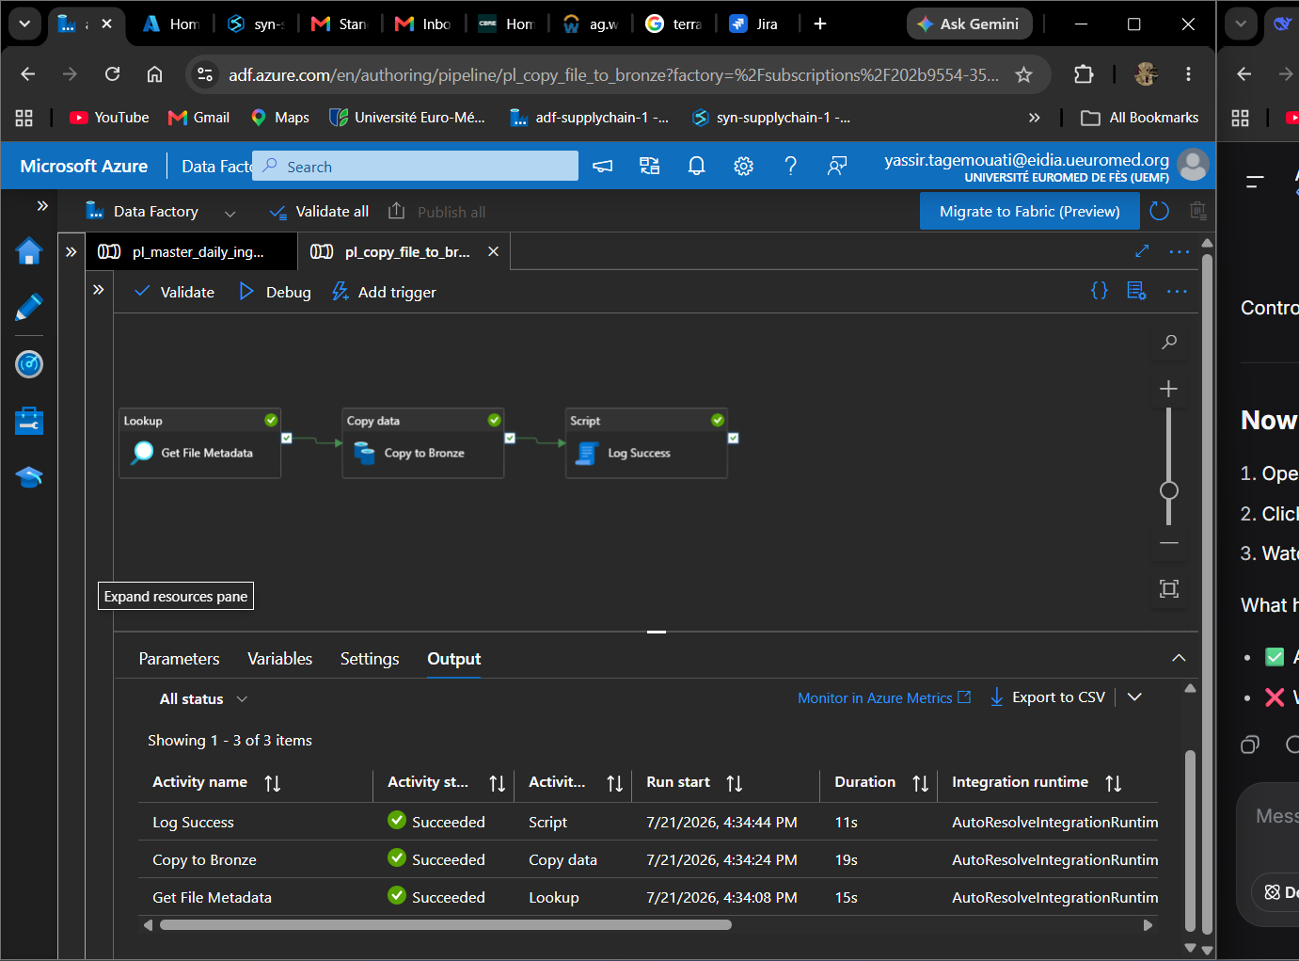
Debug to the master:
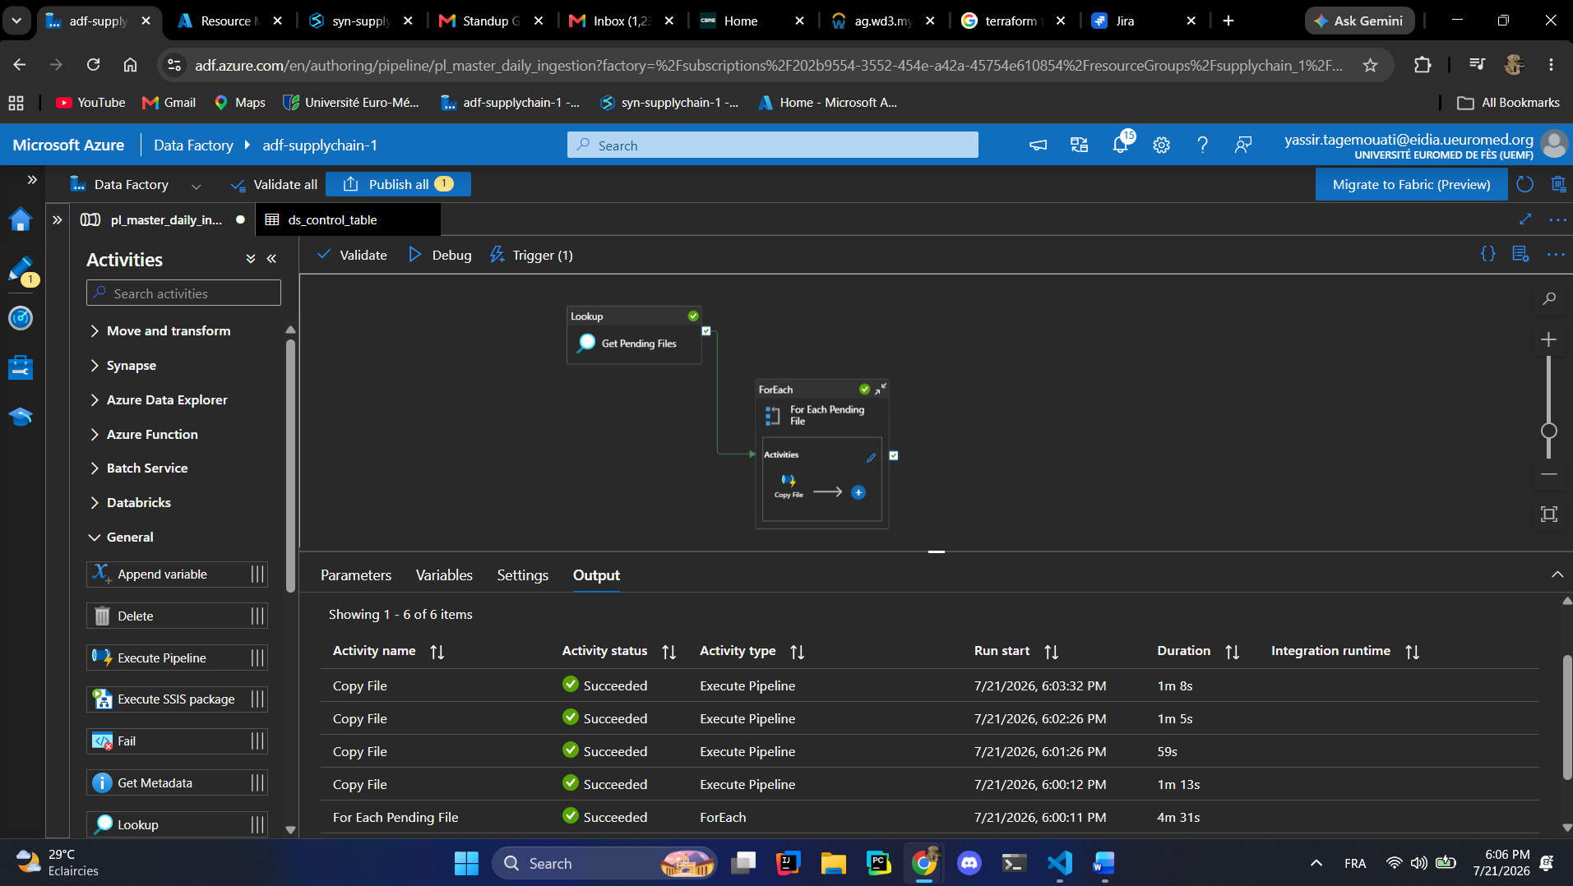
Took a 5 min to copy!!
We created a code that changes the status from pending to success using a spark code we activated the 1 minute of idle to keep the best consummation optimization of resource:
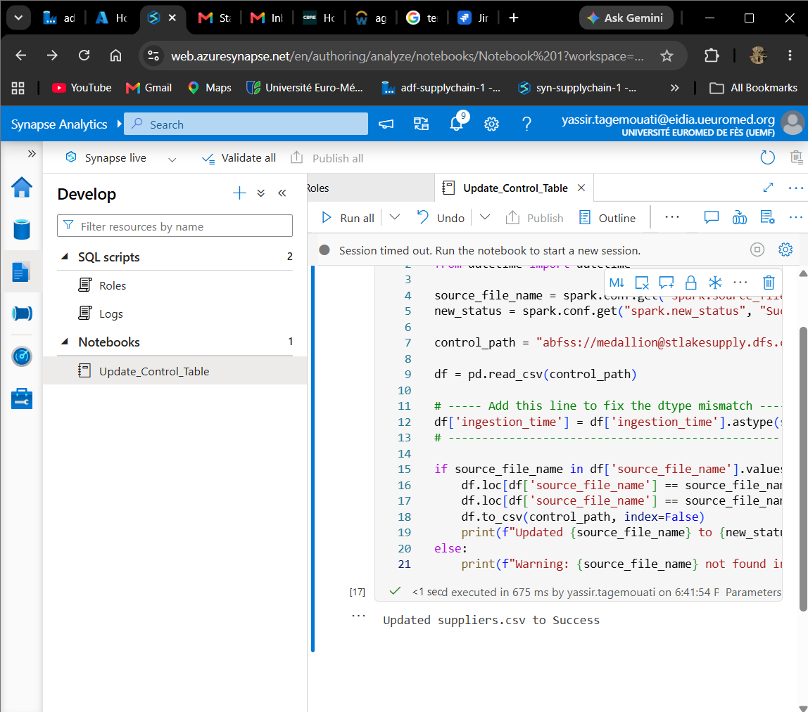
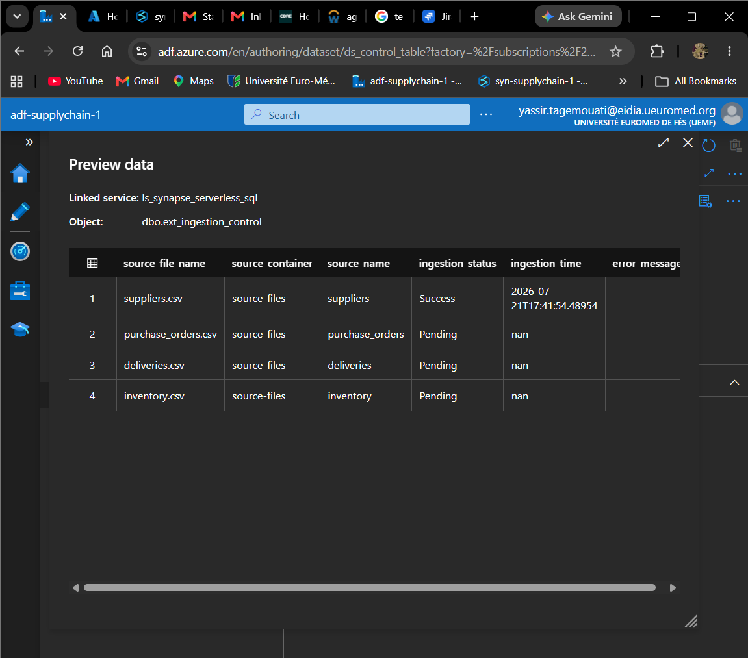
Added the automatic change of status of the file after being copied from the sink to the bronze architecture:
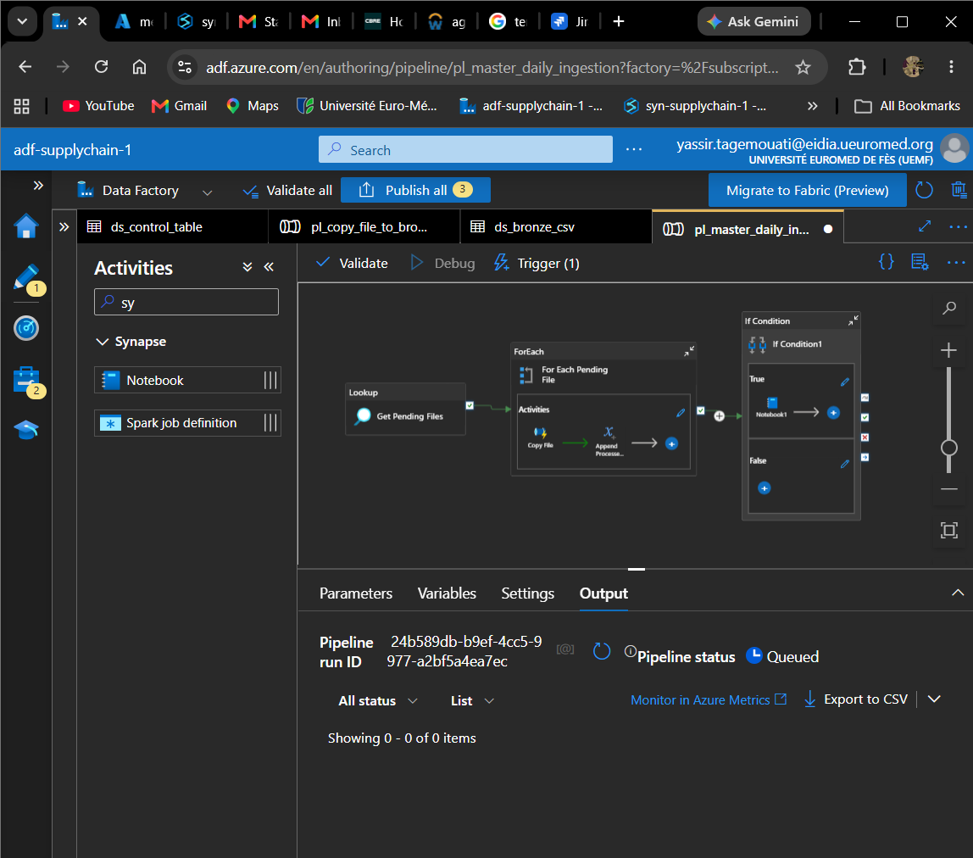
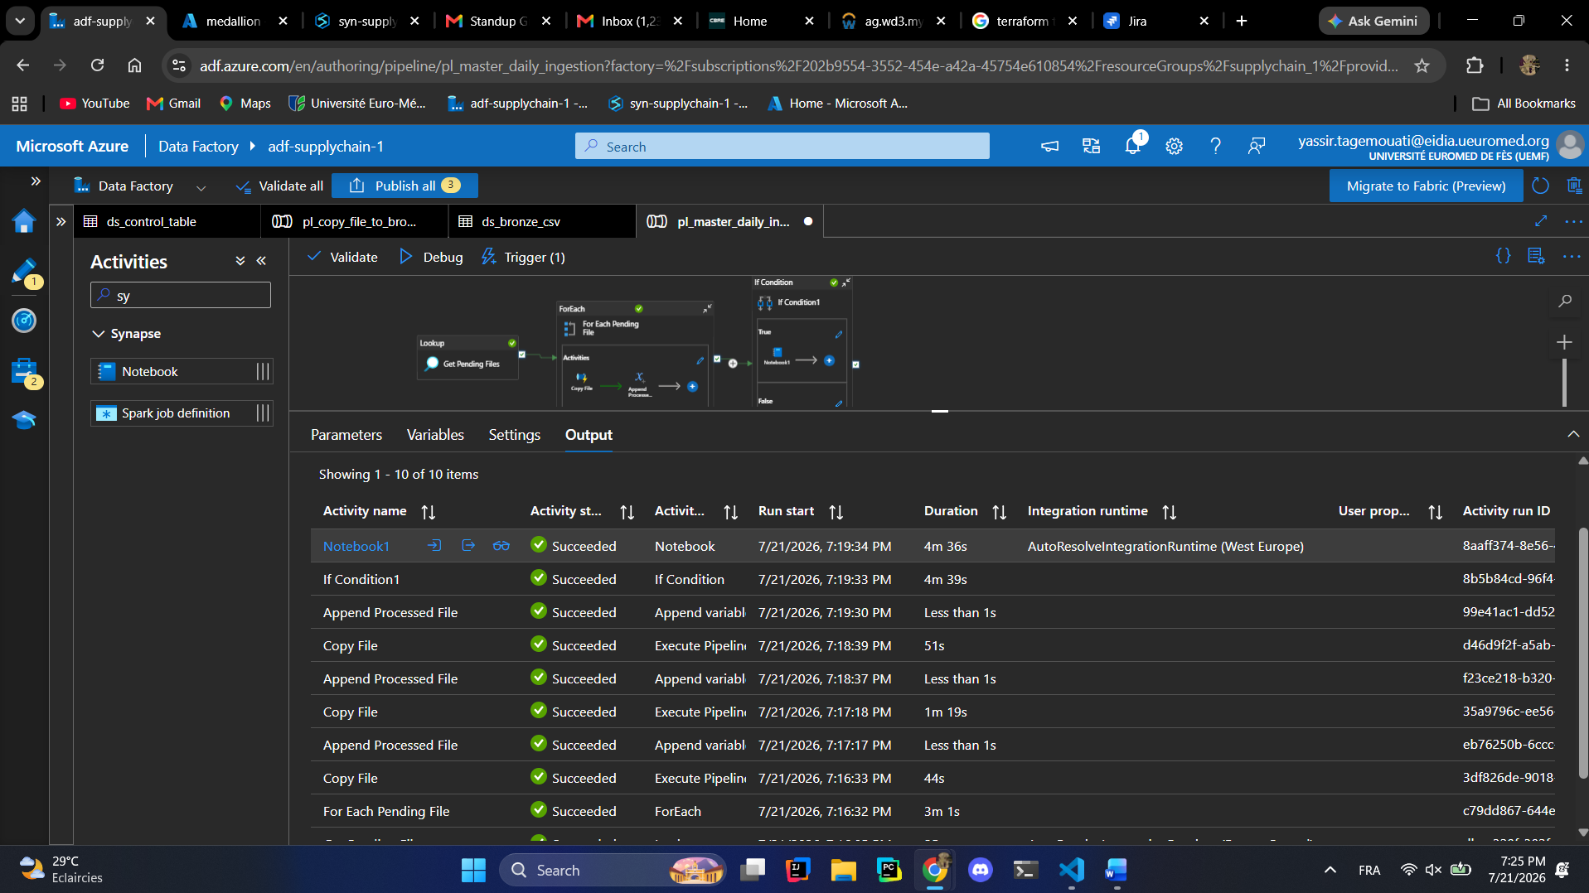
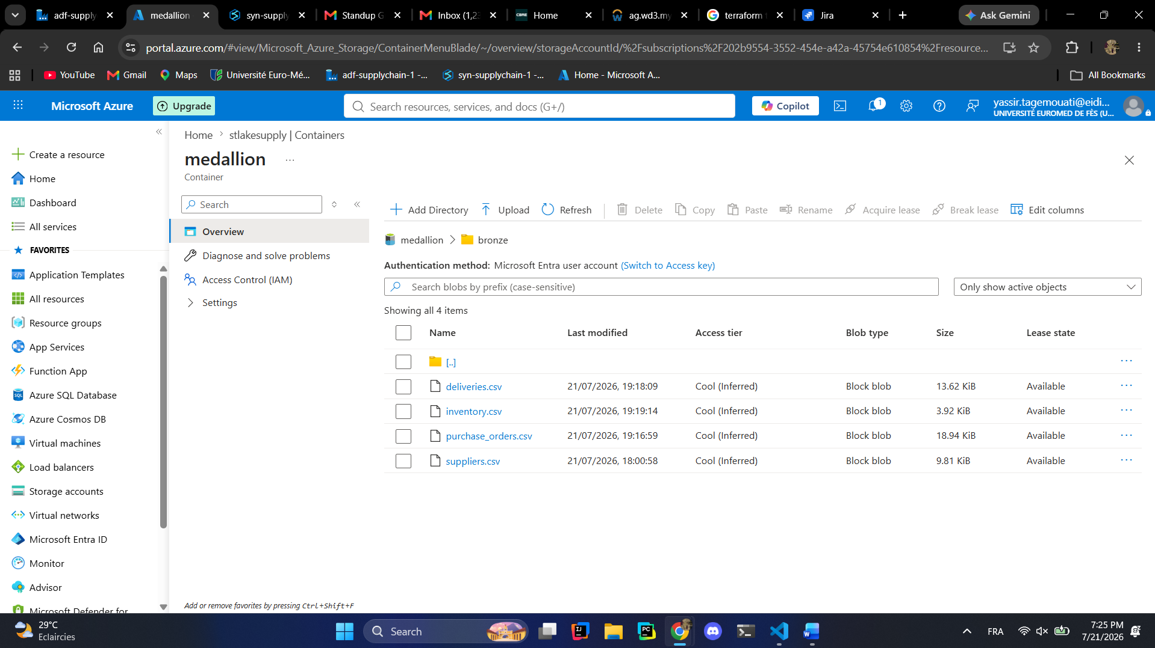on the image you can see that only the files still with the pending status that are now being copied another time but now we changed their status so means if I try other time to copy it will not work!!!!
In the automation I get the problem that the cellules that is created automatically is launched the second one which leaves us with no table or variables to process!!!
To fix we try to update the list of the parameter’s cellule the first one!!!!!!!!!!
And you need to toggle the first cellule as parameter.
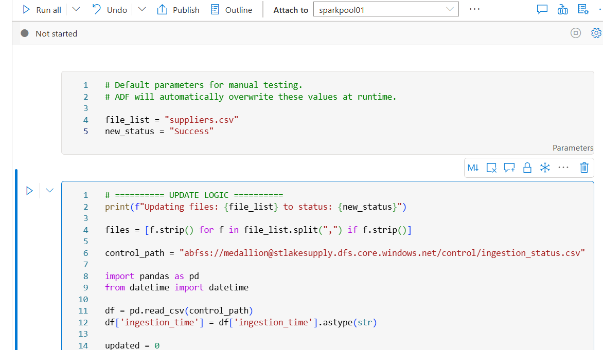
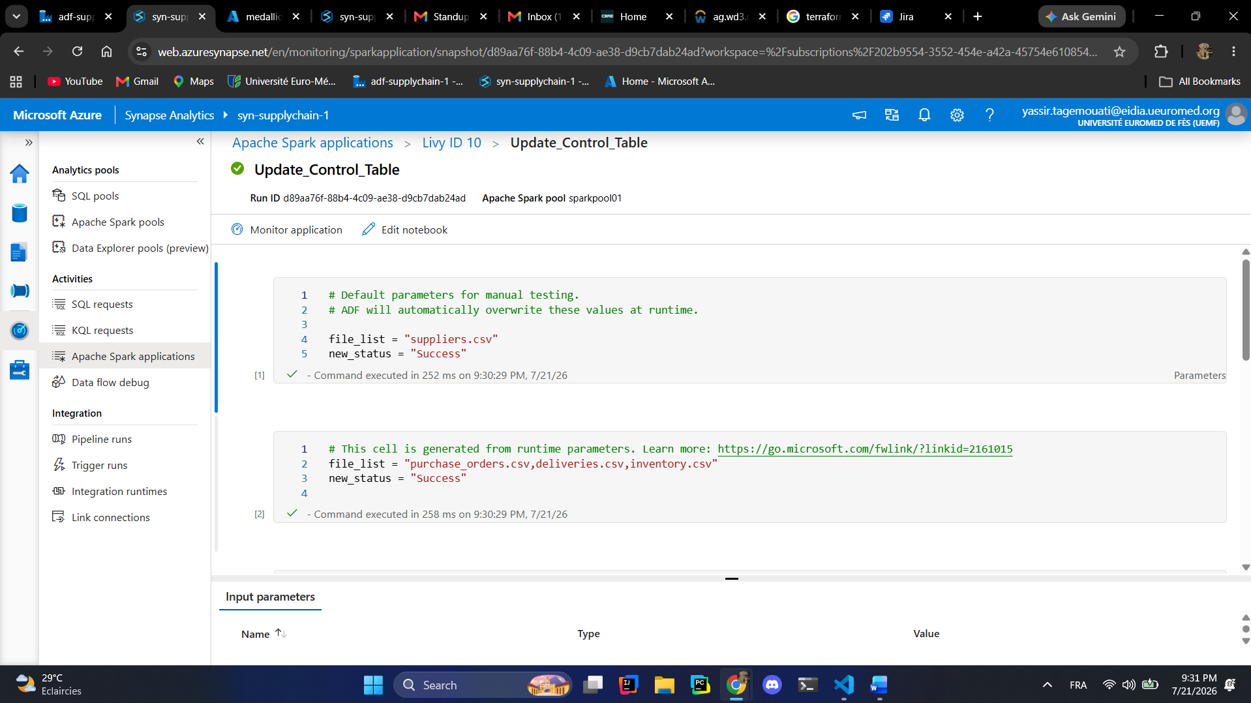
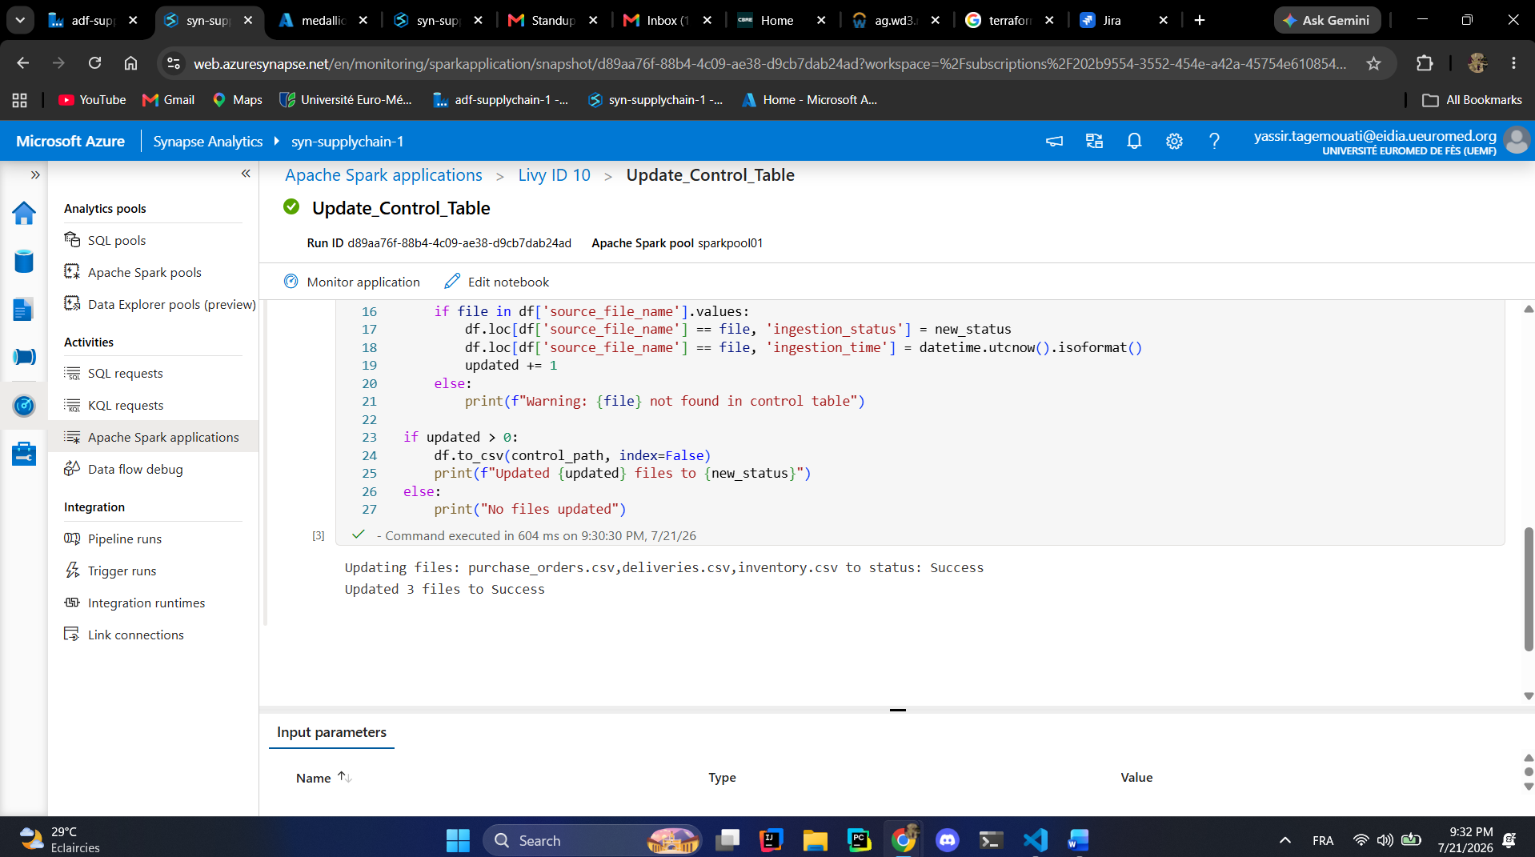
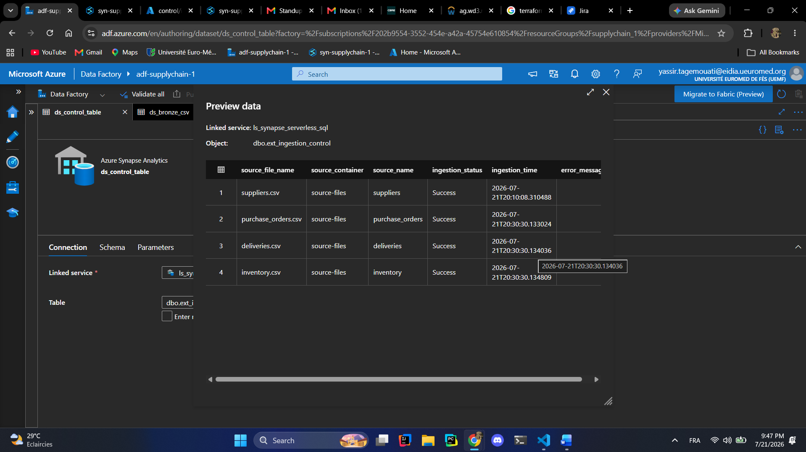
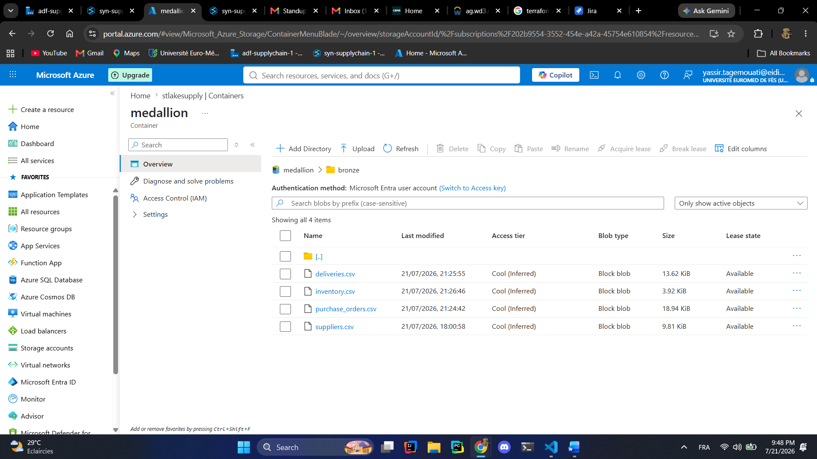
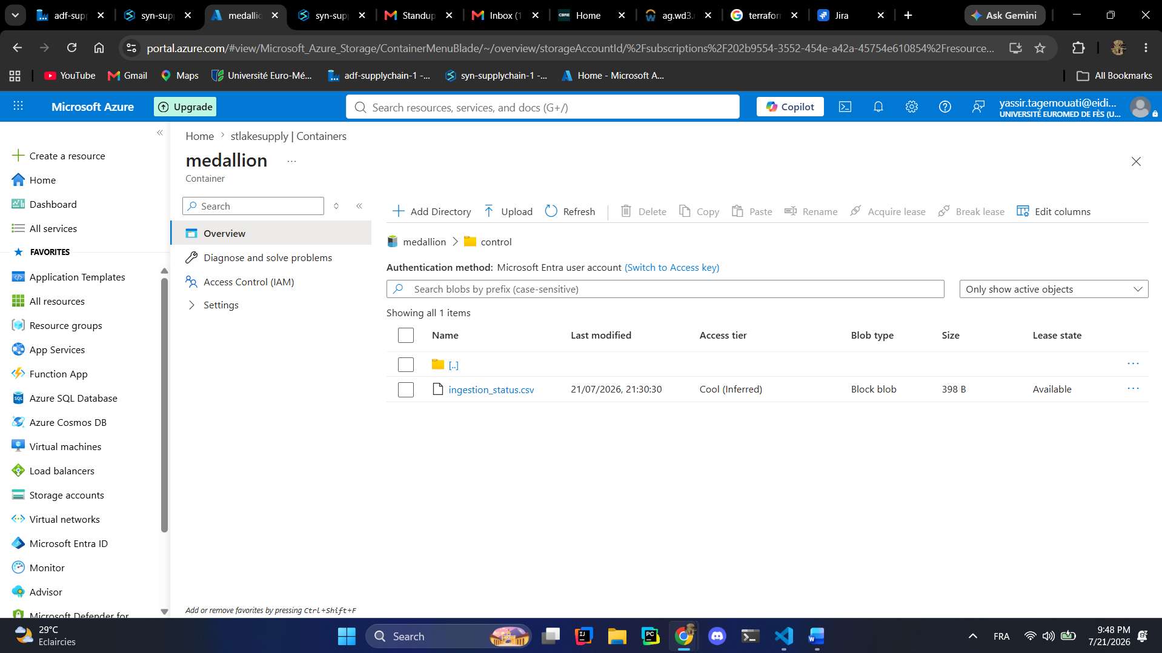
Now we activate our trigger for 2 am and we will see what happen tomorrow!!!
Trigger is set let us generate the data!!!
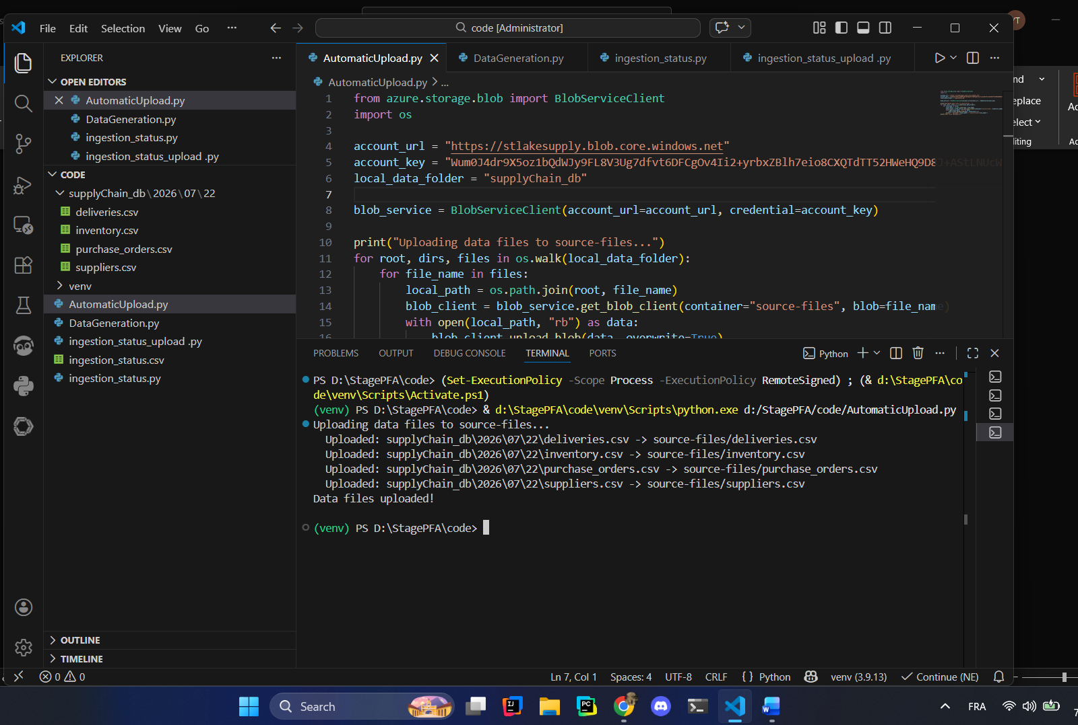
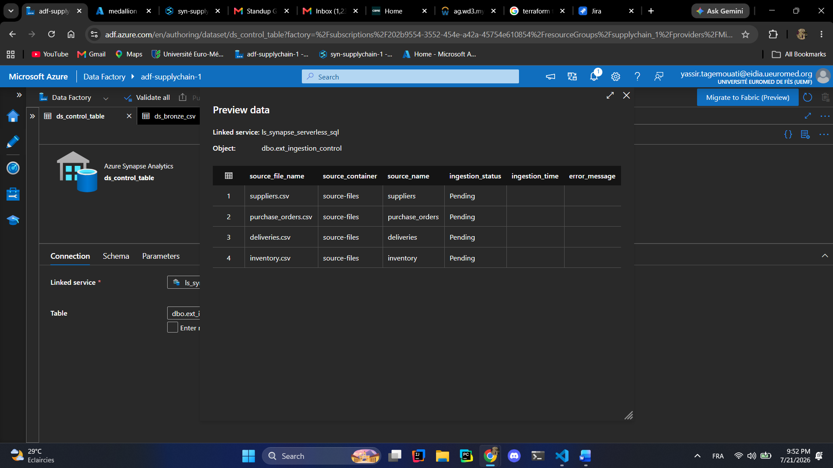
See you tomorrow!!!
Hi again the ingestion worked fine
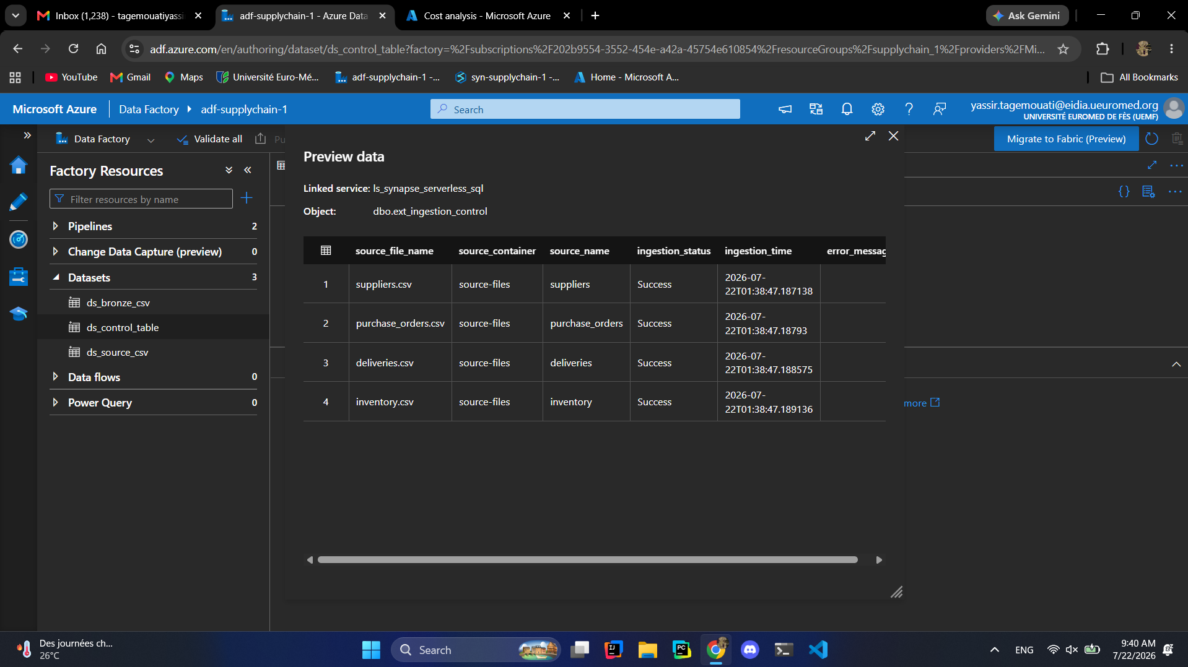
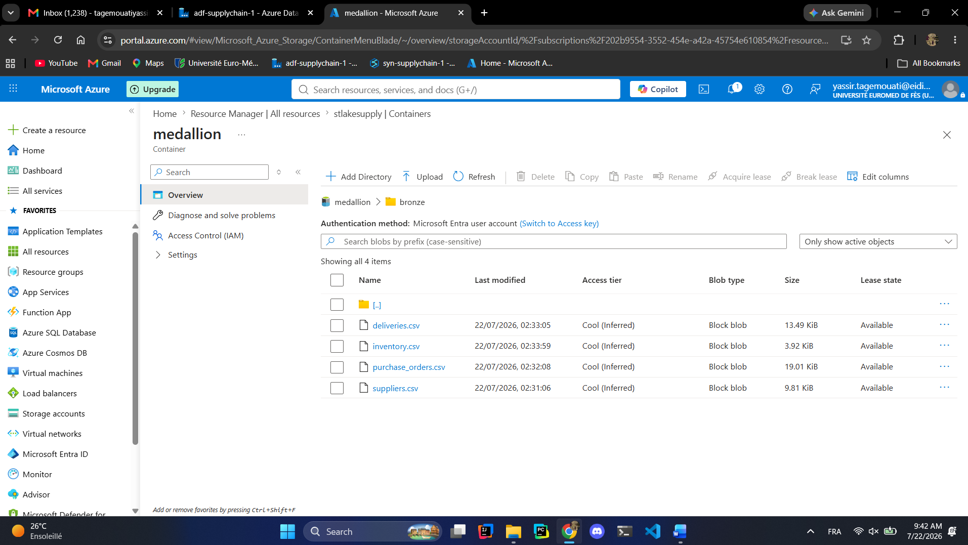
Great all working let us turn off the trigger!!

