Epic 3:
Now we create the processing code for the cleaning in silver:
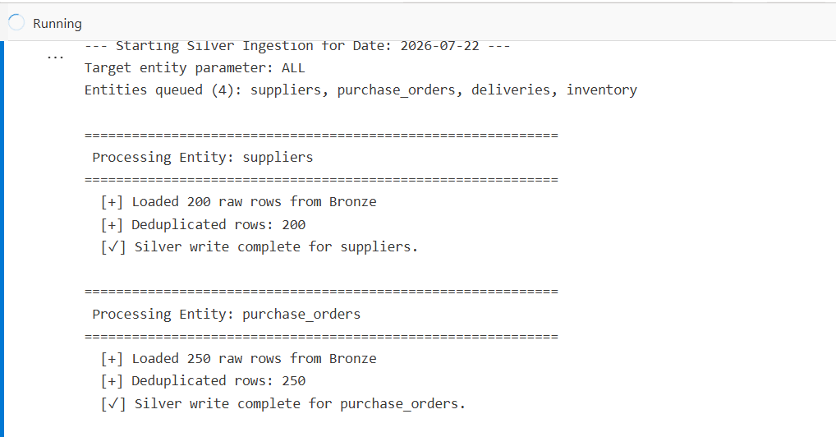
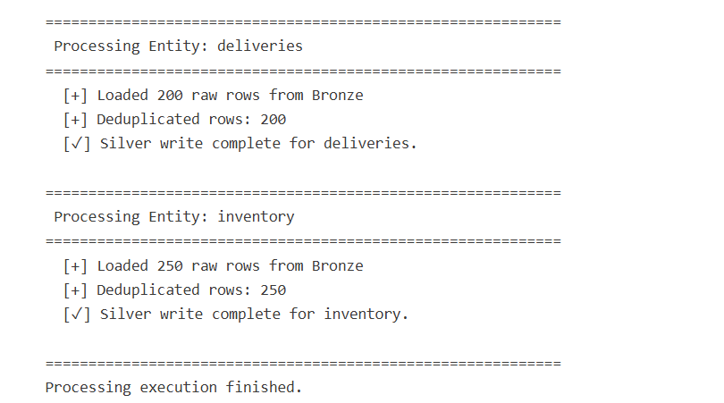
Check:
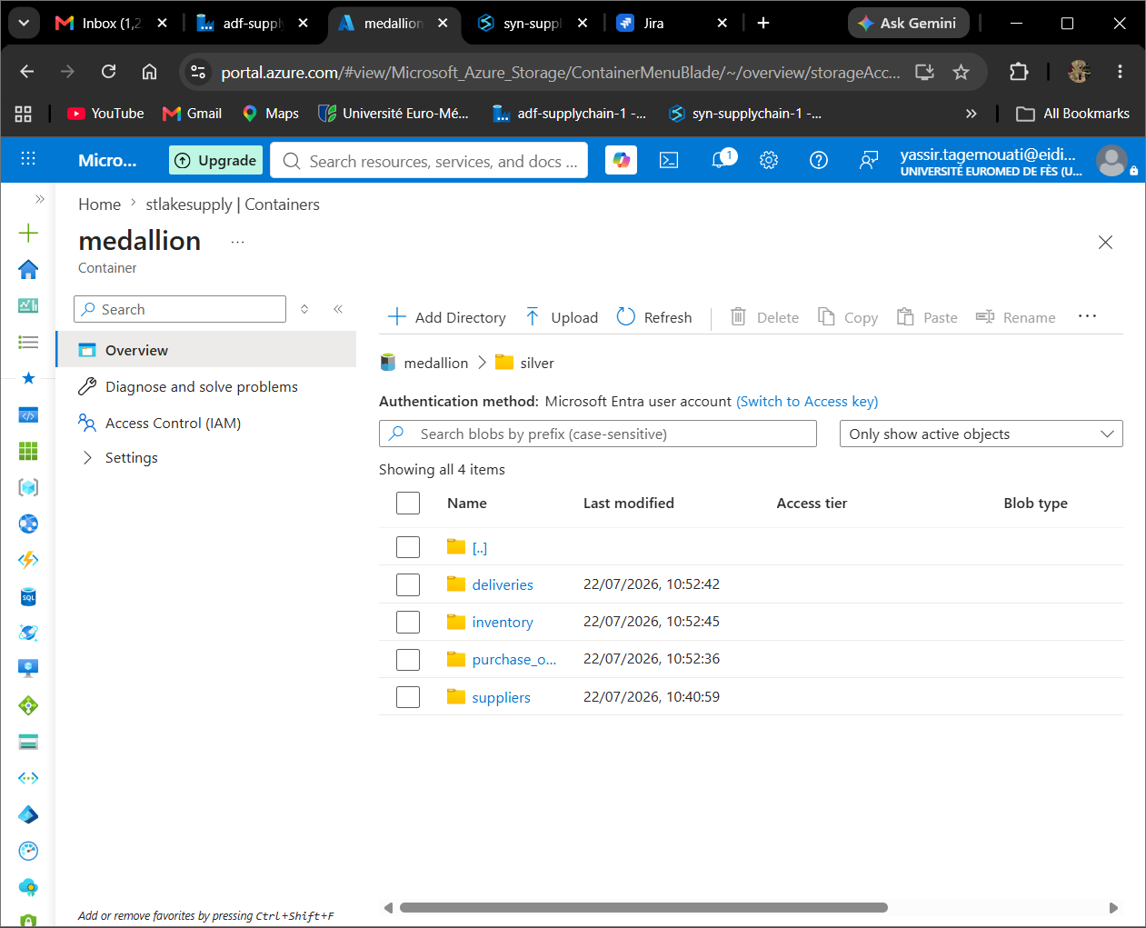
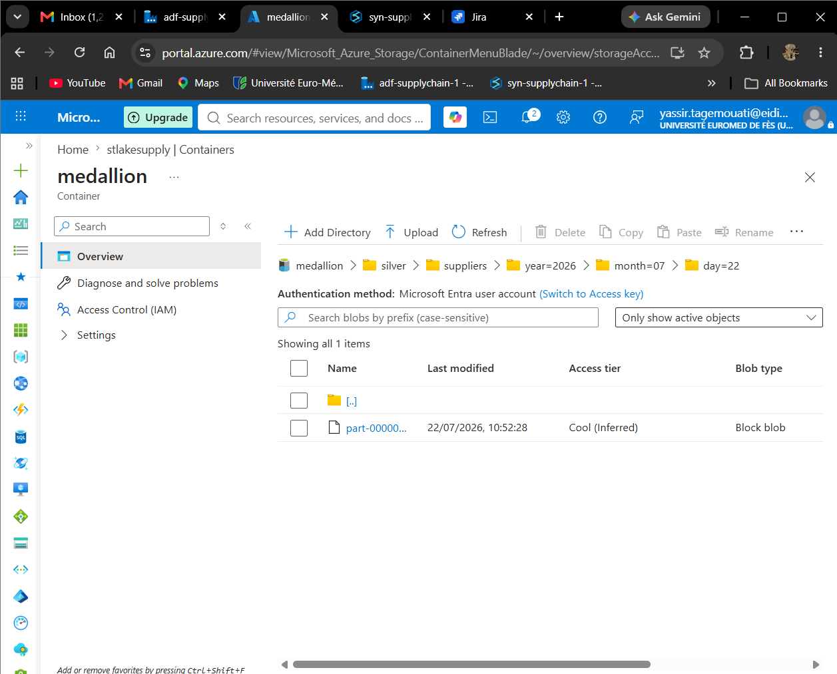
All is good!!!
Now we will try to add the data quality gate to check on the silver layer important to avoid any problems!!!
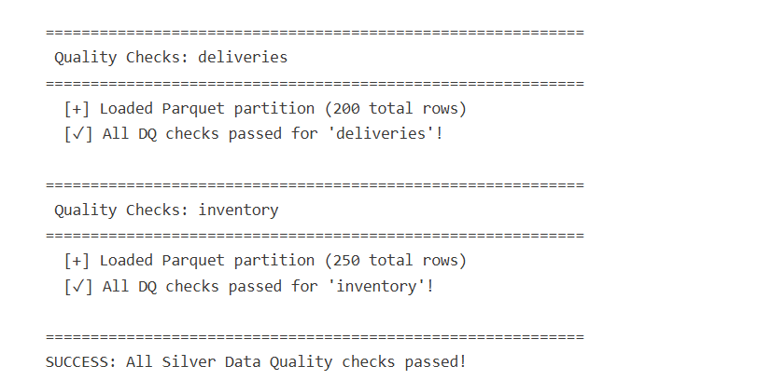
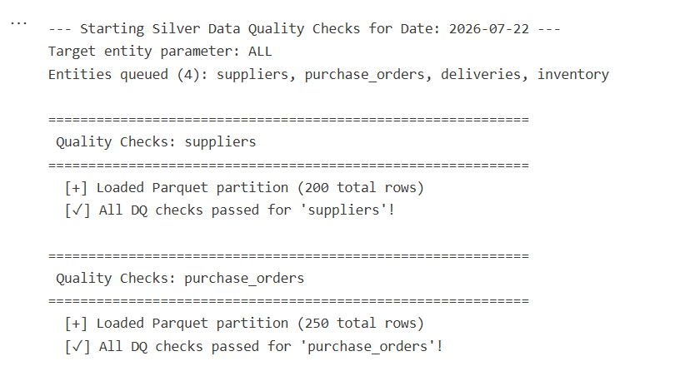
we try to create a log for this step to make sure everything is ok!!!!
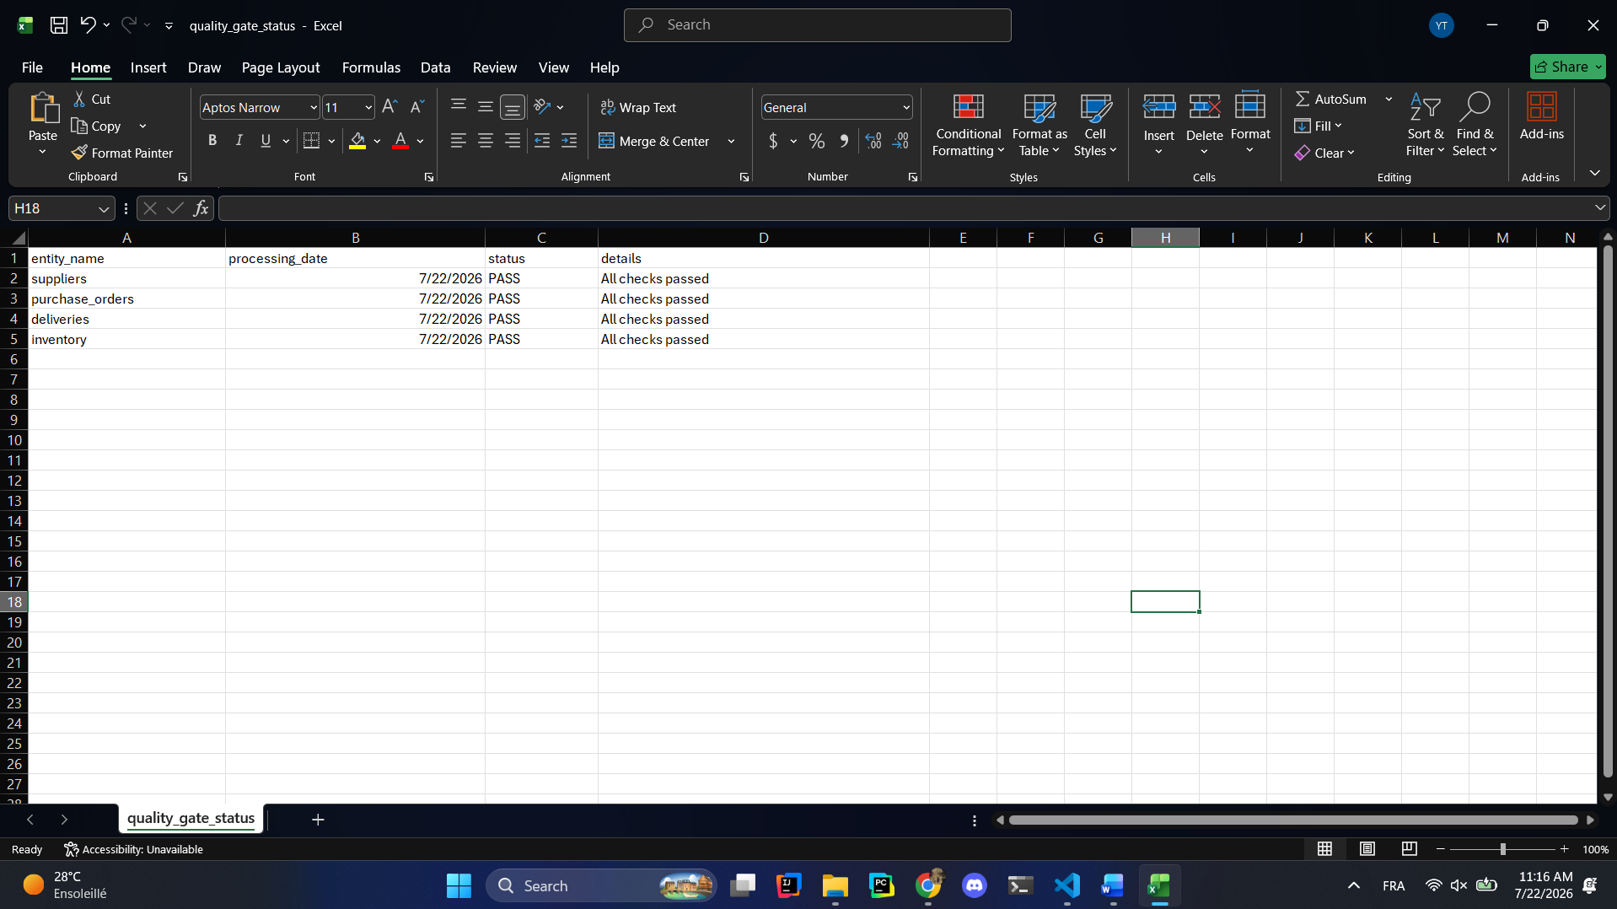
Now let us go and create the automated pipeline for those:
We need to check that the ingestion is good then we move to the automation to not waste the resources and get duplication and logic error:
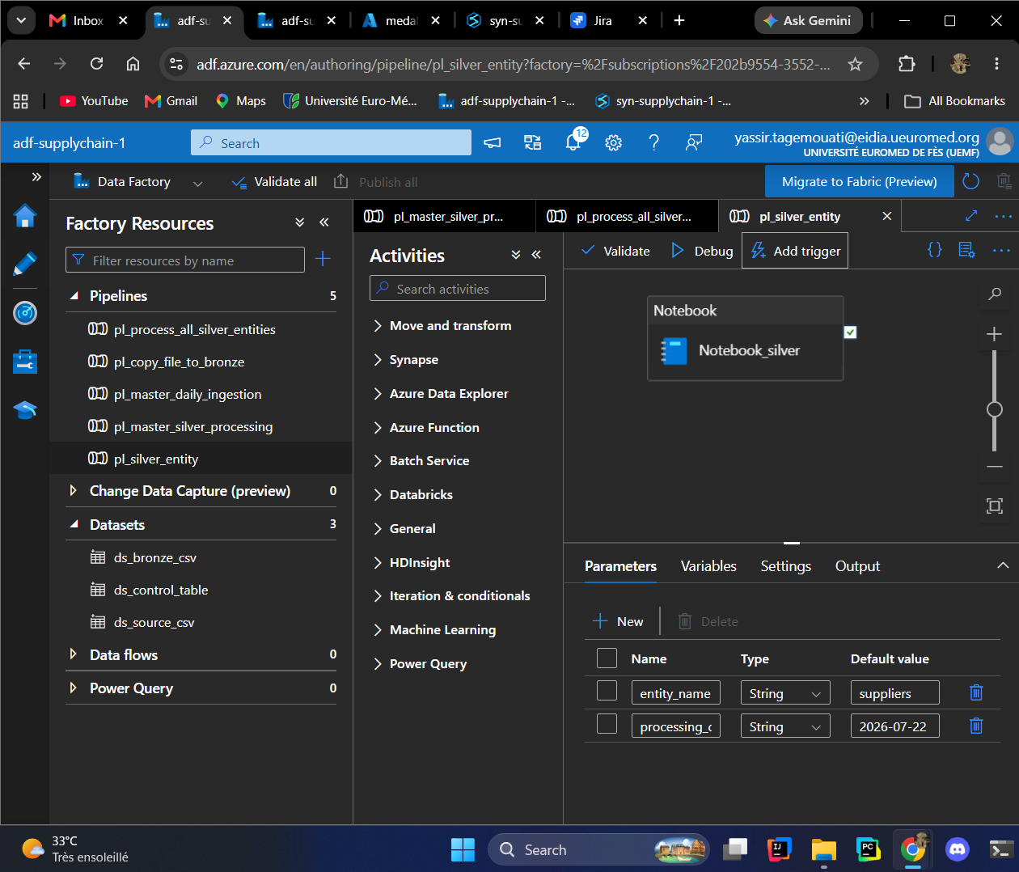
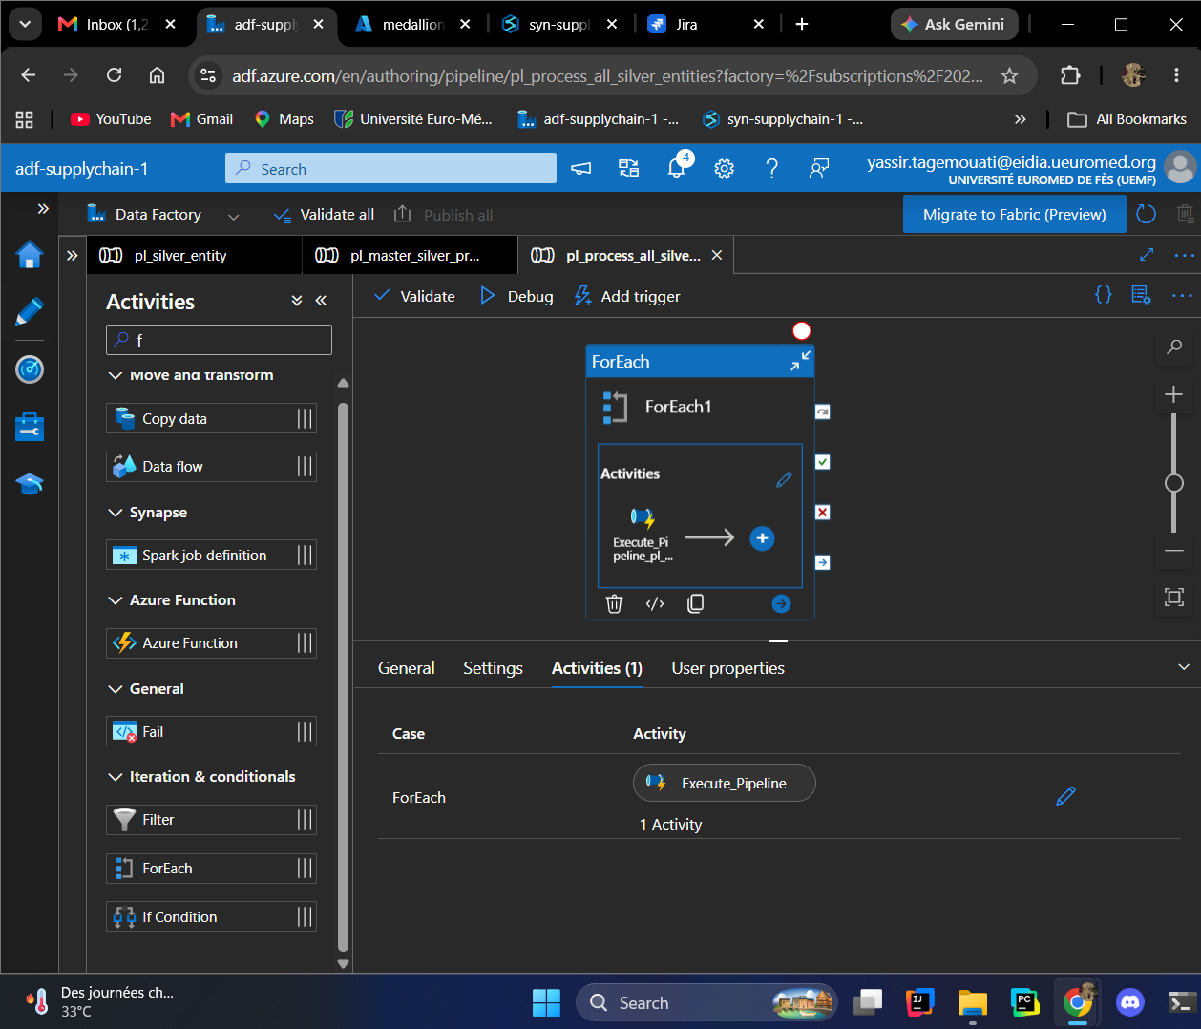
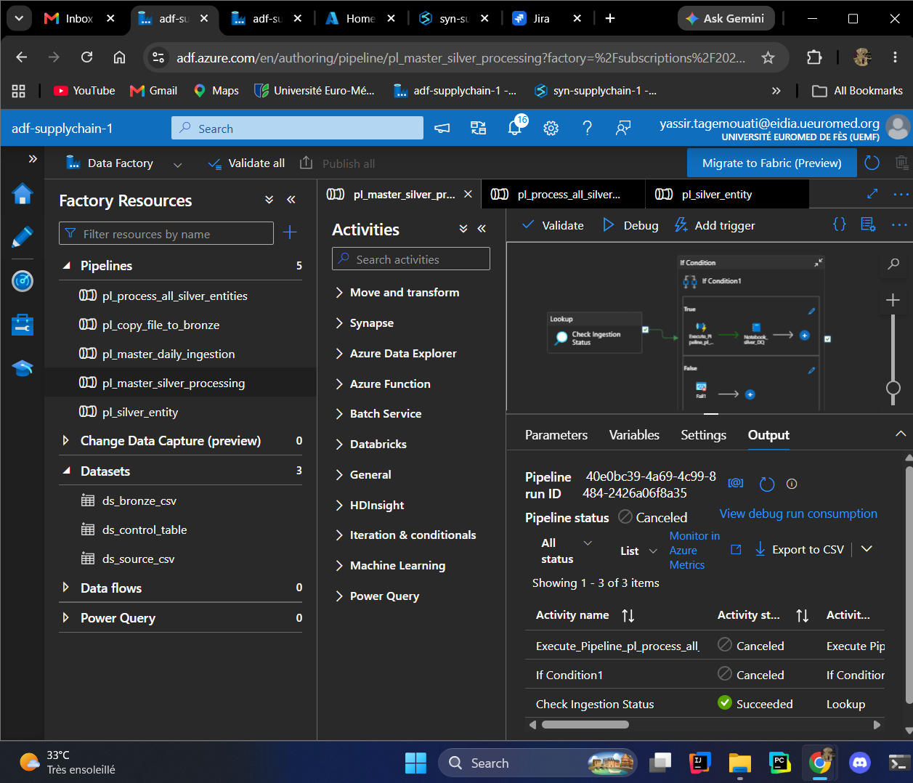

The azure forbids the nested loop so I was obliged to create a new pipeline containing!!!!!
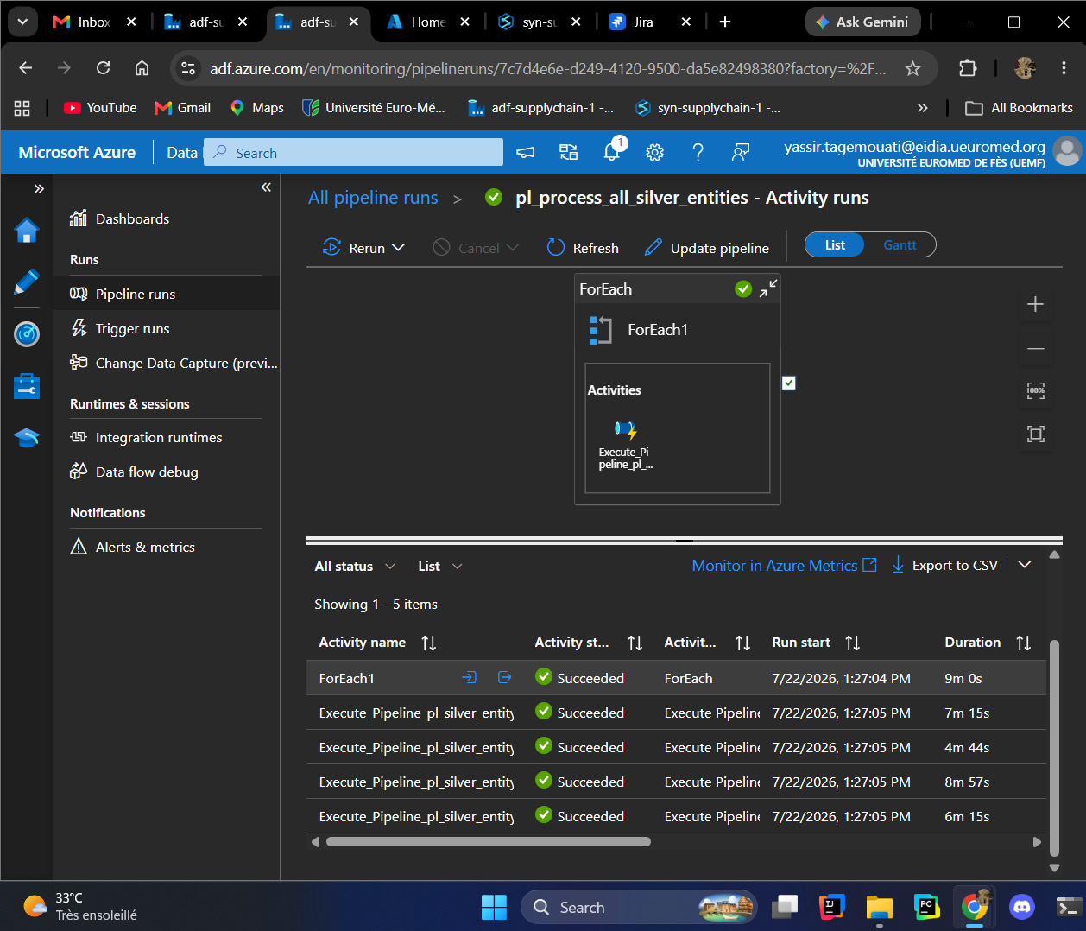
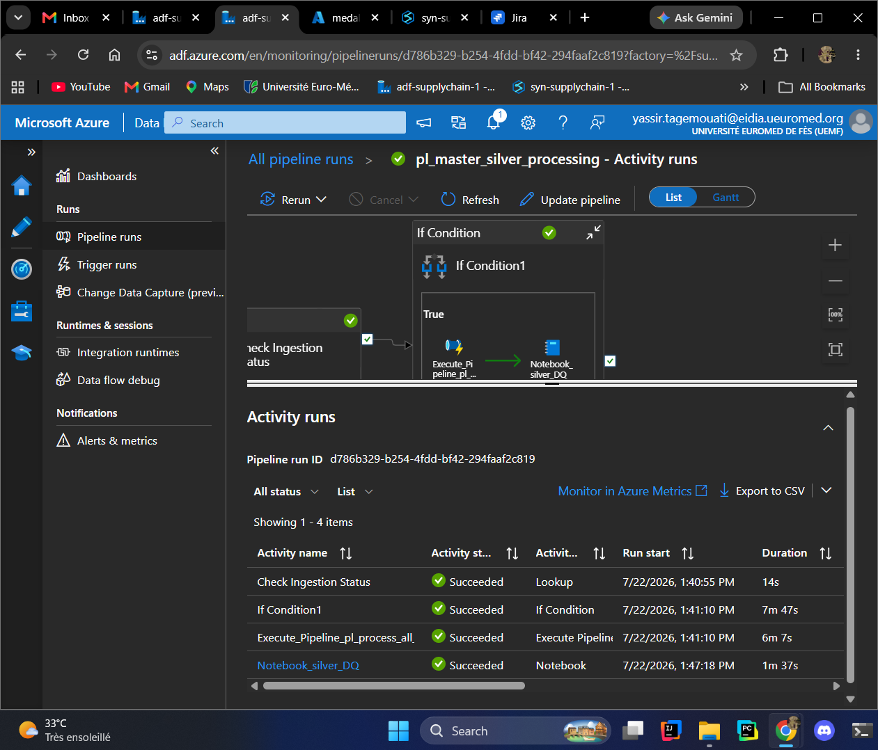
now for the trigger better than having a time trigger and restart all resources I will try to use the trigger is the execute of the bronze is finished so we make sure to consume less
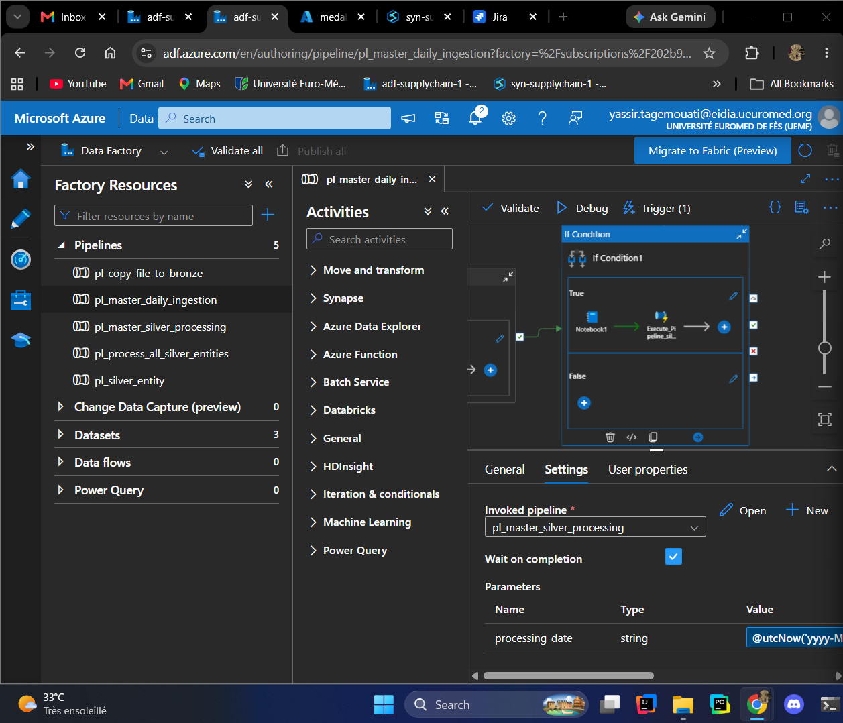
I added it to the automation of the daily ingest!!
The architecture I’m using is causing some problems of duplication!!
Now we will try to create the gold_db:
In the SQL I have */*/*/* which will accumulate the data and then it will need a very big computation power means you will need then more resources which we don’t have solution -> we create a fact_delevries_(date) generate a problem that we will have a nightmare of query to get all those list in same place means solution ->
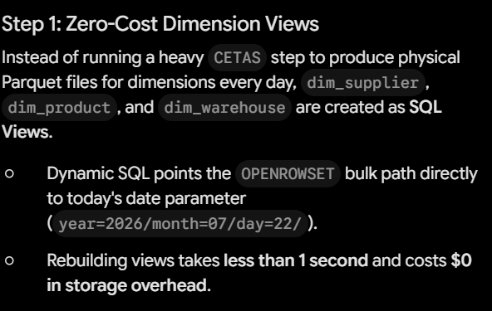
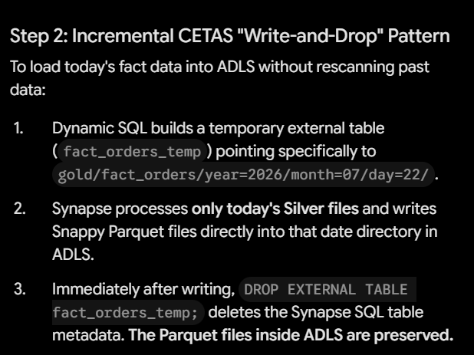
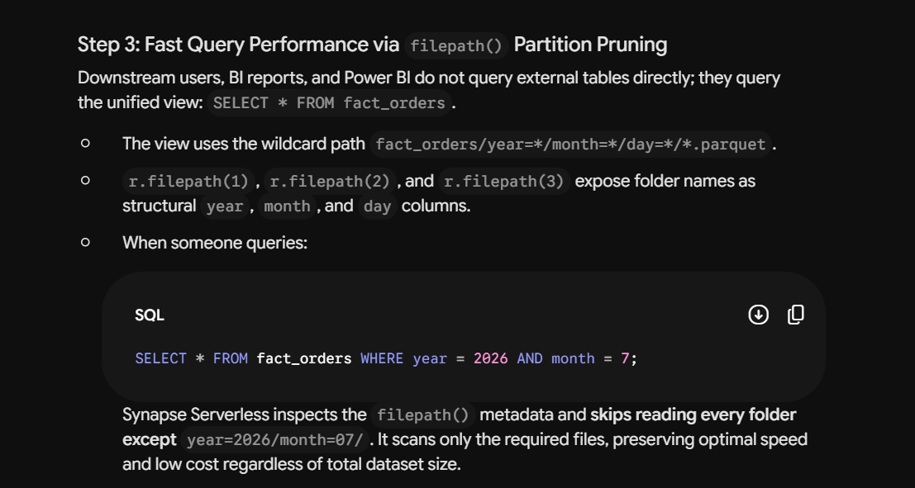
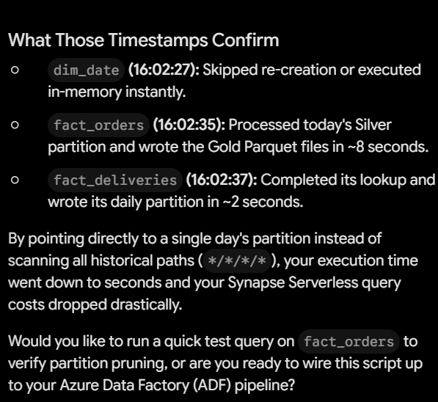
Add it to the pipeline:
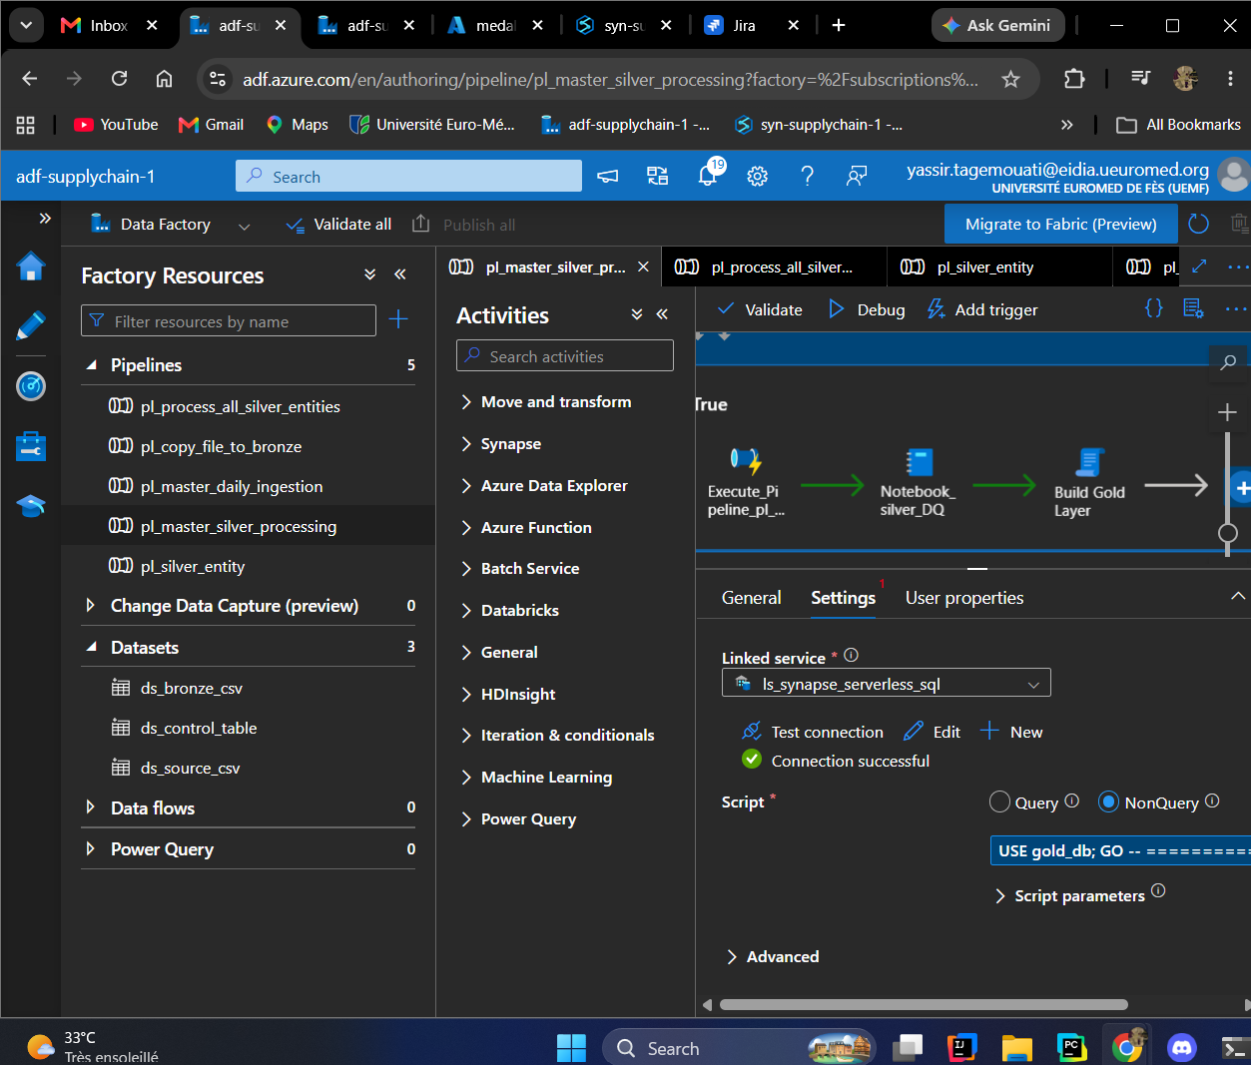
Now let us run a test and then activate the trigger for tomorrow!!!
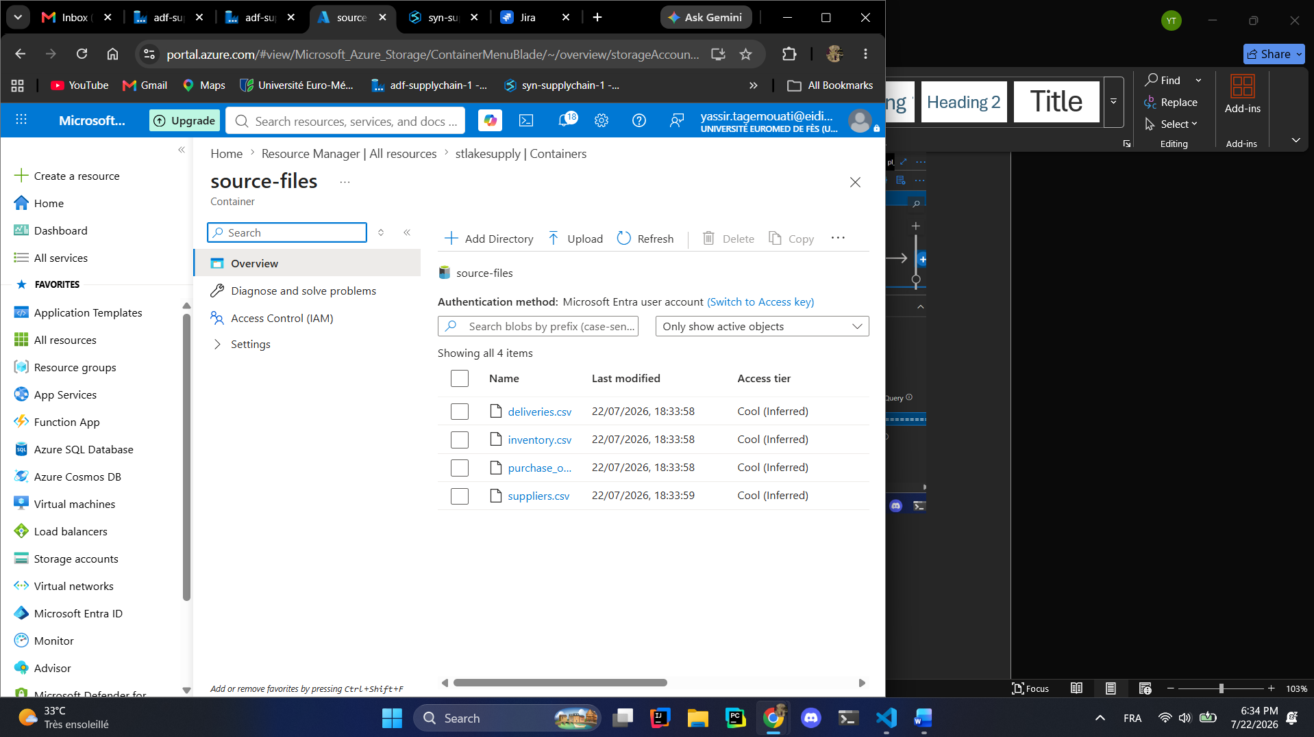
We wait:
See you tomorrow
