Steps to optimize the SQL queries:
if I have the dims saved and they grow in the calculations I will need to repeat all calculation for all the days to have a ready fact for query means too much cost on the spark pool
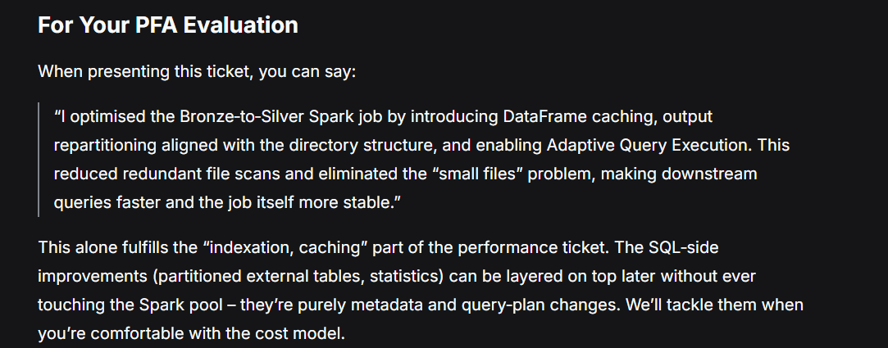
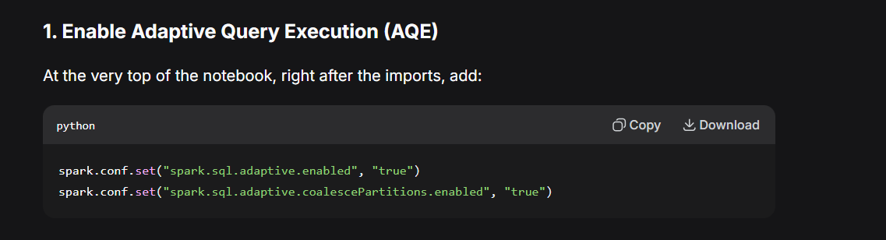
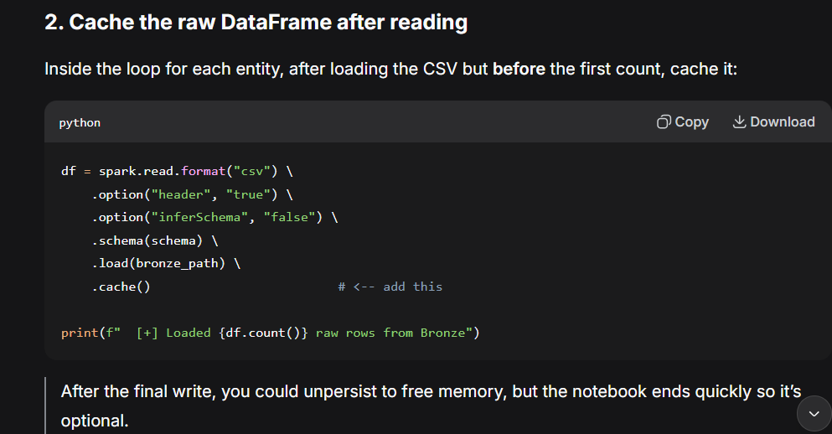
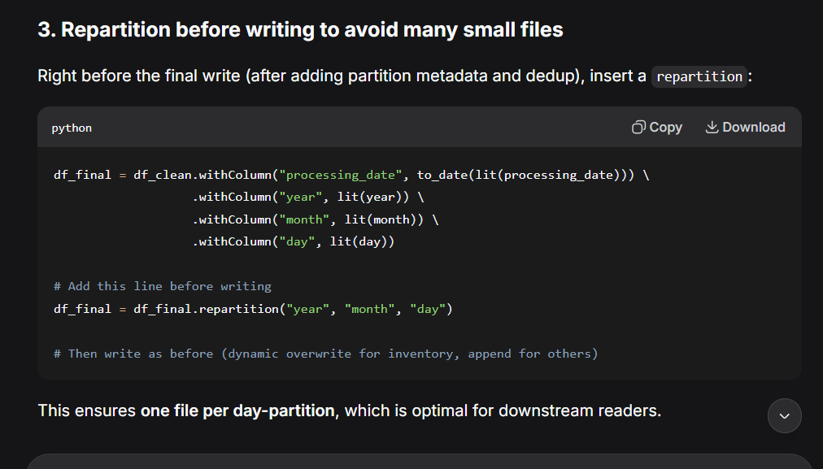
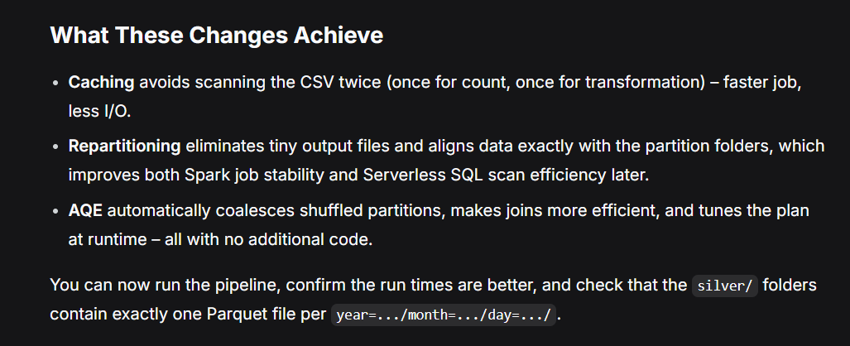
Optimized the transformation so now let us try to optimize the BI also:
