- docker compose down --remove-orphans
- docker rm -f namenode datanode

- The data is being downloaded from the backwebsite of the nasa –((https://ita.ee.lbl.gov/traces/))
- Run docker desktop first then use the command.
- To run docker: docker-compose up -d
docker-compose -f docker-compose.kafka.yml up -d
- docker exec -it kafka kafka-topics --create --topic nasa-logs --partitions 3 --replication-factor 1 --bootstrap-server localhost:9092
- docker exec -it kafka kafka-topics --list --bootstrap-server localhost:9092
- python kafka_producer.py --input "D:\nasa-bigdata-pipeline\access_log_combined" --topic nasa-logs --rate 1000 --broker localhost:9092the rate was asked by the teacher as exemple.
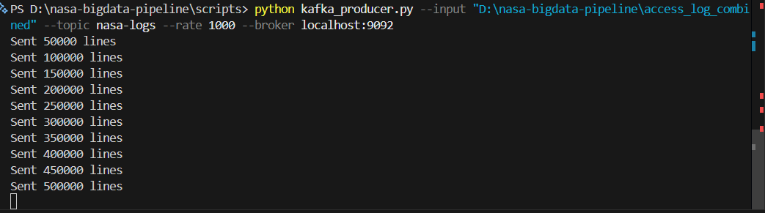
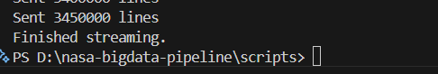
- python scripts\kafka_consumer_hdfs.py
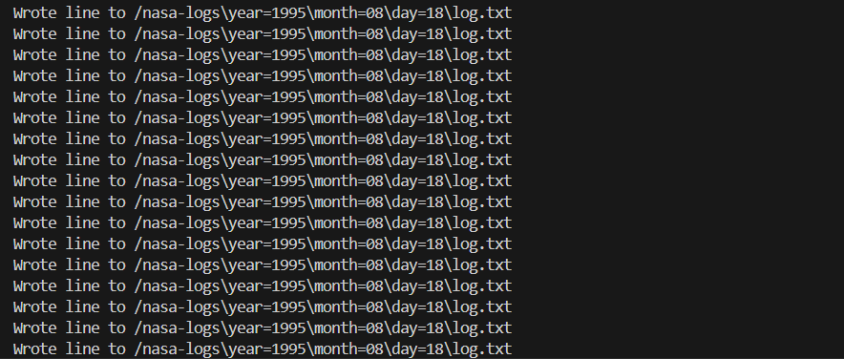
- We have multiple logs for the same day that is why we have a lot of logs writing.
to enter inside a container using cmd. (docker exec -it namenode bash).
- (rm /nasa-log-mr-1.0-SNAPSHOT.jar) to remove a file.
- docker cp D:\nasa-bigdata-pipeline\nasa-logs namenode:/tmp/nasa-logs to copy files in the namenode.
- Copy the temp files to the namenode before the datanode receive.
- Check if the nodes are on (hdfs dfsadmin -report).
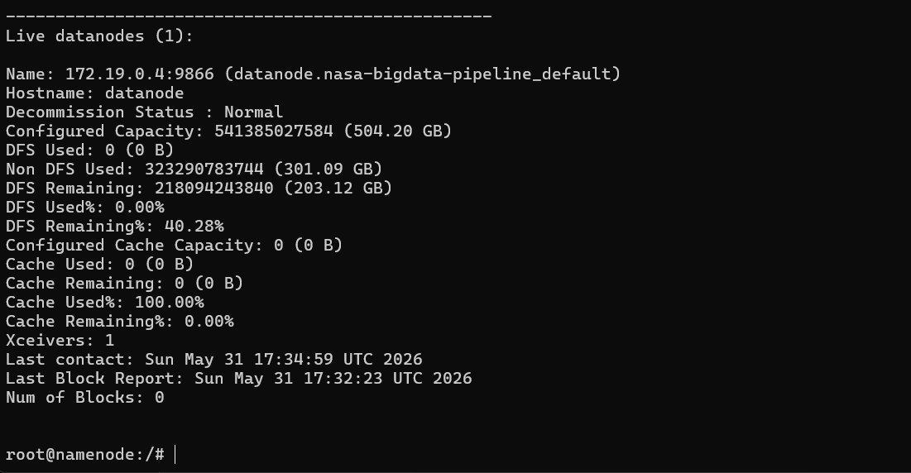
- Make sure to add on the namenode the conf of the hdfs:9000 or it will not work took for me 4 hours to solve.
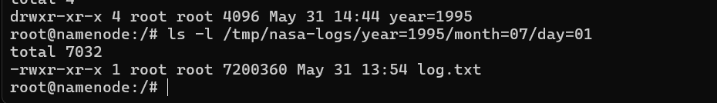
- Now we need to copy the files in the datanode.
- To check first we need to create only one subfolder of logs of 1 days and copy the logs to it and check if everything is ok before sending all the logs.
- (hdfs dfs -ls /nasa-logs/year=1995/month=07/day=01)
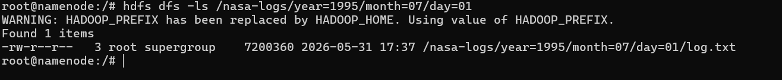
- Now the jar we created before and we pushed to the namenode we will be using.
- docker cp "C:\Users\fftt7\IdeaProjects\Nasa\target\nasa-log-mr-1.0-SNAPSHOT.jar" namenode:/root/nasa-log-mr-1.0-SNAPSHOT.jar
- Now we copy also all the folder of nasa logs to the datanodes.
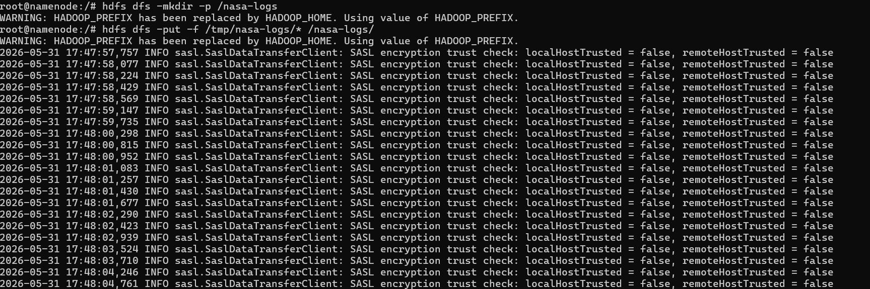
- # 1) Create the HDFS destination root
hdfs dfs -mkdir -p /nasa-logs

- # 2) Copy the whole local folder (recursive)
hdfs dfs -put -f /tmp/nasa-logs/* /nasa-logs/

- (hdfs dfs -ls -R /nasa-logs | head)
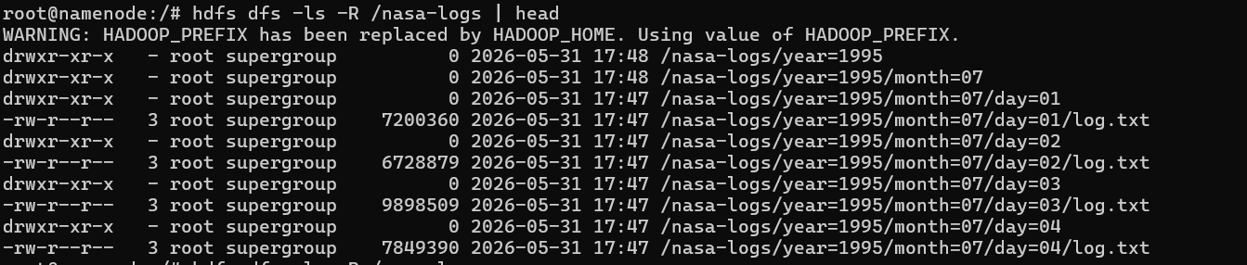
- hdfs dfs -rm -r -f /out/top-urls
- hadoop jar /root/nasa-log-mr-1.0-SNAPSHOT.jar nasa.TopURLsJob /nasa-logs/year=*/month=*/day=*/log.txt /out/top-urls
- in order to consider each file not the nasa-logs folder as a file.error using (hadoop jar /root/nasa-log-mr-1.0-SNAPSHOT.jar nasa.TopURLsJob /nasa-logs /out/top-urls)
- to check on the TopURL output: (hdfs dfs -cat /out/top-urls/part* | head -50).
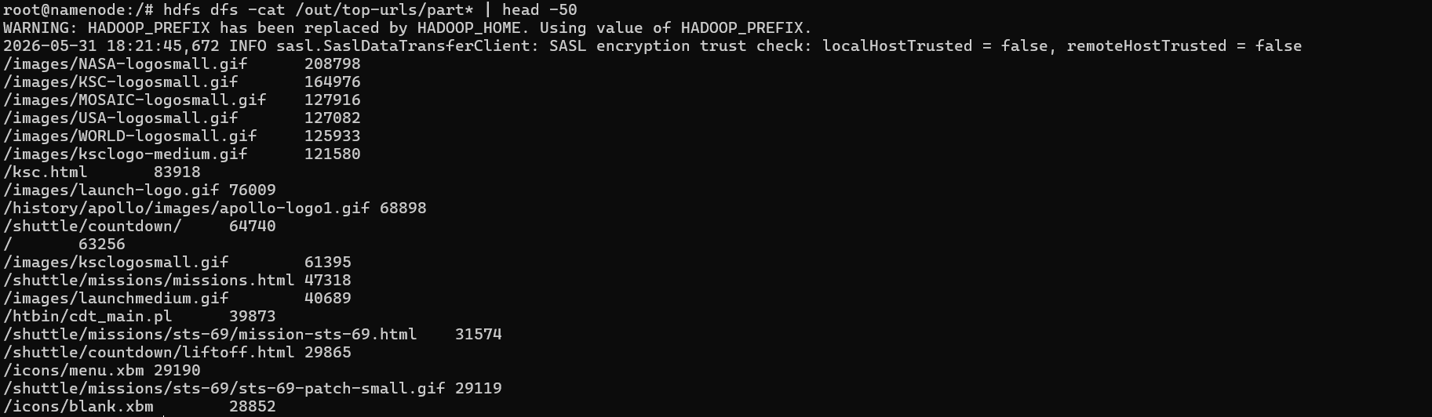
- hdfs dfs -rm -r -f /out/hourly-errors
- hadoop jar /root/nasa-log-mr-1.0-SNAPSHOT.jar nasa.HourlyErrorsJob /nasa-logs/year=*/month=*/day=*/log.txt /out/hourly-errors
- hdfs dfs -cat /out/hourly-errors/part* | head -50
- The job parses each web server log line to extract the request timestamp and HTTP status code, maps each record to the hour of day (00–23) when it occurred, and emits (hour, status). The reducer counts total, 200, 404, and 500 responses per hour and computes the hourly error rate as the percentage of 404+500 responses over all requests. The final output is one line per hour with counts for OK, 404, 500 and the formatted error rate (e.g., "HH\tok\t404\t500\terrRate%").
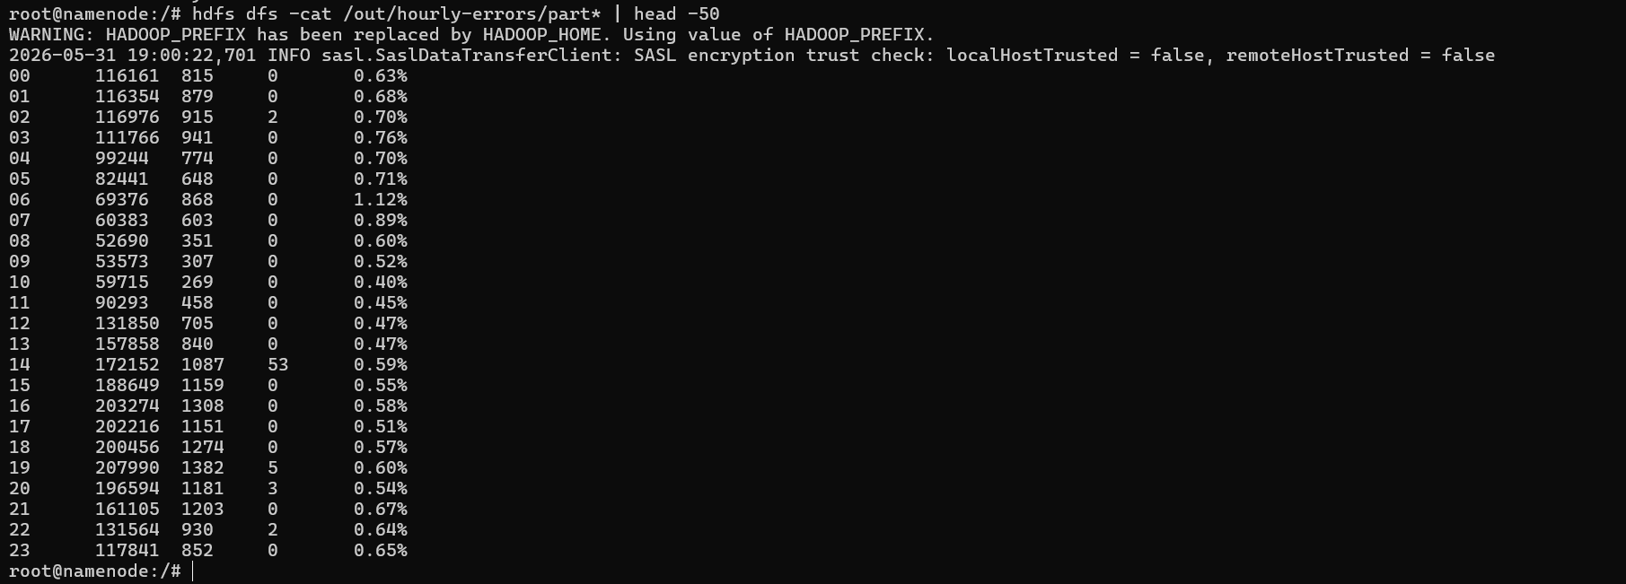
- Table structure: each data row is the reducer output for one hour (00–23). Columns are: hour, count of 200 OK responses, count of 404 responses, count of 500 responses, and the computed error rate as a percentage (404+500 divided by total requests for that hour). This matches the reducer output format in HourlyErrorsJob which writes hour then "ok\t404\t500\terrRate%".
- Example and interpretation: the row starting with "00" shows that during hour 00 there were ~116,161 successful (200) responses, 815 not-founds (404), 0 server errors (500), and an error rate of about 0.63%. The dataset shows much higher request volumes in daytime hours (midday/afternoon) and relatively low error rates overall (typically well under 1%), with a few hours slightly higher than others.
- hdfs dfs -rm -r -f /out/suspicious-ips
- hadoop jar /root/nasa-log-mr-1.0-SNAPSHOT.jar nasa.SuspiciousIPsJob /nasa-logs/year=*/month=*/day=*/log.txt /out/suspicious-ips
- hdfs dfs -cat /out/suspicious-ips/part* | head -50
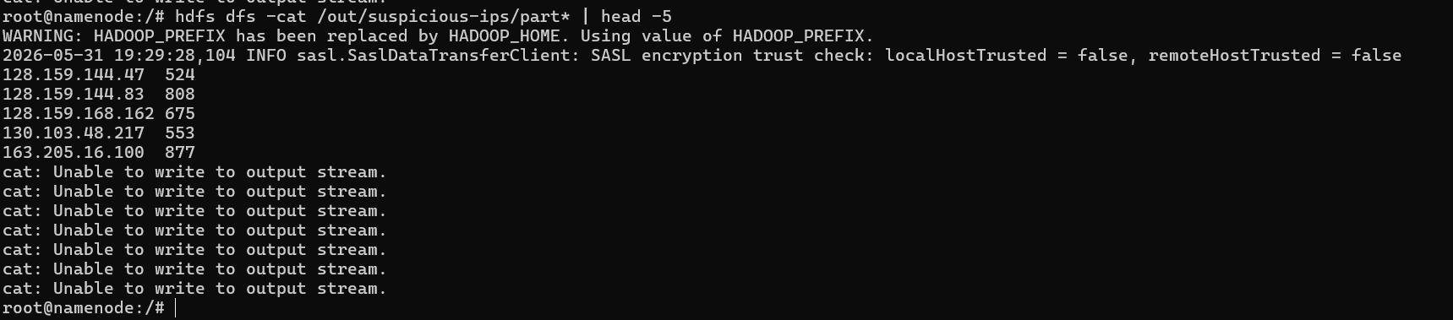
- The mapper parses each log line and emits only IPv4-looking hosts as keys with a count of 1.
- The custom partitioner groups keys by the third octet (rough /24 grouping using floorMod) so related IPs are sent to the same reducer, which sums counts per IP.
- The reducer writes out any IP with more than 500 requests, highlighting hosts that may be suspicious (bots, scrapers, or abusive clients).
- After creating the orchestration file use: (chmod +x jobs_orchestrator.sh)
To run (./jobs_orchestrator.sh).
Bonus:
To install results manually use (docker cp namenode:/results "C:\nasa-results")
Automatic:
I change the docker compose for automatic copy of the jar and automatic download of result:
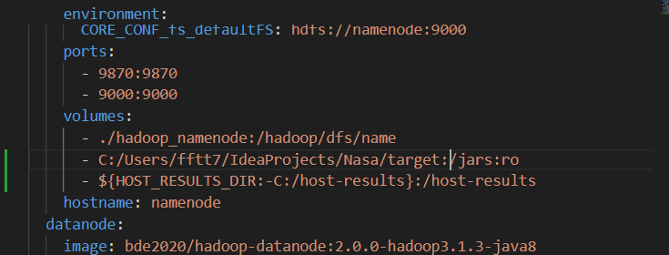
Results:
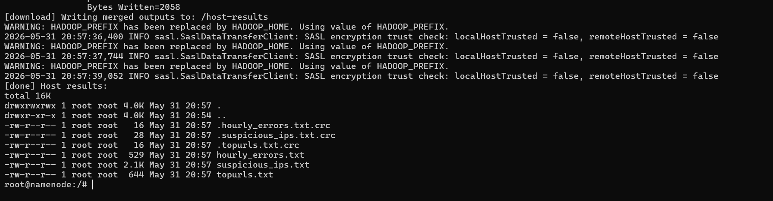
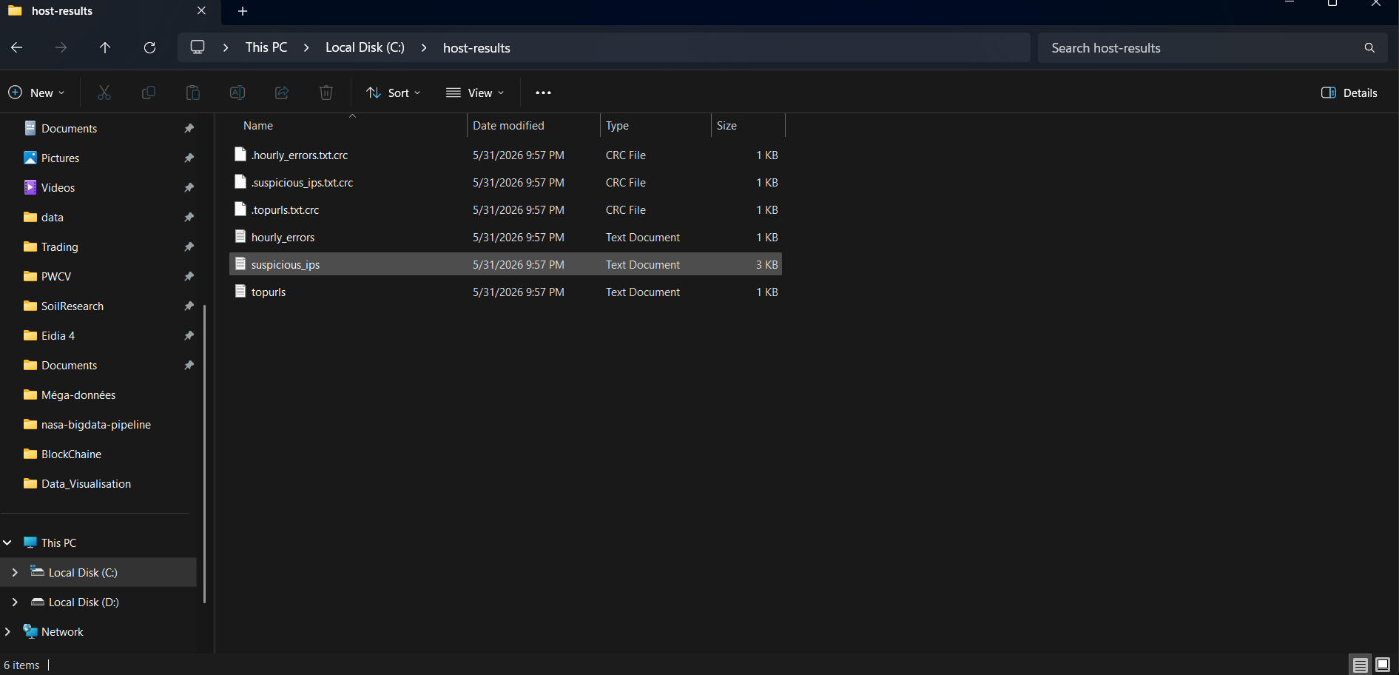

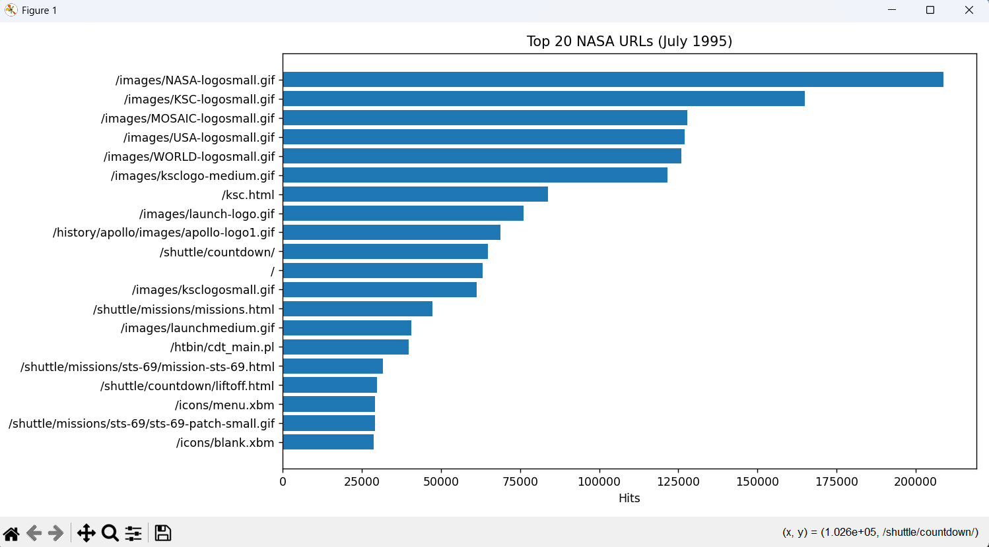
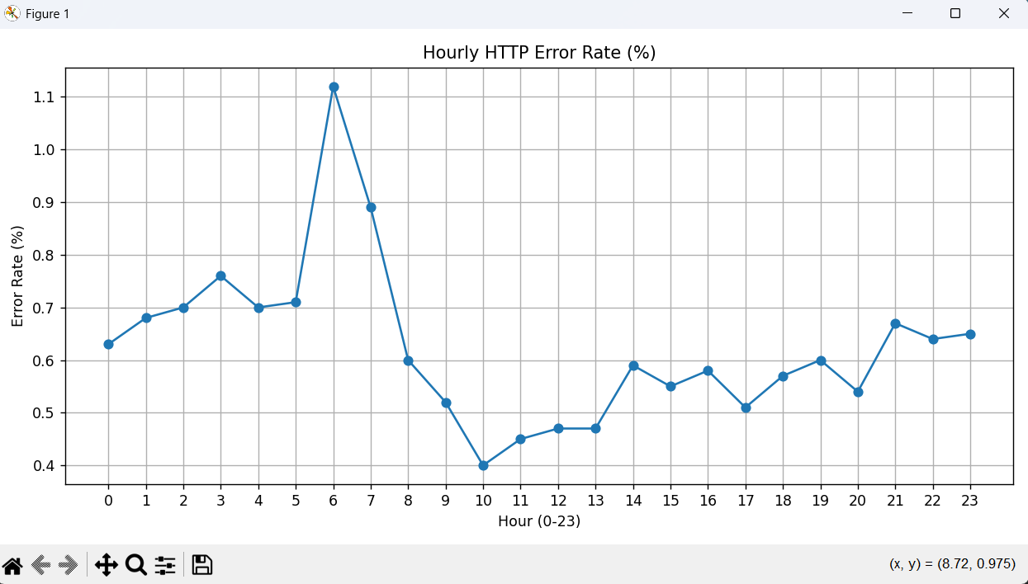
Higher rates of error at night more then day morning. (still can’t say nothing until we calculate the mean of all hours or split it to two parts from 00 to 11 and 12 to 23.

Install nano :

cat > /etc/apt/sources.list <<'EOF'
deb http://archive.debian.org/debian stretch main contrib non-free
deb http://archive.debian.org/debian-security stretch/updates main contrib non-free
EOF

cat /etc/apt/sources.list

apt-get -o Acquire::Check-Valid-Until=false update

apt-get install -y nano

apt-get install -y ca-certificates

