**1. Introduction**

**Choosing a Framework**

**Speak about ionic and any other framework.**

**Using PhoneGap to allow distribution on IOS and Android as apposed to a native app.**

**About my application**

**Small breakdown about the application**

**What makes it unique**

**2. Research**

**Setting up PhoneGap**

**PhoneGap desktop application**

The PhoneGap desktop application provides a simpler alternative to those who are not confident working on the command line. It is a visual user interface that requires simple tasks to get your first PhoneGap application setup and running. When initially testing my PhoneGap app with the desktop application the setup was fast and simple. However not long after the setup, the application continuously crashed and irregularly updated when prompted to. This is because the application is still in its beta stages.

**PhoneGap CLI**

The command line interface (CLI) states that it is the recommended platform to use if you are comfortable using the command line. Currently the CLI has additional features for building, running and packaging your application that are not yet available with the desktop application. I was not too familiar with the command line prior to this project. However the step-by-step install instructions are easy to follow and once it is setup, you maintain it with a single line of writing each time you begin working. I decided to continue to use the CLI because it took less processing power to run, it is faster to use, it is a good platform to learn and as stated before you gain additional features not available on the desktop application.

**Psychology of colours**

E-mu, which stands for emotional music, is a mobile music application that focuses on the users emotions. When designing the colour scheme for the application it was apparent that colours are widely used to portray emotion. A colours meaning, interpretation and perception are widely varied between different cultures. This makes it difficult to ensure every individual will feel the same emotion when shown a certain colour. The psychology behind colours can be very subjective, however there are proven links to colours and emotions that will be shared among a large percentage of humans. [1]

When selecting the colours for E-mu’s emotion playlists it was important to try and cater for the largest audience possible, this meant finding widely acknowledged emotional colours. By combining colours that across cultures represent the same emotion, can improve the emotional connection towards a colour for a greater number of users.[2]

**User tests**

**Screen grabs and information about the user tests I will do on Dom, Jemma and Daniela.**

**3. Design**

**Colour scheme**

**Angry**

The most common colours used globally to represent anger are: red, black and yellow. In the East, red is used to represent happiness and power, black is the colour commonly used to represent anger and evilness.[3] The combination of red and yellow are more globally recognised as anger.



The usage of black/red and vibrant red together in a radial gradient creates a dark and menacing background.

**Happy**

White, yellow and orange are the most commonly used colours to represent the emotion happiness. In the East, white represents death and sadness, whereas orange signifies happiness.



The combination of yellow and orange in a radial gradient makes this background seem calm and joyful.

**Calm**

**WRITE ABOUT THE COLOURS FOR BEING CALM**



**Sad**

The colours most frequently used for this emotion are blue, purple and white. In the East, blue is used to represent life and immortality. It also is commonly regarded as a feminine colour. Purple is used to signify sorrow and mourning.



The mix of dark blue and light blue in a radial gradient gives the feeling of sombreness and being alone.

**Loving**

Pink and red are quite globally regarded as colours to represent passion and love. In South Africa, the colour red is used to signify mourning. [4]



The combination of red and pink in this radial gradient gives the background a warm and loving feeling.

**Typography**

When choosing the fonts for each emotion in my application, it was important to portray each emotion through the corresponding typography. Once the font was selected it would then be converted into a web-safe font using font squirrels web-font generator [5]. The web-font generator allows you to convert standard font file types (.ttf, .eot, .woff) into web-safe fonts and produces the relevant CSS code block to allow for easy use. You must ensure the fonts used are eligible to be converted before doing so.

**Anger**



Helv children was the font used for the emotion anger. It is a large, bold and aggressive font that when combined with the deep red coloured background conveyed a feeling of anger.

**Joy**

Oduda is the font used for the emotion joy. Oduda is a large, bold, rounded and friendly font that gives the user a feeling of joy when complementing and yellow background.



**Relaxation**

Moon is the font used for the emotion relaxation. Moon is a clean, thin and simplistic typography that flows well and allows the user to feel comfortable and calm with the security of not having any intrusive text.

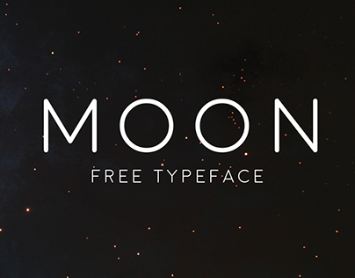

**Sadness**



Underwood champion is the text used for the emotion sadness. It is a

**Love**



Fonarto is the text used for the emotion sadness.

**Icons**

**Anger**

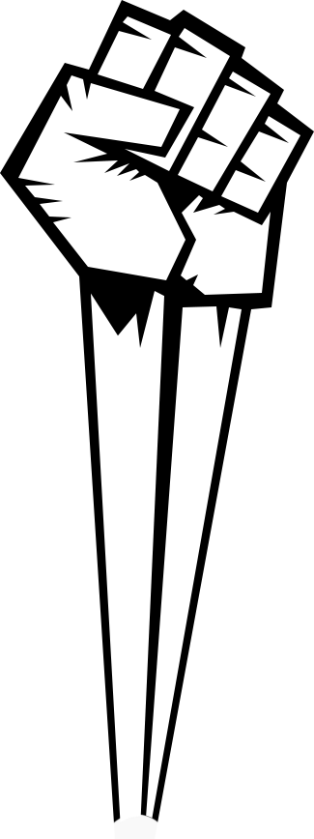

**Joy**

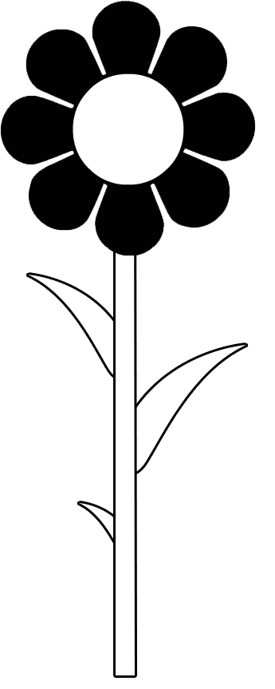

**Relaxation**

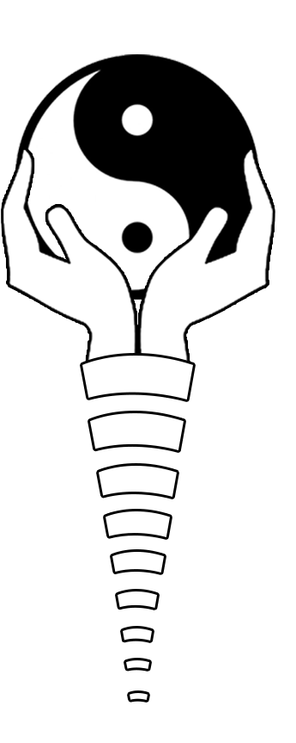

**Sadness**

**Love**



**4. Development**

**Debugging the application in real-time**

**Weinre**

Weinre was the tool chosen to debug the mobile application. It is used as a remote web inspector to allow the developer to remotely debug a mobile app through their computer browser.[6] Unfortunately this method of debugging was not integrated with my mobile application well enough. It did not have a virtual example of my application, therefor I had to solely test on the mobile device and check the browser console logs. It did not allow stepping through with the source files.

**Ripple**

Ripple is an open source debugger extension for Google Chrome. It allows the user to test their mobile application in the browser by emulating a mobile device. You can view your mobile application in the browser and fully inspect it using any standard web inspector. Ripple has an informative interface to allow users to get the best experience out of Ripple possible. The emulator treats the mobile application as a standard web application, allowing the developer to debug as thorough as they would a web application.

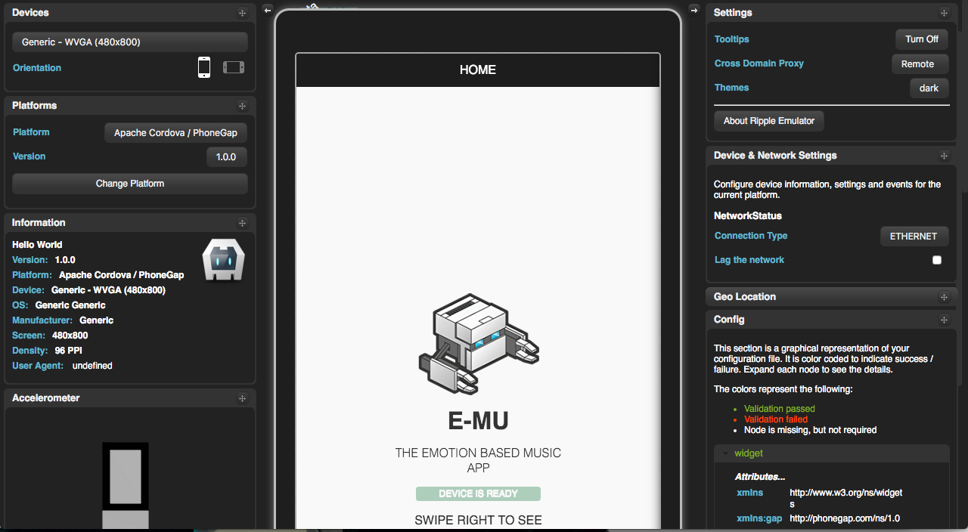

**Adding touch sensitive swipe gesture to app.**

Jquery mobile was implemented to allow touch sensitive gestures to be used throughout the mobile application. Adding touch sensitive swipe gestures allowed for streamline navigation throughout the application.

**Soundcloud API/SDK**

**Reason for not using Deezer anymore**

**Reason for choosing Soundcloud SDK**

**Using get request to access soundcloud playlists and select the tracks**

**Using SC.oembed to display the player from soundcloud**

**Function to not repeat skipped song until all have been used up.**

**What will the application evolve to become?**

**Login system to hold personal information**

**The ability to like and dislike songs to personalise your experience**

**Maybe the ability to make your own playlists**

**Bibliography**

Adobe PhoneGap. (2016). *Debugging.* Available: http://docs.phonegap.com/references/developer-app/debugging/. Last accessed 24th Feb 2016.

Art Therapy. (2016). *Color Psychology: The Emotional Effects of Colors.* Available: http://www.arttherapyblog.com/online/color-psychology-psychologica-effects-of-colors/#.VvFb9hKLSRs. Last accessed 22nd March 2016.

Colour affects. (2008). *Psychological Properties Of Colours.* Available: http://www.colour-affects.co.uk/psychological-properties-of-colours. Last accessed 22nd March 2016.

Changing minds. (2008). *The Meaning of Colors.* Available: http://changingminds.org/disciplines/communication/color_effect.htm. Last accessed 22nd March 2016.

Font squirrel. (2016). *Webfont generator.* Available: https://www.fontsquirrel.com/tools/webfont-generator. Last accessed 3rd April 2016.

1. Art Therapy. (2016). *Color Psychology: The Emotional Effects of Colors.* Available: http://www.arttherapyblog.com/online/color-psychology-psychologica-effects-of-colors/#.VvFb9hKLSRs. Last accessed 22nd March 2016.
2. Colour affects. (2008). *Psychological Properties Of Colours.* Available: http://www.colour-affects.co.uk/psychological-properties-of-colours. Last accessed 22nd March 2016.
3. Changing minds. (2008). *The Meaning of Colors.* Available: http://changingminds.org/disciplines/communication/color_effect.htm. Last accessed 22nd March 2016.
4. Changing minds. (2008). *The Meaning of Colors.* Available: http://changingminds.org/disciplines/communication/color_effect.htm. Last accessed 22nd March 2016.
5. Font squirrel. (2016). *Webfont generator.* Available: https://www.fontsquirrel.com/tools/webfont-generator. Last accessed 3rd April 2016.
6. Adobe PhoneGap. (2016). *Debugging.* Available: http://docs.phonegap.com/references/developer-app/debugging/. Last accessed 24th Feb 2016.