Exercise 1: Backend Thinking

Question 1 — Backend operations of a daily app (WhatsApp)
When you tap Send on a WhatsApp message, the backend does the following:
- Authentication check — The server verifies your identity using your session token to confirm you are a logged-in user before processing anything.
- Message delivery routing — The server looks up the recipient's account and determines which device(s) to deliver the message to, including handling multiple devices.
- Message persistence — The message is saved to a database temporarily until delivery is confirmed. If the recipient is offline, it is queued for later delivery.
- End-to-end encryption processing — The backend handles key exchange and encrypted message packaging so only the sender and recipient can read the content.

Question 2 — Hospital Patient Management System
Data the backend would need to store:
Patients
Staff
Appointments
Prescriptions
Billing

Business rules to implement:
- A patient can only book an appointment with a doctor who is available at that time slot — no double-booking.
- A patient can have 0 or many billings
- Only a registered doctor can create or modify prescriptions.
- Access control patients can view their own records only; doctors can view records of their patients

Question 3 — Frontend or Backend?
Feature | Responsibility
Displaying a user's profile photo | Frontend
Checking if a username is already taken during registration | Backend
Sending a password reset email | Backend
Showing a loading spinner while data is being fetched | Frontend
Calculating the total price of items in a shopping cart | Both
Encrypting a user's password before storing it | Backend

Exercise 2: HTTP & APIs

Part A — Match the HTTP Method
Action | HTTP Method
Viewing your bank account balance | GET
Creating a new social media account | POST
Changing your profile picture | PUT
Removing a product from your shopping cart | DELETE
Searching for a book on an online store | GET
Submitting a job application form | POST
Updating your delivery address | PUT
Unsubscribing from a mailing list | DELETE

Part B — HTTP Status Code Scenario
Scenario | Status Code
You successfully log in to your account | 200 OK
You try to access a page that has been removed | 404 Not Found
You submit a form but forget required fields | 400 Bad Request
The server crashes while processing your request | 500 Internal Server Error
You try to view private messages without being logged in | 401 Unauthorized
You successfully register a new account | 201 Created

Part C — Write JSON
1. A Book
{
"title": "Things Fall Apart",
"author": "Chinua Achebe",
"yearPublished": 1958,
"numberOfPages": 209,
"isAvailable": true
}
2. A Student
{
"name": "David Mugisha",
"registrationNumber": "2024/CS/001",
"course": "Computer Science",
"yearOfStudy": 2,
"subjects": [
"Data Structures", "Algorithms", "Database Systems"
]
}
3. A Mobile Money Transaction
{
"senderPhoneNumber": "0771234567",
"receiverPhoneNumber": "0782345678",
"amount": 50000,
"currency": "UGX",
"timestamp": "2025-07-17T14:32:00Z"
}

Exercise 3: Command Line Practice

Part A — Getting Started (Practical)

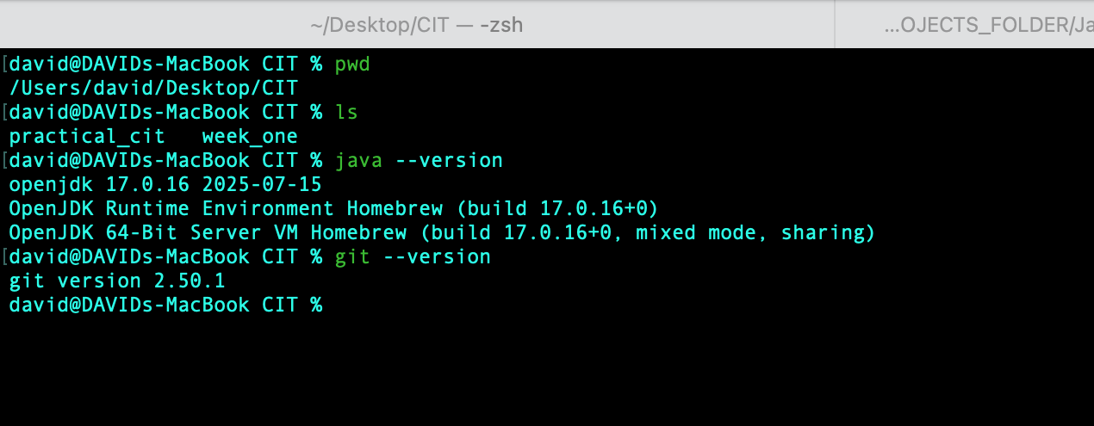

d

Part B — Build a Project Structure (Practical)
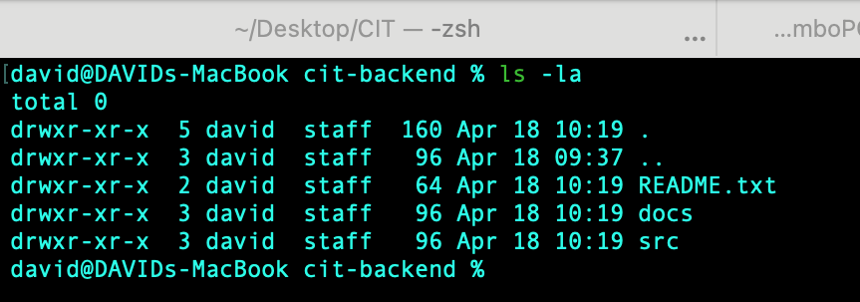

Exercise 4: Bonus Challenge — EduTrack School Management System

1. Five Types of Data (Resources)
- Students
- Teachers
- Classes
- Attendance
- Results

2. Sample JSON Objects
Student
{
"id": 1,
"fullName": "Grace Nakato",
"registrationNumber": "STU-2025-0042",
"dateOfBirth": "2005-03-14",
"gender": "Female",
"classId": 10,
"isActive": true
}
Teacher
{
"id": 5,
"fullName": "Mr. James Opio",
"staffNumber": "TCH-0017",
"subjects":
[
"Mathematics", "Physics"
],
"email": "james.opio@edutrack.ug",
"isActive": true
}
Class / Course
{
"id": 10,
"className": "Senior 3 East",
"teacherId": 5,
"schedule": "Mon/Wed/Fri 08:00-09:00",
"capacity": 40,
"enrolledCount": 35
}
Attendance
{
"id": 302,
"studentId": 1,
"classId": 10,
"date": "2025-07-17",
"status": "present"
}
Result / Grade
{
"id": 88,
"studentId": 1,
"courseId": 10,
"assessmentType": "End of Term Exam",
"score": 76,
"grade": "B",
"term": "Term 1 2025"
}

3. API Endpoints for the Students Resource
HTTP Method | URL Path | What It Does | Success Code | Failure Code(s)
GET | /students | Retrieves a list of all students in the system. | 200 OK | 500 if server error
POST | /students | Creates and registers a new student record. | 201 Created | 400 if invalid data
PUT | /students/{id} | Updates an existing student's details. | 200 OK | 404 if not found, 400 if bad data

5. Project Folder Structure (Practical)

