# A Project Report on

Tracking Workplace Condition To

Ensure Employee Safety In

Warehouse

Submited to Smart Bridge

By:

Satish Kona 18481A0246

Tagore Rao Kosireddy 18481A0248

Vijay Kumar Kommu 18481A0245

Yedukondala Naga Sai Vinay Kotari 18481A0250

Vijay Babu Kowju 18481A0252



Under the guidance of Mr. Rammohan

Lead – Artiﬁcial Intelligence at SmartBridge Educational Services Pvt. Ltd

Table of Contents:

|  |  |  |
| --- | --- | --- |
| **S**  **No** | **TOPIC** | **PAGE No** |
| **1** | **ABSTRACT** | **3** |
| **2** | **INTRODUCTION** | **4** |
| **3** | **LITERATURE SURVEY** | **5-6** |
| **4** | **THEORETICAL ANALYSIS** | **7** |
| **5** | **EXPERIMENTAL INVESTIGATIONS** | **8-9** |
| **6** | **FLOWCHART** | **10** |
| **7** | **RESULT** | **10-11** |
| **8** | **ADVANTAGES AND DISADVANTAGES** | **11-12** |
| **9** | **APPLICATIONS** | **12** |
| **10** | **FUTURE SCOPE** | **13** |
| **11** | **CONCLUSION** | **13** |
| **12** | **BIBLIOGRAPHY** | **13** |

# Abstract:

Visual examination of the workplace and in-time reminder to the failure of wearing a safety helmet is of particular importance to avoid injuries of workers at the construction site. Video monitoring systems provide a large amount of unstructured image data on-site for this purpose, however, requiring a computer vision-based automatic solution for real-time detection. Although a growing body of literature has developed many deep learning-based models to detect helmets for the traﬃc surveillance aspect, an appropriate solution for the industry application is less discussed in view of the complex scene in the warehouse. In this regard, we develop a deep learning-based method for the real-time detection of a safety helmet at the storage facilities. The presented model uses the algorithm that is based on convolutional neural networks.

A dataset containing 180 images of safety helmets collected from two sources, i.e., manual capture from the video monitoring system at the workplace and open images obtained using web crawler technology, is established. The image set is divided into a training set, , and test set, with a sampling ratio of nearly 2: 1. The experiment results demonstrate that the presented deep learning- based model is capable of detecting the unsafe operation of failure of wearing a helmet at the construction site, with satisfactory accuracy and eﬃciency.

# Introduction:

Warehouse maintenance is a high-risk job where workers tend to be hurt in the work process. Head injuries are very serious and oGen fatal. According to the accident statistics released by the state administration of work safety from 2015 to 2018, among the recorded 78 Industry accidents, 53 events happened owing to the fact that the workers did not wear safety helmets properly, accounting for 67.95% of the total number of accidents.

In safety management at the work site, it is essential to supervise the safety protective equipment wearing condition of the workers. Safety helmets can bear and disperse the hit of falling objects and alleviate the damage of workers falling from heights. Workers tend to ignore safety helmets because of weak safety awareness. Traditional supervision of the workers wearing safety helmets on site oGen requires manual work. These factors make manual supervision diﬃcult and ineﬃcient and it is diﬃcult to track and manage the whole workers at the warehouses accurately in real time. Hence, it is hard to satisfy the modern requirement of safety management only relying on the traditional manual supervision. In this context, it remains a signiﬁcant issue to study on the automatic detection and recognition of safety helmets wearing conditions.

The automatic monitoring method can contribute to monitoring the workers and conﬁrm the safety helmet wearing conditions at the warehouse. In particular, considering that the traditional manual supervision of the workers is oGen costly, time-consuming, error-prone, and not suﬃcient to satisfy the modern requirements of construction safety management, the automatic supervision method can be beneﬁcial to real-time on-site monitoring.

# Literature Survey:

At present, previous studies of safety helmet detection can be divided into three parts, sensor-based detection, machine learning-based detection, and deep learning-based detection. Sensor-based detection usually locates the safety helmets and workers. The methods usually use the RFID tags and readers to locate the helmets and workers and monitor how personal protective equipment is worn by workers in real time. Kelm et al. designed a mobile Radio Frequency Identiﬁcation (RFID) portal for checking personal protective equipment (PPE) compliance of personnel. However, the working range of the RFID readers is limited and the RFID readers can only suggest that the safety helmets are close to the workers but unable to conﬁrm that the safety helmets are being properly worn.

Up to date, machine learning-based object detection technologies are widely used in many domains for its powerful object detection and classiﬁcation capacity. Remarkable studies are made by Rubaiyat et al. , who proposed an automatic detection method to obtain the features of construction workers and safety helmets and detect safety helmets. The method combines the frequency domain information of the image with the histogram of oriented gradient (HOG) and the circle Hough transform (CHT) extractive technique to detect the workers and the helmets in two steps. The detection methods based on machine learning can detect safety helmets accurately and precisely under various scenarios but also have some drawbacks. Sometimes the method can only detect safety helmets with a speciﬁc color and it is diﬃcult to distinguish the hats with similar color and shape to the safety helmets. Moreover, the method cannot detect faces and safety helmets thoroughly under some circumstances; for example, some workers do not turn their faces towards the camera at the construction site.

Deep Learning-Based Object Detection

The above mentioned methods are commonly based on traditional machine learning to detect and classify the helmets and choose features artiﬁcially with a strong subjectivity, a complex design process, and poor generalization ability. In recent years, with the rapid development of deep learning technology, the object detection algorithm turns to the one based on convolutional neural networks with a great promotion of speed and accuracy.

The methods construct convolutional neural networks with diﬀerent depths to detect safety helmets. Some other strategies such as multi-scale training, increasing the number of anchors and introducing the online hard example mining, are added to increase the detection accuracy. However, these methods have some limitations in the preprocessing aspects of image sharpness, object proportion, and the colour diﬀerence between background and foreground.

Considering its excellent ability to extract features, in the paper, we use the convolutional neural network (CNN) to build a safety helmet detection model. Automatic detection of safety helmets worn by construction workers at the construction site and timely warning of workers without helmets can largely avoid accidents caused by workers wearing safety helmets improperly. The CNN is trained using the Tensor Flow framework. The contributions of the research include a deep learning-based safety helmet detection model and a safety helmet image dataset for further research. The model provides an opportunity to detect the helmets and improve safety management.

Deep learning-based methods are commonly used to detect unsafe behaviors on-site. Nevertheless, many traditional measures of safety helmet detection are commonly sensor-based and machine-based, thus limited by problems such as sensor failure over long distances, the manual and subjective features choice, and the chaotic scene interference. Based on the previous studies, we present a deep learning-based method to detect the safety helmets in the workplace, which is supposed to avoid the above mentioned limitations.

# Theoretical Analysis:

A convolutional neural network (CNN) is a multilayer neural network. It is a deep learning method designed for image recognition and classiﬁcation tasks. It can solve the problems of too many parameters and diﬃcult training of the deep neural networks and can get better classiﬁcation eﬀects. The structure of most CNN’s consists of input layer-convolutional layer (Conv layer)-activation function-pooling layer-fully connected layer (FC layer). The main characteristics of CNN’s are local connectivity and parameter sharing in order to reduce the number of parameters and increase the eﬃciency of detection.

The Conv layer and the pooling layer are the core parts, and they can extract the object features. OGen, the convolutional layer and the pooling layer may occur alternately. The Conv layers can extract and reinforce the object features. The pooling layers can ﬁlter multiple features, remove the unimportant features, and compress the features. The activation layers use non-linear activation functions to enhance the expression ability of the neural network models and can solve the non-linear problems eﬀectively. The FC layers combine the data features of objects and output the feature values. By this means the CNN’s can transfer the original input images from the original pixel values to the ﬁnal classiﬁcation conﬁdence layer by layer.

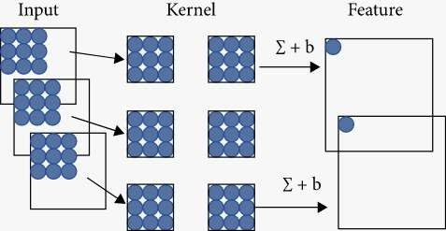

# Experimental Investigations:

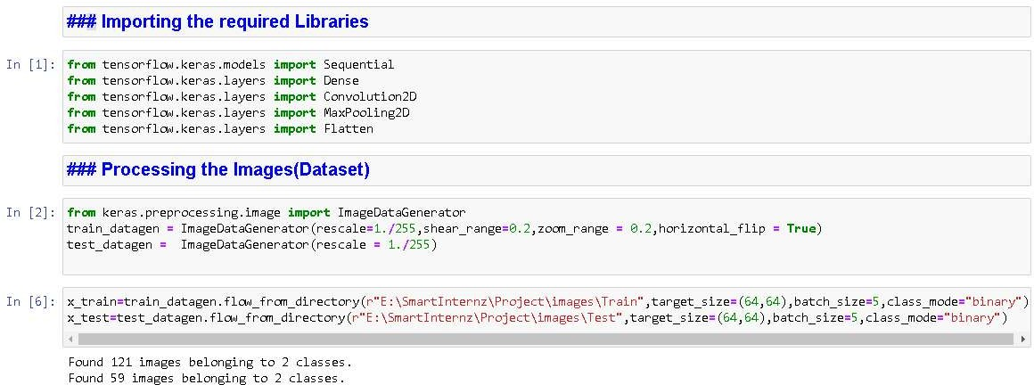

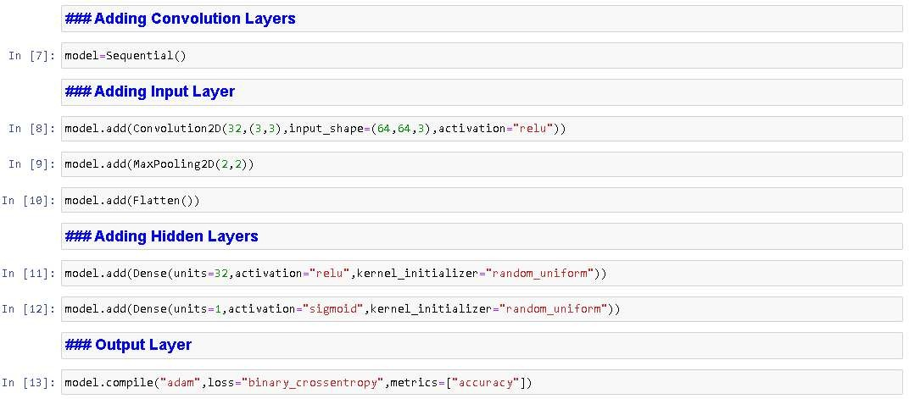

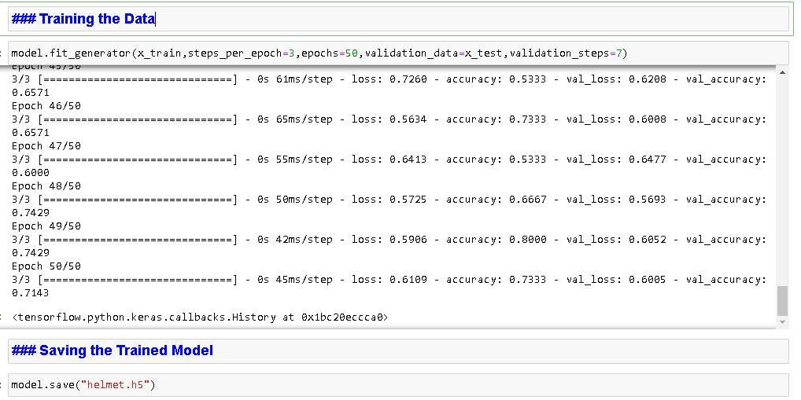



Flow Chart:



Results:

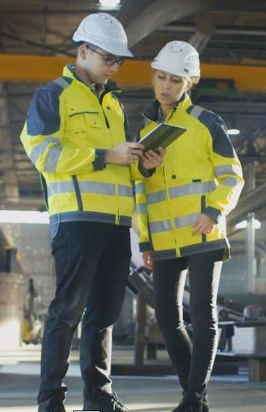Input:



Output:

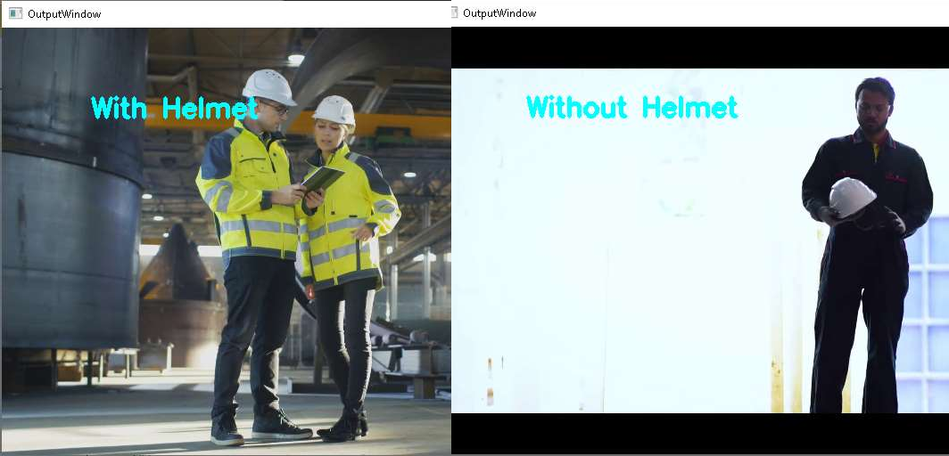

# Advantages:

The proposed automatic detection method based on deep learning to detect safety helmets worn by workers provides an eﬀective opportunity to improve safety management in warehouses. Previous studies have demonstrated the eﬀectiveness of locating the safety helmets and workers and detecting the helmets. However, most of the studies have limitations in practical application. Sensor-based detection methods have a limited read range of readers and cannot be able to conﬁrm the position relationship between the helmets and the workers. The machine learning-based detection methods choose features artiﬁcially with a strong subjectivity, a complex design process, and poor generalization ability. Therefore, the study proposed a method based on deep learning to detect safety helmets automatically using convolutional neural networks. The experimental results have suggested the eﬀectiveness of the proposed method.

A dataset of 180 images containing various helmets is trained and tested on the model. The experimental results demonstrate the feasibility of the model. And the model does not require the selection of handcraG features and has a good capacity of extracting features in the images. The high precision and recall show the great performance of the model. The proposed model provides an opportunity to detect the helmets and improve construction safety management on-site.

# Disadvantages:

However, the detection model has a poor performance when the images are not very clear, the safety helmets are too small and obscure, and the background is too complex. Moreover, the presented model is limited by the problems that some images of the dataset are less in quantity; the preprocessing operations of the images are conﬁned to rotation, cutting, and zooming; the manual labeling is not comprehensive and may miss some objects. In some extreme cases, for example, only part of the head is visible and the safety helmet is obstructed, the model cannot detect the helmets accurately. This is the common limitation of the-state-of-art algorithms. Due to the above reasons, the detection performance is not good enough and there are some detection errors.

# Applications:

This can be used in various industries and other workplaces by adding more training and computation power to the system.

Industries like construction, steel industries, and various other industries in manufacturing

# Future Scope:

The algorithm we use emphasizes the real-time detection and fast speed. However, the accuracy of the detection is also quite important and the performance needs to be improved. Hence, in the ongoing studies, we are working at the expansion and improvement of the dataset in order to solve the problems of inadequate data with poor quality. More comprehensive preprocessing operations should be done to improve the performance of the model.

# Conclusion:

The proposed method in the project for detecting the wearing of safety helmets by the workers based on convolutional neural networks. The model uses the algorithm to detect safety helmets. Then, a dataset of 180 images containing various helmets is built and divided into two parts to train and test the model. The Tensor Flow framework is chosen to train the model. AGer the training and testing process, the helmet detection model is built. The experiment results demonstrate that the method can be used to detect the safety helmets worn by the warehouse workers at the warehouses and storage facilities. The presented method oﬀers an alternative solution to detect the safety helmets and improve the safety management of the workers at the warehouse facilities.

# Bibliography:

Dataset using the image crawler, w ww.images.google.com.

Sample Video for analysis from [www.youtube.com](http://www.youtube.com/)