HIGH-LEVEL ARCHITECTURE & CLOUD TOPOLOGY SPECIFICATION
BugBountyTrack — Multi-Tenant Vulnerability Disclosure Platform with Client-Side Cryptographic Isolation and Evidence-Based Remediation Tracking

Document Control & Academic Metadata
Attribute | Specification
Document Title | High-Level Architecture & Cloud Topology Specification
Document Version | Revision 1.1 (Academic Milestone Baseline — Evaluator Aligned)
Release Date | October 16, 2026
Author / Candidate | Taha Asadullah (Roll No: `24-ST-013`)
Academic Institution | Punjab Tianjin University of Technology (PTUT), Lahore
Department & Program | Department of Software Engineering Technology — BS Software Engineering Technology
Batch / Section | Batch 24-SET-Fall / Section SET-B (24-st-013@students.ptut.edu.pk)
FYP Project Supervisor | Sir Umar Hayat (Assistant Professor, PTUT Lahore)
Project Identifier | PTUT - PRJ - 089 (Sub-Field: 9. Cybersecurity, Privacy & LegalTech)
Milestone | Week 3 — High-Level Architecture & Cloud Topology
Governing Standards | IEEE Std 42010-2011 (Architecture Description), IEEE Std 830-1998 & ISO/IEC/IEEE 29148:2018
Technical Stack | Next.js 14+ (App Router, TypeScript), Node.js 22 LTS, PostgreSQL 16 (Neon), Cloudflare R2, OpenPGP.js v6
Google Drive Document Link | View High-Level Architecture Specification (Google Drive)

Supporting Deliverable Documents & Reference Artifacts
Deliverable Document | Scope Covered | Cloud & Repository Reference
Week 1 Discovery: Personas, Charter & MVP Features (`WEEK_1_DISCOVERY_REPORT.docx`) | Executive Context, 4 Operational Frictions, 2 Provisional Composite Personas, and 5 Core MVP Features | View Week 1 Discovery Doc (Google Drive) (https://docs.google.com/document/d/1drXMfAk4pIKc_9aMKZav62KfVZQ04--zT6VyuhDZKFA/edit?usp=drive_link)
Week 2 Formal IEEE 830 Software Requirements Specification (`SRS.docx`) | Complete IEEE 830 SRS (Revision 2.8), Table 2.2 Permission Matrix, FR-1 to FR-8, UC-01 to UC-07, 4 UML Diagrams, and NFRs | View Week 2 IEEE 830 SRS Doc (Google Drive) (https://docs.google.com/document/d/1n8VKmXeK4TSTPPR-mDXp3NkKwDxvzTzEWR9tgdZlxSg/edit?usp=drive_link)
Week 3 High-Level Architecture & Cloud Topology (`HIGH_LEVEL_ARCHITECTURE.docx`) | 3-Tier Zero-Plaintext Model, DFD Level 0 & Level 1, Defensible System Boundaries, and Cloud Topology Justification | Local Word: architecture/HIGH_LEVEL_ARCHITECTURE.docx / Resources/HIGH_LEVEL_ARCHITECTURE.docx

1. Executive Architecture Summary & Core Objectives
1.1 Architectural Vision & The Zero-Knowledge Paradigm
BugBountyTrack (PTUT - PRJ - 089) is a multi-tenant vulnerability coordination platform designed for small software teams (5–50 engineers) and ethical security researchers. Traditional bug bounty systems adopt a trusted-server architecture where vulnerability reports, reproduction steps, and exploit attachments reside in plaintext on application servers.
BugBountyTrack replaces this model with a client-side cryptographic architecture governed by three core principles:
1. Zero-Plaintext Server Storage: Vulnerability descriptions, proof-of-concept (PoC) scripts, and triage discussions are encrypted in the client browser using OpenPGP.js v6 (`RFC 9580` Curve25519: `Ed25519` signing + `X25519` encryption) before transmission. The application server and database store strictly armored ciphertexts, key fingerprints, and coarse operational metadata (Class A).
2. Direct-to-Object Encrypted Attachment Pipeline: Binary evidence files (<= 25 MiB each, <= 50 MiB per report) are encrypted in browser memory into RFC 9580 SEIPDv2 binary packets and streamed directly to Cloudflare R2 via presigned S3 URLs, completely bypassing serverless memory limits and execution timeouts.
3. Evidence-Based Remediation & Attested Retest State Machine: Tickets cannot be closed on informal declarations. Defenders must supply verifiable proof—either an authoritative GitHub commit SHA verified via the GitHub REST API v3 (FR-6.2) or an encrypted configuration snapshot bound to a SHA-256 hash (FR-6.3)—before transitioning through an attested 15-state lifecycle automaton backed by an append-only, dual hash-chained audit ledger (tenant_row_hash and report_chain_hash, FR-8.5).
1.2 Architectural Quality Attributes & Non-Functional Goals
The high-level architecture is optimized against four primary non-functional engineering constraints:
• Confidentiality & Minimal Trust (`NFR-04`, `NFR-05`): Application servers, database administrators, and cloud hosting providers possess zero technical capability to decrypt submitted vulnerability bodies or attachments.
• Deterministic Remediation Verifiability (`NFR-06`): Every state transition from ACCEPTED to a terminal state (VERIFIED_RESEARCHER, VERIFIED_INTERNAL, or CLOSED_UNVERIFIED_TIMEOUT) is immutably anchored in an append-only ledger using SHA-256 dual state chaining (tenant_row_hash and report_chain_hash).
• Sub-Second Operational Latency (`NFR-01`, `NFR-02`): API serverless routes achieve p95 latency <= 400 ms on warm invocations and <= 1,200 ms on cold starts; client-side OpenPGP v6 Curve25519 key generation executes in < 50 ms; deterministic CVSS v3.1 scoring executes in < 5 ms.
• Zero-Dollar Academic Feasibility & Linear Commercial Scaling: The entire production architecture operates at $0.00/month on verified permanent free tiers for university evaluation, while commercial scaling requires only ~$61.00/month for 10–25 organizations.

2. 3-Tier Zero-Plaintext System Architecture
2.1 Architectural Tier Model Specification
The system is structured as an authoritative 3-Tier Distributed Architecture, where each tier enforces strict physical and cryptographic isolation boundaries:
+-------------------------------------------------------------------------------+
| TIER 1: CLIENT PRESENTATION & CRYPTOGRAPHIC BOUNDARY |
| - Modern Web Browser (Next.js 14 Client Runtime, React 18+, Tailwind CSS) |
| - OpenPGP.js v6 WebCrypto / WebAssembly Curve25519 (Ed25519 / X25519) |
| - IndexedDB KeyStore, Turnstile Widget, rehype-sanitize AST Cleansing |
+-------------------------------------------------------------------------------+
| ^
HTTPS / TLS 1.3 (JSON REST) | | Direct S3 Presigned Upload / Download
v | (Encrypted Ciphertext Attachments)
+-------------------------------------------------------------------------------+
| TIER 2: PRESENTATION & GATEWAY / API SERVER TIER |
| - Unified Next.js 14+ App Router on Node.js 22 LTS (Vercel Serverless Fleet) |
| - Stateless API Handlers (/api/v1/*, /.well-known/security.txt) |
| - Server-Side RBAC, CSPRNG Session Tokens, Shared-Store Rate Limiting |
| - Pure TypeScript FIRST.org CVSS v3.1 Base Scoring Engine (8.22 Constant) |
| - GitHub REST API v3 Integration & Resend Transactional Mail Service |
| - Scheduled Cron Worker (POST /api/v1/internal/cron/sla-check HMAC-SHA256) |
+-------------------------------------------------------------------------------+
|
TLS 1.3 Pooled TCP (PgBouncer: Port 6543)
v
+-------------------------------------------------------------------------------+
| TIER 3: PERSISTENCE & STORAGE TIER |
| - Relational Database: Neon Serverless PostgreSQL 16 (bbt_core Schema) |
| * FORCE ROW LEVEL SECURITY on all tenant tables (bbt_app role) |
| * Hardened SECURITY DEFINER Functions (SET search_path = pg_catalog,...) |
| * Dual Hash-Chained Audit Ledger (tenant_row_hash & report_chain_hash) |
| - Object Storage: Cloudflare R2 (S3-Compatible, SSE-R2 At-Rest Encryption) |
+-------------------------------------------------------------------------------+
Tier 1: Client Presentation & Cryptographic Boundary (Web Browser)
The client tier executes inside the user's web browser (Firefox, Chromium, Safari). It is the sole trust boundary where unencrypted vulnerability data exists:
• UI & Rendering Engine: Next.js 14+ Client Components styled with Tailwind CSS, conforming to WCAG 2.2 AA accessibility standards (24 x 24 px minimum touch targets).
• Client Cryptographic Engine: Pinned OpenPGP.js v6 utilizing the browser's native crypto.subtle WebCrypto API and WebAssembly for high-speed Curve25519 (Ed25519 signing, X25519 encryption). It executes:
◦ Account-less ephemeral key generation (< 50 ms).
◦ Multi-recipient payload encryption wrapping symmetric session keys for authorized program defenders (PROGRAM_DEFENDER) and organization recovery keys.
◦ Symmetric encryption of .bbt-recovery.json packages using RFC 9580 SYMENC+SEIPDv2 with Argon2id S2K (s2kType = argon2).
• Client Storage & Sanitization: Private keys are maintained in IndexedDB protected by user passphrases. Decrypted report bodies and Markdown comments pass through rehype-sanitize AST cleansing, neutralizing the 100-vector OWASP XSS attack corpus prior to DOM injection.
Tier 2: Presentation & Gateway / API Server Tier (Serverless Compute)
The application tier runs as a serverless fleet on Node.js 22 LTS hosted on Vercel's global infrastructure:
• Stateless API Gateway: Exposes structured JSON REST endpoints under /api/v1/ and public RFC 9116 endpoints (/.well-known/security.txt). Serverless functions are stateless, achieving warm p95 response times <= 400 ms and cold-start execution <= 1,200 ms (NFR-01).
• Authentication & RBAC Middleware: Manages session governance using 256-bit cryptographically secure pseudorandom values (CSPRNG), storing only SHA-256 hashes in the database (bbt_core.sessions.token_hash). User passwords are protected using Argon2id (FR-1.3a). Session cookies use the secure cookie name __Host-bbt-session with attributes SameSite=Lax, Secure, HttpOnly, and Path=/. The SameSite=Lax policy allows legitimate top-level navigations (such as following email notifications or external bookmarks) to retain active session state, preventing disruptive session drops on safe GET requests, while withholding cookies on cross-site subrequests. All state-changing endpoints (POST, PUT, PATCH, DELETE) enforce JSON payload requirements and anti-CSRF request validation. Tenant isolation is enforced by injecting organization_id into database execution contexts, and mandatory TOTP MFA step-up is required for ORG_OWNER operations (FR-1.3c).
• Deterministic CVSS v3.1 Engine: A pure TypeScript implementation of FIRST.org CVSS v3.1 Base scoring (FR-4.1 – FR-4.4). It accepts valid CVSS v3.1 base metrics in any ordering, parses and validates all mandatory metrics, computes the Base score using the official coefficient `8.22` and Appendix A RoundUp ceiling function in < 5 ms (NFR-02), and serializes metrics into the canonical FIRST.org vector format (CVSS:3.1/AV:X/AC:X/PR:X/UI:X/S:X/C:X/I:X/A:X).
• External Adapters & Scheduled Worker: Integrates with the GitHub REST API v3 to verify commit existence and branch inclusion via GET /repos/{owner}/{repo}/compare/{branch}...{sha} (FR-6.2), dispatches metadata-only notification emails via Resend (FR-5.3), and executes hourly claim-lease cleanup tasks on POST /api/v1/internal/cron/sla-check authenticated via HMAC-SHA256 request headers (X-Cron-Timestamp and X-Cron-Signature: sha256=<64-hex-hmac>, FR-8.4c).
Tier 3: Persistence & Storage Tier (Managed Cloud Data)
The persistence tier provides durability, multi-tenant isolation, and binary storage:
• Neon Serverless PostgreSQL 16: Relational storage partitioned under the dedicated bbt_core schema. All tables enforce `FORCE ROW LEVEL SECURITY` using the unprivileged bbt_app database role (NOSUPERUSER NOBYPASSRLS). Connection pooling is multiplexed through PgBouncer (?pgbouncer=true) to eliminate connection exhaustion during traffic spikes.
• Dual Hash-Chained Audit Ledger: Implements an immutable audit trail (bbt_core.audit_events) where every state transition, access grant, and remediation attestation is cryptographically bound using two concurrent hash chains:
1. tenant_row_hash: A tenant-wide chronological hash chain linking all organization audit events.
2. report_chain_hash: A report-scoped hash chain linking the lifecycle events of an individual report.
Both chains compute SHA-256 digests over (prev_hash, sequence_no, event_type, actor_id, payload_digest, timestamp).
• Cloudflare R2 Object Storage: S3-compatible, zero-egress-fee distributed object storage holding client-encrypted binary PoC attachments. Objects are addressed by immutable UUIDv4 keys and protected at rest by Cloudflare SSE-R2 AES-256 encryption.

2.2 Visual 3-Tier Architecture Diagram
The structural relationship, protocols, and security boundaries across the three tiers are illustrated below:
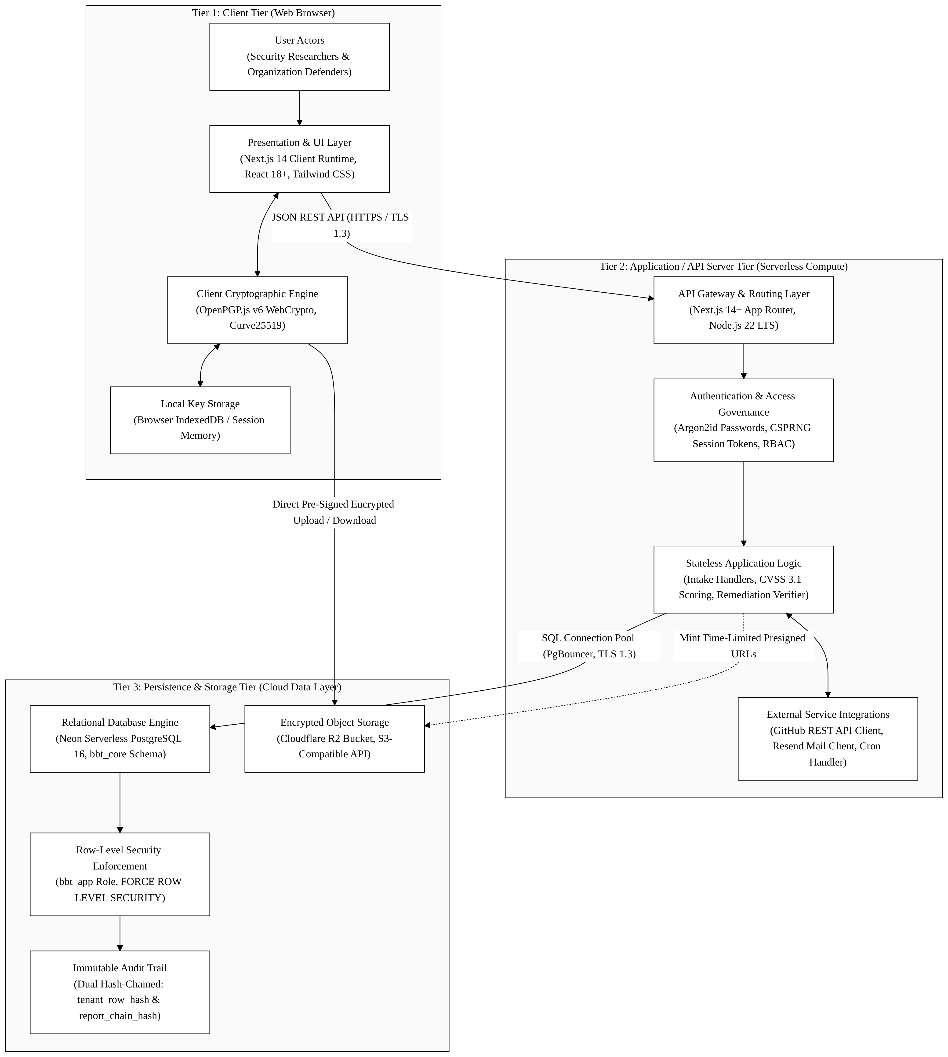

2.3 Tier-to-Tier Communication Protocols & Interface Contracts
Interface Channel | Source Tier | Destination Tier | Transport Protocol | Authentication & Payload Contract
Client API Calls | Tier 1 (Browser) | Tier 2 (Next.js API) | HTTPS (TLS 1.3) | __Host-bbt-session Cookie (SameSite=Lax, Secure, HttpOnly) or Turnstile Token; JSON payloads (Class A metadata + Class B/C armored ciphertext).
Direct Attachment Upload | Tier 1 (Browser) | Tier 3 (Cloudflare R2) | HTTPS (TLS 1.3) | Pre-signed S3 PUT URL with If-None-Match: *; binary RFC 9580 SEIPDv2 encrypted ciphertext.
Direct Attachment Download | Tier 1 (Browser) | Tier 3 (Cloudflare R2) | HTTPS (TLS 1.3) | Pre-signed S3 GET URL (15-minute lease expiry); streaming binary ciphertext decrypted locally in browser.
Database Queries & Pools | Tier 2 (Next.js API) | Tier 3 (Neon DB) | TLS 1.3 TCP (Port 6543) | Prisma ORM 5.x connection via PgBouncer as unprivileged bbt_app role; queries execute within parameterized SQL transactions.
Commit Attestation Query | Tier 2 (Next.js API) | External (GitHub API) | HTTPS (TLS 1.3) | GitHub App / PAT Bearer token; queries GET /repos/{owner}/{repo}/compare/{branch}...{sha} and commit metadata.
Transactional Email Alerts | Tier 2 (Next.js API) | External (Resend API) | HTTPS (TLS 1.3) | Resend API Bearer Token; dispatches JSON containing Class A metadata only (zero vulnerability body).
Hourly Cron Invocation | External (GitHub GHA) | Tier 2 (Next.js API) | HTTPS (TLS 1.3) | HTTP POST /api/v1/internal/cron/sla-check with X-Cron-Timestamp and X-Cron-Signature: sha256=<64-hex-hmac> (FR-8.4c).

3. Data Flow Diagrams (DFD)
3.1 DFD Level 0: System Context Diagram
The Level 0 Context Diagram models BugBountyTrack as a unified central process (0.0), identifying the six external entities that interact across its perimeter:
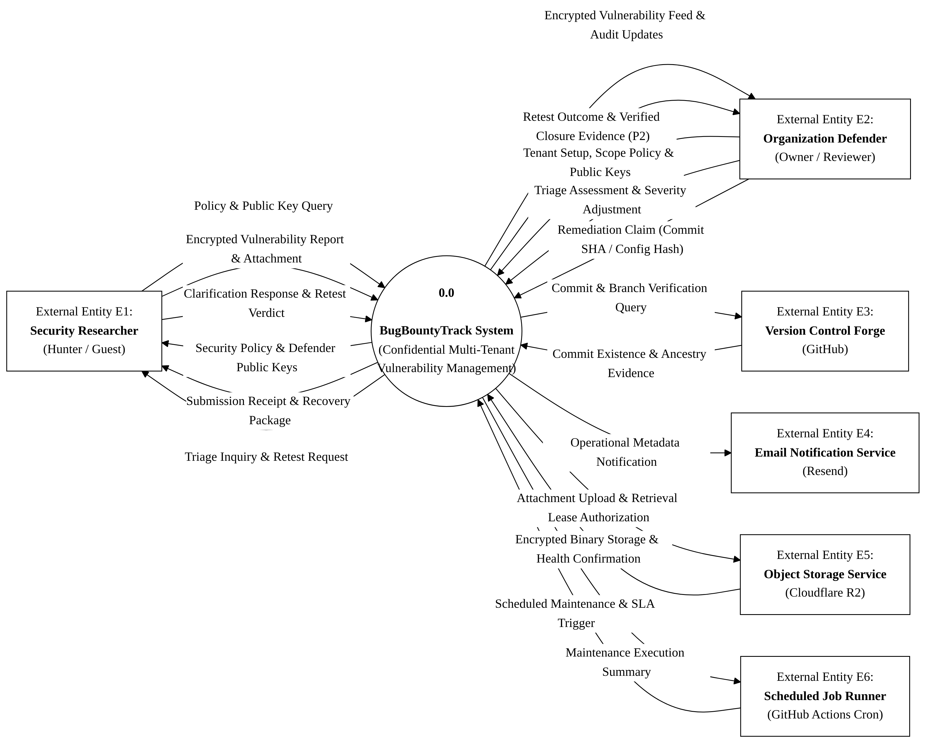
External Entity Inflow & Outflow Specifications
1. E1: Security Researcher (Ethical Hacker / Account-Less Guest)
◦ Inflows to System: Policy discovery requests (GET /.well-known/security.txt), Turnstile verification tokens, encrypted vulnerability submission payloads (Class B ciphertext), guest recovery passphrases, encrypted triage responses, and attested retest verdicts.
◦ Outflows to Researcher: Signed RFC 9116 security policies, presigned R2 upload URLs, secret tracking URL fragments (#token=...), encrypted .bbt-recovery.json recovery packages, and encrypted defender clarification requests.
2. E2: Organization Defender (Security Lead / Program Owner)
◦ Inflows to System: Organization registration parameters, program scope definitions, Ed25519/X25519 public keys, encrypted triage comments (Class B/C), CVSS base metric adjustments, remediation claims (GitHub commit SHA or config snapshot), and closure triggers.
◦ Outflows to Defender: Encrypted vulnerability report queues, computed CVSS scores and canonical vectors, retest outcome notifications, and signed cryptographic closure evidence exports (.bbt-closure-export.json, P2 extension under FR-7.7).
3. E3: Version Control Forge (GitHub REST API v3)
◦ Inflows to System: Authoritative commit verification responses (sha, author, timestamp, parent tree), branch comparison inclusion flags (ahead, identical), and rate-limit headers (x-ratelimit-remaining).
◦ Outflows from System: Automated commit lookup requests (GET /repos/{owner}/{repo}/commits/{sha}) and branch compare queries (GET /repos/{owner}/{repo}/compare/{branch}...{sha}).
4. E4: Email Notification Service (Resend Mail Service)
◦ Outflows from System: Minimal Class A operational metadata notification payloads (organization name, report tracking ID, coarse status update, zero plaintext vulnerability descriptions).
5. E5: Object Storage Service (Cloudflare R2 Storage)
◦ Inflows to Storage: Direct streaming encrypted binary ciphertext uploads (PUT) via presigned URLs issued to researchers.
◦ Outflows to System / Browser: Direct streaming encrypted binary ciphertext downloads (GET) via presigned URLs issued to authorized defenders; attachment storage health and lease reclamation confirmations.
6. E6: Scheduled Job Runner (GitHub Actions Automation)
◦ Inflows to System: Scheduled hourly HTTP POST /api/v1/internal/cron/sla-check triggers authenticated via HMAC-SHA256 request signatures (X-Cron-Signature: sha256=<64-hex-hmac>) initiating claim-lease cleanup, overdue clarification timeouts, and storage reclamation (FR-8.4c).
◦ Outflows to Scheduler: Structured JSON execution summary containing processed count, reclaimed bytes, and backlog status (has_more_backlog).

3.2 DFD Level 1: Functional System Decomposition
The Level 1 Data Flow Diagram decomposes Process 0.0 into seven discrete functional sub-processes interacting with seven persistent data stores:
Functional Sub-Process Specifications
• Process 1.0: Tenant Registration & Session Governance (`FR-1.1` – `FR-1.5`)
◦ Handles organization onboarding, custom slug reservation, Argon2id user password hashing (FR-1.3a), CSPRNG 256-bit session token issuance with SHA-256 persistence in token_hash, __Host-bbt-session cookie management (SameSite=Lax, Secure), and mandatory TOTP MFA step-up verification.
◦ Data Stores: Reads/Writes D1: Organizations & Tenant Registry and D2: Cryptographic Key Store; Writes audit events to D6: Hash-Chained Audit Ledger Store.
• Process 2.0: RFC 9116 Policy & Cryptographic Key Management (`FR-2.1` – `FR-2.5`, `FR-3.1` – `FR-3.8`)
◦ Generates RFC 9116 security.txt files, facilitates browser cleartext PGP signing (-----BEGIN PGP SIGNED MESSAGE-----), verifies domain ownership via DNS TXT challenges, and catalogs active defender public keys.
◦ Data Stores: Reads D1; Reads/Writes D2; Writes key lifecycle events to D6.
• Process 3.0: Cryptographic Intake & Storage Accounting (`FR-3.5`, `FR-3.6`, `FR-1.6`, `FR-8.3`, `FR-8.4`)
◦ Verifies Cloudflare Turnstile tokens, enforces IP-based rate limiting (10 submissions/hour/IP, FR-8.3), validates program key version snapshots (recipient_set_version), checks storage quota boundaries (20 MiB intake pool, 6 MiB reserve floor, FR-8.4), generates S3 presigned upload URLs, stores encrypted binary attachments in D5, and records initial reports in status = NEW (D3).
◦ Data Stores: Reads D2, D7; Writes D3: Reports & Triage Message Store, D5: Encrypted Attachment Store, and D6: Hash-Chained Audit Ledger Store; Emits initial base metrics to P4.
• Process 4.0: Deterministic CVSS v3.1 Scoring Engine (`FR-4.1` – `FR-4.4`)
◦ Parses the 8 FIRST.org Base metrics in any order, verifies completeness, executes the official mathematical scoring algorithm with the 8.22 coefficient in < 5 ms (NFR-02), and serializes the canonical vector string and calculated numeric score into D3.
◦ Data Stores: Writes score and canonical vector to D3.
• Process 5.0: Dual-Lane Triage & Notification Broker (`FR-5.1` – `FR-5.4`)
◦ Orchestrates report-scoped encrypted message threads, enforcing strict dual-lane isolation: Class B (shared researcher/defender) vs. Class C (internal defender-only). Dispatches Class A metadata-only alerts to external mail service E4: Resend.
◦ Data Stores: Reads D2; Reads/Writes D3; Writes triage events to D6 and triggers E4: Resend.
• Process 6.0: Remediation Attestation & GitHub Verification (`FR-6.1` – `FR-6.4`)
◦ Enforces the 3-step remediation workflow: captures proposed fix metadata (remediation_attempt_no = N), executes live commit verification against the GitHub REST API v3 (GET /repos/{owner}/{repo}/compare/{branch}...{sha}) or validates encrypted configuration snapshots bound to SHA-256 hashes, and advances report status to RETEST_PENDING.
◦ Data Stores: Reads/Writes D4: Remediation & Commit Store; Updates D3; Queries E3: Version Control Forge.
• Process 7.0: Attested Retest Lifecycle & Audit Ledger Engine (`FR-7.1` – `FR-7.6`, `FR-7.7` [P2 Extension], `FR-8.4`, `FR-8.5`)
◦ Executes the 15-state lifecycle automaton, records attested retest confirmations or timeout closures, appends SHA-256 dual hash-chained audit events (tenant_row_hash and report_chain_hash), coordinates hourly claim-lease R2 garbage collection, and exports verifiable closure evidence packets (P2 extension under FR-7.7).
◦ Data Stores: Reads/Writes D3, D4, D6, and D7; Purges expired attachments from D5.
Persistent Data Store Specifications
Store ID | Name & Physical Entity | Storage Engine | Scope & Retention
D1 | Organizations & Tenant Registry | Neon PostgreSQL (bbt_core.organizations) | Tenant metadata, slug bindings, subscription tiers, and domain verification challenges.
D2 | Cryptographic Key Store | Neon PostgreSQL (bbt_core.user_keys, program_defenders) | Armored public keys, key fingerprints, user key bindings, and report recipient version snapshots.
D3 | Reports & Triage Message Store | Neon PostgreSQL (bbt_core.reports, triage_messages) | Encrypted titles (title_ciphertext), operational labels, state versions, and Class B/C message threads.
D4 | Remediation & Commit Store | Neon PostgreSQL (bbt_core.remediation_records) | Commit SHAs, verification timestamps, config artifact ciphertexts, and config SHA-256 hashes.
D5 | Encrypted Attachment Store | Cloudflare R2 (bbt-attachments-prod) | Encrypted binary attachments (RFC 9580 SEIPDv2 packets), immutable UUID keys, zero plaintext.
D6 | Hash-Chained Audit Ledger Store | Neon PostgreSQL (bbt_core.audit_events) | Append-only sequence numbers, actor commitments, event digests, and cryptographic dual hash chains (tenant_row_hash & report_chain_hash).
D7 | Storage Quotas & Claim Leases | Neon PostgreSQL (cluster_storage_state, upload_reservations) | Multi-tenant quota accounting (20 MiB intake, 6 MiB reserve floor), and active claim-lease records (claim_expires_at).

4. Defensible System Boundaries & Trust Domain Isolation
4.1 Boundary Domain Architecture
The security posture of BugBountyTrack rests on establishing four unambiguous, non-overlapping trust domains:
[ UNTRUSTED PUBLIC INTERNET ]
|
+ - - - - - v - - - - - - - - - - - - - - - - - - - - - - - - - - - - - +
: DOMAIN 1: CLIENT CRYPTOGRAPHIC TRUST BOUNDARY (Browser Client) :
: * Plaintext vulnerability data and private keys exist ONLY here. :
: * OpenPGP.js v6 WebCrypto encryption/decryption execution. :
: * DOMPurify / rehype-sanitize AST cleansing prior to rendering. :
+ - - - - - - - - - - - - - - - - - - - - - - - - - - - - - - - - - - - +
| HTTPS TLS 1.3 (Ciphertext Only)
+ - - - - - v - - - - - - - - - - - - - - - - - - - - - - - - - - - - - +
: DOMAIN 2: SERVERLESS API ROUTING BOUNDARY (Vercel Node.js 22 LTS) :
: * Zero plaintext visibility; handles only armored ciphertext. :
: * Ephemeral execution memory (no disk or cache persistence). :
: * RBAC, CSPRNG Session Validation, Turnstile verification. :
+ - - - - - - - - - - - - - - - - - - - - - - - - - - - - - - - - - - - +
| TLS 1.3 Pooled TCP (bbt_app role)
+ - - - - - v - - - - - - - - - - - - - - - - - - - - - - - - - - - - - +
: DOMAIN 3: DATABASE PERSISTENCE BOUNDARY (Neon PostgreSQL 16) :
: * FORCE ROW LEVEL SECURITY isolates tenant data rows. :
: * Unprivileged bbt_app role (NOSUPERUSER NOBYPASSRLS). :
: * Dual hash-chained audit ledger prevents tampering or deletion. :
+ - - - - - - - - - - - - - - - - - - - - - - - - - - - - - - - - - - - +
| HTTPS S3 API (Direct Presigned Upload/Download)
+ - - - - - v - - - - - - - - - - - - - - - - - - - - - - - - - - - - - +
: DOMAIN 4: OBJECT STORAGE BOUNDARY (Cloudflare R2) :
: * Presigned URL time-limited access (15-minute lease). :
: * Client-side encrypted binary payloads (SSE-R2 at rest). :
: * Zero server byte proxying. :
+ - - - - - - - - - - - - - - - - - - - - - - - - - - - - - - - - - - - +
4.2 Comprehensive STRIDE Threat Mitigation Analysis
Threat Category (STRIDE) | Attack Vector & Surface | Primary Architectural Mitigation & Security Control | Target Requirement
Spoofing Identity | Malicious actor attempts to forge researcher identity or impersonate an organization defender. | 1. Argon2id password hashing + mandatory TOTP MFA for ORG_OWNER with 10-minute step-up.<br/>2. Account-less guest requests require single-use guest_mutation_nonces and detached OpenPGP v6 Ed25519 signatures (X-Guest-Signature).<br/>3. Hourly cron requests require HMAC-SHA256 authentication (X-Cron-Timestamp and X-Cron-Signature: sha256=<64-hex-hmac>) on /api/v1/internal/cron/sla-check. | FR-1.3, FR-1.6f, FR-5.4, FR-8.4c
Tampering with Data | Attacker modifies vulnerability write-up, alters audit records, or tampers with closure status. | 1. Client payloads use OpenPGP SEIPDv2 with AEAD integrity verification.<br/>2. Audit ledger enforces append-only semantics via PostgreSQL triggers and SHA-256 dual hash chaining (tenant_row_hash and report_chain_hash).<br/>3. Optimistic concurrency (state_version) prevents lost updates or race condition tampering. | FR-3.1, FR-7.1, FR-8.5
Repudiation | Defender falsely claims a bug was fixed, or researcher denies submitting a report. | 1. Fixing requires automated verification of a real GitHub commit SHA via the GitHub REST API v3 (compare/{branch}...{sha}) or an immutable config hash.<br/>2. Retest closures generate cryptographic Closure Evidence Exports signed with Ed25519 (Priority 2 Extension under FR-7.7). | FR-6.2, FR-6.3, FR-7.7
Information Disclosure | Database breach or malicious platform operator attempts to harvest zero-day exploit details. | 1. Client-Side OpenPGP v6 Curve25519 encryption: server and database store strictly ciphertext (title_ciphertext, report body, attachments).<br/>2. Dual-lane threading guarantees Class C internal notes are never encrypted for the researcher's key.<br/>3. Raw guest access_token values are never stored in database retry caches; sessions use CSPRNG tokens with SHA-256 hashes in token_hash. | FR-3.3, FR-5.2, FR-1.3b, FR-1.6b
Denial of Service | Bot swarm exhausts serverless function compute, floods database storage, or uploads huge files. | 1. Cloudflare Turnstile bot verification required before issuing submission session tokens.<br/>2. Shared-store rate limiter restricts unauthenticated submissions to 10 submissions/hour/IP (FR-8.3).<br/>3. Strict multi-tenant storage quotas: separate 20 MiB intake pool and 6 MiB Priority-0 reserve floor (FR-8.4). | FR-8.3, FR-8.4, NFR-09
Elevation of Privilege | Tenant user attempts to access reports belonging to another organization (IDOR / Multi-Tenant leak). | 1. PostgreSQL FORCE ROW LEVEL SECURITY on all tenant tables bound to app.current_org_id.<br/>2. Runtime executes under unprivileged role bbt_app (NOSUPERUSER NOBYPASSRLS).<br/>3. Hardened SECURITY DEFINER functions enforce clean search_path = pg_catalog, bbt_core, pg_temp. | FR-8.2, FR-1.1

4.3 Defensible System Boundaries: What BugBountyTrack Controls vs Does NOT Control
To establish honest engineering boundaries and prevent false assurances, the table below explicitly defines what BugBountyTrack architecturally controls versus external operational factors beyond its perimeter:
System Domain | What BugBountyTrack DOES Architecturally Control | What BugBountyTrack DOES NOT Control (External Dependencies)
Cryptographic Confidentiality | In-browser client encryption/decryption using OpenPGP.js v6 Curve25519; server-side zero-knowledge storage; mathematical segregation of Class B (shared) vs Class C (internal) ciphertexts. | Client endpoint integrity; malware, keyloggers, or malicious browser extensions on researcher/defender devices; compromised physical machines.
Application & API Routing | Stateless API routing; rate limiting (10 submissions/hr/IP); session token issuance (256-bit CSPRNG); Argon2id password KDF; HMAC-SHA256 cron signature validation. | Network-level BGP routing or Anycast IP hijacking; upstream DNS provider compromises; ISP-level TLS interception if client root certificates are tampered with.
Remediation Attestation | Automated querying of GitHub REST API v3 to confirm commit existence and branch ancestry (compare/{branch}...{sha}); cryptographic SHA-256 hash binding of configuration files. | Real-world server deployment of the verified commit; whether defender deployed the patch to production; defender server infrastructure security or CI/CD runner compromises.
Database & Multi-Tenancy | Database tenant isolation via PostgreSQL FORCE ROW LEVEL SECURITY; unprivileged execution via bbt_app role; append-only dual hash-chained audit logging (FR-8.5). | Physical hardware or hypervisor integrity of cloud database provider (Neon); physical infrastructure seizure; external side-channel attacks on host hardware.
Object Storage & Evidence | Time-limited presigned S3 URLs (15-min lease); RFC 9580 SEIPDv2 binary ciphertext storage; automated hourly lease reclamation and quota enforcement (20 MiB intake, 6 MiB reserve). | Cloudflare R2 underlying physical storage hardware; third-party cloud provider internal outages; unencrypted temporary local copies saved by users outside the platform.
Notifications & Messaging | Zero-plaintext Class A operational metadata payloads dispatched to the notification provider; redaction of vulnerability descriptions from alert emails. | Upstream SMTP deliverability; recipient mail server spam filters; mail server security at rest on the recipient's mail provider.

5. Cloud Infrastructure Stack Justification & Cost Feasibility
5.1 Cloud Infrastructure Topology
The physical hosting deployment across Cloudflare Edge, Vercel Serverless, Neon PostgreSQL, and Cloudflare R2 is mapped below:
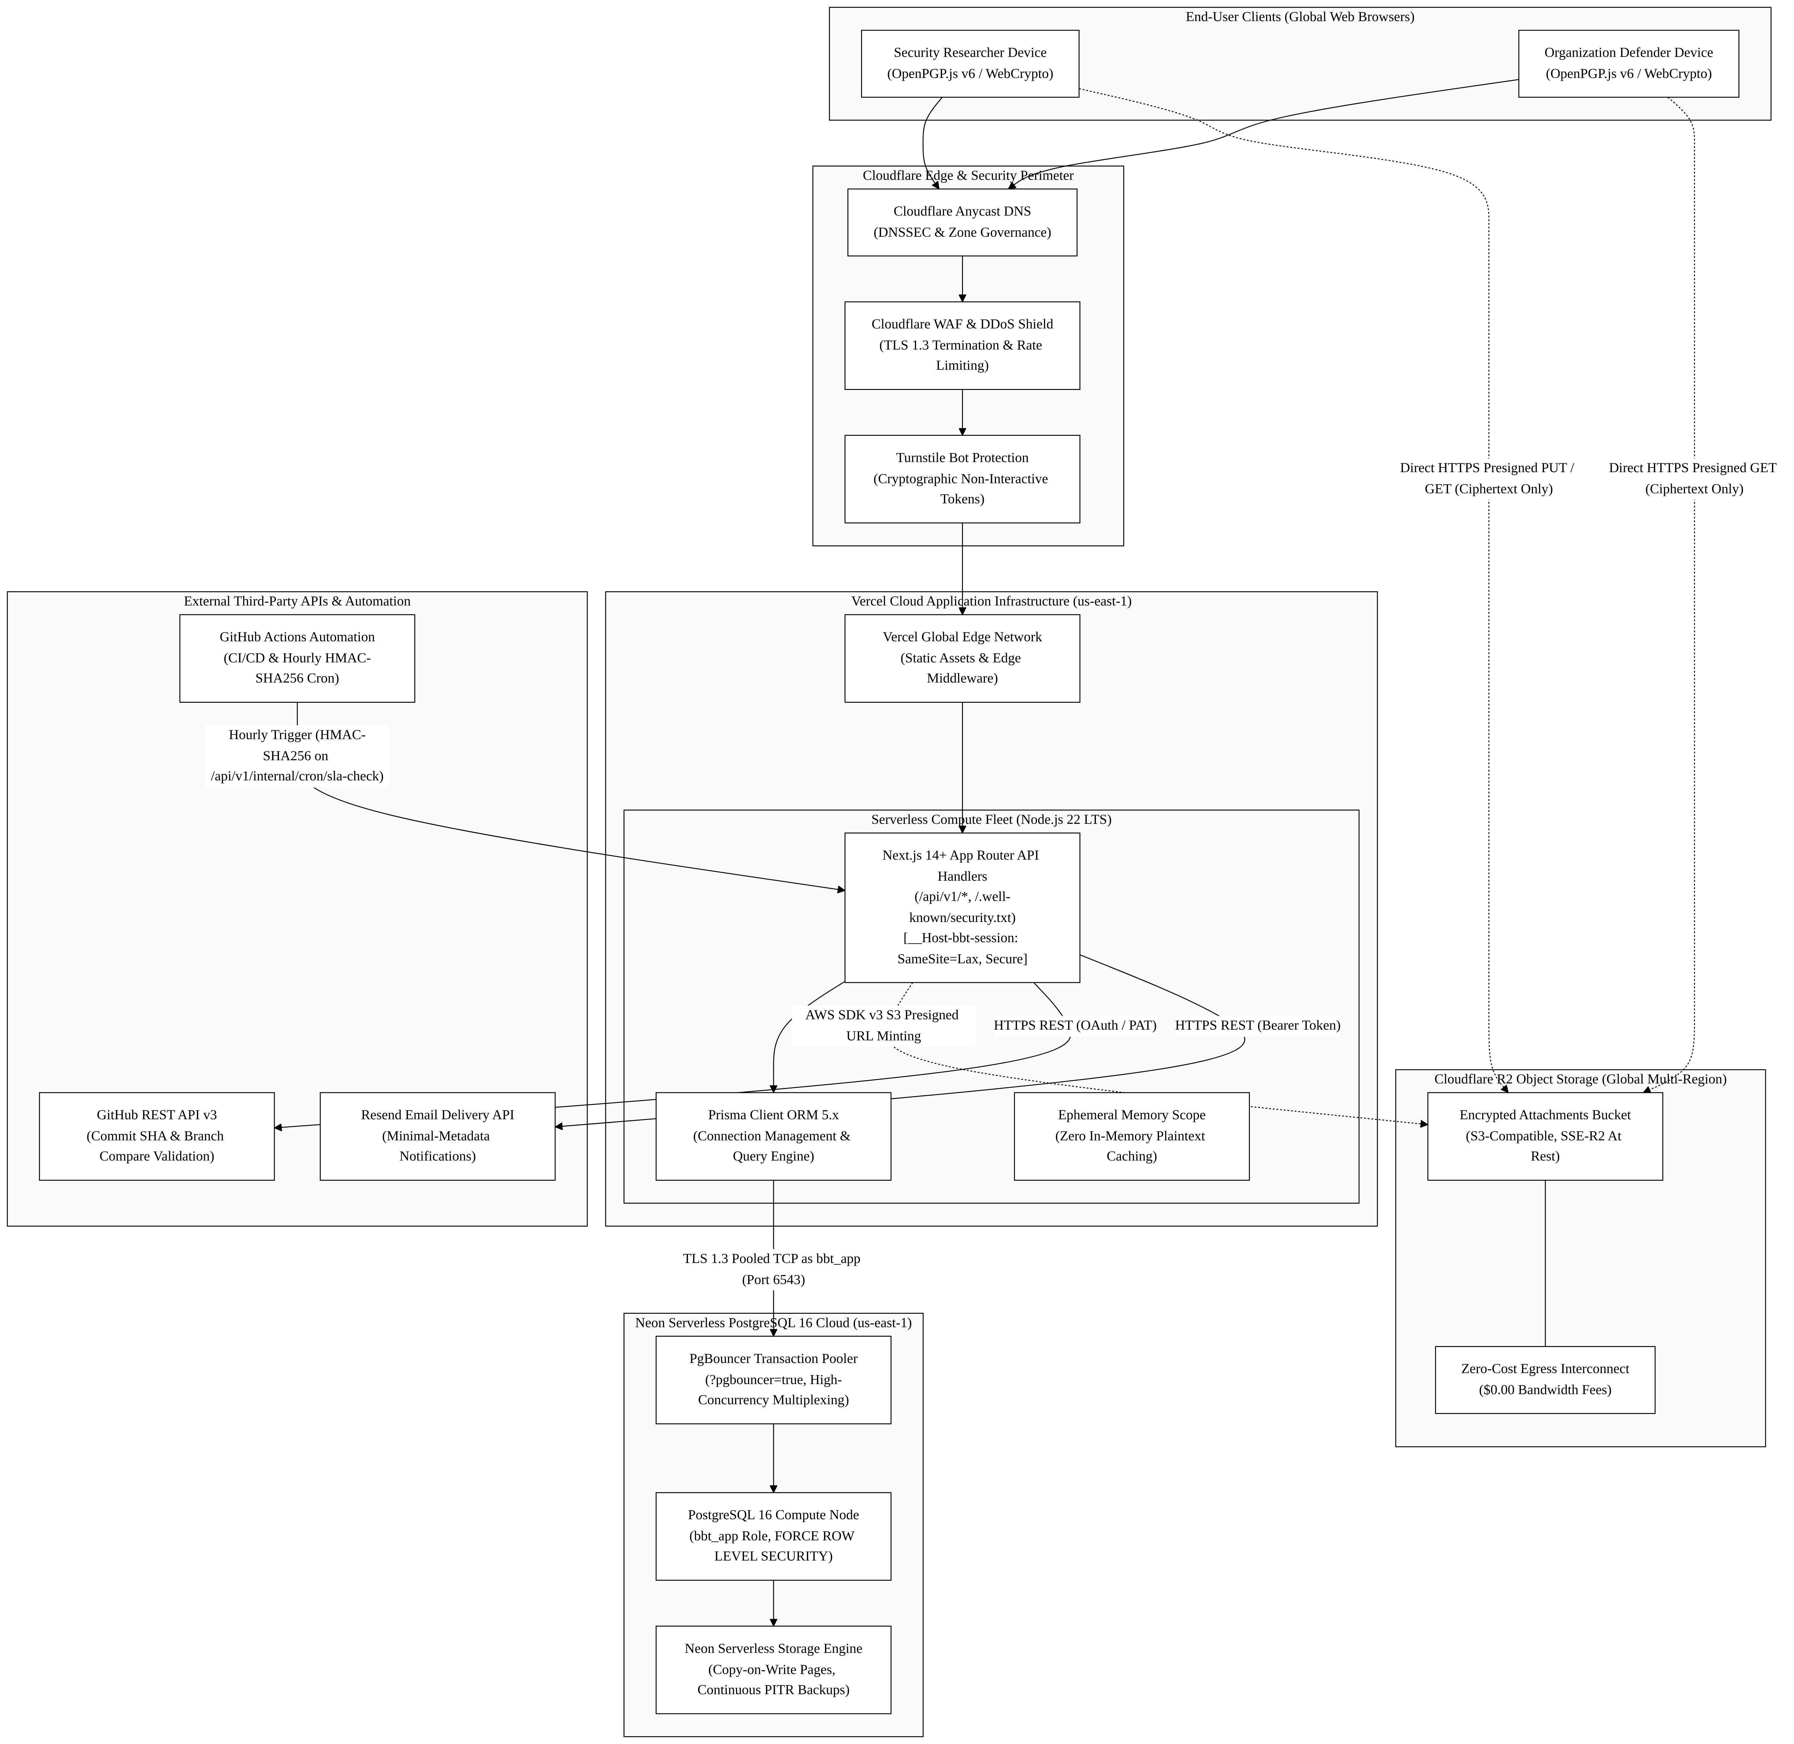

5.2 Component-by-Component Technology Stack Justification
+-------------------------------------------------------------------------------------------------------------------------+
| TECHNOLOGY STACK EVALUATION & JUSTIFICATION MATRIX |
+-------------------+------------------------------+-------------------------------+--------------------------------------+
| Subsystem Layer | Chosen Technology | Primary Alternatives Evaluated| Architectural Rationale & Trade-Off |
+-------------------+------------------------------+-------------------------------+--------------------------------------+
| Frontend & API | Next.js 14+ App Router | React SPA + Express.js API; | Unified TypeScript codebase eliminates API contract |
| Fullstack Engine | (Node.js 22 LTS on Vercel) | Go / Gin Microservices | drift; React Server Components provide zero-bundle |
| | | | rendering; Serverless scales to zero with no idle fee|
+-------------------+------------------------------+-------------------------------+--------------------------------------+
| Application | Vercel Serverless Compute | AWS ECS / Fargate (Docker); | Eliminates container orchestration toil, OS patching,|
| Runtime Fleet | (Global Edge + Lambda Core) | Kubernetes (EKS / GKE); VPS | and VPC maintenance for a solo student engineer; |
| | | | warm p95 <= 400 ms, cold start <= 1,200 ms (NFR-01). |
+-------------------+------------------------------+-------------------------------+--------------------------------------+
| Relational | Neon Serverless PostgreSQL 16| Supabase; AWS Aurora; | True serverless compute autoscaling (0.25 to 2 CU); |
| Database Engine | (with PgBouncer Pooling) | MongoDB Atlas; DynamoDB | built-in PgBouncer pooling prevents connection drops;|
| | | | robust RLS engine (bbt_app role) & ACID audit ledger.|
+-------------------+------------------------------+-------------------------------+--------------------------------------+
| Object Storage | Cloudflare R2 | AWS S3 Standard; | S3-compatible API with ZERO bandwidth egress fees |
| Persistence | (Direct Presigned Uploads) | Google Cloud Storage (GCS) | (eliminating unbounded egress billing risks from |
| | | | large PoC video downloads); global multi-region speed|
+-------------------+------------------------------+-------------------------------+--------------------------------------+
| Bot Protection & | Cloudflare Turnstile | Google reCAPTCHA v3; | Privacy-preserving, non-interactive bot verification;|
| Perimeter Defense | & Cloudflare Anycast WAF | hCaptcha | zero user tracking cookies; seamless Next.js drop-in;|
| | | | protects unauthenticated guest intake endpoints. |
+-------------------+------------------------------+-------------------------------+--------------------------------------+
| Transactional | Resend API | AWS SES; SendGrid; | Clean modern REST API with native React Email support|
| Notification Mail | (Node.js REST SDK) | Postmark | and zero complex SMTP handshake overhead; free tier |
| | | | provides 3,000 metadata-only alerts/month. |
+-------------------+------------------------------+-------------------------------+--------------------------------------+
| Continuous | GitHub Actions | GitLab CI; CircleCI; | Native repository integration; provides 2,000 free |
| Automation & Cron | (Ubuntu 22.04 LTS Runners) | AWS EventBridge | runner minutes/month; executes hourly scheduled jobs |
| | | | via HMAC-SHA256 on /api/v1/internal/cron/sla-check. |
+-------------------+------------------------------+-------------------------------+--------------------------------------+

5.3 Infrastructure Cost Feasibility & Financial Viability Analysis
Academic Demonstration Budget (Zero-Cost Baseline)
To satisfy university evaluation requirements without requiring external departmental funding or personal cash outlay, the entire architecture operates within documented permanent free tiers:
Infrastructure Layer | Cloud Provider & Tier | Quota Allocation | Demonstration Cost
Application & API Serverless | Vercel Cloud (Hobby Developer Tier) | 100 GB-hrs compute, 100 GB bandwidth, unlimited SSL | $0.00
Serverless Database | Neon PostgreSQL 16 (Free Tier) | 512 MB storage, 1 project, autoscaling 0.25 CU, PgBouncer | $0.00
Encrypted File Storage | Cloudflare R2 (Free Tier) | 10 GB storage, 1M Class A operations, 10M Class B ops, $0 egress | $0.00
Perimeter Bot Defense | Cloudflare Turnstile (Free Tier) | Unlimited unauthenticated visitor challenges | $0.00
Transactional Email Alerts | Resend (Developer Free Tier) | 3,000 emails/month, 100 emails/day | $0.00
CI/CD & Hourly Cron Automation | GitHub Actions (Standard Runners) | 2,000 free Linux build minutes/month | $0.00
TOTAL ACADEMIC EVALUATION COST | — | Fully Functional FYP Prototype | $0.00 / month
Commercial Production Budget (10–25 Organizations Baseline)
When transitioning to commercial production for small software startups, the architecture scales linearly with minimal fixed overhead:
Infrastructure Layer | Commercial Cloud Tier | Purpose & Sizing Bounds | Monthly Cost ($USD)
Vercel Pro Application Fleet | Vercel Pro ($20/seat, 1 seat) | Commercial SLA (99.5% uptime NFR-07), zero cold-start optimization | $20.00
Neon Production Database | Neon Launch Plan | 10 GB storage, autoscaling compute up to 2 CU, 7-day PITR | $19.00
Cloudflare R2 Object Storage | R2 Pay-As-You-Go ($0.015/GB-mo) | 50 GB pooled encrypted attachment storage ($0.00 egress) | $0.75
Resend Commercial Email | Resend Pro Baseline | 50,000 transactional notification emails/month | $20.00
Cloudflare Domain & DNS | Cloudflare Registrar (.security) | Amortized yearly domain registration fee ($15/year) | $1.25
TOTAL COMMERCIAL RUNTIME BASELINE | — | Supports 25 Startups (~2,500 reports/year) | ~$61.00 / month
Financial Viability Finding: At a modest commercial price point of $49.00/month per organization for the Team Tier, BugBountyTrack achieves break-even profitability with just two paying customers ($98.00 revenue - $61.00 cloud cost = +$37.00 net margin), establishing exceptional commercial sustainability.

6. Bidirectional Architecture Traceability Matrix (RTM)
This matrix maps high-level architectural tiers, components, and DFD processes directly to the Week 2 SRS Functional Requirements and formal Use Cases:
DFD Process | Architectural Tier & Component | Traced Functional Requirements | Traced Use Cases | Verification Criterion
1.0 | Tier 2 (Auth Middleware, Session Service) | FR-1.1, FR-1.2, FR-1.3, FR-1.4, FR-1.5 | UC-06, UC-07 | CSPRNG session token issuance (SHA-256 token_hash); Argon2id password KDF; TOTP MFA step-up verification; bbt_app role tenant context injection.
2.0 | Tier 1 (Crypto Engine) & Tier 2 (RFC 9116 Router) | FR-2.1, FR-2.2, FR-2.3, FR-2.4, FR-2.5, FR-3.1 | UC-01, UC-06 | Valid RFC 9116 manifest rendered; Ed25519 in-browser cleartext signature; DNS TXT challenge match.
3.0 | Tier 1 (OpenPGP.js) & Tier 3 (R2 Bucket, Neon DB) | FR-3.3, FR-3.5, FR-3.6, FR-1.6, FR-8.3, FR-8.4 | UC-01 | Turnstile CAPTCHA validation; rate limiting (10 req/hr/IP); presigned S3 upload; zero raw plaintext in SQL insert; 20 MiB intake / 6 MiB reserve quota check; .bbt-recovery.json issuance.
4.0 | Tier 2 (CVSS v3.1 Pure TypeScript Engine) | FR-4.1, FR-4.2, FR-4.3, FR-4.4 | UC-03 | Accepts valid metrics in any order; 100% mathematical parity across 45 FIRST.org test fixtures; calculation completes in < 5 ms (NFR-02).
5.0 | Tier 2 (Triage Controller) & Tier 3 (Neon DB) | FR-5.1, FR-5.2, FR-5.3, FR-5.4 | UC-02, UC-03 | Dual-lane message separation (Class B vs C); recipient version snapshot matching; minimal metadata email dispatch via Resend.
6.0 | Tier 2 (Remediation Service) & External (GitHub) | FR-6.1, FR-6.2, FR-6.3, FR-6.4 | UC-04 | GitHub REST API commit validation (compare/{branch}...{sha}); encrypted config snapshot hash binding.
7.0 | Tier 2 (FSM Engine) & Tier 3 (Audit Ledger, Neon) | FR-7.1, FR-7.2, FR-7.3, FR-7.4, FR-7.5, FR-7.6, FR-7.7, FR-8.4, FR-8.5 | UC-05, UC-07 | 15-state transition guard; append-only dual hash-chained audit logging (tenant_row_hash & report_chain_hash); hourly claim-lease R2 reclamation; signed closure export (P2 extension).

7. Document Submission & Milestone Sign-Off
7.1 Single Student Author Endorsement
I hereby certify that this High-Level Architecture & Cloud Topology Specification (Revision 1.1) represents an original, standards-compliant architectural baseline authored independently for BugBountyTrack (PTUT - PRJ - 089). All architectural patterns, trust boundaries, data flows, and infrastructure cost models have been rigorously formulated to satisfy the University Final Year Project syllabus and align completely with the approved IEEE 830 Software Requirements Specification (Revision 2.8).
• Student Author: Taha Asadullah
• Roll Number: 24-ST-013 (Section SET-B)
• Signature: [Signed Electronically — Taha Asadullah]
• Date: October 16, 2026

7.2 Academic Supervisor Review & Endorsement
I have reviewed the High-Level Architecture & Cloud Topology Specification, including the 3-Tier Zero-Plaintext Model, Data Flow Diagrams (DFD Level 0 and Level 1), System Trust Boundaries, and Cloud Infrastructure Justification. The architectural design meets departmental requirements for Phase 2 system design.
• Academic Supervisor: Sir Umar Hayat
• Department: Department of Software Engineering Technology, PTUT Lahore
• Status: [PENDING ACADEMIC SUPERVISOR EVALUATION & SIGN-OFF]
• Date: ____________________

