Punjab Tianjin University of Technology
Department of Software Engineering Technology
FINAL YEAR PROJECT (FYP) ENGINEERING SPECIFICATION
SOFTWARE REQUIREMENTS SPECIFICATION (SRS)
Project: BugBountyTrack
A Multi-Tenant Vulnerability Disclosure Platform with Cryptographic Payload Isolation and Evidence-Based Remediation Traceability
Academic & Engineering Parameter | Specification
Student Author | Taha Asadullah
Roll Number / Student ID | 24-ST-013
Session | Session 2024–2028
Batch / Section | Batch 24-SET-Fall / Section SET-B
Official Student Email | 24-st-013@students.ptut.edu.pk
FYP Project Supervisor | Sir Umar Hayat
Project Identifier | PTUT - PRJ - 089
Department Sub-Field | 9. Cybersecurity, Privacy & LegalTech
Standard Compliance | IEEE Std 830-1998 / ISO/IEC/IEEE 29148:2018
Client Platform | Modern Web (Next.js 14+ App Router, React 18+, TypeScript 5.x, Tailwind CSS, OpenPGP.js)
Backend & API Engine | Unified Next.js Fullstack (Serverless API Routes on Node.js 22 LTS / Vercel Pro)
Database Architecture | PostgreSQL 16 (Neon Serverless Cloud) / Prisma ORM 5.x
Document Release State | Commercial Baseline & Academic Evaluation Specification (Version 3.2.0)

Table of Contents
1. Introduction
1.1 Purpose & Target Scope
1.2 Document Conventions & Release Tier Schema
1.3 Intended Audience & Stakeholder Matrix
1.4 Problem Horizon & Commercial Positioning
2. Overall Description & System Architecture
2.1 3-Tier System Architecture
2.2 Defensible Protection Boundary & Cryptographic Assumptions
2.3 User Classes & Provisional Personas
2.4 Operating Environment & Technical Bounds
2.5 Design & Implementation Constraints
3. Specific Functional Requirements (FR)
3.1 Multi-Tenant Workspaces, Onboarding & Access Governance (FR-1)
3.2 RFC 9116 Policy & Safe Harbor Generator (FR-2)
3.3 Browser-Side OpenPGP Cryptographic Pipeline & Neutral Labeling (FR-3)
3.4 Deterministic CVSS 3.1 Base Scoring Engine (FR-4)
3.5 Confidential Triage, Structured Messaging & SLA Timers (FR-5)
3.6 Git-Linked Remediation & Evidence Verification (FR-6)
3.7 Attested Retest State Machine, Accountable Closure & Redacted Exports (FR-7)
3.8 Application Hardening, Defensive Controls & Storage Quotas (FR-8)
3.9 Optional Extensions & Future Commercial Releases
4. System Modeling & UML Diagrams
4.1 Textual Use Case Specifications
4.2 Component Architecture Diagram (Figure 4.1)
4.3 Use Case Model Diagram (Figure 4.2)
4.4 Sequence: Browser-Side OpenPGP Submission (Figure 4.3)
4.5 Sequence: In-Browser Decryption & Confidential Conversation (Figure 4.4)
4.6 State Machine: Remediation & Attested Retest Lifecycle (Figure 4.5)
4.7 Relational Prisma Schema & Domain ERD (Figure 4.6)
5. External Interface Requirements
5.1 User Interfaces & Screen Catalog
5.2 Software & External API Interfaces
6. Non-Functional Requirements (NFR)
7. Verification, Acceptance Criteria & Traceability
7.1 Bidirectional Traceability Matrix
7.2 Verification Test Pyramid & Acceptance Criteria

1. Introduction

1.1 Purpose & Target Scope
This Software Requirements Specification (SRS) establishes the formal engineering requirements baseline for BugBountyTrack. It defines the functional behaviors, cryptographic boundaries, mathematical calculation engines, relational persistence models, security controls, and commercial launch capabilities for an evaluated academic prototype and launch-ready B2B micro-VDP, conforming to IEEE Std 830-1998 and ISO/IEC/IEEE 29148:2018.

1.2 Document Conventions & Release Tier Schema
To eliminate scheduling contradictions, every requirement is categorized by its implementation priority and target delivery release:
• Requirement Priorities:
• P1 (Mandatory): Core functionality required for a functional prototype demonstration, academic evaluation, and baseline commercial utility.
• P2 (Important): Secondary capabilities that enhance usability, robustness, SLA tracking, and auditability.
• P3 (Nice-to-Have): Exploratory enhancements implemented if sprint capacity permits.
• Target Delivery Milestones (18 Calendar Weeks Total):
• Part A: Core Academic Evaluation Baseline (Weeks 1–12, 264 Hours): Multi-tenant RBAC, database-backed sessions, browser-side cleartext security.txt signing, client OpenPGP encryption (Ed25519/X25519), title encryption with neutral operational labels, pure TypeScript CVSS 3.1 calculation, in-browser decryption, basic triage transitions, early Markdown AST sanitization, PostgreSQL Row-Level Security, GitHub REST API commit & branch compare verification, non-code config SHA-256 hashing, attested retest state machine with 3 distinct terminal closure branches, storage quota enforcement, controlled peer usability evaluation (3–5 peers), and academic defense.
• Part B: Commercial Launch & Deployment Extension (Weeks 13–18, 160 Hours): Guided onboarding wizard with mandatory offline Organization Master Recovery Key export challenge, account-less guest submission with secret tracking URLs, direct-to-R2 presigned upload engine with orphan cleanup, SLA countdown engine with hourly scheduled checks and Slack webhooks, redacted PDF/JSON closure evidence export, Merchant of Record (Lemon Squeezy) subscription billing ($49/mo Team & Free Tier), marketing landing page, legal pack (ToS, Privacy, DPA), comprehensive security hardening and self pen-test pass, Sentry observability, and disaster recovery sandbox drill.

1.3 Intended Audience & Stakeholder Matrix
Stakeholder Role | Interaction with Specification | Primary Concerns
Taha Asadullah (Author) | Implementation lead; responsible for delivering verifiable codebase adhering to this specification. | Technical feasibility, schedule adherence, architectural clarity, and test coverage.
Sir Umar Hayat (Supervisor) | Evaluator; reviews requirements rigor, state machine validity, and empirical demonstration. | Academic compliance, architectural soundness, verification evidence, and thesis defense.
Software Engineering Peers | Participants in controlled usability evaluation (3–5 peers). | Usability of submission workflow, triage clarity, and retest evidence verification.
Target Commercial Buyer (Small SaaS Engineering Lead) | Prospective commercial customer; evaluating the platform for confidential vulnerability intake and fix attestation. | Data confidentiality, ease of setup, non-leaking notifications, fix verification, exportable closure proof.

1.4 Problem Horizon & Commercial Positioning
Vulnerability coordination platforms (VDPs) are standard in mature enterprises. However, early-stage startups and small software engineering teams (5–50 developers) lack accessible tooling: commercial managed-service contracts typically exceed 15,000–30,000/year, and while entry offerings like HackerOne Essential VDP provide discovery and intake, they operate on a server-managed triage model where exploit reproduction steps are held unencrypted on vendor servers and distributed through standard notification pipelines. Small teams face a difficult trade-off between building ad-hoc disclosure mechanisms and trusting multi-tenant platforms with sensitive zero-day exploit details. Furthermore, standard platforms treat remediation as an informal ticket status change, lacking verifiable git commit linkage and customer-controlled redacted closure exports.
BugBountyTrack fills this specific need with:
> Core Value Proposition: A confidential vulnerability reporting workspace that helps small software teams receive reports, coordinate fixes, and document how each issue was retested and closed.

2. Overall Description & System Architecture

2.1 3-Tier System Architecture
BugBountyTrack is structured into three clean architectural tiers:
1. Client Browser Tier: Next.js 14+ App Router, Tailwind CSS, OpenPGP.js client-side encryption/decryption, and WebCrypto API.
2. Serverless Application Tier: Next.js Route Handlers running on Node.js 22 LTS, enforcing server-side RBAC, database-backed session authentication, SLA countdown monitoring, presigned R2 upload URL generation, and GitHub REST API commit/branch validation.
3. Cloud Persistence Tier: Neon Serverless PostgreSQL 16 (enforcing Row-Level Security and append-only audit ledgers) and Cloudflare R2 (storing client-encrypted binary attachments).

2.2 Defensible Protection Boundary & Cryptographic Assumptions
• Client-Side OpenPGP Payload Isolation: Vulnerability titles (title_ciphertext), descriptions, reproduction steps, and attachments are encrypted in the submitter's browser using OpenPGP multi-recipient packets prior to network transit. The server and database persist and route ciphertext only.
• Algorithm Pinning & Performance: All keys are standardized exclusively on RFC 9580 Version 6 Ed25519 (Signing) and X25519 (Encryption) Curve25519 keys (targeting sub-50ms bare key generation) with 64-character hexadecimal SHA-256 fingerprints. Legacy RSA-4096 and OpenPGP v4 keys are deprecated and excluded to eliminate in-browser keygen freezes, satisfy NFR-02 (<1.5s), and adhere to modern standards.
• Key Storage & Protection: Private keys in IndexedDB are encrypted using OpenPGP's native Argon2id S2K string-to-key derivation (t=3, m=65536, p=4), introducing an intentional, estimated cryptographic delay of ~200–400ms on modern client hardware to resist brute-force attacks while separating login credentials from local encryption keys.
• Account-Less (Guest) Vulnerability Intake: External researchers can submit reports without account registration. The browser autonomously generates an ephemeral RFC 9580 v6 Curve25519 keypair, encrypts the report to the target program's defenders, the offline recovery key, and the report key, and receives an opaque secret tracking URL (/report/track/BBT-RPT-XXXX#token=<secret>) and downloadable versioned .bbt-recovery.json package allowing anonymous dialogue and retest submission.
• Offline Organization Master Recovery Key: Generated during onboarding, the public recovery key is added as an extra PKESK on all reports. The private key is exported offline as an emergency recovery kit. Organization activation is gated on a mandatory browser test decryption challenge, ensuring disaster recovery without server-side escrow.
• Dual-Lane Recipient Isolation: Public reports are encrypted for the Submitter + Program Defenders (up to 10 authorized defenders) + Org Recovery Key; internal triage notes are encrypted strictly for Program Defenders + Org Recovery Key, excluding the researcher.
• Concurrency Guard (`recipient_set_version`): Keyrings maintain a version counter; submissions against stale reviewer rosters are rejected with 409 Conflict.
• Historical-Access Isolation & Audited Session Re-Wrapping: Newly onboarded defenders receive access only to reports submitted after their onboarding. Access to historical reports requires an existing authorized defender to locally decrypt the session key (K_S), re-wrap it with the new defender's public key, and append the PKESK packet, emitting an immutable audit event (HISTORICAL_ACCESS_GRANTED).
• Browser Trust Boundary: Client-side cryptography isolates sensitive exploit payloads from backend database compromises, cloud snapshot exposures, and untrusted database administrators. However, the system operates within the standard web security model: the delivered client web application (HTML/JS) and the server's public-key distribution endpoint must be trusted.
• Tamper-Evident Hash-Chained Audit Boundary: Immutability of the audit ledger is enforced at the database level: PostgreSQL role privileges on audit_events grant INSERT and SELECT operations only, with each record maintaining a cryptographic SHA-256 prev_hash chain.

2.3 User Classes & Provisional Personas
• Alex Vance (Ethical Researcher / Hunter - Provisional Persona): Independent security researcher discovering web flaws. Seeks confidential intake, explicit Safe Harbor terms, clear CVSS scoring, and verifiable closure credit.
• Sarah Chen (Security Lead / Defender - Provisional Persona): Lead engineer at an early-stage startup. Needs encrypted report intake, confidential discussion with reporters, internal notes for dev teams, and verifiable fix proof before closing tickets.
• David Ross (Management Member - Read-Only): Startup co-founder inspecting program metrics and SLA compliance without viewing raw exploit payloads.
• Platform SuperAdmin: Manages global tenant provisioning, system health, and abusive tenant suspension without access to decrypted tenant vulnerability payloads.

2.4 Operating Environment & Technical Bounds
• Client Runtime: Evergreen desktop and mobile web browsers (Chromium ≥ 110, Firefox ≥ 110, Safari ≥ 16.4) supporting Web Crypto API (crypto.subtle) and IndexedDB.
• Server Runtime: Node.js 22 LTS on Vercel Serverless Functions (maximum execution duration: 15 seconds per API route).
• Database: PostgreSQL 16 on Neon Serverless Cloud with native Row-Level Security (RLS). Connection pooling via PgBouncer.

2.5 Design & Implementation Constraints
• Two-Tier Budget Feasibility: Operates strictly within free cloud developer tiers (0.00/month TCO) for academic evaluation, with a verified commercial production architecture costing ~61.00/month covered by 2 paying tenants ($49/mo).
• No Server-Side Key Storage: The server never stores user passphrases or unencrypted private keys.
• Plain Technical Language: Inflated marketing terminology is barred from the specification and codebase.

3. Specific Functional Requirements (FR)

3.1 Multi-Tenant Workspaces, Onboarding & Access Governance (FR-1)
• FR-1.1 (P1, Core): The system shall support multiple organization workspaces within a single database, using an organization_id foreign key on all tenant entities.
• FR-1.2 (P1, Core): The server shall strictly enforce Role-Based Access Control (RBAC) across distinct roles:
• ORG_OWNER: Full administrative control over workspace, policies, keys, subscription billing, and member invitations.
• ORG_DEFENDER: Triage permissions, payload decryption, CVSS scoring, retest requests, and internal notes.
• ORG_READONLY: View non-sensitive report metadata, SLA timers, and aggregated program metrics.
• HUNTER: View and update submitted reports, participate in confidential conversation, conduct retests.
• FR-1.3 (P1, Core): Users shall register and authenticate via email and bcrypt/Argon2-hashed passwords, backed by database-persisted session tokens stored in secure, HTTP-only cookies. ORG_OWNER and ORG_DEFENDER roles shall support Time-Based One-Time Password (TOTP) Multi-Factor Authentication with encrypted secrets at rest.
• FR-1.4 (P1, Commercial): The platform shall provide a Guided Onboarding Wizard enabling organization leads to complete program configuration (domain DNS challenge, policy scope definition, browser key generation, offline master recovery key export with client-side test challenge, and security.txt signing) within 15 minutes.
• FR-1.5 (P2, Commercial): The platform shall support both public disclosure programs (/programs/[slug]) and private invitation-only programs accessible via cryptographically tokenized invitation URLs (/programs/[slug]/join?token=...). Public programs permit unauthenticated guest submissions. Private programs require a valid invitation token (token_hash) to submit; guests possessing an invitation token may submit without registering, but uninvited anonymous submissions to private programs are rejected.
• FR-1.6 (P1, Core): The platform shall provide Account-Less (Guest) Vulnerability Intake: external researchers can submit vulnerability reports without registering an account. The client browser generates an ephemeral RFC 9580 v6 Curve25519 keypair and creates three distinct, cryptographically isolated items:
• Durable Guest Actor Identity (`guest_actor_id`): A persistent UUIDv4 generated at intake and assigned to REPORT.guest_actor_id, referenced across all subsequent discussion messages, retest evidence, and audit events. Rotating access tokens does not alter historical attribution.
• Guest Access Token (`guest_access_token`): An opaque, high-entropy bearer token returned by the server upon submission to authorize HTTP retrieval of the encrypted report record. The server stores only its cryptographic hash (guest_token_hash).
• Ephemeral Report Private Key (`K_report_priv`): RFC 9580 Curve25519 private key stored in IndexedDB that decrypts the report session key in-browser.
• Versioned Downloadable Recovery Package (`.bbt-recovery.json`): An exportable JSON package (schema version 1) containing { version: 1, report_id, guest_actor_id, access_token, key_format: "openpgp-rfc9580-v6", key_fingerprint, encrypted_private_key, checksum protected with Argon2id S2K. Mnemonic 24-word recovery is explicitly deferred to preserve zero-knowledge server guarantees.
• URL Fragment Protection & Address Bar Scrubbing: Tracking URLs are formatted as /report/track/BBT-RPT-XXXX#token=<access_token>. The private key is never included in the URL. Upon initial load, page JavaScript reads the fragment into runtime memory and immediately scrubs the address bar via window.history.replaceState(null, '', window.location.pathname).
• Telemetry Sanitization: Application telemetry hooks (Sentry beforeSend) shall explicitly strip URI fragments, Authorization headers, and all decrypted vulnerability payloads.
• Multi-Device Portability & Clean-Browser Acceptance: Guests accessing from a different browser or device can navigate to /report/restore and import their .bbt-recovery.json file.
• Acceptance Criteria: Submit anonymously -> download .bbt-recovery.json -> clear browser cache/storage -> open in clean browser -> import recovery package -> decrypt confidential messages -> submit retest attestation.

3.2 RFC 9116 Policy & Safe Harbor Generator (FR-2)
• FR-2.1 (P1, Core): The platform shall generate a compliant RFC 9116 text policy file available for download and preview at /api/v1/programs/[slug]/security.txt adhering strictly to RFC 9116 syntax.
• FR-2.2 (P1, Core): The security.txt file shall be signed in the client browser using the organization's private signing key and exported as a standard OpenPGP cleartext signed document. The tenant organization downloads this signed document and publishes it on their own root domain at https://[org-domain]/.well-known/security.txt, with the Contact: directive pointing back to BugBountyTrack's intake portal.
• FR-2.3 (P1, Core): The platform shall verify cleartext signed security.txt files using the organization's advertised public key.
• FR-2.4 (P1, Core): The policy builder shall generate a standardized Safe Harbor policy based on Disclose.io Core terms, defining authorized research, scope boundaries, and explicit limitations without asserting universal third-party legal immunity.
• FR-2.5 (P2, Core): The platform shall verify domain ownership by performing automated DNS TXT record challenge lookups (_bbt-challenge.<domain>) prior to activating a public program.

3.3 Browser-Side OpenPGP Cryptographic Pipeline & Neutral Labeling (FR-3)
• FR-3.1 (P1, Core): The client browser shall generate OpenPGP keypairs pinned strictly to RFC 9580 Version 6 Curve25519 (Ed25519 for signing, X25519 for encryption). Key fingerprints shall be formatted as 64-character hexadecimal strings (SHA-256). Generating bare Curve25519 keypairs in under 50ms is designated as an empirical benchmark target on modern browsers. Legacy RSA-4096 and OpenPGP v4 keys are deprecated and excluded.
• FR-3.2 (P1, Core): Private keys shall be exported armored and stored locally in browser IndexedDB, encrypted using OpenPGP Argon2id S2K (t=3, memory=64MB, p=4). User accounts distinguish between the Login Password (auth) and the Local Encryption Passphrase (unlocking IndexedDB). To support WebAssembly execution of Argon2 in OpenPGP.js, the Content Security Policy shall include 'wasm-unsafe-eval'.
• FR-3.3 (P1, Core): When submitting a report, the client shall encrypt the sensitive fields (title_ciphertext, description, reproduction_steps, impact, and attachment_payload) using OpenPGP multi-recipient encryption targeted to:
• The program's active authorized defenders assigned via PROGRAM_DEFENDER (up to 10 authorized defenders).
• The organization's offline master recovery key.
• The reporting researcher's public encryption key (or ephemeral report key).
• FR-3.4 (P1, Core): The client shall capture a server-readable neutral operational category label (operational_label enum: AUTHENTICATION_BYPASS, INJECTION_VULNERABILITY, INFORMATION_DISCLOSURE, CROSS_SITE_SCRIPTING, ACCESS_CONTROL_ISSUE, DENIAL_OF_SERVICE, OTHER) to facilitate safe dashboard filtering, queue management, and external notifications without leaking exploit titles.
• FR-3.5 (P1, Core): Encrypted attachment binaries (up to 25 MB) shall be uploaded directly from the browser to Cloudflare R2 using presigned URLs requested from /api/uploads/presign, completely bypassing serverless function payload size ceilings (4.5 MB).
• FR-3.6 (P2, Core): Key lifecycle management shall include a mandatory offline Organization Master Recovery Key. During organization setup, an offline Curve25519 recovery keypair is generated and passphrase-protected with Argon2id S2K conforming to RFC 9580 v6. The Organization Owner must export the key offline and complete an in-browser verification challenge by selecting and loading the recovery file into browser memory to decrypt an ephemeral test challenge payload locally. The private recovery key is never transmitted across the network and never stored in server databases. In managed JavaScript runtime environments where garbage collection prohibits guaranteed zeroization of memory, the application exercises strict security hygiene: temporary typed arrays (Uint8Array) are explicitly zeroized where supported, persisted credentials are deleted from IndexedDB, and all in-memory JavaScript references are immediately nullified to allow prompt garbage collection. Recovery operations are restricted to ORG_OWNER with mandatory TOTP MFA step-up and trigger an immediate notification and audit alert to all active program defenders.

3.4 Deterministic CVSS 3.1 Base Scoring Engine (FR-4)
• FR-4.1 (P1, Core): The platform shall incorporate a pure TypeScript calculation function computing FIRST.org CVSS 3.1 Base scores (0.0 to 10.0), mathematically verified with 100% parity against the 45 canonical unique test vectors documented in [CVSS_TEST_FIXTURES.md](file:///run/media/thefoolishcrow/New%20Volume/Obsidian/TheFallenCrow/projects/BugBountyTrack/requirements/CVSS_TEST_FIXTURES.md) via verify_cvss_engine.py using the official FIRST.org coefficient 8.22.
• FR-4.2 (P1, Core): The engine shall evaluate the 8 standard metrics: Attack Vector (AV:N/A/L/P), Attack Complexity (AC:L/H), Privileges Required (PR:N/L/H), User Interaction (UI:N/R), Scope (S:U/C), Confidentiality (C:N/L/H), Integrity (I:N/L/H), and Availability (A:N/L/H).
• FR-4.3 (P1, Core): The platform shall provide bidirectional conversion between metric selection and canonical vector strings (e.g., CVSS:3.1/AV:N/AC:L/PR:N/UI:N/S:U/C:H/I:H/A:H).
• FR-4.4 (P1, Core): The schema shall decouple the researcher-suggested severity (cvss_suggested) from the defender-assigned official rating (cvss_score), recording assessor user ID and written justification.

3.5 Confidential Triage, Structured Messaging & SLA Timers (FR-5)
• FR-5.1 (P1, Core): Authorized organization reviewers shall decrypt report payloads in-browser by unlocking their local private key with their passphrase.
• FR-5.2 (P1, Core): The triage interface shall support two separate discussion lanes:
• Researcher–Organization Conversation: Confidential thread encrypted for Submitter + Program Defenders + Org Recovery Key.
• Reviewer Internal Notes: Private discussion encrypted strictly for Program Defenders + Org Recovery Key, inaccessible to researchers.
• FR-5.3 (P1, Core): External notifications (email via Resend/Postmark or Slack-compatible webhooks) shall convey operational metadata only (Report ID, operational_label, Timestamp, authenticated URL link), containing zero exploit payload bytes.
• FR-5.4 (P2, Commercial): The system shall track SLA response targets based on severity (Critical: 48h initial triage, 14d fix; High: 72h triage, 30d fix), rendering countdown timers and sending automated reminder alerts via hourly scheduled checks.
• FR-5.5 (P2, Core): Duplicate handling shall be reviewer-driven: reviewers may link related reports internally after authorized in-browser decryption without disclosing details between unrelated researchers.

3.6 Git-Linked Remediation & Evidence Verification (FR-6)
• FR-6.1 (P1, Core): Remediation claims shall be formally proposed under status FIX_PROPOSED, requiring the reviewer to select an evidence type: CODE_COMMIT or CONFIG_INFRASTRUCTURE.
• FR-6.2 (P1, Core): For CODE_COMMIT evidence, the platform shall query the GitHub REST API v3 (GET /repos/{owner/{repo/commits/{ref) and the compare API to verify that the referenced 40-character commit SHA exists, verify commit author, and confirm commit is present on the specified branch across public or private repositories (with Personal Access Tokens encrypted at rest).
• FR-6.3 (P1, Core): For CONFIG_INFRASTRUCTURE evidence, the client browser shall compute the SHA-256 hash of the configuration document or WAF rule locally via WebCrypto and submit the resulting 64-character hexadecimal hash to establish an immutable baseline on the server.
• FR-6.4 (P1, Core): The remediation proposal shall record the target deployment environment (Staging, Pre-Production, Production) and version string where the fix is available for retest.

3.7 Attested Retest State Machine, Accountable Closure & Redacted Exports (FR-7)
• FR-7.1 (P1, Core): The platform shall enforce an explicit, audited lifecycle state machine:
`
NEW -> TRIAGING -> ACCEPTED -> FIX_PROPOSED -> RETEST_PENDING -> [TERMINAL STATES]

v v
REJECTED / NEED_MORE_INFO /
DUPLICATE RETEST_FAILED (returns to ACCEPTED)
`
• FR-7.2 (P1, Core): From RETEST_PENDING, reports shall transition to final closure exclusively under one of three distinct terminal states:
• VERIFIED_RESEARCHER: The reporting researcher independently confirmed the vulnerability is mitigated on the target deployment.
• VERIFIED_INTERNAL: An authorized organization reviewer certified the fix, recording whether they authored the fix.
• CLOSED_UNVERIFIED_TIMEOUT: Closed following an expired grace period (≥ 14 days) strictly via an authorized reviewer action with recorded administrative justification. Never counted as a verified fix.
• FR-7.3 (P1, Core): Additional supported terminal states include:
• CLOSED_INCOMPLETE: Clarification inquiry (NEED_MORE_INFO) expired after 14 days of researcher inactivity at intake. Strictly distinct from CLOSED_UNVERIFIED_TIMEOUT (which applies only to deployed fixes awaiting retest).
• RISK_ACCEPTED: Formal organization acceptance of operational risk without code modification. Requires an authorized decision-maker (ORG_OWNER or designated Lead Defender), a mandatory written business and security rationale, and a scheduled review date. Under no circumstances does RISK_ACCEPTED count as a passed retest or verified remediation in platform metrics or exports.
• REJECTED_SPAM: Direct closure of noise or automated scans from NEW.
• REJECTED_INVALID: Validated as non-vulnerability or out of program scope.
• DUPLICATE: Linked to an existing active or closed report.
• WITHDRAWN: Voluntarily retracted by the submitting researcher.
• FR-7.4 (P1, Core): If an empirical retest demonstrates that the vulnerability persists, the state transition shall record a RETEST_FAILED audit event and return to ACCEPTED, retaining the failed retest evidence in the immutable audit log.
• FR-7.5 (P1, Core): Reports in NEED_MORE_INFO shall automatically transition to CLOSED_INCOMPLETE after 14 days of researcher inactivity without clarification, recording an automated timeout event. Reopening is permitted if the researcher subsequently provides the required clarification.
• FR-7.6 (P1, Core): The system shall permit reopening a closed report exclusively from remediation closures (VERIFIED_RESEARCHER, VERIFIED_INTERNAL, CLOSED_UNVERIFIED_TIMEOUT), intake abandonment (CLOSED_INCOMPLETE), or disputed non-remediation outcomes (RISK_ACCEPTED, REJECTED_INVALID, DUPLICATE). Reopening requires an authorized Defender or Tenant Owner action recording an immutable justification log, transitioning the ticket back to TRIAGING. Scanner spam (REJECTED_SPAM) and voluntary retractions (WITHDRAWN) cannot be reopened.
• FR-7.7 (P2, Commercial): The platform shall generate exportable Redacted Closure Evidence summaries (PDF and JSON formats) capturing the operational label, report lifecycle timestamps, verified commit SHA/branch, deployment environment, retest attestations, and closing officer identity, suitable for sharing with enterprise clients and security auditors without disclosing raw exploit instructions. Included in the $49/mo Team plan.

3.8 Application Hardening, Defensive Controls & Storage Quotas (FR-8)
• FR-8.1 (P1, Core): Decrypted Markdown content shall be parsed and sanitized before rendering using unified / remark-parse / rehype-sanitize enforcing strict HTML tag and attribute allowlists to neutralize Stored XSS.
• FR-8.2 (P1, Core): PostgreSQL Row-Level Security (RLS) policies shall be enforced on all tenant tables, setting tenant context dynamically within interactive transactions via SET LOCAL app.current_tenant_id = :org_id.
• FR-8.3 (P1, Core): Public report submission endpoints shall enforce shared store rate limiting (PostgreSQL / Upstash) and Cloudflare Turnstile CAPTCHA (5 submissions / hour / IP).
• FR-8.4 (P2, Core): Direct-to-R2 presigned upload routes shall validate storage quotas (500 MB Community, 2 GB demo, 10 GB Team) at URL issuance time. For Community tier tenants exceeding the 5 active reports limit, submissions 6+ shall be encrypted and held in a QUOTA_HELD intake queue. If hard storage (500 MB) or rate limits (10 submissions/hr) are saturated, intake returns HTTP 429/507 directing submitters to the program's fallback email (security@tenant.com). The system shall display administrative warnings when usage reaches 90% of configured quota, strictly reject new allocations with HTTP 413 Payload Too Large if projected usage exceeds 100%, and run an automated orphan cleanup job.
• FR-8.5 (P1, Core): The audit ledger shall enforce append-only constraints with a SHA-256 prev_hash chain: database permissions on audit_events shall grant INSERT and SELECT operations only, preventing UPDATE and DELETE actions by any application role.
• FR-8.6 (P2, Commercial): The platform shall integrate with Lemon Squeezy as Merchant of Record to handle subscription billing ($49/mo Team and free Community tier), global sales tax and VAT remittance, webhook subscription synchronization, and direct bank payouts to Pakistani accounts.
• FR-8.7 (P2, Commercial): The platform shall maintain an automated disaster recovery drill script for PostgreSQL and Cloudflare R2 backup restoration in an isolated sandbox, alongside a privileged GDPR tenant hard-deletion purge script.

3.9 Optional Extensions & Future Commercial Releases
• FR-9.1 (P3, Optional Extension): The platform may record simulated bounty awards (mock credit points only, no financial payout rails or tax documentation) and display a public researcher Hall of Fame leaderboard.
• FR-9.2 (Deferred, Later Commercial Roadmap): GitLab REST API integration, Enterprise SAML 2.0 / SCIM SSO, FIRST.org CVSS 4.0 MacroVectors, custom PDF branding, and Stripe Connect real-money settlement.

4. System Modeling & UML Diagrams

4.1 Textual Use Case Specifications

Use Case UC-01: Submit Encrypted Vulnerability Report & Generate Recovery Package
• Primary Actor: Ethical Security Researcher (Hunter or Guest Hunter).
• Preconditions: Researcher is on the organization's public program page (or possesses a valid private program invitation token).
• Main Success Scenario:
1. Researcher selects in-scope target asset, selects a neutral operational category label (operational_label enum), and enters specific vulnerability title.
2. Researcher inputs sensitive vulnerability description, reproduction steps, and optional PoC attachment.
3. Client browser generates an ephemeral RFC 9580 v6 Curve25519 keypair in memory (<50ms target).
4. Client browser fetches the program's active public defender encryption subkeys and the offline master recovery key.
5. Client browser generates an ephemeral AES-256 session key, encrypts title (title_ciphertext), description, and PoC, and encrypts the session key with the program defenders' subkeys, recovery key, and ephemeral report key.
6. If attachment is present: Browser requests presigned URL from /api/uploads/presign and streams encrypted ciphertext directly to Cloudflare R2.
7. Browser dispatches HTTP POST request with neutral operational metadata, OpenPGP ciphertext payload, and attachment R2 references.
8. Backend validates Turnstile CAPTCHA, tenant asset scope, and persists ciphertext in PostgreSQL.
9. System issues a Guest Access Token, stores ephemeral private key in IndexedDB, and displays a Secret Tracking URL using a client-side URI fragment (/report/track/BBT-RPT-XXXX#token=<secret>). Client JavaScript immediately executes window.history.replaceState to scrub the token from the browser address bar.
10. System generates a downloadable Guest Recovery Package (.bbt-recovery.json, version 1) containing { report_id, guest_actor_id, access_token, encrypted_private_key, checksum to enable multi-device restoration, and sets report state to NEW.
• Extensions:
• 4a. Organization public key missing or invalid: Browser displays error; submission blocked.
• 8a. Rate limit exceeded: Backend returns 429 Too Many Requests; submission blocked.

Use Case UC-02: Decrypt & Triage Vulnerability Report
• Primary Actor: Organization Triage Lead (Defender).
• Preconditions: Defender is authenticated with ORG_DEFENDER role; report is in state NEW or TRIAGING.
• Main Success Scenario:
1. Defender navigates to report view. Client retrieves encrypted payload and local private key from IndexedDB.
2. Defender enters local encryption passphrase to unlock private key (Argon2 S2K).
3. Client decrypts AES session key, decrypts ciphertext, sanitizes HTML via AST parser, and renders plaintext.
4. Defender reviews report, adjusts CVSS 3.1 metrics, inputs assessment justification, and updates state to ACCEPTED.
5. System records CVSS score, vector, and assessor ID in immutable audit log.
• Extensions:
• 2a. Passphrase incorrect: Client displays decryption failure; private key remains locked.
• 4a. Report lacks sufficient reproduction details: Defender updates state to NEED_MORE_INFO and posts question in confidential thread.
• 4b. Report identified as duplicate: Defender links report to existing Report ID and transitions state to DUPLICATE.
• 4c. Report out of scope or invalid: Defender updates state to REJECTED with required policy citation.
• 4d. Spam/Scanner noise: Defender updates state to REJECTED_SPAM directly from NEW.

Use Case UC-03: Propose Remediation Evidence
• Primary Actor: Organization Triage Lead (Defender).
• Preconditions: Report is in state ACCEPTED.
• Main Success Scenario:
1. Defender selects "Propose Remediation" and chooses evidence type CODE_COMMIT or CONFIG_INFRASTRUCTURE.
2. If CODE_COMMIT: Defender inputs GitHub repository URL, target branch, and 40-character commit SHA.
3. System calls GitHub REST API v3 (GET /repos/{owner/{repo/commits/{ref) and compare API to verify that the commit exists, verify commit author, and confirm commit is present on the specified branch.
4. If CONFIG_INFRASTRUCTURE: Browser hashes configuration locally via WebCrypto SHA-256 and transmits the digest.
5. Defender specifies deployment target (Staging v1.2.0) and submits proposal.
6. System records remediation metadata, transitions state to FIX_PROPOSED, and dispatches metadata notification to researcher.

Use Case UC-04: Attested Retest & Accountable Closure
• Primary Actor: Ethical Security Researcher (Hunter) or Organization Reviewer (Defender).
• Preconditions: Report is in state RETEST_PENDING with deployed environment details recorded.
• Main Success Scenario:
1. Verifier accesses target deployment environment and executes reproduction steps.
2. If flaw is mitigated: Verifier completes structured retest attestation form recording test date, environment URL, and empirical verification notes.
3. System transitions report to terminal state VERIFIED_RESEARCHER (or VERIFIED_INTERNAL).
• Extensions:
• 2a. Flaw persists: Verifier submits failed retest evidence. System records failed attempt and transitions state to RETEST_FAILED (returning report to ACCEPTED).
• 2b. Researcher unresponsive after ≥ 14 days: Authorized Defender executes explicit administrative timeout action with recorded rationale, transitioning state to CLOSED_UNVERIFIED_TIMEOUT.

Use Case UC-05: Export Redacted Closure Evidence
• Primary Actor: Organization Owner (Tenant Owner) or Reviewer (Defender).
• Preconditions: Report is in a terminal closed state (VERIFIED_RESEARCHER, VERIFIED_INTERNAL, or CLOSED_UNVERIFIED_TIMEOUT).
• Main Success Scenario:
1. Defender clicks "Export Closure Evidence".
2. System generates a sanitized PDF/JSON report summarizing: Report reference ID, neutral operational category, initial discovery timestamp, verified GitHub commit SHA and branch, deployment environment URL/version, retest attestation details, and closing officer identity.
3. All raw exploit code, zero-day reproduction steps, and confidential internal chatter are excluded from the exported document.
4. Defender downloads the signed PDF for compliance records or enterprise customer verification.

4.2 Component Architecture Diagram (Figure 4.1)
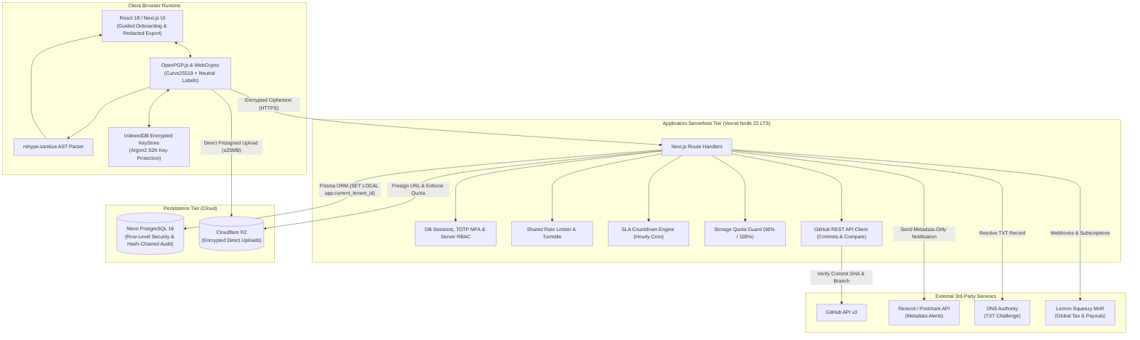
[Figure 4.1: BugBountyTrack 3-Tier Decoupled Component Architecture]

4.3 Use Case Model Diagram (Figure 4.2)
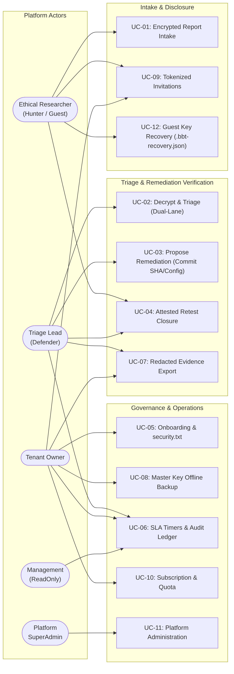
[Figure 4.2: BugBountyTrack Use Case Model & Actor Roles]

4.4 Sequence: Browser-Side OpenPGP Submission (Figure 4.3)
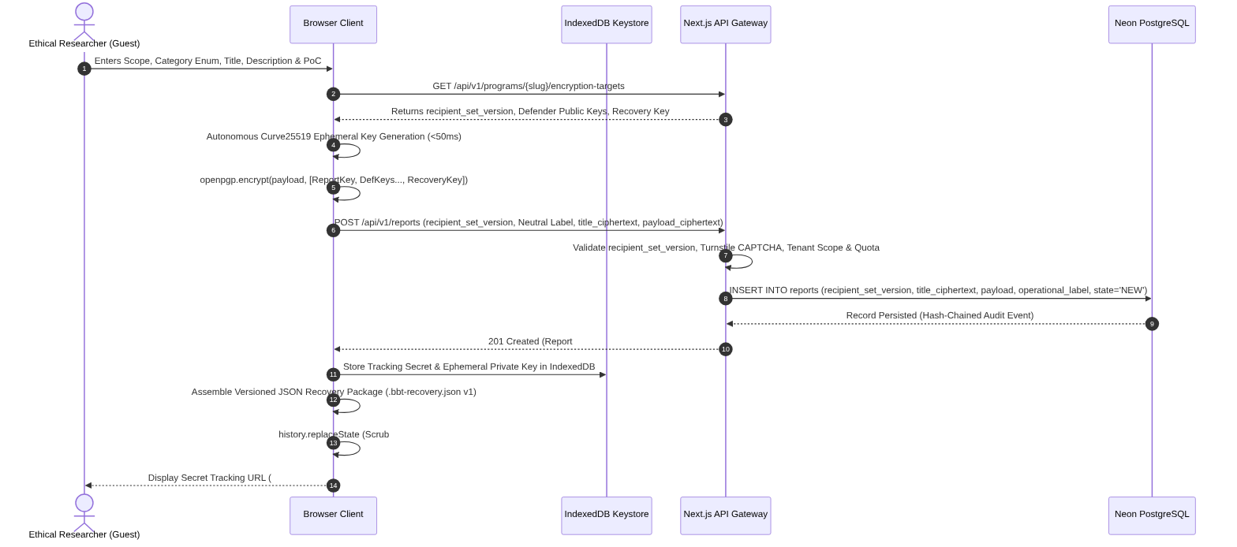
[Figure 4.3: Sequence: Browser-Side OpenPGP Encrypted Submission]

4.5 Sequence: In-Browser Decryption & Confidential Conversation (Figure 4.4)
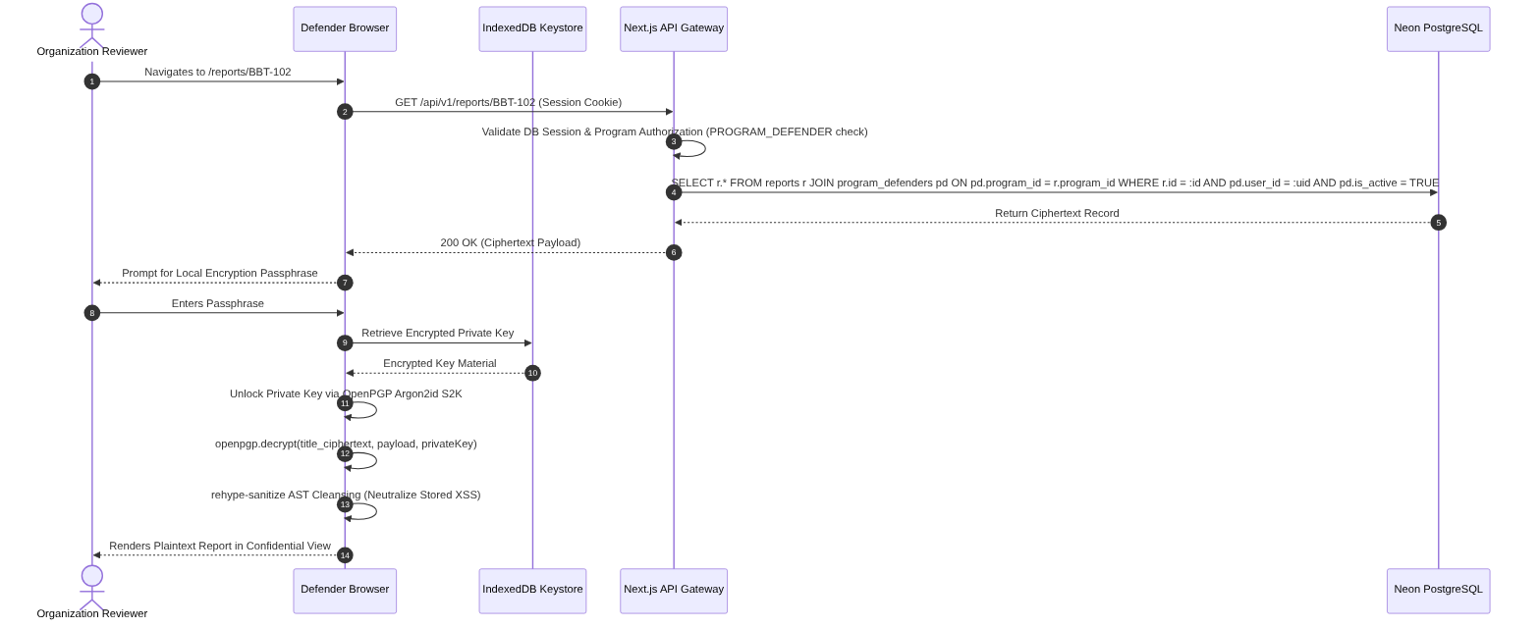
[Figure 4.4: Sequence: In-Browser Decryption & Confidential Conversation]

4.6 State Machine: Remediation & Attested Retest Lifecycle (Figure 4.5)
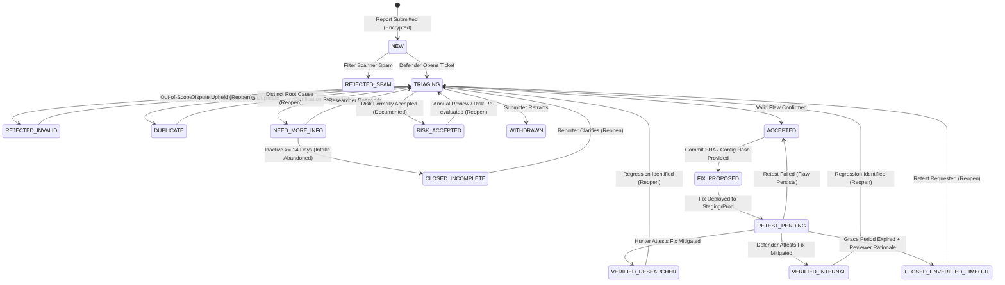
[Figure 4.5: Remediation & Attested Retest Lifecycle State Machine]

Lifecycle State Transition Matrix
Current State | Event / Trigger Action | Permitted Actor | Guard Conditions & Business Rules | Next State | Required Attestation & Evidence
NEW | Triage Intake Initiated | Defender | Report exists, valid ciphertext envelope | TRIAGING | Intake timestamp, assigned triager user ID
NEW | Filter Scanner Spam | Defender | Automated scan output, non-vulnerability | REJECTED_SPAM | Spam categorization record
TRIAGING | Accept Vulnerability | Defender | Flaw in-scope; valid reproduction; CVSS Base score computed | ACCEPTED | CVSS 3.1 Base vector string, numeric score, textual justification
TRIAGING | Request Clarification | Defender | PoC incomplete or unable to reproduce | NEED_MORE_INFO | Structured inquiry posted in Researcher–Org discussion lane
NEED_MORE_INFO | Submit Clarification | Hunter | Supplementary details or revised PoC provided | TRIAGING | Encrypted clarification response payload
NEED_MORE_INFO | Inactivity Timeout | System Cron | Researcher inactive ≥ 14 days after inquiry | CLOSED_INCOMPLETE | Automated timeout record (intake abandoned without proof)
TRIAGING | Reject Submission | Defender | Out of program scope, invalid bug, or non-actionable | REJECTED_INVALID | Mandatory rejection category and policy citation
TRIAGING | Mark as Duplicate | Defender | Identical root cause previously reported; verified in-browser | DUPLICATE | Reference to primary parent Report ID
TRIAGING | Accept Operational Risk | Defender / Owner | Management formally accepts risk; requires written rationale & review date | RISK_ACCEPTED | Executive risk acceptance justification and scheduled review date
TRIAGING | Withdraw Finding | Hunter | Reporter retracts mistaken submission | WITHDRAWN | Submitter retraction statement
ACCEPTED | Propose Remediation | Defender | Validated GitHub commit SHA or SHA-256 config hash | FIX_PROPOSED | 40-char commit SHA + target branch OR config SHA-256 hash
FIX_PROPOSED | Deploy Fix & Request Retest | Defender | Remediation deployed to designated accessible environment | RETEST_PENDING | Deployment environment URL, version tag, retest instructions
RETEST_PENDING | Retest Passed (Researcher) | Hunter | Fix independently verified mitigated by reporter on target env | VERIFIED_RESEARCHER | Empirical retest log, verification date, reporter confirmation
RETEST_PENDING | Retest Passed (Internal) | Defender | Fix verified mitigated internally; author conflict disclosed | VERIFIED_INTERNAL | Reviewer empirical test evidence, conflict-of-interest disclosure
RETEST_PENDING | Grace Period Inactivity Closure | Defender | Researcher inactive ≥ 14 days after deployment notification | CLOSED_UNVERIFIED_TIMEOUT | Explicit reviewer closure action with recorded administrative rationale
RETEST_PENDING | Retest Failed (Flaw Persists) | Hunter / Defender | Empirical retest demonstrates vulnerability remains exploitable | ACCEPTED (via RETEST_FAILED event) | Detailed failure reproduction notes, error logs; preserves audit record
VERIFIED_RESEARCHER / VERIFIED_INTERNAL / CLOSED_UNVERIFIED_TIMEOUT / CLOSED_INCOMPLETE / RISK_ACCEPTED / REJECTED_INVALID / DUPLICATE | Reopen Ticket | Defender / Tenant Owner | Regression identified, risk re-evaluated, or formal dispute upheld | TRIAGING | Mandatory reopening audit justification and incident link

4.7 Relational Prisma Schema & Domain ERD (Figure 4.6)
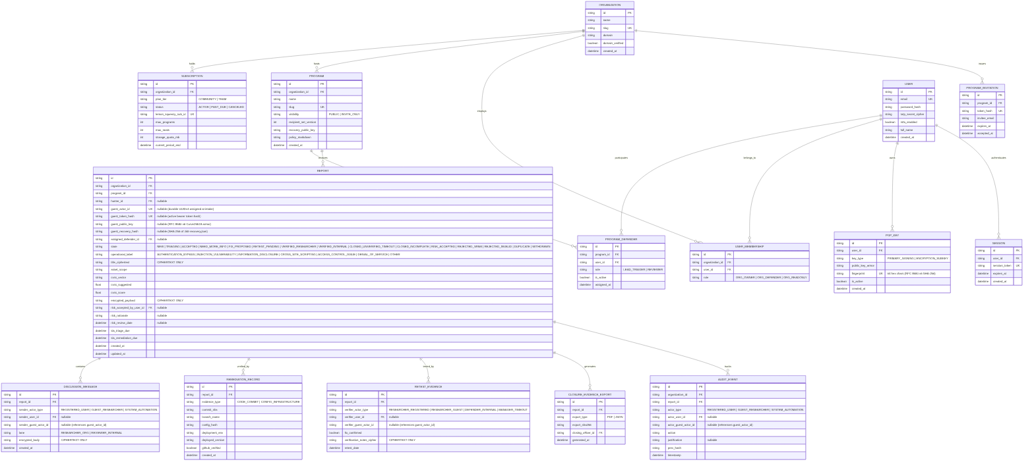
[Figure 4.6: Relational Prisma ERD & Multi-Tenant Model]

Entity Governance & Data Integrity Rules
1. `PROGRAM_DEFENDER` Governance Rules:
• Same-Organization Constraint: A user can only be assigned to a program if user.organization_id == program.organization_id. Cross-tenant defender assignments are blocked by database constraints.
• Unique Membership Constraint: Enforced compound uniqueness on @@unique([program_id, user_id]).
• Atomic Assignment & Versioning: Inserting or removing a PROGRAM_DEFENDER record must execute within an atomic transaction that increments the parent program.recipient_set_version.
• Program-Level Authorization Boundary: Report retrieval, attachment presigning, and closure exports verify active membership in PROGRAM_DEFENDER for the specific program_id, not merely general tenant membership.
2. Durable Guest Actor Model:
• REPORT.guest_actor_id establishes an immutable UUIDv4 identity generated at intake. All subsequent discussion messages, retest attestations, and audit records reference this durable ID. Rotating or re-issuing guest_token_hash allows credential recovery without altering historical attribution.

5. External Interface Requirements

5.1 User Interfaces & Screen Catalog
The platform provides a clean, responsive web interface comprising 8 core screens:
1. `SCR-01: Public Program Discovery (/programs/[slug])`: Displays organization logo, Safe Harbor statement, in-scope domains, rules of engagement, and active PGP public key.
2. `SCR-02: Cryptographic Report Submission (/programs/[slug]/submit)`: Form for neutral operational category selection, specific title, asset selection, CVSS calculator, encrypted description, PoC input, and file attachment dropzone (supporting guest intake).
3. `SCR-03: Triage & Confidential Discussion Desk (/dashboard/reports/[id])`: Passphrase-unlocked view displaying decrypted report, dual-lane discussion threads, SLA countdown timers, CVSS adjustment controls, and state transitions.
4. `SCR-04: Remediation Proposal Modal`: Form for selecting evidence type (CODE_COMMIT vs. CONFIG_INFRASTRUCTURE), inputting GitHub commit SHA, and recording target deployment environment.
5. `SCR-05: Attested Retest Form`: Formal modal prompting for empirical retest results, deployment URL, test logs, and certification sign-off.
6. `SCR-06: Organization Policy & Key Settings (/settings/security-txt)`: Interface for generating RFC 9116 text, in-browser cleartext PGP signing, armored key backup/succession, and DNS TXT verification.
7. `SCR-07: Guided Onboarding Wizard (/onboarding)`: Multi-step setup wizard guiding new organization owners through domain DNS challenge verification, policy definition, local PGP key generation, offline master recovery key export challenge, and RFC 9116 publication in under 15 minutes.
8. `SCR-08: Redacted Closure Evidence Export Modal (/dashboard/reports/[id]/export)`: Configuration modal allowing defenders to generate and download sanitized, audit-ready PDF/JSON closure evidence summaries.

5.2 Software & External API Interfaces
• GitHub REST API v3: GET /repos/{owner/{repo/commits/{ref and compare API verifying commit SHAs, author identity, and repository branch membership across public and private repositories.
• DNS Resolver (Node.js `dns.promises`): resolveTxt() resolving _bbt-challenge.<domain> records for domain ownership validation.
• Resend / Postmark API v1: POST /emails dispatching metadata-only transaction notifications over TLS.
• Cloudflare R2 Object Storage (S3 API Client): PutObjectCommand and GetObjectCommand storing client-encrypted attachments with zero egress fees via presigned URLs.
• Lemon Squeezy API v1: Merchant of Record checkout sessions, webhook handlers for subscription lifecycle, and customer portal.

6. Non-Functional Requirements (NFR)
• NFR-01 (API Latency Target): 95% of non-cryptographic API requests (GET /api/v1/programs, GET /api/v1/reports) shall respond within ≤ 300 ms under a concurrent load of 10 requests on reference hardware (Node.js 22 serverless runtime).
• NFR-02 (Client Cryptographic Benchmark): Client-side OpenPGP key generation and payload encryption (≤ 100 KB text) shall complete within ≤ 1,500 ms on modern desktop browsers (Chromium 120+, Apple M-series or Intel Core i5 reference). Pinned Curve25519 executes in <50ms.
• NFR-03 (Row-Level Security Dynamic Context): The database driver shall set tenant context dynamically on pooled connections via SET LOCAL app.current_tenant_id = :org_id within every transactional query block, preventing tenant context leaks across connection pool reuse.
• NFR-04 (WCAG 2.2 AA Accessibility): All interactive touch targets shall meet the minimum criterion of 24 × 24 CSS px per WCAG 2.2 AA (with 44 × 44 CSS px enforced on primary mobile navigation controls as an enhanced target). Color contrast ratios shall maintain ≥ 4.5:1 for normal text and ≥ 3.0:1 for large text.
• NFR-05 (Stored XSS Neutralization): The Markdown rendering engine shall parse input into an Abstract Syntax Tree (AST) and sanitize via rehype-sanitize against a strict allowlist. It shall neutralize 100% of standard test attack vectors from the OWASP Cross-Site Scripting Filter Evasion Cheat Sheet (including <script>, javascript:, onerror=, and data: URIs).
• NFR-06 (Storage Quota Enforcement): Tenant storage shall be capped at 50 MB database volume and 2 GB Cloudflare R2 object volume for demo tenants, and 10 GB for Team tenants. The platform shall display administrative warnings when usage reaches 90% of configured quota, and strictly reject new allocations with HTTP 413 Payload Too Large if projected usage exceeds 100%.
• NFR-07 (Append-Only Audit Ledger Integrity): The PostgreSQL audit_events table shall enforce database-level grant constraints permitting INSERT and SELECT operations only, with a cryptographic prev_hash chain preventing record modification or deletion even in the event of application-level credential compromise.
• NFR-08 (SLA Countdown Engine Accuracy): The SLA countdown monitor shall evaluate report targets with hourly precision, flagging breached targets and dispatching automated reminders within 60 minutes of deadline expiration.

7. Verification, Acceptance Criteria & Traceability

7.1 Bidirectional Traceability Matrix
Requirement ID | Functional Capability Description | Target Delivery Milestone | Automated Test Case ID | WBS Package Code
FR-1.1 | Multi-tenant schema isolation & monorepo | Part A (W1–W8) | TC-SEC-01 (Tenant RLS isolation test) | WP-1.1 / WP-1.2
FR-1.2 | Server-enforced 4-tier RBAC middleware | Part A (W1–W8) | TC-AUTH-02 (Role boundary verification) | WP-2.3
FR-1.3 | DB sessions, password auth & TOTP MFA | Part A / Part B | TC-AUTH-01 (Password hashing, DB session kill) | WP-2.2 / WP-7.1
FR-1.4 | Guided onboarding & offline recovery key | Part B (W13–W14) | TC-ONBOARD-01 (Onboarding flow completion test) | WP-7.2
FR-1.5 | Private program access (token_hash invite) | Part B (W13–W14) | TC-INVITE-01 (Tokenized invite redemption test) | WP-7.3
FR-1.6 | Account-less guest vulnerability intake | Part B (W13–W14) | TC-GUEST-01 (Guest intake & secret tracking test) | WP-7.3
FR-2.1 | RFC 9116 security.txt endpoint & download | Part A (W1–W8) | TC-POL-01 (RFC 9116 syntax validator) | WP-3.1
FR-2.2 | Browser cleartext PGP signing of policy | Part A (W1–W8) | TC-POL-02 (Cleartext signature verification) | WP-3.2
FR-2.5 | DNS TXT challenge domain verification | Part A (W1–W8) | TC-POL-03 (DNS TXT record challenge mock) | WP-3.3
FR-3.1 | WebCrypto keypair generation (Ed25519/X25519) | Part A (W1–W8) | TC-CRYPTO-01 (Curve25519 capability check) | WP-3.4
FR-3.2 | Argon2 S2K encrypted IndexedDB keystore | Part A (W1–W8) | TC-CRYPTO-02 (Local keystore decrypt assertion) | WP-3.4
FR-3.3 | Multi-defender encryption (recipient_set_version) | Part A (W1–W8) | TC-CRYPTO-03 (Multi-defender decryption test) | WP-4.1
FR-3.4 | Neutral operational category labeling | Part A (W1–W8) | TC-CRYPTO-05 (Operational label categorization test) | WP-4.1
FR-3.5 | Direct-to-R2 presigned upload (≤ 25 MB) | Part A / Part B | TC-CRYPTO-04 (Direct R2 presigned upload test) | WP-4.2 / WP-7.4
FR-3.6 | Offline recovery key & audited re-wrapping | Part A / Part B | TC-CRYPTO-06 (Session key re-wrap audit assertion) | WP-7.2
FR-4.1 | Deterministic CVSS 3.1 Base scoring engine | Part A (W1–W8) | TC-CVSS-01 (45 verified vectors in CVSS_TEST_FIXTURES.md) | WP-4.3
FR-4.4 | Decoupled suggested vs assigned CVSS score | Part A (W1–W8) | TC-CVSS-02 (Suggested vs assigned score test) | WP-4.3
FR-5.1 | In-browser decryption & working prototype | Part A (W1–W8) | TC-TRIAGE-01 (In-browser decrypt pipeline test) | WP-4.4
FR-5.2 | Dual-lane triage (Conversation vs. Internal) | Part A (W9–W10) | TC-TRIAGE-02 (Internal notes key isolation test) | WP-5.1
FR-5.3 | Minimal-metadata alerts & duplicate linking | Part A (W9–W10) | TC-NOTIF-01 (Minimal-metadata email dispatch mock) | WP-5.2
FR-5.4 | SLA countdown engine & Slack webhooks | Part B (W15–W16) | TC-SLA-01 (Hourly SLA cron & webhook test) | WP-7.5
FR-6.2 | GitHub REST API commit SHA & branch check | Part A (W9–W10) | TC-VCS-01 (GitHub API commit & compare mock) | WP-5.3
FR-6.3 | Infrastructure config SHA-256 hash binder | Part A (W9–W10) | TC-VCS-02 (Hash reproducibility test) | WP-5.4
FR-7.1 | Basic intake triage transitions (NEW->ACCEPTED) | Part A (W1–W8) | TC-STATE-01 (Intake state transition test) | WP-4.4
FR-7.2 | Attested retest state machine (3 fan-outs) | Part A (W11–W12) | TC-STATE-02 (Mandatory retest attestation check) | WP-6.1
FR-7.3 | Expanded states (RISK_ACCEPTED, REJECTED_SPAM) | Part A (W11–W12) | TC-STATE-03 (Expanded state transitions check) | WP-6.1
FR-7.4 | Failed retest event loopback to ACCEPTED | Part A (W11–W12) | TC-STATE-04 (Failed retest transition & log test) | WP-6.1
FR-7.6 | Ticket reopening audit logging | Part A (W11–W12) | TC-STATE-05 (Reopen justification audit log test) | WP-6.1
FR-7.7 | Redacted closure evidence export (PDF/JSON) | Part B (W15–W16) | TC-EXPORT-01 (Redacted export sanitization check) | WP-7.6
FR-8.1 | AST Markdown HTML sanitization | Part A (W1–W8) | TC-SEC-02 (OWASP XSS cheat sheet corpus test) | WP-1.3
FR-8.2 | PostgreSQL Row-Level Security isolation | Part A (W1–W8) | TC-SEC-01 (Tenant RLS boundary test) | WP-1.2
FR-8.3 | Shared store rate limiter & Turnstile | Part A (W3–W4) | TC-SEC-03 (Turnstile & shared rate limit test) | WP-2.4
FR-8.4 | Storage quota monitor & presigned direct R2 | Part A / Part B | TC-SEC-04 (Tenant quota enforcement test) | WP-6.2 / WP-7.4
FR-8.5 | Append-only audit ledger with SHA-256 hash | Part A (W1–W8) | TC-SEC-05 (Audit table UPDATE/DELETE rejection) | WP-1.2
FR-8.6 | Merchant of Record (Lemon Squeezy) Billing | Part B (W15–W16) | TC-BILL-01 (Lemon Squeezy webhook idempotency) | WP-7.7
FR-8.7 | Disaster recovery restore & hard deletion | Part B (W17–W18) | TC-OPS-01 (Automated DB & R2 restore sandbox drill) | WP-7.12

7.2 Verification Test Pyramid & Acceptance Criteria
• Unit Tests (Jest / TypeScript):
• Deterministic CVSS 3.1 calculation accuracy across 45 verified test vectors documented in CVSS_TEST_FIXTURES.md (100% mathematical parity against FIRST.org specification).
• In-browser OpenPGP encryption/decryption roundtrip verifying program-scoped multi-defender envelope and title ciphertext.
• Markdown AST sanitizer asserting zero execution of embedded <script> or event-handler payloads.
• Integration Tests (Supertest / PostgreSQL):
• Multi-tenant RLS tests verifying that query connections with tenant_A context receive zero records from tenant_B.
• State transition test asserting that transitioning directly from NEW to VERIFIED_RESEARCHER throws HTTP 400 Bad Request.
• GitHub REST API mock verifying handling of valid commit SHAs, non-existent SHAs, and non-collaborator authors across public and private repositories.
• Outbox worker test asserting exponential retry on delivery failure and idempotency deduplication.
• Append-only database assertion confirming that attempting UPDATE or DELETE on audit_events throws a database permission error.
• Acceptance Gates Across Delivery Milestones:
• Gate 1 (Week 7 Live Prototype): Core intake, client encryption targeting program defenders, local key unlocking, in-browser decryption, AST sanitization, pure TypeScript CVSS 3.1 scoring, basic state transitions (NEW → TRIAGING → ACCEPTED), and PostgreSQL RLS tenant isolation.
• Gate 2 (Week 12 Academic Defense Baseline): GitHub commit SHA verification, non-code SHA-256 config hashing, empirical retest workflow with 3 separate terminal branches (VERIFIED_RESEARCHER, VERIFIED_INTERNAL, CLOSED_UNVERIFIED_TIMEOUT), failed retest event loopback to ACCEPTED, and controlled peer usability evaluation (3–5 peers).
• Gate 3 (Weeks 13–14 Commercial Core Intake): Guided Onboarding Wizard, offline Organization Master Recovery Key export with test challenge, account-less guest intake, direct-to-R2 presigned upload hardening, and SuperAdmin console.
• Gate 4 (Weeks 15–16 Commercial Operations Ready): SLA countdown engine with hourly checks, Slack webhooks, redacted PDF/JSON closure evidence export, Lemon Squeezy MoR billing ($49/mo Team & Free Tier), landing page, and legal pack.
• Gate 5 (Weeks 17–18 Commercial Production Release - DoRG): Security hardening (strict CSP with 'wasm-unsafe-eval' for OpenPGP.js Argon2 S2K execution, SRI, CSRF, lockout, SSRF checks), self pen-test pass, Sentry observability, and automated disaster recovery sandbox drill.
--- End of Software Requirements Specification (SRS) ---

