HIGH-LEVEL ARCHITECTURE & CLOUD TOPOLOGY SPECIFICATION
BugBountyTrack — Multi-Tenant Vulnerability Disclosure Platform with Client-Side Cryptographic Isolation and Evidence-Based Remediation Tracking

Document Control & Academic Metadata
Attribute | Specification
Document Title | High-Level Architecture & Cloud Topology Specification
Document Version | Revision 1.2 (Milestone Architecture Baseline — Work-in-Progress Review)
Release Date | October 16, 2026
Author / Candidate | Taha Asadullah (Roll No: `24-ST-013`)
Academic Institution | Punjab Tianjin University of Technology (PTUT), Lahore
Department & Program | Department of Software Engineering Technology — BS Software Engineering Technology
Batch / Section | Batch 24-SET-Fall / Section SET-B (24-st-013@students.ptut.edu.pk)
FYP Project Supervisor | Sir Umar Hayat (Assistant Professor, PTUT Lahore)
Project Identifier | PTUT - PRJ - 089 (Sub-Field: 9. Cybersecurity, Privacy & LegalTech)
Milestone | Week 3 — High-Level Architecture & Cloud Topology
Governing Standards | IEEE Std 42010-2011 (Architecture Description), IEEE Std 830-1998 & ISO/IEC/IEEE 29148:2018
Technical Stack | Next.js 14+ (App Router, TypeScript), Node.js 22 LTS, PostgreSQL 16 (Neon), Cloudflare R2, OpenPGP.js v6
Requirements Baseline | Submitted IEEE 830 SRS (Revision 2.8, Pending Formal Supervisor Evaluation)

Supporting Deliverable Documents & Reference Artifacts
Deliverable Document | Scope Covered | Repository & Cloud Reference
Week 1 Discovery: Personas, Charter & MVP Features (`WEEK_1_DISCOVERY_REPORT.docx`) | Executive Context, 4 Operational Frictions, 2 Provisional Composite Personas, and 5 Core MVP Features | View Week 1 Discovery Doc (Google Drive) (https://docs.google.com/document/d/1drXMfAk4pIKc_9aMKZav62KfVZQ04--zT6VyuhDZKFA/edit?usp=drive_link)
Week 2 Formal IEEE 830 Software Requirements Specification (`SRS.docx`) | Complete Submitted IEEE 830 SRS (Revision 2.8), Table 2.2 Permission Matrix, FR-1 to FR-8, UC-01 to UC-07, 4 UML Diagrams, and NFRs | View Week 2 IEEE 830 SRS Doc (Google Drive) (https://docs.google.com/document/d/1n8VKmXeK4TSTPPR-mDXp3NkKwDxvzTzEWR9tgdZlxSg/edit?usp=drive_link)
Week 3 High-Level Architecture & Cloud Topology (`HIGH_LEVEL_ARCHITECTURE.docx`) | 3-Tier Zero-Plaintext Model, Balanced DFD Level 0 & Level 1, Defensible System Boundaries, and Cloud Topology Justification | Local Word: architecture/HIGH_LEVEL_ARCHITECTURE.docx / Resources/HIGH_LEVEL_ARCHITECTURE.docx

1. Executive Architecture Summary & Core Objectives
1.1 Architectural Vision & The Zero-Knowledge Paradigm
BugBountyTrack (PTUT - PRJ - 089) is a multi-tenant vulnerability coordination platform designed for small software teams (5–50 engineers) and ethical security researchers. Traditional bug bounty systems adopt a trusted-server architecture where vulnerability reports, reproduction steps, and exploit attachments reside in plaintext on application servers.
BugBountyTrack replaces this model with a client-side cryptographic architecture governed by three core principles:
1. Zero-Plaintext Server Storage: Vulnerability descriptions, proof-of-concept (PoC) scripts, and triage discussions are encrypted in the client browser using OpenPGP.js v6 (`RFC 9580` Curve25519: `Ed25519` signing + `X25519` encryption) before transmission. The application server and database store strictly armored ciphertexts, key fingerprints, and coarse operational metadata (Class A).
2. Direct-to-Object Encrypted Attachment Pipeline: Binary evidence files (<= 25 MiB each, <= 50 MiB per report) are encrypted in browser memory into RFC 9580 SEIPDv2 binary packets and streamed directly to Cloudflare R2 via presigned S3 URLs, completely bypassing serverless memory limits and execution timeouts.
3. Evidence-Based Remediation & Attested Retest State Machine: Tickets cannot be closed on informal declarations. Defenders must supply verifiable proof—either an authoritative GitHub commit SHA checked for ancestry via the GitHub REST API v3 (FR-6.2) or an encrypted configuration snapshot bound to a SHA-256 hash (FR-6.3)—before transitioning through an attested 15-state lifecycle automaton backed by an append-only, dual hash-chained audit ledger (row_hash and report_chain_hash, FR-8.5).
1.2 Architectural Quality Attributes & Non-Functional Goals
The high-level architecture is designed against four primary non-functional engineering objectives:
• Confidentiality & Minimal Trust (`NFR-03`, `NFR-05`): Application servers, database storage engines, and hosting providers hold only armored ciphertexts and operational metadata; they lack access to the client-held private keys required to decrypt report descriptions or attachments without unauthorized access to client endpoint keystores.
• Deterministic Remediation Verifiability (`NFR-06`): Every state transition from ACCEPTED to a terminal state (VERIFIED_RESEARCHER, VERIFIED_INTERNAL, or CLOSED_UNVERIFIED_TIMEOUT) is cryptographically chained in an append-only audit ledger using SHA-256 hashes (row_hash and report_chain_hash), restricting application-level modification and supporting detection of changes to recorded history.
• Operational Latency Targets (`NFR-01`, `FR-4`): The system establishes engineering performance targets of p95 latency <= 400 ms and p99 latency <= 800 ms for core API operations under specified benchmark loads (NFR-01), with client-side OpenPGP v6 Curve25519 key generation targeted at < 50 ms and deterministic CVSS v3.1 scoring targeted at < 5 ms as proposed design goals.
• Cloud Infrastructure Feasibility: The architecture establishes an engineering cost model estimated at $0.00/month during academic demonstration by operating within cloud provider free allowances, while commercial multi-tenant operation is projected at an estimated baseline of ~$61.00/month for 10–25 small organizations, subject to actual platform workload and provider quota adjustments.

2. 3-Tier Zero-Plaintext System Architecture
2.1 Architectural Tier Model Specification
The system is structured as an authoritative 3-Tier Distributed Architecture, where each tier enforces strict physical and cryptographic isolation boundaries:
+-------------------------------------------------------------------------------+
| TIER 1: CLIENT PRESENTATION & CRYPTOGRAPHIC BOUNDARY |
| - Modern Web Browser (Next.js 14 Client Runtime, React 18+, Tailwind CSS) |
| - OpenPGP.js v6 WebCrypto / WebAssembly Curve25519 (Ed25519 / X25519) |
| - IndexedDB KeyStore, Turnstile Widget, rehype-sanitize AST Cleansing |
+-------------------------------------------------------------------------------+
| ^
HTTPS / TLS 1.3 (JSON REST) | | Direct S3 Presigned Upload / Download
v | (Encrypted Ciphertext Attachments)
+-------------------------------------------------------------------------------+
| TIER 2: PRESENTATION & GATEWAY / API SERVER TIER |
| - Unified Next.js 14+ App Router on Node.js 22 LTS (Vercel Serverless Fleet) |
| - Stateless API Handlers (/api/v1/*, /.well-known/security.txt) |
| - Server-Side RBAC, CSPRNG Session Tokens, Shared-Store Rate Limiting |
| - Pure TypeScript FIRST.org CVSS v3.1 Base Scoring Engine (8.22 Constant) |
| - GitHub REST API v3 Integration & Resend Transactional Mail Service |
| - Scheduled Cron Worker (POST /api/v1/internal/cron/sla-check HMAC-SHA256) |
+-------------------------------------------------------------------------------+
|
TLS 1.3 Pooled TCP (PgBouncer: Port 6543)
v
+-------------------------------------------------------------------------------+
| TIER 3: PERSISTENCE & STORAGE TIER |
| - Relational Database: Neon Serverless PostgreSQL 16 (bbt_core Schema) |
| * FORCE ROW LEVEL SECURITY on all tenant tables (bbt_app role) |
| * Hardened SECURITY DEFINER Functions (SET search_path = pg_catalog,...) |
| * Dual Hash-Chained Audit Ledger (row_hash & report_chain_hash) |
| - Object Storage: Cloudflare R2 (S3-Compatible, SSE-R2 At-Rest Encryption) |
+-------------------------------------------------------------------------------+
Tier 1: Client Presentation & Cryptographic Boundary (Web Browser)
The client tier executes inside the user's web browser (Firefox, Chromium, Safari). It is the sole trust boundary where unencrypted vulnerability data exists:
• UI & Rendering Engine: Next.js 14+ Client Components styled with Tailwind CSS, conforming to WCAG 2.2 AA accessibility standards (24 x 24 px minimum touch targets).
• Client Cryptographic Engine: Pinned OpenPGP.js v6 utilizing the browser's native crypto.subtle WebCrypto API and WebAssembly for Curve25519 (Ed25519 signing, X25519 encryption). It executes:
◦ Account-less ephemeral key generation (< 50 ms target).
◦ Multi-recipient payload encryption wrapping symmetric session keys for authorized program defenders (PROGRAM_DEFENDER) and organization recovery keys (FR-3.6).
◦ Symmetric encryption of .bbt-recovery.json packages using RFC 9580 SYMENC+SEIPDv2 with Argon2id S2K (s2kType = argon2). Guest passphrases are entered and processed strictly within browser memory and are never transmitted to application servers.
• Client Storage & Sanitization: Private keys are maintained in IndexedDB protected by user passphrases. Decrypted report bodies and Markdown comments pass through rehype-sanitize AST cleansing, filtering unsafe HTML elements, scripting attributes, and dangerous URI schemes via strict Markdown AST sanitization prior to DOM rendering.
Tier 2: Presentation & Gateway / API Server Tier (Serverless Compute)
The application tier runs as a serverless fleet on Node.js 22 LTS hosted on Vercel's global infrastructure:
• Stateless API Gateway: Exposes structured JSON REST endpoints under /api/v1/ and public RFC 9116 endpoints (/.well-known/security.txt). Serverless functions are stateless, with an engineering design latency target of p95 <= 400 ms and p99 <= 800 ms under specified benchmark conditions (NFR-01).
• Authentication & RBAC Middleware: Manages session governance using 256-bit cryptographically secure pseudorandom values (CSPRNG), storing only SHA-256 hashes in the database (bbt_core.sessions.token_hash). User passwords are protected using Argon2id (FR-1.3a). Session cookies use the secure cookie name __Host-bbt-session with attributes SameSite=Lax, Secure, HttpOnly, and Path=/. The SameSite=Lax policy allows legitimate top-level navigations (such as following email notifications or external bookmarks) to retain active session state, preventing disruptive session drops on safe GET requests, while withholding cookies on cross-site subrequests. All state-changing endpoints (POST, PUT, PATCH, DELETE) enforce JSON payload requirements and anti-CSRF request validation. Tenant isolation is enforced by injecting organization_id into database execution contexts, and mandatory TOTP MFA step-up is required for ORG_OWNER operations (FR-1.3c).
• Deterministic CVSS v3.1 Engine: A pure TypeScript implementation of FIRST.org CVSS v3.1 Base scoring (FR-4.1 – FR-4.4). It accepts valid CVSS v3.1 base metrics in any ordering, parses and validates all mandatory metrics, computes the Base score using the official coefficient `8.22` and Appendix A RoundUp ceiling function with a proposed design target of < 5 ms (FR-4), and serializes metrics into the canonical FIRST.org vector format (CVSS:3.1/AV:X/AC:X/PR:X/UI:X/S:X/C:X/I:X/A:X), verifying computational parity against the 45 official FIRST.org reference test fixtures.
• External Adapters & Scheduled Worker: Integrates with the GitHub REST API v3 to check commit existence and verify its ancestry relationship with the target branch via GET /repos/{owner}/{repo}/compare/{branch}...{sha} (FR-6.2). A successful API response confirms repository ancestry; it does not establish production deployment or prove the fix works. Dispatches metadata-only notification emails via Resend (FR-5.3), and executes hourly claim-lease cleanup tasks on POST /api/v1/internal/cron/sla-check authenticated via HMAC-SHA256 request headers (X-Cron-Timestamp and X-Cron-Signature: sha256=<64-hex-hmac>, FR-5.4).
Tier 3: Persistence & Storage Tier (Managed Cloud Data)
The persistence tier provides durability, multi-tenant isolation, and binary storage:
• Neon Serverless PostgreSQL 16: Relational storage partitioned under the dedicated bbt_core schema. All tables enforce `FORCE ROW LEVEL SECURITY` using the unprivileged bbt_app database role (NOSUPERUSER NOBYPASSRLS). Connection pooling is multiplexed through PgBouncer (?pgbouncer=true) to eliminate connection exhaustion during traffic spikes.
• Dual Hash-Chained Audit Ledger: Implements an immutable audit trail (bbt_core.audit_events) where every state transition, access grant, and remediation attestation is cryptographically bound using two concurrent hash chains:
1. row_hash: The canonical tenant-wide chronological hash chain linking all organization audit events (row_hash = SHA-256(prev_tenant_row_hash || "|" || event_digest)).
2. report_chain_hash: The report-scoped hash chain linking the lifecycle events of an individual report (report_chain_hash = SHA-256(prev_report_chain_hash || "|" || event_digest)).
This dual-chain structure restricts application-level modification and supports independent detection of changes to recorded history.
• Storage Quota Enforcement (`FR-8.4`): The database layer enforces multi-tenant capacity boundaries: a 20 MiB intake pool for pending/unverified reports, a 6 MiB security and triage reserve, and a 300 KiB Priority-0 floor within that reserve strictly reserved for compact critical operations (such as researcher reply/retest attestations and status updates).
• Cloudflare R2 Object Storage: S3-compatible distributed object storage holding client-encrypted binary PoC attachments. Objects are addressed by immutable UUIDv4 keys and protected at rest by Cloudflare SSE-R2 AES-256 encryption.

2.2 Visual 3-Tier Architecture Diagram
The structural relationship, protocols, and security boundaries across the three tiers are illustrated below:
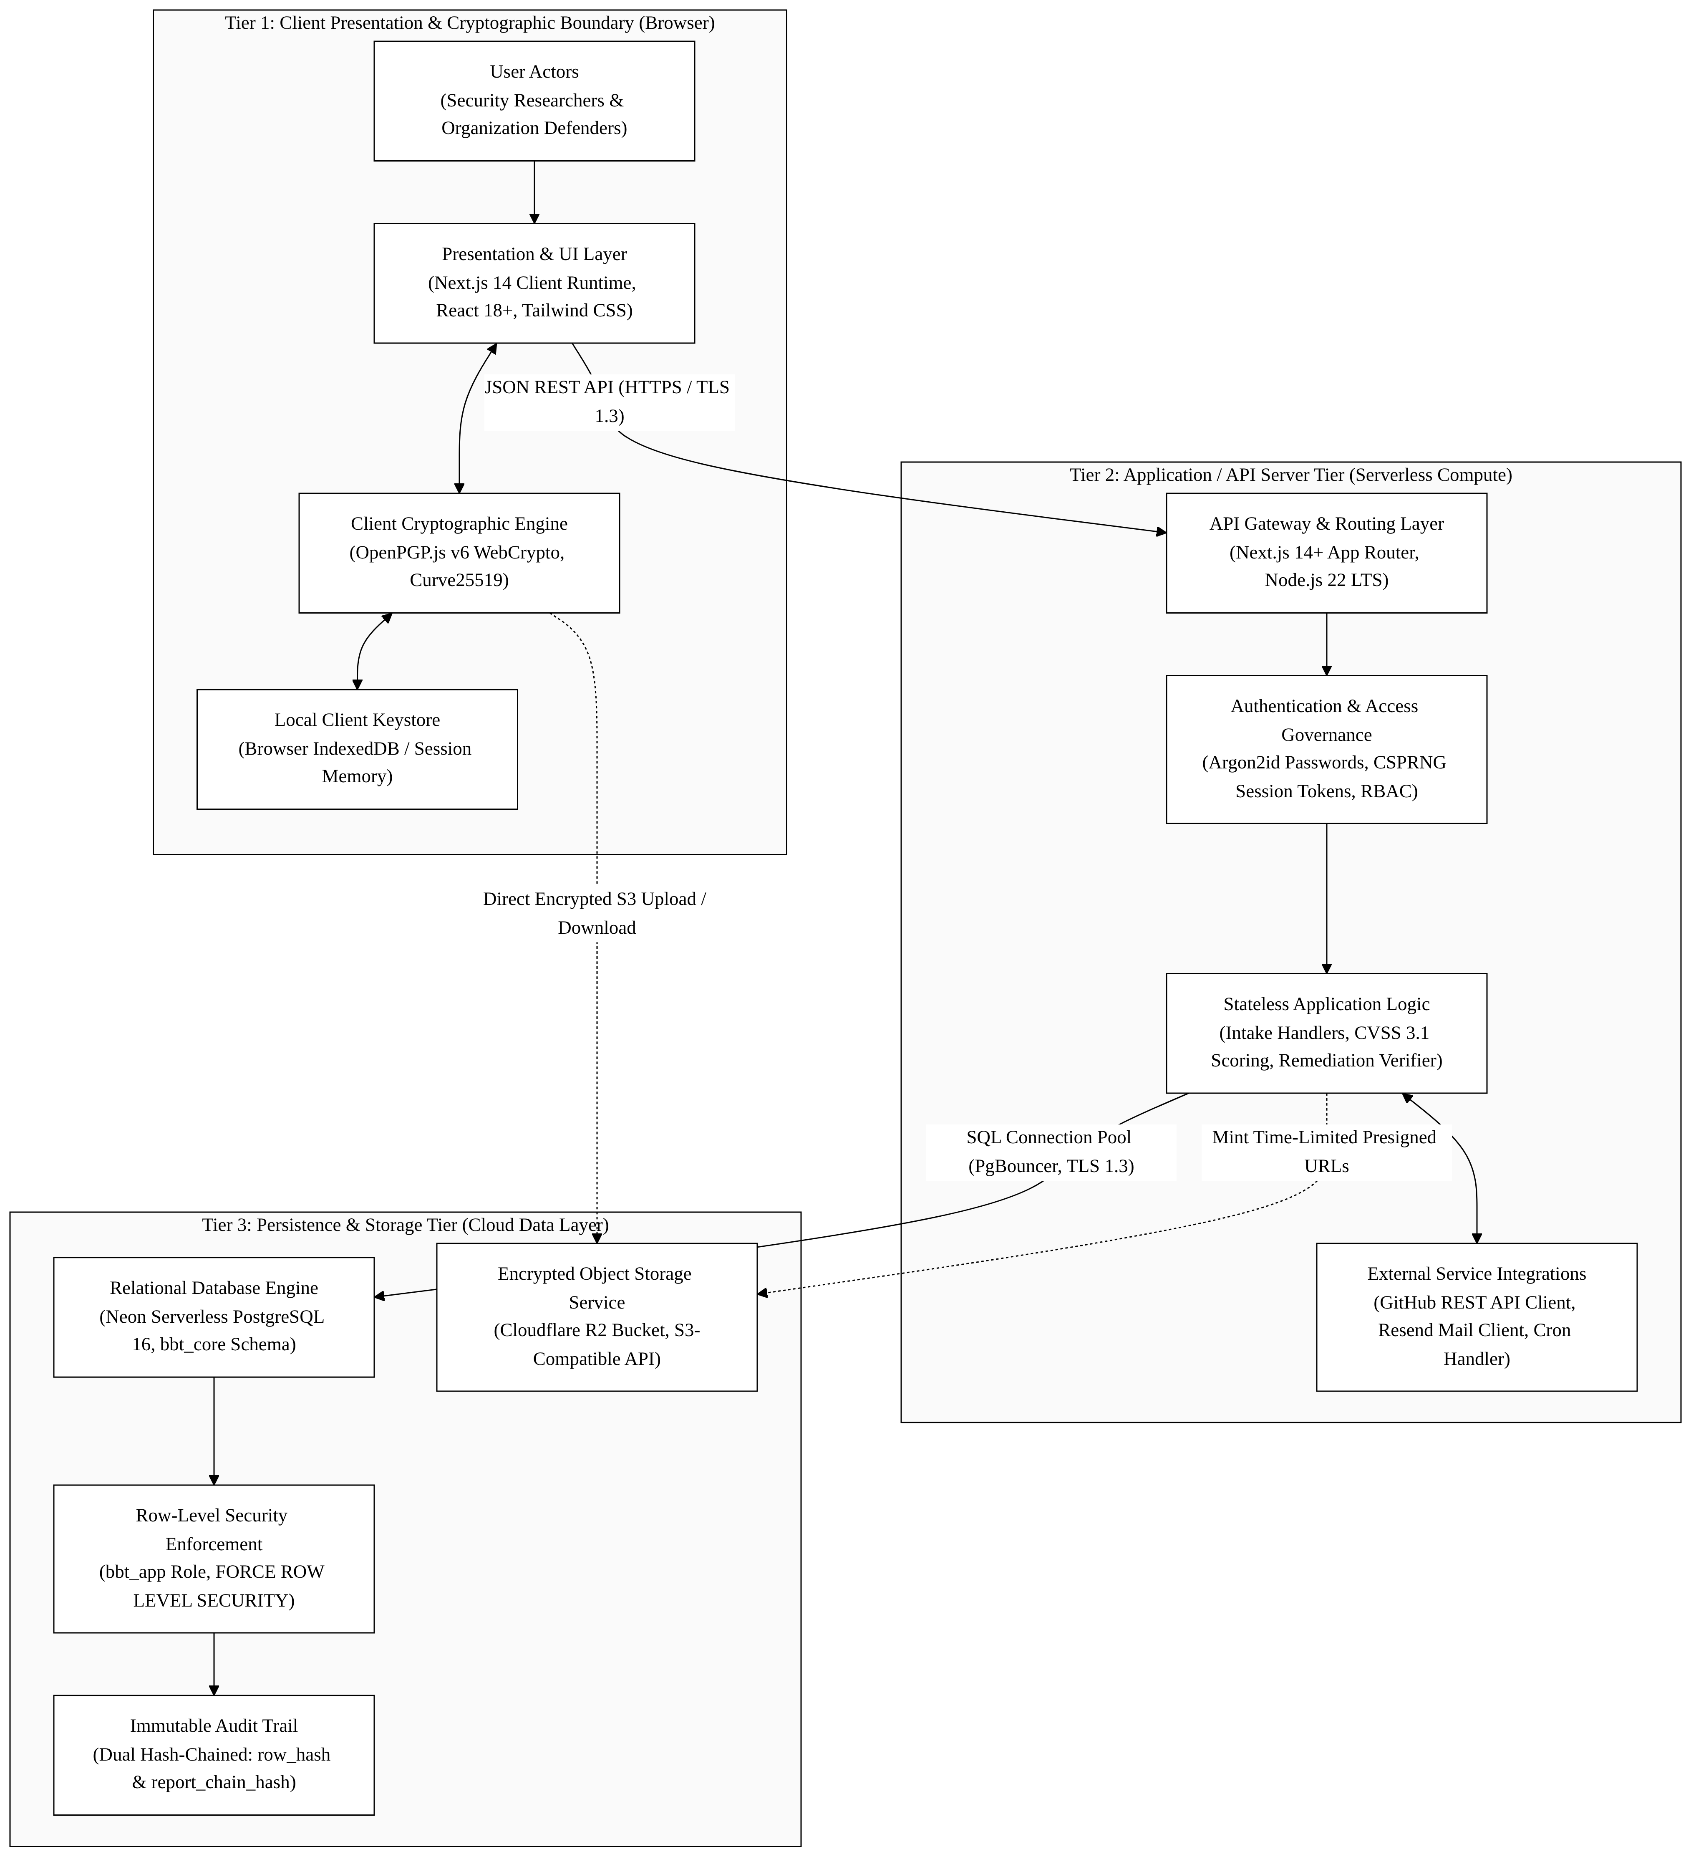

2.3 Tier-to-Tier Communication Protocols & Interface Contracts
Interface Channel | Source Tier | Destination Tier | Transport Protocol | Authentication & Payload Contract
Client API Calls | Tier 1 (Browser) | Tier 2 (Next.js API) | HTTPS (TLS 1.3) | __Host-bbt-session Cookie (SameSite=Lax, Secure, HttpOnly) or Turnstile Token; JSON payloads (Class A metadata + Class B/C armored ciphertext).
Direct Attachment Upload | Tier 1 (Browser) | Tier 3 (Cloudflare R2) | HTTPS (TLS 1.3) | Pre-signed S3 PUT URL with If-None-Match: *; binary RFC 9580 SEIPDv2 encrypted ciphertext.
Direct Attachment Download | Tier 1 (Browser) | Tier 3 (Cloudflare R2) | HTTPS (TLS 1.3) | Pre-signed S3 GET URL (15-minute lease expiry); streaming binary ciphertext decrypted locally in browser.
Database Queries & Pools | Tier 2 (Next.js API) | Tier 3 (Neon DB) | TLS 1.3 TCP (Port 6543) | Prisma ORM 5.x connection via PgBouncer as unprivileged bbt_app role; queries execute within parameterized SQL transactions.
Commit Attestation Query | Tier 2 (Next.js API) | External (GitHub API) | HTTPS (TLS 1.3) | GitHub App / PAT Bearer token; queries GET /repos/{owner}/{repo}/compare/{branch}...{sha} to confirm commit existence and branch ancestry.
Transactional Email Alerts | Tier 2 (Next.js API) | External (Resend API) | HTTPS (TLS 1.3) | Resend API Bearer Token; dispatches JSON containing Class A metadata only (zero vulnerability body).
Hourly Cron Invocation | External (GitHub GHA) | Tier 2 (Next.js API) | HTTPS (TLS 1.3) | HTTP POST /api/v1/internal/cron/sla-check with X-Cron-Timestamp and X-Cron-Signature: sha256=<64-hex-hmac> (FR-5.4).

3. Data Flow Diagrams (DFD)
3.1 DFD Level 0: System Context Diagram
The Level 0 Context Diagram models BugBountyTrack as a unified central process (0.0), identifying the six external entities that interact across its perimeter:
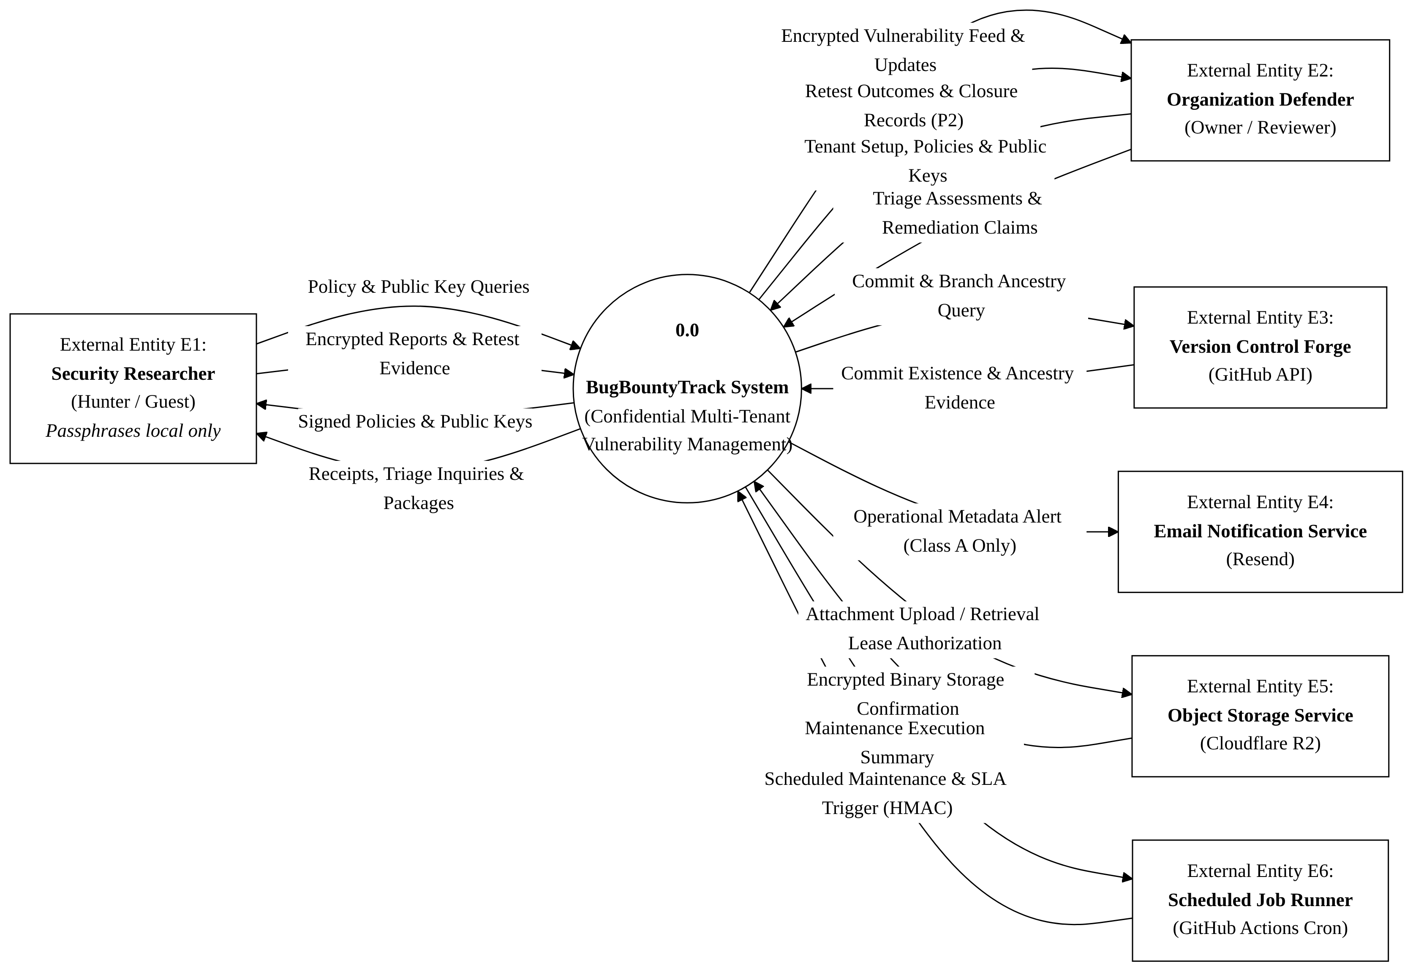
External Entity Inflow & Outflow Specifications
1. E1: Security Researcher (Ethical Hacker / Account-Less Guest)
◦ Inflows to System: Policy discovery requests (GET /.well-known/security.txt), Turnstile verification tokens, encrypted vulnerability submission payloads (Class B ciphertext), encrypted triage responses, and attested retest verdicts. Note: Guest recovery passphrases are entered and processed strictly within browser memory and are never transmitted to the backend.
◦ Outflows to Researcher: Signed RFC 9116 security policies, presigned R2 upload URLs, secret tracking URL fragments (#token=...), encrypted .bbt-recovery.json recovery packages, and encrypted defender clarification requests.
2. E2: Organization Defender (Security Lead / Program Owner)
◦ Inflows to System: Organization registration parameters, program scope definitions, Ed25519/X25519 public keys, encrypted triage comments (Class B/C), CVSS base metric adjustments, remediation claims (GitHub commit SHA or config snapshot), and closure triggers.
◦ Outflows to Defender: Encrypted vulnerability report queues, computed CVSS scores and canonical vectors, retest outcome notifications, and signed cryptographic closure evidence exports (.bbt-closure-export.json, P2 extension under FR-8.6).
3. E3: Version Control Forge (GitHub REST API v3)
◦ Inflows to System: Authoritative commit verification responses (sha, author, timestamp, parent tree), branch ancestry status (ahead, identical), and rate-limit headers (x-ratelimit-remaining).
◦ Outflows from System: Automated commit lookup requests (GET /repos/{owner}/{repo}/commits/{sha}) and branch ancestry comparison queries (GET /repos/{owner}/{repo}/compare/{branch}...{sha}).
4. E4: Email Notification Service (Resend Mail Service)
◦ Outflows from System: Minimal Class A operational metadata notification payloads (organization name, report tracking ID, coarse status update; strictly excluding confidential report content).
5. E5: Object Storage Service (Cloudflare R2 Storage)
◦ Inflows to Storage: Direct streaming encrypted binary ciphertext uploads (PUT) via presigned URLs issued to researchers.
◦ Outflows to System / Browser: Direct streaming encrypted binary ciphertext downloads (GET) via presigned URLs issued to authorized defenders; attachment storage health and lease reclamation confirmations.
6. E6: Scheduled Job Runner (GitHub Actions Automation)
◦ Inflows to System: Scheduled hourly HTTP POST /api/v1/internal/cron/sla-check triggers authenticated via HMAC-SHA256 request signatures (X-Cron-Signature: sha256=<64-hex-hmac>) initiating claim-lease cleanup, overdue clarification timeouts, and storage reclamation (FR-5.4).
◦ Outflows to Scheduler: Structured JSON execution summary containing processed count, reclaimed bytes, and backlog status (has_more_backlog).

3.2 DFD Level 1: Functional System Decomposition
The Level 1 Data Flow Diagram decomposes Process 0.0 into seven discrete functional sub-processes interacting with seven persistent data stores and the six external boundary entities:

Functional Sub-Process Specifications
• Process 1.0: Tenant Registration & Session Governance (`FR-1.1` – `FR-1.5`)
◦ Handles organization onboarding, custom slug reservation, Argon2id user password hashing (FR-1.3a), CSPRNG 256-bit session token issuance with SHA-256 persistence in token_hash, __Host-bbt-session cookie management (SameSite=Lax, Secure), and mandatory TOTP MFA step-up verification.
◦ Data Stores: Reads/Writes D1: Organizations & Tenant Registry and D2: Cryptographic Key Store; Writes audit events to D6: Hash-Chained Audit Ledger Store.
• Process 2.0: RFC 9116 Policy & Cryptographic Key Management (`FR-2.1` – `FR-2.5`, `FR-3.1` – `FR-3.8`)
◦ Generates RFC 9116 security.txt files, facilitates browser cleartext PGP signing (-----BEGIN PGP SIGNED MESSAGE-----), verifies domain ownership via DNS TXT challenges, and catalogs active defender public keys.
◦ Data Stores: Reads D1; Reads/Writes D2; Writes key lifecycle events to D6.
• Process 3.0: Cryptographic Intake & Storage Accounting (`FR-3.5`, `FR-3.6`, `FR-1.6`, `FR-8.3`, `FR-8.4`)
◦ Verifies Cloudflare Turnstile tokens, enforces IP-based rate limiting (10 submissions/hour/IP, FR-8.3), validates program key version snapshots (recipient_set_version), checks storage quota boundaries (20 MiB intake pool, 6 MiB security reserve with 300 KiB Priority-0 floor, FR-8.4), generates S3 presigned upload URLs referencing hosted service E5: Cloudflare R2, catalogs attachment metadata in D5: Encrypted Attachment Registry, and records initial reports in status = NEW (D3).
◦ Data Stores: Reads D2, D7; Writes D3: Reports & Triage Message Store, D5: Encrypted Attachment Registry, and D6: Hash-Chained Audit Ledger Store; Emits initial base metrics to P4; Requests presigns from E5.
• Process 4.0: Deterministic CVSS v3.1 Scoring Engine (`FR-4.1` – `FR-4.4`)
◦ Parses the 8 FIRST.org Base metrics in any order, verifies completeness, executes the official mathematical scoring algorithm with the 8.22 coefficient with a design target of < 5 ms (FR-4), and serializes the canonical vector string and calculated numeric score into D3.
◦ Data Stores: Writes score and canonical vector to D3.
• Process 5.0: Dual-Lane Triage & Notification Broker (`FR-5.1` – `FR-5.4`)
◦ Orchestrates report-scoped encrypted message threads, enforcing strict dual-lane isolation: Class B (shared researcher/defender) vs. Class C (internal defender-only). Dispatches Class A metadata-only alerts to external mail service E4: Resend.
◦ Data Stores: Reads D2; Reads/Writes D3; Writes triage events to D6 and triggers E4: Resend.
• Process 6.0: Remediation Attestation & GitHub Verification (`FR-6.1` – `FR-6.4`)
◦ Enforces the 3-step remediation workflow: captures proposed fix metadata (remediation_attempt_no = N), executes commit existence and ancestry verification against the GitHub REST API v3 (GET /repos/{owner}/{repo}/compare/{branch}...{sha}) or validates encrypted configuration snapshots bound to SHA-256 hashes, and advances report status to RETEST_PENDING.
◦ Data Stores: Reads/Writes D4: Remediation & Commit Store; Updates D3; Queries E3: Version Control Forge.
• Process 7.0: Attested Retest Lifecycle & Audit Ledger Engine (`FR-7.1` – `FR-7.7`, `FR-8.4`, `FR-8.5`, `FR-8.6` [P2 Extension])
◦ Executes the 15-state lifecycle automaton, records attested retest confirmations or timeout closures, executes controlled report reopening (FR-7.7), appends SHA-256 dual hash-chained audit events (row_hash and report_chain_hash), coordinates hourly claim-lease cleanup by purging expired objects from E5: Cloudflare R2 Service, updating records in D5: Encrypted Attachment Registry, and exporting verifiable closure evidence packets (P2 extension under FR-8.6).
◦ Data Stores: Reads/Writes D3, D4, D6, and D7; Purges expired attachments via E5 and updates D5.
Persistent Data Store Specifications
Store ID | Name & Physical Entity | Storage Engine | Scope & Retention
D1 | Organizations & Tenant Registry | Neon PostgreSQL (bbt_core.organizations) | Tenant metadata, slug bindings, subscription tiers, and domain verification challenges.
D2 | Cryptographic Key Store | Neon PostgreSQL (bbt_core.user_keys, program_defenders) | Armored public keys, key fingerprints, user key bindings, and report recipient version snapshots.
D3 | Reports & Triage Message Store | Neon PostgreSQL (bbt_core.reports, triage_messages) | Encrypted titles (title_ciphertext), operational labels, state versions, and Class B/C message threads.
D4 | Remediation & Commit Store | Neon PostgreSQL (bbt_core.remediation_records) | Commit SHAs, verification timestamps, config artifact ciphertexts, and config SHA-256 hashes.
D5 | Encrypted Attachment Registry | Neon PostgreSQL (bbt_core.attachments) | Database catalog of encrypted attachment metadata, UUID keys, byte sizes, and digests, referencing objects hosted in Cloudflare R2 (E5).
D6 | Hash-Chained Audit Ledger Store | Neon PostgreSQL (bbt_core.audit_events) | Append-only sequence numbers, actor commitments, event digests, and cryptographic dual hash chains (row_hash & report_chain_hash).
D7 | Storage Quotas & Claim Leases | Neon PostgreSQL (cluster_storage_state, upload_reservations) | Multi-tenant quota accounting (20 MiB intake, 6 MiB security reserve, 300 KiB Priority-0 floor), and active claim-lease records (claim_expires_at).

4. Defensible System Boundaries & Trust Domain Isolation
4.1 Boundary Domain Architecture
The security posture of BugBountyTrack rests on establishing four unambiguous, non-overlapping trust domains:
[ UNTRUSTED PUBLIC INTERNET ]
|
+ - - - - - v - - - - - - - - - - - - - - - - - - - - - - - - - - - - - +
: DOMAIN 1: CLIENT CRYPTOGRAPHIC TRUST BOUNDARY (Browser Client) :
: * Plaintext vulnerability data and private keys exist ONLY here. :
: * OpenPGP.js v6 WebCrypto encryption/decryption execution. :
: * DOMPurify / rehype-sanitize AST cleansing prior to rendering. :
+ - - - - - - - - - - - - - - - - - - - - - - - - - - - - - - - - - - - +
| HTTPS TLS 1.3 (Ciphertext Only)
+ - - - - - v - - - - - - - - - - - - - - - - - - - - - - - - - - - - - +
: DOMAIN 2: SERVERLESS API ROUTING BOUNDARY (Vercel Node.js 22 LTS) :
: * Zero plaintext visibility; handles only armored ciphertext. :
: * Ephemeral execution memory (no disk or cache persistence). :
: * RBAC, CSPRNG Session Validation, Turnstile verification. :
+ - - - - - - - - - - - - - - - - - - - - - - - - - - - - - - - - - - - +
| TLS 1.3 Pooled TCP (bbt_app role)
+ - - - - - v - - - - - - - - - - - - - - - - - - - - - - - - - - - - - +
: DOMAIN 3: DATABASE PERSISTENCE BOUNDARY (Neon PostgreSQL 16) :
: * FORCE ROW LEVEL SECURITY isolates tenant data rows. :
: * Unprivileged bbt_app role (NOSUPERUSER NOBYPASSRLS). :
: * Restricts application modification & detects history tampering. :
+ - - - - - - - - - - - - - - - - - - - - - - - - - - - - - - - - - - - +
| HTTPS S3 API (Direct Presigned Upload/Download)
+ - - - - - v - - - - - - - - - - - - - - - - - - - - - - - - - - - - - +
: DOMAIN 4: OBJECT STORAGE BOUNDARY (Cloudflare R2) :
: * Presigned URL time-limited access (15-minute lease). :
: * Client-side encrypted binary payloads (SSE-R2 at rest). :
: * Zero server byte proxying. :
+ - - - - - - - - - - - - - - - - - - - - - - - - - - - - - - - - - - - +
4.2 Comprehensive STRIDE Threat Mitigation Analysis
Threat Category (STRIDE) | Attack Vector & Surface | Primary Architectural Mitigation & Security Control | Target Requirement
Spoofing Identity | Malicious actor attempts to forge researcher identity or impersonate an organization defender. | 1. Argon2id password hashing + mandatory TOTP MFA for ORG_OWNER with 10-minute step-up.<br/>2. Account-less guest requests require single-use guest_mutation_nonces and detached OpenPGP v6 Ed25519 signatures (X-Guest-Signature).<br/>3. Hourly cron requests require HMAC-SHA256 authentication (X-Cron-Timestamp and X-Cron-Signature: sha256=<64-hex-hmac>) on /api/v1/internal/cron/sla-check. | FR-1.3, FR-1.6f, FR-5.4
Tampering with Data | Attacker modifies vulnerability write-up, alters audit records, or tampers with closure status. | 1. Client payloads use OpenPGP SEIPDv2 with AEAD integrity verification.<br/>2. Audit ledger restricts application-level modification via database permissions and supports tamper detection via SHA-256 dual hash chaining (row_hash and report_chain_hash).<br/>3. Optimistic concurrency (state_version) prevents lost updates or race condition tampering. | FR-3.1, FR-7.1, FR-8.5
Repudiation | Defender falsely claims a bug was fixed, or researcher denies submitting a report. | 1. Fixing requires automated check of commit existence and branch ancestry via the GitHub REST API v3 (compare/{branch}...{sha}) or an immutable config hash.<br/>2. Retest closures generate cryptographic Closure Evidence Exports signed with Ed25519 (Priority 2 Extension under FR-8.6). | FR-6.2, FR-6.3, FR-8.6
Information Disclosure | Database breach or malicious platform operator attempts to harvest zero-day exploit details. | 1. Client-Side OpenPGP v6 Curve25519 encryption: server and database store strictly ciphertext envelopes (title_ciphertext, report body, attachments).<br/>2. Dual-lane threading guarantees Class C internal notes are never encrypted for the researcher's key.<br/>3. Raw guest access_token values are never stored in database retry caches; sessions use CSPRNG tokens with SHA-256 hashes in token_hash. | FR-3.3, FR-5.2, FR-1.3b, FR-1.6b
Denial of Service | Bot swarm exhausts serverless function compute, floods database storage, or uploads huge files. | 1. Cloudflare Turnstile bot verification required before issuing submission session tokens.<br/>2. Shared-store rate limiter restricts unauthenticated submissions to 10 submissions/hour/IP (FR-8.3).<br/>3. Strict multi-tenant storage quotas: separate 20 MiB intake pool, 6 MiB security reserve, and 300 KiB Priority-0 reserve floor (FR-8.4). | FR-8.3, FR-8.4, NFR-09
Elevation of Privilege | Tenant user attempts to access reports belonging to another organization (IDOR / Multi-Tenant leak). | 1. PostgreSQL FORCE ROW LEVEL SECURITY on all tenant tables bound to app.current_org_id.<br/>2. Runtime executes under unprivileged role bbt_app (NOSUPERUSER NOBYPASSRLS).<br/>3. Hardened SECURITY DEFINER functions enforce clean search_path = pg_catalog, bbt_core, pg_temp. | FR-8.2, FR-1.1

4.3 Defensible System Boundaries: What BugBountyTrack Controls vs Does NOT Control
To establish honest engineering boundaries and prevent false assurances, the table below explicitly defines what BugBountyTrack architecturally controls versus external operational factors beyond its perimeter:
System Domain | What BugBountyTrack DOES Architecturally Control | What BugBountyTrack DOES NOT Control (External Dependencies)
Cryptographic Confidentiality | In-browser client encryption/decryption using OpenPGP.js v6 Curve25519; server-side zero-knowledge storage; mathematical segregation of Class B (shared) vs Class C (internal) ciphertexts. | Client endpoint integrity; malware, keyloggers, or malicious browser extensions on researcher/defender devices; compromised physical machines.
Application & API Routing | Stateless API routing; rate limiting (10 submissions/hr/IP); session token issuance (256-bit CSPRNG); Argon2id password KDF; HMAC-SHA256 cron signature validation. | Network-level BGP routing or Anycast IP hijacking; upstream DNS provider compromises; ISP-level TLS interception if client root certificates are tampered with.
Remediation Attestation | Automated querying of GitHub REST API v3 to confirm commit existence and branch ancestry (compare/{branch}...{sha}); cryptographic SHA-256 hash binding of configuration files. | Real-world server deployment of the verified commit; whether defender deployed the patch to production; defender server infrastructure security or CI/CD runner compromises.
Database & Multi-Tenancy | Database tenant isolation via PostgreSQL FORCE ROW LEVEL SECURITY; unprivileged execution via bbt_app role; append-only dual hash-chained audit logging (FR-8.5). | Physical hardware or hypervisor integrity of cloud database provider (Neon); physical infrastructure seizure; external side-channel attacks on host hardware.
Object Storage & Evidence | Time-limited presigned S3 URLs (15-min lease); RFC 9580 SEIPDv2 binary ciphertext storage; automated hourly lease reclamation and quota enforcement (20 MiB intake, 6 MiB reserve). | Cloudflare R2 underlying physical storage hardware; third-party cloud provider internal outages; unencrypted temporary local copies saved by users outside the platform.
Notifications & Messaging | Notifications contain only approved Class A metadata and exclude confidential report content; redaction of vulnerability descriptions from alert emails. | Upstream SMTP deliverability; recipient mail server spam filters; mail server security at rest on the recipient's mail provider.

5. Cloud Infrastructure Stack Justification & Cost Feasibility
5.1 Cloud Infrastructure Topology
The physical hosting deployment across Cloudflare Edge, Vercel Serverless, Neon PostgreSQL, and Cloudflare R2 is mapped below:
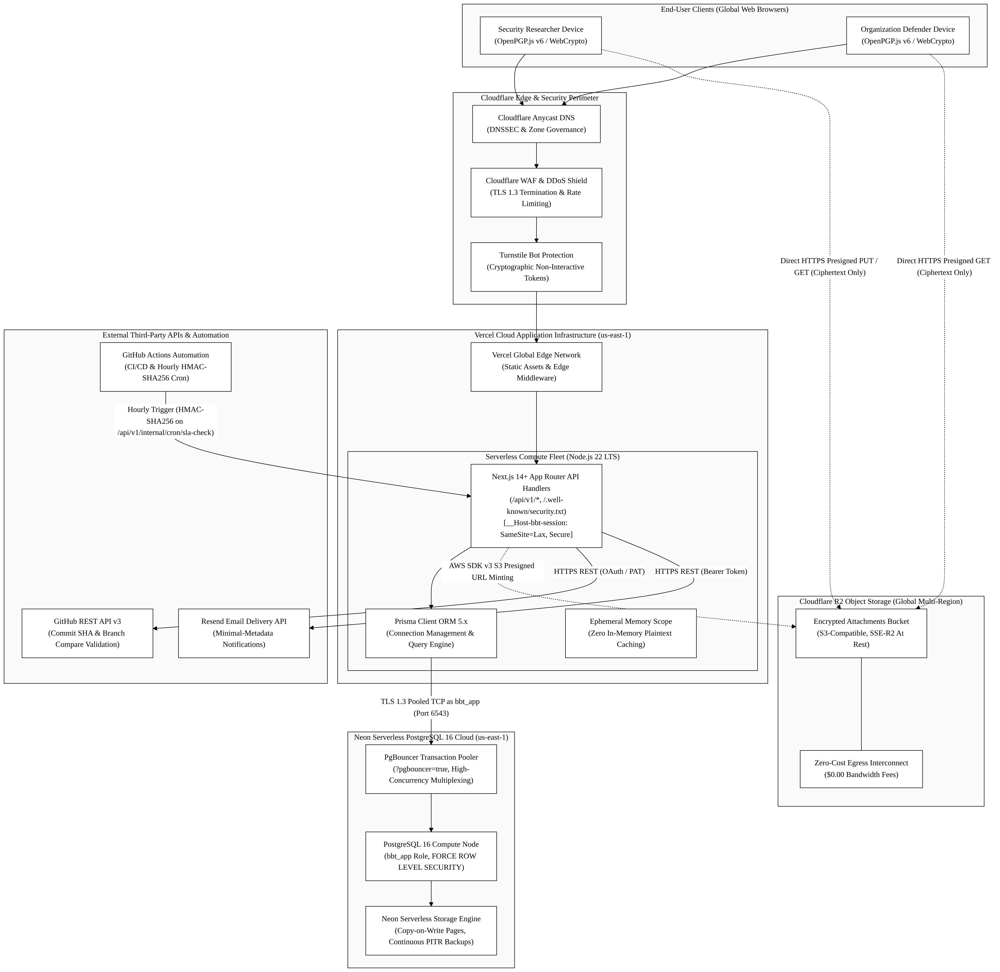

5.2 Component-by-Component Technology Stack Justification
Subsystem Layer | Chosen Technology | Primary Alternatives Evaluated | Architectural Rationale & Trade-Off
Frontend & API Fullstack Engine | Next.js 14+ App Router (Node.js 22 LTS on Vercel) | React SPA + Express.js API; Go / Gin Microservices | Unified TypeScript codebase eliminates API contract drift; React Server Components provide zero-bundle rendering; serverless architecture scales to zero during idle periods.
Application Runtime Fleet | Vercel Serverless Compute (Global Edge + Lambda Core) | AWS ECS / Fargate (Docker); Kubernetes (EKS / GKE); VPS | Eliminates container orchestration toil, OS patching, and VPC maintenance for a solo student engineer; engineering design target of p95 <= 400 ms and p99 <= 800 ms (NFR-01).
Relational Database Engine | Neon Serverless PostgreSQL 16 (with PgBouncer Pooling) | Supabase; AWS Aurora; MongoDB Atlas; DynamoDB | True serverless compute autoscaling (0.25 to 2 CU); built-in PgBouncer pooling prevents connection drops; robust RLS engine (bbt_app role) & ACID audit ledger.
Object Storage Persistence | Cloudflare R2 (Direct Presigned Uploads) | AWS S3 Standard; Google Cloud Storage (GCS) | S3-compatible API with zero egress fees, eliminating bandwidth charges for PoC downloads; provides predictable cost boundaries for academic demo and commercial sizing.
Bot Protection & Perimeter Defense | Cloudflare Turnstile & Cloudflare Anycast WAF | Google reCAPTCHA v3; hCaptcha | Privacy-preserving, non-interactive bot verification; zero user tracking cookies; seamless Next.js drop-in; protects unauthenticated guest intake endpoints.
Transactional Notification Mail | Resend API (Node.js REST SDK) | AWS SES; SendGrid; Postmark | Clean modern REST API with native React Email support and zero complex SMTP handshake overhead; free tier provides 3,000 metadata-only alerts/month.
Continuous Automation & Cron | GitHub Actions (Ubuntu 22.04 LTS Runners) | GitLab CI; CircleCI; AWS EventBridge | Native repository integration; provides 2,000 free runner minutes/month; executes hourly scheduled jobs via HMAC-SHA256 on /api/v1/internal/cron/sla-check (FR-5.4).

5.3 Infrastructure Cost Feasibility & Workload Sizing Analysis
Academic Demonstration Budget (Zero-Cost Baseline Estimate)
To satisfy university evaluation requirements without requiring external departmental funding or personal cash outlay, the architecture is sized to operate within documented cloud provider free tier allowances during prototype demonstration:
Infrastructure Layer | Cloud Provider & Tier | Quota Allocation | Demonstration Cost Estimate
Application & API Serverless | Vercel Cloud (Hobby Developer Tier) | 100 GB-hrs compute, 100 GB bandwidth, unlimited SSL | $0.00
Serverless Database | Neon PostgreSQL 16 (Free Tier) | 512 MB storage, 1 project, autoscaling 0.25 CU, PgBouncer | $0.00
Encrypted File Storage | Cloudflare R2 (Free Tier) | 10 GB storage, 1M Class A operations, 10M Class B ops, $0 egress | $0.00
Perimeter Bot Defense | Cloudflare Turnstile (Free Tier) | Unlimited unauthenticated visitor challenges | $0.00
Transactional Email Alerts | Resend (Developer Free Tier) | 3,000 emails/month, 100 emails/day | $0.00
CI/CD & Hourly Cron Automation | GitHub Actions (Standard Runners) | 2,000 free Linux build minutes/month | $0.00
TOTAL ACADEMIC EVALUATION ESTIMATE | — | Subject to Provider Quotas & Workload | $0.00 / month
Commercial Production Budget (10–25 Organizations Workload Projection)
When transitioning to commercial production for small software startups, the architecture is projected to scale with minimal fixed infrastructure overhead:
Infrastructure Layer | Commercial Cloud Tier | Sizing Bounds & Purpose | Monthly Cost Estimate ($USD)
Vercel Pro Application Fleet | Vercel Pro ($20/seat, 1 seat) | Commercial SLA (99.5% uptime target NFR-07), zero cold-start optimization | $20.00
Neon Production Database | Neon Launch Plan | 10 GB storage, autoscaling compute up to 2 CU, 7-day PITR | $19.00
Cloudflare R2 Object Storage | R2 Pay-As-You-Go ($0.015/GB-mo) | 50 GB pooled encrypted attachment storage ($0.00 egress) | $0.75
Resend Commercial Email | Resend Pro Baseline | 50,000 transactional notification emails/month | $20.00
Cloudflare Domain & DNS | Cloudflare Registrar (.security) | Amortized yearly domain registration fee ($15/year) | $1.25
TOTAL ESTIMATED MONTHLY RUNTIME BASELINE | — | Baseline Projection for 10–25 Startups | ~$61.00 / month
Budget Sizing Note: The figures above represent an engineering cost projection subject to cloud provider terms, pricing changes, and actual application throughput. Commercial operations will be calibrated against production usage rather than speculative profitability assertions.

6. Implementation Phases and Clarifications
6.1 Phase 1 Working Demonstration: Core Workflow Baseline
To ground system development in running software and avoid circular document revisions, the initial implementation milestone will demonstrate the complete central vulnerability coordination workflow:
Submit Encrypted Report -> Review & Triage -> Record Fix Evidence -> Retest Attestation -> Record Closure Outcome
This central demonstration validates all essential cross-tier interfaces:
1. Intake & Cryptographic Isolation: A security researcher generates an ephemeral keypair in browser memory, encrypts report content using OpenPGP.js v6 Curve25519, and submits ciphertext to the serverless API with zero server plaintext visibility.
2. Defender Review & CVSS Scoring: An authenticated organization defender (__Host-bbt-session, SameSite=Lax) decrypts encrypted report content client-side, reviews triage parameters, and verifies deterministic FIRST.org CVSS v3.1 calculation.
3. Remediation Evidence Verification: A defender records a remediation claim verified through the GitHub REST API (compare/{branch}...{sha}) to confirm commit existence and branch ancestry, or submits an encrypted configuration snapshot bound to a SHA-256 hash.
4. Attested Retest: The researcher verifies the remediation and submits an attested outcome (VERIFIED_RESEARCHER or RETEST_FAILED).
5. Closure & Ledger Recording: The state machine advances to a terminal status and appends an immutable, hash-chained record to the PostgreSQL audit ledger.
6.2 Milestone Staging vs. Requirement Priority Obligations
Sequencing functional features across subsequent implementation milestones organizes the engineering development plan; it does not remove or diminish any P1 obligation established in the submitted IEEE 830 SRS (Revision 2.8).
• Mandatory P1 Invariants: All requirements designated as P1 in the submitted specification—including RFC 9116 security.txt manifest generation (FR-2), dual-lane triage message isolation (FR-5), state machine quota pause handling (FR-7.5), controlled report reopening (FR-7.7), database Row-Level Security (FR-8.2), and append-only audit chaining (FR-8.5)—remain planned mandatory deliverables for subsequent development sprints.
• Secondary P2 Extensions: Features formally categorized as P2 in the submitted SRS—specifically Redacted Closure Evidence Exports (FR-8.6), automated disaster recovery drills (FR-8.7), and advanced export tooling—are scheduled after the core P1 operational pipeline is verified through running tests.
6.3 Supervisor Governance on Scope Realignment
If empirical testing during early implementation reveals that advanced edge-case mechanisms—specifically:
1. Multi-recipient historical key re-wrapping upon defender offboarding (FR-3.8),
2. Offline Organization Master Recovery Key unlocking procedures (FR-3.6, FR-3.8b), or
3. Dual concurrent audit ledger chains (row_hash and report_chain_hash, FR-8.5)—
introduce disproportionate architectural complexity or stability risks within the academic semester timeframe, the student author will formally propose explicit scope deferrals directly to the FYP Academic Supervisor (Sir Umar Hayat).
Architectural specifications must not silently relabel or dilute submitted P1 requirements as optional without formal academic supervisor consultation and written endorsement.

7. Bidirectional Architecture Traceability Matrix (RTM)
This matrix maps high-level architectural tiers, components, and DFD processes directly to the Week 2 SRS Functional Requirements and formal Use Cases:
DFD Process | Architectural Tier & Component | Traced Functional Requirements | Traced Use Cases | Verification Criterion
1.0 | Tier 2 (Auth Middleware, Session Service) | FR-1.1, FR-1.2, FR-1.3, FR-1.4, FR-1.5 | UC-06, UC-07 | CSPRNG session token issuance (SHA-256 token_hash); Argon2id password KDF; TOTP MFA step-up verification; bbt_app role tenant context injection.
2.0 | Tier 1 (Crypto Engine) & Tier 2 (RFC 9116 Router) | FR-2.1, FR-2.2, FR-2.3, FR-2.4, FR-2.5, FR-3.1 | UC-01, UC-06 | Valid RFC 9116 manifest rendered; Ed25519 in-browser cleartext signature; DNS TXT challenge match.
3.0 | Tier 1 (OpenPGP.js) & Tier 3 (R2 Bucket, Neon DB) | FR-3.3, FR-3.5, FR-3.6, FR-1.6, FR-8.3, FR-8.4 | UC-01 | Turnstile CAPTCHA validation; rate limiting (10 req/hr/IP); presigned S3 upload referencing E5; zero raw plaintext in SQL insert; 20 MiB intake / 6 MiB reserve quota check; .bbt-recovery.json issuance.
4.0 | Tier 2 (CVSS v3.1 Pure TypeScript Engine) | FR-4.1, FR-4.2, FR-4.3, FR-4.4 | UC-03 | Accepts valid metrics in any order; computational parity across 45 FIRST.org test fixtures; calculation completes in < 5 ms proposed design target (FR-4).
5.0 | Tier 2 (Triage Controller) & Tier 3 (Neon DB) | FR-5.1, FR-5.2, FR-5.3, FR-5.4 | UC-02, UC-03, UC-07 | Dual-lane message separation (Class B vs C); recipient version snapshot matching; minimal metadata email dispatch via Resend; scheduled cron execution via HMAC-SHA256 (FR-5.4).
6.0 | Tier 2 (Remediation Service) & External (GitHub) | FR-6.1, FR-6.2, FR-6.3, FR-6.4 | UC-04 | GitHub REST API commit verification (compare/{branch}...{sha}) confirming commit existence and branch ancestry; encrypted config snapshot hash binding.
7.0 | Tier 2 (FSM Engine) & Tier 3 (Audit Ledger, Neon) | FR-7.1, FR-7.2, FR-7.3, FR-7.4, FR-7.5, FR-7.6, FR-7.7, FR-8.4, FR-8.5, FR-8.6 (P2) | UC-05, UC-06, UC-07 | 15-state transition guard; controlled reopening (FR-7.7); append-only dual hash-chained audit logging (row_hash & report_chain_hash); hourly claim-lease R2 reclamation via E5 and D5; signed closure export (FR-8.6, P2 extension).

8. Document Submission & Milestone Sign-Off
8.1 Single Student Author Endorsement
I hereby certify that this High-Level Architecture & Cloud Topology Specification (Revision 1.2) represents an original, standards-compliant architectural baseline authored independently for BugBountyTrack (PTUT - PRJ - 089). All architectural patterns, trust boundaries, data flows, and infrastructure cost estimates have been formulated as a work-in-progress deliverable to satisfy the University Final Year Project syllabus and align completely with the submitted IEEE 830 Software Requirements Specification (Revision 2.8).
• Student Author: Taha Asadullah
• Roll Number: 24-ST-013 (Section SET-B)
• Signature: [Signed Electronically — Taha Asadullah]
• Date: October 16, 2026

8.2 Academic Supervisor Review & Endorsement
I have reviewed the High-Level Architecture & Cloud Topology Specification, including the 3-Tier Zero-Plaintext Model, Data Flow Diagrams (DFD Level 0 and Level 1), System Trust Boundaries, and Cloud Infrastructure Justification. The architectural design meets departmental requirements for Phase 2 system design.
• Academic Supervisor: Sir Umar Hayat
• Department: Department of Software Engineering Technology, PTUT Lahore
• Status: [PENDING ACADEMIC SUPERVISOR EVALUATION & SIGN-OFF]
• Date: ____________________

