**Lab #06(Resolving Errors)**

***Resolving Error#01***

*Write Constructor which takes Single Argument in point.h*



***Output***



***Resolving Error#02***

*Overload = operator with return type Point*



***Output***



***Resolving Error#03***

*Overload > operator with return type int.*

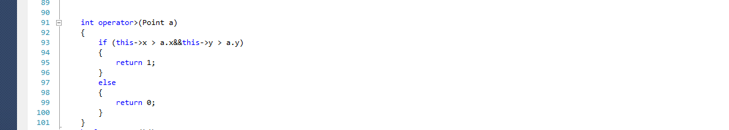

***Output***

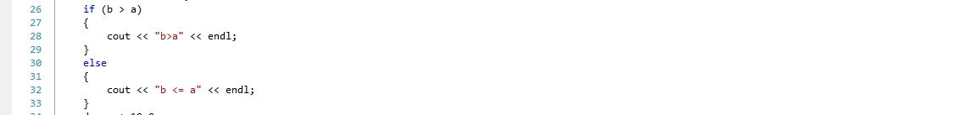

***Resolving Error#04***

*Overload + operator whose 2nd argument is float.*



***Output***



***Resolving Error#05***

*Overload + operator using friend function*

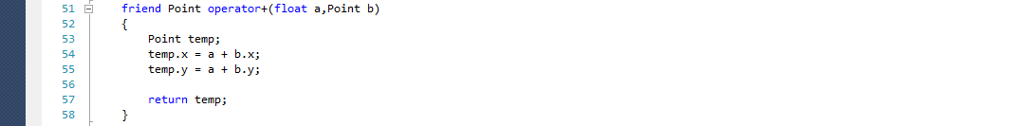

***Output***



***Resolving Error#07***

*Overload = operator with return type bool.*

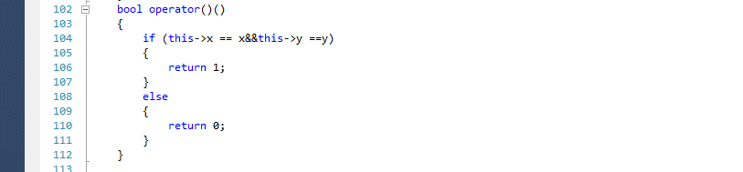

***Output***

