**Lab#3 Create a web-based TODO App using AngularJS.**

**Outcome:**

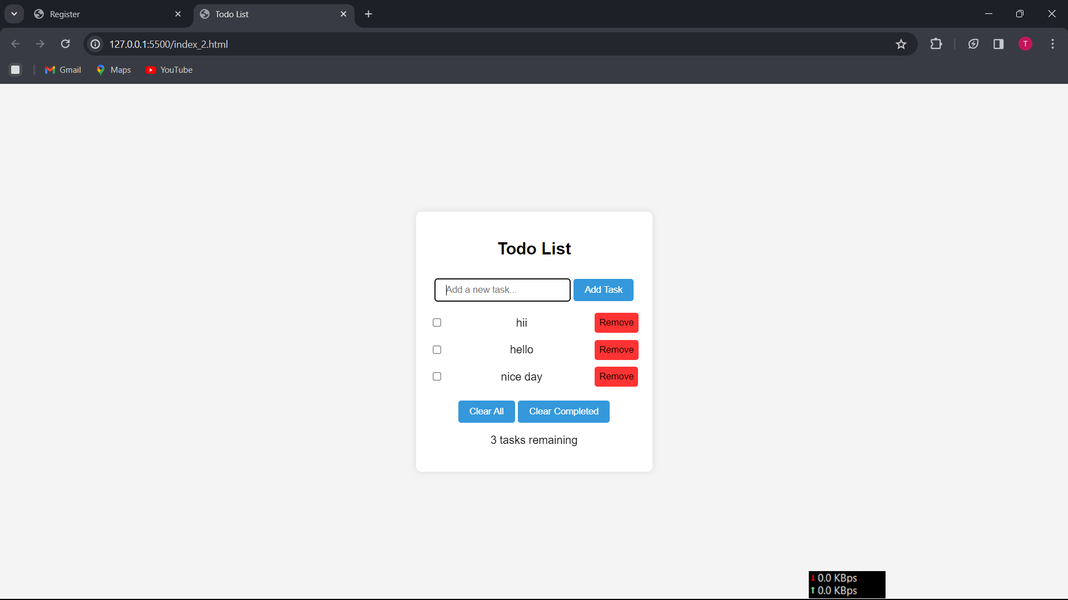

**Html:**

**index.html**

<!DOCTYPE html>

<html lang="en" ng-app="todoApp">

<head>

<meta charset="UTF-8" />

<meta name="viewport" content="width=device-width, initial-scale=1.0" />

<title>Todo List</title>

<link rel="stylesheet" href="style.css">

</head>

<body>

<div ng-controller="todoController" class="todo-container">

<h2>Todo List</h2>

<form ng-submit="addTask()">

<input

class="input"

type="text"

ng-model="newTask"

placeholder="Add a new task..."

required

/>

<button type="submit" class="btn">Add Task</button>

</form>

<div class="todo-item" ng-repeat="task in tasks track by $index">

<input

type="checkbox"

ng-model="task.completed"

ng-change="updateTask()"

/>

<span>{{ task.taskdec }}</span>

<button class="remove-btn" ng-click="removeTask(task)">Remove</button>

</div>

<button ng-click="clearAll()" class="btn">Clear All</button>

<button ng-click="clearCompleted()" class="btn">Clear Completed</button>

<p>{{ remainingTasks() }} tasks remaining</p>

</div>

<script src="https://ajax.googleapis.com/ajax/libs/angularjs/1.8.2/angular.min.js"></script>

<script src="script.js"></script>

</body>

</html>

**style.css**

body {

font-family: Arial, sans-serif;

background-color: #f4f4f4;

margin: 0;

display: flex;

align-items: center;

justify-content: center;

height: 100vh;

}

.todo-container {

background-color: #fff;

border-radius: 8px;

box-shadow: 0 0 10px rgba(0, 0, 0, 0.1);

padding: 20px;

width: 300px;

text-align: center;

}

.todo-item {

display: flex;

justify-content: space-between;

align-items: center;

margin-bottom: 10px;

}

.todo-item input {

margin-right: 10px;

}

.btn {

background-color: #3498db;

color: #fff;

padding: 8px 16px;

border: none;

border-radius: 4px;

cursor: pointer;

margin-top: 10px;

}

form{

margin-bottom: 1rem

}

.btn:hover {

background-color: #2980b9;

}

.remove-btn{

background-color: rgba(255, 0, 0, 0.8);

padding: 0.4rem;

border-radius: 4px;

border: none;

cursor: pointer;

}

input{

padding: 8px 16px;

border-radius: 4px;

border: 1px solid black;

}

**app.js**

var app = angular.module("todoApp", []);

app.run(function ($rootScope) {

$rootScope.tasks = JSON.parse(localStorage.getItem("tasks")) || [];

console.log($rootScope);

});

app.controller("todoController", function ($rootScope, $scope) {

// $scope.tasks = [];

$scope.newTask = "";

$scope.addTask = function () {

if ($scope.newTask.trim() !== "") {

$rootScope.tasks.push({

taskdec: $scope.newTask,

completed: false,

});

$scope.newTask = "";

$scope.updateTask();

}

};

$scope.updateTask = function () {

localStorage.setItem("tasks", JSON.stringify($rootScope.tasks));

};

$scope.removeTask = function (task) {

var index = $scope.tasks.indexOf(task);

$rootScope.tasks.splice(index, 1);

$scope.updateTask();

};

$scope.clearAll = function () {

$rootScope.tasks = [];

$scope.updateTask();

};

$scope.clearCompleted = function () {

$rootScope.tasks = $scope.tasks.filter(function (task) {

return !task.completed;

});

$scope.updateTask();

};

$scope.remainingTasks = function () {

var count = 0;

angular.forEach($scope.tasks, function (task) {

count += task.completed ? 0 : 1;

});

return count;

};

});