Exercise 1.2: Box Detection Discussion

Results
For the result I first detected the floor plane and then used the remaining points to find the top of the box. The output figures show the main intermediate results:
- amplitude image,
- distance image,
- floor mask,
- box top mask,
- overlay with floor, box top and corners,
- a small 3D point cloud plot.
The figures I generated are:

- example1kinect_exercise_1_1.png
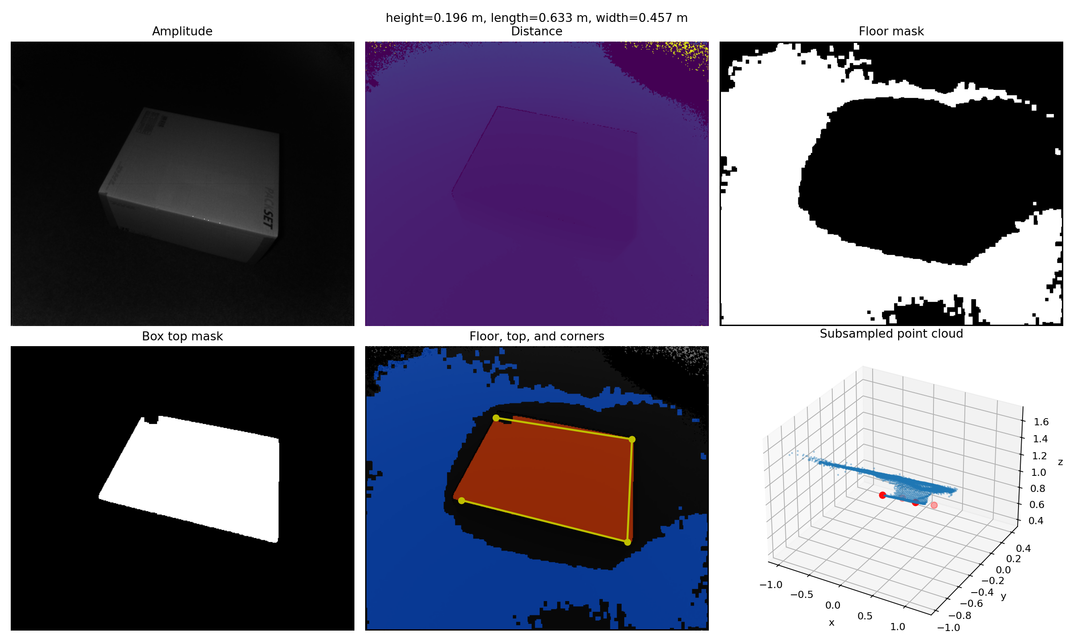

- example2kinect_exercise_1_1.png
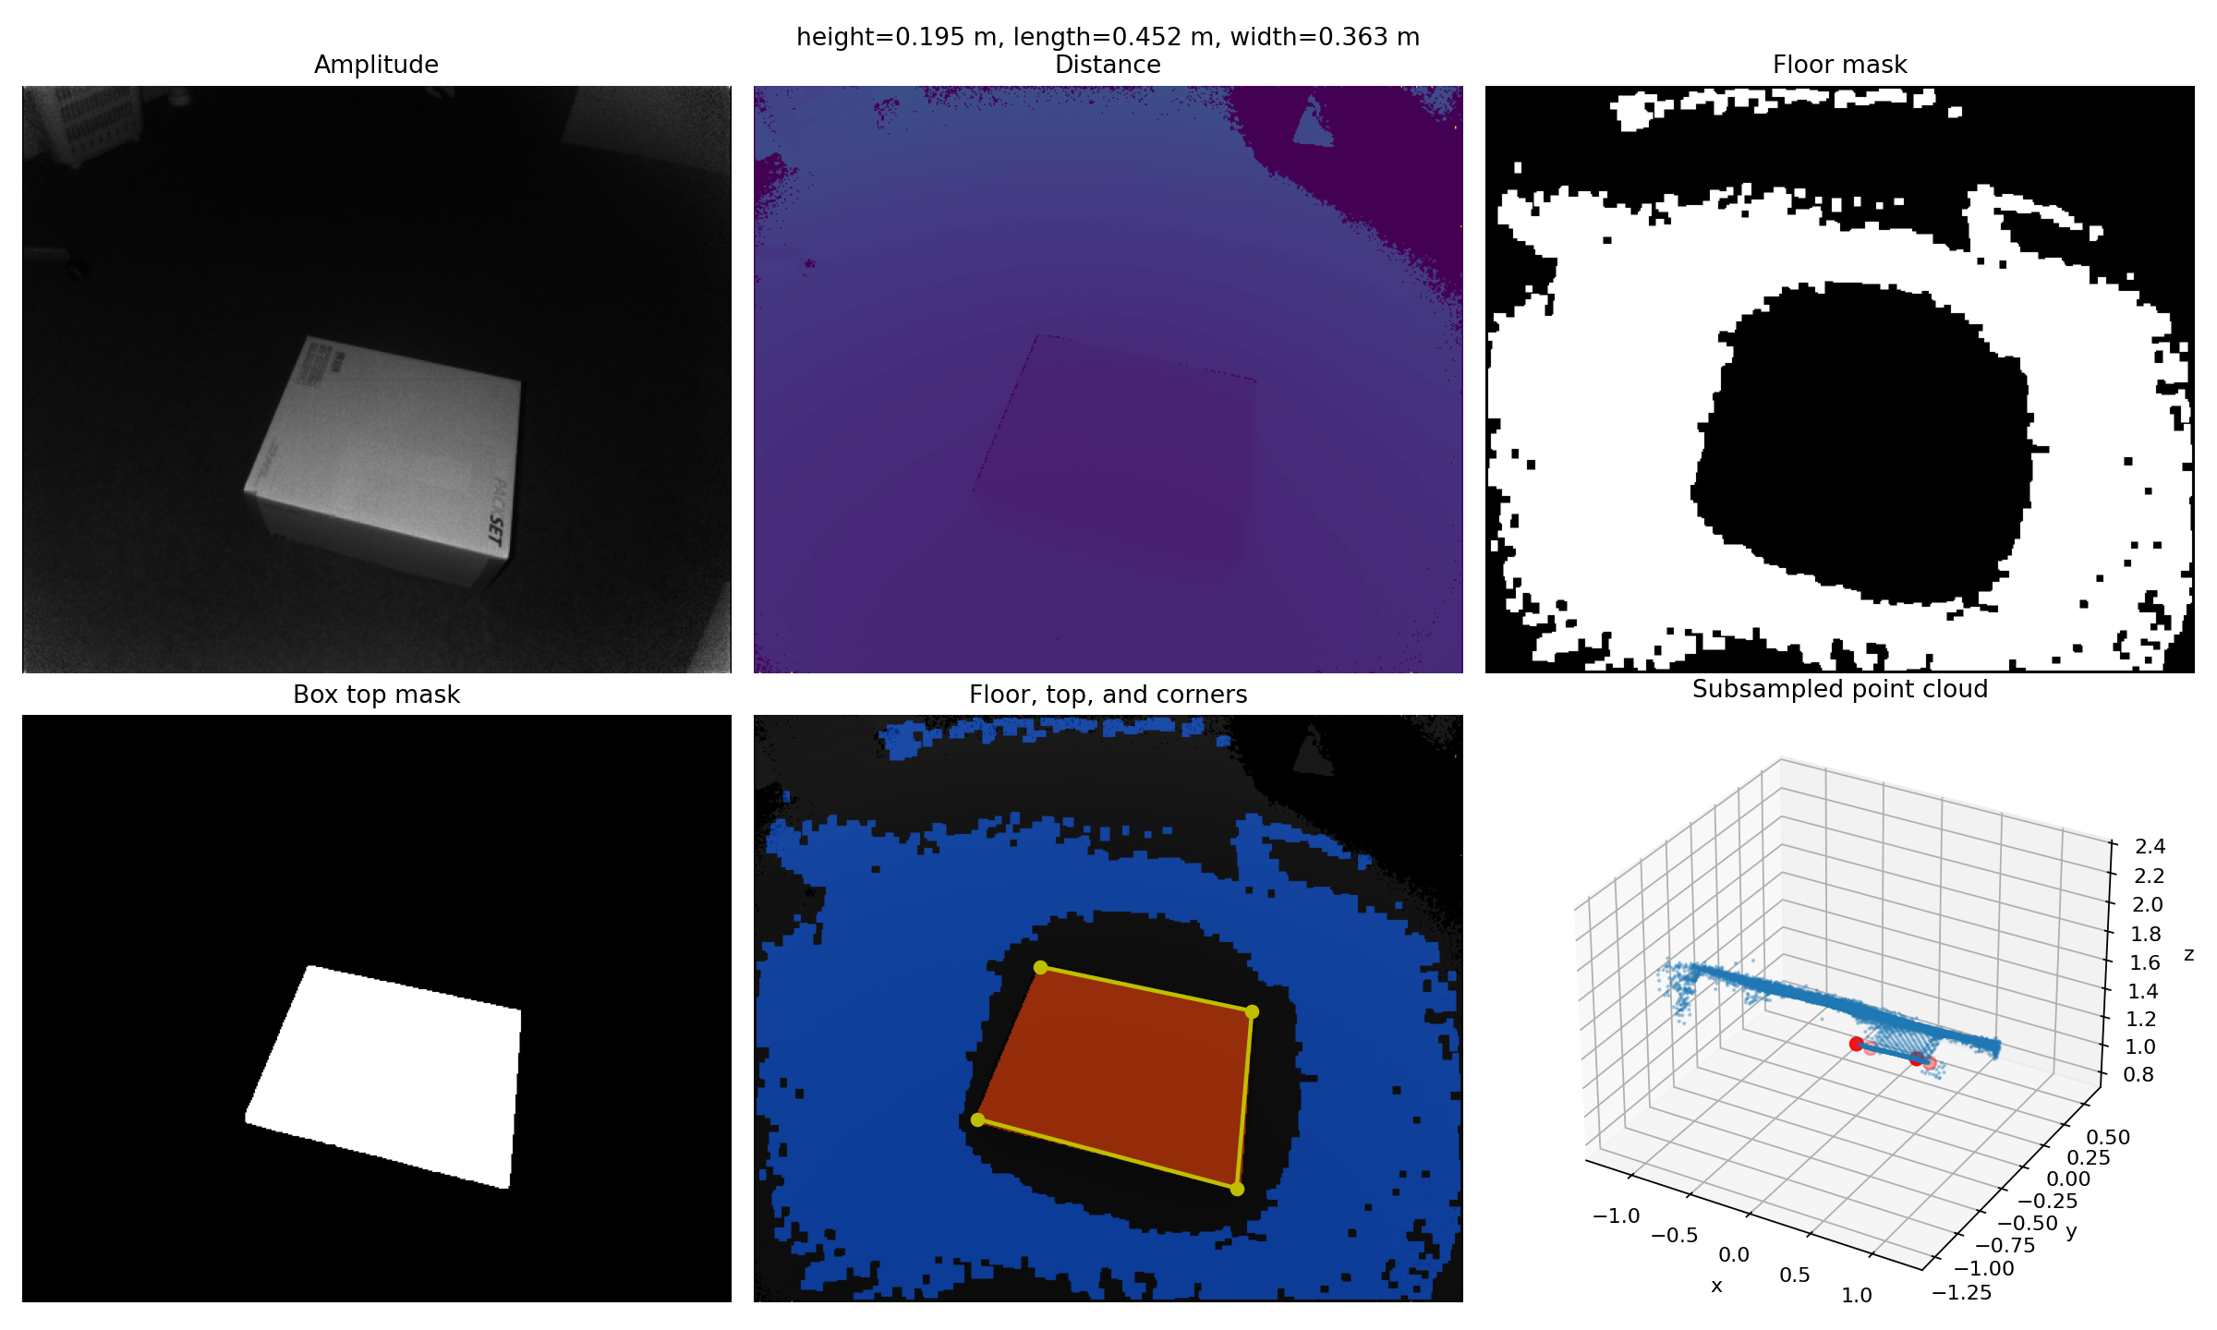

- example3kinect_exercise_1_1.png
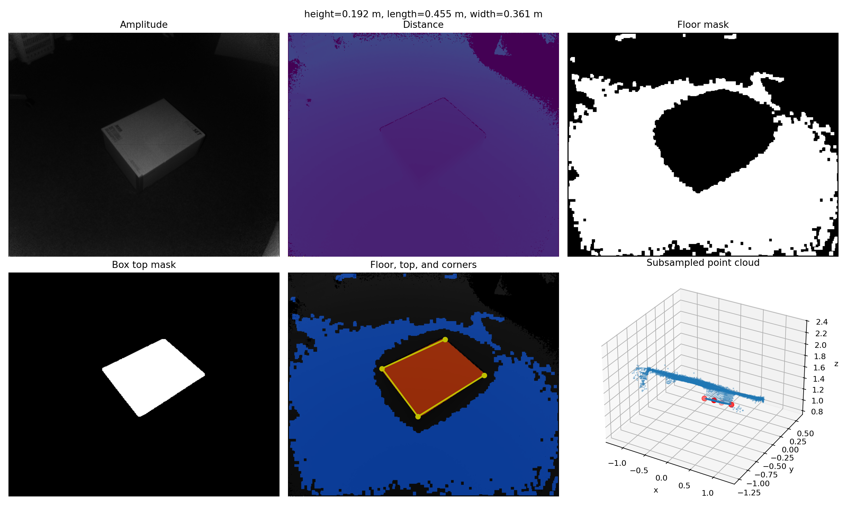
- example4kinect_exercise_1_1.png
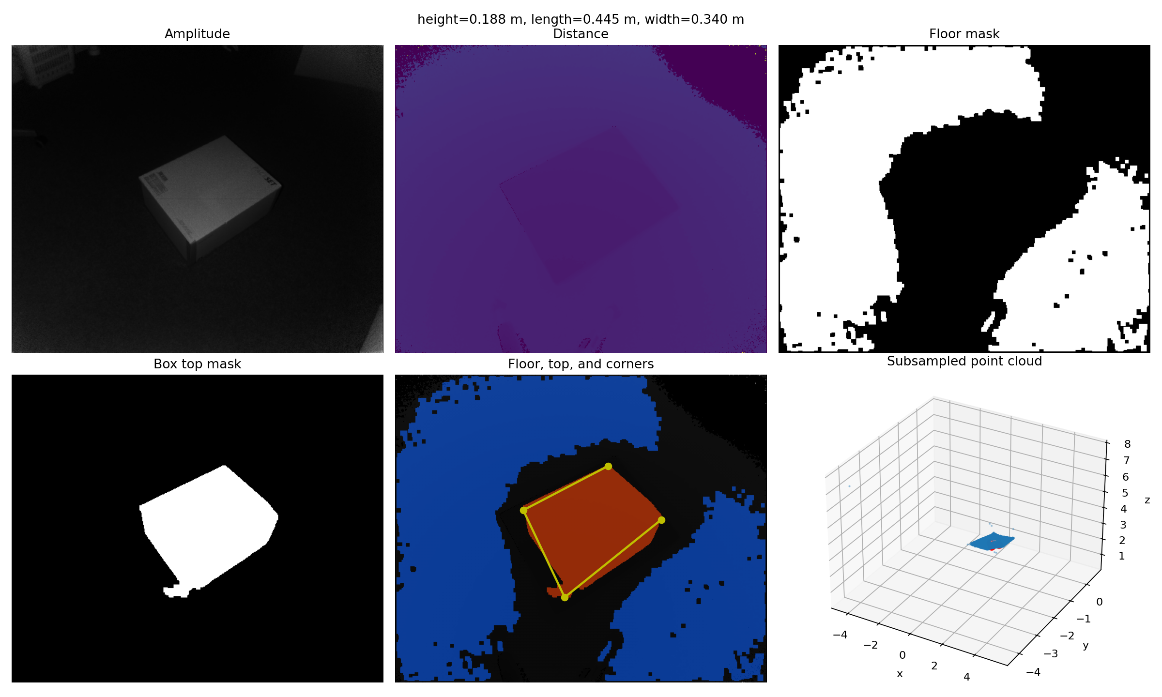

For the first example, the estimated dimensions are:
Example | Height | Length | Width
example1kinect.mat | 0.1961 m | 0.6331 m | 0.4569 m
example2kinect.mat | 0.1947 m | 0.4525 m | 0.3633 m
example3kinect.mat | 0.1925 m | 0.4555 m | 0.3615 m
example4kinect.mat | 0.1877 m | 0.4448 m | 0.3401 m

The height is calculated from the distance between the floor plane and the top plane. For the length and width I used the detected top part of the box and projected its 3D points into the coordinate system of the top plane.

Short description of the method
Some points in the point cloud are invalid, so I ignored points where z is 0. For RANSAC I used three random points to make a plane and then counted how many other points are close to that plane. After the best plane was found, I fitted it again with all inlier points.
After the floor was found, I cleaned the mask a little bit with morphological operations. Then I removed the floor from the point cloud. The remaining points still contain some background, so I used connected components and the amplitude image to keep the part that most likely belongs to the box. Then I ran RANSAC again to find the top plane.

Weaknesses
The result depends quite a lot on the chosen parameters. For example the RANSAC thresholds, the number of iterations and the mask filtering parameters were selected by trying values on the given examples.
RANSAC can still find a wrong plane if there is a large flat background area. This happened more easily near the image border, therefore I removed border-connected components.
The method assumes that the floor and the box top are mostly planar. If the box is partly hidden, tilted in a strange way or has a bad depth measurement, the plane fit can become worse.
The corner positions depend on the top mask. If this mask misses parts of the box or includes too many extra pixels, the measured length and width also change.
I used the amplitude image because the box is rather bright in these examples. This is helpful here, but it would not always work, for example for a dark box or different lighting.
The RANSAC loop is also not the fastest method because many random planes are tested. For these small examples it is fine, but for larger data it would become slower.

Possible improvements
One improvement would be to choose the thresholds automatically from the data instead of setting them manually.
The second plane could also be forced to be almost parallel to the floor plane, because the top of the box should normally be parallel to the floor.
The candidate mask could be improved by combining more information, for example distance, amplitude and maybe local surface normals.
The corner estimation could be made more robust with a better oriented bounding rectangle or by removing outliers from the top mask before measuring the size.
The final plane fitting could use weights, so points with low amplitude or high residual have less influence.
For speed, RANSAC could run on fewer sampled points first and then only refine the best result on the full point cloud.
It would also be useful to print a confidence value, for example based on the number of inliers and the residual error of the fitted planes.

