

**Signals and Systems**

Lab Report#05

# Name:

Taha Saeed

**Registration number:**

FA18-EEE-032

**Submitted to:**

Dr. Ghufran Shafiq

**In-Lab Tasks**

**Task 01: Find out if the discrete-time system described by the I/O relationship  is:**

1. Static or Dynamic (input signal )
2. Causal or non-causal (input signal)
3. Linear or non-linear(input signals )
4. Shift invariant or shift variant (input signaland shift)

**Solution:**

**Part (a):**

n=[-2:1:2];

Xn=2*n;

subplot(2,1,1)

stem(n,Xn);

title('input signal');

subplot(2,1,2)

stem(-n,Xn);

title('output signal');

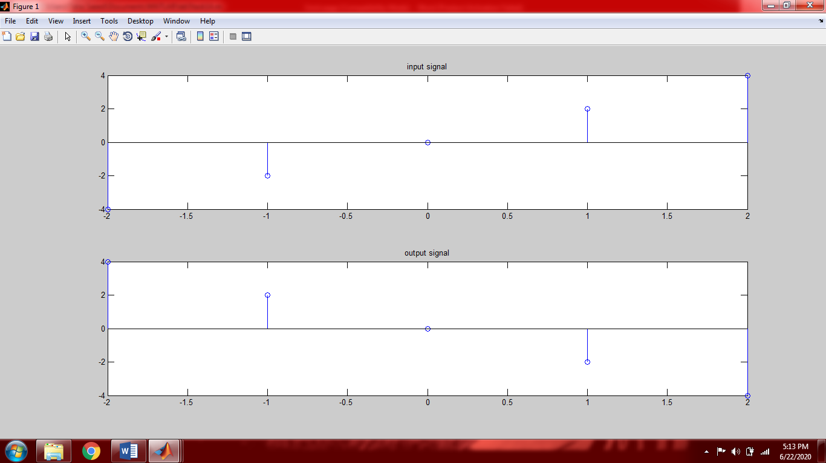

The system is dynamic i.e. the system has memory because the output is depending upon the future and past values of input.

**Part (b):**

n=[-2:1:2];

Xn=2*n;

subplot(2,1,1)

stem(n,Xn);

title('input signal');

subplot(2,1,2)

stem(-n,Xn);

title('output signal');

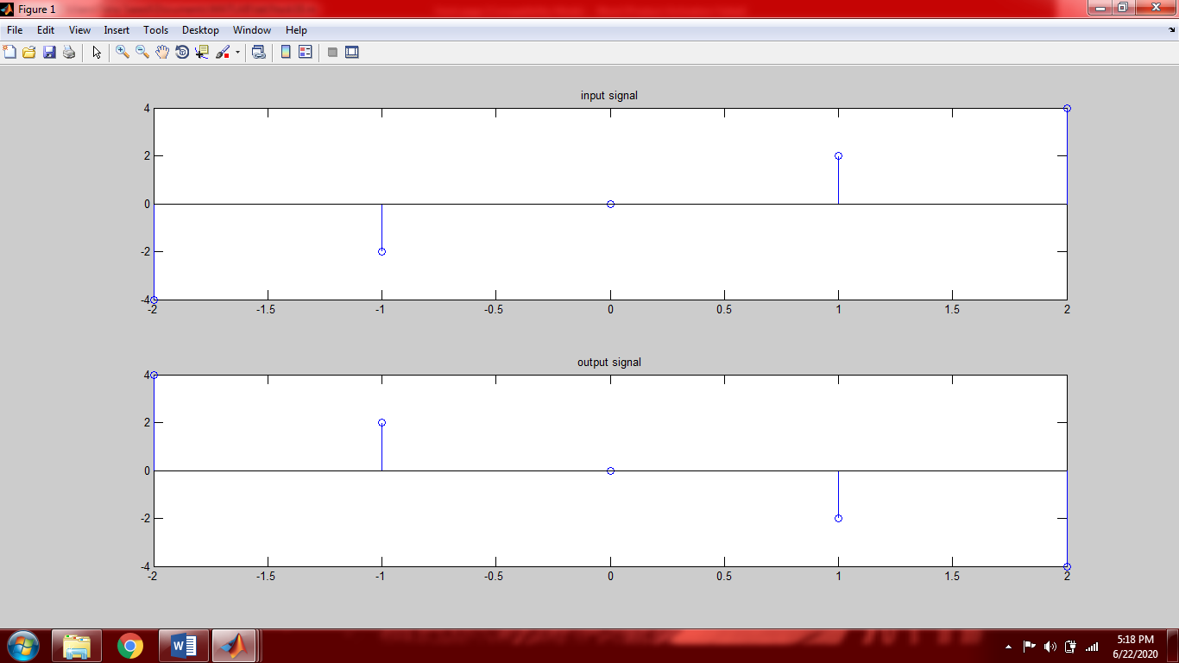

The system is non-causal because the output is depending upon the future values.

**Part (c):**

n=[-2:1:4];

a1=2;

a2=3;

X1n=2*n;

X2n=n./3;

X=a1*X1n+a2*X2n;

subplot(2,1,1);

stem(-n,X);

title('output 1');

y1n=X1n;

y2n=X2n;

y=a1*y1n+a2*y2n;

subplot(2,1,2);

stem(-n,y);

title('output 2');

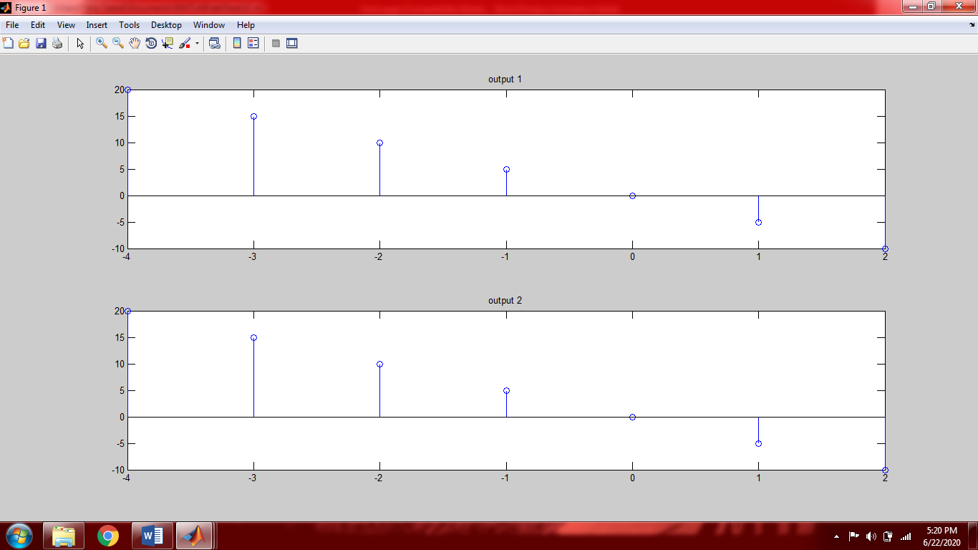

From the above graphs we can see that the output is same. Which means that the system is linear because it is following both law of additivity and law of homogeneity

**Part (d):**

n=[-2:1:4];

n0=3;

Xn=2.*n;

subplot(3,1,1)

stem(-n,Xn)

title('Y[n]');

subplot(3,1,2)

stem(-n-3,Xn)

title('Y[n+3]');

subplot(3,1,3)

stem(-(n-3),Xn)

title('X[n+3]')

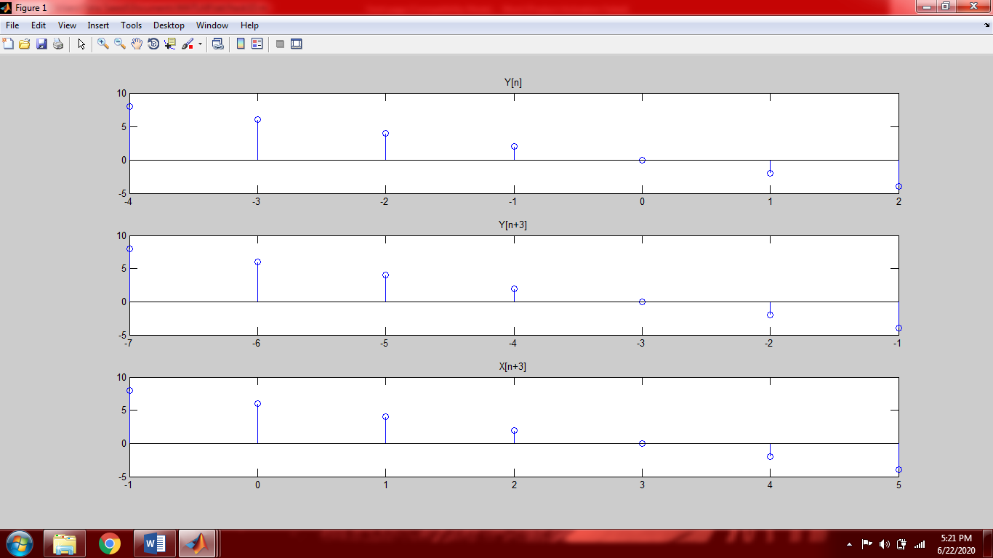

Since both the obtained graphs are same it means the system is time invariant.

**Task 02: Find out if the discrete-time system described by the I/O relationship **

**is:**

1. Static or Dynamic (input signal )
2. Causal or non-causal (input signal)
3. Linear or non-linear (input signals )
4. Shift invariant or shift variant (input signaland shift)

**Part (a):**

n=[-2:1:2];

Xn=2*n;

subplot(2,1,1);

stem(n,Xn);

title('input signal');

subplot(2,1,2);

stem(-Xn-1,Xn);

title('output signal');

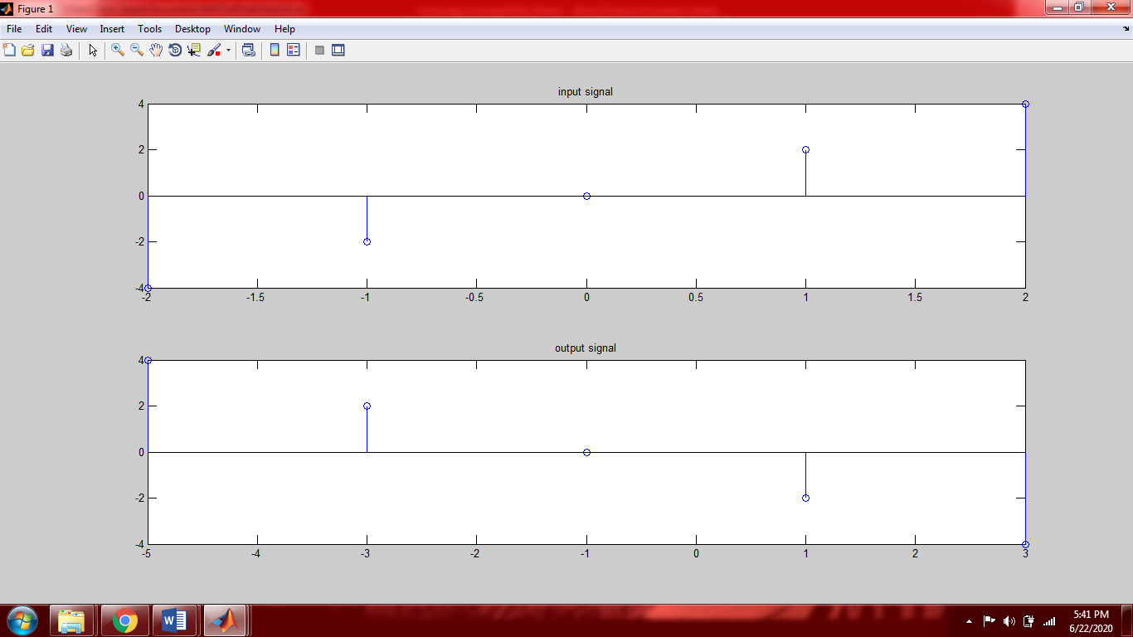

We can see from the above graph that the system is not depending upon the present value of input therefore the system is dynamic and has memory.

**Part (b):**

n=[-2:1:2];

Xn=2*n;

subplot(2,1,1);

stem(n,Xn);

title('input signal');

subplot(2,1,2);

stem(-Xn-1,Xn);

title('output signal');

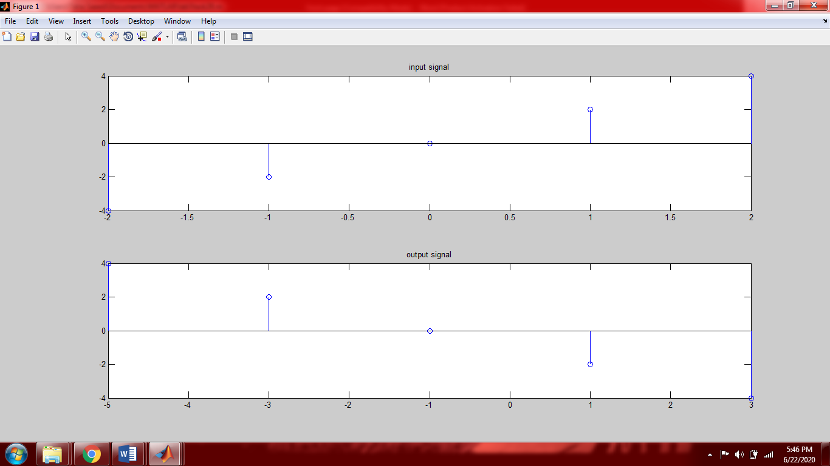

The system is non-causal because we can see in graph that it is depending upon the future values of input.

**Part (c):**

n=[-2:1:4];

a1=2;

a2=3;

X1n=a1*n;

X2n=n./a2;

X=a1*X1n + a2*X2n;

subplot(2,1,1);

stem(-1-2*n,X);

y1n= a1*X1n;

y2n= a2*X2n;

Y=y1n+y2n;

subplot(2,1,2);

stem(-1-2*n,Y);

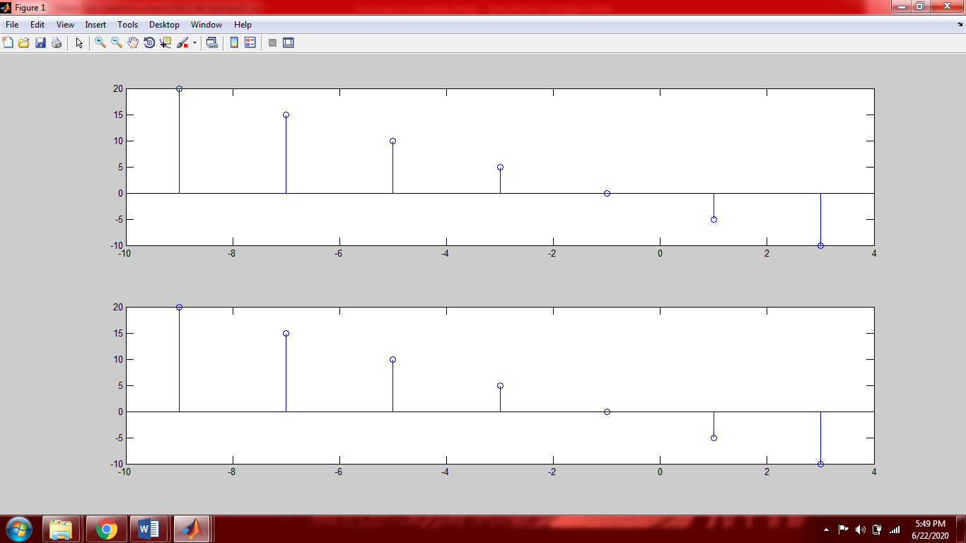

From the above graphs we can see that the output is same. Which means that the system is linear because it is following both law of additivity and law of homogeneity

**Part (d):**

n=[-2:1:4];

n0=3;

Xn=2*n;

subplot(3,1,1)

stem(-1-2*n,Xn)

title('Y[n]');

subplot(3,1,2)

stem(-n0-1-2*n,Xn)

title('Y[n+3]');

subplot(3,1,3)

stem(-1-2*(-n0+n),Xn)

title('X[n+3]');

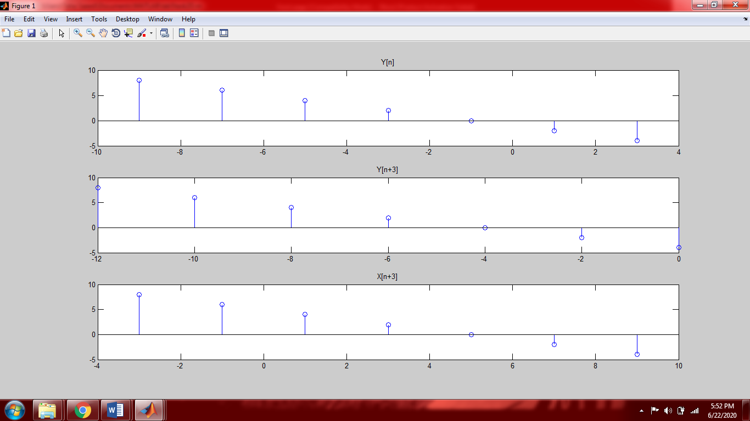

From the above figure we can see that the two outputs are different one has a time shift in it. Which means the system is time Variant

**Post-Lab Task**

## Critical Analysis / Conclusion:

In this lab we studied causal non-causal, static and dynamic, linear and non-linear, time variant and time invariant systems by plotting their input and output signals.

A system is causal if the output of the system does not depend on the Future values of the input.

A system is static if the output of the system only depends upon the present values of input and is dynamic if output depends upon past or future values.

A system is linear if it proves the following equation.



If the system proves the above equation then it means the system follows law of additivity and homogeneity