**In-lab Tasks**

**Task 01:** Create a function “impseq”, which performs following operations:

Function [x,n]=impseq(n0,n1,n2)

* Takes three parameters (n0, n1, n2) as input, where ‘n1’ and ‘n2’ are lower and upper limits of n-axis, and ‘n0’ is the delay.
* Generates a unit-impulse sequence using above mentioned three parameters.
* There should be two output arguments [x, n] of function ‘impseq’, where ‘x’ is impulse sequence and ‘n’ is its corresponding n-axis.
* Finally, plot unit impulse ‘x’ against vector ‘n’.
* On the main window, type “[x,n]=impseq(0,-5,5)”
  + Unit Sample Sequence
    - The resulting plot looks like this



**MATLAB Code:**

function [ X,n ] = impseq( n0,n1,n2 )

%IMPSEQ Summary of this function goes here

% Detailed explanation goes here

n=[n1:1:n2];

X=n==n0;

stem(n,X)

end

**Output:**

impseq(-1,-5,5)

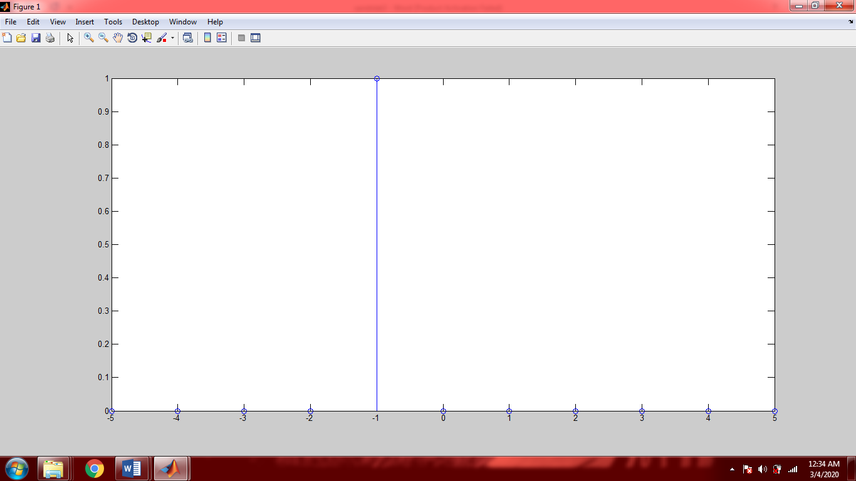

**Task 02:** Make a function to form “stepseq” function which will output unit-step sequence.

Function [x,n]=stepseq(n0,n1,n2)

* + Unit Step Sequence
    - We can have another elegant way to produce a step function
    - Alternatively, we can use the “ones” function
    - Type “stepseq[x,n]=(0,-5,5)” we get:



**MATLAB Code:**

function [ X,n ] = stepseq( n0,n1,n2 )

%STEPSEQ Summary of this function goes here

% Detailed explanation goes here

n=[n1:1:n2];

X=n>=n0;

stem(n,X)

end

**Output:**

stepseq(-2,-5,5)

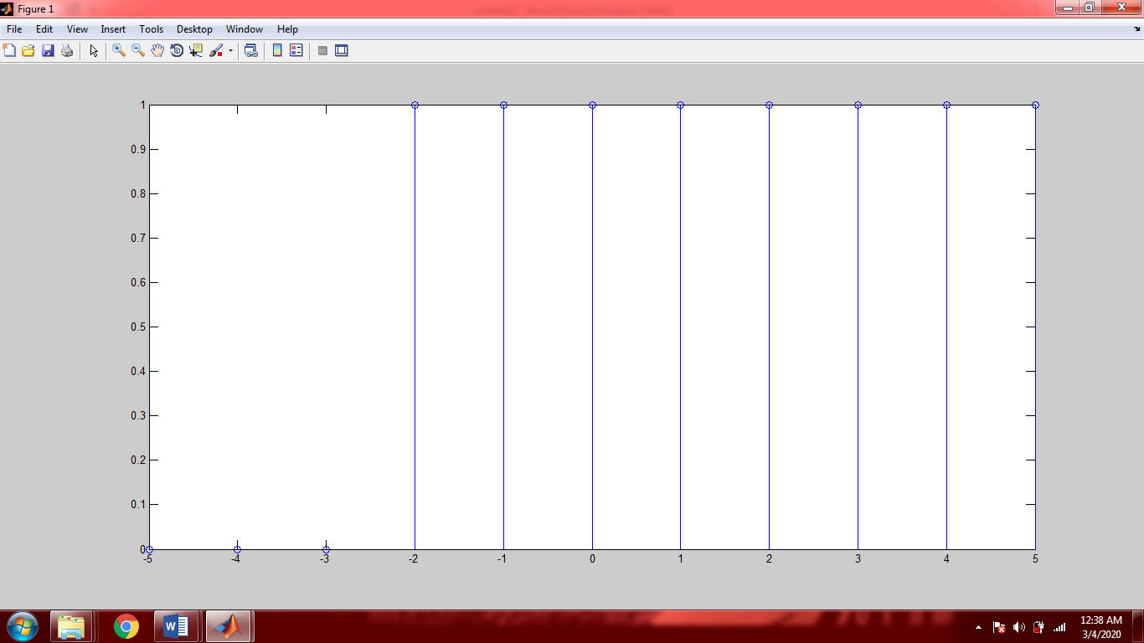

**Task 03:** Create a function “rampseq”, which performs following operations:

Function [x,n]=rampseq(n0,n1,n2)

* Takes three parameters (n0, n1, n2) as input, where ‘n1’ and ‘n2’ are lower and upper limits of n-axis, and ‘n0’ is the delay.
* Generates a ramp sequence using above mentioned three parameters.
* There should be two output arguments [x, n] of function ‘rampseq’, where ‘x’ is impulse sequence and ‘n’ is its corresponding n-axis.
* Finally, plot ramp impulse ‘x’ against vector ‘n’.

**MATLAB Code:**

function [ x,n ] = rampseq( n0,n1,n2 )

%RAMPSEQ Summary of this function goes here

% Detailed explanation goes here

n=[n1:1:n2];

x=n.*(n>=n0);

stem(n,x)

end

**Output:**

rampseq(0,-5,5)

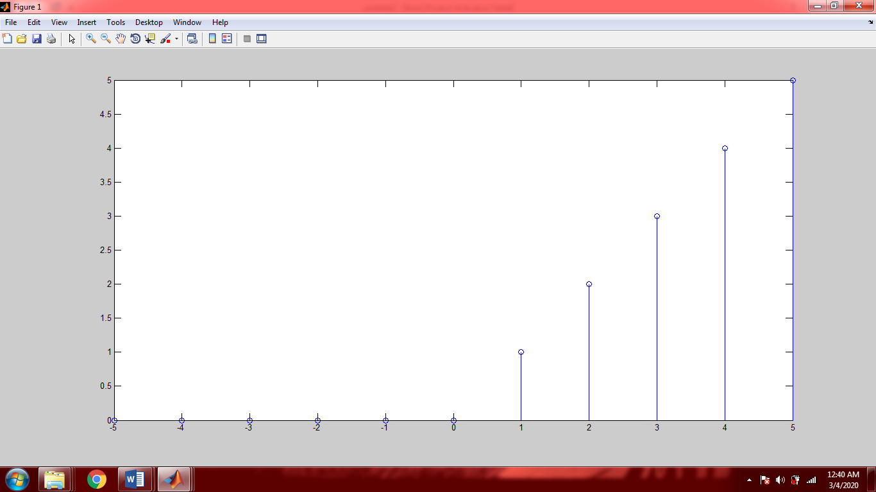

**Task 04:** Create a function “sigseq”, which performs following operations:

Function [x,n]=sigpseq(n0,n1,n2)

* Takes three parameters (n0, n1, n2) as input, where ‘n1’ and ‘n2’ are lower and upper limits of n-axis, and ‘n0’ is the delay.
* Generates a signum sequence using above mentioned three parameters.
* There should be two output arguments [x, n] of function ‘sigseq’, where ‘x’ is impulse sequence and ‘n’ is its corresponding n-axis.
* Finally, plot signum sequence ‘x’ against vector ‘n’.

**MATLAB Code:**

function [ x,n ] = sigseq( n0,n1,n2 )

%SIGSEQ Summary of this function goes here

% Detailed explanation goes here

n=[n1:1:n2];

a=n>=n0;

b=(n<n0).*-1;

x=a+b;

stem(n,x)

end

**Output:**

sigseq(1,-5,5)

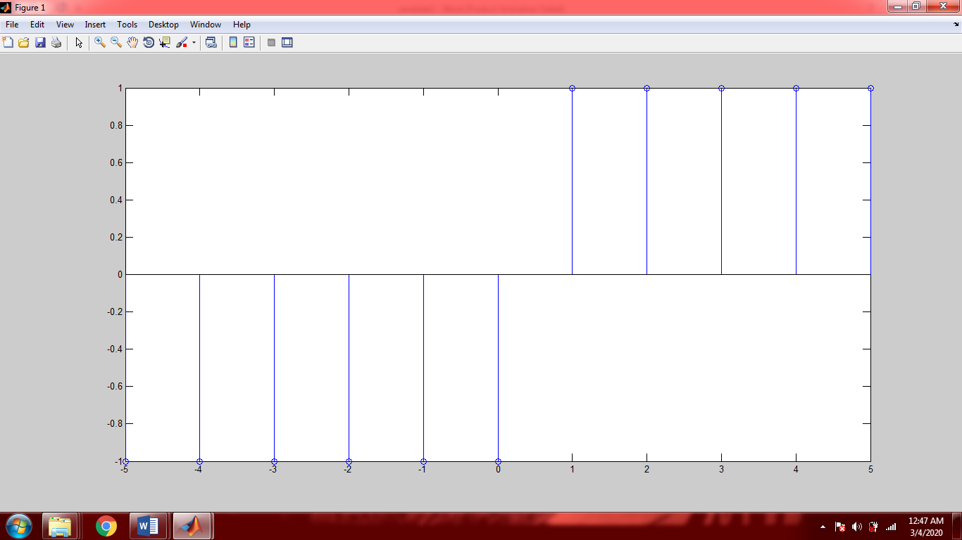

**Task 05:** Find $E_{∞}$ for the following signal

$$tri\left(t\right)= \left\{\begin{aligned}1- \left|t\right| \left|t\right| <1 \\ 0 \left|t\right| ≥1\end{aligned}\right.$$

**MATLAB Code:**

t=[0:0.001:10];

y=1-abs(t);

y1=y.^2;

energy=trapz(t,y1)

**Output:**

energy =243.3333

**Task 06:** Find $P_{∞}$ for the following signal

$$x\left[n\right]=cos⁡(\frac{π}{4}n)$$

**MATLAB Code:**

n=[0:0.01:2*pi];

TimePeriod=2*pi;

x=cos(pi/4.*n);

Xsqr=x.^2;

A=sum(Xsqr/TimePeriod)

**Output:**

**A =47.9010**

**Reason:**

Since it is a cosine signal which means it is periodic it will repeats it values after every cycle. Since cosine repeats its value after **2*pi** that is why I chosen from **0 to 2*pi.**

**Task 07:** Write a function which plot or stem a unit impulse and unit step signals. The function takes values for starting and ending value of independent variable, i.e. t and n, and a character for identification of discrete and continuous signal. Finally t plot or stem the function or signal. e.g;

function f_name ( arg1 (start) , arg2 (end) , arg3 (D/C) )

**MATLAB Code**:

function [ x,y,X,Y ] = f_name( a1,a2,ch )

%F_NAME Summary of this function goes here

% Detailed explanation goes here

if ch=='c' || ch=='C'

x=[a1:1:a2];

y=(x==0);

subplot(2,1,1)

plot(x,y)

y=(x>0);

subplot(2,1,2)

plot(x,y)

else

X=[a1:1:a2];

Y=(X==0);

subplot(2,1,1)

stem(X,Y)

Y=(X>0);

subplot(2,1,2)

stem(X,Y)

end

end

**Output:**

1. For continuous signals

f_name(-5,5,'c')

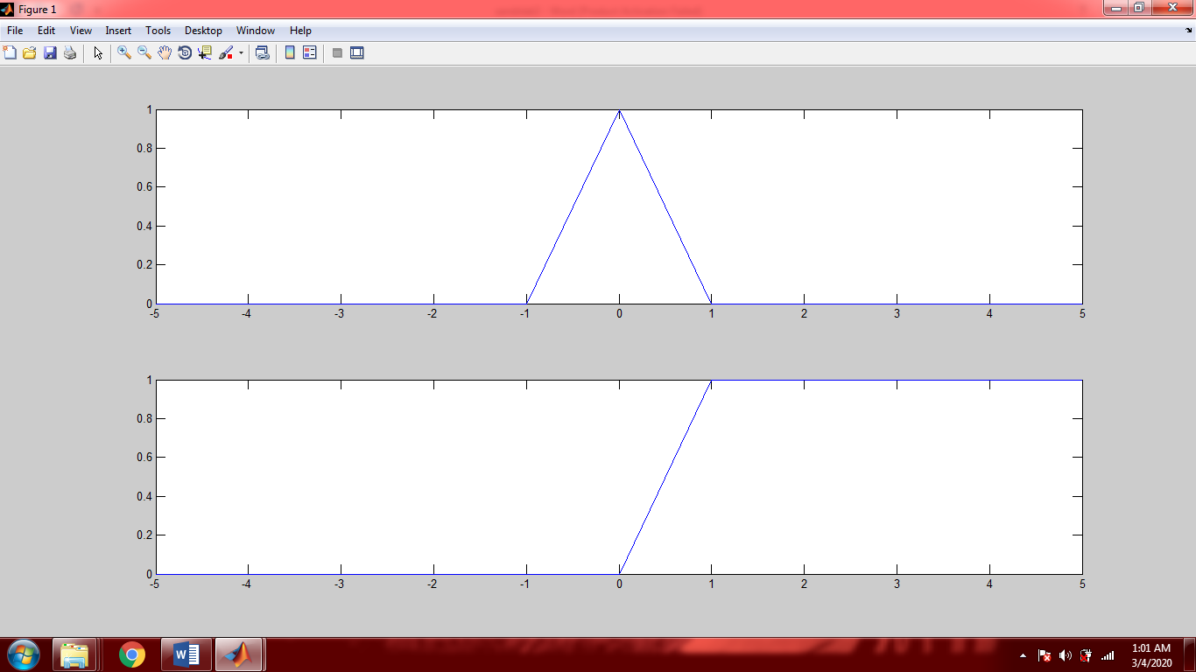

1. For discrete signals

f_name(-5,5,'d')

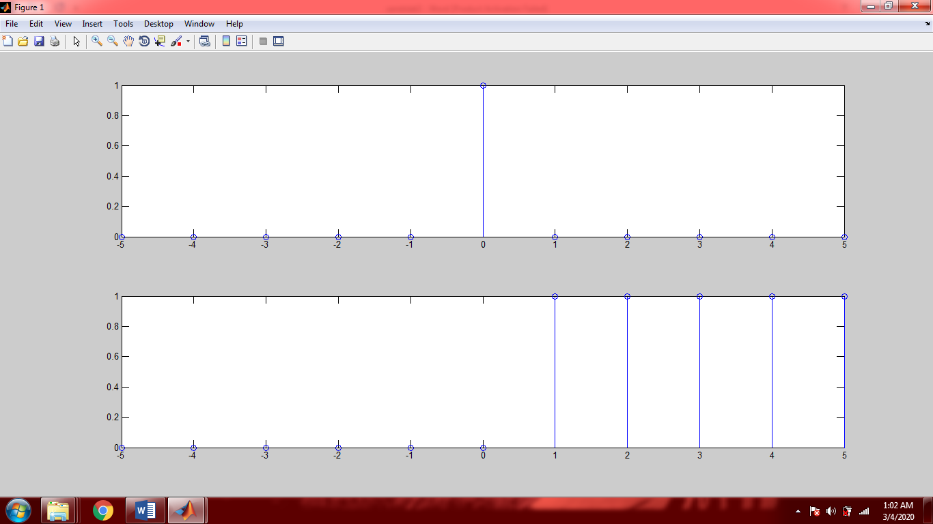

**Post-lab Task**

## Critical Analysis / Conclusion

|  |
| --- |
| In this lab we learned how to plot the following discrete and continuous:   1. Unit impulse 2. Unit step 3. Ramp functions   We also found the value of energy and power for different signals. Since periodic signals repeat after certain time so while finding power and energy for such signals over infinite interval we just find the value for only one cycle. |