
NAME: TAHA MOIZ ELECTRICWALA
ROLLNO: 26ITB002
COURSE CODE: 1CS501CC26
PRACTICAL NUMBER: 3

AIM: (A) Write a program to take the values for A, B, C of a quadratic equation A∗ X 2+B∗ X+C=0 and then find all the roots of the equation. It is guaranteed that A≠ 0 and that the equation has at least one real root.
METHODOLOGY:
#include <stdio.h>
#include <math.h>

int main(){

float A, B, C;
float D, x1, x2;

printf("Enter the coeff of x^2, x and constant: \n");
scanf("%f %f %f", &A, &B, &C);
D = sqrt(B*B - 4*A*C);

x1 = (-B+D)/2*A;
x2 = (-B-D)/2*A;

printf("The roots of the given eqn are: %f & %f", x1, x2);

return 0;
}

INPUT/OUTPUT:
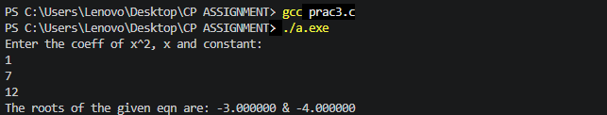
AIM: (B) In an organization, employees are paid on an hourly basis. Clerks are paid 100/hr, Teachers are paid 200/hr and the principal is paid 400/hr. If the weekly hours exceed 44, then employees should be paid 2 times their regular pay for the overtime. Write a C program to compute the weekly salary of the employee and also the program should take care that the employee should not be paid for hours beyond 50 in a week. Use the best suitable control construct to implement the program.
METHODOLOGY:
#include <stdio.h>

int main(){

int type, pay, hr, salary;

printf("Enter the type of employee\n");
printf("Press 1 for clerk\n");
printf("Press 2 for teacher\n");
printf("Press 3 for principal\n");
scanf("%d", &type);
printf("Enter the number of hours worked");
scanf("%d", &hr);

if(type == 1) pay = 100; //For clerk
else if (type == 2) pay = 200; //For teacher
else if (type ==3) pay = 400; //For principal
else {
printf("Wrong input");
return 0;
}

if(hr>50) hr=50;

if(hr>44){
salary = (44*pay) + (2*(hr-44)*pay);
}
else {
salary = hr*pay;
}

printf("The salary of the employee is: %d", salary);
return 0;
}

INPUT/OUTPUT:
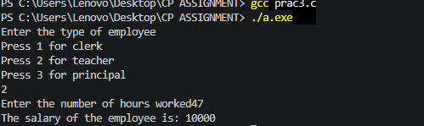
AIM: (C) Ajay and Amit are playing a game with a number X. In one turn, they 1,2,3,4can multiply X by 2. The goal of the game is to make X divisible by 10. Write a C program to find the number of turns necessary to win the game (it may be possible to win in zero turn, 1 turn or it might be impossible (-1 turns)).
METHODOLOGY:
#include <stdio.h>

int main(){
int x;
printf("Enter the number: ");
scanf("%d", &x);

if(x%10 == 0){
printf("0");
}else if(x%5 == 0){
printf("1");
}else{
printf("-1");
}

return 0;
}

INPUT/OUTPUT:
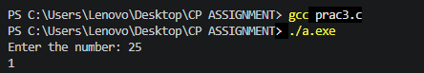
AIM: (D) Write a program to implement a simple number guessing game. Program should generate an integer randomly and ask the user to guess the integer. Based on the number guessed, it should display the appropriate message (correct or incorrect).

METHODOLOGY:
#include <stdio.h>
#include <stdlib.h>
#include <time.h>

int main(){
int num, guess;

num =rand() %100+1;
printf("Guess the number: ");
scanf("%d", &guess);

if( num == guess){
printf("You are the lucky winner!");
}else{
printf("Better luck next time\n");
printf("The number was: %d ", num);
}

return 0;
}

INPUT/OUTPUT:
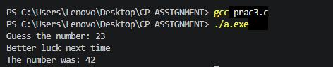
AIM: (E) Write a C program to find the grade of a student based on the following policy. Class test: 12% weightage, Tutorial-12%, SE:16%, LPW:20%, SEE:40%. Grade is decided based on the below range of total marks.
Grade Range of total marks
A+ 91-100
A 81-90
B+ 71-80
B 61-70
C+ 51-60
C >40
Fail <40

METHODOLOGY:
#include <stdio.h>

int main(){
float test, tutorial, se, lpw, see, totalMarks;

//Taking marks of student from user.

printf("Enter marks of class test: \n");
scanf("%f", &test);

printf("Enter marks of tutorial: \n");
scanf("%f", &tutorial);

printf("Enter marks of SE: \n");
scanf("%f", &se);

printf("Enter marks of LPW: \n");
scanf("%f", &lpw);

printf("Enter marks of SEE: \n");
scanf("%f", &see);

totalMarks = 0.12*test + 0.12*tutorial + 0.16*se + 0.2*lpw + 0.4*see;

//calculating grade
printf("Your total marks are: %f \nYour grade is:", totalMarks);
if(totalMarks >= 91){
printf("A+");
}else if(totalMarks >= 81){
printf("A");
}else if(totalMarks >= 71){
printf("B+");
}else if(totalMarks >= 61){
printf("B");
}else if(totalMarks >= 51){
printf("C+");
}else if(totalMarks >= 40){
printf("C");
}else{
printf("Fail");
}

return 0;
}
INPUT/OUTPUT:
