
NAME: TAHA MOIZ ELECTRICWALA
ROLLNO: 26ITB002
COURSE CODE: 1CS501CC26 – COMPUTER PROGRAMMING
PRACTICAL NUMBER: 4
DATE: 15/09/2026

AIM: (A)
Write C Programs:
To solve following patterns:
A 1
A B 01
A B C 101
A B C D 0101

METHODOLOGY (1):
#include <stdio.h>

int main(){

for (char ch1='A'; ch1<='D'; ch1++){
for (char ch2='A'; ch2<=ch1; ch2++){
printf("%c ", ch2);
}
printf("\n");
}

return 0;
}
METHODOLOGY (2):
#include <stdio.h>

int main(){
int n=4;
for (int i=1; i<=n; i++){
for (int j=1; j<=i; j++){
if((i+j)%2==0){
printf("1 ");
}else{
printf("0 ");
}
}
printf("\n");
}
return 0;
}

INPUT/OUTPUT:
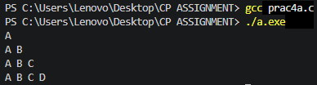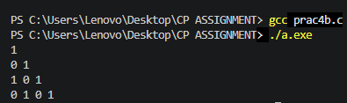
AIM: (B)
To determine whether the entered number is Prime
METHODOLOGY:
#include <stdio.h>

int main(){
int num;
int ans = 0;
printf("Enter a number: ");
scanf("%d", &num);

for(int i=2; i*i<=num; i++){
if(num%i == 0){
ans=1;
break;
}
}

if(ans == 0){
printf("number is prime");
}else{

printf("Numeber is not prime");
}
return 0;
}
INPUT/OUTPUT:
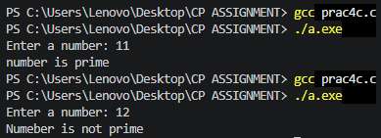
AIM: (C)
Enhance the number guessing game developed earlier. The program should now display more appropriate messages (Greater, Smaller or Correct). It should allow a maximum of 5 attempts from the user and still if the user cannot guess the number correctly, it should display “Sorry”.
METHODOLOGY:
#include <stdio.h>
#include <stdlib.h>
#include <time.h>

int main(){

int guess, i;
srand(time(0));
int num = rand()%100 +1;

for (i=0; i<5; i++){
printf("Enter your guess: \n");
scanf("%d", &guess);

if (guess == num){
printf("Correct, you won!!!\n");
break;
}else if(guess < num){
printf("Your guess is low\n");
}else{
printf("Your guess is high\n");
}
}

if(i == 5 && num!=guess) printf("You lost, the number was: %d", num);
return 0;
}
INPUT/OUTPUT:
