

CINESTOP
The Ultimate Collection of Movies & Series

Lab: Introduction to Computer Science
Students:
Taha – BSCS2512374
Muhammad Yousuf – BSCS2512363
Date of Submission: December 31, 2025

CONTEXT

Table of Contents
ABSTRACTION 3
INTRODUCTION 1
ABOUT CINESTOP 2
Our Mission 2
What Makes CineStop Special? 2
PLATFORM OVERVIEW 3
Website Layout 3
GENERE CATEGORIES 4
1) ACTION 4
2) COMEDY 4
3) DRAMA 4
4) HORROR 5
5) SCI-FI 5
6) ROMANCE 5
7) THRILLER 6
8) ANIMATION 6
SOME SNIPPETS OF CINESTOP 7
7
VIEWING TIPS & NAVIGATION GUIDE 8
Describing Content 8
FLOWCHARTS 9
User Journey 9
Content Classification 10
CONCLUSION 11

ABSTRACTION

CineStop is a user-focused movie and series browsing platform designed to simplify content discovery and enhance the overall viewing experience. The website provides access to a diverse collection of films and series across multiple genres, ranging from classic favorites to the latest trending titles. By presenting content in a structured and visually clean layout, CineStop allows users to explore entertainment options without the frustration of excessive scrolling or complicated navigation.
The platform uses abstraction by representing each movie or series through essential details such as title, genre, release year, and brief descriptions rather than overwhelming users with unnecessary information. Content is organized into well-defined categories, making it easy for users to locate what they are interested in quickly. Advanced search and filtering features further improve accessibility by allowing users to narrow down choices based on their preferences.
Built using HTML and CSS, CineStop emphasizes simplicity, clarity, and usability. Every element of the interface is designed to support smooth interaction and easy understanding, ensuring that users of all experience levels can navigate the platform confidently. This abstraction highlights the core structure and functionality of CineStop while keeping the focus on an efficient and enjoyable user experience.

INTRODUCTION
Welcome to CineStop, your premier destination for discovering and enjoying an extensive collection of movies and series across multiple genres. This user guide has been designed to help you navigate through our platform effortlessly and make the most of your viewing experience. Whether you're a first-time visitor or a regular user, this comprehensive guide will serve as your complete reference for all aspects of the CineStop platform.
CineStop brings together a carefully curated selection of content ranging from classic films to trending series. Whether you're a fan of heart-pounding action, thought-provoking dramas, or lighthearted comedies, CineStop has something special for everyone. Our platform eliminates the confusion of endless scrolling by organizing content into clear, distinct categories that make finding your next favorite movie or series simple and enjoyable.
This guide will walk you through understanding the platform's layout, navigating through different genre categories, discovering featured content, and optimizing your viewing experience on our HTML/CSS based streaming platform. We'll cover everything from basic navigation to advanced search features, content organization systems, and tips for getting the most out of your CineStop experience. By the end of this guide, you'll be confident in using every feature the platform has to offer.
The CineStop platform was built with user experience as the top priority. Every design decision, from the clean interface to the intuitive navigation system, was made to ensure that finding and enjoying content is as seamless as possible. This guide reflects that same commitment to clarity and user-friendliness, providing you with straightforward instructions and helpful insights.

ABOUT CINESTOP

Our Mission
CineStop was created to provide entertainment enthusiasts with a streamlined, user-friendly platform where they can easily discover, explore, and enjoy their favorite movies and series. We believe that finding the perfect content to watch should be an enjoyable experience, not a frustrating search through endless options. Our mission is to simplify content discovery while maintaining a diverse, high-quality library that appeals to all tastes and preferences.
In today's digital age, viewers are often overwhelmed by too many choices and complex interfaces. CineStop addresses this challenge by providing a clean, organized platform that respects your time and makes entertainment accessible. We've eliminated unnecessary complexity while maintaining the features that matter most to our users.

What Makes CineStop Special?
CineStop stands out in the streaming landscape through several key features and design principles that prioritize user experience above all else.
- Clean Design: Built with HTML and CSS, CineStop offers a clean, responsive interface that works seamlessly across all devices. The straightforward design means you spend less time figuring out how to use the platform and more time enjoying content. There are no confusing menus, hidden features, or unnecessary complications.
- Easy Navigation: Our organized structure makes it simple to browse by genre or search for specific titles. The navigation system is intuitive enough for first-time users while being efficient for regular viewers. You can move between sections effortlessly, and the consistent layout means you always know where you are.
- Dual Content: Access both movies for quick entertainment and series for extended viewing experiences. This flexibility allows you to choose content based on your available time and commitment level. Whether you have two hours or want to binge-watch a series over several days, CineStop accommodates your viewing style.

PLATFORM OVERVIEW

Website Layout
The CineStop homepage serves as your gateway to our entire content library and has been carefully designed to provide immediate access to everything the platform offers. The layout follows a logical flow that guides you naturally from exploration to selection, with several key sections working together to create a cohesive user experience.
Header Section: Contains the CineStop logo and main navigation menu with links to all genre categories and key features. The logo serves as a home button, allowing instant return to the main page from anywhere on the site. The clean design of the header ensures it provides functionality without cluttering the visual space.
Featured Section: Showcases selected movies and series that are worth watching, including popular titles and new additions. This section is updated regularly to keep the content fresh and give you new viewing options. Featured content is chosen to represent the diversity of the CineStop library, ensuring that different genres and styles are highlighted. This is often the best place to start if you're not sure what you want to watch, as featured selections are specifically chosen for their broad appeal and quality.
Genre Grid: Displays all eight genre categories with visual representation, making it easy to jump directly to your preferred content type. Each genre is represented by appealing imagery that captures the essence of that category. The grid layout is responsive, adjusting to your screen size while maintaining easy accessibility. Clicking on any genre tile takes you directly to that category's full collection, where you can browse all available content.
Footer: Includes navigation links and additional platform information. The footer provides secondary navigation options and gives you quick access to important links without cluttering the main interface. It also contains information about the platform and any relevant details users might need.

GENERE CATEGORIES
CineStop organizes its extensive library into eight distinct genre categories. Each genre page features its own curated collection of movies and series.

ACTION
Action content delivers excitement and adrenaline with spectacular sequences and thrilling storylines.

What to Expect:
- High-stakes scenarios and intense sequences
- Fast-paced storytelling
- Heroic protagonists and epic confrontations
- Explosive and visually stunning moments
- Edge-of-your-seat entertainment

COMEDY
Comedy brings laughter and joy, ranging from clever humor to hilarious situations that lighten your mood.
What to Expect:
- Witty dialogue and memorable one-liners
- Hilarious characters and situations
- Feel-good storylines
- Various comedy styles from slapstick to satire
- Perfect for entertainment and relaxation

DRAMA
Drama explores complex emotions, relationships, and compelling narratives with depth and authenticity.
What to Expect:
- Powerful storytelling and character development
- Emotional depth and human connections
- Thought-provoking themes
- Realistic portrayals of life situations
- Engaging narratives that resonate

HORROR
Horror delivers chills and suspense, exploring fears through various styles from psychological terror to supernatural scares.
What to Expect:
- Suspenseful atmosphere and tension
- Thrilling and scary moments
- Mystery and supernatural elements
- Psychological intensity
- Perfect for thrill-seekers

SCI-FI
Science fiction transports viewers to imaginative worlds with futuristic technology and mind-bending concepts.
What to Expect:
- Futuristic settings and advanced technology
- Space exploration and time travel themes
- Philosophical questions about humanity
- Innovative visual concepts
- Intellectually stimulating content

ROMANCE
Romance celebrates love stories and emotional connections in various forms and settings.
What to Expect:
- Heartfelt love stories
- Emotional journeys and relationships
- Character-driven narratives
- Romantic tension and chemistry
- Satisfying emotional experiences

THRILLER
Thrillers keep audiences engaged with suspenseful plots, unexpected twists, and psychological intensity.
What to Expect:
- Suspenseful and gripping plots
- Mystery elements and plot twists
- Psychological tension
- Fast-paced storytelling
- Keep-you-guessing narratives

ANIMATION
Animation brings stories to life through artistry, appealing to all ages with imaginative worlds and universal themes.
What to Expect:
- Stunning visual artistry
- Imaginative storytelling
- Universal themes for all audiences
- Creative animation styles
- Entertainment for the whole family

SOME SNIPPETS OF CINESTOP
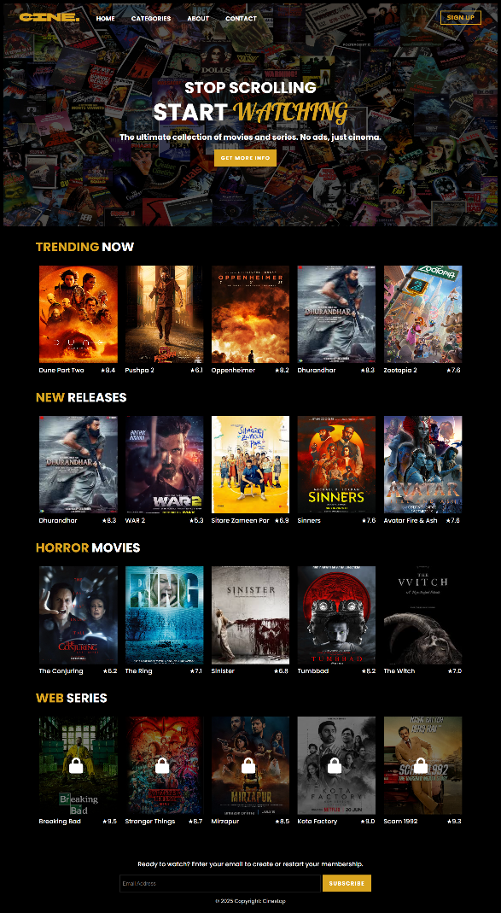
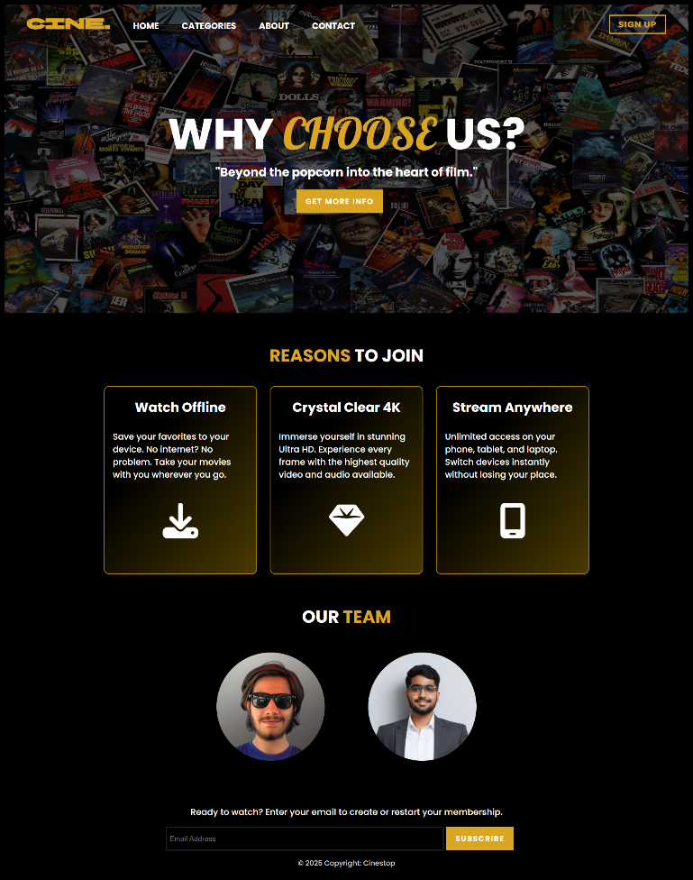
Figure 1 About Page
Figure 2 Home Page

VIEWING TIPS & NAVIGATION GUIDE

Describing Content
Finding great content to watch is one of the most important aspects of any streaming platform, and CineStop makes this process both simple and enjoyable through multiple discovery methods.
Explore Different Genres: Browse various categories to discover new favorites beyond your usual preferences. One of the joys of streaming is the ability to explore content you might not encounter otherwise. CineStop's genre organization makes it easy to step outside your comfort zone and try something new. You might discover that you enjoy genres you never considered before.
Check Featured Sections: Featured content highlights quality selections worth watching. These carefully chosen titles represent some of the best content available on the platform and are updated regularly to keep things fresh. If you're unsure what to watch, featured sections are an excellent starting point that saves you the effort of browsing through extensive catalogs.
Consider Your Mood: Choose genres that match your current mood and available viewing time. If you're looking for excitement, action might be perfect. If you want something thought-provoking, drama or sci-fi could be ideal. The genre system helps you align content with your emotional state and viewing intentions.
Genre Mixing: Explore multiple genres to expand your entertainment options and prevent viewing fatigue. While it's natural to have favorites, exposing yourself to different types of content keeps your viewing experience fresh and exciting.
Quality Focus: The platform's curated selection ensures quality across all categories, so you can feel confident that any choice will provide a worthwhile viewing experience. The curation process means you're less likely to encounter disappointing content.

FLOWCHARTS

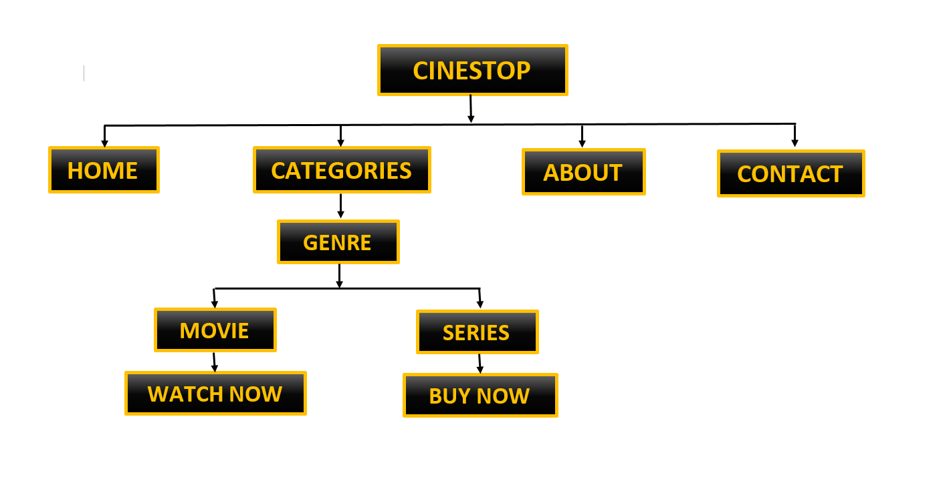
User Journey
Figure 3 User Journey Flowchart

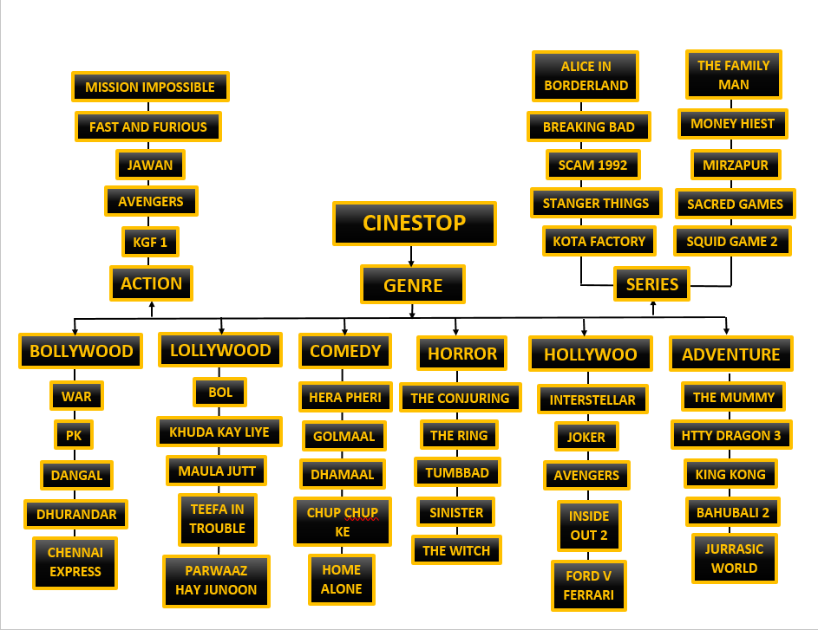
Content Classification
Figure 4 Content Classification Flowchart

CONCLUSION
Thank you for choosing CineStop as your entertainment platform. We've designed this HTML/CSS based service with simplicity and user experience in mind, creating an intuitive and accessible way to explore our diverse content collection. This user guide has provided you with comprehensive information about every aspect of the platform, from basic navigation to advanced features, ensuring you can make the most of your CineStop experience.
Whether you're searching for movies or series, action-packed content or heartwarming dramas, CineSto p's organized structure makes it easy to find exactly what you're looking for. Our eight genre categories, clean interface, and simple navigation ensure your perfect entertainment is always just a few clicks away. The platform's design philosophy prioritizes your time and satisfaction, eliminating unnecessary complications while maintaining all the features you need.

