Function add new Todo into Todo List

Get value from Form

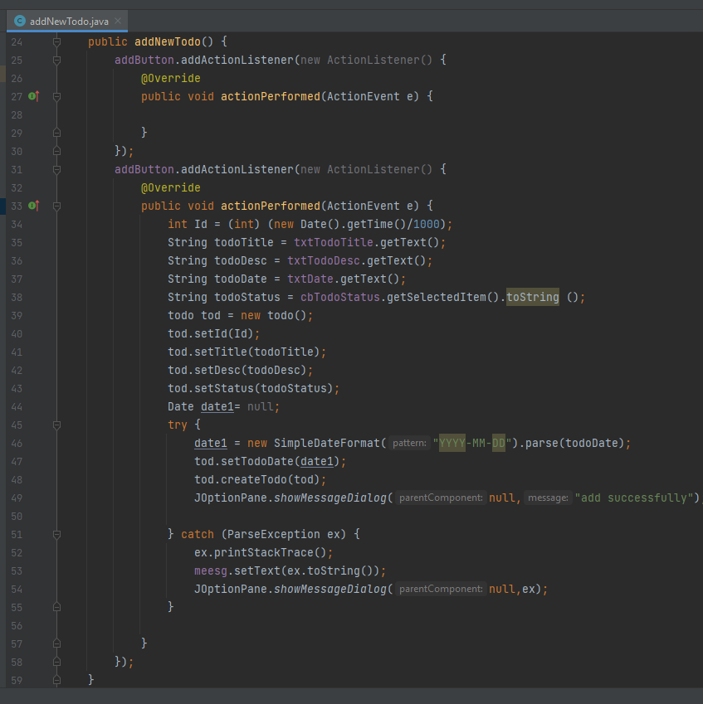

Show message after insert data

Function write data into CSV file.

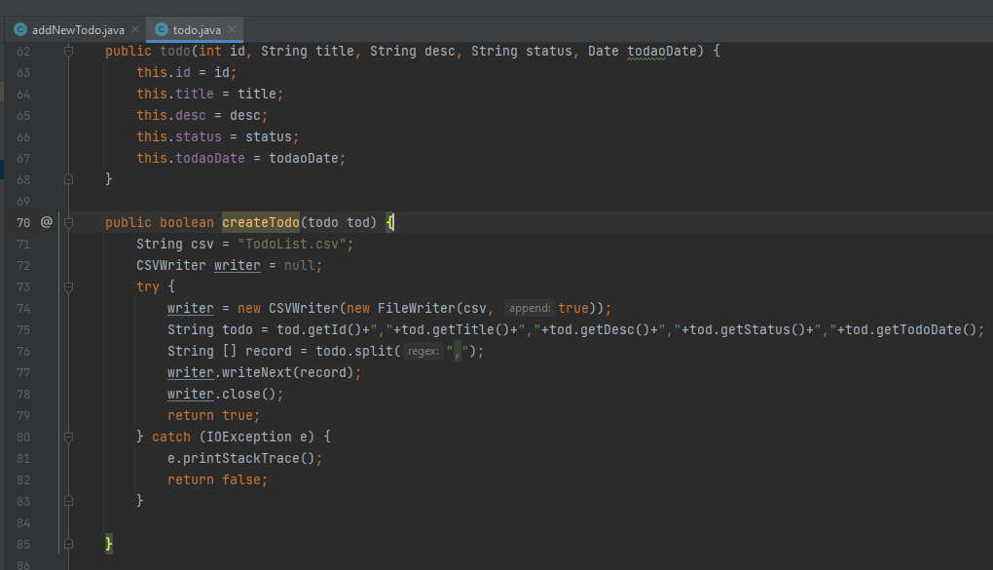

Function Read Data from CSV file

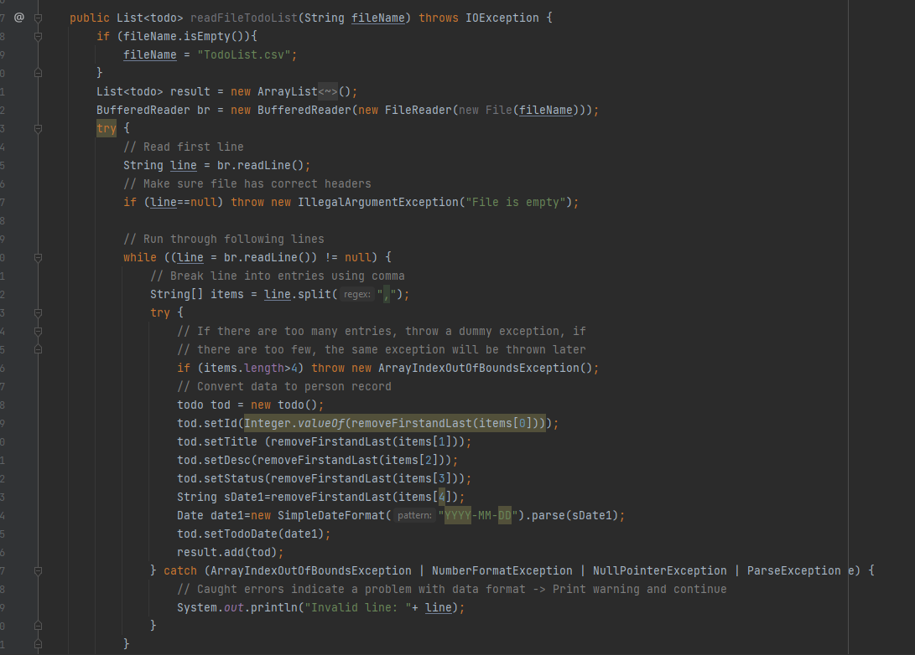

Function open Form

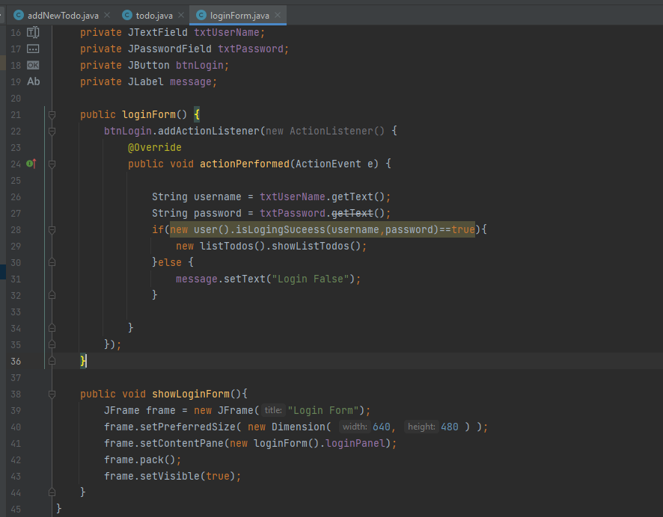

Function Create User

This function create new user and save it into CSV file.

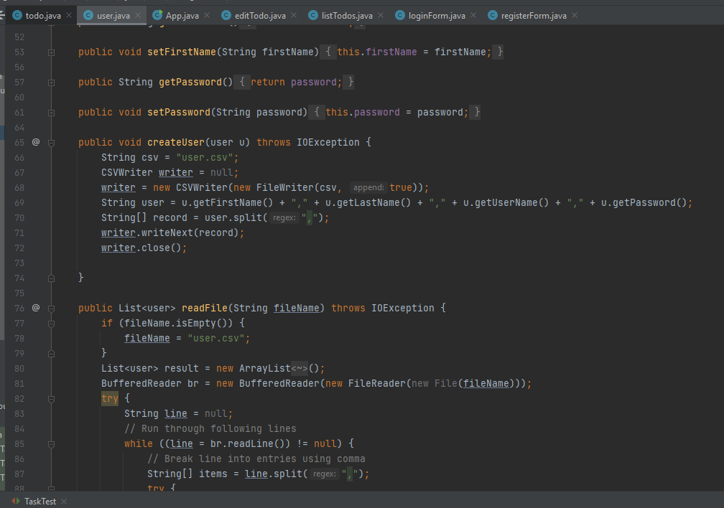

Function login

This function to check user name and password.

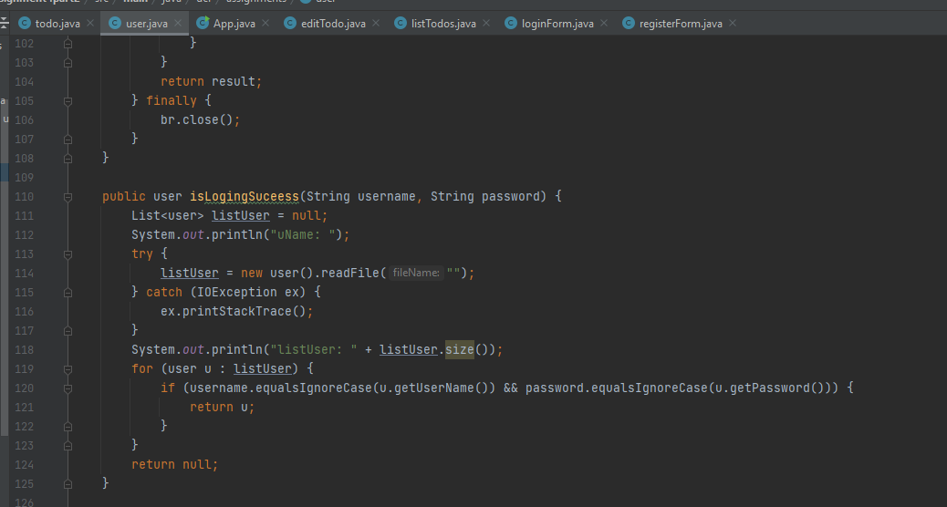

Function Get user information based on username

We use Stream support in java 8 to find item from list

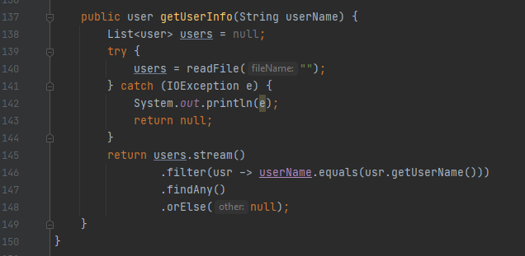

Function create todo list

This function will create and save data in csv file

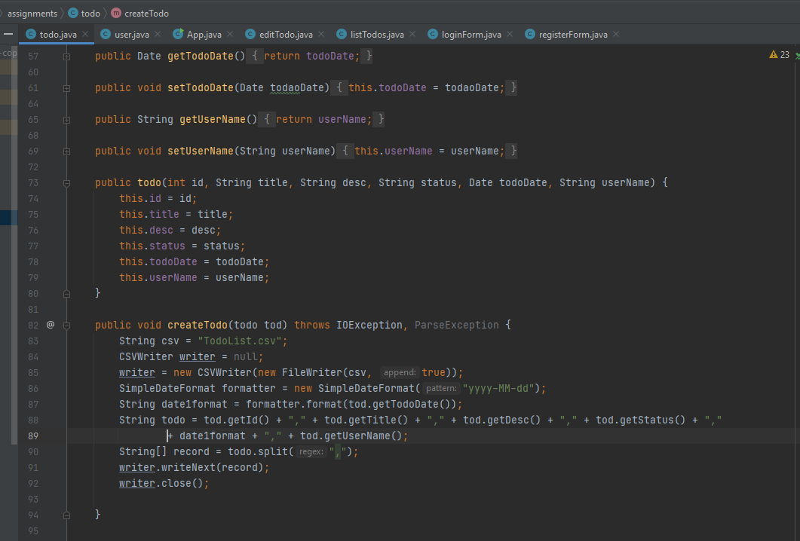

Function list all Item in to do list

We need read data from CSV file into List

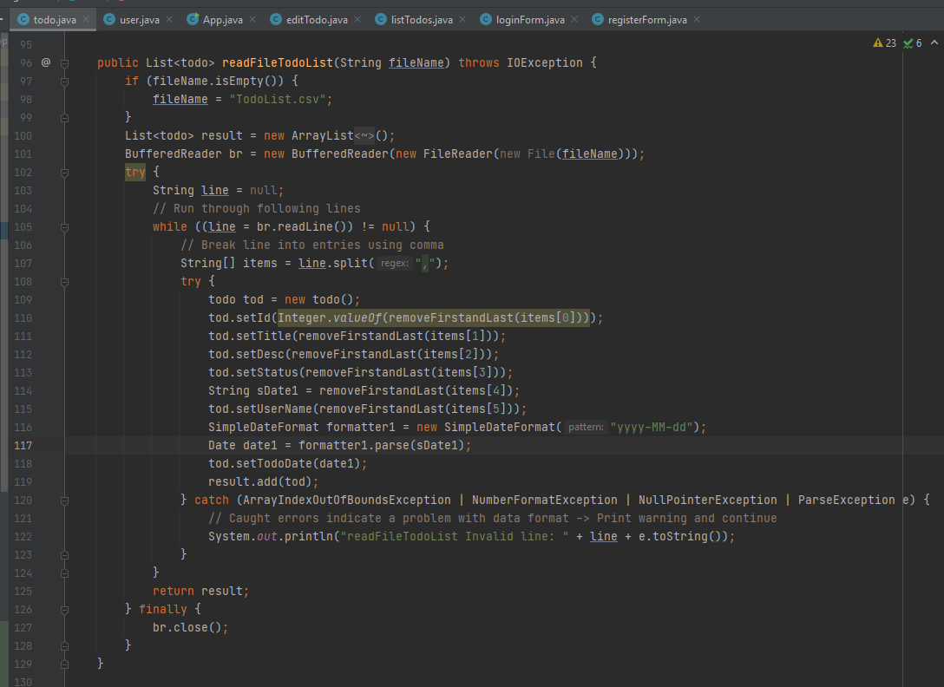

Function Edit Todo list

Because we don't’ use SQL, We only use text file to store data, every time modify data I save it a backup file.

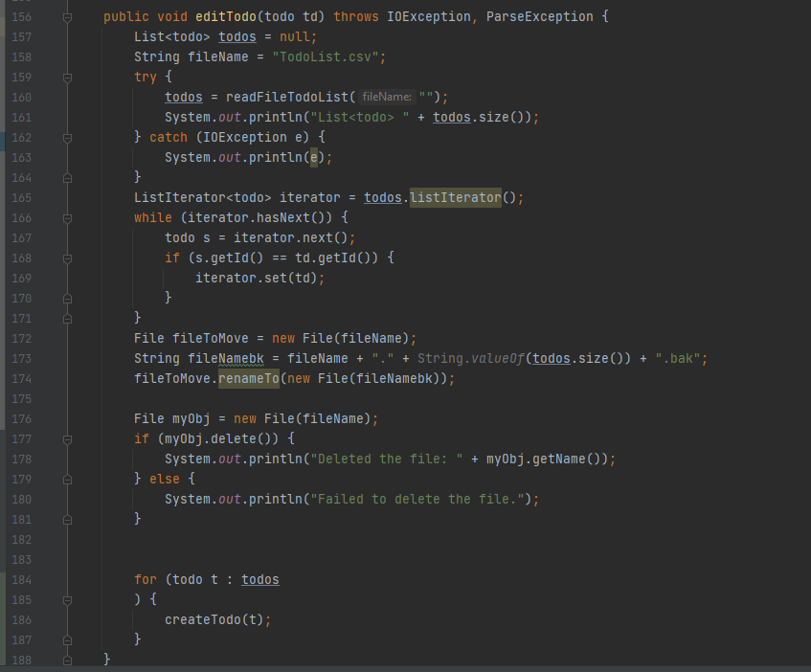

Function delete Todo List

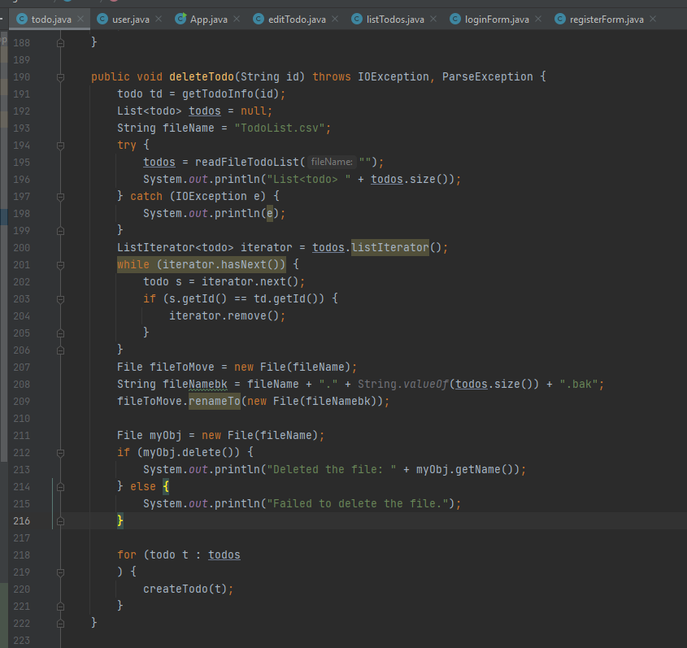

Function Clear all Todo List

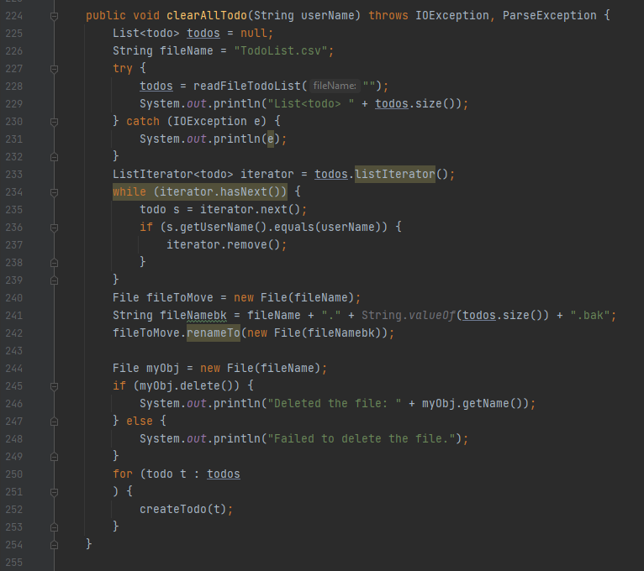

**Unit Test:**

**We create unit test for testing field value input**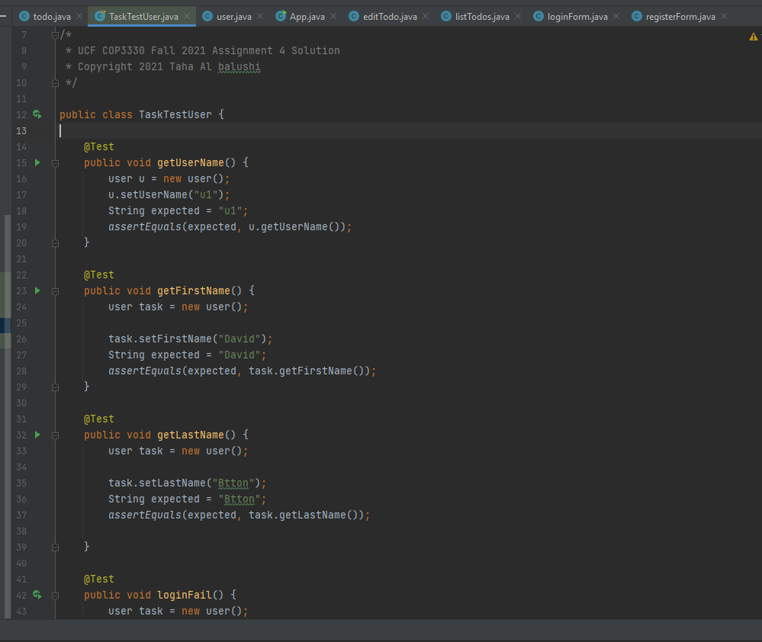

**Simple case for test login and create User**

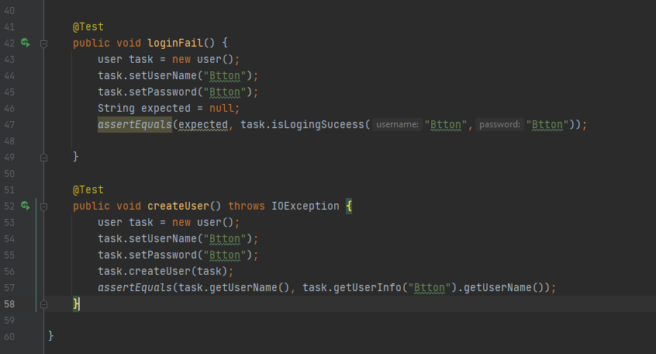

**Function test fields Todo**

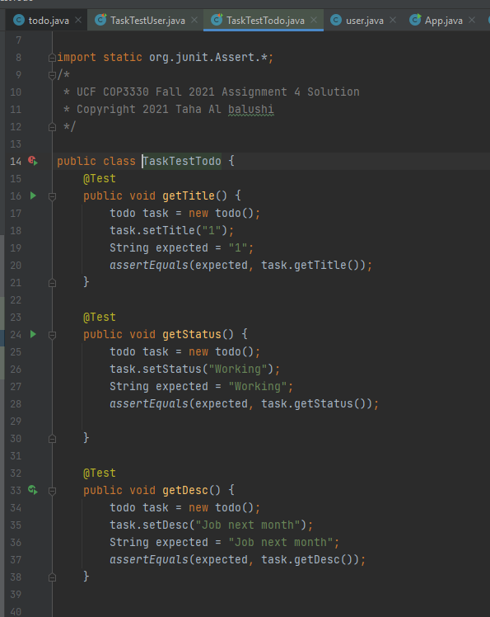

**This test is fail, because Date time is can not cast**

